**ECON 2105 GT Quiz 8 Chapters 14 Money and Banking**

Name: __________________________ Date: _____________

|  |  |
| --- | --- |
| 1. | Included in the *M*1 definition of money is: |
| A) | demand deposits. |
| B) | savings deposits. |
| C) | U.S. Treasury bills. |
| D) | all of the above. |

|  |  |
| --- | --- |
| 2. | If currency in circulation is $100 million, demand deposits are $500, savings deposits are $300 million and travelers' checks are $10 million, then the *M*1 money supply is: |
| A) | $100 million. |
| B) | $410 million. |
| C) | $610 million. |
| D) | $900 million. |

Use the following to answer question 3:

Table: Balance Sheet

|  |  |
| --- | --- |
| Assets | Liabilities |
| Loans | Deposits |
| Reserves $20,000 |  |

|  |  |
| --- | --- |
| 3. | (Table: Balance Sheet) If the reserve ratio is 25%, loans are: |
| A) | $5,000. |
| B) | $15,000. |
| C) | $60,000. |
| D) | $80,000. |

|  |  |
| --- | --- |
| 4. | Suppose the reserve ratio is 20%. If Holly deposits $1,000 of cash into her checking account and her bank lends $600 to Freda, the money supply: |
| A) | remains the same. |
| B) | decreases by $1,000 |
| C) | decreases by $600. |
| D) | increases by $600 |

Use the following to answer question 5:

Exhibit: Money Creation

The reserve requirement is 20%, and Leroy deposits his $1,000 check received as a graduation gift in his checking account. The bank does NOT want to hold excess reserves.

|  |  |
| --- | --- |
| 5. | (Exhibit: Money Creation) What is the maximum expansion in the money supply possible? |
| A) | $1,000 |
| B) | $1,800 |
| C) | $4,000 |
| D) | $5,000 |

|  |  |
| --- | --- |
| 6. | If a bank gets a new deposit of $100 cash and it has a 20% required reserve ratio, then the total amount deposits can increase by is: |
| A) | $20. |
| B) | $100. |
| C) | $500. |
| D) | $1,000. |

|  |  |
| --- | --- |
| 7. | If Congress places a $5 tax on each ATM transaction, the real demand for money will likely: |
| A) | increase. |
| B) | decrease. |
| C) | decrease initially, and then decrease. |
| D) | be unaffected. |

Use the following to answer question 8:

Figure: Money Market

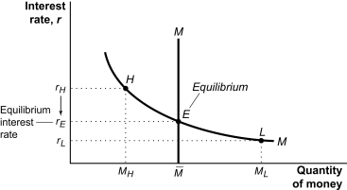

|  |  |
| --- | --- |
| 8. | (Figure: Money Market) If the money market is initially in equilibrium at point *E* and the central bank sells bonds, then the interest rate will: |
| A) | move toward point *H*. |
| B) | move toward point *L*. |
| C) | remain at point *E*. |
| D) | do none of the above. |

Use the following to answer questions 9-10:

Figure: Monetary Policy 1

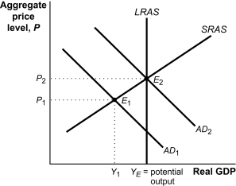

|  |  |
| --- | --- |
| 9. | (Figure: Monetary Policy 1) If the money market is initially at *E*1 and the central bank chooses to buy bonds, then: |
| A) | *AD*2 will shift to the right, creating an inflationary gap. |
| B) | *AD*2 may shift to *AD*1, creating a recessionary gap. |
| C) | *AD*1 may shift to AD2,closing an existing recessionary gap. |
| D) | *AD*1 will shift to the left,increasing an existing recessionary gap. |

|  |  |
| --- | --- |
| 10. | (Figure: Monetary Policy 1) If the money market is initially at *E*2 and the central bank chooses to sell bonds, then: |
| A) | *AD*2 will shift to the right, creating an inflationary gap. |
| B) | *AD*2 may shift to *AD*1, creating a recessionary gap. |
| C) | *AD*1 may shift to *AD*2,closing an existing recessionary gap. |
| D) | *AD*1 will shift to the left,increasing an existing recessionary gap. |