Econ 2106

FINAL EXAM

**ANSWER KEY**

Fall 2015

Dr. Richard FritzName: __________________________ Date: _____________

|  |  |  |
| --- | --- | --- |
| 1. | Which of the following policies is most likely to reduce traffic congestion in a large metropolitan area? | |
| A) | a limited number of free “early bird” parking passes given only to those who arrive prior to 6 A.M. |
| **B)** | **a toll road that requires each car to pay a fee to enter the city center** |
| C) | an increase in the price of subway and bus fare to and from the city |
| D) | asking citizens to carpool |

|  |  |  |
| --- | --- | --- |
| 2. | When the United States and Mexico trade: | |
| A) | the United States will be worse off because wages in Mexico are so low. |
| B) | Mexico will be worse off because the United States is a stronger economic power. |
| **C)** | **both Mexico and the United States will be better off.** |
| D) | both Mexico and the United States will be worse off. |

|  |  |  |
| --- | --- | --- |
| 3. | Two neighbors, Molly and Sandy, are separated by a white picket fence. Each neighbor has a garden that grows tomatoes and peppers. How could Molly and Sandy gain from trade? | |
| A) | Molly could trade tomatoes to Sandy in exchange for peppers if Molly was the more efficient grower of peppers. |
| B) | Sandy could trade tomatoes to Molly in exchange for peppers if Sandy was the more efficient grower of peppers. |
| C) | Sandy could trade peppers to Molly in exchange for tomatoes if Molly was the more efficient grower of peppers. |
| **D)** | **Molly could trade peppers to Sandy in exchange for tomatoes if Molly was the more efficient grower of peppers.** |

|  |  |  |
| --- | --- | --- |
| 4. | Twelve friends got together to celebrate a birthday. If the birthday cake is cut into 12 pieces of the same size and one slice is given to each of the 12 partygoers, this cake distribution is: | |
| A) | efficient but not equitable. |
| B) | equitable but not efficient. |
| C) | efficient and equitable. |
| **D)** | **equitable.** |

|  |  |  |
| --- | --- | --- |
| 5. | If an economy has to sacrifice only one unit of good *X* for each unit of good *Y* produced throughout the relevant range, then its production possibility frontier has: | |
| A) | a zero slope. |
| **B)** | **a constant, negative slope.** |
| C) | an increasing, negative slope. |
| D) | a decreasing, negative slope. |

Use the following to answer question 6:

**Figure: Strawberries and Submarines**

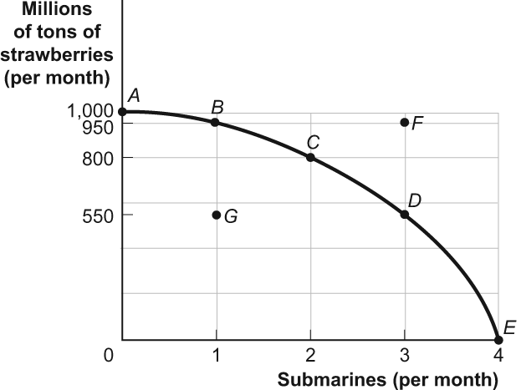

|  |  |  |
| --- | --- | --- |
| 6. | (Figure: Strawberries and Submarines) Look at the figure Strawberries and Submarines. Suppose the economy now operates at point *C.* Moving to point *E* would require that the economy: | |
| A) | achieve full employment and an efficient allocation of resources. |
| **B)** | **eliminate its production of strawberries.** |
| C) | reduce its production of submarines. |
| D) | improve its technology or increase the quantities of factors of production it has. |

|  |  |  |
| --- | --- | --- |
| 7. | Professor Macro wants to use a numerical graph to show the percentage of government spending accounted for by its various components. Which of the following graphs is most suitable for this purpose? | |
| A) | bar graph |
| **B)** | **pie chart** |
| C) | time-series graph |
| D) | scatter diagram |

Use the following to answer question 8:

**Figure: Demand for Coconuts**

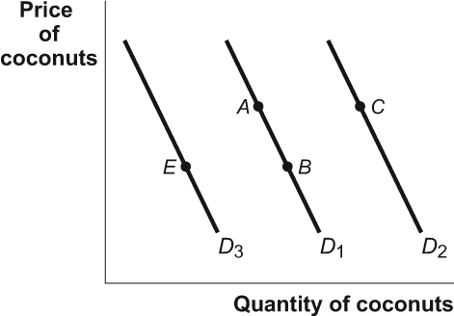

|  |  |  |
| --- | --- | --- |
| 8. | (Figure: Demand for Coconuts) Look at the figure Demand for Coconuts. If coconuts are a normal good and the income level of consumers falls, it will be represented in the figure as a movement from: | |
| A) | *A* to *C.* |
| B) | *B* to *A.* |
| **C)** | ***C* to *A.*** |
| D) | *E* to *B.* |

|  |  |  |
| --- | --- | --- |
| 9. | Which of the following *always* results in an increase in price and quantity? | |
| A) | an increase in supply and a decrease in demand |
| **B)** | **an increase in demand with no change in supply** |
| C) | an increase in supply with no change in demand |
| D) | a decrease in demand and supply |

|  |  |  |
| --- | --- | --- |
| 10. | In the market for tacos, you observe that the equilibrium price and quantity have increased. This can be caused only by: | |
| A) | an increase in the price of beef. |
| B) | an increase in the wages of taco shop workers. |
| C) | fewer taco shops. |
| **D)** | **an increase in the incomes of people who eat tacos.** |

|  |  |  |
| --- | --- | --- |
| 11. | French fries and hamburgers are complements. Suppose the cost of the ingredients used to make hamburgers rises, so that the price of a hamburger rises. Then the equilibrium relative price of french fries ________ and the equilibrium quantity ________. | |
| A) | rises; increases |
| B) | rises; decreases |
| C) | falls; increases |
| **D)** | **falls; decreases** |

Use the following to answer question 12:

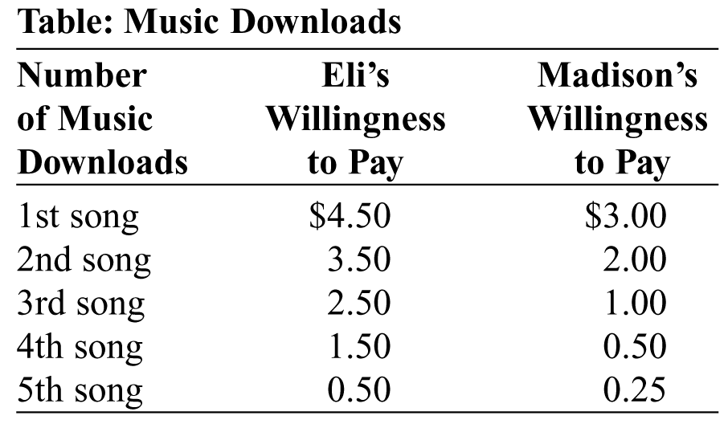

|  |  |  |
| --- | --- | --- |
| 12. | (Table: Music Downloads) Look at the table Music Downloads. Two consumers, Eli and Madison, like to download songs to their MP3 players, and the table represents their willingness to pay for each downloaded song. If an individual song can be downloaded at a price of $1, what is the total consumer surplus received by these consumers? | |
| A) | $19.25 |
| B) | $18 |
| C) | $10 |
| **D)** | **$11** |

|  |  |  |
| --- | --- | --- |
| 13. | Vonda and Aleiyah are shopping together at the mall for new jeans. Vonda is willing to pay $90 and Aleiyah is willing to pay $50 for a pair of jeans. What is the gain in total consumer surplus when the price decreases from $59 to $40? | |
| A) | $10 |
| **B)** | **$29** |
| C) | $31 |
| D) | $60 |

|  |  |  |
| --- | --- | --- |
| 14. | Suppose the United States removes the current sugar quotas and the market price of sugar drops. In the candy bar market, we would expect: | |
| **A)** | **the consumer surplus to increase.** |
| B) | the consumer surplus to decrease. |
| C) | the consumer surplus to be unchanged. |
| D) | the deadweight loss to increase. |

|  |  |  |
| --- | --- | --- |
| 15. | The number of seats in a football stadium is fixed at 70,000. The team raises the price of a ticket from $30, where 70,000 are sold, to $40, and it sells 60,000 tickets. The price change caused a change in the consumer surplus of ________. | |
| A) | –$10. |
| **B)** | **–$50,000** |
| C) | –$100,000 |
| D) | –$10,000 |

|  |  |  |
| --- | --- | --- |
| 16. | Suppose you pay $8 to see Tom Cruise in his next movie. Suppose Mr. Cruise receives $21 million to work in this movie. This means that: | |
| A) | you would have been better off being more self-reliant in the movie market. |
| B) | Tom Cruise received a producer surplus of $21 million. |
| C) | you received a consumer surplus of $8. |
| **D)** | **you and Tom Cruise benefited from this transaction.** |

Use the following to answer question 17:

**Figure: The Shrimp Market**

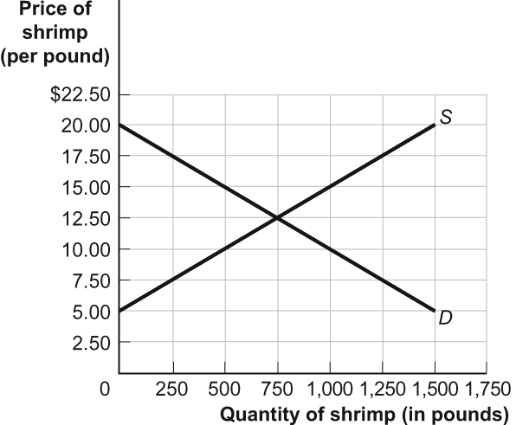

|  |  |  |
| --- | --- | --- |
| 17. | (Figure: The Shrimp Market) Look at the figure The Shrimp Market. If the government wants to limit shrimp sales to 500 pounds, it could impose a: | |
| A) | price floor of $15. |
| B) | price floor of $10. |
| C) | price ceiling of $10. |
| **D)** | **price floor of $15 or a price ceiling of $10.** |

|  |  |  |
| --- | --- | --- |
| 18. | Egg producers know that the elasticity of demand for eggs is 0.1. If they want to increase sales by 5%, they will have to lower price by: | |
| A) | 0.1%. |
| B) | 1%. |
| C) | 5%. |
| **D)** | **50%.** |

|  |  |  |
| --- | --- | --- |
| 19. | The only producer of chocolate bunnies in the world, Choco's Bunny Company, recently expanded its production capacity from 1,000 to 2,000 bunnies per day. If the price elasticity of demand for bunnies is 3.33, by how much will the company need to reduce its price to sell the additional 1,000 bunnies (using the midpoint method)? | |
| A) | 2.5% |
| B) | 25% |
| C) | 125% |
| **D)** | **20%** |

|  |  |  |
| --- | --- | --- |
| 20. | Sometimes airlines raise ticket prices as the flight departure date approaches in the hope of increasing revenue. The airlines raise their prices on the assumption that: | |
| A) | consumer demand becomes more price-elastic as departure time approaches. |
| **B)** | **consumer demand becomes less price-elastic as departure time approaches.** |
| C) | consumers are not aware of airline prices. |
| D) | consumer demand is unrelated to prices. |

|  |  |  |
| --- | --- | --- |
| 21. | When the price of chocolate-covered peanuts decreases from $1.10 to $0.95, the quantity demanded increases from 190 bags to 215 bags. In this price range, the demand for chocolate covered peanuts is _________ and total revenue will _______ when price decreases. | |
| A) | elastic; increase |
| B) | elastic; decrease |
| C) | inelastic; increase |
| **D)** | **inelastic; decrease** |

Use the following to answer question 22:

**Figure: The Shrimp Market**

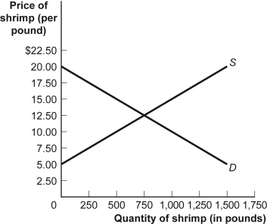

|  |  |  |
| --- | --- | --- |
| 22. | (Figure: The Shrimp Market) Look at the figure The Shrimp Market. If the government wants to limit shrimp sales to 500 pounds, it can impose a ________ excise tax on sellers, and the total tax revenue generated will be ________. | |
| **A)** | **$5; $2,500** |
| B) | $7.50; $7,500 |
| C) | $10; $2,500 |
| D) | The answer cannot be determined from the information provided. |

|  |  |  |
| --- | --- | --- |
| 23. | If the government decides to impose a $700 tax on U.S. citizens traveling abroad, then the deadweight loss from this tax will be: | |
| A) | relatively small. |
| **B)** | **relatively large.** |
| C) | zero. |
| D) | absorbed by foreign governments. |

|  |  |  |
| --- | --- | --- |
| 24. | The number of seats in a football stadium is fixed at 70,000. The city decides to impose a tax of $10 per ticket. In response, the team management raises the ticket price from $30 to $40 and still sells all 70,000 tickets. The tax caused a change in the consumer surplus of ________, a change in the producer surplus of ________, and a deadweight loss of ________. | |
| A) | –$10; $0; $10 |
| B) | –$700,000; $0; $700,000 |
| C) | –$10; $0; $0 |
| **D)** | **–$700,000; $0; $0** |

|  |  |  |
| --- | --- | --- |
| 25. | If the government imposes an excise tax in a market in which the demand curve is perfectly inelastic, the burden of the tax will fall completely on the ________, and the deadweight loss will equal ________. | |
| **A)** | **consumers; zero** |
| B) | producers; zero |
| C) | consumers; the government's tax revenue |
| D) | producers; the government's tax revenue |

Use the following to answer question 26:

**Figure: The Market for Hamburgers**

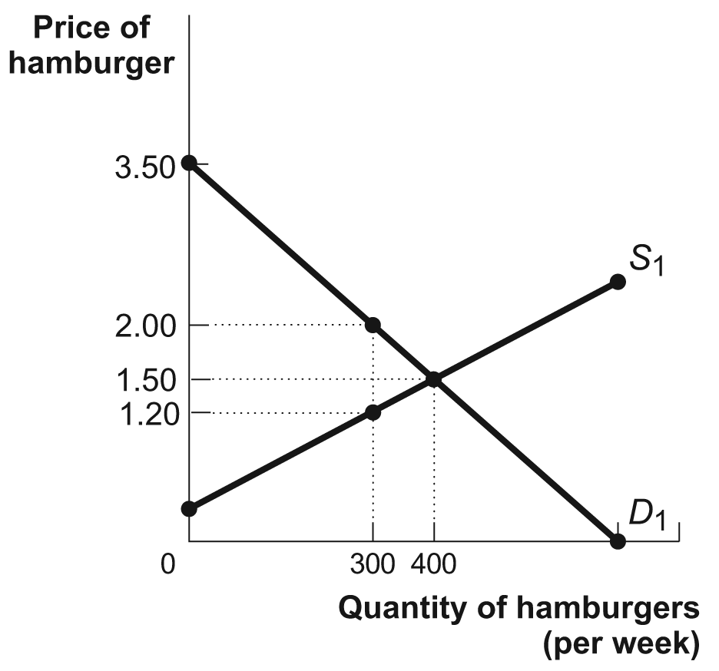

|  |  |  |
| --- | --- | --- |
| 26. | (Figure: The Market for Hamburgers) Look at the figure The Market for Hamburgers. If the market is originally in equilibrium and the government imposes an excise tax of $0.80 per unit of the good sold, consumer surplus will be reduced by: | |
| **A)** | **$175.** |
| B) | $240. |
| C) | $105. |
| D) | $90. |

|  |  |  |
| --- | --- | --- |
| 27. | The United States, at the point where it is currently producing, must give up the production of 300 motorcycles to produce 20 additional SUVs with the same resources. In this case, the opportunity cost of producing 5 SUVs is ________________ motorcycles. | |
| A) | 5 |
| B) | 20 |
| C) | 100 |
| **D)** | **75** |

|  |  |  |
| --- | --- | --- |
| 28. | France and England both produce wine and cloth under conditions of constant opportunity costs. France can produce 150 barrels of wine if it produces no cloth or 100 bolts of cloth if it produces no wine. England can produce 50 barrels of wine if it produces no cloth or 150 bolts of cloth if it produces no wine. When international trade takes place, each country specializes in the production of the good in which it has a comparative advantage—1 barrel of wine exchanges for 1 bolt of cloth—and France exports 50 units of wine. We can conclude that France produces ________ units of wine and ________ units of cloth and that France consumes ________ units of wine and ________ units of cloth. | |
| A) | 150; 100; 100; 100 |
| **B)** | **150; 0; 100; 50** |
| C) | 150; 0; 50; 50 |
| D) | 0; 100; 50; 50 |

|  |  |  |
| --- | --- | --- |
| 29. | According to the Heckscher–Ohlin model, Brazil will have a comparative advantage in oranges if the factors ________ in the production of oranges are ________. | |
| **A)** | **intensive; abundantly available** |
| B) | intensive; imported from other nations |
| C) | that are scarce; imported from other nations |
| D) | intensive; inexpensive |

|  |  |  |
| --- | --- | --- |
| 30. | In a single year, Argentina can raise 100 tons of beef or produce 1,000 boxes of tulips. In the same growing season, Venezuela can raise 50 tons of beef or produce 750 boxes of tulips. When the two countries begin trading beef for tulips, we would expect the price of beef in Argentina: | |
| A) | to fall from the autarky price. |
| **B)** | **to rise from the autarky price.** |
| C) | to remain at the autarky price. |
| D) | to be 10 boxes of tulips. |

|  |  |  |
| --- | --- | --- |
| 31. | Suppose a local hardware store has explicit costs of $2 million per year and implicit costs of $44,000 per year. If the store earned an economic profit of $50,000 last year, this means that the store's accounting profit equaled: | |
| **A)** | **$94,000.** |
| B) | $6,000. |
| C) | $2,050,000. |
| D) | $2,044,000. |

|  |  |  |
| --- | --- | --- |
| 32. | Joan loves to eat sushi. Her first piece of sushi normally gives her a marginal benefit of $5. Each additional piece creates a marginal benefit that declines by $0.25 per piece. If her favorite sushi bar charges $2.75 per piece of sushi, how many pieces should she eat? | |
| A) | 8 |
| **B)** | **10** |
| C) | 5 |
| D) | 11 |

|  |  |  |
| --- | --- | --- |
| 33. | When total utility is at a maximum, marginal utility is: | |
| A) | rising. |
| B) | at its average value. |
| C) | at a maximum. |
| **D)** | **zero.** |

|  |  |  |
| --- | --- | --- |
| 34. | Chuck spends all of his income on two goods: tacos and milkshakes. His income is $100, the price of tacos is $10, and the price of milkshakes is $2. If the price of each good doubles and Chuck's income doubles, which of the following statements is correct? | |
| **A)** | **Chuck's budget line will be unaffected.** |
| B) | Chuck's budget line will shift out. |
| C) | Chuck's budget line will shift in. |
| D) | Chuck will now be able to buy more of both goods. |

|  |  |  |
| --- | --- | --- |
| 35. | Emilio finds a new job that doubles his income. He adjusts his consumption. From this we know that for every normal good Emilio buys, Emilio's: | |
| A) | marginal utility per dollar will rise. |
| **B)** | **marginal utility per dollar will fall.** |
| C) | marginal utility per dollar will stay constant. |
| D) | total utility will fall. |

Use the following to answer question 36:

**Figure: Income and Substitution Effects**

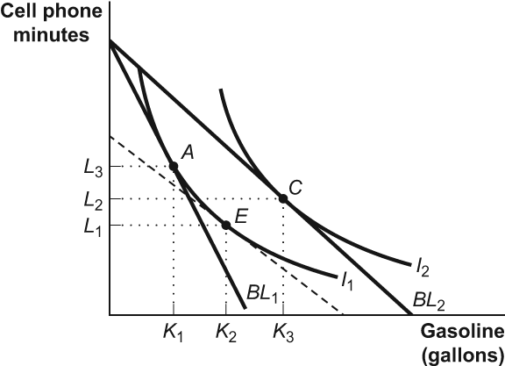

|  |  |  |
| --- | --- | --- |
| 36. | (Figure: Income and Substitution Effects) Look at the figure Income and Substitution Effects. Carlos is originally consuming his optimal consumption bundle at point *A* in the figure when the price of gasoline falls. The movement from *K*2 to *K*3 reflects: | |
| A) | the total change in quantity demanded due to the decrease in the price of gasoline*.* |
| **B)** | **the income effect of the price decrease of gasoline*.*** |
| C) | the substitution effect of the price decrease of gasoline*.* |
| D) | the income effect of the price decrease of gasoline and the substitution effect of the price decrease of gasoline*.* |

|  |  |  |
| --- | --- | --- |
| 37. | When Caroline's dress factory hires two workers, the total product is 50 dresses. When she hires three workers, total product is 48, and when she hires four workers, total product is 46. The marginal product of the third and fourth workers is | |
| A) | increasing and positive |
| B) | increasing and negative |
| C) | decreasing and positive |
| **D)** | **decreasing and negative.** |

|  |  |  |
| --- | --- | --- |
| 38. | Austin's total fixed cost at the bakery is $3,600 a month. Austin employs 20 workers and pays each worker $8 an hour. The marginal product of the twentieth worker is 12 iced cupcakes an hour. What is the marginal cost of the last cupcake produced by the last worker Austin hired? | |
| A) | $0.26 |
| **B)** | **$0.66** |
| C) | $3.81 |
| D) | $8 |

|  |  |  |
| --- | --- | --- |
| 39. | The average total cost of producing cell phones in a factory is $20 at the current output level of 100 units per week. If fixed cost is $1,200 per week: | |
| A) | average fixed cost is $20. |
| B) | total cost is $3,200. |
| C) | variable cost is $2,000. |
| **D)** | **average variable cost is $8.** |

|  |  |  |
| --- | --- | --- |
| 40. | In a perfectly competitive industry, the market demand curve is usually: | |
| A) | perfectly inelastic. |
| B) | perfectly elastic. |
| **C)** | **downward sloping.** |
| D) | relatively elastic. |

|  |  |  |
| --- | --- | --- |
| 41. | The equilibrium price of a guidebook is $35 in the perfectly competitive guidebook industry. Our firm produces 10,000 guidebooks for an average total cost of $38, marginal cost of $30, and average variable cost of $30. Our firm should: | |
| A) | raise the price of guidebooks, because the firm is losing money. |
| B) | keep output the same, because the firm is producing at minimum average variable cost. |
| **C)** | **produce more guidebooks, because the next guidebook produced increases profit by $5.** |
| D) | shut down, because the firm is losing money. |

|  |  |  |
| --- | --- | --- |
| 42. | Zoe's Bakery operates in a perfectly competitive industry. When the market price of iced cupcakes is $5, the profit-maximizing output level is 150 cupcakes. Her average total cost is $4, and her average variable cost is $3. Zoe's marginal cost is ________, and her short-run profits are: | |
| **A)** | **$5; $150** |
| B) | $5; $300 |
| C) | $1; $150 |
| D) | $1; $300 |

|  |  |  |
| --- | --- | --- |
| 43. | A monopoly is producing at the output level where average total cost equals $30, marginal revenue is $40, and the price is $50. If *ATC* is at its minimum level and the *ATC* curve is U-shaped, in order to maximize profits this firm should: | |
| **A)** | **increase output.** |
| B) | reduce output. |
| C) | do nothing; it is already maximizing profits. |
| D) | shut down. |

|  |  |  |
| --- | --- | --- |
| 44. | If a monopolist is producing a quantity that generates *MC* = *P,* then profit: | |
| A) | is maximized. |
| B) | is maximized only if *MR* = *P.* |
| C) | can be increased by increasing production. |
| **D)** | **can be increased by decreasing production.** |

Use the following to answer questions 45-46:

**Figure: A Profit-Maximizing Monopoly Firm**

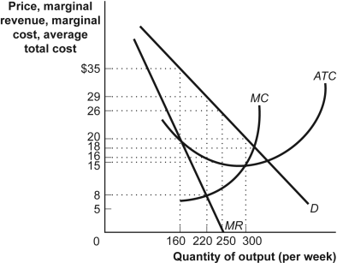

|  |  |  |
| --- | --- | --- |
| 45. | (Figure: A Profit-Maximizing Monopoly Firm) Look at the figure A Profit-Maximizing Monopoly Firm. This firm's cost per unit at its profit-maximizing quantity is: | |
| A) | $8. |
| B) | $15. |
| **C)** | **$16.** |
| D) | $18. |

|  |  |  |
| --- | --- | --- |
| 46. | (Figure: A Profit-Maximizing Monopoly Firm) Look at the figure A Profit-Maximizing Monopoly Firm. This firm's profit per unit is: | |
| A) | $5. |
| **B)** | **$13.** |
| C) | $14. |
| D) | $20. |

Use the following to answer question 47:

**Figure: Prisoners' Dilemma for Thelma and Louise**

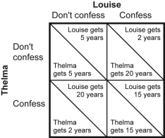

|  |  |  |
| --- | --- | --- |
| 47. | (Figure: Prisoners' Dilemma for Thelma and Louise) Look at the Figure Prisoners' Dilemma for Thelma and Louise. Thelma and Louise are arrested and put in jail for murder. Given the payoff matrix in the figure, the Nash equilibrium behavior for Thelma and Louise is for: | |
| A) | Thelma to confess and Louise not to confess. |
| **B)** | **both Thelma and Louise to confess.** |
| C) | Louise to confess and Thelma not to confess. |
| D) | neither Thelma nor Louise to confess. |

|  |  |  |
| --- | --- | --- |
| 48. | Suppose a monopolistically competitive firm is making a profit but it can increase its profits by increasing output. Then it must be the case that at the current level of output: | |
| **A)** | **marginal revenue is greater than marginal cost.** |
| B) | price is less than marginal cost. |
| C) | price is less than average total cost. |
| D) | marginal revenue is less than marginal cost. |

Use the following to answer question 49:

**Figure: Firms in Monopolistic Competition**

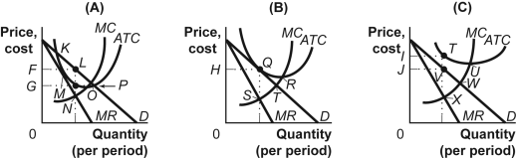

|  |  |  |
| --- | --- | --- |
| 49. | (Figure: Firms in Monopolistic Competition) In panel A of the figure Firms in Monopolistic Competition, economic profit per unit is: | |
| A) | *KL.* |
| **B)** | ***LM.*** |
| C) | *MN.* |
| D) | *NO.* |

|  |  |  |
| --- | --- | --- |
| 50. | Toby operates a small deli downtown. The deli industry is monopolistically competitive. Toby tells you that his and every other deli in town is producing the quantity that minimizes their average total cost. Assuming the delis are maximizing profits, you know that the: | |
| A) | number of delis will soon decrease. |
| **B)** | **number of delis will soon increase.** |
| C) | delis' prices equal their average total costs. |
| D) | delis have excess capacity. |

**Answer Key**

|  |  |
| --- | --- |
| 1. | B |
| 2. | C |
| 3. | D |
| 4. | D |
| 5. | B |
| 6. | B |
| 7. | B |
| 8. | C |
| 9. | B |
| 10. | D |
| 11. | D |
| 12. | D |
| 13. | B |
| 14. | A |
| 15. | B |
| 16. | D |
| 17. | D |
| 18. | D |
| 19. | D |
| 20. | B |
| 21. | D |
| 22. | A |
| 23. | B |
| 24. | D |
| 25. | A |
| 26. | A |
| 27. | D |
| 28. | B |
| 29. | A |
| 30. | B |
| 31. | A |
| 32. | B |
| 33. | D |
| 34. | A |
| 35. | B |
| 36. | B |
| 37. | D |
| 38. | B |
| 39. | D |
| 40. | C |
| 41. | C |
| 42. | A |
| 43. | A |
| 44. | D |
| 45. | C |
| 46. | B |
| 47. | B |
| 48. | A |
| 49. | B |
| 50. | B |