**EXAM #1a**

**ANSWER KEY**

**ECON 2106**

**Principles of Microeconomics**

**Fall 2015**

**Dr. Richard Fritz**

Name: _______**Econ 2106 Sp 2015 ANSWER KEY**______ Date: __**Exam #1a**___

|  |  |  |
| --- | --- | --- |
| 1. | A college student is faced with a difficult decision of how to spend one hour tonight. She could babysit her professor's child at an hourly wage of $7, she could work at the college library at a wage of $6, or she could finish her economics homework assignment. If she chooses to complete her homework assignment, she has incurred an opportunity cost equal to: | |
| **A)** | **$7.** |
| B) | $6. |
| C) | $13. |
| D) | $0. |

|  |  |  |
| --- | --- | --- |
| 2. | When the San Francisco city manager faces a complaint that the city council chamber podium is not accessible to individuals with disabilities, he responds that the $1 million improvement will not happen because “that money could be spent building 70 curb ramps.” This statement best represents this economic concept: | |
| A) | Resources are scarce. |
| **B)** | **The real cost of something is what you must give up to get it.** |
| C) | “How much” is a decision at the margin. |
| D) | When markets don't achieve efficiency, government intervention can improve society's welfare. |

|  |  |  |
| --- | --- | --- |
| 3. | Which of the following is *not* one of the four principles of individual choice? | |
| A) | Resources are scarce. |
| **B)** | **Unpaid volunteer work is irrational, since economic rationality dictates that individuals should only engage in work they are paid for.** |
| C) | The real cost of something is its opportunity cost. |
| D) | People usually take advantage of opportunities to make themselves better off. |

|  |  |  |
| --- | --- | --- |
| 4. | Grades are low in class and your professor makes available a 10-point extra credit assignment. Most of the students turn in the assignment. This statement best represents this economic concept: | |
| A) | The real cost of something is what you must give up to get it. |
| B) | “How much” is a decision at the margin. |
| **C)** | **People usually exploit opportunities to make themselves better off.** |
| D) | There are gains from trade. |

|  |  |  |
| --- | --- | --- |
| 5. | If all of the opportunities to make someone better off (without making someone else worse off) have been exploited, an economy is | |
| A) | equitable. |
| B) | inefficient. |
| C) | marginally optimal. |
| **D)** | **efficient.** |

|  |  |  |
| --- | --- | --- |
| 6. | A trade-off between equity and efficiency may exist because of all of the following *except* that: | |
| **A)** | **allocating resources fairly may cause efficiency.** |
| B) | an efficient allocation of resources may lead to an outcome that most people consider unfair. |
| C) | policies that promote equity often come at a cost of decreased efficiency. |
| D) | allocating resources fairly may cause inefficiency. |

|  |  |  |
| --- | --- | --- |
| 7. | During the Great Depression, consumers and producers in the United States dramatically reduced their spending as compared to the quantity of goods and services available at the time. This statement best represents this economic concept: | |
| A) | Resources are scarce. |
| B) | When markets don't achieve efficiency, government intervention can improve society's welfare. |
| **C)** | **Overall spending sometimes gets out of line with the economy's productive capacity.** |
| D) | Government policies can change spending. |

Use the following to answer questions 8-10:

**Figure: Strawberries and Submarines**

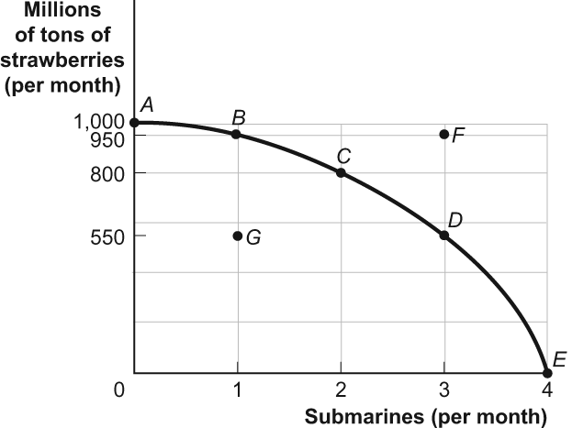

|  |  |  |
| --- | --- | --- |
| 8. | (Figure: Strawberries and Submarines) Look at the figure Strawberries and Submarines. Suppose the economy is operating at point *G.* This implies that: | |
| A) | the economy can move to a point such as *C* only if it improves its technology. |
| **B)** | **the economy has unemployment and/or inefficiently allocates resources.** |
| C) | the economy lacks the resources to achieve a combination such as *C.* |
| D) | people in this economy don't really like strawberries and submarines. |

|  |  |  |
| --- | --- | --- |
| 9. | (Figure: Strawberries and Submarines) Look at the figure Strawberries and Submarines. As the economy moves from point *A* toward point *D,* it will find that the opportunity cost of each additional submarine: | |
| A) | falls. |
| **B)** | **rises.** |
| C) | remains unchanged. |
| D) | doubles. |

|  |  |  |
| --- | --- | --- |
| 10. | (Figure: Strawberries and Submarines) Look at the figure Strawberries and Submarines. Suppose the economy now operates at point *C.* Moving to point *E* would require that the economy: | |
| A) | achieve full employment and an efficient allocation of resources. |
| **B)** | **eliminate its production of strawberries.** |
| C) | reduce its production of submarines. |
| D) | improve its technology or increase the quantities of factors of production it has. |

|  |  |  |
| --- | --- | --- |
| 11. | If they produce only hamburgers, in a single day Sarah can produce 10 hamburgers while Abe can produce 5 hamburgers. If they make milkshakes only, in a single day Sarah can produce 10 milkshakes while Abe can produce 4 milkshakes. We know that: | |
| A) | Sarah has an absolute advantage and a comparative advantage in making hamburgers. |
| **B)** | **Sarah has an absolute advantage and a comparative advantage in making milkshakes.** |
| C) | Abe has an absolute advantage and a comparative advantage in making hamburgers. |
| D) | Abe has an absolute advantage and a comparative advantage in making milkshakes. |

|  |  |  |
| --- | --- | --- |
| 12. | If Brazil gives up 3 automobiles for each ton of coffee it produces, while Peru gives up 7 automobiles for each ton of coffee it produces, then: | |
| A) | Brazil has a comparative advantage in automobile production and should specialize in coffee. |
| B) | Brazil has a comparative advantage in coffee production and should specialize in the production of automobiles. |
| **C)** | **Brazil has a comparative advantage in coffee production and should specialize in coffee production.** |
| D) | Brazil has a comparative advantage in automobile production and should specialize in automobile production. |

Use the following to answer questions 13-14:

**Figure: Comparative Advantage**

Eastland and Westland produce only two goods, boxes of peaches and boxes of oranges, and this figure shows each nation's production possibility frontier for the two goods.

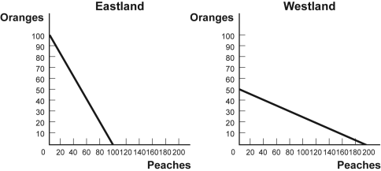

|  |  |  |
| --- | --- | --- |
| 13. | (Figure: Comparative Advantage) Look at the figure Comparative Advantage. The opportunity cost of producing 1 box of oranges for Westland is: | |
| A) | 1 box of peaches. |
| B) | 1/4 box of peaches. |
| **C)** | **4 boxes of peaches.** |
| D) | 10 boxes of peaches. |

|  |  |  |
| --- | --- | --- |
| 14. | (Figure: Comparative Advantage) Look at the figure Comparative Advantage. The opportunity cost of producing 1 box of peaches for Westland is: | |
| A) | 1 box of oranges. |
| **B)** | **1/4 box of oranges.** |
| C) | 4 boxes of oranges. |
| D) | 10 boxes of oranges. |

|  |  |  |
| --- | --- | --- |
| 15. | The simplest circular-flow model shows the interaction between households and firms. In this model: | |
| A) | only barter transactions take place. |
| B) | households and firms interact in the market for goods and services, but firms are the only participants in the factor markets. |
| **C)** | **firms supply goods and services to households, which in turn supply factors of production to firms.** |
| D) | attention is focused on “real” flows of goods, services, and factors of production, but money flows between households and firms are ignored for simplicity. |

Use the following to answer question 16:

**Figure: Unemployment Rate over Time**

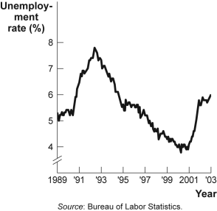

|  |  |  |
| --- | --- | --- |
| 16. | (Figure: Unemployment Rate over Time) Look again at the figure Unemployment Rate over Time. In the time-series graph, as we move from 1991 to 1993, we see that the unemployment rate has: | |
| A) | decreased from approximately 5% to approximately 4%. |
| **B)** | **increased from approximately 5.5% to approximately 7%.** |
| C) | decreased from approximately 7.8% to approximately 5%. |
| D) | increased from approximately 4% to approximately 6.3%. |

|  |  |  |
| --- | --- | --- |
| 17. | In much of the country, homeowners choose to heat their houses with either natural gas or home heating oil. Which of the following would cause a change in the demand for natural gas? | |
| A) | a change in the price of home heating oil |
| B) | a change in income |
| C) | an increase in consumer tastes for natural gas as an energy source |
| **D)** | **all of the above** |

|  |  |  |
| --- | --- | --- |
| 18. | Raclette is a popular wintertime dish in Switzerland. It is essentially melted Raclette cheese over boiled new potatoes. If the price of Raclette cheese decreased, we would expect to see: | |
| A) | an increase in demand for Raclette cheese. |
| **B)** | **an increase in demand for new potatoes.** |
| C) | no effect on the demand for either of the Raclette ingredients, since this is a traditional dish and its consumption does not depend on the prices of the ingredients. |
| D) | an increase in demand for Raclette cheese and for new potatoes. |

|  |  |  |
| --- | --- | --- |
| 19. | Over the past several years, consumers have had an increasing interest in getting a tattoo. This means that the ________ for tattoos has ________. | |
| A) | quantity demanded; increased |
| B) | demand; decreased |
| **C)** | **demand; increased** |
| D) | quantity demanded; decreased |

Use the following to answer questions 20-21:

**Figure: Demand for Coconuts**

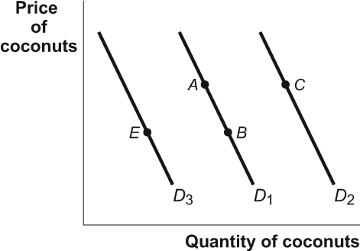

|  |  |  |
| --- | --- | --- |
| 20. | (Figure: Demand for Coconuts) Look at the figure Demand for Coconuts. If coconuts are a normal good and the price of coconuts increases, it would be represented in the figure as a movement from: | |
| A) | *A* to *B.* |
| **B)** | ***B* to *A.*** |
| C) | *C* to *A.* |
| D) | *E* to *B.* |

|  |  |  |
| --- | --- | --- |
| 21. | (Figure: Demand for Coconuts) Look at the figure Demand for Coconuts. If fish is a substitute good for coconuts and the price of fish increases, it will be represented in the figure as a movement from: | |
| **A)** | ***A* to *C.*** |
| B) | *B* to *A.* |
| C) | *C* to *A.* |
| D) | *B* to *E.* |

|  |  |  |
| --- | --- | --- |
| 22. | In the market for tacos, each of the following shifts the supply curve to the left *except:* | |
| A) | an increase in the price of beef. |
| B) | an increase in the wages of taco shop workers. |
| C) | fewer taco shops. |
| **D)** | **a decrease in the price of tacos.** |

|  |  |  |
| --- | --- | --- |
| 23. | In the local market for coffee, what would happen if Joyce's Java and Everyday Joe's coffee shops go out of business? | |
| A) | The supply curve shifts to the right. |
| B) | The demand curve shifts to the left. |
| **C)** | **The supply curve shifts to the left.** |
| D) | The demand curve shifts to the right. |

|  |  |  |
| --- | --- | --- |
| 24. | Consider the supply curve for cotton shirts. An increase in the price of cotton will: | |
| A) | increase the supply of cotton shirts. |
| **B)** | **decrease the supply of cotton shirts.** |
| C) | increase the quantity supplied of cotton shirts. |
| D) | decrease the demand for cotton shirts. |

Use the following to answer questions 25-26:

**Figure: Supply of Coconuts**

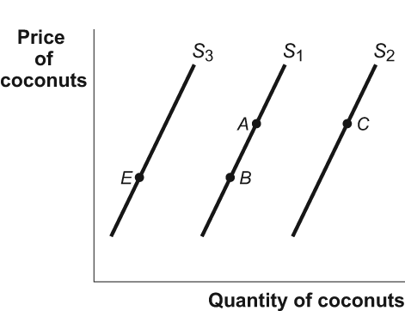

|  |  |  |
| --- | --- | --- |
| 25. | (Figure: Supply of Coconuts) Look at the figure Supply of Coconuts. If the prices of inputs (e.g., labor, fertilizer, and fuel) used to produce and transport coconuts increased, it would be represented in the figure as a movement from: | |
| A) | *A* to *B.* |
| B) | *B* to *A.* |
| **C)** | ***C* to *A.*** |
| D) | *E* to *B.* |

|  |  |  |
| --- | --- | --- |
| 26. | (Figure: Supply of Coconuts) Look at the figure Supply of Coconuts. An expectation on the part of coconut suppliers that the price of coconuts will be significantly higher in the very near future would be represented in the figure as a movement from | |
| A) | *A* to *B.* |
| B) | *B* to *A.* |
| C) | *A* to *C.* |
| **D)** | ***B* to *E.*** |

Use the following to answer question 27:

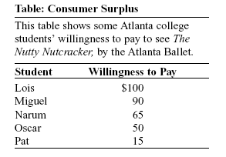

|  |  |  |
| --- | --- | --- |
| 27. | (Table: Consumer Surplus) Look at the table Consumer Surplus. If the price of a ticket to see *The Nutty Nutcracker* is $50 and there is no other market for tickets, total consumer surplus for the five students is: | |
| **A)** | **$105.** |
| B) | $130. |
| C) | $270. |
| D) | $320. |

|  |  |  |
| --- | --- | --- |
| 28. | Mark and Rasheed are at the bookstore buying new calculators for the semester. Mark is willing to pay $75 and Rasheed is willing to pay $100 for a graphing calculator. The price for a calculator at the bookstore is $65. How much is total consumer surplus? | |
| A) | $10 |
| B) | $35 |
| **C)** | **$45** |
| D) | $60 |

|  |  |  |
| --- | --- | --- |
| 29. | Jeanette is willing to pay $100 for the first pair of shoes, $80 for the second pair, $50 for the third, and $30 for the fourth. If shoes cost $50, Jeanette will buy ________ pairs of shoes and her total consumer surplus equals ________. | |
| A) | 4; $110 |
| B) | 3; $230 |
| **C)** | **3; $80** |
| D) | 4; $80 |

|  |  |  |
| --- | --- | --- |
| 30. | Along a given demand curve, an increase in the price of a good will cause consumer surplus to: | |
| A) | increase. |
| **B)** | **decrease.** |
| C) | not change. |
| D) | cannot be determined without information about the supply curve. |

|  |  |  |
| --- | --- | --- |
| 31. | Vonda and Aleiyah are shopping together at the mall for new jeans. Vonda is willing to pay $90 and Aleiyah is willing to pay $50 for a pair of jeans. What is the gain in total consumer surplus when the price decreases from $59 to $40? | |
| A) | $10 |
| **B)** | **$29** |
| C) | $31 |
| D) | $60 |

Use the following to answer question 32:

**Figure: Gain in Producer Surplus**

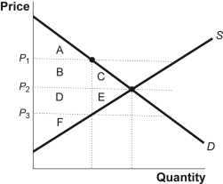

|  |  |  |
| --- | --- | --- |
| 32. | (Figure: Gain in Producer Surplus) Look at the figure Gain in Producer Surplus. Which of the following area or areas represent producer surplus when the price is equal to *P*2? | |
| **A)** | **D, E, and F** |
| B) | B and C |
| C) | D and E |
| D) | A, B, and C |

Use the following to answer question 33:

**Figure: Producer Surplus**

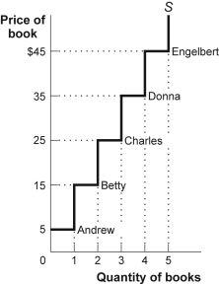

|  |  |  |
| --- | --- | --- |
| 33. | (Figure: Producer Surplus) Look at the figure Producer Surplus. When the price falls from $45 to $35, producer surplus ________ for a total producer surplus of ________. | |
| A) | increases by $10; $140 |
| **B)** | **decreases by $40; $60** |
| C) | increases by $35; $180 |
| D) | decreases by $10; $140 |

Use the following to answer question 34:

**Figure: The Market for Hamburgers**

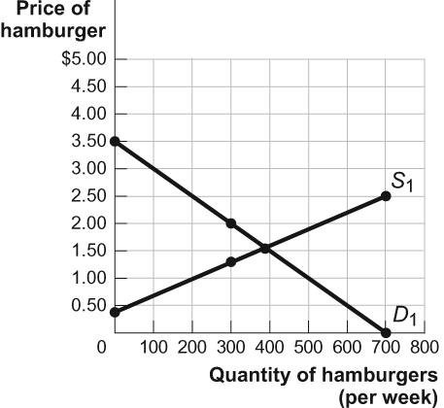

**0.30**

|  |  |  |
| --- | --- | --- |
| 34. | (Figure: The Market for Hamburgers) Look at the figure The Market for Hamburgers. The maximum total surplus for the market is ________, and it occurs at a price equal to ________. | |
| A) | $550; $1.50 |
| **B)** | **$640; $1.50** |
| C) | $1,050; $2 |
| D) | Not enough information is provided to answer this question, since the maximum total surplus could occur anywhere. |

|  |  |  |
| --- | --- | --- |
| 35. | The NFL wants to give the “common fan” the opportunity to attend the Super Bowl, so it sets Super Bowl prices “low”—tickets for a regular seat at Super Bowl XXXVII cost just $400. Scalpers, however, sell tickets for $1,500 or more. If there are no transaction costs to selling a ticket, the true cost of a regular ticket to Super Bowl XXXVII is: | |
| A) | at most $400. |
| **B)** | **at least $1,500.** |
| C) | the monetary price paid to obtain the ticket. |
| D) | $1,100 less than the opportunity cost of a ticket. |

Use the following to answer question 36:

**Figure: The Market for Hybrid Cars**

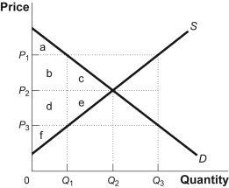

|  |  |  |
| --- | --- | --- |
| 36. | (Figure: The Market for Hybrid Cars) Look at the figure The Market for Hybrid Cars. If there were a binding price ceiling in the market for hybrid cars, one possible price would be equal to ________, consumers would demand ________, and producers would supply ________. | |
| A) | *P*1; *Q*1; *Q*3 |
| B) | *P*2; *Q*2; *Q*2 |
| C) | *P*1; *Q*3; *Q*1 |
| **D)** | ***P*3; *Q*3; *Q*1** |

|  |  |  |
| --- | --- | --- |
| 37. | Farmers in developing countries want the United States to reduce the subsidies that it gives to American farmers because subsidized agricultural products from the United States: | |
| **A)** | **lead to agricultural surpluses and lower prices for developing country farmers.** |
| B) | raise the world price of agricultural products. |
| C) | has led to a global shortage of agricultural products. |
| D) | has led to an increase in the demand for agricultural products from the developing world. |

|  |  |  |
| --- | --- | --- |
| 38. | The persistent unwanted surplus that results from a price floor creates inefficiencies that include all of the following *except:* | |
| **A)** | **inefficiently low quality.** |
| B) | inefficient allocation of sales among sellers. |
| C) | wasted resources. |
| D) | the temptation to break the law by selling below the legal price. |

|  |  |  |
| --- | --- | --- |
| 39. | If New York City had no medallion system for taxicabs, the price of a taxicab ride would: | |
| A) | increase because of the higher safety hazards. |
| B) | not change from its current level. |
| **C)** | **decrease.** |
| D) | increase, but only slightly. |

|  |  |  |
| --- | --- | --- |
| 40. | If the U.S. government imposes a quota on the amount of French wine allowed into the United States and the quota is set at a quantity below equilibrium, the price of French wine in the United States will ________ while the U.S.-produced wine will ________. | |
| **A)** | **increase; increase** |
| B) | increase; decrease |
| C) | decrease; increase |
| D) | decrease; decrease |

**Answer Key**

|  |  |
| --- | --- |
| 1. | A |
| 2. | B |
| 3. | B |
| 4. | C |
| 5. | D |
| 6. | A |
| 7. | C |
| 8. | B |
| 9. | B |
| 10. | B |
| 11. | B |
| 12. | C |
| 13. | C |
| 14. | B |
| 15. | C |
| 16. | B |
| 17. | D |
| 18. | B |
| 19. | C |
| 20. | B |
| 21. | A |
| 22. | D |
| 23. | C |
| 24. | B |
| 25. | C |
| 26. | D |
| 27. | A |
| 28. | C |
| 29. | C |
| 30. | B |
| 31. | B |
| 32. | A |
| 33. | B |
| 34. | B |
| 35. | B |
| 36. | D |
| 37. | A |
| 38. | A |
| 39. | C |
| 40. | A |