Econ 2106

Exam 2B Answer Key

Fall 2015

Dr. Richard FritzName: __________________________ Date: _____________

Use the following to answer question 1:

**Figure: The Demand for Shirts**

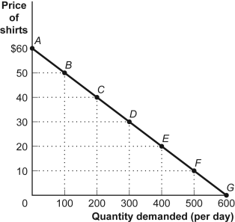

|  |  |  |
| --- | --- | --- |
| 1. | (Figure: The Demand for Shirts) Look again at the figure The Demand for Shirts. The price elasticity of demand for the segment *EF,* using the midpoint method, is: | |
| A) | 1.3. |
| B) | 1. |
| C) | 0.7. |
| **D)** | **0.33.** |

|  |  |  |
| --- | --- | --- |
| 2. | Each month Jessica buys exactly 15 Big Macs regardless of the price. Jessica's price elasticity of demand for Big Macs is: | |
| **A)** | **0.** |
| B) | 1. |
| C) | greater than 1. |
| D) | less than 1 but greater than 0. |

|  |  |  |
| --- | --- | --- |
| 3. | Egg producers know that the elasticity of demand for eggs is 0.1. If they want to increase sales by 5%, they will have to lower price by: | |
| A) | 0.1%. |
| B) | 1%. |
| C) | 5%. |
| **D)** | **50%.** |

|  |  |  |
| --- | --- | --- |
| 4. | Suppose the price elasticity of demand for fishing lures equals 1.5 in South Carolina and 0.63 in Alabama. To increase revenue, fishing lure manufacturers should: | |
| A) | lower prices in each state. |
| B) | raise prices in each state. |
| **C)** | **lower prices in South Carolina and raise prices in Alabama.** |
| D) | leave prices unchanged in South Carolina and raise prices in Alabama. |

|  |  |  |
| --- | --- | --- |
| 5. | If your purchases of shoes increase from 9 pairs per year to 11 pairs per year when the price of shirts increases from $8 to $12, for you, shoes and shirts are considered: | |
| A) | inferior goods. |
| B) | luxury goods. |
| **C)** | **substitute goods.** |
| D) | complementary goods. |

|  |  |  |
| --- | --- | --- |
| 6. | Eric's income increased from $40,000 to $50,000 per year. Eric's consumption of tickets to pro football games increased from two to four per year. Using the midpoint formula, his income elasticity of demand for pro football game tickets is equal to ________, and football game tickets are ________ goods. | |
| A) | –1/3; inferior |
| B) | +2/3; normal |
| C) | –3; inferior |
| **D)** | **+3; normal** |

|  |  |  |
| --- | --- | --- |
| 7. | Suppose you manage a convenience mart and are in charge of ordering products but do not set the price. The home office provides the prices. In your area, the income elasticity of demand for peanut butter is –0.5. Due to local factory closings, you expect local incomes to decrease by 20% on average in the next month. As a result, you should stock: | |
| A) | 20% more peanut butter on the shelves. |
| B) | 5% more peanut butter on the shelves. |
| **C)** | **10% more peanut butter on the shelves.** |
| D) | 10% less peanut butter on the shelves. |

|  |  |  |
| --- | --- | --- |
| 8. | A rancher in Oklahoma decides to raise the price of her beef by 19% over the prevailing market price. If the demand for beef is perfectly elastic, this rancher's quantity demanded will: | |
| **A)** | **fall to 0.** |
| B) | not change. |
| C) | fall slightly. |
| D) | increase slightly. |
| 9. | Suppose the price of real estate increases by 37.11% in Oakland next year. If the quantity of new homes supplied does not change, this means that the price elasticity of ________ will be perfectly ________ in Oakland next year. | |
| A) | demand; elastic |
| **B)** | **supply; inelastic** |
| C) | demand; inelastic |
| D) | supply; elastic |

|  |  |  |
| --- | --- | --- |
| 10. | By law, FICA (the Federal Insurance Contributions Act), a payroll tax, is collected equally from the employers and the employees. In reality: | |
| A) | the law works—the employers and the employees each bear half of the burden of the tax. |
| **B)** | **the employees bear almost all of the burden of the tax.** |
| C) | the employers bear almost all of the burden of the tax. |
| D) | it's impossible to determine who bears the burden of the tax. |

|  |  |  |
| --- | --- | --- |
| 11. | If labor is scarce in Sri Lanka but capital is abundant, when Sri Lanka opens to trade: | |
| A) | the prices of labor and capital will rise. |
| B) | the prices of labor and capital will fall. |
| C) | the price of labor will rise, and the price of capital will fall. |
| **D)** | **the price of labor will fall, and the price of capital will rise.** |

|  |  |  |
| --- | --- | --- |
| 12. | If demand and supply are both very inelastic, a decrease in the rate of an excise tax will likely | |
| **A)** | **decrease government revenue.** |
| B) | increase government revenue. |
| C) | not affect government revenue. |
| D) | make demand and supply both elastic. |

|  |  |  |
| --- | --- | --- |
| 13. | Suppose a local hardware store has explicit costs of $2 million per year and implicit costs of $44,000 per year. If the store earned an economic profit of $50,000 last year, this means that the store's accounting profit equaled: | |
| **A)** | **$94,000.** |
| B) | $6,000. |
| C) | $2,050,000. |
| D) | $2,044,000. |

Use the following to answer questions 14-15:

**Figure and Table: The Market for Taxi Rides**

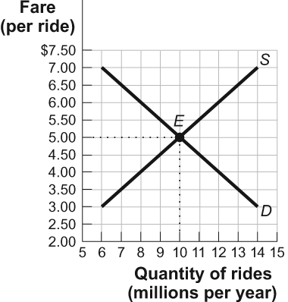

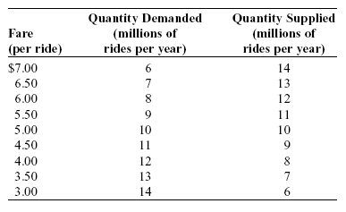

|  |  |  |
| --- | --- | --- |
| 14. | (Figure and Table: The Market for Taxi Rides) Look at the figure and table The Market for Taxi Rides. If the government imposes an excise tax of $1 per ride (causing the supply curve to shift upward by that amount), then the government will collect tax revenues of ________. However, there will be a deadweight loss to society of ________ caused by this tax. | |
| **A)** | **$9 million; $0.5 million** |
| B) | $16 million; $1 million |
| C) | $45 million; $1 million |
| D) | $50 million; $0.5 million |

|  |  |  |
| --- | --- | --- |
| 15. | (Figure and Table: The Market for Taxi Rides) Look at the figure and table The Market for Taxi Rides. If the government imposes an excise tax of $1 per ride (causing the supply curve to shift upward by that amount), then people who ride taxis will pay ________ of each $1 tax. | |
| A) | $1 |
| **B)** | **$0.50** |
| C) | $0.25 |
| D) | $0.00 |

Use the following to answer questions 16-17:

**Figure: The Market for Yachts**

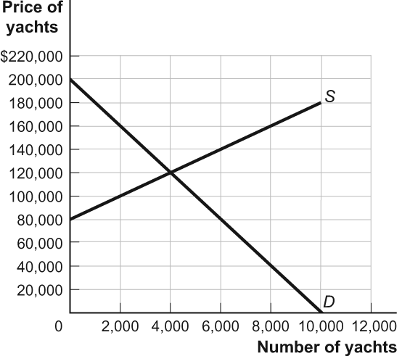

|  |  |  |
| --- | --- | --- |
| 16. | (Figure: The Market for Yachts) Look at the figure The Market for Yachts. A quota of ________ will bring about the same price and output in the market for yachts as would an excise tax of $30,000. | |
| A) | 2,000 |
| **B)** | **3,000** |
| C) | 4,000 |
| D) | The answer is impossible to determine. |

|  |  |  |
| --- | --- | --- |
| 17. | (Figure: The Market for Yachts) Look at the figure The Market for Yachts. A price ________ of ________ will bring about the same price and output in the market for yachts as would an excise tax of $30,000. | |
| A) | ceiling; $80,000 |
| B) | ceiling; $100,000 |
| C) | floor; $120,000 |
| **D)** | **floor; $140,000** |

|  |  |  |
| --- | --- | --- |
| 18. | Assume the same upward supply curve for each of the following goods. Considering demand only, a tax on which of the following goods would result in the largest deadweight loss? | |
| A) | gasoline |
| B) | medicine |
| **C)** | **restaurant meals** |
| D) | tobacco |

|  |  |  |
| --- | --- | --- |
| 19. | The number of seats in a football stadium is fixed at 70,000. The city decides to impose a tax of $10 per ticket. In response, the team management raises the ticket price from $30 to $40 and still sells all 70,000 tickets. The tax caused a change in the consumer surplus of ________, a change in the producer surplus of ________, and a deadweight loss of ________. | |
| A) | –$10; $0; $10 |
| B) | –$700,000; $0; $700,000 |
| C) | –$10; $0; $0 |
| **D)** | **–$700,000; $0; $0** |

|  |  |  |
| --- | --- | --- |
| 20. | The poorest 20% of families in the United States pay a ________ share of their total income in taxes. | |
| A) | very large |
| B) | somewhat large |
| C) | small |
| **D)** | **negative** |

|  |  |  |
| --- | --- | --- |
| 21. | In a Ricardian model of international trade, the production possibility frontiers are ________, indicating that the opportunity cost of increasing the production of one item relative to another ________. | |
| A) | convex; is constant |
| B) | concave; increases |
| **C)** | **straight lines; is constant** |
| D) | straight lines; decreases |

|  |  |  |
| --- | --- | --- |
| 22. | In a single year, the Netherlands can raise 100 tons of beef or produce 1,000 boxes of tulips. In the same growing season, Belgium can raise 50 tons of beef or produce 750 boxes of tulips. At which of these prices will trade occur between the two countries? | |
| A) | One ton of beef costs 20 boxes of tulips. |
| B) | One ton of beef costs 5 boxes of tulips. |
| **C)** | **One ton of beef costs 12 boxes of tulips.** |
| D) | One ton of beef costs 8 boxes of tulips. |

|  |  |  |
| --- | --- | --- |
| 23. | Which model states that nations that are abundant in a factor will have a comparative advantage in a good whose production is intensive in that factor? | |
| A) | the pauper labor fallacy model. |
| B) | the Ricardian model |
| **C)** | **the Heckscher–Ohlin model** |
| D) | the oligopoly model |

Use the following to answer questions 24-25:

**Figure: The Market for Laptop Sleeves**

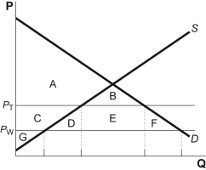

|  |  |  |
| --- | --- | --- |
| 24. | (Figure: The Market for Laptop Sleeves) Look at the figure The Market for Laptop Sleeves. Identify the area or areas of consumer surplus when a tariff raises the domestic price from the world price to *P*1. | |
| **A)** | **A + B** |
| B) | A + B + C + D + E + F |
| C) | A + C + G |
| D) | D + F |

|  |  |  |
| --- | --- | --- |
| 25. | (Figure: The Market for Laptop Sleeves) Look at the figure The Market for Laptop Sleeves. Identify the area or areas of deadweight loss when a tariff raises the domestic price from the world price to *P*1. | |
| A) | A + B |
| B) | C + D + E + F |
| C) | D + E + F |
| **D)** | **D + F** |

|  |  |  |
| --- | --- | --- |
| 26. | Assume that the United States imposes a quota on Italian shoes. Relative to the equilibrium world price that would exist in the absence of quotas, the equilibrium price of shoes in the United States will most likely ________, and the equilibrium price of shoes in Italy will most likely ________. | |
| **A)** | **increase; decrease** |
| B) | decrease; remain the same |
| C) | decrease; increase |
| D) | increase; remain the same |

|  |  |  |
| --- | --- | --- |
| 27. | During its only year of operation, a firm collected $175,000 in revenue and spent $50,000 on raw materials, labor, and utilities. The owners of the firm spent $100,000 of their own money to build the firm's factory (instead of buying bonds and earning a 10% annual rate of return), which they sold at the end of the year for $100,000. The firm's economic profit is: | |
| A) | $35,000. |
| B) | $125,000. |
| **C)** | **$115,000.** |
| D) | $25,000. |

|  |  |  |
| --- | --- | --- |
| 28. | Bessie wants to calculate the accounting and economic profits on her cattle farm in Nebraska. She pays $30,000 per year for the cost of raising cattle, $80,000 in wages, and $20,000 in insurance. she forgoes $30,000 per year that she could make as a teacher. If her total revenue equals $140,000, that means her accounting profit is ________ and her economic profit is ________. | |
| **A)** | **$10,000; –$20,000** |
| B) | $30,000; –$30,000 |
| C) | –$10,000; –$10,000 |
| D) | $60,000; $30,000 |

|  |  |  |
| --- | --- | --- |
| 29. | According to the optimal output rule, if the marginal benefit is: | |
| **A)** | **more than the marginal cost, an activity should be increased.** |
| B) | less than the marginal cost, an activity should be increased. |
| C) | equal to the marginal cost, an activity should be increased. |
| D) | more than the marginal cost, net benefit is maximized. |

|  |  |  |
| --- | --- | --- |
| 30. | Pauli's Pizza offers the following prices: one slice for $2, two slices for $3.50, three slices for $4.50, four slices for $5.00. Sal orders two slices. From this we know that Sal's marginal benefit from the second slice must be at least ________, while the marginal benefit from the third slice must be less than ________. | |
| A) | $3.50; $4.50 |
| B) | $3.50; $1.00 |
| **C)** | **$1.50; $1.00** |
| D) | $1.50; $4.50 |

Use the following to answer questions 31-32:

**Figure: The Optimal Quantity**

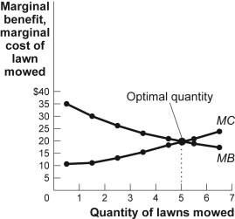

|  |  |  |
| --- | --- | --- |
| 31. | (Figure: The Optimal Quantity) Look at the figure The Optimal Quantity. If the demand for lawn-mowing decreased, the ________ curve in the figure would shift to the ________ and the optimal quantity would be ________ five lawns mowed. | |
| A) | marginal benefit; right; more than |
| B) | marginal cost; right; fewer than |
| **C)** | **marginal benefit; left; fewer than** |
| D) | marginal cost; left; more than |

|  |  |  |
| --- | --- | --- |
| 32. | (Figure: The Optimal Quantity) Look at the figure The Optimal Quantity. If the cost of producing lawn-mowing increased, the ________ curve in the figure would shift to the ________ and the total net gain would ________. | |
| A) | marginal benefit; right; increase |
| B) | marginal cost; right; increase |
| C) | marginal benefit; left; decrease |
| **D)** | **marginal cost; left; decrease** |

|  |  |  |
| --- | --- | --- |
| 33. | An individual gets 5 units of utility from one slice of pizza and 9 units of utility from two slices of pizza. The principle of diminishing marginal utility implies that the total utility from three slices of pizza will be: | |
| A) | exactly 12 units of utility. |
| **B)** | **less than 13 units of utility.** |
| C) | less than 9 units of utility. |
| D) | more than 14 units of utility. |

|  |  |  |
| --- | --- | --- |
| 34. | Freddy has eaten three corn dogs at the county fair and knows that if he eats another, he will get sick on the roller coaster. Knowing this, and ignoring any impact that price might have on his decision, we can say that the: | |
| A) | total utility of the fourth corn dog is less than zero. |
| **B)** | **marginal utility of the fourth corn dog is less than zero.** |
| C) | total utility curve is still increasing at the fourth corn dog. |
| D) | marginal utility curve is still increasing at the fourth corn dog. |

Use the following to answer questions 35-36:

**Figure: Budget Lines for Tea and Scones**

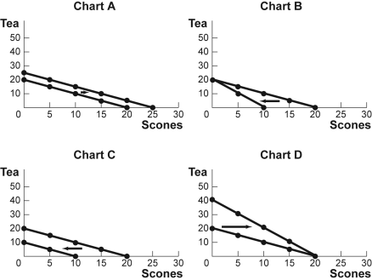

|  |  |  |
| --- | --- | --- |
| 35. | (Figure: Budget Lines for Tea and Scones) Look at the figure Budget Lines for Tea and Scones. For months now, Agnes has had $20 per month to spend on tea and scones. The price of each cup of tea and each scone has been $1. Which of the charts in the figure shows what will happen to her budget line if her income decreases to $10? | |
| A) | Chart A |
| B) | Chart B |
| **C)** | **Chart C** |
| D) | Chart D |

|  |  |  |
| --- | --- | --- |
| 36. | (Figure: Budget Lines for Tea and Scones) Look at the figure Budget Lines for Tea and Scones. For months now, Agnes has had $20 per month to spend on tea and scones. The price of each cup of tea and each scone has been $1. Which of the charts in the figure shows what will happen to her budget line if the price of a scone rises to $2? | |
| A) | Chart A |
| **B)** | **Chart B** |
| C) | Chart C |
| D) | Chart D |

|  |  |  |
| --- | --- | --- |
| 37. | An increase in a consumer's income will do all of the following *except:* | |
| A) | shift the budget line away from the origin. |
| B) | increase the horizontal intercept. |
| C) | increase the vertical intercept. |
| **D)** | **change the slope of the budget line.** |

Use the following to answer question 38:

**Figure: Consumer Equilibrium I**

The figure shows three of Owen's indifference curves for pizza and soda per week. Owen has $180 per month to spend on the two goods, and the price of a pizza is $20 and the price of a soda is $1.50.

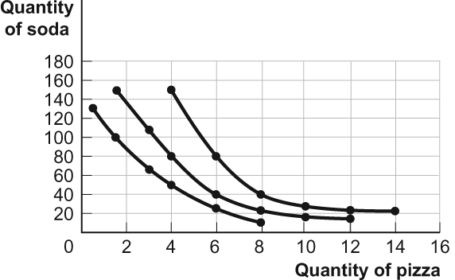

|  |  |  |
| --- | --- | --- |
| 38. | (Figure: Consumer Equilibrium I) Look at the figure Consumer Equilibrium I. What is Owen's optimal consumption bundle? | |
| A) | 4 pizzas and 150 sodas |
| B) | 8 pizzas and 40 sodas |
| **C)** | **6 pizzas and 40 sodas** |
| D) | 14 pizzas and 20 sodas |

|  |  |  |
| --- | --- | --- |
| 39. | LaToya sees honey and sugar as perfect substitutes. She is always willing to substitute 1 teaspoon of honey for 2 teaspoons of sugar. If honey is twice as expensive as sugar, LaToya will: | |
| A) | use only honey. |
| B) | use only sugar. |
| C) | use a lot of honey and a little sugar. |
| **D)** | **be willing to purchase either sugar or honey.** |

Use the following to answer question 40:

**Figure: Income and Substitution Effects**

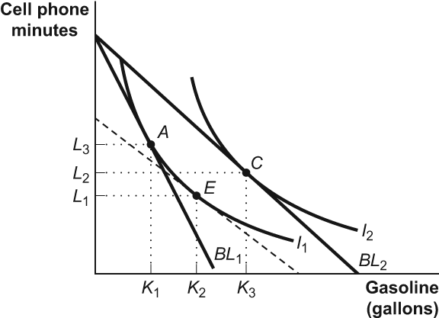

|  |  |  |
| --- | --- | --- |
| 40. | (Figure: Income and Substitution Effects) Look at the figure Income and Substitution Effects. Carlos is originally consuming his optimal consumption bundle at point *A* in the figure when the price of gasoline falls. The dashed line tangent to *I*1 shows a hypothetical budget line reflecting: | |
| A) | the original income, original price of cell phone minutes, and the new price of gasoline*.* |
| **B)** | **the new relative prices of gasoline in terms of cell phone minutes and a change in income to keep Carlos on the original indifference curve.** |
| C) | the new relative prices of gasoline in terms of cell phone minutes and a change in income to allow Carlos to reach an indifference curve higher than *I*1. |
| D) | the income and substitution effects. |

**Answer Key**

|  |  |
| --- | --- |
| 1. | D |
| 2. | A |
| 3. | D |
| 4. | C |
| 5. | C |
| 6. | D |
| 7. | C |
| 8. | A |
| 9. | B |
| 10. | B |
| 11. | D |
| 12. | A |
| 13. | A |
| 14. | A |
| 15. | B |
| 16. | B |
| 17. | D |
| 18. | C |
| 19. | D |
| 20. | D |
| 21. | C |
| 22. | C |
| 23. | C |
| 24. | A |
| 25. | D |
| 26. | A |
| 27. | C |
| 28. | A |
| 29. | A |
| 30. | C |
| 31. | C |
| 32. | D |
| 33. | B |
| 34. | B |
| 35. | C |
| 36. | B |
| 37. | D |
| 38. | C |
| 39. | D |
| 40. | B |