Econ 2106

Exam 3 ANSWER KEY

Fall 2015

Dr. Richard FritzName: __________________________ Date: _____________

|  |  |  |
| --- | --- | --- |
| 1. | When Caroline's dress factory hires two workers, the total product is 50 dresses. When she hires three workers, total product is 60, and when she hires four workers, total product is 75. The slope of the marginal product curve when two to four workers are hired is | |
| **A)** | **upward sloping.** |
| B) | downward sloping. |
| C) | vertical. |
| D) | horizontal. |

Use the following to answer questions 2-3:

**Figure: The Total Product**

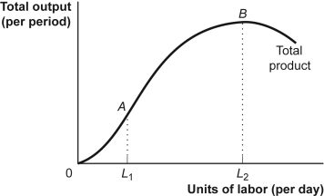

|  |  |  |
| --- | --- | --- |
| 2. | (Figure: The Total Product) Look at the figure The Total Product. After hiring *L*2 labor and producing at point *B* on the total product curve, hiring more labor beyond *L2* would result in which of the following statements being true of the total product curve? | |
| A) | The marginal product of labor is rising. |
| **B)** | **The marginal product of labor is negative.** |
| C) | The total product is negative. |
| D) | The total product is zero. |

|  |  |  |
| --- | --- | --- |
| 3. | (Figure: The Total Product) Look at the figure The Total Product. As labor is hired between *L*1 and *L*2, the ________ is ________ and the ________ is ________. | |
| **A)** | **total product; rising; marginal product; positive** |
| B) | marginal product; zero; total product; falling |
| C) | total product; rising; marginal product; negative |
| D) | total product; rising; marginal product; zero |

|  |  |  |
| --- | --- | --- |
| 4. | If Marie Marionettes is operating under conditions of diminishing marginal product, the marginal costs will be: | |
| A) | equal to average total cost*.* |
| B) | decreasing. |
| **C)** | **increasing.** |
| D) | constant. |

|  |  |  |
| --- | --- | --- |
| 5. | The average total cost of producing cell phones in a factory is $20 at the current output level of 100 units per week. If fixed cost is $1,200 per week: | |
| A) | average fixed cost is $20. |
| B) | total cost is $3,200. |
| C) | variable cost is $2,000. |
| **D)** | **average variable cost is $8.** |

Use the following to answer question 6:

**Figure: The Average Total Cost Curve**

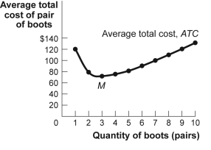

|  |  |  |
| --- | --- | --- |
| 6. | (Figure: The Average Total Cost Curve) Look at the figure The Average Total Cost Curve. In the figure, the total cost of producing three pairs of boots is approximately: | |
| A) | $24. |
| B) | $72. |
| C) | $75. |
| **D)** | **$216.** |

|  |  |  |
| --- | --- | --- |
| 7. | When Aishe's Bar-B-Que produces 10 pork sandwiches, the total cost is $5. When 11 pork sandwiches are produced, the total cost rises to $6. From this we know that the marginal cost of the eleventh pork sandwich: | |
| A) | is equal to the average cost of 11 pork sandwiches. |
| **B)** | **is greater than the average cost of 11 pork sandwiches.** |
| C) | is less than the average cost of 11 pork sandwiches. |
| D) | can't be calculated without more information. |

|  |  |  |
| --- | --- | --- |
| 8. | Suppose the marginal cost curve in the short run first decreases, then reaches a minimum, and then increases. If we are at an output where marginal cost is decreasing, then: | |
| A) | marginal product must be increasing. |
| B) | average variable cost must be decreasing. |
| C) | average total cost must be increasing. |
| **D)** | **marginal product must be increasing and average variable cost must be decreasing.** |

|  |  |  |
| --- | --- | --- |
| 9. | Suppose Cyd knows the average total cost of producing 9 scones is $5, while the average total cost of producing 10 scones is $5.20. What is the marginal cost of the 10th scone? | |
| **A)** | **$7** |
| B) | $5.20 |
| C) | $0.20 |
| D) | $5 |

|  |  |  |
| --- | --- | --- |
| 10. | Kaile Cakes produces 10 cakes per day. The marginal cost of the tenth cake is $24, and average total cost of 10 cakes is $6. The average total cost of 9 cakes is: | |
| **A)** | **$4.** |
| B) | $5. |
| C) | $6. |
| D) | $8. |

|  |  |  |
| --- | --- | --- |
| 11. | In a perfectly competitive industry, the market demand curve is usually: | |
| A) | perfectly inelastic. |
| B) | perfectly elastic. |
| **C)** | **downward sloping.** |
| D) | relatively elastic. |

|  |  |  |
| --- | --- | --- |
| 12. | Consider a perfectly competitive firm in the short run. Assume the firm produces the profit-maximizing output and that it earns economic profits. At the profit-maximizing output, all of the following are correct *except*: | |
| A) | price is equal to marginal cost. |
| B) | price is equal to marginal revenue. |
| **C)** | **price is equal to average total cost.** |
| D) | marginal cost is greater than average total cost. |

|  |  |  |
| --- | --- | --- |
| 13. | A perfectly competitive small organic farm that produces 1,000 cauliflower heads in the short run has an *ATC* = $6 and *AFC* = $2. The market price is $3 per head and is equal to *MC.* In order to maximize profits (or minimize losses), this farm should: | |
| A) | increase output. |
| B) | reduce output but continue to produce a positive amount of output. |
| **C)** | **shut down.** |
| D) | do nothing; the firm is already maximizing profits. |

|  |  |  |
| --- | --- | --- |
| 14. | Wenqin is a farmer, and in the short run she produces 100 bushels of wheat. Her average total cost per bushel is $1.75, total revenue is $450, and (total) fixed costs are equal to $100. Wenqin's: | |
| A) | average fixed cost is equal to $1.50. |
| **B)** | **profit per bushel is equal to $2.75.** |
| C) | average variable cost is equal to $1.25. |
| D) | economic profit is equal to $250. |

Use the following to answer question 15:

**Figure: Prices, Cost Curves, and Profits**

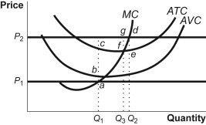

|  |  |  |
| --- | --- | --- |
| 15. | (Figure: Prices, Cost Curves, and Profits) Look at the figure Prices, Cost Curves, and Profits. If the price is *P*1and the firm decides to produce at output *Q*1, then the firm earns: | |
| A) | a loss equal to (*ba*) × *Q*1. |
| **B)** | **a loss equal to (*ca*) × *Q*1.** |
| C) | a loss equal to (*bc*) × *Q*1. |
| D) | zero. |

|  |  |  |
| --- | --- | --- |
| 16. | The market for beef is in long-run equilibrium at a price of $3.25 per pound. The announcement that mad cow disease has been discovered in the United States reduces the demand for beef sharply, and the price falls to $2.00 per pound. If the long-run supply curve is horizontal, then when the long-run equilibrium is reestablished, the price will be: | |
| **A)** | **$3.25 per pound.** |
| B) | $2.00 per pound. |
| C) | greater than $2.00 per pound but less than $3.25 per pound. |
| D) | More information is needed to answer this question. |

Use the following to answer question 17:

**Figure: The Perfectly Competitive Firm**

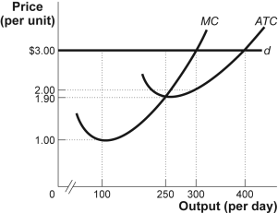

|  |  |  |
| --- | --- | --- |
| 17. | (Figure: The Perfectly Competitive Firm) Look at the figure The Perfectly Competitive Firm. The firm faces demand curve *d,* has the cost curves shown, and maximizes profit. In a long-run equilibrium, this firm will produce ________ units of output and sell its output at a price of ________. | |
| A) | 100; $1.00 |
| **B)** | **250; $1.90** |
| C) | 300; $2.00 |
| D) | 400; $3.00 |

|  |  |  |
| --- | --- | --- |
| 18. | Wendy has a monopoly in the retailing of motor homes. She can sell five per week at $21,000 each. If she wants to sell six, she can only charge $20,000 each. The price effect of selling the sixth motor home is: | |
| A) | $20,000. |
| B) | –$15,000. |
| **C)** | **–$5,000.** |
| D) | $25,000. |

|  |  |  |
| --- | --- | --- |
| 19. | A monopolist responds to an increase in demand by ________ price and ________ output. | |
| A) | increasing; decreasing |
| **B)** | **increasing; increasing** |
| C) | decreasing; increasing |
| D) | decreasing; decreasing |

|  |  |  |
| --- | --- | --- |
| 20. | The GoSports Company is a profit-maximizing firm with a monopoly in the production of school team pennants. The firm sells its pennants for $10 each. We can conclude that GoSports is producing a level of output at which: | |
| A) | average total cost equals $10. |
| B) | average total cost is greater than $10. |
| C) | marginal revenue equals $10. |
| **D)** | **marginal cost equals marginal revenue.** |

Use the following to answer questions 21-22:

**Figure: A Profit-Maximizing Monopoly Firm**

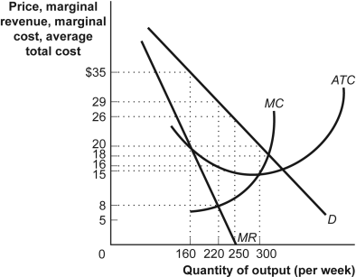

|  |  |  |
| --- | --- | --- |
| 21. | (Figure: A Profit-Maximizing Monopoly Firm) Look at the figure A Profit-Maximizing Monopoly Firm. This firm's cost per unit at its profit-maximizing quantity is: | |
| A) | $8. |
| B) | $15. |
| **C)** | **$16.** |
| D) | $18. |

|  |  |  |
| --- | --- | --- |
| 22. | (Figure: A Profit-Maximizing Monopoly Firm) Look at the figure A Profit-Maximizing Monopoly Firm. This firm's profit per unit is: | |
| A) | $5. |
| **B)** | **$13.** |
| C) | $14. |
| D) | $20. |

|  |  |  |
| --- | --- | --- |
| 23. | In order to engage in price discrimination a firm must be: | |
| A) | a price-taker. |
| B) | a price-setter. |
| C) | able to identify consumers whose elasticities differ. |
| **D)** | **a price-setter, and it must be able to identify consumers whose elasticities differ.** |

|  |  |  |
| --- | --- | --- |
| 24. | The city bus system charges lower fares to senior citizens than to other passengers. Assuming that this pricing strategy increases the profits of the bus system, we can conclude that senior citizens must have a ________ for bus service than other passengers. | |
| A) | greater demand |
| B) | lower demand |
| **C)** | **more elastic demand** |
| D) | less elastic demand |

Use the following to answer question 25:

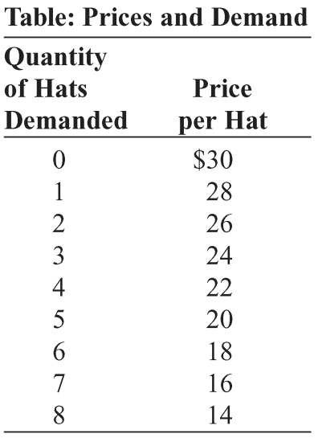

|  |  |  |
| --- | --- | --- |
| 25. | (Table: Prices and Demand) Look at the table Prices and Demand. The New Orleans Saints have a monopoly on Saints logo baseball hats. The Saints sell at most one hat to each customer, and the table shows each customer's willingness to pay. The marginal cost of producing a hat is $18. How many hats should the Saints produce, and what price should the organization charge to maximize its profits? | |
| A) | 1; $28 |
| B) | 2; $26 |
| **C)** | **3; $24** |
| D) | 4; $22 |

Use the following to answer questions 26-27:

**Figure: The Profit-Maximizing Output and Price**

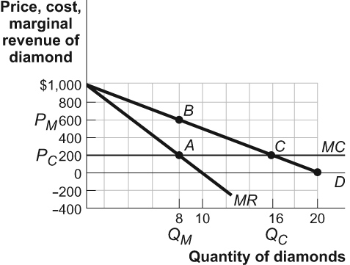

|  |  |  |
| --- | --- | --- |
| 26. | (Figure: The Profit-Maximizing Output and Price) Look at the figure The Profit-Maximizing Output and Price. Assume there are no fixed costs and *AC* = *MC*. At the profit-maximizing quantity of production for the monopolist, total revenue is ________, total cost is ________, and profit is ________. | |
| A) | $600; $200; $400 |
| B) | $1,600; $3,200; $1,600 |
| C) | $4,800; $3,200; $1,600 |
| **D)** | **$4,800; $1,600; $3,200** |

|  |  |  |
| --- | --- | --- |
| 27. | (Figure: The Profit-Maximizing Output and Price) Look at the figure The Profit-Maximizing Output and Price. A perfect competitor would produce at a price of ________ and output of ________. | |
| A) | $600; 8 units |
| B) | $200; 8 units |
| **C)** | **$200; 16 units** |
| D) | $600; 16 units |

|  |  |  |
| --- | --- | --- |
| 28. | Oligopoly is a market structure that is characterized by a ________ number of ________ firms that produce ________ products. | |
| A) | large; relatively small and independent; identical |
| B) | small; independent; identical or differentiated |
| C) | large; relatively small and independent; differentiated |
| **D)** | **small; interdependent; identical or differentiated** |

|  |  |  |
| --- | --- | --- |
| 29. | A monopoly will have a Herfindahl–Hirschman index (HHI) equal to: | |
| A) | 1. |
| B) | 100. |
| C) | 1,000. |
| **D)** | **10,000.** |

|  |  |  |
| --- | --- | --- |
| 30. | Which of the following Herfindahl–Hirschman indices is most likely to indicate a perfectly competitive market? | |
| **A)** | **100** |
| B) | 1,800. |
| C) | 10,000. |
| D) | 100,000. |

|  |  |  |
| --- | --- | --- |
| 31. | Collusive agreements are typically difficult for cartels to maintain because each firm can increase profits by: | |
| **A)** | **producing more output than the quantity that maximizes joint cartel profits.** |
| B) | producing less output than the quantity that maximizes joint cartel profits. |
| C) | increasing the price above the price that maximizes joint cartel profits. |
| D) | engaging in less advertising than the level of advertising that maximizes joint cartel profits. |

Use the following to answer questions 32-33:

**Figure: Collusion**

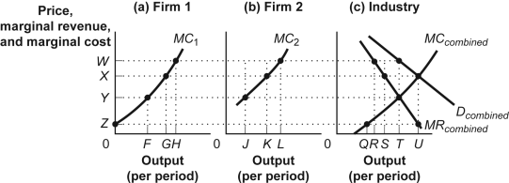

|  |  |  |
| --- | --- | --- |
| 32. | (Figure: Collusion) In the figure Collusion, panel (c) gives the combined marginal revenue, demand, and marginal cost curves for an industry containing several firms. Panels (a) and (b) give marginal cost curves for two of those firms. The quantity of output produced by the industry with collusion is shown by: | |
| A) | *Q.* |
| B) | *R.* |
| C) | *S.* |
| **D)** | ***T.*** |

|  |  |  |
| --- | --- | --- |
| 33. | (Figure: Collusion) In the figure Collusion, panel (c) gives the combined marginal revenue, demand, and marginal cost curves for an industry containing several firms. Panels (a) and (b) give marginal cost curves for two of those firms. The price charged by the industry with collusion is shown by: | |
| **A)** | ***W.*** |
| B) | *X.* |
| C) | *Y.* |
| D) | *Z.* |

|  |  |  |
| --- | --- | --- |
| 34. | Gary's Gas and Frank's Fuel are the only two providers of gasoline in their town. Gary and Frank decide to form a cartel. Later, Gary summarizes his pricing strategy as, “I'll cheat on the cartel because regardless of what Frank does, cheating gives me the best payoff.” This is an example of: | |
| **A)** | **a dominant strategy.** |
| B) | a tit-for-tat strategy. |
| C) | an irrational strategy. |
| D) | product differentiation. |

Use the following to answer question 35:

**Figure: Payoff Matrix I for Blue Spring and Purple Rain**

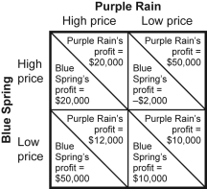

|  |  |  |
| --- | --- | --- |
| 35. | (Figure: Payoff Matrix I for Blue Spring and Purple Rain) The figure Payoff Matrix I for Blue Spring and Purple Rain refers to two producers of bottled water. Each has two strategies available to it: a high price and a low price. The dominant strategy for Purple Rain is to: | |
| A) | always charge a low price. |
| B) | always charge a high price. |
| C) | always adopt the same strategy as Blue Spring. |
| **D)** | **Purple Rain does not have a dominant strategy.** |

Use the following to answer question 36:

**Figure: Payoff Matrix for the United States and the European Union**

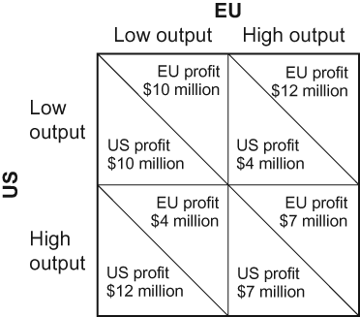

|  |  |  |
| --- | --- | --- |
| 36. | (Figure: Payoff Matrix for the United States and the European Union) Look at the figure Payoff Matrix for the United States and the European Union. Suppose that the United States and the European Union both produce corn, and each region can make more profit if output is limited and the price of corn is high. If either regions increase their output of corn, the profits of both are affected as shown in the payoff matrix. The Nash equilibrium combination is for: | |
| **A)** | **both the United States and the European Union to produce a high output.** |
| B) | the United States to produce a high output and the European Union to produce a low output. |
| C) | both the United States and the European Union to produce a low output. |
| D) | the European Union to produce a high output and the United States to produce a low output. |

Use the following to answer question 37:

**Figure: Profit Maximization for a Firm in Monopolistic Competition**

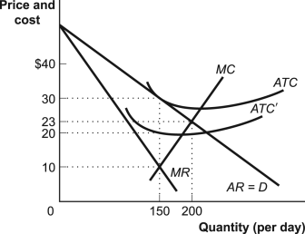

|  |  |  |
| --- | --- | --- |
| 37. | (Figure: Profit Maximization for a Firm in Monopolistic Competition) Look at the figure Profit Maximization for a Firm in Monopolistic Competition. Suppose that an innovation reduces a firm's fixed costs and reduces cost from *ATC* to *ATC**.* Before the innovation reduced the cost, the firm's maximum economic profit was: | |
| **A)** | **$0.** |
| B) | $30. |
| C) | $750. |
| D) | $4,500. |

|  |  |  |
| --- | --- | --- |
| 38. | The profit-maximizing rule, expressed as ________, is adhered to by firms operating in a market that is________. | |
| A) | *MC* > *MR;* monopolistically competitive but not perfectly competitive |
| **B)** | ***MC* = *MR;* both monopolistically competitive and perfectly competitive** |
| C) | *MC* > *MR;* perfectly competitive but not monopolistically competitive |
| D) | *MC* = *MR;* either monopolistically competitive or perfectly competitive, depending on the costs of production |

|  |  |  |
| --- | --- | --- |
| 39. | The restaurant industry is characterized by excess capacity. This means that: | |
| A) | restaurants are producing more than their profit-maximizing level. |
| **B)** | **the profit-maximizing level is less than the level that minimizes average total costs.** |
| C) | the restaurants are producing less than their profit-maximizing level. |
| D) | the quantity of restaurant meals supplied exceeds the quantity of restaurant meals demanded. |

|  |  |  |
| --- | --- | --- |
| 40. | Two firms, firm A and firm B, have identical cost curves. Firm A operates in perfect competition and firm B operates in monopolistic competition. In the long run, what can we say about the price and output that each firm charges? | |
| A) | Firm A's price will be lower than firm B's price, and firm A's output will be lower than firm B's output. |
| B) | Firm A's price will be greater than firm B's price, and firm A's output will be greater than firm B's output. |
| C) | Firm A's price will be greater than firm B's price, and firm A's output will be lower than firm B's output. |
| **D)** | **Firm A's price will be lower than firm B's price, and firm A's output will be greater than firm B's output.** |

**Answer Key**

|  |  |
| --- | --- |
| 1. | A |
| 2. | B |
| 3. | A |
| 4. | C |
| 5. | D |
| 6. | D |
| 7. | B |
| 8. | D |
| 9. | A |
| 10. | A |
| 11. | C |
| 12. | C |
| 13. | C |
| 14. | B |
| 15. | B |
| 16. | A |
| 17. | B |
| 18. | C |
| 19. | B |
| 20. | D |
| 21. | C |
| 22. | B |
| 23. | D |
| 24. | C |
| 25. | C |
| 26. | D |
| 27. | C |
| 28. | D |
| 29. | D |
| 30. | A |
| 31. | A |
| 32. | D |
| 33. | A |
| 34. | A |
| 35. | D |
| 36. | A |
| 37. | A |
| 38. | B |
| 39. | B |
| 40. | D |