MGT 4352 Exam 2

Tuesday, December 10, 2013

**Name:___________________________________________ID#:_____________________**

***Note: Answer each question/sub question clearly and to the point. Attach any computer printouts to support your answer. Label your attachments clearly and directly to your answers. It is an individual test. Cooperation is absolutely not allowed. Turn in the test sheets, your answers and attachments together at 11-12PM on Tuesday (12/10) in my office 448.***

1. Ben Golfy is a major golf supply manufacturer. One of the major products Ben Golfy produces is a titanium golf head. The demand for the golf head is 250,000 annually and is very stable from time to time. To set up a production run for the golf head, it is estimated to cost $2,000 each time the production system is changed over and set it up. The average value of the golf head including material, semi-finished product and finished product is estimated at $35 per unit by cost accounting department. The holding cost including capital interest, taxes, insurance, floor space, and administration overhead is estimated at 30% of the inventory value. (10 points, 2 points each)
2. Compute the economic order quantity for each production run assuming the production rate is infinite.
3. Based on the EOQ from 1), how many weeks of supply in average for this golf head assuming there are 52 weeks per year.
4. Following 1), what is the annual total inventory cost (TIC) including ordering (production run) cost and holding cost?
5. Following 1), if the production order quantity is 15% more than the EOQ, how much more is the TIC in terms of %?
6. If the production rate is not infinite but with 15000 units per week and the demand can be backordered with a backorder (shortage) cost of $10 per unit per year, what is the revised EOQ?
7. A manufacturer uses large quantity of a purchased part in his assembly operations. He wants to use a constant purchase lot size, i.e. order quantity, and he plans to have no shortage. The following data are relevant to the problem of determining the optimal lot size;
   * Annual requirement of the part: 300,000 units uniformly (constantly) required over the year.
   * Manufacturer’s fixed cost of placing an order: $95.
   * Annual cost of interest, insurance, storage, and taxes on average inventory investment: 25% of the value of average inventory (this is the unit annual holding cost).
   * Vendor’s price structure:

|  |  |
| --- | --- |
| Order Size (Q) | Unit Price |
| 0 < Q < 10,000 | $1.00 |
| 10,000 ≤ Q < 30,000 | $0.97 |
| 30,000 ≤ Q < 50,000 | $0.92 |
| 50,000 ≤ Q | $0.90 |

Show your analysis for the purchase situation and propose an order quantity to minimize the overall cost. (5 points)

1. Home Depot (HD) buys artificial Christmas trees for sales during the holiday season. Typically, HD gives an order to a major international vendor in the summer and the trees will be delivered and sold during the holiday period. This year the tree costs $65 each and will be sold at $155 each. After the holiday, the left over trees will be sold at a deep discount price of $35 each. HD has also estimated that if a customer cannot get the tree, it will have a goodwill cost of $5. Past history says that the season demand for the tree averages 15,000 with a standard deviation of 5000 trees, normally distributed. (8 points, 2 points each)
   1. Calculate Cs and Co?
   2. How many trees should HD order for this holiday season in order to optimize the profit?
   3. What is the customer service level (fill rate) for this policy?
2. When the demand follows approximately normal distribution, the expected profit for the policy can be estimated by the following equation. How much is the seasonal profit for HD? Assume that the ordering cost (K) is $2500. (2 Points)

EP(Q) = (p-s) – (c-s)Q – (p+g-s) E(n) – K

Where

p = per unit selling price of the good.

c = per unit purchasing or production cost of the good.

s = per unit salvage value of unsold good.

g = per unit goodwill cost.

❍ = average daily demand.

K = fixed ordering or setup cost

Q = order or production quantity.

E(n) = expected shortage given Q.

EP(Q) = expected profit if Q units are ordered/produced

1. For American Aerospace case, Scarlett has proposed a (Q, R) model to control the inventory and production order for part 10003487. In particular, with 85% of no shortage during order lead time, Scarlett proposed Q = 166 and R = 153. The analytical result for this proposed (Q, R) model is posted on T-Square. Bryan has adopted the policy and implemented in the next two years. However, Bryan feels that more data may help to develop a more accurate policy. During the next two year periods, the following information has been collected for MX332 demands and the order lead-times for part 10003487 (as usual, these are the solid steel part order lead times).

**MX332 Demands**

|  |  |  |  |
| --- | --- | --- | --- |
| Month of Year 4 | Quantity | Month of Year 5 | Quantity |
| 1 | 45 | 1 | 39 |
| 2 | 51 | 2 | 55 |
| 3 | 48 | 3 | 55 |
| 4 | 52 | 4 | 67 |
| 5 | 75 | 5 | 72 |
| 6 | 49 | 6 | 62 |
| 7 | 58 | 7 | 55 |
| 8 | 81 | 8 | 69 |
| 9 | 79 | 9 | 72 |
| 10 | 56 | 10 | 75 |
| 11 | 64 | 11 | 52 |
| 12 | 68 | 12 | 80 |

**Part 10003487 Order Lead-time in Days**

|  |  |  |  |  |  |  |  |
| --- | --- | --- | --- | --- | --- | --- | --- |
| Lead-time | Lead-time | Lead-time | Lead-time | Lead-time | Lead-time | Lead-time | Lead-time |
| 1 | 20 | 8 | 26 | 25 | 53 | 40 | 58 |
| 46 | 23 | 26 | 26 | 55 | 46 | 43 | 7 |
| 33 | 26 | 25 | 21 | 10 | 15 | 33 | 54 |
| 53 | 29 | 27 | 44 | 56 | 41 | 40 | 37 |
| 26 | 32 | 32 | 52 | 16 | 25 | 33 | 37 |
| 60 | 35 | 46 | 26 | 27 | 16 | 39 | 35 |
| 19 | 38 | 41 | 25 | 27 | 38 | 2 | 51 |
| 42 | 41 | 3 | 5 | 58 | 40 | 24 | 12 |
| 30 | 44 | 1 | 35 | 38 | 43 | 38 | 4 |
| 5 | 47 | 60 | 24 | 32 | 33 | 17 | 53 |

By combining the original three year data with these new two year information, AA has 5 year data of demand and lead-times for part 10003487.

* 1. What are the revised mean and standard deviation of the **monthly demands** for **Part 10003487**? (2 points)
  2. What are the revised mean and standard deviation of the **order lead-times** for **Part 10003487**? (2 points)
  3. If American Aerospace continues to use the (Q, R) policy for Part 10003487, what should be the new Q and R? Assume that all the cost information remains the same except that AA is changing to **92% no shortage during order**. That is, the desired probability that a shortage for machine part 10003487 will not occur between the time an order for the steel part is placed and the time the steel part is delivered is **0.92**. (5 points)
  4. What is the estimated average annual holding cost, shortage cost, and setup/order cost associated with this new inventory policy? Based on this policy, what is the safety stock (*ss*) and what is the customer service level, i.e., instant fill rate? (5 points)

1. This problem is based on the JIT Example handout for a single kanban system. The setups are as the example described. For simplicity, assume that each container requires half an hour to complete at each work center. The following figure shows the initial setup right before 8AM for a normal starting day. The waiting kanbans are in the holders (queue is from the left (first) to the right). Full containers with kanbans attached at the storage areas are shown in the figure. Assume all the triggered actions are taken immediately. (10 points)

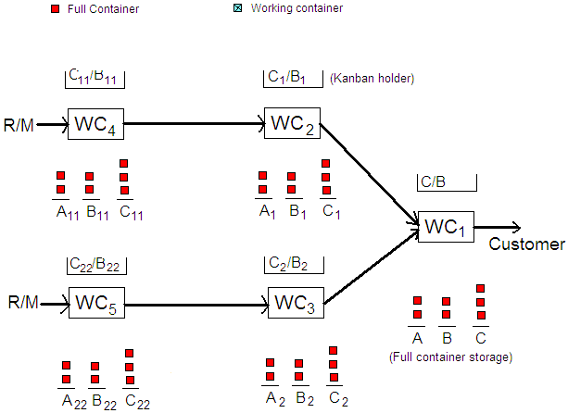

1. Note that each container will be finished in half of an hour. At 8AM, if one full container of B is withdrawn by the customer, and all WCs are free to work at 8AM, complete the system status right after the moment, including the waiting kanbans in holder, full containers in storages, and the working status at each WC. Assume all the triggered actions are taken immediately.

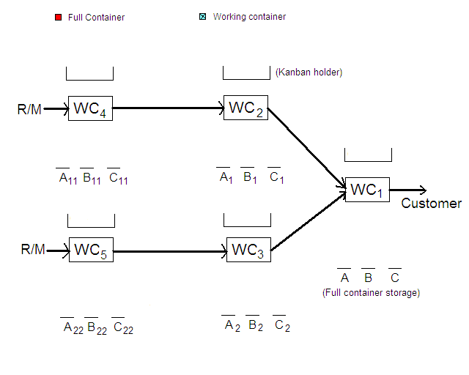

1. Following the last half of an hour operation, right at 8:30AM, if one container of C is taken and removed by the customer, complete the system status right after the moment, including the waiting kanbans in holder, full containers in storages, and the working status at each WC. Assume all the triggered actions are taken immediately.



1. Tom’s Sailboard manufacturers custom wind surfers in Seattle. The incoming orders follow different routes through shop, but all orders must stop at each of the three work centers (WCs) in the plant. The following table contains information regarding the four jobs that arrive over five days and need to be scheduled at the company. It is currently December 12, 2011 early morning and Tom’s works a five-day week. (10 Points)

|  |  |  |  |  |  |  |
| --- | --- | --- | --- | --- | --- | --- |
| Order | Arrival  Date | Due  Date | Job/WC  Routing | Processing Time (Days) | | |
| WC1 | WC2 | WC3 |
| (B)iff | Dec. 12 | Dec .22 | 3-2-1 | 3 | 3 | 1 |
| (G)riff | Dec. 12 | Dec. 27 | 3-1-2 | 1 | 3 | 2 |
| (H)erbie | Dec. 14 | Dec. 21 | 1-2-3 | 3 | 1 | 3 |
| (K)erri | Dec. 16 | Dec. 24 | 2-1-3 | 2 | 3 | 1 |

Assume that the material for all orders is ready for processing as soon as the orders arrive. Each order arrives in the early morning on its arrival date. All three work centers are idle as work begins on orders B and G on December 12 early morning and no other jobs have been scheduled on the three WCs.

* 1. Assume the shortest process time (SPT) sequencing rule is used at all work centers. Construct a Gantt chart depicting the processing and idle times for the three work centers for these four jobs. When is each order finished and what is the total and average flow time (in business day) for the four orders? Are there any job tardy and how many days tardy?

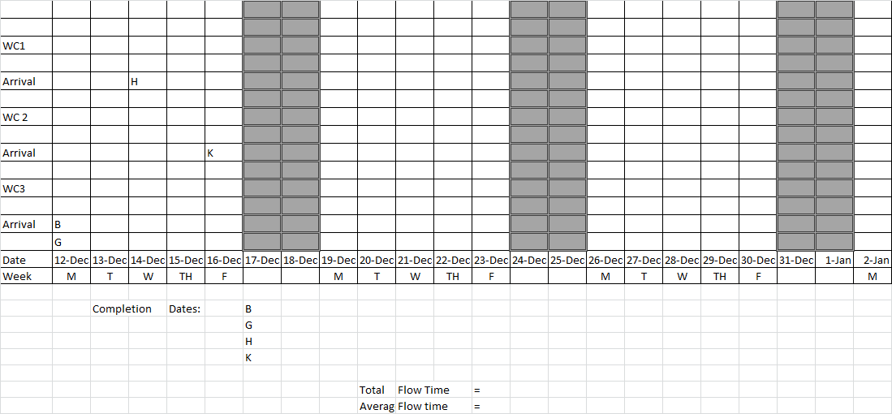

* 1. Assume the earliest due date (EDD) sequencing rule is used at all work centers. Construct a Gantt chart depicting the processing and idle times for the three work centers for these four jobs. When is each order finished and what is the total and average flow time (in business day) for the four orders? Are there any job tardy and how many days tardy?

1. For the OPT Throughput Challenge case, let’s extend to the following situation. After a much improved process, all the setup times for each operation are reduced to 30 minutes and the operation times for 1-30, 2-30, 2-40, 4-10, and 4-40 are also reduced. The following figure shows the revised routing with new operation times. Assume all the other data remains the same. (20 points, 5 points each)

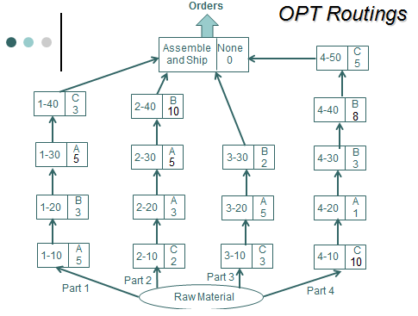

1. Without including setup times, recreate the production schedule for one unit based on STR rule and provide the schedule on a Gantt chart (in one page). What is the completion time (*Cmax*) for this schedule?
2. From 1), now include the setup time 30 minutes and recreate the Gantt chart of STR schedule for one unit (in one page). What is the completion time (*Cmax*) for this schedule?
3. Since the control unit requires one unit from each part, AM manager concludes that there is no point to use different batch sizes for the four parts. Based on the schedule sequence from 2) and 1), create a daily schedule (in 1440 minutes) by simply assuming that each part and operation only produces one batch for the day. Each batch will move to the next operation after the whole batch is complete in a machine. In this case, the batch size is the same as transfer size. How many control units can AM produce for the day? Provide the Gantt chart for this daily schedule. Compute the utilization rates for each machine based on this daily schedule. Also compute “the Goal” that AM can achieve for the day.
4. TOC has taught the AM manager that the transfer size should not be the same as the production batch size. Recreate the production schedule for 3) by using the transfer sizes of 1. How many control units can AM produce for the day? Provide the Gantt chart for this daily schedule. Compute the utilization rates for each machine based on this daily schedule. Also compute “the Goal” that AM can achieve for the day. (4 Points)
5. The following questions are based on the DataStor case. (2 points each except 10 points for (7))
6. Assuming that the DS400 manufacturing process is functioning properly, the PDQ test scores historically followed a normal distribution with a mean value of 7.0 and a standard deviation of 0.3 when the process has been in control. The hard drive product has a lower specification limit (LSL) of 6.2 PDQ value, but no upper specification limit (i.e., the higher the better). What is the process capability (PC) of DataStor’s drive production process? What is the probability of a single unit being defective (i.e., PDQ<6.2)? What is the process capability index *Cp* or *Cpk*? Is the index value consistent with the computed process capability?
7. If the DS400 drive production process is functioning properly, i.e., the process is in control, what is the probability that a single shipment would be rejected by Four-D (i.e., at least one out of ten is defective)? (The probability of a single unit being defective (i.e., PDQ<6.2) or good (i.e., PDQ>6.2) can be found from question 1.)
8. Still assuming that the process is functioning properly, i.e., the process is in control, what is the probability of four or more rejected shipments in 20 days? (The probability of a single shipment rejected can be found from question 2.)
9. Given the information from the above three questions, and that Four-D did actually reject four of the last twenty shipments, is this evidence that the quality of the DS400 has deteriorated, or do you believe that the rejected shipments are just due to random chance? Why or why not?
10. Use Excel Data Analysis tool to create a histogram to describe the shape of the distribution of PDQ values. Verbally interpret the shape of the distribution. Do the data appear normally distributed? Based on the obtained data, what is the mean (******) and standard deviation (******)? (Data set : 07 DataStor Data.xlsx)
11. Are there any PDQ values below 6.2? Is there unusual pattern from the above histogram? Speculate any reasons for the abnormality, if any.
12. To further help determine the possible causes of the quality deterioration, use eight observations for each shift (8 hours) as a sample. That is, the sample size (***n***) is eight. Perform the following control charts to discover any abnormal patterns:

* X-bar, R and s charts for the time series data

(Data set: 07 DataStor Data - Sampled.xlsx)

* X-bar, R and s charts for the time series data for each shift

(Data set: 07 DataStor by Shift - Sampled.xlsx)

**Shift 1:**

**Shift 2:**

**Shift 3:**

* X-bar, R and s charts for the time series data for each day of week

(Data set: 07 DataStor by Day - Sampled.xlsx)

**Day 1:**

**Day 2:**

**Day 3:**

**Day 4:**

**Day 5:**

1. Do you think that the qualities among shifts or days of week are different? Do you have evidence to support it?