MSE 2001E, Fall 2014

Quiz on Chapters 7

# Name: ____________________________________________

From the phase diagram below, answer the following questions.

T5

T8

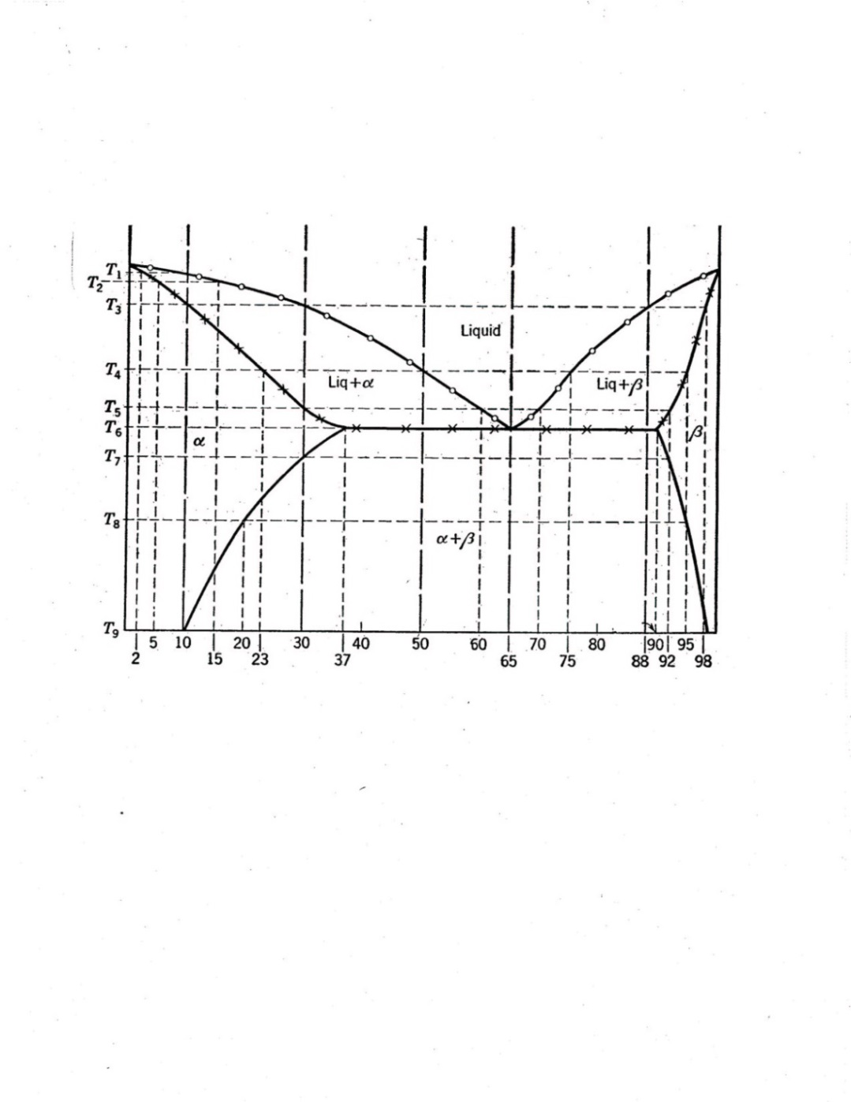

**A Composition of B (%) B**

1. (4 points) At the eutectic isotherm, what are the phases and their compositions of the phases in equilibrium?

Solid   solid  and liquid. (See p.251 in your textbook)

The composition X = 0.37 B (= 37 % B)

The composition X = 0.90 B (= 90 % B)

Liquid compositon XL = 0.65 B (= 65 % B)

1. (9 points) For an alloy containing 50 % B, at T5, what phases will you have? Calculate the fraction of these phases and their compositions at this temperature.

Liquid and solid .

Fraction of liquid = fL = (50-30)/(60-30) = 0.67

The composition XL = 0.6 B (= 60 % B).

Fraction of solid  = f = (60-50)/(60-30) = 0.33 (or f = 1-0.67 = 0.33)

The composition X = 0.3 B (= 30 % B).

1. (3 points) For an alloy containing 50 % B, calculate the fraction of solid  phase and its composition at T8.

Fraction of solid * * = f = (95-50)/(95-20) = 0.60

The composition X = 0.20 B (= 20 % B)

1. (4 points) For an alloy containing 88 % B at a temperature just below the eutectic temperature, what is the primary solid phase and how much of it is formed?

Primary  is the first solid to form on cooling of hypereutectic alloy.

Fraction of solid  = f = (88-37)/(90-37) = 0.96