**PSYC 3020: Biopsychology**

**Mid-Term Exam I**

9/14/12

# **PLEASE WRITE YOUR NAME ON EACH PAGE.**

# **Name: _____________________________________________**

**A)True or B)False, please fill in the answer on your scantron. 2 points each.**

1. Broca’s area is caudal to Wernicke’s area.

A)True B)False

1. Blindsight supports the idea that some neural processing is beyond our conscious awareness.

A)True B)False

1. With regards to laminar organization, layer IV is considered the primary input layer while layer VI is considered the primary output layer.

A)True B)False

1. Calcium facilitates the docking of synaptic vesicles to the presynaptic membrane?

A)True B)False

1. EPSPs and IPSPs cannot occur in a postsynaptic neuron at the same time.

A)True B)False

1. Like the brain, the spinal cord is covered by three meninges.

A)True B)False

1. A person with hemispatial neglect caused by right parietal damage is less likely to be aware of visual, auditory and somatosensory information on the left side of space.

A)True B)False

# **Name: _____________________________________________**

1. Patients with Wernicke’s aphasia still have good speech comprehension.

A)True B)False

1. LSD produces hallucinations, likely because it affects adrenergic receptors

A)True B)False

1. Drugs are not selective to specific neurotransmitter systems.

A)True B)False

**Multiple choice, please fill in your answer on the scantron. 2 points each**

1. Curare is a naturally occurring toxin that has been used by South American Indians in poisoned blow darts. Curare is effective for paralyzing prey because__________________________.
   1. Curare is a nicotinic receptor agonist and causes rigid paralysis of respiratory muscles
   2. Curare is a nicotinic receptor antagonist and causes flaccid paralysis of respiratory muscles
   3. Curare is a muscarinic receptor agonist and causes rigid paralysis of respiratory muscles
   4. Curare is a muscarinic receptor antagonist and causes flaccid paralysis of respiratory muscles
2. The somatic sensory system is generally associated with _____________.
   1. Voluntary movement
   2. Fight-or-flight response
   3. Rest-and-digest response
   4. Drug addiction
3. Two small EPSPs occur at the same postsynaptic location close together in time. This will produce _______________.
   1. No change in the post-synaptic potential, due to cancellation
   2. Two separate EPSPs, due to localization
   3. One large EPSP, due to summation
   4. One large IPSP, due to transubstantiation

**Name:** _____________________________________________

1. Which of the following factors is the most important for determining whether an EPSP or an IPSP will be elicited in the postsynaptic neuron?
   1. The type of neurotransmitter
   2. Whether the synapse is in the central or peripheral nervous system
   3. The type of ion channel opened when the neurotransmitter binds the receptor
   4. Whether the synapse is axo-dendritic or not.
2. Whether the synapse is axo-dendritic or not. Which of the following statements about the blood-brain barrier are true? (mark all that are correct).
   1. Astrocytes make contact both with capillaries and neurons in the central nervous system, thereby bridging the blood-brain barrier.
   2. All neurotransmitters can pass the blood-brain barrier.
   3. The junctions between epithelial cells in the central nervous system capillaries are very tight.
   4. Neurons come directly in contact with blood.
3. The choroid plexus produces __________.
   1. Dopamine
   2. Cerebral Spinal Fluid
   3. Glial cells
   4. Myelin
4. Where are the majority of neurotransmitters produced?
   1. Frontal cortex
   2. Cerebellum
   3. Temporal lobe
   4. Brainstem
5. The Basal ganglia is ____________, because it contains cell bodies, which are called __________ in the central nervous system.
   1. confusingly named, nuclei
   2. appropriately named, ganglion
   3. confusingly named, tracts
   4. appropriately named, basalia
6. Monoamines are considered a class of neurotransmitters because they all _____________.
   1. Produce IPSPs
   2. Have receptors in the same brain regions
   3. Have similar molecular structures
   4. Produce similar behaviors

**Name:** _____________________________________________

1. Botox, or botulinum toxin, is used in cosmetic procedures to smooth wrinkles by causing flaccid paralysis. This effect occurs because botulinum toxin is an _______________, which ___________________.
   1. Acetylcholine agonist, binds to ACh receptors
   2. Acetylcholine agonist, inhibits reuptake of ACh by pre-synaptic neuron
   3. Acetylcholine antagonist, blocks ACh receptor binding
   4. Acetylcholine antagonist, degrades presynaptic ACh vesicles
2. The nervous system is divided into the _________________ and ________________, with the _____________________ being further divided into the _________________ and ________________________divisions.
   1. Autonomic, somatic, autonomic, central, and peripheral
   2. Central, peripheral, peripheral, autonomic, and somatic
   3. Autonomic, somatic, somatic, central, and peripheral
   4. Central, peripheral, central, autonomic, and somatic
3. Heavy cocaine use would most likely cause death to which types of neurons?
   1. Cholinergic
   2. Serontonergic
   3. Adrenergic
   4. Dopaminergic
4. __________ is a naturally-occurring drug found in the Nightshade family of plants (e.g. Mandrake roots, Mad Hatter) and acts by antagonizing muscarinic receptors, thereby inhibiting parasympathetic activity.
   1. Atropine
   2. Nicotine
   3. Codeine
   4. Heroin
5. Phrenology was important because it introduced the concept of ____________.
   1. Summation
   2. Neurotransmitters
   3. Myelination
   4. Localization

**Name:** _____________________________________________

1. Nicotine is a cholinergic agonist that causes increased sympathetic activity. How is this possible if acetylcholine is the primary neurotransmitter of the parasympathetic nervous system?
   1. Nicotine doesn’t cross the blood brain barrier
   2. Nicotine doesn’t bind to muscarinic receptors, which are found in the parasympathetic nervous system.
   3. Nicotine is an antagonist of muscarinic receptors, which are found in the parasympathetic nervous system.
   4. Nicotine binds to both nicotinic and muscarinic receptors but with higher affinity for muscarinic receptors.

# **Name: _____________________________________________**

**Fill in the blank. 2 points each**

1. Saltatory conduction is the mechanism by which the action potential jumps from node to node along the axon. These nodes are also called _____Nodes of Ranvier_________.
2. Glial cells/Glia have many functions including structural support, nutritional support and cerebral spinal fluid production.
3. _____Oligodendrocytes_____________ are glial cells which provide myelin for the central nervous system, while ________Schwann Cells_____________ provide myelin peripheral nervous system axons. (1 point each).
4. Efflux of the ion ____K+____________________________________ would produce an IPSP.
5. A complete cut of the ____corpus callosum____________________________________________ could produce a syndrome in which patients cannot state what object has been presented in the left visual field but can draw the object with the left hand.
6. The two mechanisms by which neurotransmitters are inactivated are reuptake and _enzymatic breakdown_____________________.
7. ____The meso-limbic pathway________ is the most important pathway involved in addiction.
8. __Ephedrine/ephedra (or Mormon tea)_____________________________________ may be the oldest naturally occurring drug that our human ancestors may have used ~60,000 years ago, according to the archaeological record.
9. ____Broca’s aphasia_______________________________________________ is associated with non-fluent speech production but good comprehension.
10. Babies are born with almost all of their neurons. However, brain size quadruples between birth and adulthood via ____myelination______ and _____arborization___________. (1 point each)

# **Name: _____________________________________________**

**Essay questions. 10 points each**

1. Please describe the underlying events contributing to points 1-7 of the figure below. Be sure to include and **discuss** the following terms, making it clear that you understand their meaning and significance: **leak channels, voltage-gated channels, sodium, potassium, resting potential, action potential, depolarization, diffusion pressure, electrostatic pressure, graded potential, hyperpolarization, refractory period, threshold of excitation, rising and falling phases.**

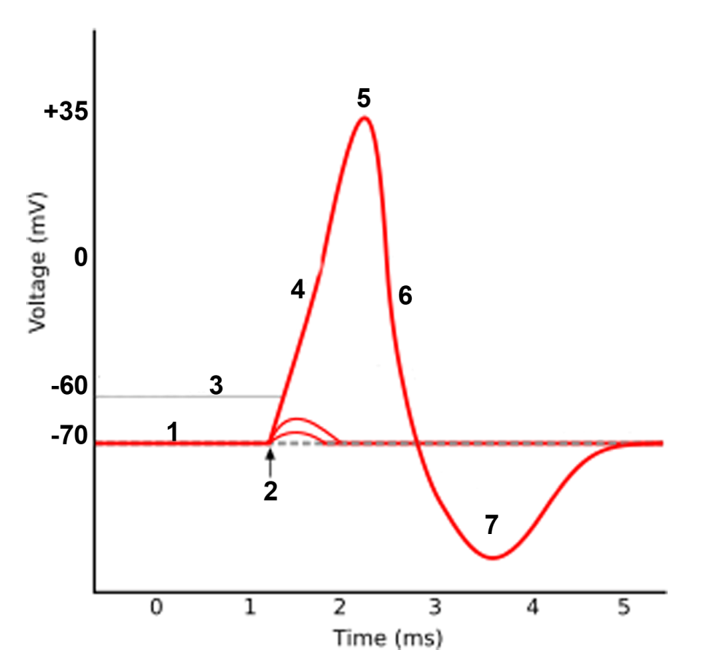

(1). Resting membrane potential is roughly -70mV and the result of an imbalance of ions across the membrane. Sodium has a higher concentration outside the cell while potassium has a higher concentration inside the cell. The factors that maintain the resting membrane potential are the greater diffusion than electrostatic pressure on potassium, causing a net efflux of potassium and the sodium/potassium pump also maintains the unequal distribution of ions (2pts). When sodium begins to flow into the cell, through down its diffusion and electrostatic gradients, the cell will begin to depolarize (2). These are graded potentials which return to the resting state when sodium diffuses away (2pts). When the membrane potential reaches the threshold of excitation of the action potential (3), which is also the threshold of the voltage gated sodium channels, they will open and sodium will rush into the cell down its diffusion and electrostatic gradients. This causes the rising phase (4) of the action potential (2pts). At the peak of the action potential (5) the voltage-gated sodium channels will close and become inactivated/refractory and the voltage-gated potassium channels will open causing potassium to leave the cell down diffusion and electrostatic gradients, resulting in the falling phase (6). During period 5/6 when the V-gated Na+ channels are inactive, the neuron is refractory because no amount of stimulation will result in another action potential (2pts). The cell repolarizes in the falling phase but actually hyperpolarizes below the resting state (7) because the voltage-gated potassium channels are slow to close. Eventually they close and the cell returns to baseline. The hyperpolarization phase (7) is also the relative refractory period, when another action potential could be triggered with enough stimulation (2pts).

# **Name: _____________________________________________**

37. Imagine there is one type of drug that blocks monoamine reuptake transporters and another that causes them to work more efficiently, pumping more neurotransmitter into the presynaptic neuron. Compare and contrast the effects of these two drugs. Be sure to include the following terms/ideas where relevant: **agonist, antagonist, sympathetic, parasympathetic, mood, attention/focus, movement, sleep, appetite, heart rate.**

A drug that blocks monoamine reuptake transporters is an antagonist of the reuptake transporters and therefore, an agonist of the monoamines (1pt). The monoamines include Dopamine, Norepinephrine/noradrenaline and Serotonin (1pt). By allowing these monoamines to interact with the postsynaptic receptors longer, the effects of these neurotransmitters are facilitated (1 pt). This includes increased sympathetic activity, which is mediated by norepinephrine, leading to increased heart rate, decreased appetite, and generally increased arousal, including reduced need for sleep (1pt). The facilitation of Serotonin would lead to an improvement in mood/euphoria/feeling of happiness (1pt). Finally, the increase in Dopaminergic activity would lead to several effects including increased movement, increased attention/focus and possibly addiction (1pt). By contrast, a drug that causes the monoamine reuptake transporters to work more efficiently would be an agonist of those transporters and therefore an antagonist of the monoamines (1pt). The effects of such a drug would be the opposite of the drug that antagonizes the pumps. For example, reducing the activity of norepinephrine, the primary neurotransmitter of the sympathetic nervous system, would lead to unopposed activity in the parasympathetic nervous system. This would produce increased “rest and digest” functions like an increase in appetite, digestion, sleepiness Heart rate would also be reduced. (1pt). Lower levels of serotonin would likely impair one’s mood, leading to depression and/or anxiety (1pt). Finally, reduced levels of Dopamine could inhibit movement, as in Parkinson’s disease, as well as reduce one’s ability to focus/attend (1pt). Given the role that serotonin seems to play in sleep and appetite, it is also possible that a drug that antagonizes the reuptake transporters for serotonin would also promote sleep and enhance appetite while a drug that agonizes the pumps would reduce sleep and appetite (could also get points for this).

38. Compare and contrast the characteristics of addiction to stimulants like methamphetamine with that of opiates, like heroin. Please include the following terms: **route of administration,** **tolerance, physical and psychological dependence, therapeutic index, overdose, withdrawal.**

Methamphetamine and other stimulants and opiates like heroin can all be administered through several routes (insufflation (“snorting”), injected via the veins, taken orally/digestively or inhaled (smoked)). The faster the route, the more likely the person will become addicted. (1pt). Psychologically, people crave these drugs because of their effects on the mesolimbic reward circuit of the brain.(1pt). Stimulants mediates their effects, like euphoria, wakefulness/arousal, appetite suppression, increased attention, and decongestion, by binding to reuptake pumps for the monoamines causing them to pump in reverse, resulting in more dopamine, norepinephrine, and serotonin being released into the synaptic cleft. They are monoaminergic agonists. Opiates mediate their effects like analgesia, sedation, and cough suppression by binding agonistically to opioid receptors. (2pts) As people become regular users of stimulants, there is a downregulation of monoamine receptors and for opiates, a downregulation of opioid receptors. Regular use also results in more efficient enzymatic breakdown of these drugs. These changes are what underlie tolerance and result in more of the drug needed to reach the same “high.” Tolerance and withdrawal are signs of physical dependence (2pts). When someone overdoses on stimulants, the result may be tachycardia, and hypertension, leading to overdose and death from heart attack, stroke or aneurysm, whereas overdose of opiates results in respiratory suppression. Overdose is more likely for potent stimulants and opiates like methamphetamine and heroin because they have relatively lower therapeutic indices than other stimulants and opiates.(2pts) Signs of withdrawal are the opposite of the effects of the drug. For methamphetamine withdrawal includes hunger, fatigue, runny nose, sleep disorders, depression, anxiety and craving for the drug. Withdrawal from methamphetamine is not dangerous and there is no treatment. Opiate withdrawal is dangerous and includes tachycardia, hypertension, pain, and vomiting. (2pts).