# **Validation of the ns-3 implementation of BIC TCP using Network Stack Tester NeST**

**Results**

# **Topology 1 - point router point**

**n1 -->-- r1 -->-- n2**

**Queue Disc:** Pfifo

**A.CWND**

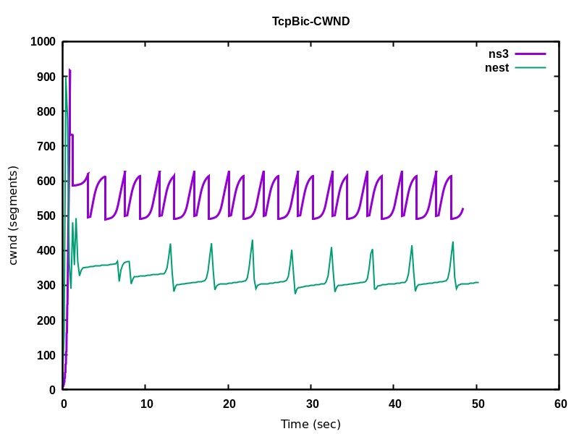

**B.RTT**

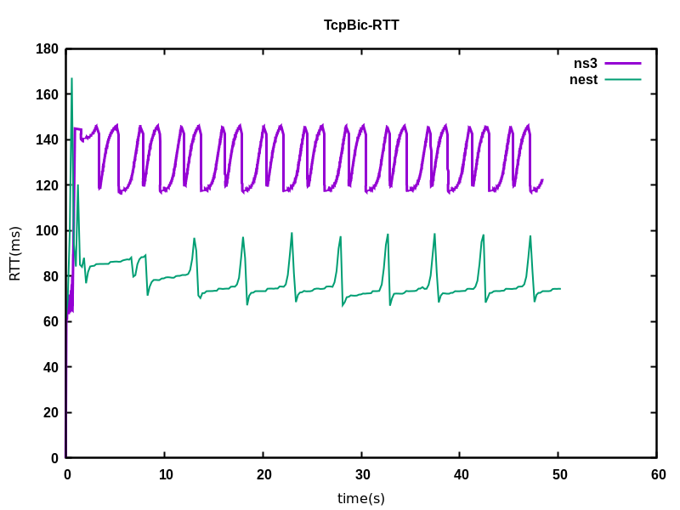

## 

## 

# **Topology 2 - two sender nodes and one receiver node.**

## 

### **A. h1->h3 CWND**

**Queue Disc:** Pfifo

### 

### **B.h1-h3 RTT**

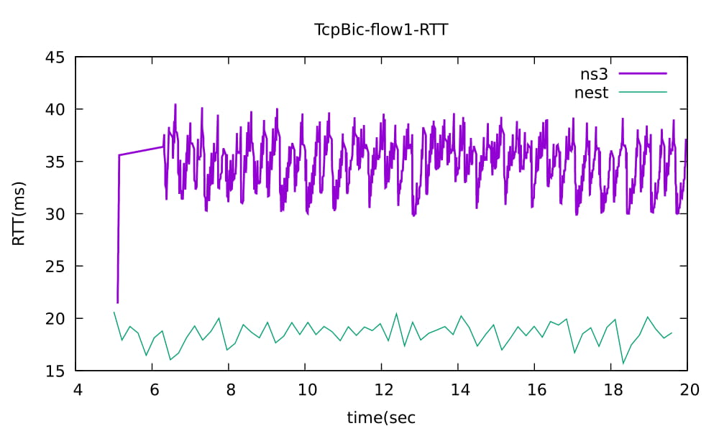

### **C.h2-h3 CWND**

**Queue Disc:** Pfifo

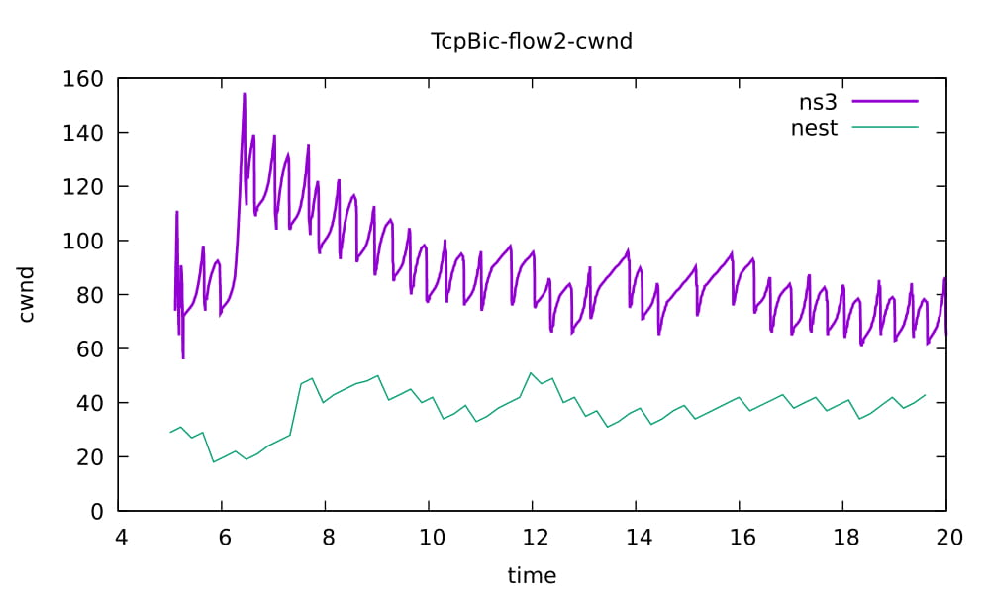

### **D.h2-h3 RTT**

