Updated at 2022/5/1

By Chen Nuo.

Function we have now:

1. Create new task with different symbols by using the add button under bottom center.

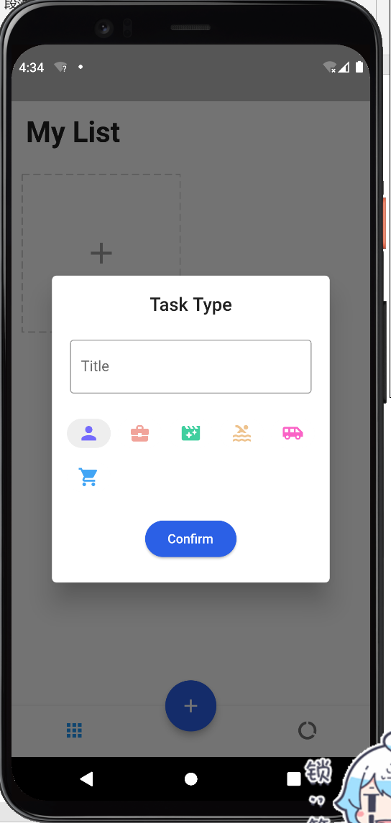 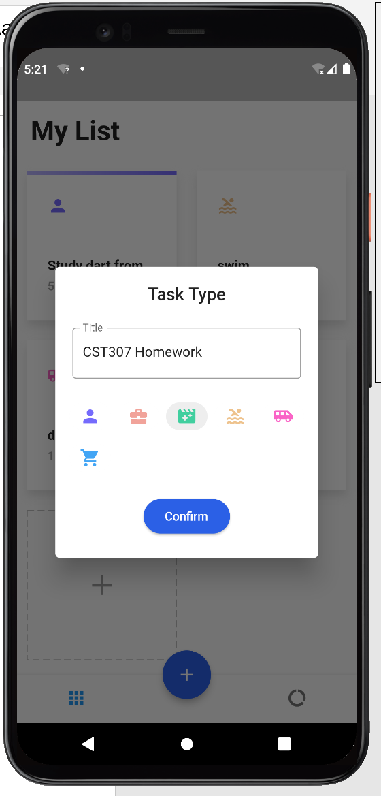 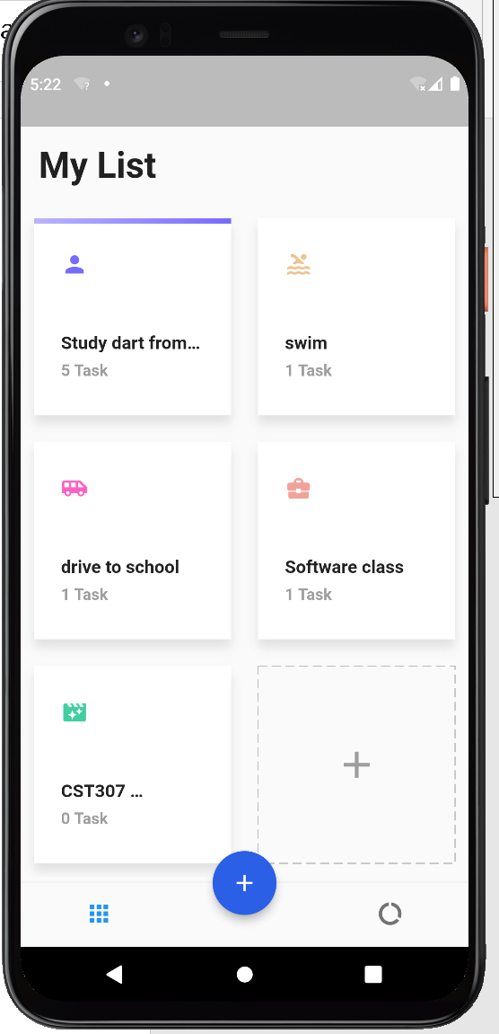

1. Add new sub-task under corresponding task :

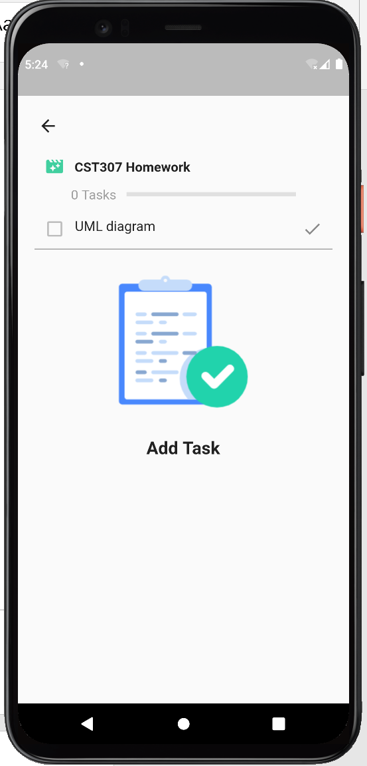 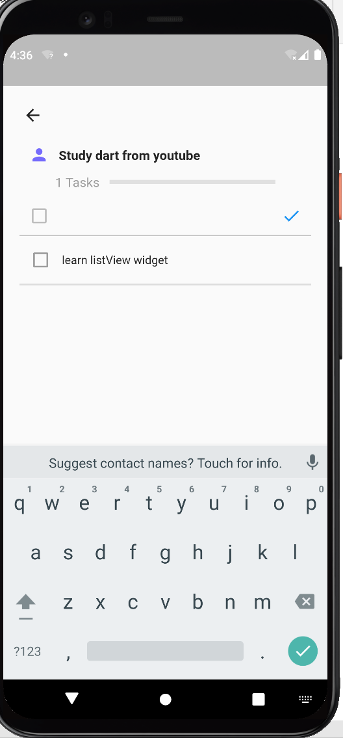 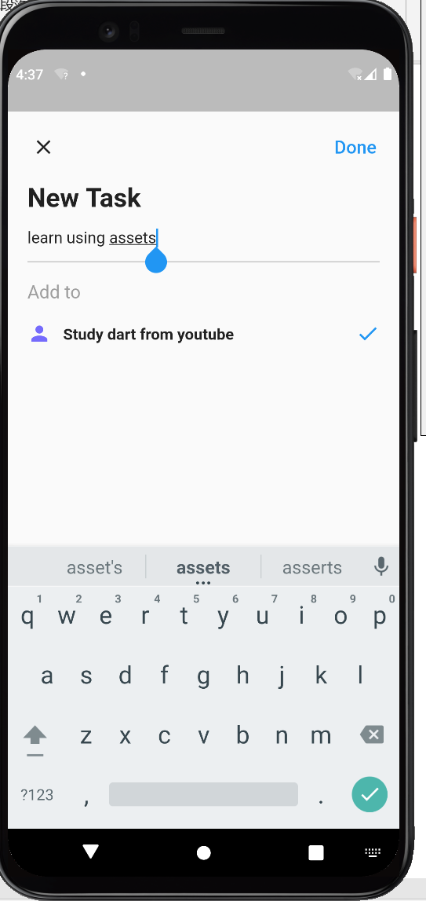

1. Delete tasks by long enter and drag to the trash button

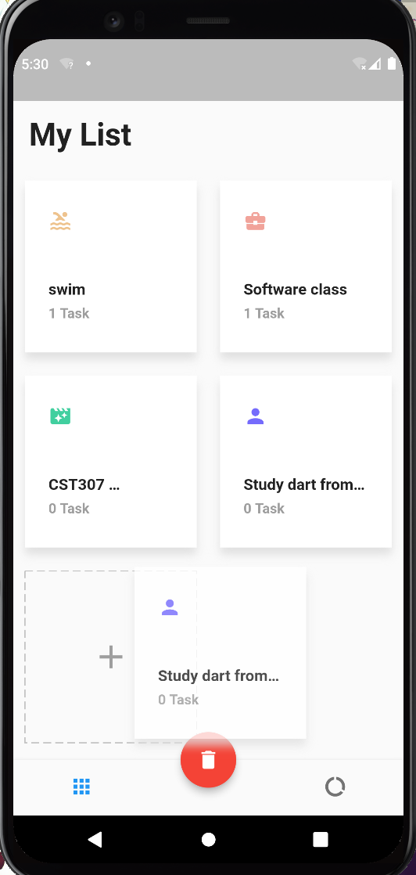 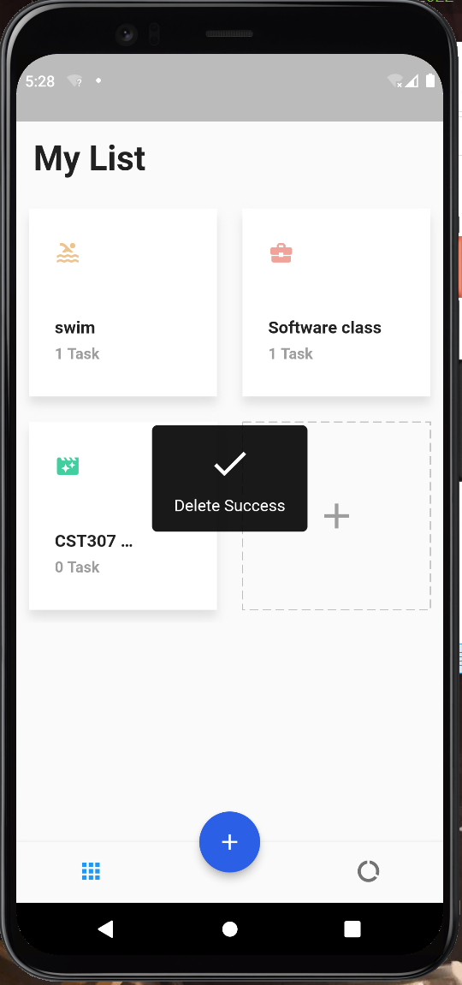

1. Delete the completed task under sub-task(by left drag):

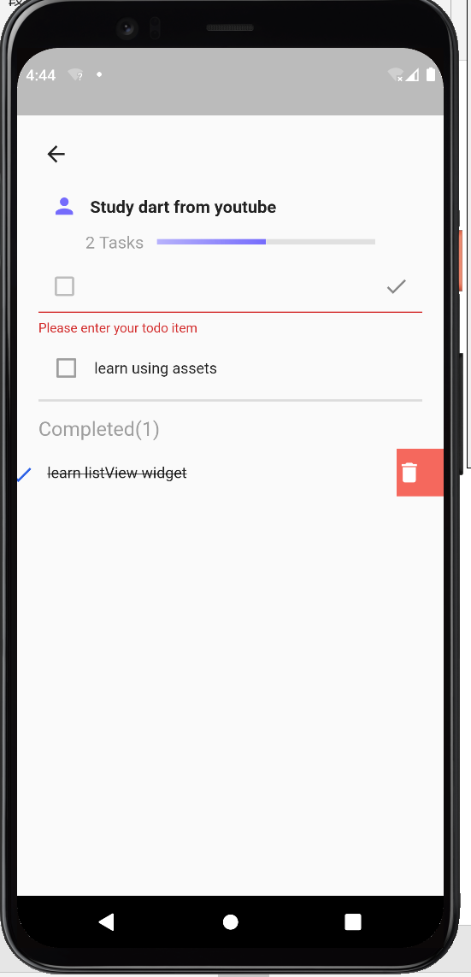 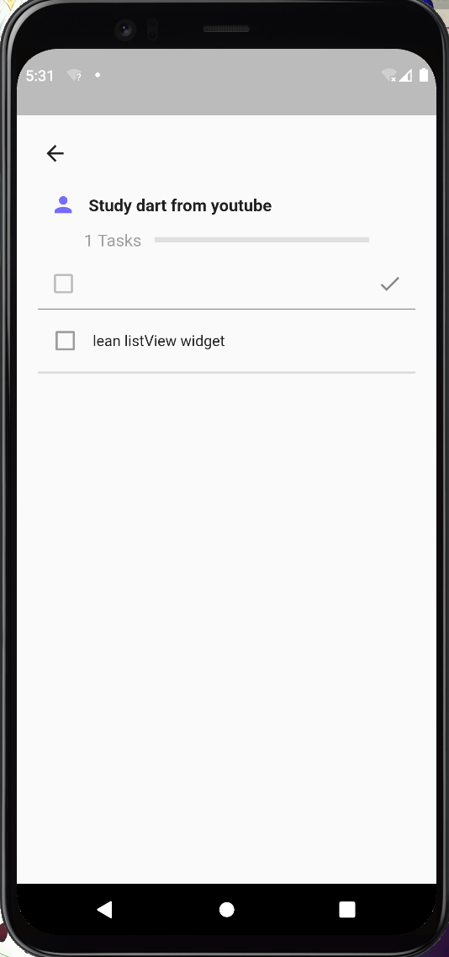

1. See task competition report based on the live tasks and total tasks.

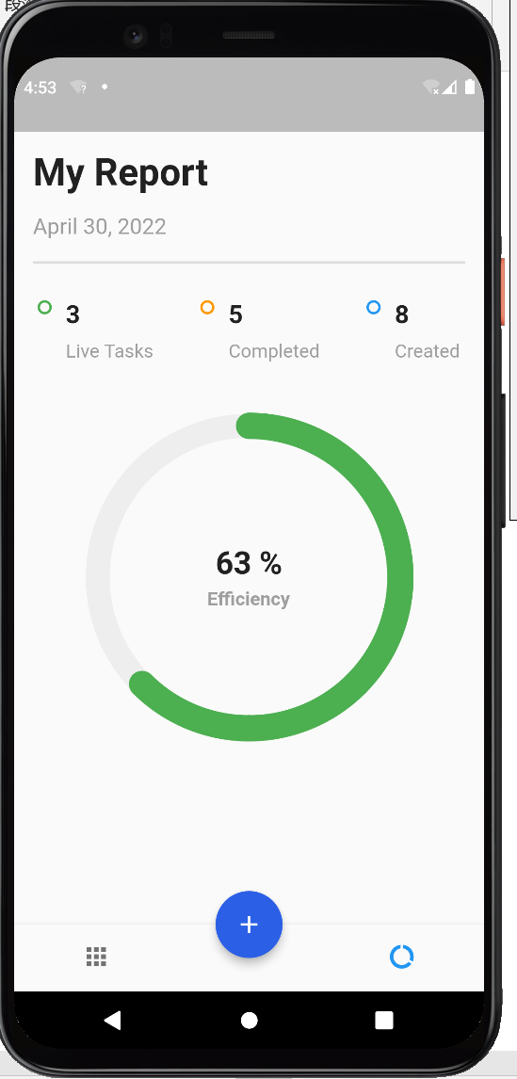

1. Completed progress is displayed above the task card:

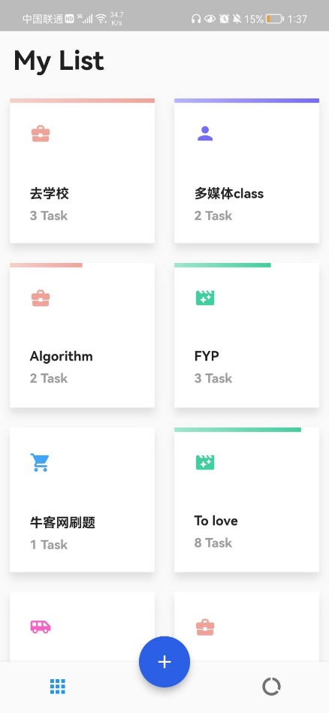

Need to improve:

1. Provide more icons and themes for the task creation.
2. Provide time calendar function similar to Mondays.com app:

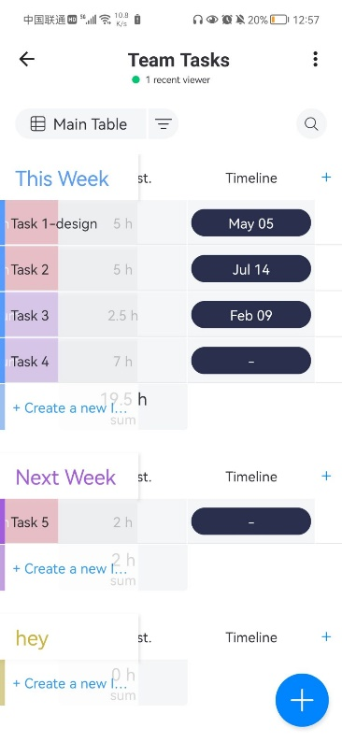

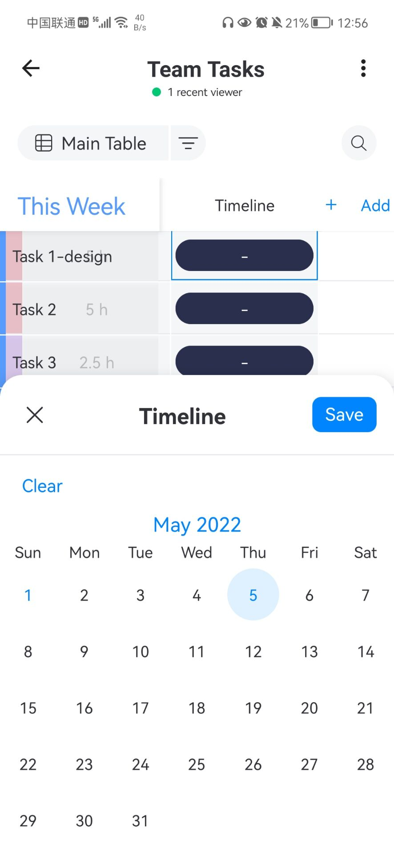

1. Add order task (task cards) function by long entering.

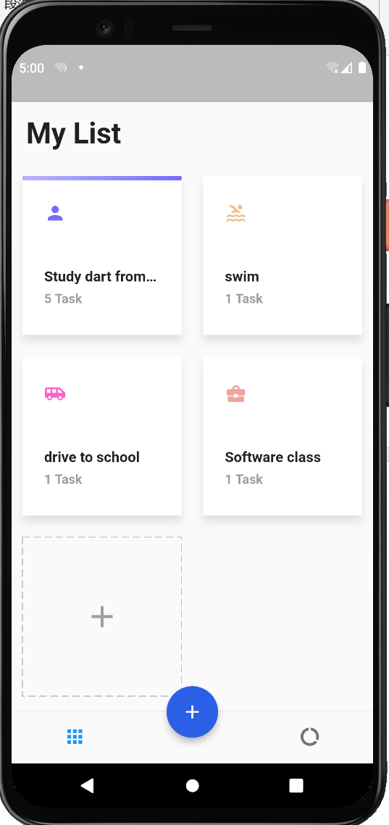

1. Add user navigation button similar to Mondays.com app:

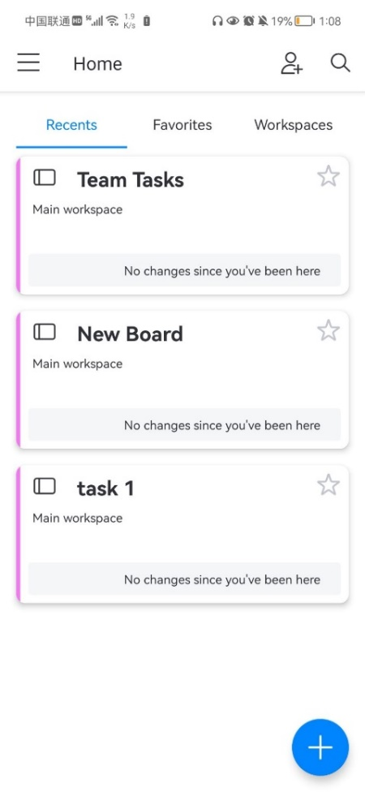

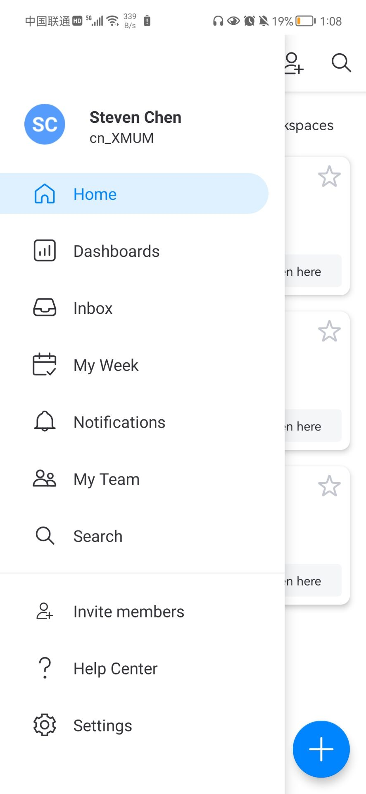

1. Add task name and task contents editing function.
2. Add priority ranking function for task and sub-tasks.
3. Add app theme colors choosing function.
4. Provide alarm function to inform user the deadline time and so on.
5. New button on bottom navigator: team(team member/team communication…)
6. Add whole timeline overviews for all tasks like this:

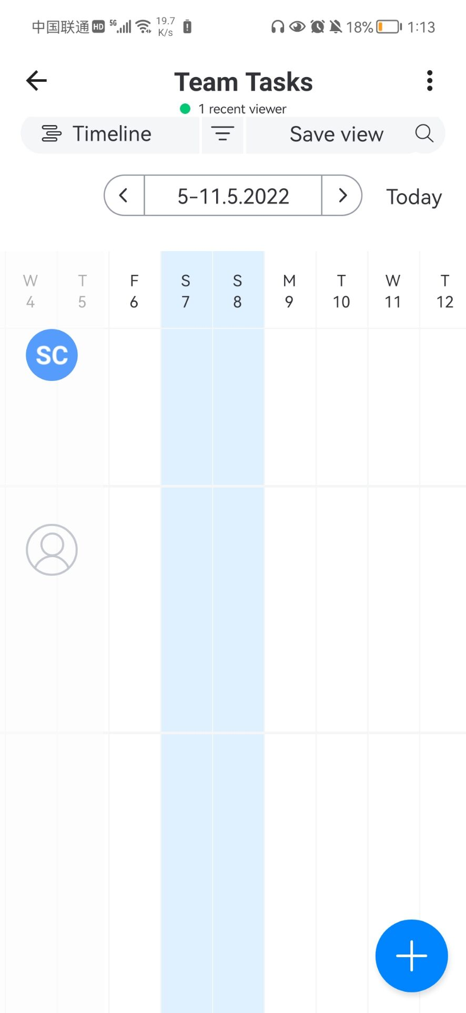

**Appendix:**

1. .apk file download:

<https://xmueducn-my.sharepoint.com/personal/cst1909128_xmu_edu_my/_layouts/15/onedrive.aspx?id=%2Fpersonal%2Fcst1909128%5Fxmu%5Fedu%5Fmy%2FDocuments%2Fapp%2Eapk&parent=%2Fpersonal%2Fcst1909128%5Fxmu%5Fedu%5Fmy%2FDocuments&ga=1>

2. Flutter development screen shot in Android Studio:

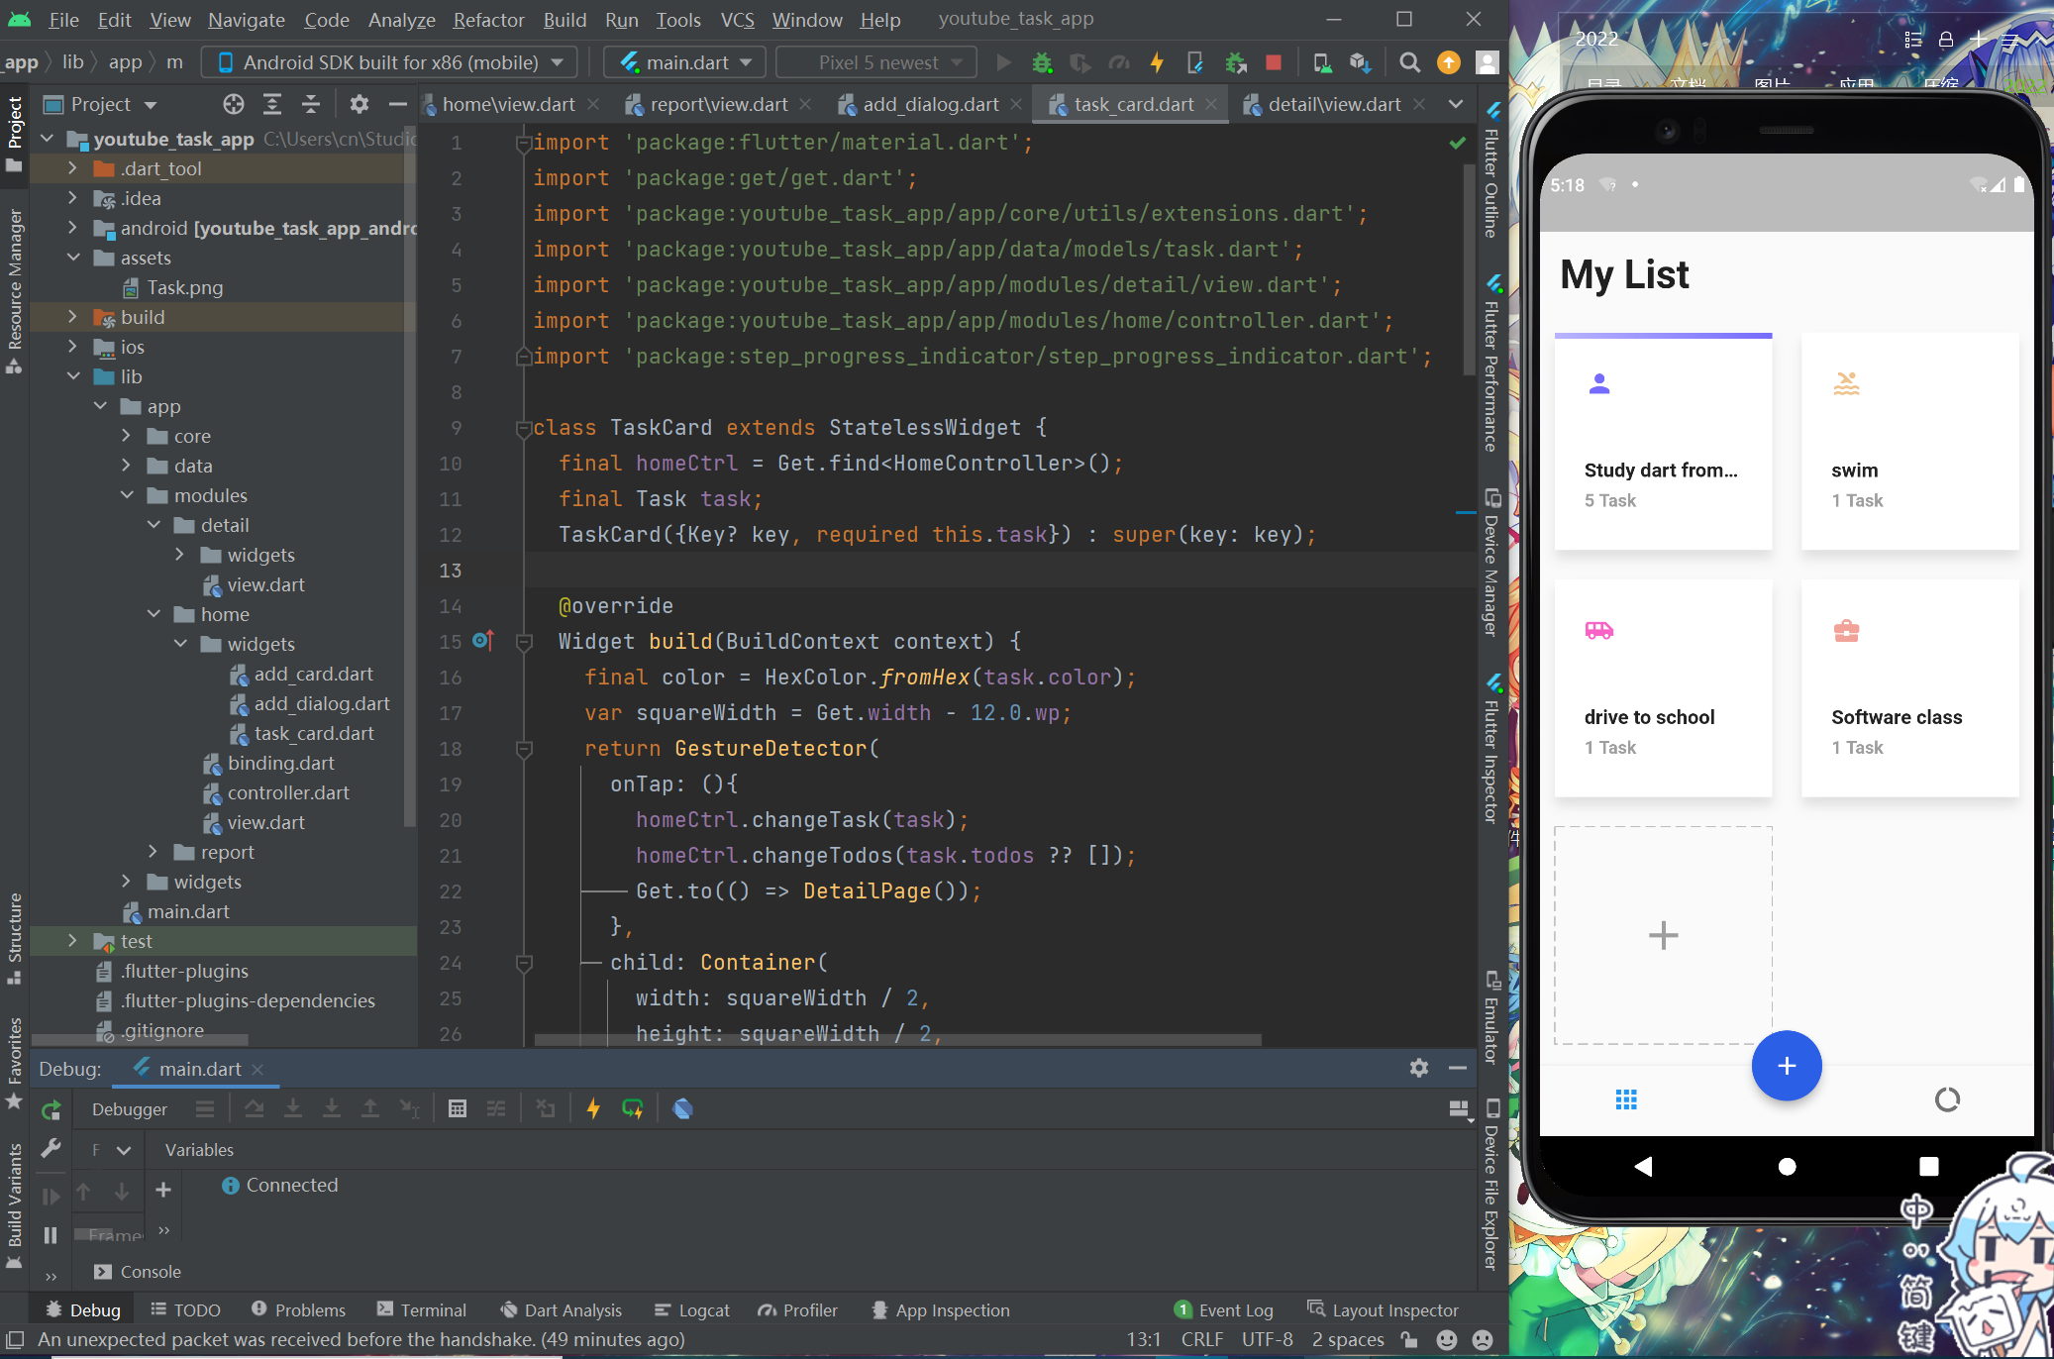

1. 客户端和管理员端
2. 采用多级显示，管理员端可以看见class view, student view(same as student端)
3. 用figma做一个样本
4. 改成topic？project？
5. Link:

<https://xmueducn.sharepoint.com/sites/FYPmeetingforChenNuo/Shared%20Documents/General/Recordings/Meeting%20in%20_General_-20220507_214701-Meeting%20Recording.mp4?web=1>

1. Active, close, completed, tasks.