**FYP Proposal:**

**Task Management App Based on Flutter Development**

**Chen Nuo**

**CST1909128**

**Introduction**

The emergence of software project management can be traced back to the 1970s, at the same time, because of the many difficult problems encountered in the development process, such as the development of the slow progress, the quality is difficult to meet the demand of users exceeds bid or budget problems, finally, after in-depth research, found that these problems are often caused by poor management, So people came up with the concept of software project management. Hope that through software project management to the entire development process of global management, and ultimately under the scheduled time, speed, and cost, efficient development of high-quality products (Sun Z, 2017).

Currently on the market have been a lot of task management, and team cooperation types of APP, such as ProofHub, Monday.com, and GanttPro (Vartika K, 2022), but because too professional, sophisticated, and so on reasons, the team management APP tend to perform better on the web end, and in the mobile terminal, Users often do not get a good user experience. However, with the significant increase of mobile devices worldwide in recent years, mobile applications have become a rapidly developing expanding media (Fulcher A, 2013), which can carry out the lightweight transfer of knowledge and information and is more suitable for the various needs of people's fast-paced life at present.

Because of the time constraints on the project, we had to make sure our software development process was small, low barrier to entry, and was efficient, so we had to find a way to develop it that was easy to use. Finally, we chose to use Figma for prototype design and Flutter architecture for software development. Figma is a popular UI/UX prototype design software in recent years. It is famous for its many beautiful and efficient plug-ins. Most importantly, Figma has a very low threshold for use, as long as people with a little web design experience, it only takes about a week to master all its basic operations. We chose the Flutter architecture because of its ease of operation for software development and adaptability to multiple platforms.

Every developer knows that in the mobile Internet era, to reach as many users as possible, you need to develop your app for Android and iOS simultaneously -- which means maintaining two different code bases at the same time or even requiring two teams to develop them separately, which inevitably slows development down. Flutter, a cross-platform framework, allows developers to run their apps on both Android and iOS platforms using just a single code base, making application maintenance easier and more efficient.

**Aim & Objective / Problem Statement**

Web client applications tend to be more complex than mobile client application functions and strong, but we think that although the mobile application user interface is trapped in a palm-sized screen, we should also weigh some based on considerations of mobile user requirements, the software should have the function of the maximum loading into this small "box", Instead of haphazard stacking of all functions, or haphazard functional castration.

1. **Software convenience and simplicity**

In our app, the using should be simple, which means that users can complete all functions with fewer clicks, easy to understand, and user-friendly operations. For example, teachers can easily and quickly check students' personal information and task completion degrees through some screen sliding lists, rather than a lot of clicking and sliding to achieve.

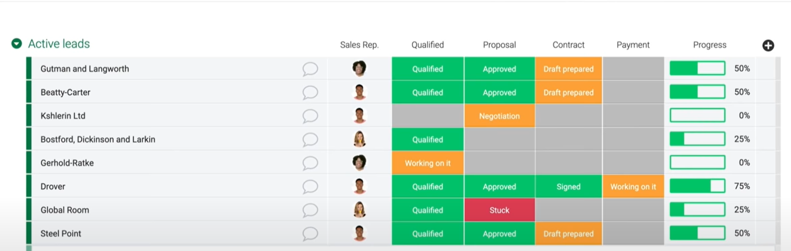

1. **Suitable for small and medium-sized teams**

Based on the previously mentioned software simplification, our APP targets users to choose the small and medium-sized teams, so that we can more efficient to a minimum but the function of quality assurance, to achieve our team management, and not just like some apps on the market, to face to more customers, the function development of very complex and heavy, For small and medium-sized users, this will undoubtedly increase their usage costs significantly.

1. **Easy to communicate**

Nowadays, many people still choose social media such as What's APP, WeChat, or email to communicate with others in the face of teamwork. These methods are convenient and efficient to use in daily work, study and life. However, in the face of team collaboration, the efficiency of these methods is often not obvious and even causes communication barriers. For example, daily information and teamwork information are mixed, which often leads to information asymmetry and lag. So it's important to have an efficient communication channel only between teams, and that's one of the key features we're going to implement in the APP.

**Theoretical Framework**

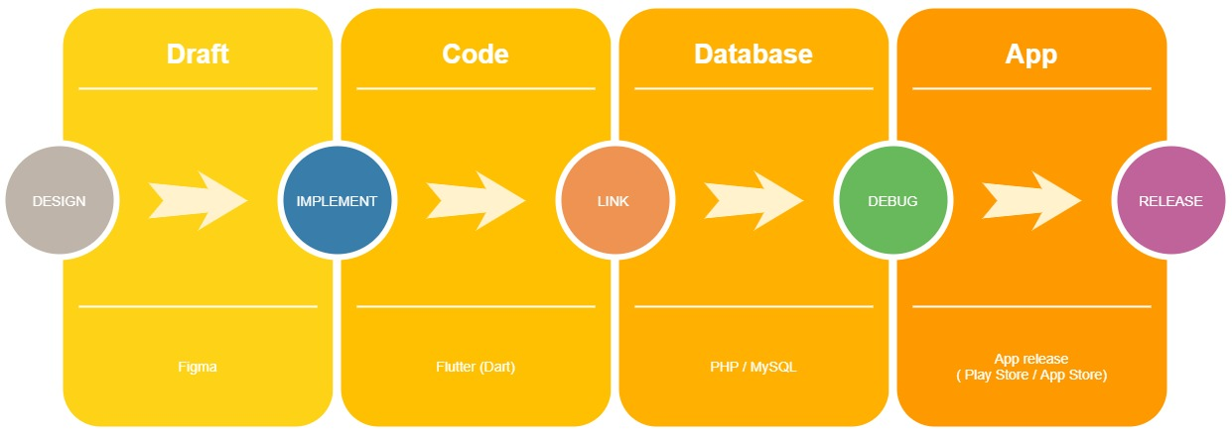

* Research process
* Requirements analysis and prototyping(app design by Figma)
* Theory learning and practice
* APP development in Flutter(dart)
* Debugging
* Link to database
* Final release

**Research Methodology**

**Specific case analysis:** We take teachers and students in universities as a use case analysis.

The APP will be divided into two clients: teacher side and student side.

**Teacher side:** the teacher can view the task completion of the class taught by the teacher. When entering the class, the teacher can view the task completion of all students in the class and so on. After clicking the corresponding student, you can view the completion degree of each task of the student in the task list.

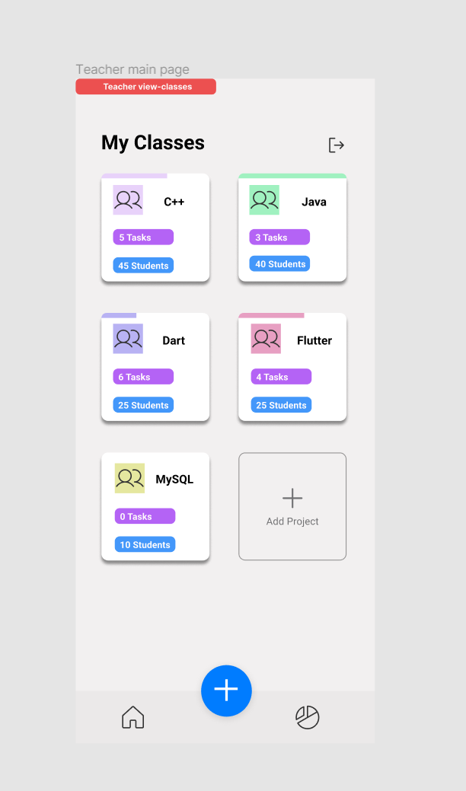

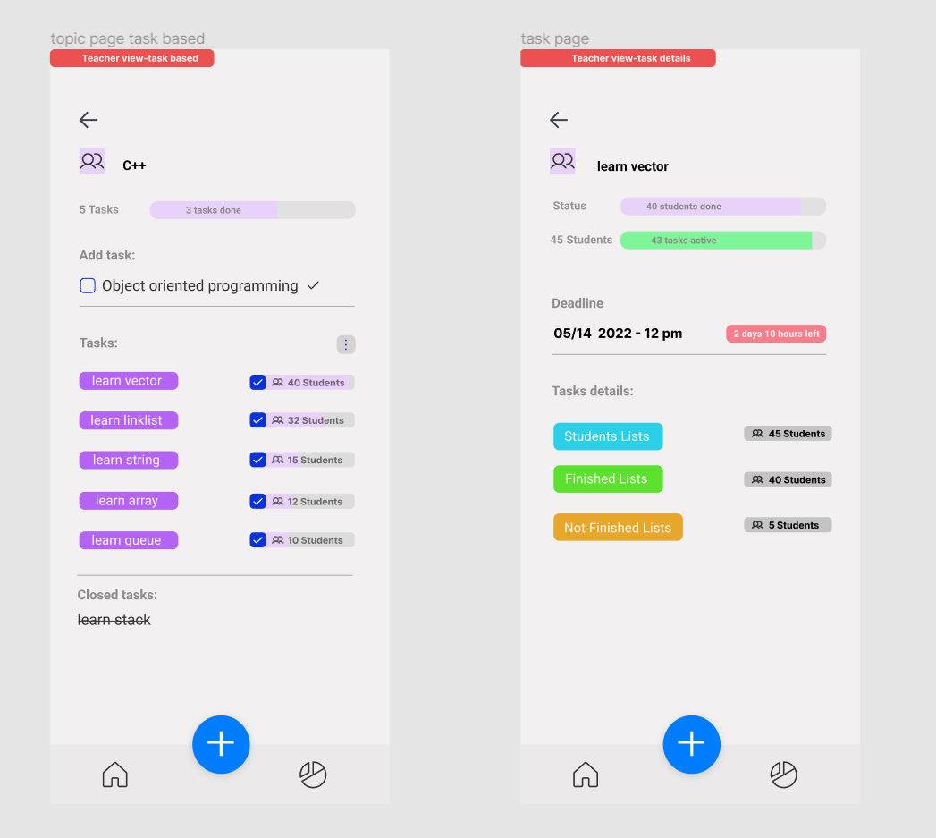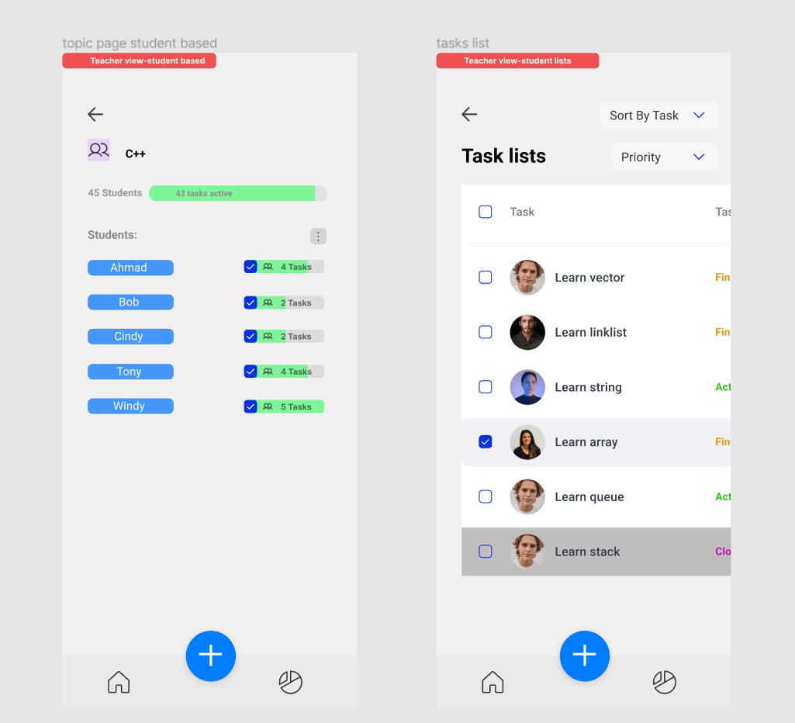

**Student side:** You can view all the current classes and the completion degree of the corresponding tasks. After entering the corresponding class, you can view all the tasks in the current class (**Active/Completed/Close**), the complete degree of the tasks, the task progress statement, etc.

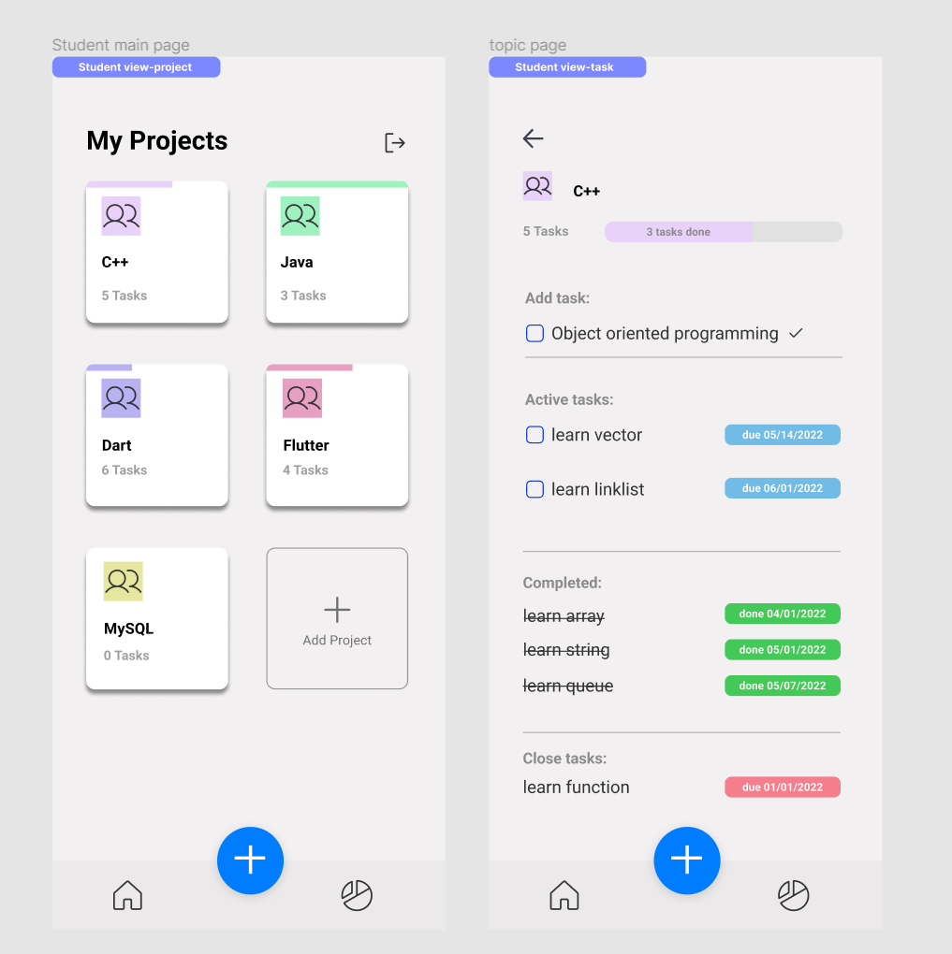

**References**

1. Fulcher, A., Chong, J. (., White, S. A., Neal, J. C., Williams-Woodward, J. L., Adkins, C. R., . . . Windham, A. S. (2013). Developing a mobile application as an extension education tool: A case study using ipmpro. HortTechnology, 23(4), 402-406. doi:10.21273/horttech.23.4.402
2. Sun, Z. (2017). For software design and realization of the project management team collaboration platform (master's degree paper, Harbin industrial university). https://kns.cnki.net/KCMS/detail/detail.aspxdbname=CMFD201801&filena me=1017863211.nh
3. Vartika, K. (2022). 55 Best Project Management Tools & Software for 2022. <https://www.proofhub.com/articles/top-project-management-tools-list>