1. in a CLI/terminal of VS code while cd’ed into the Pharmanet folder run the npm install command (make sure the node version is 16 +).

2. in the CLI/terminal run npx hardhat node

3. in the CLI/ terminal run npx hardhat run scripts/deploy.js –local network.

4. in VS code go to the search icon and place this in the search box: resourceAddress = "0x5FC8d32690cc91D4c39d9d3abcBD16989F875707";

5. Also place the pasted search item in the replace box. But then replace the eth address with the address that prints to the console after running step 3. hit the replace all button.

6. in the CLI/terminal run the npm start command. (this builds the front end version of the application and will display in your default browser:

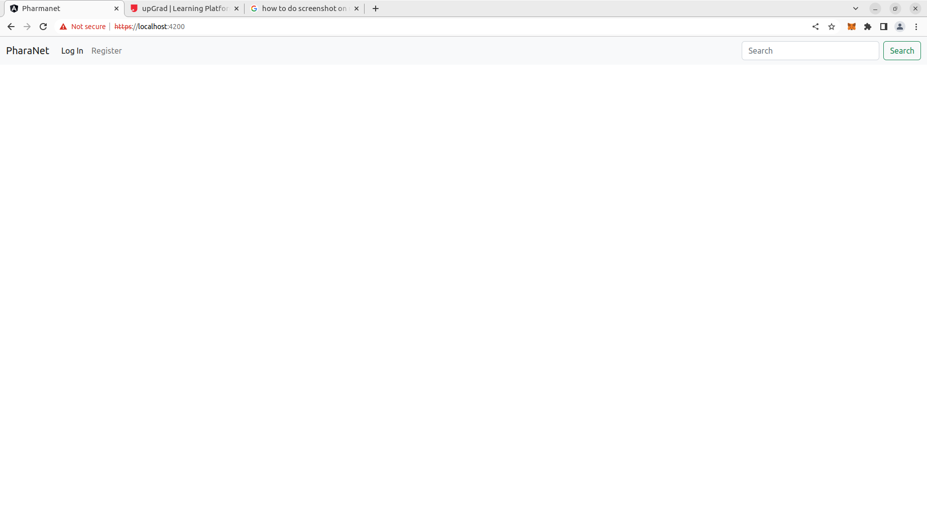
7. go to the register tab:

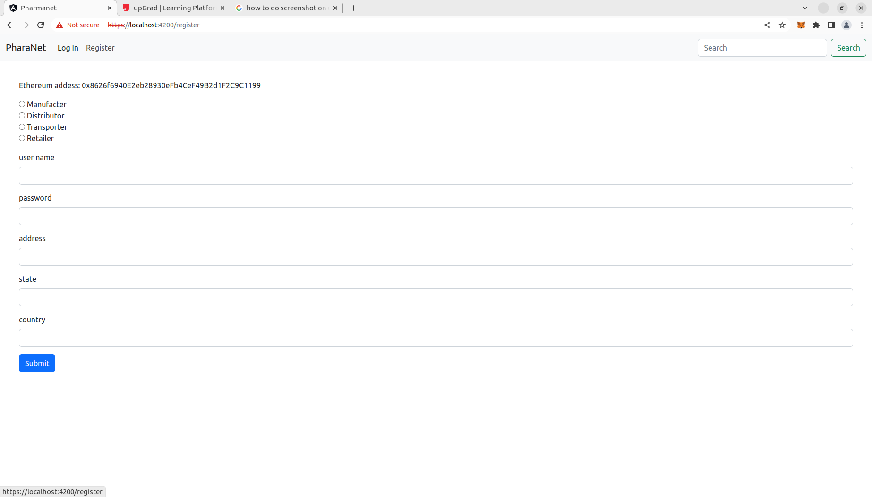
8. fill in new user info for a manufacter:
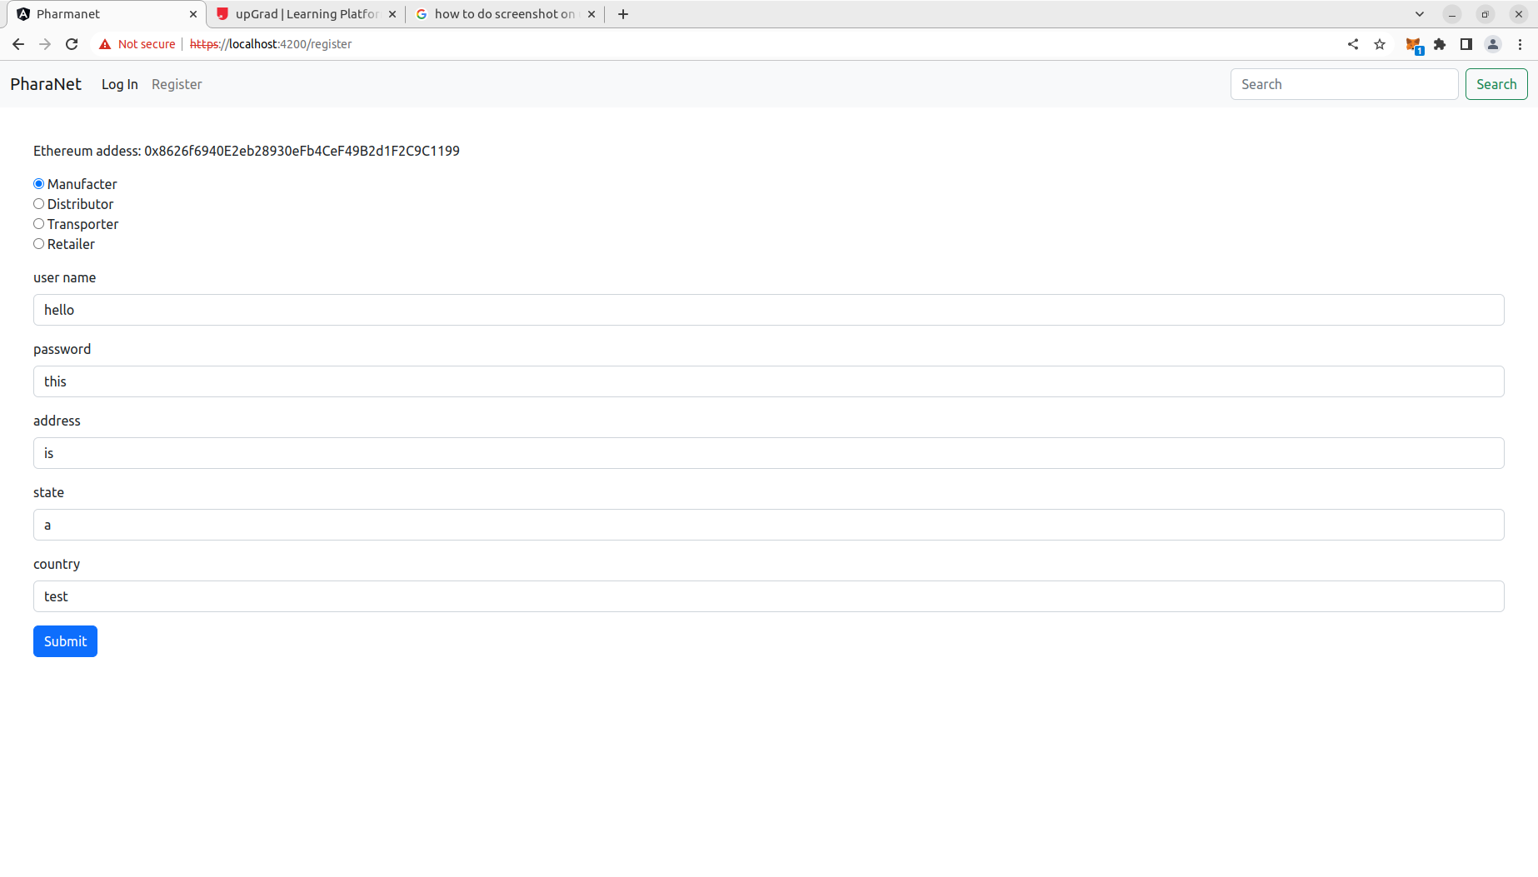
9. hit submit the metamask should pop up to execute the smart contract:

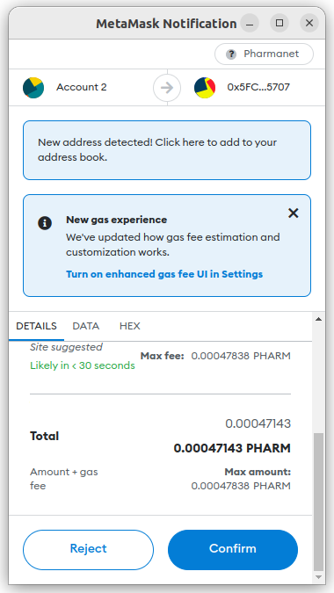
!!br0k !!br0k !!br0k !!br0k !!br0k !!br0k !!br0k 10. go to the log in screen and type in the username and password you used to create the manufacter user:

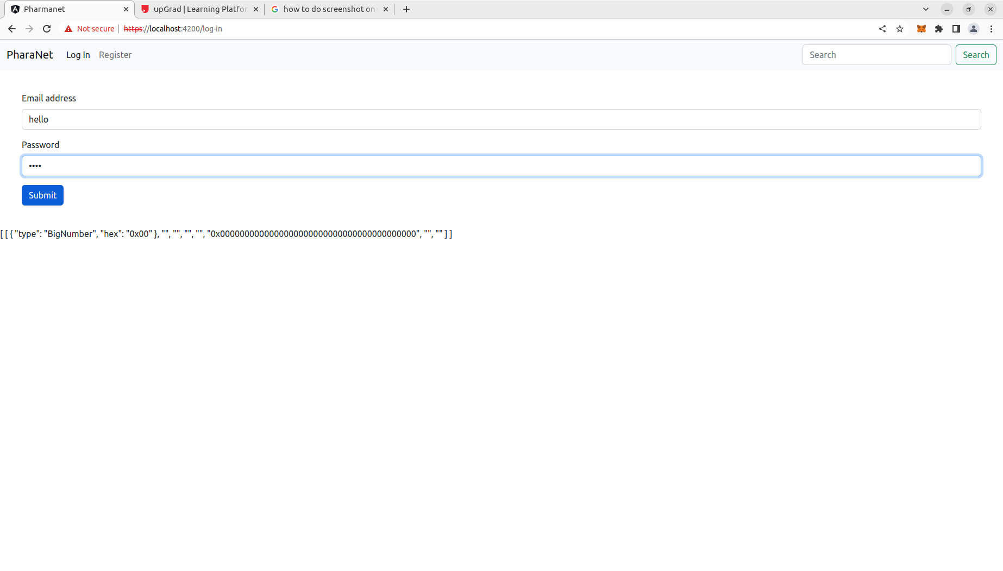
11. once you hit submit the meta mask will pop up hit confirm and you will be redirected to the manufacter page to start creating drugs:

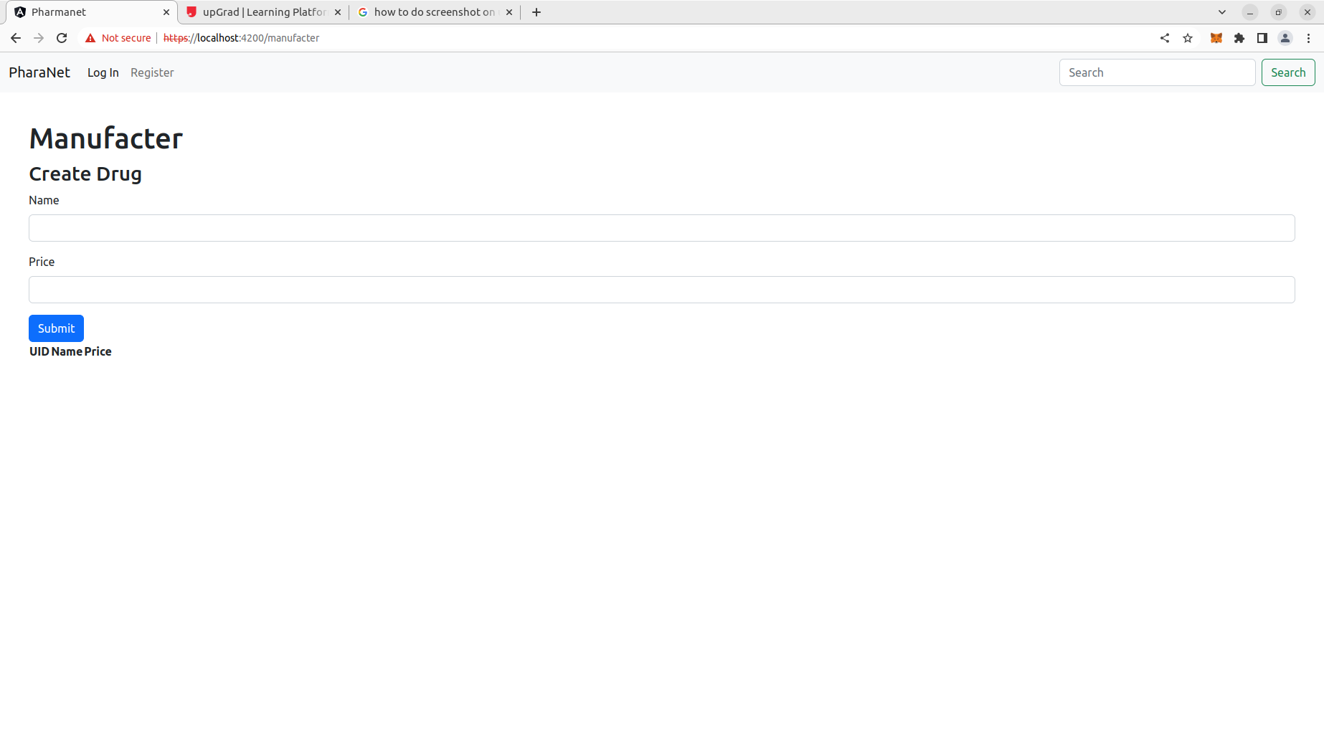
12. start creating drugs one at a time with name and price of drug. (there is a bug that only populates the drugs after two have been added with the output lagging one behind):

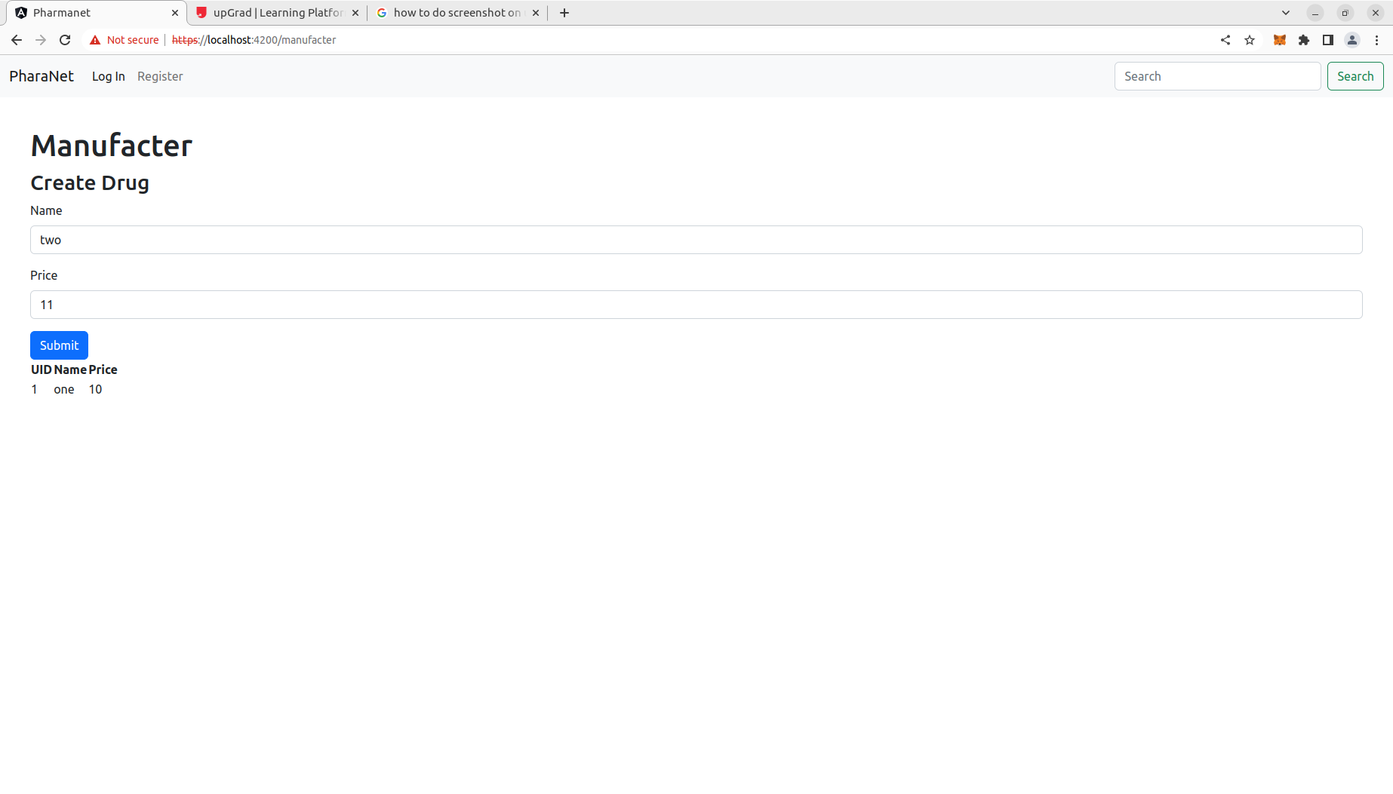
13. create a distributor the same way you created a manufacter except choose distributor as user type and log in with the username and password you choose you will then be redirected to the distributor page:

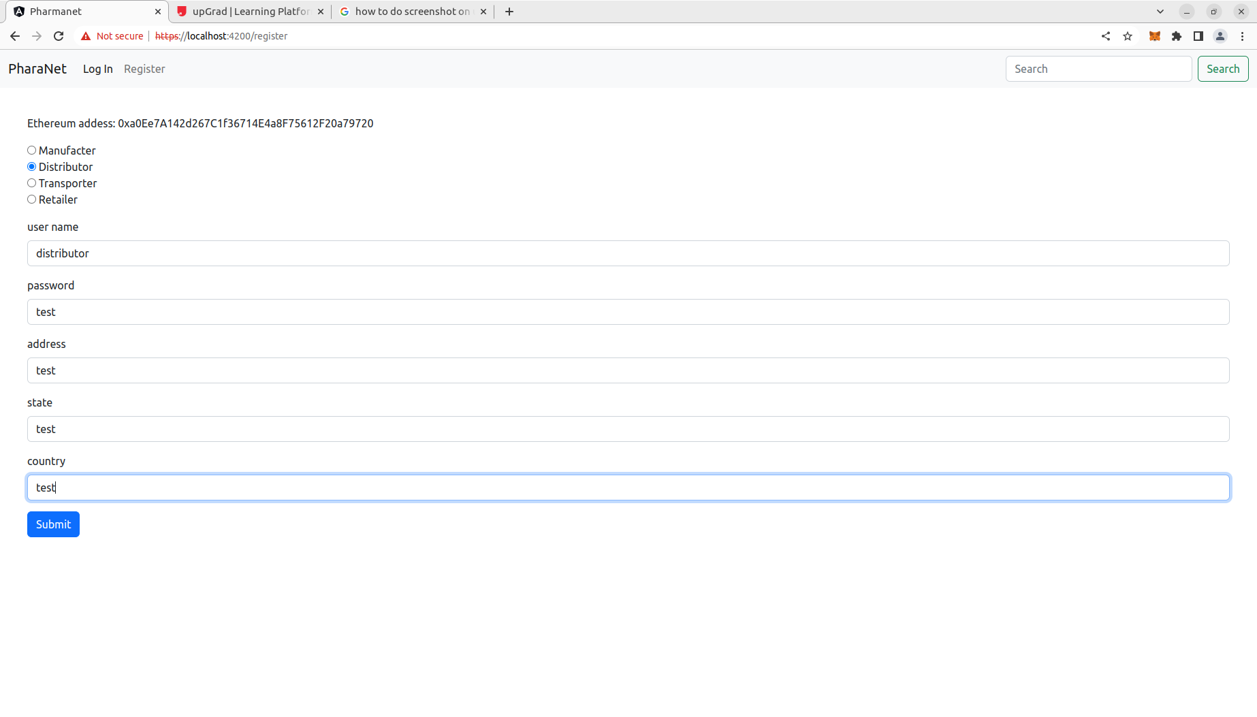
14. log in:
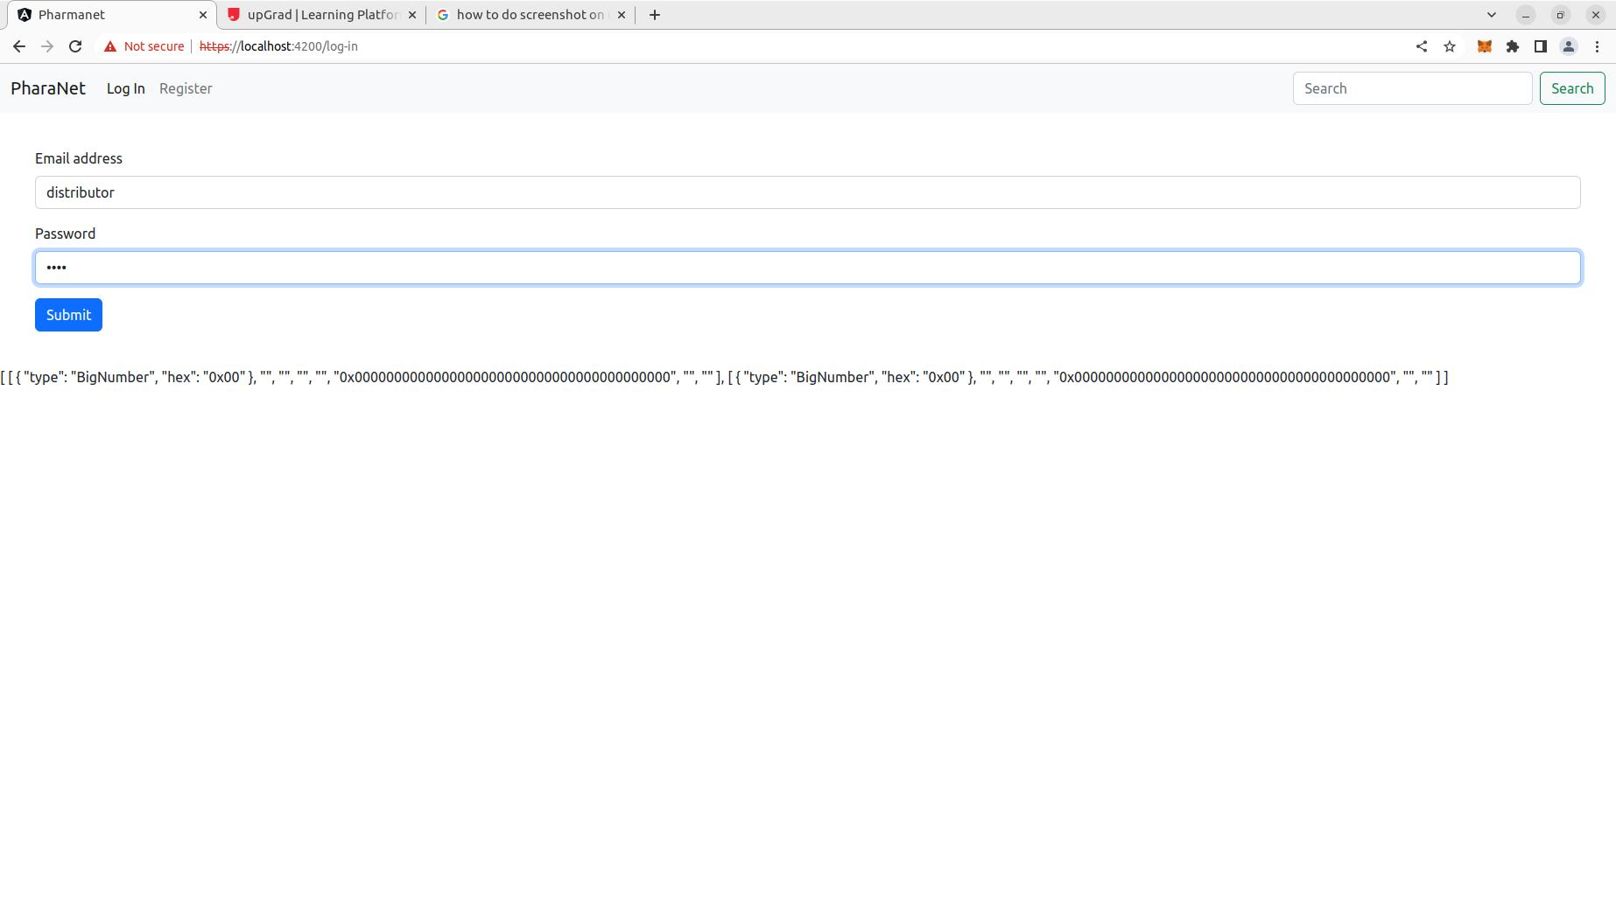
15. now yu are redirected to the distributor page to create purchase orders based on the available drugs from manufacters:

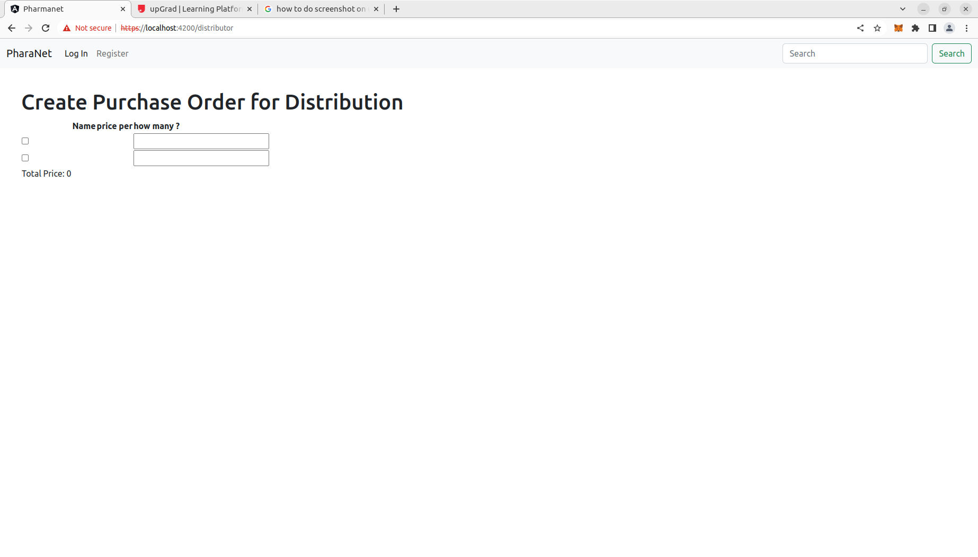

16. NOTE because of the time expiration I was unable to figure out the bugs in the code that prevents a user from selecting the available drugs because they getDrugs method returns empty array objects.

This also effected the rest of the functionality of the application flow you can make a transporter and retailer user which will redirect to those pages but the data needed is not rendering as it should.

Thanks,

Christopher Nabors

