RESEARCH PROPOSAL
Health Systems Research Institute (HSRI) — Fiscal Year 2027

Artificial Intelligence (AI)-Assisted Screening for Acute Febrile Illness
in Remote Areas, Chiang Rai, Northern Thailand

Lead Institution | Mae Fah Luang University (MFU) — School of Applied Digital Technology (ADT)
Partner Institution | Chiang Rai Clinical Research Unit (CCRU) / Mahidol Oxford Tropical Medicine Research Unit (MORU)
Principal Investigator | Assoc. Prof. Dr. Nacha Choldarongkul (Dean, School of ADT)  nacha.cho@mfu.ac.th | 0 5391 6744
Co-Investigators | Asst. Prof. Dr. Phattaramon Wuttipitayamongkol (MFU ADT, Co-PI)  Dr. Carlo Perrone (CCRU / MORU, Chiang Rai)
HSRI Research Framework | 3.1.1 — Improving health service efficiency through medical technology  3.1.2 — Antimicrobial resistance (AMR) management research
Project Duration | 18 months (October 2026 – March 2028) | FY 2027–2028
Requested Budget: 4,967,420 THB (HSRI 5-category structure, FY2570) | 5,005,000 THB (approx.) — incl. 10% institutional overhead and CCRU field support
Study Sites | Chiang Rai: CCRU/MORU + 3–5 partner district hospitals (Phase 2 prospective validation) + MFU; SHPH deployment planned post-validation
Technology Readiness Level | TRL 3 (proof-of-concept) to TRL 6 (validated field prototype)

Section 1: Background and Problem Statement
1.1 Problem Situation
Acute Febrile Illness (AFI) is a leading cause of morbidity and preventable death in rural communities of northern Thailand, particularly among highland ethnic minority populations with limited access to health services. The principal diseases encountered in this area include scrub typhus, dengue haemorrhagic fever, leptospirosis, and bacteraemia/sepsis.
A critical gap at the primary care level is that community health workers (CHW/อสม.) and nurses at Sub-district Health Promotion Hospitals (SHPH/รพ.สต.) lack a practical decision-support tool to determine which febrile patients require urgent referral and which can be safely managed locally. This diagnostic uncertainty also drives inappropriate antibiotic prescribing, contributing to antimicrobial resistance (AMR) patterns documented by CCRU in Chiang Rai province.
1.2 Knowledge and Innovation Gaps
A review of the literature and the Thai health system landscape reveals the following:
- No Thai-language clinical decision support system (CDSS) for AFI currently exists that is designed for resource-limited settings.
- Existing health AI in Thailand focuses predominantly on medical imaging (e.g., Chest 4 All AI) rather than differential diagnosis for infectious diseases.
- CCRU/MORU holds the most comprehensive AFI clinical and AMR dataset in the region — covering more than 2,000 retrospective cases from Chiang Rai province with confirmed diagnoses, laboratory results, epidemiological data, and treatment outcomes — forming an invaluable training dataset and Bayesian Prior source for ML model development.
- Mae Fah Luang University (MFU) has demonstrated expertise in Thai-language AI and NLP.
1.3 Alignment with HSRI Research Framework FY 2027
HSRI Framework | Alignment
3.1.1 — Improve efficiency through medical technology | Develop an AI platform for febrile illness diagnosis and risk prediction; increase access to services in resource-limited settings
3.1.2 — AMR management research | Embedded antibiotic stewardship signal reduces unnecessary antibiotic prescribing in AFI cases; aligned with National AMR Plan 2023–2027
KR1 — Reduce infectious disease burden | AI system reduces late diagnosis of scrub typhus and sepsis
KR2 — Multi-sector collaboration network | 1 network: MFU (university) + CCRU/MORU (international research) + ≥3 SHPHs (service) + Chiang Rai PHO (government)
KR3 / KR5 — Technology deployed; population served | 1 AI AFI screening tool deployed in ≥3 district hospitals (validation); SHPH deployment in Phase 2; ≥150 validated cases; catchment population ≥10,000 reached in scale-up phase

Section 2: Objectives and Targets
2.1 Primary Objective
To develop and evaluate the effectiveness of an AI-powered clinical decision support system (AI-CDSS) for screening patients presenting with acute febrile illness at primary care level in remote areas of Chiang Rai, operable by community health workers in the field.
2.2 Secondary Objectives
- Develop a Thai-language Clinical NLP module to extract symptoms, exposure history, and vital signs from voice recordings or structured text input.
- Design and validate an antibiotic stewardship signal embedded in the system to reduce unnecessary antibiotic prescribing in AFI cases.
- Evaluate the usability and clinical accuracy of the system under real-world conditions at CCRU-network district hospitals (Phase 2 field validation).
- Build the system on an Offline-first architecture using on-device SQLite storage, with automatic FHIR R4 sync to HIS when internet connectivity is available — ensuring full functionality in remote areas without internet, and preparing for integration with the Ministry of Public Health HIS/EMR infrastructure in a subsequent phase.
2.3 Key Performance Indicators (KPIs)
KPI | Target | Measurement Method
Sensitivity (AFI screening) | ≥ 85% | Compared against specialist physician diagnosis
Specificity (avoid over-referral) | ≥ 75% | Compared against specialist physician diagnosis
Antibiotic appropriateness rate | Increase ≥ 15% | Before-vs-after system deployment
Usability score | ≥ 70 / 100 | CHW and nurse questionnaire
Word Error Rate (medical terms) | ≤ 10% | Tested on medical speech test set
Validated patient cases | ≥ 150 cases | From ≥3 district hospital partner sites

Section 3: Conceptual Framework and Research Methodology
3.1 Conceptual Framework
This project applies a Human-centred Design approach with community health workers (CHWs) and nurses at SHPHs as the primary user group. The system functions as a "Structured Checklist with Probabilistic Guidance" — a decision-support tool, not an automated diagnostic system. Clinicians and health personnel retain full responsibility for all final decisions.
Because SHPHs in remote Chiang Rai may lack stable internet connectivity, the system is built on an Offline-first principle: all core functions — voice input, text processing, risk assessment, and result recording — operate fully without any internet connection or HIS access. All data are stored in an on-device SQLite database and automatically synced to the HIS when connectivity is available. Three operating modes are supported: (1) Standalone — no internet; (2) Cached — intermittent connectivity; (3) Connected — live HIS sync.
System Architecture — 5 Processing Layers
Layer 1 — Input capture: The system accepts data from four sources: natural Thai-language speech from the patient or CHW; structured questionnaire responses; manually entered vital signs; and prior medical history retrieved from the HIS when connected, or manually entered in Offline mode. Speech is transcribed by a Whisper model fine-tuned for Thai medical vocabulary, targeting a Word Error Rate (WER) of no more than 10%.
Layer 2 — Structured clinical data extraction: Transcribed text is cleaned and normalised, then a zero-shot Named Entity Recognition (NER) model (GLiNER) extracts clinically relevant entities — including symptoms, exposure history, duration of illness, current medications, blood pressure, body temperature, and SpO2 — and populates them into a predefined AFI Clinical Schema.
Layer 3 — AI risk assessment: The structured clinical data are passed to a risk-scoring model that combines a Bayesian Prior derived from CCRU retrospective data (reflecting local disease prevalence in Chiang Rai) with an LLM reasoning layer for additional clinical inference. Outputs include probability scores for four target diseases — scrub typhus, dengue haemorrhagic fever, leptospirosis, and bacteraemia/sepsis — alongside a triage recommendation and an AMR Stewardship Signal.
Layer 4 — Review, record, and sync: All outputs are presented to a clinician or nurse for review, editing, and explicit approval before any record is saved. Upon approval, data are written to on-device SQLite storage immediately and automatically synced to the HIS via FHIR R4 when internet is available (optional). The system also dispatches automated follow-up alerts to the CHW on Day 3 and Day 7 post-assessment.
Figure 3-1 and Figure 3-2 illustrate the system architecture and patient journey respectively.

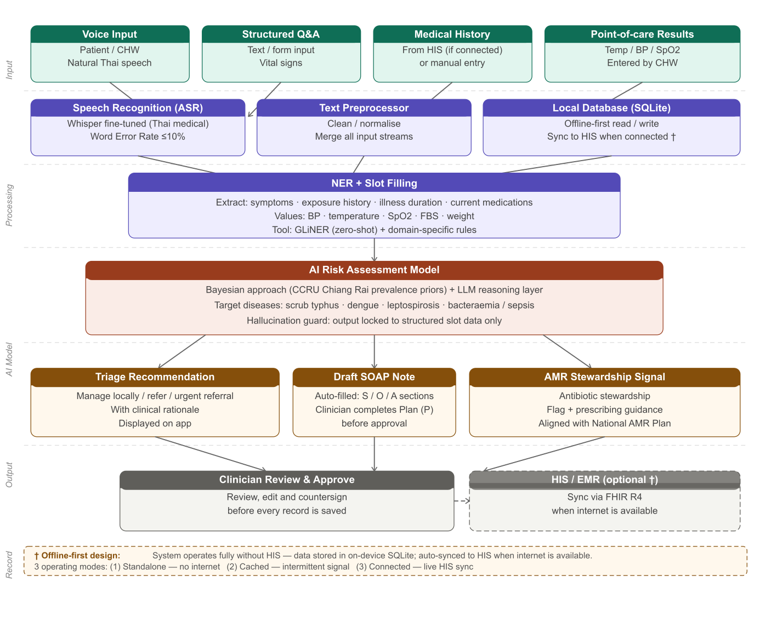
Figure 3-1: System Architecture — Offline-first 5-layer AI AFI Screening pipeline, from data input to local storage and optional HIS sync.

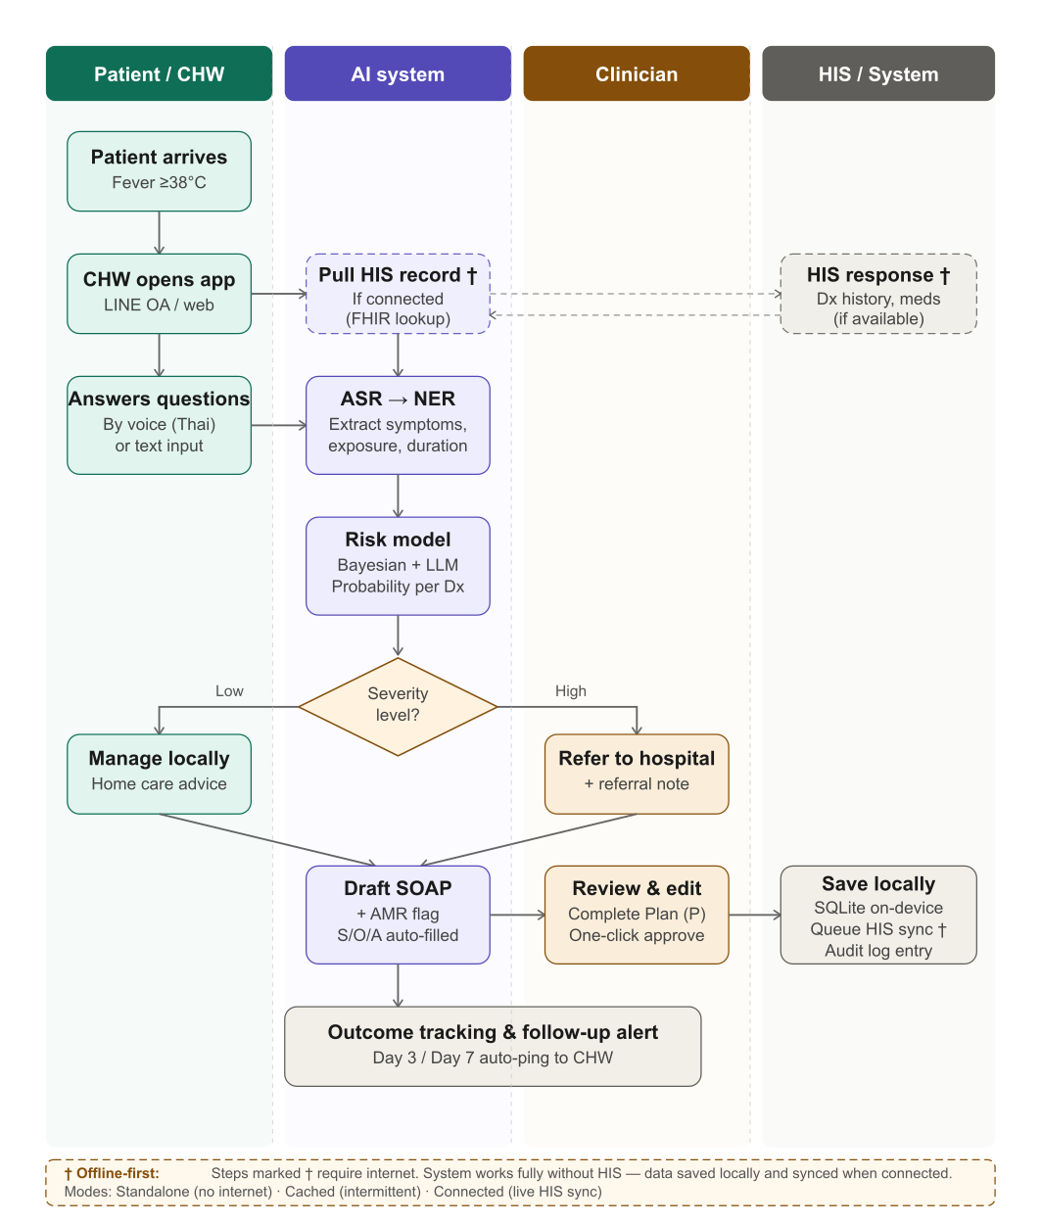
Figure 3-2: Patient Journey — from CHW assessment to record and automated follow-up. Steps marked † require internet connectivity.
3.2 Research Methodology
Phase | Activities | Duration | Deliverables
Phase 0  Data & Infrastructure | Submit IRB (MFU + CCRU/OxTREC) | Analyse CCRU retrospective AFI data (de-identified) | Define disease prevalence baseline | Draft Data Sharing Agreement | Months 1–3 | IRB approval + AFI dataset schema + DSA signed
Phase 1  Model Development | Fine-tune Whisper for Thai medical domain | Build AFI Clinical Schema | Develop risk model on CCRU retrospective data | Prototype mobile UI (LINE OA + web) | Months 4–8 | System prototype v1 | WER ≤10% | Slot-fill accuracy ≥0.85
Phase 2  Field Validation | Deploy at 3–5 CCRU-network district hospitals | Validate on 150+ real AFI cases with blood-confirmed diagnoses (PCR/serology) | Measure sensitivity/specificity and usability | Test offline and connected modes | Iterate model | Months 9–15 | Clinical validation report | All KPIs met
Phase 3  Dissemination | Analyse results | Submit peer-reviewed publication | Produce policy brief for MoPH and HSRI | Release de-identified open dataset | Discuss Phase 2 funding (Wellcome Trust / NRCT) | Months 16–18 | ≥1 publication + policy brief + open dataset

3.2.1 CCRU Dataset for ML Model Development
CCRU/MORU holds a unique data asset that is central to the AI development in this project:
- Retrospective AFI patient records: more than 500 cases from rural and highland communities in Chiang Rai, with confirmed diagnoses (PCR/serology) for scrub typhus, dengue, leptospirosis, and bacteraemia — forming the labelled training and validation dataset.
- Disease prevalence priors: seasonal and geographic distribution data used to calibrate Bayesian Priors in the risk-scoring model to reflect local epidemiological context.
- Clinical features and lab correlates: symptoms, vital signs, basic blood results, and outcomes for feature engineering and training set construction.
- AMR and antibiotic-use patterns: antimicrobial susceptibility testing (AST) results and prescribing patterns for development of the Antibiotic Stewardship Signal.
- Field network: established relationships with district hospital staff and CHWs in the CCRU Chiang Rai network, enabling prospective data collection with confirmatory diagnostics in the field validation phase.
All CCRU data will be de-identified to HIPAA-equivalent standards before transfer to the MFU team, governed by a formal Data Sharing Agreement (DSA) executed in Months 1–2.
3.3 Study Population and Sites
Target population: patients presenting with acute febrile illness (temperature ≥38°C for no more than 2 weeks) at district hospitals within the CCRU Chiang Rai network, Chiang Rai province.
Inclusion criteria: age ≥15 years | presenting with AFI | able to provide informed consent.
Exclusion criteria: patients who have already received antibiotics for ≥48 hours | patients unable to communicate.
Sites: 3–5 district hospitals in the CCRU Chiang Rai network (names to be confirmed in consultation with Dr. Carlo Perrone). District hospitals are selected because staff routinely perform blood draws enabling gold-standard confirmatory diagnosis (PCR/serology/culture), consistent with how the CCRU retrospective dataset was collected. Field validation sites include hospitals both with and without stable internet connectivity, ensuring the offline-first architecture is tested under realistic conditions. Following successful validation, the tool will be adapted and deployed at SHPH level.
Section 4: Collaboration and Roles
Organisation | Primary Role | Contributions
Mae Fah Luang University (MFU) | Lead grant recipient | AI/NLP system development | Thai-language UI design | HIS integration architecture | Grant administration | AI/ML research team | MoU with MoPH | IRB process | Infrastructure
CCRU / MORU, Chiang Rai | [1] ML Training Dataset: deliver de-identified AFI database (>500 cases) with confirmed diagnoses, lab results, and outcomes for training/validation and Bayesian Prior calibration  [2] Clinical Trial Support: prospective data source for Phase 2 field validation at district hospitals (where blood draws enable confirmed diagnosis); clinical expert review of model outputs; coordination of 150+ case collection  [3] AMR and Clinical Expertise: design of antibiotic stewardship signal; field research assistants and travel costs (via MFU–MORU subcontract) | AFI retrospective dataset (>500, labelled) | Disease prevalence priors | AMR/AST data | District hospital field network | Clinical validation site | Expert ground-truth review | Oxford/Wellcome affiliation
Partner District Hospitals (≥3 sites) | Future deployment sites (post-validation) | Real end-users (CHWs/nurses) | Community engagement for scale-up | Real AFI patients | Local context | User feedback
Chiang Rai Provincial Health Office (PHO) | Policy stakeholder | Scale-up pathway | Institutional legitimacy | Policy pathway

Note: All research funding flows through MFU as the lead institution in compliance with HSRI regulations. Budget allocated to CCRU/MORU for field research assistants and travel is administered via a formal subcontract or Research Collaboration Agreement between MFU and MORU.
Section 5: Work Plan and Timeline
Month | Key Activities | Milestone
1–3 | Submit IRB (MFU + CCRU/OxTREC) | Negotiate CCRU Data Sharing Agreement | Analyse retrospective data | Draft AFI Clinical Schema | IRB approved | DSA signed | Schema v1
4–6 | Fine-tune Whisper Thai medical ASR | Develop NER/slot-filler | Build risk model (Bayesian + ML) on retrospective data | WER ≤10% | Slot-fill accuracy ≥0.85
7–8 | Build mobile UI (LINE OA primary + web fallback) | Internal testing | User Acceptance Testing (UAT) with CHWs/nurses | UX refinement | System prototype v1 | Internal usability score ≥65
9–12 | Deploy at 2 district hospitals (soft field trial) | Collect 75 cases with blood-confirmed diagnoses | Measure sensitivity/specificity Round 1 | Go/No-go review | Mid-field-trial report | Model iteration
13–15 | Expand to ≥3 district hospitals | Complete 150+ cases | Measure AMR stewardship outcomes | Final clinical validation | Clinical validation report | All KPIs met
16–18 | Analyse and write up results | Submit peer-reviewed paper | Produce policy brief | Release open dataset | Discuss Phase 2 funding (Wellcome Trust / NRCT) | ≥1 publication | Policy brief | Public dataset

Section 6: Indicative Budget
Budget Category / Line Item | Calculation Basis / Details | Amount (THB)
Category 1 — Personnel Compensation (หมวดค่าตอบแทน)
21.0% of total excl. equipment — compliant with <=30% HSRI cap
Principal Investigator (PhD) | 45,000 THB/mo x 15% FTE x 18 mo | 121,500
Co-Principal Investigator (PhD, Asst. Prof.) | 35,000 THB/mo x 19% FTE x 18 mo | 119,700
AI/ML Developer (Master's degree) | 22,000 THB/mo x 100% FTE x 18 mo | 396,000
Clinical Research Assistant (Bachelor's degree) | 18,000 THB/mo x 100% FTE x 18 mo | 324,000
Subtotal — Category 1 |  | 961,200
Category 2 — Project Management Overhead (หมวดค่าบริหารจัดการ)
9.9% of total excl. equipment — compliant with <=15% HSRI cap
Documentation — inception, interim and final research reports | 3 reports x lump sum | 80,000
Office supplies and stationery | Lump sum over 18 months | 36,000
Telephone and internet — project coordination charges | 2,000 THB/mo x 12 mo | 24,000
Liaison travel — HSRI / MoPH progress review meetings | 4 trips x 15,000 THB (Bangkok) | 60,000
Printing and reproduction — reports, manuals, consent forms | Lump sum | 30,000
Publication fees | 2 peer-reviewed journal articles x 60,000 THB | 120,000
Conference presentations (domestic + regional) | 2 conferences x 50,000 THB | 100,000
Subtotal — Category 2 |  | 450,000
Category 3 — Research Operations (หมวดค่าดำเนินงาน)
Includes MFU-MORU subcontract (HSRI Sec. 3.2.3)
Cloud AI infrastructure — AWS/GCP (compute, LLM API, storage, CI/CD) | ~52,778 THB/mo average × 18 months (consolidated) | 950,000
CCRU/MORU subcontract — Field RA salary [MFU-MORU subcontract agreement] | 25,000 THB/mo x 12 mo | 300,000
CCRU/MORU subcontract — Field travel and site logistics | Lump sum; 5 SHPH sites across Chiang Rai province (incl. CHW field comm.) | 200,000
Field data collection travel — MFU research team | 20 planned field visits × 10,000 THB avg. (travel + accommodation) | 200,000
CHW and nurse training workshops | 5 training sites × 24,000 THB per site (lump sum) | 120,000
Participant engagement and consent process costs | 5 sites × 16,000 THB per site (consent facilitation + participant incentives, lump sum) | 80,000
Data annotation and labeling services | Clinical audio transcription + entity labeling; 2,000 records | 300,000
External statistical analysis consultant | 1 consultant; fixed-fee contract | 65,000
Clinical expert advisory — 3 external reviewers + UAT facilitation | CDSS rule validation, UAT protocol review, 2 rounds clinical feedback | 200,000
Software tool subscriptions (LLM API, annotation platform, NLP tools, CI/CD) | Multiple subscriptions < 20,000 THB/unit; classified as operations per HSRI | 200,000
AI development tool licenses (coding assistant, IDE plugins) | 3,500 THB/developer/mo × 2 developers × 18 mo | 126,000
Subtotal — Category 3 |  | 2,741,000
Category 4 — Equipment (หมวดค่าครุภัณฑ์)
All items >= 20,000 THB/unit; excluded from Cat 1 percentage denominator
GPU development workstation — on-site model training and inference | 1 unit x 200,000 THB | 200,000
High-performance research laptops | 3 units x 40,000 THB | 120,000
Digital vital-signs monitors (SpO2, BP, temperature) — field validation | 4 sets x 20,000 THB | 80,000
Subtotal — Category 4 |  | 400,000
Category 5 — Institutional Overhead Fee (หมวดค่าธรรมเนียมหน่วยงานผู้รับทุน)
10% of (Cat 1+2+3) = 4,152,200 THB — compliant with <=10% HSRI cap
MFU institutional overhead — utilities, workspace, admin, shared IT infrastructure | 10% x (Category 1 + 2 + 3) = 10% x 4,152,200 THB | 415,220
Subtotal — Category 5 |  | 415,220
HSRI compliance | Personnel (Cat 1): 961,200 / 4,567,420 = 21.0% <= 30% Overhead (Cat 2): 9.9% <= 15% Fee (Cat 5): 10.0% <= 10%
GRAND TOTAL (HSRI FY2570 — Research Framework 3.1.1 + 3.1.2) |  | 4,967,420 THB

Note: The above figures are indicative estimates. Final amounts will be aligned with the official HSRI budget template upon submission.
Section 7: Expected Outputs, Outcomes, and Impact
7.1 Outputs
- Open-source Thai-language AI AFI screening tool (mobile app: LINE OA + web)
- Fine-tuned Thai medical speech recognition model (publicly released)
- De-identified AFI patient dataset from Chiang Rai (open data release)
- At least one peer-reviewed journal article
- Policy brief for the Ministry of Public Health and HSRI
7.2 Outcomes
- CHWs and SHPH nurses equipped with a practical, field-ready decision-support tool that works without internet access
- Reduced late diagnosis of scrub typhus and sepsis at pilot sites
- Reduced inappropriate antibiotic prescribing in AFI cases by at least 15%
- Foundation established for scale-up through the MoPH Digital Health network in a subsequent phase
7.3 Long-term Impact
- Reduced health inequity for vulnerable populations in remote northern Thailand
- Support for the National AMR Strategic Plan 2023–2027
- Replicable model for Thai-language AI health tools for infectious diseases, scalable to the GMS/ASEAN region
- Pathway to further funding: Wellcome Trust, NRCT (บพข.), or Gates Foundation
- Regulatory pathway: Phase 2 will pursue FDA (Thailand) registration as a Software as a Medical Device (SaMD) to enable formal adoption in the public health system
- NHSO (สปสช.) benefit package pathway: following clinical validation and SaMD registration, the system will be proposed for inclusion in the NHSO benefit package as a primary-level digital health service, securing long-term financial sustainability
7.4 Communication and Utilisation Plan
Audience 1 — Policy makers (MoPH, HSRI, Chiang Rai PHO): two policy briefs (Months 12 and 18); presentation to the Chiang Rai PHO and MoPH Bureau of Policy and Strategy for consideration of provincial and national scale-up.
Audience 2 — Health professionals and researchers: at least one peer-reviewed publication (Months 16–18); presentation at a national or international academic conference; open dataset release for the research community.
Audience 3 — Communities and CHWs: Training of Trainers (ToT) workshop for CHWs and SHPH nurses at field sites, enabling independent system operation after project completion.
Section 8: Research Ethics
This project involves human subjects research and will be conducted under full ethical oversight as follows:
- Ethics approval from the MFU Human Research Ethics Committee will be obtained before any data collection commences.
- Ethics review from the CCRU/MORU Ethics Committee (Oxford Tropical Research Ethics Committee: OxTREC, or equivalent) will be sought in parallel.
- All research participants will provide written informed consent prior to enrolment.
- All patient data will be de-identified before entering any AI processing pipeline; no personally identifiable information will be used.
- A formal Data Sharing Agreement (DSA) between MFU and CCRU/MORU will be executed before the project commences.
- The AI system is a decision-support tool, not an autonomous diagnostic system, which mitigates patient safety risk.
Section 9: Research Team
Name | Affiliation | Role | Expertise
Assoc. Prof. Dr. Nacha Choldarongkul | MFU, School of ADT | Principal Investigator | AI/ML, Health Informatics, NLP, Software Engineering
Asst. Prof. Dr. Phattaramon Wuttipitayamongkol | MFU, School of ADT | Co-Investigator (Co-PI) | AI/ML, Digital Health, Health Informatics
Dr. Carlo Perrone | CCRU / MORU, Chiang Rai | Co-Investigator | Acute Febrile Illness, AMR, Scrub Typhus, Tropical Medicine
[Clinical Collaborator TBC] | Chiang Rai PHO / Chiang Rai Hospital | Clinical Advisor | Infectious Disease, Primary Care

Submit via NRIIS: www.nriis.go.th | Deadline: 30 April 2026
HSRI enquiries: 02 027 9701 ext. 9056 (Ms. Piyachat Somthong)

