

HL7 Virtual Medical Record for Clinical Decision Support (vMR-CDS) XML Implementation Guide, Release 2

Project Coordinator and Document Editor

Kensaku Kawamoto, MD, PhD, University of Utah

Claude Nanjo, MPH, MAAS, Zynx Health Incorporated

Collaborators

David Shields, University of Utah

Victor Lee, MD, Zynx Health Incorporated

Aziz Boxwala, MD, PhD, FACMI, Meliorix Inc

Mark Roche, MD, MSMI, Roche Consulting

Bryn Rhodes, Veracity Solutions

Davide Sottara, PhD, Arizona State University

Andrew K. McIntyre, FRACP, MBBS, Medical-Objects

Yongjian Bao, PhD, GE Healthcare

Howard R. Strasberg, MD, MS, Wolters Kluwer Health

Peter R. Tattam, Tattam Software Enterprises Pty Ltd

Scott Bolte, MS, GE Healthcare

Peter Scott, MBBS, Medical-Objects

Keith Boone, GE Healthcare

Zhijing Liu, PhD, Siemens Healthcare

Chris Melo, Philips Healthcare

Nathan Hulse, PhD, Intermountain Healthcare

Jim Basilakis, MBBS, MS, University of Western Sydney

Robert Worden, Open Mapping Software, Limited

Daryl Chertcoff, HLN Consulting

Clayton Curtis, MD, PhD, U.S. Veterans Health Administration

Guilherme Del Fiol, MD, PhD, University of Utah

Emory Fry, MD, Uniformed Service University Health Sciences

Jean-Charles Dufour, MD, PhD, Université Aix-Marseille

Laurent CHARLOIS, Université de la Méditerranée

Project Sponsor

HL7 Clinical Decision Support

HL7 Project #1016

U.S. Realm Informative Specification

Identifying Information for Specification:

Specification Name and Release Number: HL7 Virtual Medical Record for Clinical Decision Support (vMR-CDS) XML Implementation Guide, Release 2

Realm: U.S.

Ballot Level: Informative

Ballot Cycle: September 2013

Specification Date: September 2013

Version Number within Release 2: 1.0

Note Regarding Realm and Ballot Level:

Per guidance from the HL7 Technical Steering Committee, this release of the specification is balloted as an informative U.S. Realm specification. It is anticipated that future releases of the specification may be balloted in the normative track and/or in the Universal Realm.

Table of Contents

Table of Contents 3

1 Executive Summary 4

2 XML implementation Guide for VMR 5

2.1 Overview 5

2.2 datatypes.xsd 5

2.3 vmr.xsd 6

2.4 cdsInput.xsd 10

2.5 cdsInputSpecification.xsd 11

2.6 cdsOutput.xsd 12

2.1 cdsOutputSpecification.xsd 14

2.2 Examples 15

# Executive Summary

A Virtual Medical Record (vMR) for Clinical Decision Support (CDS) is a data model for representing the data that are analyzed and/or produced by CDS engines. The purpose of the vMR effort is to define a standard vMR that (i) can be used across CDS implementations and (ii) is simple and intuitive for a typical CDS knowledge engineer to understand, use, and implement.

The vMR XML Implementation Guide provides guidance on how to implement the semantics of the vMR Logical Model in an XML format. Release 1 of the specification was successfully balloted as a DSTU in May 2013. Release 2 of the specification is informed by the requirements and pilot activities of the Standards and Interoperability Framework’s Health eDecisions initiative, which is using the vMR as a core underlying information model.

Conformant XML instances must validate against the accompanying XML schemas. Validation against the XML schemas is a necessary but not sufficient condition for a vMR represented in this XML format to be considered valid, as additional requirements may be specified in the text of the vMR Logical Model.

All accompanying examples and diagrams shall be considered supplemental in nature. The XML schemas are based on the vMR Logical Model Release 3.

# XML Implementation Guide for VMR

## Overview

The vMR XML specification consists of 6 XSD schema files which follow a similar conceptual categorization compared to the categorization defined in the vMR Logical Model, Release 3:

1. datatypes.xsd
2. vmr.xsd
3. cdsInput.xsd
4. cdsInputSpecification.xsd
5. cdsOutput.xsd
6. cdsOutputspecification.xsd

These schemas were auto-generated from the vMR Logical Model using the Enterprise Architect tool, with minimal post-processing as noted in the README accompanying the schemas.

Diagrams have been added for illustrative purposes only.

The following table lists the schema namespaces.

|  |  |
| --- | --- |
| Schema | Namespace |
| datatypes.xsd | urn:hl7-org:cdsdt:r3 |
| vmr.xsd | urn:hl7-org:vmr:r3 |
| cdsInput.xsd | urn:hl7-org:cdsinput:r3 |
| cdsOutput.xsd | urn:hl7-org:cdsoutput:r3 |
| cdsInputSpecification.xsd | urn:hl7-org:cdsinputspecification:r3 |
| cdsOutputSpecification.xsd | urn:hl7-org:cdsoutputspecification:r3 |

Figure 1 - Schema Namespaces

## datatypes.xsd

This schema defines the base vMR data types which consist of a constrained subset of ISO 21090 data types. Please see the vMR Logical Model for further details.

This schema is imported by all other schemas.

## vmr.xsd

This schema specifies information about a patient relevant for CDS. Note that, associated with each evaluated person, such as a patient, is a set of clinical statements and demographic information about this person. An evaluated person may be associated with other entities such as people or facilities. Also note that clinical statements may be related to other clinical statements. The vMR schema also allows for the addition of new attributes to clinical statements and entities using a coded name-value pair extension mechanism.

This schema is imported by both the cdsInput.xsd and cdsOutput.xsd schemas. The main components of the vmr.xsd schema are shown below. Please refer to the schema for the actual specification.

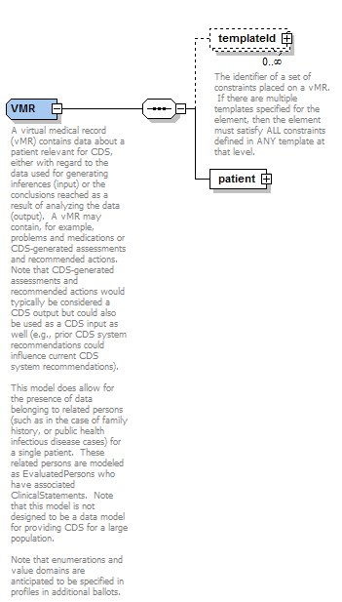

Figure 2 - The VMR complex type

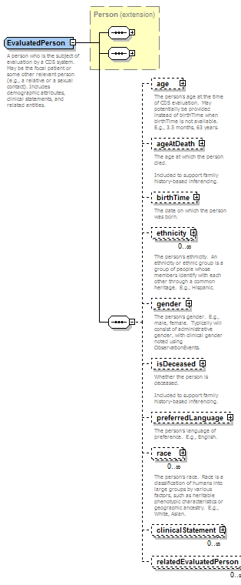

Figure 3 - EvaluatedPerson

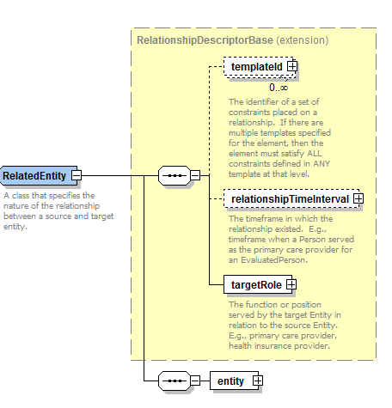

Figure 4 - RelatedEntity relates a target entity to a source entity or clinical statement

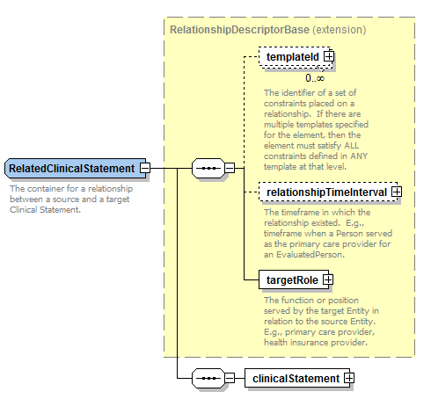

Figure 5 - RelatedClinicalStatement relates a target clinical statement to a source clinical statement

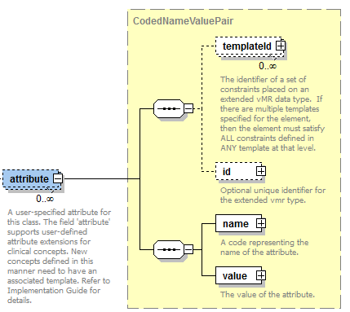

Figure 6 - Name-Value-Pair extension mechanism for clinical statement subclasses and entities

## cdsInput.xsd

The cdsInput.xsd schema represents input data used by a CDS system. The main components of the cdsInput.xsd schema are shown below. Please refer to the schema for the actual specification.

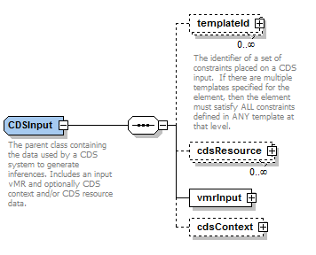

Figure 7 – CDSInput complex type

## cdsInputSpecification.xsd

This schema specifies the specific CDS input data required for a specific CDS use case. The main components of the cdsInputSpecification.xsd schema are shown below. Please refer to the schema for the actual specification.

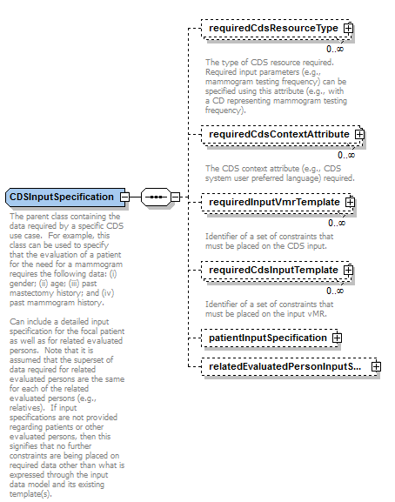

Figure 8 – CDSInputSpecification complex type

## cdsOutput.xsd

This schema specifies output data generated by CDS systems. The base CDSOutput is an abstract element that is instantiated as a concrete extension. Extensions defined within this specification include a CDSOutputAsVMR element that contains a vMR output, a CDSOutputAsDataType element that contains a data type value, and a CDSOutputAsStringNameValuePair element that contains string name-value pairs. Please refer to the schema for the actual specification.

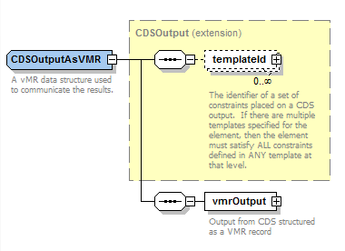

Figure 9 – CDSOutputAsVMR complex type

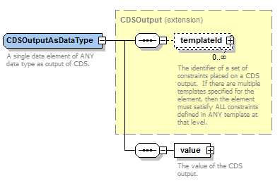

Figure 10 – CDSOutputAsDataType complex type

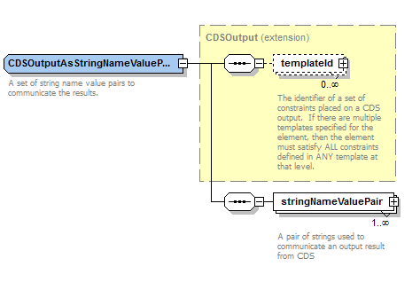

Figure 11 – CDSOutputAsStringNameValuePair complex type

## cdsOutputSpecification.xsd

This schema specifies the specific CDS output data to be provided by a specific CDS use case. There is a separate CDS output specification for each type of CDS output as specified above. The main components of these CDS output specifications are shown below. Please refer to the schema for the actual specification.

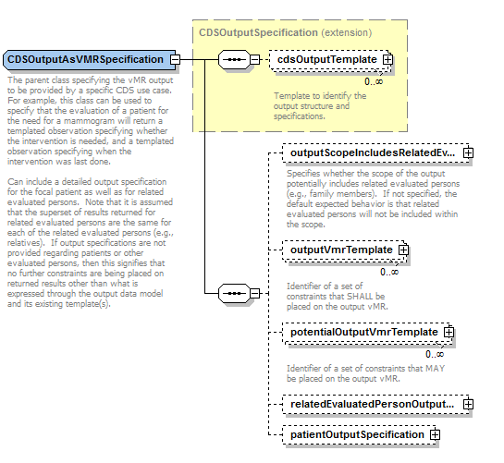

Figure 12 – CDSOutputAsVMRSpecification complex type

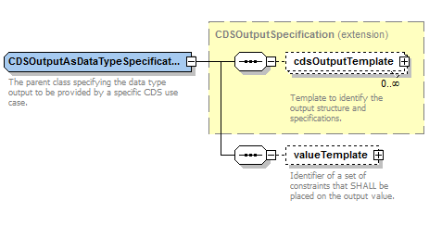

Figure 13 – CDSOutputAsDataTypeSpecification complex type

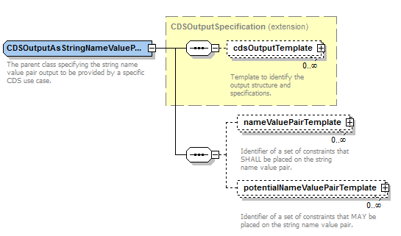

Figure 14 – CDSOutputAsStringNameValuePairSpecification complex type

## Examples

An informative vMR is provided in the supplemental files.

## 