|  |  |
| --- | --- |
|  | **2013** |
|  | HL7 vMR  Prepared by: Claude Nanjo |

|  |
| --- |
| **[Modeling Allergies]** |
| Modeling Allergies and Intolerances in the vMR. Harmonization with the Patient Care Allergy model. |

# Purpose

This document proposes an approach to model allergies and intolerances based on current vMR structure and principles.

# Design Considerations

During the September 2013 Working Group a number of comments have been received indicating the need for a concrete allergy & intolerance class separate from the current Problem class. Given the similarity between problems and allergies/intolerances in terms of attribute content, we have decided to model this concept within the Problem inheritance hierarchy rather than as a wholly separate Clinical Statement hierarchy. This allows for better inferencing given that both concepts are related. One camp considers AllergyOrIntolerance as a *subset* of Problem. In this case, AllergyOrIntolerance could be modeled as a specialization of the Problem class. *However*, another camp preferred to view Problem and AllergyOrIntolerance as a partition of the set of possible patient conditions. The latter viewpoint was adopted and thus Problem and AllergyOrIntolerance are siblings rather than AllergyOrIntolerance being a subclass of Problem. The chosen structure was chosen primarily for inferencing concerns and a new layer of AbstractCondition/DeniedAbstractCondition has been introduced as a result.

Note that the vMR uses concrete DeniedXYZ classes for a number of reasons which include:

1. Providing clearer semantics than the negative indicator. One problem with the negative indicator is that it can toggle a class’ semantics purely on its value.
2. Reducing the likelihood of human error. Forgetting to set the negative indicator flag could lead to adverse consequences at the point of care.
3. Potentially more easily processed by rules engines.

**A Note about Terminology**

When coding allergies or intolerances, a post-coordinated approach is favored. For instance, if one wishes to model an allergy to peanuts, one would choose the following approach:

conditionCode = ‘Allergy’

agent = ‘Peanuts’

Rather than the following approach:

conditionCode = ‘Allergy to peanuts’

agent = NULL or ‘Peanuts’ (or erroneously ‘Walnuts’)

A challenge does arise when coding statements such as ‘*No known allergies’*, ‘*No known drug allergies’*, or ‘*No allergy to peanuts’*.

‘*No allergy to peanuts’* is modeled as follows:

Class: DeniedAllergyOrIntolerance

conditionCode: ‘Allergy’

agent: ‘Peanuts’

It should *not* be modeled as a problem as illustrated below:

Class: Problem

conditionCode: ‘Allergy to peanuts’

agent: NULL or ‘Peanuts’

# Allergy Model from Patient Care

The vMR has been updated to better harmonize with the Patient Care Allergy Model below:

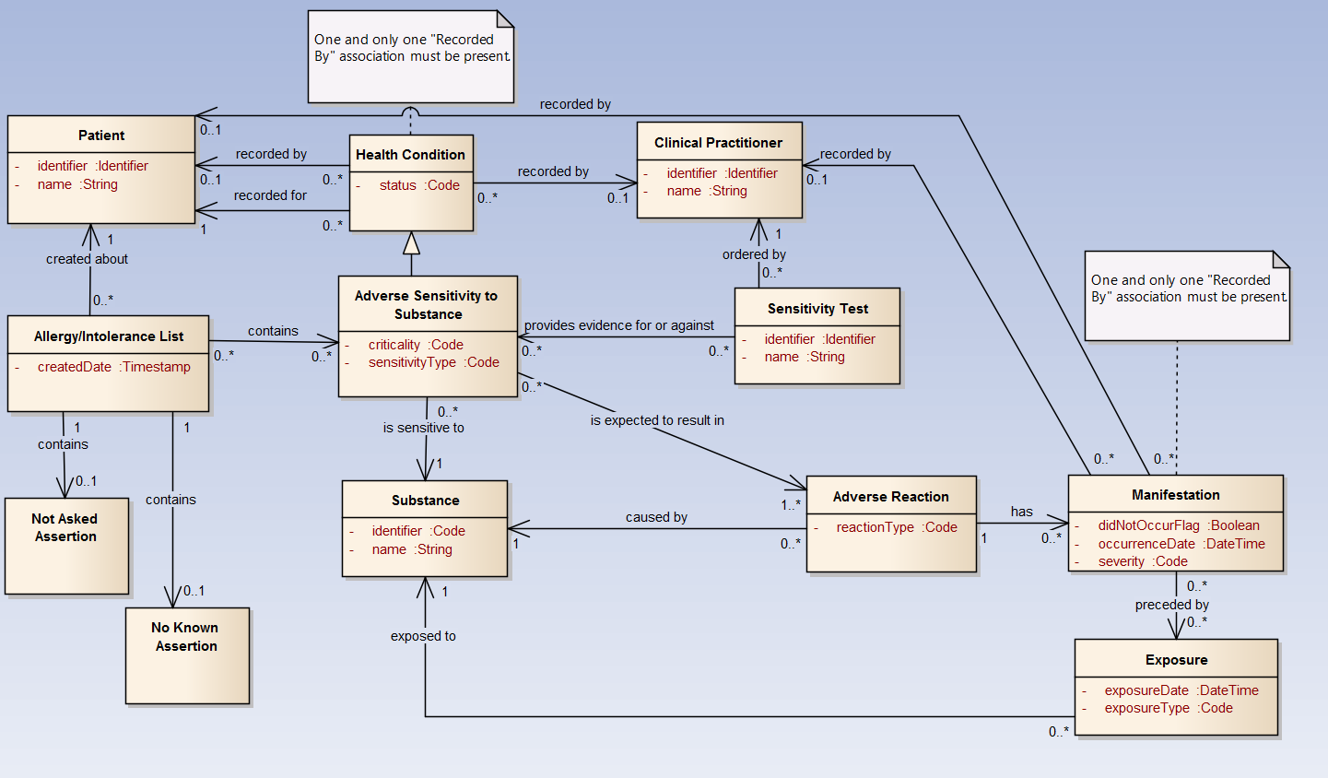

* Patient is represented in the vMR as VMR.patient (EvaluatedPerson type).
  + A patient has a list of clinical statement which include statements about Allergies or Intolerances.
* The Health Condition concept is equivalent to the AbstractCondition in the vMR’s AllergyOrIntolerance hierarchy.
* Clinical Practitioner can be related to the Practitioner class (newly introduced in the vMR as a first class concept) via a related entity relationship.
* Adverse Sensitivity to Substance is equivalent to the vMR concept of AllergyOrIntolerance
  + Criticality maps one-to-one with AbstractCondition.criticality
  + sensitivityType maps one-to-one with ConditionBase.conditionCode (e.g., ‘allergy’, ‘intolerance’)
* The Substance concept is modeled in the vMR as AllergyOrIntolerance.agent (CD). The agent could be a medication (penicillin), a food item (peanuts), or some other type of substance (latex).
* The relationship to Adverse Reaction is modeled in the vMR as a related clinical statement to the concept AdverseReaction.
* The Manifestation concept is modeled in the vMR as a related clinical statement to the ObservationResult class.
* Sensitivity Test can also be modeled using a related clinical statement to a ProcedureProposal/Order/Event (or specialization thereof) depending on the Order lifecycle stage.

# Proposed vMR AllergyOrIntolerance/Problem/AdverseEvent Model

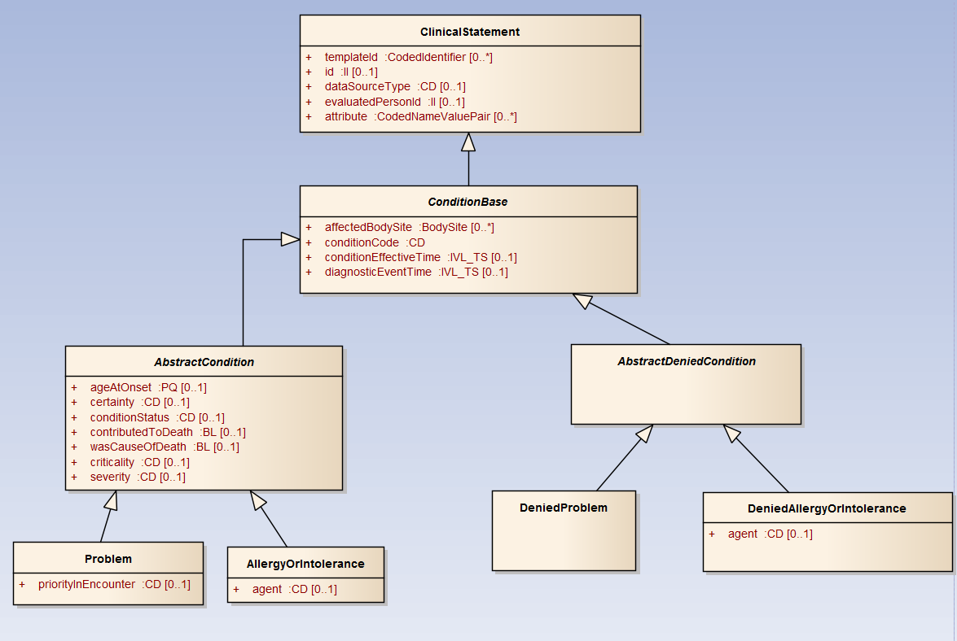

Figure : Allergy or Intolerance Hierarchy

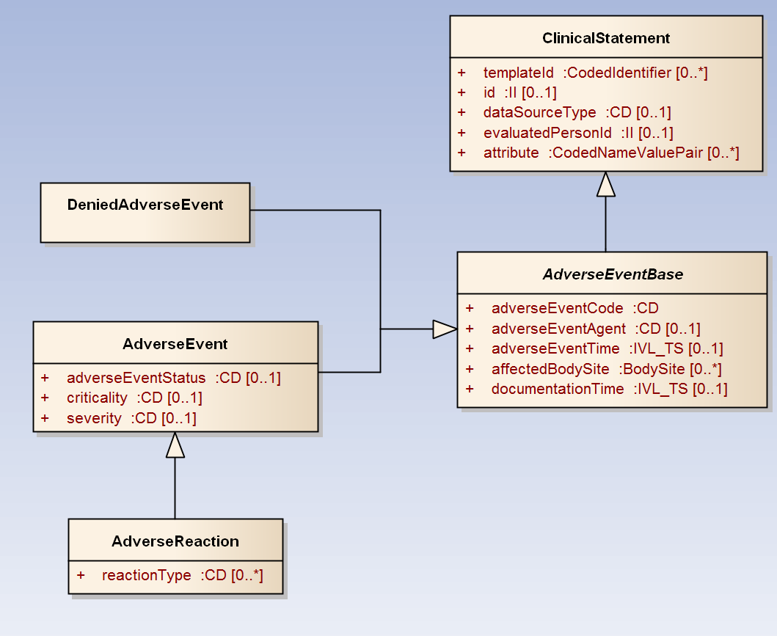

Figure : Adverse Reaction Hierarchy