|  |  |
| --- | --- |
|  | **2013** |
|  | HL7 vMR  Prepared by Claude Nanjo |

|  |
| --- |
| **[Harmonizing medications between the vMR and fhir]** |
| This document compares the vMR representation of SubstanceAdministration concepts with their counterparts in FHIR |

# The MedicationAdministration Concept in FHIR

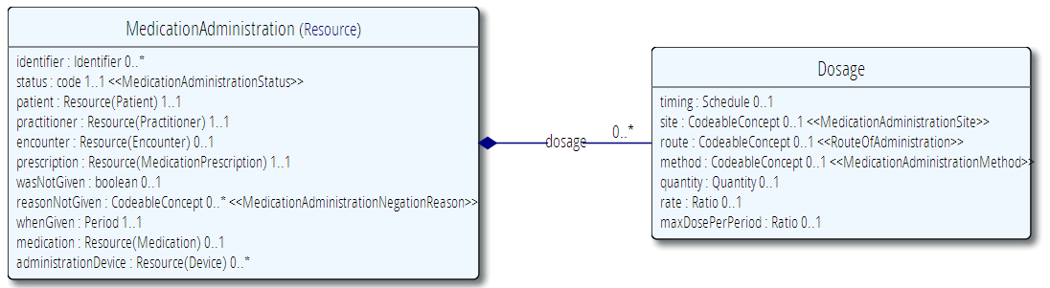

# The Order Concept in FHIR

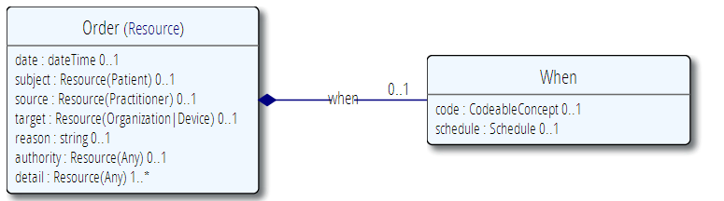

# The Medication Concept in FHIR

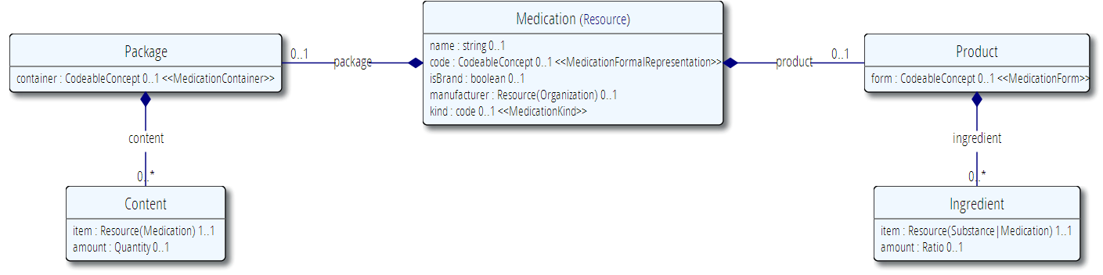

# The SubstanceAdministration Concept in the vMR

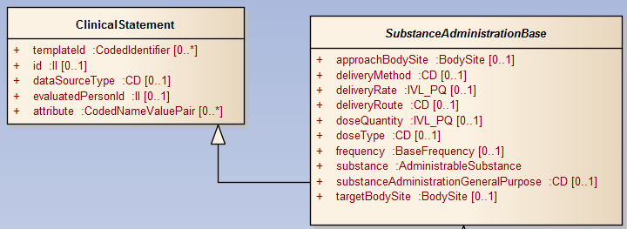

# The SubstanceAdministration Proposal/Order Concept in the vMR

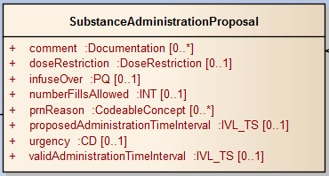

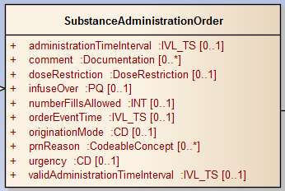

# The AdministrableSubstance Concept in FHIR

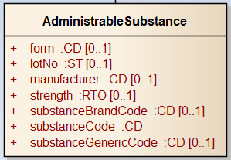

# Comparing the Two Models

## Substance Administration

One of the core differences between the vMR and FHIR lies in the cardinality of dosage. In the SubstanceAdministrationBase class of the vMR model, the implied cardinality between the SubstanceAdministration concept and Dosage is 0..1. However, in FHIR it is 0..*. Given the multiple cardinality of Dosage in FHIR, Dosage is essentially a separate class.

Another important difference between the models is that while in FHIR patient, practioner, and encounter are attributes of the MedicationAdministration class, in the vMR they are related to the statement in different ways. Given that the vMR is patient-centric, Patient is directly associated to the VMR concept. In essence, the VMR is a collection of statements made about a given patient. Hence, the patient attribute is not necessary in the vMR. [Ask David about Practitioner]. In the vMR, an encounter related to a SubstanceAdministration statement is modeled using a related clinical statement.

The vMR also takes a different approach to the negation of a statement. Rather than using negation attributes such as wasNotGiven, the vMR uses separate classes to indication either the non-occurrence of an event or the denial of existence. Classes that model the non-occurrence of an event have a ‘reason’ field to indicate why the event did not occur.

Interestingly, the vMR models maxDosePerPeriod in FHIR, not as a dosing attribute but in one of the subclasses. [Need to revisit this – inconsistency with FHIR model].

The following table compares FHIR MedicationAdministration attributes with those of the vMR’s SubstanceAdministrationBase:

|  |  |  |  |  |  |  |  |
| --- | --- | --- | --- | --- | --- | --- | --- |
| FHIR | | | | vMR | | | |
| Name | **Type** | **Card.** | **Definition** | **Name** | **Type** | **Card.** | **Definition** |
| identifier | Identifier | 0..1 | A logical identifier that is or can be used to identify an object or entity. | id | II | 0..1 |  |
| status | Code | 1..1 | Will generally be set to show that the administration has been completed. For some long running administrations such as infusions it is possible for an administration to be started but not completed or it may be paused while some other process is under way. Codes include active, held, completed, entered in error, stopped. | No equivalent |  |  |  |
| patient | Patient | 1..1 | A link to a resource representing the person to whom the medication was given. | VMR.patient | Evaluated Person | 1..1 |  |
| practitioner | Practitioner | 1..1 | The individual who is responsible for giving the medication to the patient. | Ask David |  |  |  |
| encounter | Encounter | 0..1 | An link to a resource that identifies the particular occurrence of contact between patient and health care provider. | Via related clinical statement |  |  |  |
| prescription | Medication Prescription | 1..1 | A link to a resource that provides the original request, instruction and authority to perform the administration. | No equivalent concept in vMR |  |  |  |
| wasNotGiven | boolean | 0..1 | Set this to true if the record is saying that the medication was NOT administered. | Modeled as separate class – Undelivered Substance Administration |  |  |  |
| reasonNot Given | Codeable Concept | 0..* | A code indicating why the administration has been negated. Use only if isNegated is set to TRUE. | Modeled as separate class – Undelivered Substance Administration |  |  |  |
| whenGiven | Period | 1..1 | An interval of time during which the administration takes place. For many administrations, such as swallowing a tablet the lower and upper values of the interval will be the same. | SubstanceAdministrationEvent. administrationTimeInterval |  |  |  |
| medication | Medication | 0..1 |  | substance | Administrable Substance |  |  |
| Administrative  Device | Device | 0..* | An identifier or a link to a resource that identifies a device used in administering the medication to the patient. | No equivalent |  |  |  |
| timing (Dosage) | Schedule | 0..1 | The timing schedule for giving the medication to the patient. The Schedule data type allows many different expressions, for example. "Every 8 hours"; "Three times a day"; "1/2 an hour before breakfast for 10 days from 23-Dec 2011:"; "15 Oct 2013, 17 Oct 2013 and 1 Nov 2013". | frequency | Base Frequency |  |  |
| site (Dosage) | Codeable Concept | 0..1 | A coded specification of the anatomic site where the medication first enters the body. | approachBodySite | BodySite |  |  |
| route (Dosage) | Codeable Concept | 0..1 | A code specifying the route or physiological path of administration of a therapeutic agent into or onto a subject. | deliveryRoute | CD | 0..1 |  |
| method (Dosage) | Codeable  Concept | 0..1 | A coded value indicating the method by which the medication is introduced into or onto the body. Most commonly used for injections. Examples: Slow Push; Deep IV. Terminologies used often pre-coordinate this term with the route and or form of administration. | deliveryMethod | CD | 0..1 |  |
| quantity (Dosage) | Quantity | 0..1 | The amount of themedication given at one administration event. Use this value when the administration is essentially an instantaneous event such as a swallowing a tablet or giving an injection. | doseQuantity | IVL_PQ | 0..1 |  |
| rate (Dosage) | Ratio | 0..1 | Identifies the speed with which the medication is introduced into the patient. Typically the rate for an infusion e.g. 200ml in 2 hours. May also expressed as a rate per unit of time such as 100ml per hour - the duration is then not specified, or is specified in the quantity. | deliveryRate | IVL_PQ | 0..1 |  |
| maxDosePer Period (Dosage) | Ratio | 0..1 | The maximum total quantity of a therapeutic substance that my be administered to a subject over the period of time. E.g. 1000mg in 24 hours. | SubstanceAdministrationProposal. doseRestriction | Dose Restriction | 0..1 |  |

## Medication vs Administrable Substance

Interesting discrepancy vis-à-vis ‘strength’. In the vMR strength is defined for the AdministrableSubstance code. In FHIR, strength is specified *per ingredient.* If the medication has a single ingredient, then both models are equivalent. However, for composite medications, FHIR is actually more expressive in this case.

The vMR does not seem to have the notion of package as perhaps this concept is less relevant in CDS. It does have the notion of lotNo which is important in the case of drug recalls.

|  |  |  |  |  |  |  |  |
| --- | --- | --- | --- | --- | --- | --- | --- |
| FHIR | | | | vMR | | | |
| Name | **Type** | **Card.** | **Definition** | **Name** | **Type** | **Card.** | **Definition** |
| name | String | 0..1 | The common name of the medication. | No equivalent |  |  |  |
| code | Codeable Concept | 0..1 | References to codes for this medication in standard medication terminologies, drug dictionaries, etc. | substanceCode or substanceGenericCode |  |  |  |
| isBrand | Boolean | 0..1 | Set to true if the item is attributable to a specific manufacturer (even if we don't know who that is). | substanceBrandCode |  |  |  |
| manufacturer | Organization | 0..1 | Describes the details of the manufacturer. | manufacturer |  |  |  |
| kind | Medication  Kind | 0..1 | Whether the medication is a product or a package | No equivalent. The vMR models this concept as a product and not a package. |  |  |  |
| product | Product | 0..1 | If is a product. | Always true in the vMR so not explicitly called out (I think) |  |  |  |
| product.form | Codeable Concept | 0..1 | Describes the form of the item. Powder; tables; carton. | form |  |  |  |
| product. ingredient | Ingredient | 0..* | The ingredients of the medication. The ingredients need not be a complete list; usually only active ingredients are listed. | No equivalent in the vMR. The vMR does not go to this level of granularity. Can be done via extensions to the vMR. |  |  |  |
| product. ingredient. item | Substance or Medication | 1..1 | The actual ingredient - either a substance (simple ingredient) or another medication. | No equivalent in the vMR. The vMR does not go to this level of granularity. Can be done via extensions to the vMR. |  |  |  |
| product. ingredient. amount | Ratio | 0..1 | Specifies how many (or how much) of the items there are in this Medication. E.g. 250 mg per tablet. | strength |  |  |  |
| package | Package | 0..1 | Specifies Ingredient / Product / Package. | No equivalent except for Lot No. |  |  |  |
| package. container | Codeable Concept | 0..1 | The kind of container that this package comes as. |  |  |  |  |
| package. content | Content | 0..* | A set of components that go to make up the described item. |  |  |  |  |
| package. content.item | Medication | 1..1 | The product that is in the package. |  |  |  |  |
| package. content. amount | Quantity | 0..1 | The amount of the product that is in the package. |  |  |  |  |

## MedicationAdministrationOrder or SubstanceAdministrationOrder

|  |  |  |  |  |  |  |  |
| --- | --- | --- | --- | --- | --- | --- | --- |
| FHIR | | | | vMR | | | |
| Name | **Type** | **Card.** | **Definition** | **Name** | **Type** | **Card.** | **Definition** |
| date | dateTime | 0..1 | When the order was made. | administrationTimeInterval | IVL_TS | 0..1 |  |
| subject | Patient | 0..1 | Patient this order is about. |  |  |  |  |
| source | Practitioner | 0..1 | Who initiated the order. |  |  |  |  |
| target | Organization | 0..1 | Who is intended to fulfill the order. |  |  |  |  |
| reason | String | 0..1 | Text - why the order was made. | No equivalent |  |  |  |
| authority | Any | 0..1 | If required by policy. |  |  |  |  |
| detail | Medication Administration | 1..* | What action is being ordered. | SubstanceAdministrationOrder |  |  |  |
| when | When | 0..1 | When order should be fulfilled. |  |  |  |  |
| when. code | Codeable Concept | 0..1 | Code specifies when request should be done. The code may simply be a priority code. | Urgency | CD | 0..1 |  |
| when. schedule | Schedule | 0..1 | A formal schedule. | Frequency | Base  Frequency | 0..1 |  |

## Other FHIR Concepts Modeled in the vMR

MedicationStatement – SubstanceAdministrationEvent

Immunization - SubstanceAdministration

ImmunizationRecommendation - SubstanceAdministrationProposal

## Medication Concepts Not Modeled in the vMR

MedicationPrescription