|  |  |
| --- | --- |
|  | **2013** |
|  | Health Level 7  Prepared by: Claude Nanjo |

|  |
| --- |
| **[ Modeling Nutrition Orders in the vMR]** |
|  |

Contents

vMR Model 3

Nutrition Model 5

Model Comparisons 6

Nutrition Order vs Diet Order/Proposal (Oral Diets) 6

Nutrient Modifiers 8

Texture Modification 11

Enteral (Tube Feeding) Formula Order Item 13

Product (Diet & Nutrition Order Model) vs AdministrableSubstance (vMR) 17

Other Concepts 19

Special Service Designation 19

Nutritional Supplement Order Item 19

Modeling TPN Proposals/Orders 20

The example provided: 20

Current shortcomings in the vMR Composite IV model 21

Tentative Modeling Approach 22

# vMR Model

The vMR model currently provides concepts for oral diet proposals and orders as well as parenteral diet proposals and orders. In the vMR, an oral diet is considered a procedure; a parenteral nutrition proposal or order, as a substance administration.

*Note that proposal and order concepts share the same fields and thus we will illustrate most concepts using proposals.*

The vMR is a hierarchical model where specialized concepts inherit attributes from their superclasses.

Procedures follow the hierarchy below:

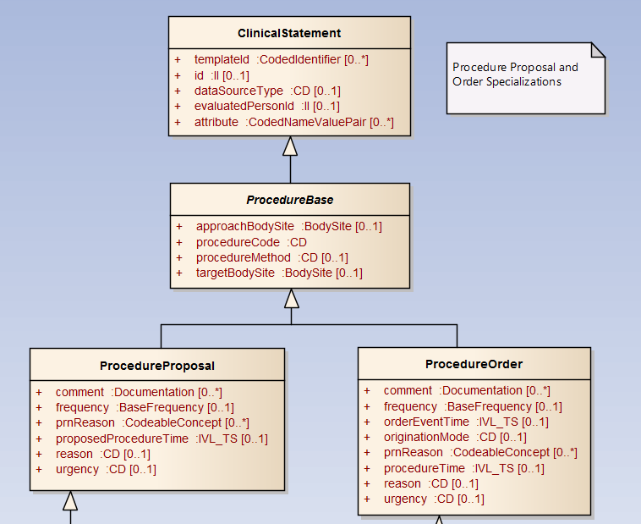

Specialization of procedures are shown below:

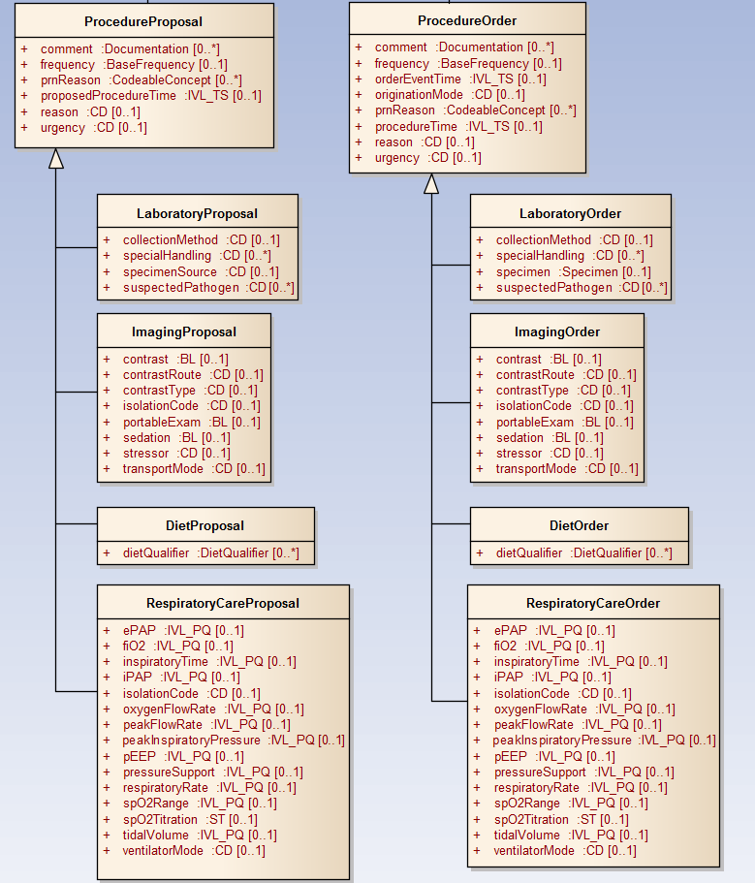

Similarly, the Substance Administration hierarchy is shown below:

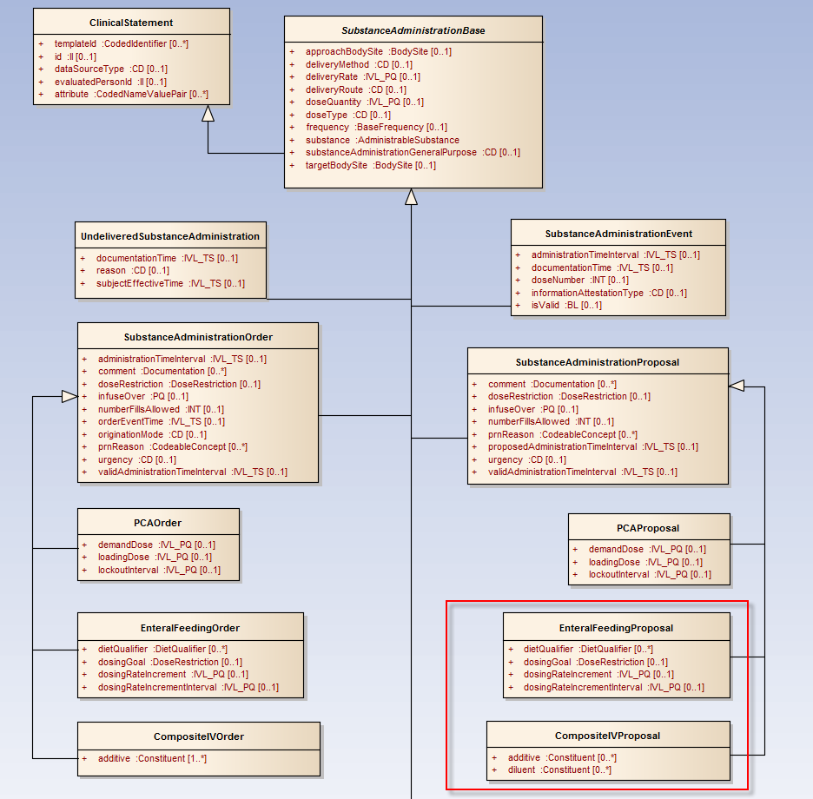

The following are relevant concepts for nutrition orders:

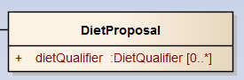

Figure - Essentially an oral diet proposal/order. It is a type of procedure.

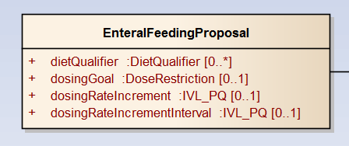

Figure - An enteral (tube feeding) proposal/order. It is a substance administration.

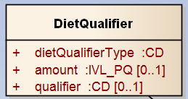

Figure - A diet nutrient qualifier including energy density

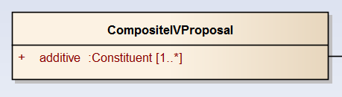

Figure - A composite IV. The diluent is captured by the substance administration itself.

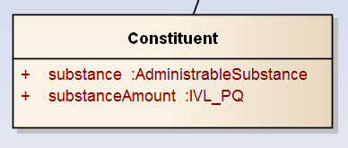

Figure - An additive to an IV or TPN order

# Nutrition Model

The following diagram illustrates the Diet and Nutrition Order Model. It is this diagram that we will consider in this document.

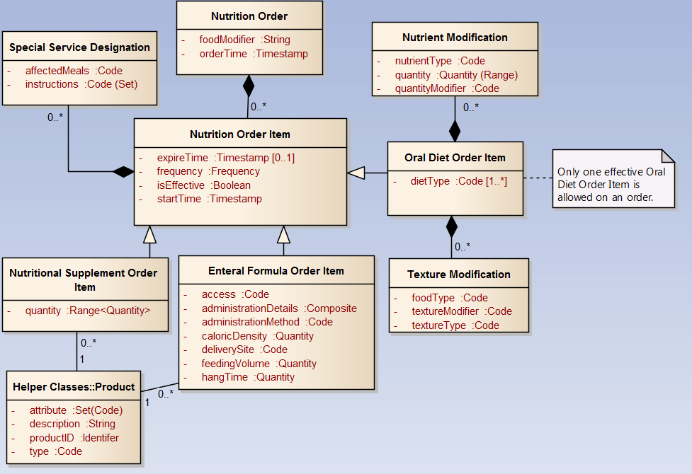

# Comparing both models

Overall the vMR is a more generic model given its intent and applications. As will be explained below, it is also more constrained than the current Diet and Nutrition Order model in certain areas. Yet, both models share significant concept and attribute overlap.

## Nutrition Order vs Diet Order/Proposal (Oral Diets)

One of the key differences between both models is that while in the vMR a nutrition order represents an order for a single diet type which can be arbitrarily modified using one or more DietQualifiers, in the Diet & Nutrition Order Model, a nutrition order represents a collection of Nutrition Order Items, each one of which may have one or more diet type codes and can be further modified using either Nutrient or Texture Modifications. The differences between both models are highlighted below:

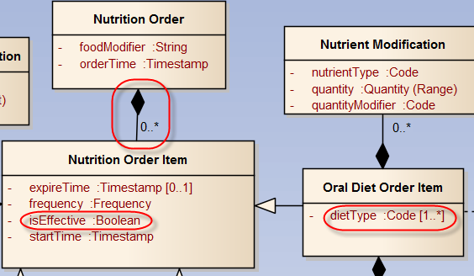

Figure - Difference between both models circled

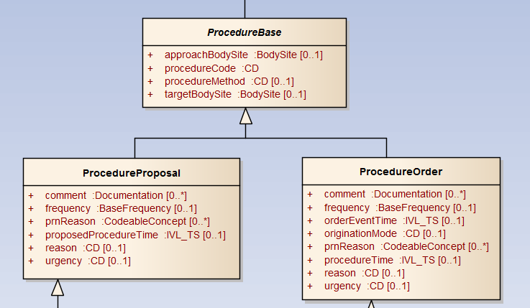

Figure - A vMR DietProposal is a ProcedureProposal



Figure - a vMR DietProposal

Understanding this difference, we will constrain a nutrition order to a single nutrition order item and compare the attributes between the two models. In later sections, we will compare the modifiers themselves. Note that to support multiple dietType codes, the vMR may be required to relax the cardinality of procedureCode or provide an alternative way to express composite diet orders.

|  |  |  |  |  |  |  |  |
| --- | --- | --- | --- | --- | --- | --- | --- |
| Diet & Nutrition Order DSTU | | | | vMR Logical Model Diet Order | | | |
| dietType | Code | 1..* | A code that controls the type of diet that a patient should receive, eg. Cultural Preference, Portion Size, Timing. | **procedureCode** | CD | 1..1 | This is the code that identifies the procedure with as much specificity as available, or as required by a template. E.g., appendectomy, coronary artery bypass graft surgery. |
| orderTime | Timestamp | 1..1 | The date and time when the order was written. | **orderEventTime** | IVL_TS | 0..1 | The time when the order was made. |
| startTime | Timestamp | 1..1 | Indicates when the diet order item is to take effect. Can be either a specific time (either now or in the future) or for a designated meal or snack period. | **procedureTime** | IVL_TS | 0..1 | Ordered time for procedure. |
| expireTime | Timestamp | 0..1 | Optional as most diet orders items will have no expireTime and will continue until the item is cancelled or replaced by a new item. | **procedureTime** | IVL_TS | 0..1 | Ordered time for procedure. |
| isEffective | Boolean | 1..1 | Indicates whether the diet order item is currently in effect for the patient. | **No Equivalent** |  |  |  |
| Frequency | Frequency | 1..1 | The frequency of when this item  should be provided. eg. Every morning, 3 times a day. | **Frequency** | Base  Frequency | 0..1 | The interval in between procedures. For instance, 'Every 8 hours', TID, BID, q8h, etc... Frequency may be represented as either a code or as an interval. |
| foodModifier | String | 1..1 | This modifier is used to convey order-specific modifiers about the type of food that should be given. These can be derived from patient allergies, intolerances, or preferences. They can also be specific to the order and not have any relationship to the allergies, intolerances, or preferences. | **Comment** | Documentation | 0..* | A comment, instruction, or note associated with the proposal. The type specifies the type of comment (e.g., 'Provider Instruction', 'Patient Instruction', 'Reason for Procedure', 'Consult Note', etc...) and the value of the comment represents the free text value. |

### Nutrient Modifiers

The Diet & Nutrition DSTU model and the vMR both allow for nutrient modifiers. While in the Diet & Nutrition Order Model, there is an explicit class to represent these types of diet modifiers, in the vMR a general DietQualifier is used for this purpose. (Note that this class may be semantically ambiguous if used to represent qualifiers other than nutrients).

These two classes are for the most part semantically equivalent in their definitions except for one attribute: quantityModifier and qualifier. In the Diet & Nutrition Order, the quantityModifier qualifies the range. In the vMR, the qualifier attribute supports the expression of nutrient amounts in more qualitative ways (e.g., ‘Low Fat’). Note that the quantityModifier is supported in the vMR as the IVL_PQ data type supports open intervals explicitly.

Also note that due to the different semantics of the last attribute of both classes, the cardinality is different. That is, in the vMR one can represent an amount quantitatively or qualitatively, hence the optional cardinality to support an ‘either-or’ scenario. In the Diet & Nutrition Order, quantity and quantityModifiers must be present as one qualifies the other (more conceptual).

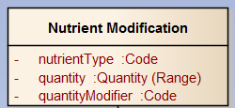

Figure - A Nutrient Modifier (Diet & Nutrition Order)



Figure - A General Diet Modifier (vMR)

|  |  |  |  |  |  |
| --- | --- | --- | --- | --- | --- |
| Diet & Nutrition Order DSTU | | | vMR Logical Model | | |
| nutrientType | Code | 1..1 | **dietQualifierType** | CD | 1..1 |
| quantity | Quantity(Range) | 1..1 | **amount** | IVL_PQ | 0..1 |
| quantityModifier | Code | 1..1 | **qualifier** | CD | 0..1 |

|  |  |  |  |
| --- | --- | --- | --- |
| Attribute Name | Definition | Attribute Name | Definition |
| nutrientType | The type of nutrient that is being indicated, eg. Carbohydrate, Calories, Protein. | **dietQualifierType** | The type of nutrient that this diet contains. Nutrient types include: carbohydrates, lipids and fats, salts such as Sodium or Potassium, fibers, and also fluids. |
| quantity | Indicates how much of the nutrient is being ordered. | **amount** | The quantity of nutrient or bound to consider for this diet. For instance, 40mg, <40mg, 30mg<x<60mg, etc... |
| quantityModifier | Whether the modification is to be less than the quantity, greater than the quantity, or equal to the quantity, eg. ensure diet is less than 50kCal. | **qualifier** | Not all nutrients will be given using physical quantities. A fat may be specified as 'Low Fat', 'No Animal Fat', etc... Other examples include: 'Ketogenic 3:1 Ratio', 'Consistent Carb Low (1200-1500 Kcal'), etc... Note that fluid consistencies may also be specified as the qualifier of a Nutrient whose type is 'Fluid'. E.g., Honey Thick Liquids, Nectar Thick Liquids, Pudding Thick Liquids, Other |

### Texture Modification

Currently the vMR DietQualifier concept cannot fully model the Text Modification concept. One reason is that it was originally designed with nutrient modification in mind. Note that the DietQualifier does not have three coded attributes which are required to properly characterize ‘Texture’. *This may represent a gap in the current vMR model.* One way to address this gap it so relax the qualifier cardinality to 0..* or to model texture and nutrient modifications in a similar manner as what was done in the Diet and Nutrition Model. That is, eliminate the DietQualifier concept and introduce the NutrientModification and TextureModification concepts explicitly provided terminologies support this.

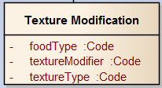

Figure - A diet texture modifier



Figure - A General Diet Modifier (vMR)

|  |  |  |  |  |  |
| --- | --- | --- | --- | --- | --- |
| Diet & Nutrition Order DSTU | | | vMR Logical Model | | |
| foodType | Code | 1..1 | **dietQualifierType** | CD | 1..1 |
| textureModifier | Code | 1..1 | **~~amount~~** | ~~IVL_PQ~~ | ~~0..1~~ |
| textureType | Code | 1..1 | **qualifier** | CD | 0..1 |

|  |  |  |  |
| --- | --- | --- | --- |
| Attribute Name | Definition | Attribute Name | Definition |
| foodType | Indicates what type of food that the texture modification applies to. | **dietQualifierType** | "Diet qualifier allows the post-coordination of diets in cases where such post-coordination is required. Diets can vary greatly in how they are represented in terminologies. The most common use case for DietQualifier is to represent a nutrient that can be either stated as a quantity, a range, or as a code (e.g., 'Low Protein').  DietQualifier consists of the dietQualifierType (e.g., Sodium), the amount in the diet (e.g., 20-30g), and/or a qualifier such as 'Low Sodium'. Note that dietQualifierType is required and of type CD. Amount is optional and of type IVL_PQ. qualifier is optional and of type CD. Either amount or qualifier is required and both may not be empty. |
| textureModifier | A further modification to the texture, eg. Pudding Thick. | **No equivalent** |  |
| textureType | A code that identifies any texture modifications that should be made, eg. Pureed, Easy to Chew. | **qualifier** | Not all nutrients will be given using physical quantities. A fat may be specified as 'Low Fat', 'No Animal Fat', etc... Other examples include: 'Ketogenic 3:1 Ratio', 'Consistent Carb Low (1200-1500 Kcal'), etc... Note that fluid consistencies may also be specified as the qualifier of a Nutrient whose type is 'Fluid'. E.g., Honey Thick Liquids, Nectar Thick Liquids, Pudding Thick Liquids, Other |

## Enteral (Tube Feeding) Formula Order Item

The Enteral Feeding Order concepts in the Diet & Nutrition Order Model and in the vMR share significant attribute overlap. The referred substance, however, is slightly different between the two model and *may* require some harmonization.

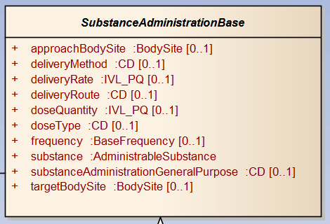

Figure – EnteralFeedingProposal/Orders are types of substance administrations

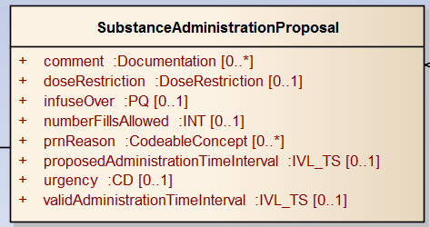

Figure - They also are proposals/orders



Figure – Fields specific to the vMR Enteral Feeding Proposal/Order

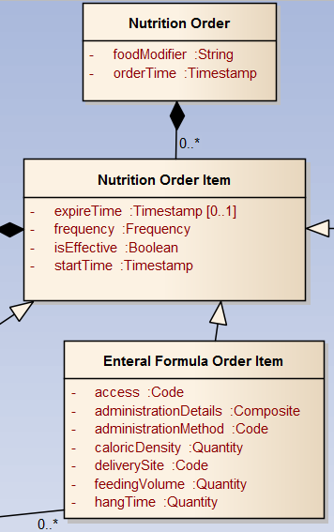

Figure - Diet & Nutrition Enteral Feeding Order

|  |  |  |  |  |  |  |  |
| --- | --- | --- | --- | --- | --- | --- | --- |
| Diet & Nutrition Order DSTU | | | | vMR Logical Model Diet Order | | | |
| orderTime | Timestamp | 1..1 | The date and time when the order was written. | **orderEventTime** | IVL_TS | 0..1 | The time when the order was made. |
| startTime | Timestamp | 1..1 | Indicates when the diet order item is to take effect. Can be either a specific time (either now or in the future) or for a designated meal or snack period. | **procedureTime** | IVL_TS | 0..1 | Ordered time for procedure. |
| expireTime | Timestamp | 0..1 | Optional as most diet orders items will have no expireTime and will continue until the item is cancelled or replaced by a new item. | **procedureTime** | IVL_TS | 0..1 | Ordered time for procedure. |
| isEffective | Boolean | 1..1 | Indicates whether the diet order item is currently in effect for the patient. | **No Equivalent** |  |  |  |
| Frequency | Frequency | 1..1 | The frequency of when this item  should be provided. eg. Every morning, 3 times a day. | **Frequency** | Base  Frequency | 0..1 | The interval in between procedures. For instance, 'Every 8 hours', TID, BID, q8h, etc... Frequency may be represented as either a code or as an interval. |
| foodModifier | String | 1..1 | This modifier is used to convey order-specific modifiers about the type of food that should be given. These can be derived from patient allergies, intolerances, or preferences. They can also be specific to the order and not have any relationship to the allergies, intolerances, or preferences. | **Comment** | Documentation | 0..* | A comment, instruction, or note associated with the proposal. The type specifies the type of comment (e.g., 'Provider Instruction', 'Patient Instruction', 'Reason for Procedure', 'Consult Note', etc...) and the value of the comment represents the free text value. |
| access | Code | 1..1 | A code further identifying how access to the delivery site is accomplished, eg. nasogastric. | **deliveryRoute** | CD | 0..1 | The physical route through which the substance is administered. E.g., IV, PO. |
| administrationDetails |  | 1..1 | A string that details the rate and any changes to the rate that affect how the food is administered. NOTE: This will be broken into more discrete elements at the logical level. | **dosingRate Increment & dosingRate Increment Interval** | IVL_PQ | 0..1 | dosingRateIncrement: Change in the dosing rate; usually an increase for a patient who is initiating tube feeding. E.g., 20 mL.  dosingRateIncrementInterval: Period of time after which the dosingRateIncrement should be attempted. E.g., 4 hours. |
| administrationMethod | Composite | 1..1 | A code that details how the food is to be administered, eg. Pump-assisted. | **deliveryMethod** | CD | 0..1 | Methodology used to administer the substance. E.g., gastric feeding tube, gastrostomy, drip |
| caloricDensity |  | 1..1 | An amount of calories per volume which identifies the type of formula. | **dietQualifier** | DietQualifier | 0..* | (See above sections for definition) |
| deliverySite |  | 1..1 | A code that identifies where the tube should deliver food to, eg. gastric. | **approach**  **Body**  **Site** | BodySite | 0..1 | The body site used for gaining access to the target body site for the purposes of the substance administration. |
| feedingVolume |  | 1..1 | How much product should be given at each feeding. | **doseQuantity** | IVL_PQ | 0..1 | The amount of substance. E.g., 1 tab, 325 mg, 1-2 tabs. |
| hangTime |  | 1..1 | How long the product should be provided at each feeding.  *Note: No definition provided in model.* | **infuseOver (?)** | PQ | 0..1 | Represents the actual time the medication is infused. Note the difference between infuseOver and duration. An orderable may call for infusing a patient TID for an hour each time over a duration of 5 days. |

## Product (Diet & Nutrition Order Model) vs AdministrableSubstance (vMR)

In an enteral feeding order, the formula is represented by a similar concept in both the Diet & Nutrition Order and vMR models. Note that the vMR neither provides a ‘description’ attribute nor the ‘attribute’ attribute.

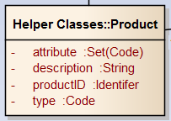

Figure - A substance or formula – can include foodtypes (Diet & Nutrition Order)

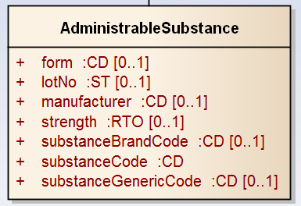

Figure - A substance or formula in the vMR

|  |  |  |  |  |  |  |  |
| --- | --- | --- | --- | --- | --- | --- | --- |
| Diet & Nutrition Order DSTU | | | | vMR Logical Model Diet Order | | | |
| attribute | Code | 1..* | A set of codes that define traits of the product, eg. spicy food, tablet medication. | **No equivalent** |  |  |  |
| description | String | 1..1 | A description of the product, eg. High Protein/2.0 Kcal formula. | **No equivalent** |  |  | Closest might be ‘strength’ or contained within the ‘substanceCode’ |
| productID | Identifier | 1..1 | A string given by a manufacturer to uniquely identify the product. | **substance**  **Brand**  **Code** | CD | 0..1 | A code describing the product as a branded or trademarked entity from a controlled vocabulary. |
| type | Code | 1..1 | A code that indicates the general classification of the product. This can be a class of products (eg. Vegetables, Opioids), a specific product (eg. Broccoli, Ibuprofen), or an attribute of a product (eg. Spicy, Tablets). | **substanceCode** | CD | 1..1 | The code that identifies the substance with as much specificity as appropriate, or as required by a template. E.g., aspirin, lisinopril. May be either a generic or brand code, unless otherwise restricted by a template. |

## Other Concepts

### Special Service Designation

The Diet & Nutrition Order Model defines certain concepts not explicitly defined in the vMR. For instance, it defines the Special Service Designation which may be represented in the vMR as an *unstructured* comment which are part of both SubstanceAdministrationProposals and ProcedureProposals.

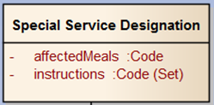

### Nutritional Supplement Order Item

The vMR does not have the concept of a Nutritional Supplement Order Item. Note, however, that the DietProposal/Order and SubstanceAdministrationProposal/Order may be used to represent such orders depending upon how these are administered. In this case, ‘quantity’ would be equivalent to ‘doseQuantity’ for SubstanceAdministration or to the DietQualifier.amount for DietProposal/Order. The ‘Product’ association can also be captured with the ‘substance’ attribute in SubstanceAdministrationProposal/Order in the vMR.

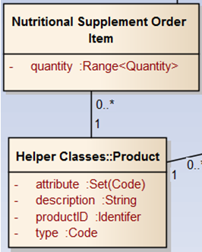

### Food Allergies, Intolerance, Preference

In the vMR, food allergies and intolerance are represented using the Problem class. This class provides an attribute to specify the problem agent and the type of allergy or intolerance can be captured by the problem code. Problems can be related to proposals and orders using the RelatedClinicalStatement relationship.

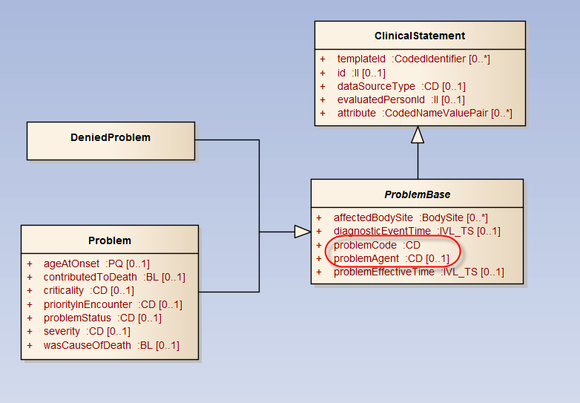

# Modeling TPN Proposals/Orders

TPN nutrition orders can be modeled in the vMR using the Composite IV Proposal/Order concept but may require some modification of the concept as it is currently defined.

## The example provided:

Here is an example Parenteral Nutrition order with some potential areas for CDS rules:

3-in-1 system compounded from 10% amino acid, 70% dextrose, 20% lipid solution – Total Fluid = 1724 mL

1. 5.5% amino acid
2. 2.5% lipid
3. 22.7% dextrose

Adult Multivitamin combination pkg

Plus Trace Element with Selenium Pkg

Vit K 1 mg (added weekly as 10 mg)

Additional ingredients:

* 60 mEq sodium chloride
* 45 mEq potassium chloride
* 30 mEq potassium phosphate
* 16 mEq calcium gluconate
* 24 mEq magnesium sulfate

*Verify CHO load is < 5.0 mg/kg/min (this is a good CDS kind of rule check)

## Current shortcomings in the vMR Composite IV model

Composite IVs are currently modeled as a SubstanceAdministrationProposal representing the diluent with any number of additives added to the mix. Such an approach, however, does not allow for attributes to be specified for composite medication as a whole. For instance, if the base substance administration fields represent the diluents and, after the addition of a number of additives, the total volume of the TPN bag doubles, there is no attribute to record the total volume of the bag nor is there a code to represent the mixture overall (e.g., SNOMED-CT: Total parenteral nutrition (regime/therapy) [225372007]) or this particular TPN order if such a code exists (e.g., a premix code of some sort).

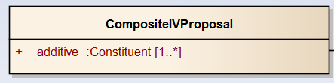

Figure - Current CompositeIVProposal – the base class represents the diluents

An alternative approach is to treat the base class as the concept that represents the overall composite orderable and explicitly specify each constituent which make up the whole composite orderable as illustrated below:

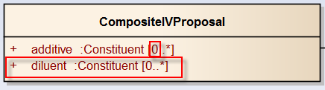

Figure - Proposed CompositeIVProposal – the base class represents the entire mix

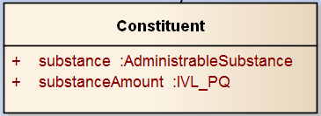

Figure - A constituent

Also note that this will require the loosening of the ‘substance’ cardinality in SubstanceAdministrationBase:

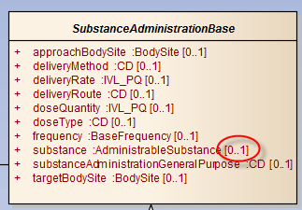

## Tentative Modeling Approach

* “3-in-1 system compounded from 10% amino acid, 70% dextrose, 20% lipid solution” may be captured by a substance code for the overall order or more generally as SNOMED-CT: Total parenteral nutrition (regime/therapy) [225372007]. Note that substance administrations do not define a ‘description’ attribute.
* Using the proposed Composite IV modeling approach, the total fluid of 1724 mL can be entered in the CompositeIVProposal.doseQuantity field (inherited from SubstanceAdministrationBase).
* The amino acid and lipid components of the TPN may be specified as additives whose percentages are the CompositeIVProposal.additive.substance.strength.
* Dextrose may be specified as either a third additive or a diluents in the same fashion as the amino acid and lipid additives.
* The Vit K 1 mg (added weekly as 10 mg) item may be defined as a separate *related* SubstanceAdministrationProposal with a frequency of once weekly.
* The additional ingredients specified in mEq may be also treated as additives in this model.
* Note that ingredient units may be constrained in a template as necessary.
* The instruction “Verify CHO load is < 5.0 mg/kg/min (this is a good CDS kind of rule check)” may either be specified as a comment to the order (CompositeIVProposal.comment) or as an associated rule.