|  |  |
| --- | --- |
|  | **2013** |
|  | HL7 vMR  Prepared by Claude Nanjo |

|  |
| --- |
| **[Harmonizing medications between the vMR and fhir]** |
| This document compares the vMR representation of medication-related concepts with their counterparts in FHIR |

Contents

Comparing the Two Models 3

Substance Administration 3

FHIR 3

vMR 3

Dosage 4

Related Resources 4

Statement Negation 5

Order-Concept Composition 5

Medication vs Administrable Substance 8

FHIR 8

vMR 8

Substance vs Medication 8

Product Ingredients 8

Package 8

Modeling Orders & Proposals 11

Dispense 13

MedicationStatement 18

FHIR 18

vMR 18

Immunization 21

FHIR 21

vMR 21

ImmunizationRecommendation 25

FHIR 25

vMR 25

Medication Prescription 28

MedicationPrescription 28

vMR 28

Recommendations for Change 33

# Comparing the Two Models

## Substance Administration

The following diagrams represent the medication/substance administration concept representations in the FHIR and vMR model.

### FHIR

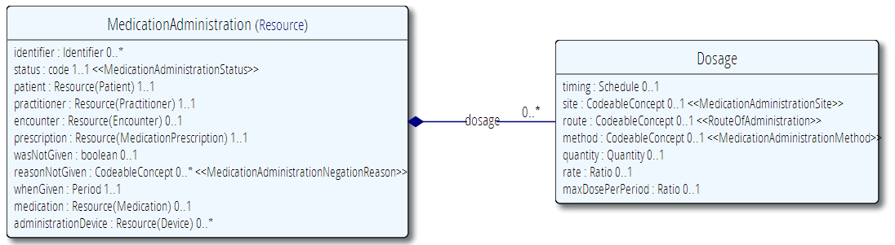

### vMR





### Dosage

The vMR and FHIR support the association of multiple doses per substance administrations. In both models Dose is represented as a separate class with a cardinality of 0..*. In FHIR, dosage attributes vary slightly (e.g., timing, additionalInstructions) depending on the clinical context (see MedicationAdministration and MedicationDispense). In the vMR, such variations are addressed in templates.

### Related Resources

Another important difference between the models is that while in FHIR patient, practitioner, and encounter are attributes of the MedicationAdministration class, in the vMR they are related to the statement in different ways. Given that the vMR is patient-centric, Patient is directly associated to the VMR concept. In essence, the VMR is a collection of statements made about a given patient. Hence, the patient attribute is not necessary in the vMR. In the vMR, an encounter related to a SubstanceAdministration statement is modeled using a related clinical statement.

### Statement Negation

The vMR also takes a different approach to the negation of a statement. Rather than using negation attributes such as wasNotGiven, the vMR uses separate classes (UndeliveredSubstanceAdministration) to indicate either the non-occurrence of an event or the denial of existence. Classes that model the non-occurrence of an event have a ‘reason’ field to indicate why the event did not occur. Note that this is different from prnReason found in the assertion statement counterpart which indicates why/when the administration should be considered. The modeling decision of using a concrete class for the negation of a statement rather than an attribute was taken so that no attribute, depending on its value, can change the entire semantics of its owning class. It was also made to reduce the likeliness of coding errors that could significantly alter the meaning of the resulting statement.

### Order-Concept Composition

While FHIR takes a compositional approach to Orders, where Order is a general class which can specify an Order ‘Detail’ by reference, in the vMR, the two concepts are merged into a single class (e.g., SubstanceAdministrationOrder). The motivation for this separation is described in FHIR as follows: “For this reason, the information about what is requested is separated from the actual request for an action to be taken. The various workflows around the actual order/fulfillment process are associated with this resource and the Order Response resource, while the details of what is actually ordered are delegated to other resources.” *While out-of-scope for this iteration of the vMR, it is recommended that the vMR adopt such a compositional approach in the future.*

The following table compares FHIR MedicationAdministration attributes with those of the vMR’s SubstanceAdministrationBase:

|  |  |  |  |  |  |  |  |
| --- | --- | --- | --- | --- | --- | --- | --- |
| FHIR | | | | vMR | | | |
| Name | **Type** | **Card.** | **Definition** | **Name** | **Type** | **Card.** | **Definition/Notes** |
| identifier | Identifier | 0..* | A logical identifier that is or can be used to identify an object or entity. | id | II | 0..1 | A unique ID of this clinical statement for reference purposes. It must be provided if user wants it returned as part of any output, otherwise it will be auto-generated, if needed, by CDS system. Does not need to be the actual ID of the source system. |
| status | Code | 1..1 | Will generally be set to show that the administration has been completed. For some long running administrations such as infusions it is possible for an administration to be started but not completed or it may be paused while some other process is under way. Codes include active, held, completed, entered in error, stopped. | No equivalent |  |  | ***Recommend adding to vMR SubstanceAdministrationEvent.*** |
| patient | Patient | 1..1 | A link to a resource representing the person to whom the medication was given. | VMR.patient | Evaluated Person | 1..1 |  |
| practitioner | Practitioner | 1..1 | The individual who is responsible for giving the medication to the patient. | Related Clinical Statement | Practitioner |  | Via a related clinical statement to ‘Practitioner’. Definition taken from FHIR: “Demographics and qualification information for an individual who is directly or indirectly involved in the provisioning of healthcare.” |
| encounter | Encounter | 0..1 | An link to a resource that identifies the particular occurrence of contact between patient and health care provider. | Related Clinical Statement | Encounter |  | Use a related clinical statement to an encounter event. |
| prescription | Medication Prescription | 1..1 | A link to a resource that provides the original request, instruction and authority to perform the administration. | SubstanceAdministrationOrder |  |  | Via a related clinical statement |
| wasNotGiven | boolean | 0..1 | Set this to true if the record is saying that the medication was NOT administered. | Modeled as separate class – Undelivered Substance Administration |  |  | Documents the non-delivery of a substance. E.g., documents that an influenza immunization was not given because the patient refused or had an adverse reaction to a previous flu vaccine. |
| reasonNot Given | Codeable Concept | 0..* | A code indicating why the administration has been negated. Use only if isNegated is set to TRUE. | UndeliveredSubstanceAdministration.reason | CD | 0..1 |  |
| whenGiven | Period | 1..1 | An interval of time during which the administration takes place. For many administrations, such as swallowing a tablet the lower and upper values of the interval will be the same. | SubstanceAdministrationEvent. administrationTimeInterval  SubstanceAdministrationProposal.proposedAdministrationTimeInterval  SubstanceAdministrationOrder.administrationTimeInterval | IVL_TS | 0..1 |  |
| medication | Medication | 0..1 | Primarily used for identification and definition of Medication, but also covers ingredients and packaging. | substance | Administrable Substance | 1..1 | A material of a particular constitution that can be given to a person to enable a clinical effect. It can have component administrable substances. |
| Administration  Device | Device | 0..* | An identifier or a link to a resource that identifies a device used in administering the medication to the patient. | No equivalent |  |  | ***Recommend adding a ‘Device’ entity to the vMR.*** |
| Dosage | 0..* |  | Separate class | Dose |  | 0..* | How the medication is to be used by or administered to the patient. |
| timing (Dosage) | Schedule | 0..1 | The timing schedule for giving the medication to the patient. The Schedule data type allows many different expressions, for example. "Every 8 hours"; "Three times a day"; "1/2 an hour before breakfast for 10 days from 23-Dec 2011:"; "15 Oct 2013, 17 Oct 2013 and 1 Nov 2013". | frequency | Cycle | 0..1 | Represents a predictable periodic interval where events may occur at specific points within this interval. Examples may include:  1. A chemotherapy regimen where a substance is administered TID on day 1,5,10 only.  2. An event that may occur TID but at specific times such as 8am, noon, and 3pm. |
| site (Dosage) | Codeable Concept | 0..1 | A coded specification of the anatomic site where the medication first enters the body. | approachBodySite | BodySite | 0..1 | A location on an EvaluatedPerson's body. E.g., left breast, heart. |
| route (Dosage) | Codeable Concept | 0..1 | A code specifying the route or physiological path of administration of a therapeutic agent into or onto a subject. | deliveryRoute | CD | 0..1 | The physical route through which the substance is administered. E.g., IV, PO. |
| method (Dosage) | Codeable  Concept | 0..1 | A coded value indicating the method by which the medication is introduced into or onto the body. Most commonly used for injections. Examples: Slow Push; Deep IV. Terminologies used often pre-coordinate this term with the route and or form of administration. | deliveryMethod | CD | 0..1 | Methodology used to administer the substance. E.g., gastric feeding tube, gastrostomy, drip |
| quantity (Dosage) | Quantity | 0..1 | The amount of themedication given at one administration event. Use this value when the administration is essentially an instantaneous event such as a swallowing a tablet or giving an injection. | doseQuantity | IVL_PQ | 0..1 | The amount of substance. E.g., 1 tab, 325 mg, 1-2 tabs. |
| rate (Dosage) | Ratio | 0..1 | Identifies the speed with which the medication is introduced into the patient. Typically the rate for an infusion e.g. 200ml in 2 hours. May also expressed as a rate per unit of time such as 100ml per hour - the duration is then not specified, or is specified in the quantity. | deliveryRate | IVL_PQ | 0..1 | Rate of substance administration. E.g., 1000 mL/hr. |
| maxDosePer Period (Dosage) | Ratio | 0..1 | The maximum total quantity of a therapeutic substance that my be administered to a subject over the period of time. E.g. 1000mg in 24 hours. | SubstanceAdministrationProposal. doseRestriction | Dose Restriction | 0..1 | This should probably move up to SubstanceAdministrationBase or to proposed new Dosage class. |

## Medication vs Administrable Substance

In both FHIR and the vMR, the Medication/Substance concept share a good deal of overlap. However, in FHIR these concepts are more expressive than in the vMR.

### FHIR

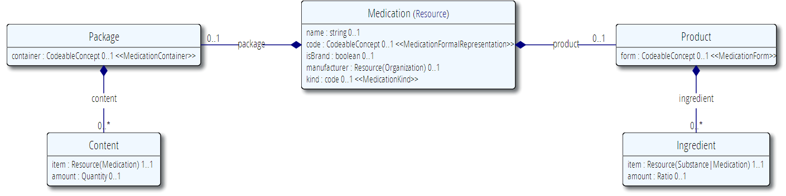

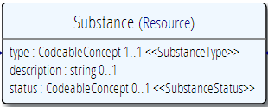

### vMR





### Substance vs Medication

FHIR distinguishes between Substance and Medication whereas the vMR does not.

### Product and Ingredients

FHIR and now the vMR allow for the accounting of ingredients in multi-ingredient medications. However, there are some differences between the two models. In the vMR, the product concept is part of the AdministrableSubstance. In this model, ‘form’ is an attribute of AdministrableSubstance and ingredients are directly associated with AdministrableSubstance. FHIR, on the other hand, defines a Product concept that specifies ‘form’ and which may relate to zero or more ingredients.

### Package

The vMR does not have the notion of package as perhaps this concept is less relevant in CDS. It does have the notion of lotNo which is important in the case of drug recalls.

The table below highlights some of the similarities and differences between the two models:

|  |  |  |  |  |  |  |  |
| --- | --- | --- | --- | --- | --- | --- | --- |
| FHIR | | | | vMR | | | |
| Name | **Type** | **Card.** | **Definition** | **Name** | **Type** | **Card.** | **Definition** |
| name | String | 0..1 | The common name of the medication. | No equivalent |  |  |  |
| code | Codeable Concept | 0..1 | References to codes for this medication in standard medication terminologies, drug dictionaries, etc. | substanceCode or substanceGenericCode | CD | 1..1  0..1 | The code that identifies the substance with as much specificity as appropriate, or as required by a template. E.g., aspirin, lisinopril. May be either a generic or brand code, unless otherwise restricted by a template.  A code describing the product as a substance produced and distributed without patent protection. |
| isBrand | Boolean | 0..1 | Set to true if the item is attributable to a specific manufacturer (even if we don't know who that is). | substanceBrandCode | CD | 0..1 | A code describing the product as a branded or trademarked entity from a controlled vocabulary. |
| manufacturer | Organization | 0..1 | Describes the details of the manufacturer. | manufacturer | CD | 0..1 | The organization that produces the substance. This is a CD and not an II because there are managed code systems for manufacturers. |
| kind | Medication  Kind | 0..1 | Whether the medication is a product or a package | No equivalent. The vMR models this concept as a product and not a package. |  |  |  |
| product | Product | 0..1 | If is a product. | Always true in the vMR so not explicitly called out |  |  |  |
| product.form | Codeable Concept | 0..1 | Describes the form of the item. Powder; tables; carton. | form | CD | 0..1 | The physical form of the substance as presented to the subject. E.g., tablet, patch, injectable, inhalant. |
| product. ingredient | Ingredient | 0..* | The ingredients of the medication. The ingredients need not be a complete list; usually only active ingredients are listed. | AdministrableSubstance.  ingredient | Ingredient | 0..* | The ingredients of the medication. |
| product. ingredient. item | Substance or Medication | 1..1 | The actual ingredient - either a substance (simple ingredient) or another medication. | Ingredient.item | Administrable  Substance | 1..1 | The actual ingredient - either a substance or another medication. |
| product. ingredient. amount | Ratio | 0..1 | Specifies how many (or how much) of the items there are in this Medication. E.g. 250 mg per tablet. | Ingredient.strength | RTO | 0..1 | The concentration of the substance. E.g., 250 mg per 5 ml. |
| package | Package | 0..1 | Specifies Ingredient / Product / Package. | No equivalent except for Lot No. |  |  | The notion of package (except for lot number) does not exist in the vMR. Lot Number may be important for drug recalls. The rest of the package information may not be highly relevant for CDS and may not lie in the 80/20. |
| package. container | Codeable Concept | 0..1 | The kind of container that this package comes as. | No equivalent. |  |  | At this time, the vMR does not model ‘Package’. |
| package. content | Content | 0..* | A set of components that go to make up the described item. | No equivalent. |  |  | At this time, the vMR does not model ‘Package’. |
| package. content.item | Medication | 1..1 | The product that is in the package. | No equivalent. |  |  | At this time, the vMR does not model ‘Package’. |
| package. content. amount | Quantity | 0..1 | The amount of the product that is in the package. | No equivalent. |  |  | At this time, the vMR does not model ‘Package’. |

## Modeling Orders & Proposals

In FHIR, the Order concept is a full-fledged class. This class then points to the resource being ordered as the order detail. FHIR does not appear to have a Proposal equivalent.

In the vMR, the notion of an order and the action being ordered (e.g. the administration of a substance) are part of a single *precoordinated* class. In the vMR, therefore, some attributes pertain to the order concept itself, while others pertain to what is being ordered.

*The separation of the order and what is being ordered are currently being considered in project Tacoma and is therefore out-of-scope for this ballot cycle given the significant refactoring such a change will entail.*

FHIR

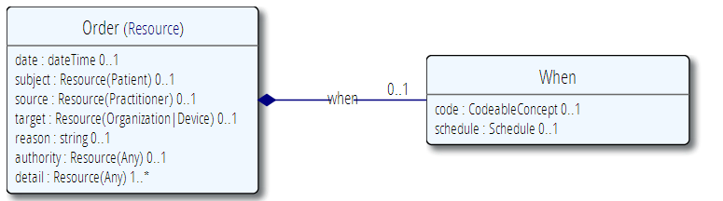

vMR (Example Order)



|  |  |  |  |  |  |  |  |
| --- | --- | --- | --- | --- | --- | --- | --- |
| FHIR | | | | vMR | | | |
| Name | **Type** | **Card.** | **Definition** | **Name** | **Type** | **Card.** | **Definition** |
| date | dateTime | 0..1 | When the order was made. | SubstanceAdministrationOrder.orderEventTime | IVL_TS | 0..1 |  |
| subject | Patient | 0..1 | Patient this order is about. | VMR.patient | Evaluated Person | 1..1 |  |
| source | Practitioner | 0..1 | Who initiated the order. | Related Clinical Statement | Practitioner |  |  |
| target | Organization | 0..1 | Who is intended to fulfill the order. | Organization (Entity) |  |  | May be related using a RelatedClinicalStatement |
| reason | String | 0..1 | Text - why the order was made. | Partial equivalent |  |  | prnReason but does not cover full intent and semantics of this field |
| authority | Any | 0..1 | If required by policy. | No equivalent |  |  | Depending on what ‘Authority’ is, the use of a related clinical statement may achieve this aim. |
| detail | Medication Administration | 1..* | What action is being ordered. | SubstanceAdministrationOrder |  |  | Precoordinated in the class (see above discussions).  Recommend post-coordinating in the future. |
| when | When | 0..1 | When order should be fulfilled. | administrationTimeInterval | IVL_TS | 0..1 | Ordered time for administering the substance. |
| when. code | Codeable Concept | 0..1 | Code specifies when request should be done. The code may simply be a priority code. | Urgency | CD | 0..1 | Urgency:  Applies to actions - orders or proposals (does not apply to problems, observations)  Characterizes how quickly an action must be initiated  Includes concepts such as stat, urgent, routine |
| when. schedule | Schedule | 0..1 | A formal schedule. | Frequency | Base  Frequency | 0..1 |  |

## Dispense

FHIR

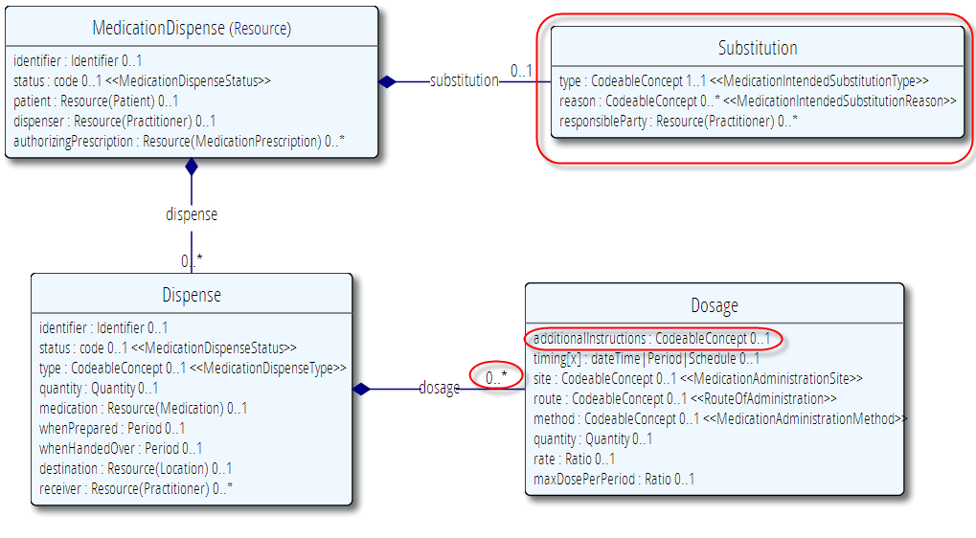

vMR

The SubstanceDispenseXYZ classes inherit from SubstanceAdministrationBase



Differences between both models

The FHIR Dispense class differs from the equivalent vMR classes in several ways:

The vMR represents the dispense concept using three classes – SubstanceDispenseOrder, SubstanceDispenseProposal, and SubstanceDispenseEvent. In FHIR, these are represented using a single MedicationDispense. The Order/Proposal equivalent in FHIR consists of an order for a prescription with the MedicationDispense as a response. The vMR approach is to define a SubstanceAdministrationOrder related to a SubstanceAdministrationEvent and SubstanceDispensationEvent as a response.

While FHIR supports the notion of medication substitution (including ‘no substitution allowed’), the vMR does not support this concept at this time but we recommend adding this concept to the vMR.

Also, while an individual Dispense can define more than one dosage, in the vMR dosage has an implicit cardinality of 0..1.

|  |  |  |  |  |  |  |  |
| --- | --- | --- | --- | --- | --- | --- | --- |
| FHIR | | | | vMR | | | |
| Name | **Type** | **Card.** | **Definition** | **Name** | **Type** | **Card.** | **Definition** |
| Medication Dispense |  |  | Dispensing a medication to a named patient. This includes a description of the supply provided and the instructions for administering the medication. | SubstanceDispenseOrder  SubstanceDispenseProposal  SubstanceDispenseEvent |  |  | A clinical order for dispensing a substance. That is the substance is to be dispensed but not administered.  Specifies that a substance needs to be dispensed but not administered to a patient (eg, “naloxone at bedside”).  This is the Event of a pharmacy filling a prescription. |
| identifier | Identifier | 0..1 | Identifier assigned by the dispensing facility - this is an identifier assigned outside FHIR. | ClinicalStatement. id | II | 0..1 | A unique ID of this clinical statement for reference purposes. It must be provided if user wants it returned as part of any output, otherwise it will be auto-generated, if needed, by CDS system. Does not need to be the actual ID of the source system. |
| status | Code | 0..1 | A code specifying the state of the set of dispense events. (in progress, on hold, completed, entered in, error, stopped) | No equivalent |  |  |  |
| patient | Patient | 0..1 | A link to a resource representing the person to whom the medication will be given. | VMR.patient | Evaluated Person | 1..1 |  |
| dispenser | Practitioner | 0..1 | The individual reponsible for dispensing the medication. | No equivalent |  |  | ***Recommend adding practitioner to vMR and relating practitioner using a relatedClinicalStatement predicate.*** |
| authorizingPrescription | Medication Prescription |  | Indicates the medication order that is being dispensed against. | No equivalent |  |  | The vMR does not define a ‘Prescription’ concept. |
| dispense | Dispense | 0..* | Indicates the details of the dispense event such as the days supply and quantity of medication dispensed. | Partial equivalent |  | 1..1 | The vMR does not support multiple cardinality for the dispensed substance. This class is a part of the SubstanceDispenseXYZ classes unlike FHIR. |
| Dispense. identifier | Identifier | 0..1 | Identifier assigned by the dispensing facility. This is an identifier assigned outside FHIR. | No equivalent |  |  | No separate class in the vMR |
| Dispense. status | Code | 0..1 | A code specifying the state of the dispense event. (in progress, on hold, completed, entered in, error, stopped) | No equivalent |  |  |  |
| Dispense.type | Codeable Concept | 0..1 | Indicates the type of dispensing event that is performed. Examples include: Trial Fill, Completion of Trial, Partial Fill, Emergency Fill, Samples, etc. | No equivalent |  |  |  |
| Dispense. quantity | Quantity | 0..1 | The amount of medication that has been dispensed. Includes unit of measure. | dispenseQuantity | PQ | 0..1 | The amount of substance provided. |
| Dispense. medication | Medication | 0..1 | Identifies the medication being administered. This is either a link to a resource representing the details of the medication or a simple attribute carrying a code that identifies the medication from a known list of medications. | SubstanceAdministrationBase. Substance | AdministrableSubstance | 1..1 | A material of a particular constitution that can be given to a person to enable a clinical effect. |
| Dispense. whenPrepared | Period | 0..1 | The time the dispense event occurred. | SubstanceDispensationTime. dispenseTime | IVL_TS | 0..1 | Time when substance was dispensed. |
| Dispensed. whenHandedOver | Period | 0..1 | The time the dispense event occurred. | No equivalent |  |  |  |
| Dispense. destination | Location | 0..1 | Identification of the facility/location where the medication was shipped to, as part of the dispense event. | Partial equivalent | Facility |  | This can be modeled using a related clinical statement to a facility entity. |
| Dispensed. receiver | Practitioner | 0..* | Identifies the person who picked up the medication. | No equivalent |  |  | Recommend adding new Practitioner entity to the vMR. |
| Dispensed. dosage | Dosage | 0..* | Indicates how the medication is to be used by the patient. | Partial equivalent |  | 0..1 | Recommend adding new Dosage class and supporting 0..* cardinality. |
| Dosage. additionalInstructions | Codeable Concept | 0..1 | Additional instructions such as "Swallow with plenty of water" which may or may not be coded. | No Equivalent |  |  | Propose adding to dosage class. |
| Dosage.timing | dateTime| Period| Schedule | 0..1 | The timing schedule for giving the medication to the patient. The Schedule data type allows many different expressions, for example. "Every 8 hours"; "Three times a day"; "1/2 an hour before breakfast for 10 days from 23-Dec 2011:"; "15 Oct 2013, 17 Oct 2013 and 1 Nov 2013". | frequency | Base Frequency | 0..1 | New concept may be added to represent chemotherapy cycles |
| Dosage.site | Codeable Concept | 0..1 | A coded specification of the anatomic site where the medication first enters the body. | approachBodySite | BodySite | 0..1 | A location on an EvaluatedPerson's body. E.g., left breast, heart. |
| Dosage.route | Codeable Concept | 0..1 | A code specifying the route or physiological path of administration of a therapeutic agent into or onto a subject. | deliveryRoute | CD | 0..1 | The physical route through which the substance is administered. E.g., IV, PO. |
| Dosage.method | Codeable Concept | 0..1 | A coded value indicating the method by which the medication is introduced into or onto the body. Most commonly used for injections. Examples: Slow Push; Deep IV. Terminologies used often pre-coordinate this term with the route and or form of administration. | deliveryMethod | CD | 0..1 | Methodology used to administer the substance. E.g., gastric feeding tube, gastrostomy, drip |
| Dosage.quantity | Quantity | 0..1 | The amount of the therapeutic or other substance given at one administration event. | doseQuantity | IVL_PQ | 0..1 | The amount of substance. E.g., 1 tab, 325 mg, 1-2 tabs. |
| Dosage.rate | Ratio | 0..1 | Identifies the speed with which the substance is introduced into the subject. Typically the rate for an infusion. 200ml in 2 hours. | deliveryRate | IVL_PQ | 0..1 | Rate of substance administration. E.g., 1000 mL/hr. |
| Dosage. maxDosePerPeriod | Ratio | 0..1 | The maximum total quantity of a therapeutic substance that my be administered to a subject over the period of time. E.g. 1000mg in 24 hours. | SubstanceAdministrationProposal. doseRestriction | Dose Restriction | 0..1 | This should probably move up to SubstanceAdministrationBase or to proposed new Dosage class. |
| substitution | Substitution | 0..1 | Indicates whether or not substitution was made as part of the dispense. In some cases substitution will be expected but doesn't happen, in other cases substitution is not expected but does happen. This block explains what substitition did or did not happen and why. | No equivalent |  |  | Discuss with Ken and Dave. |
| Substitution.type | Codeable  Concept | 1..1 | A code signifying whether a different drug was dispensed from what was prescribed. | No equivalent |  |  |  |
| Substitution.reason | Codeable  Concept | 0..* | Indicates the reason for the substitution of (or lack of substitution) from what was prescribed. | No equivalent |  |  |  |
| Substitution. reponsibleParty | Practitioner | 0..* | The person or organization that has primary responsibility for the substitution. | No equivalent |  |  |  |

## MedicationStatement

Based on its definition, the MedicationStatement may be slightly broader than its equivalent concept in the vMR – SubstanceAdministrationEvent. Also, while FHIR has the attribute wasNotGiven to indicate that the medicament was NOT given, vMR models this as a separate class – UndeliveredSubstanceAdministration. The two models’ representations are illustrated below and compared side-by-side in a tabular format.

### FHIR

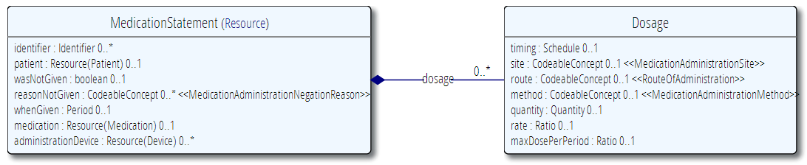

### vMR

The SubstanceAdministrationEvent inherits from SubstanceAdministrationBase

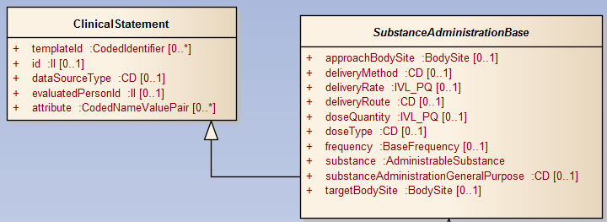

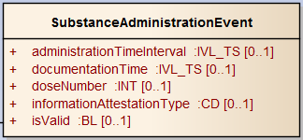

|  |  |  |  |  |  |  |  |
| --- | --- | --- | --- | --- | --- | --- | --- |
| FHIR | | | | vMR | | | |
| Name | **Type** | **Card.** | **Definition** | **Name** | **Type** | **Card.** | **Definition** |
| Medication Statement |  |  | This resource is distinct from [MedicationPrescription](http://www.hl7.org/implement/standards/fhir/medicationprescription.html), [MedicationDispense](http://www.hl7.org/implement/standards/fhir/medicationdispense.html) and [MedicationAdministration](http://www.hl7.org/implement/standards/fhir/medicationadministration.html). Each of those resources refer to specific events - an individual order, an individual provisioning of medication or an individual dosing. MedicationStatement is a broader assertion covering a wider timespan and independent of specific events. The existence of resource instances of any of the preceding three types may be used to infer a Medication statement. However, medication statements can also be captured on the basis of other information including an assertion by the patient or a care-giver, the results of a lab test, etc.  Common usage includes the recording of non-prescription and/or recreational drugs the recording of an intake medication list upon admission to hospital the summarization of a patient's "active medications" in a patient profile | **SubstanceAdministrationEvent** |  |  | The actual administration of the substance.  Handling of entries in "current medication list" with no other data than current medications could be as follows:  - SubstanceAdministrationEvent with documentationTime = time when snapshot was taken of current medication list, administrationEventTime = null if no data provided on when medication was started or stopped, administrationTime with specified Low but null High if data only provided on when medication was started.  To specify "patient takes an unknown drug", use a code for substance that represents "unknown medication". |
| identifier | Identifier | 0..* | External identifier - FHIR will generate its own internal IDs (probably URLs) which do not need to be explicitly managed by the resource. The identifier here is one that would be used by another non-FHIR system - for example an automated medication pump would provide a record each time it operated; an administration while the patient was off the ward might be made with a different system and entered after the event. Particularly important if these records have to be updated. | id | II | 0..1 | A unique ID of this clinical statement for reference purposes. It must be provided if user wants it returned as part of any output, otherwise it will be auto-generated, if needed, by CDS system. Does not need to be the actual ID of the source system. |
| patient | Patient | 0..1 | A link to a resource representing the person to whom the medication was given. | VMR.patient | Evaluated Person | 1..1 |  |
| wasNotGiven | Boolean | 0..1 | Set this to true if the record is saying that the medication was NOT administered. | Partially equivalent | UndeliveredSubstance  Administration |  | Use this class to specify that a substance was not given to the patient. |
| reasonNotGiven | Codeable  Concept | 0..1 | A code indicating why the administration has been negated. Use only if isNegated is set to TRUE. | UndeliveredSubstanceAdministration.reason | CD | 0..1 | Reason why the substance was not administered. |
| whenGiven | Period | 0..1 | An interval of time during which the administration takes place. For many administrations, such as swallowing a tablet the lower and upper values of the interval will be the same. | administrationTimeInterval | IVL_TS | 0..1 | The time when the substance is administered. An unspecified high time interval signifies that the administration is ongoing. Left optional to allow use for a medication list that does not have this data. |
| medication | Medication | 0..1 | Identifies the medication being administered. This is either a link to a resource representing the details of the medication or a simple attribute carrying a code that identifies the medication from a known list of medications. | SubstanceAdministrationBase.  substance | AdministeredSubstance | 1..1 | A material of a particular constitution that can be given to a person to enable a clinical effect. |
| Administration Device | Device | 0..* | An identifier or a link to a resource that identifies a device used in administering the medication to the patient. | No equivalent |  |  | Recommend adding a ‘Device’ entity. |
| dosage | Dosage | 0..* | Indicates how the medication is to be used by the patient. **Same as MedicationAdministration. Not repeated here.** | Implicit in Substance AdministrationBase |  | 0..1 | Recommend separating dosage and allowing multiple cardinalities. |

## Immunization

### FHIR

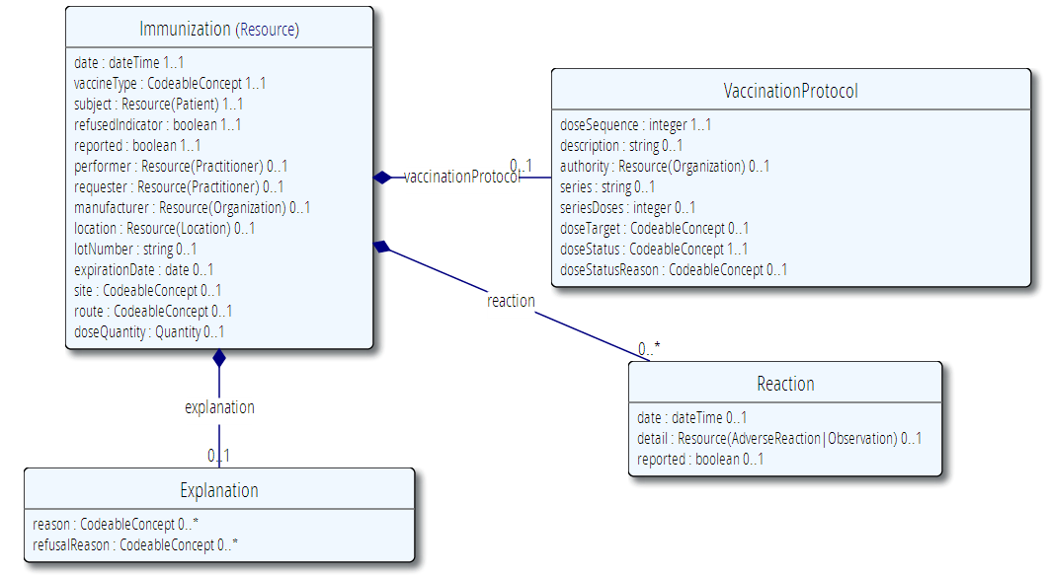

### vMR

Immunization can be modeled in the vMR using the following class: SubstanceAdministrationEvent.

|  |  |  |  |  |  |  |  |
| --- | --- | --- | --- | --- | --- | --- | --- |
| FHIR | | | | vMR | | | |
| Name | **Type** | **Card.** | **Definition** | **Name** | **Type** | **Card.** | **Definition** |
| Immunization |  |  | Immunization **event** information.  The immunization resource is intended to cover the administration of vaccines to patients across all healthcare disciplines in all care settings and all regions. This includes immunization of both humans and animals but does not include the administration of non-vaccine agents, even those that may have or claim immunological effects.  Additionally, the immunization resource is expected to cover key concepts related to the creation, revision and querying of a patient's immunization history. This resource - through consultation with the PHER work group - is believed to meet key use cases and information requirements as defined in the existing HL7 v2.x immunization implementation guide, HL7 v3 POIZ domain and Immunization Domain Analysis Model. | No direct equivalent. Use SubstanceAdministrationEvent. |  |  | Immunizations, much like allergies and intolerances, tend to be captured differently in many systems and are rather common. Should the vMR introduce a subclass for this substance administration type. |
| date | dateTime | 1..1 | Date vaccine administered or was to be administered. | SubstanceAdministrationEvent.  administrationTimeInterval | IVL_TS | 0..1 | The time when the substance is administered. An unspecified high time interval signifies that the administration is ongoing. Left optional to allow use for a medication list that does not have this data. |
| vaccineType | Codeable Concept | 1..1 | Vaccine that was administered or was to be administered. | SubstanceAdministrationBase.  substance.substanceCode | CD | 1..1 | The code that identifies the substance with as much specificity as appropriate, or as required by a template. E.g., aspirin, lisinopril. May be either a generic or brand code, unless otherwise restricted by a template. |
| subject | Patient | 1..1 | The patient to whom the vaccine was to be administered. | VMR.patient | Evaluated Person | 1..1 |  |
| refusedIndicator | boolean | 1..1 | Indicates if the vaccination was refused. | Partially equivalent |  |  | Use UndeliveredSubstanceAdministration.reason |
| reported | boolean | 1..1 | True if this administration was reported rather than directly administered. | No equivalent |  |  |  |
| performer | Practitioner | 0..1 | Clinician who administered the vaccine. | No equivalent |  |  | Recommendation – introduce Practitioner class |
| requester | Practitioner | 0..1 | Clinician who ordered the vaccination. | No equivalent |  |  | Recommendation – introduce Practitioner class |
| manufacturer | Organization | 0..1 | Name of vaccine manufacturer. | SubstanceAdministrationEvent.  substance.manufacturer | CD | 0..1 | A material of a particular constitution that can be given to a person to enable a clinical effect. It can have component administrable substances. |
| location | Location | 0..1 | The service delivery location where the vaccine administration occurred. | Partial equivalent | Location | 0..1 | Use a related clinical statement to the Facility entity. |
| lotNumber | string | 0..1 | Lot number of the vaccine product. | SubstanceAdministrationEvent.  substance.  lotNumber | ST | 0..1 | A material of a particular constitution that can be given to a person to enable a clinical effect. It can have component administrable substances. |
| expirationDate | date | 0..1 | Date vaccine batch expires. | SubstanceAdministrationEvent.  substance.  expirationDate | TS | 0..1 | Date substance expires.  Requirement: This is useful input for an Immunization CDS engine. Expired administrations cannot count and must be repeated. |
| site | Codeable  Concept | 0..1 | Body site where vaccine was administered. | SubstanceAdministrationBase.  approachBodySite | BodySite | 0..1 | The body site used for gaining access to the target body site for the purposes of the substance administration. |
| route | Codeable  Concept | 0..1 | The path by which the vaccine product is taken into the body. | SubstanceAdministrationBase.  deliveryRoute | CD | 0..1 | The physical route through which the substance is administered. E.g., IV, PO. |
| doseQuantity | Quantity | 0..1 | The quantity of vaccine product that was administered. | SubstanceAdministrationBase.  doseQuantity | IVL_PQ | 0..1 | The amount of substance. E.g., 1 tab, 325 mg, 1-2 tabs. |
| explanation | Explanation | 0..1 | Reasons why a vaccine was administered or refused. | No equivalent |  |  |  |
| explanation.  reason | Codeable  Concept | 0..* | Reasons why a vaccine was administered. | No equivalent |  |  |  |
| explanation.  refusalReason | Codeable  Concept | 0..* | Refusal or exemption reasons. | Partially equivalent |  |  | Use UndeliveredSubstanceAdministration.reason |
| reaction | Reaction | 0..* | Categorical data indicating that an adverse event is associated in time to an immunization. | Partial equivalent |  |  | Use related clinical statement to AdverseEvent or Observation |
| reaction.date | dateTime | 0..1 | Date of reaction to the immunization. | AdverseEventBase.  adverseEventTime | IVL_TS | 0..1 | The time that reflects when the subject experienced the adverse event (in the case of AdverseEvent) or when the subject did not experience the adverse event (in the case of DeniedAdverseEvent). |
| reaction.detail | AdverseReaction  Observation | 0..1 | Details of the reaction. | AdverseEvent/Observation |  |  | Via related clinical statement. |
| reaction.  reported | boolean | 0..1 | Self-reported indicator. | No equivalent |  |  |  |
| vaccinationProtocol | Vaccination  Protocol | 0..1 | Contains information about the protocol under which the vaccine was administered. | No equivalent |  |  | Is this concept needed? |
| vaccinationProtocol.doseSequence | integer | 1..1 | Nominal position in a series. | No equivalent |  |  |  |
| vaccinationProtocol.description | string | 0..1 | Contains the description about the protocol under which the vaccine was administered. | No equivalent |  |  |  |
| vaccinationProtocol.authority | Organization | 0..1 | Indicates the authority who published the protocol? E.g. ACIP. | No equivalent |  |  |  |
| vaccinationProtocol.series | string | 0..1 | One possible path to achieve presumed immunity against a disease - within the context of an authority. | No equivalent |  |  |  |
| vaccinationProtocol.seriesDoses | integer | 0..1 | The recommended number of doses to achieve immunity. | No equivalent |  |  |  |
| vaccinationProtocol.doseTarget | Codeable  Concept | 0..1 | The targeted disease. | No equivalent |  |  | Could SubstanceAdministrationBase.substanceAdministrationGeneralPurpose be used? |
| vaccinationProtocol.doseStatus | Codeable  Concept | 1..1 | Indicates if the immunization event should "count" against the protocol. | No equivalent |  |  |  |
| vaccinationProtocol.doseStatusReason | Codeable  Concept | 0..1 | Provides an explanation as to why an immunization event should or should not count against the protocol. | No equivalent |  |  |  |

## ImmunizationRecommendation

### FHIR

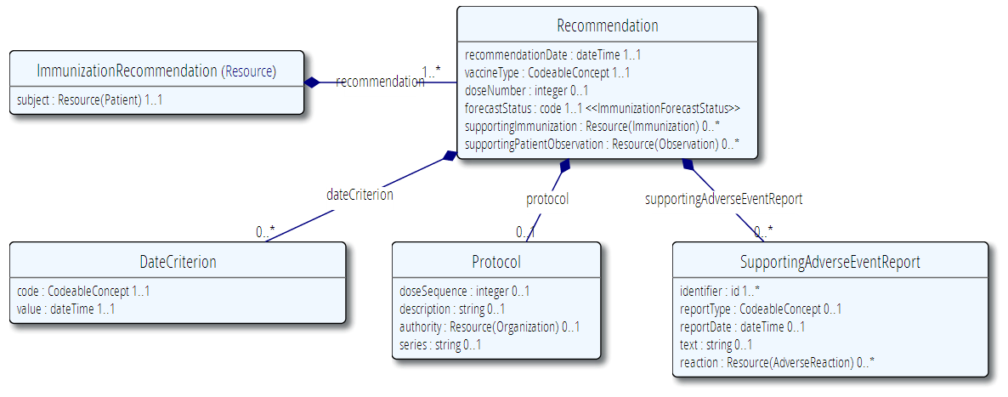

### vMR

ImmunizationRecommendation can be modeled in the vMR as a SubstanceAdministrationProposal.

|  |  |  |  |  |  |  |  |
| --- | --- | --- | --- | --- | --- | --- | --- |
| FHIR | | | | vMR | | | |
| Name | **Type** | **Card.** | **Definition** | **Name** | **Type** | **Card.** | **Definition** |
| Immunization  Recommendation |  |  | A patient's point-of-time immunization status and recommendation with optional supporting justification. | **SubstanceAdministrationProposal** |  |  | Proposal for a substance administration. Used, for example, when a CDS system proposes that a medication or vaccination be given. |
| subject | Patient | 1..1 | The patient who is the subject of the profile. | VMR.patient | Evaluated Person | 1..1 |  |
| recommendation | Recommendation | 1..* | Vaccine administration recommendations. | No equivalent |  |  | Part of the SubstanceAdministrationProposal class |
| recommendation.  recommendationDate | dateTime | 1..1 | The date of the immunization recommendation. | No equivalent |  |  |  |
| recommendation.  vaccineType | Codeable  Concept | 1..1 | Vaccine that pertains to the recommendation. | SubstanceAdministrationBase.  substance.substanceCode | CD | 1..1 | The code that identifies the substance with as much specificity as appropriate, or as required by a template. E.g., aspirin, lisinopril. May be either a generic or brand code, unless otherwise restricted by a template. |
| recommendation.  doseNumber | integer | 0..1 | Recommended dose number. | No equivalent |  |  | Recommend adding to Dose |
| recommendation.  forecastStatus | Code | 1..1 | Vaccine administration status. | No equivalent |  |  |  |
| recommendation.  dateCriterion |  | 0..* | Vaccine date recommentations - e.g. earliest date to administer, latest date to administer, etc. | No equivalent |  |  |  |
| recommendation.dateCriterion.code | Codeable  Concept | 1..1 | Date classification of recommendation - e.g. earliest date to give, latest date to give, etc. | No equivalent |  |  |  |
| recommendation.dateCriterion.value | DateTime | 1..1 | Date recommendation. | SubstanceAdministrationProposal.proposedAdministrationTimeInterval | IVL_TS | 0..1 | Proposed time for administering the substance. |
| recommendation.  protocol | Protocol | 0..1 | Contains information about the protocol under which the vaccine was administered. | No equivalent |  |  | Recommend adding |
| recommendation.  protocol.  doseSequence | integer | 0..1 | Nominal position in a series. | No equivalent |  |  | Recommend adding |
| recommendation.  protocol.  description | string | 0..1 | Contains the description about the protocol under which the vaccine was administered. | No equivalent |  |  | Recommend adding |
| recommendation.  protocol.  authority | Organization | 0..1 | Indicates the authority who published the protocol? E.g. ACIP. | No equivalent |  |  | Recommend adding |
| recommendation.  protocol.  series | string | 0..1 | One possible path to achieve presumed immunity against a disease - within the context of an authority. | No equivalent |  |  | Recommend adding |
| recommendation.  supportingImmunization | Immunization | 0..* | Immunization event history that supports the status and recommendation. | Partial equivalent |  |  | Can be achieved using a related clinical statement to one or more substance administration events. |
| recommendation.  supportingAdverseEventReport | Adverse  Event  Report | 0..* | Adverse event report information that supports the status and recommendation. | Partial equivalent |  |  | Can be achieved using a related clinical statement to one or more adverse events. Note that in FHIR, an Adverse Event is represented as a report which references zero or more reactions. |
| recommendation.  supportingAdverseEventReport.  Identifier | id | 1..* | Unique identifier of the adverse event report. | AdverseEvent.id | II | 0..1 | A unique ID of this clinical statement for reference purposes. It must be provided if user wants it returned as part of any output, otherwise it will be auto-generated, if needed, by CDS system. Does not need to be the actual ID of the source system. |
| recommendation.  supportingAdverseEventReport.  reportType | Codeable  Concept | 0..1 | Adverse event report classification. | No equivalent |  |  |  |
| recommendation.  supportingAdverseEventReport.  reportDate | dateTime | 0..1 | The date of the adverse event report. | AdverseEventBase.  documentationTime | IVL_TS | 0..* | The time when the adverse event was documented (e.g., entered into an electronic health record system by a care provider). |
| recommendation.  supportingAdverseEventReport.  Text | text | 0..1 | The content of the adverse event report. | No equivalent |  |  | Not useful for CDS unless we include NLP. |
| recommendation.  supportingAdverseEventReport.  Reaction | Adverse  Reaction | 0..* | The documented reaction described in the adverse event report. | AdverseEvent |  |  | Via related clinical statement. Note that AdverseEvent (vMR) and AdverseReaction (FHIR) do not entirely overlap in their modeling approaches. The two should eventually be harmonized. |
| recommendation.  supportingPatientObservation | Observation | 0..* | Patient observation that supports the status and recommendation. | Partial equivalent |  |  | Can be achieved using a related clinical statement to one or more patient observations |

## Medication Prescription

### MedicationPrescription

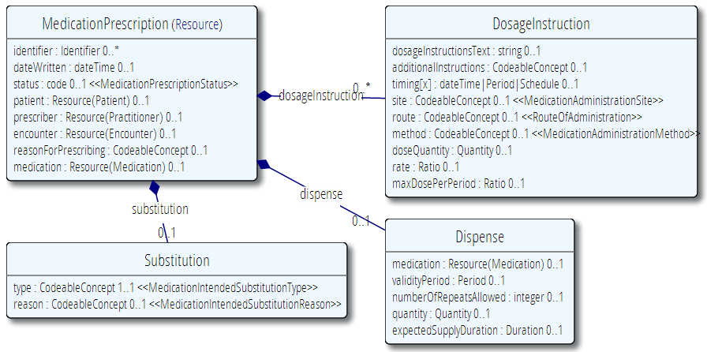

### vMR

The concept of a medication prescription is modeled in the vMR as a SubstanceAdministrationOrder associated with a SubstanceDispenseOrder using a related clinical statement with targetRole code of ‘Dispense’. The substitution fields have been added to SubstanceAdministrationOrder.

|  |  |  |  |  |  |  |  |
| --- | --- | --- | --- | --- | --- | --- | --- |
| FHIR | | | | vMR | | | |
| Name | **Type** | **Card.** | **Definition** | **Name** | **Type** | **Card.** | **Definition** |
| MedicationPresciption |  |  | An order for both supply of the medication and the instructions for administration of the medicine to a patient. | **SubstanceAdministration**  **Order** |  |  | A clinical order for a substance administration. Includes medication prescriptions. |
| identifier | Identifier | 0..* | External identifier - one that would be used by another non-FHIR system - for example a re-imbursement system might issue its own id for each prescription that is created. This is particularly important where FHIR only provides part of an erntire workflow process where records have to be tracked through an entire system. | id | II | 0..1 | A unique ID of this clinical statement for reference purposes. It must be provided if user wants it returned as part of any output, otherwise it will be auto-generated, if needed, by CDS system. Does not need to be the actual ID of the source system. |
| dateWritten | dateTime | 0..1 | The date (and perhaps time) when the prescription was written. | orderEventTime | IVL_TS | 0..1 | Time when order was made. |
| status | Code | 0..1 | A code specifying the state of the order. Generally this will be active or completed state. | No equivalent |  |  |  |
| patient | Patient | 0..1 | A link to a resource representing the person to whom the medication will be given. | VMR.patient | Evaluated Person | 1..1 |  |
| prescriber | Practitioner | 0..1 | The healthcare professional responsible for authorising the prescription. | No equivalent |  |  | Recommendation – introduce Practitioner class |
| encounter | Encounter | 0..1 | A link to a resource that identifies the particular occurrence of contact between patient and health care provider. | Partial equivalence |  |  | Use a related clinical statement to an encounter event. |
| reasonForPrescribing | Codeable  Concept | 0..1 | Can be the reason or the indication for writing the prescription. | prnReason | CD | 0..* | Indication for the proposed procedure such as shortness of breath; Reasons such as "SpO2 less than x%" should be addressed as a PRN Instruction rather than a PRN Reason as it is unlikely that a value set can be identified for such range of possible observations. For example, Pain, Shortness of Breath, Insomnia, Nausea.  If this attribute is specified, it implies that the substance administration is prn (i.e., as needed).  If trying to further characterize the prnReason, use the available comment attribute rather than the narrative attribute of the CodeableConcept. |
| medication | Medication | 0..1 | Identifies the medication being administered. This is either a link to a resource representing the details of the medication or a simple attribute carrying a code that identifies the medication from a known list of medications. | substance | Administrable  Substance | 1..1 | A material of a particular constitution that can be given to a person to enable a clinical effect. |
| dosageInstruction |  | 0..* | Indicates how the medication is to be used by the patient. | No equivalent |  |  | Propose adding to new Dose type |
| dosageInstruction.  dosageInstructionText | String | 0..1 | Free text dosage instructions for cases where the instructions are too complex to code. | No equivalent |  |  | Propose adding to new Dose type |
| dosageInstruction.  additionalInstructions | Codeable  Concept | 0..1 | Additional instructions such as "Swallow with plenty of water" which may or may not be coded. | No equivalent |  |  | Propose adding to new Dose type |
| dosageInstruction.  timing | dateTime OR Period OR Schedule | 0..1 | The timing schedule for giving the medication to the patient. The Schedule data type allows many different expressions, for example. "Every 8 hours"; "Three times a day"; "1/2 an hour before breakfast for 10 days from 23-Dec 2011:"; "15 Oct 2013, 17 Oct 2013 and 1 Nov 2013". | frequency | BaseFrequency | 0..1 | The interval in between substance administrations. For instance, 'Every 8 hours', TID, BID, q8h, etc... Frequency may be represented as either a code or as an interval. |
| dosageInstruction.  site | Codeable Concept | 0..1 | A coded specification of the anatomic site where the medication first enters the body. | approachBodySite | BodySite | 0..1 | The body site used for gaining access to the target body site for the purposes of the substance administration. |
| dosageInstruction.  route | Codeable  Concept | 0..1 | A code specifying the route or physiological path of administration of a therapeutic agent into or onto a patient. | deliveryRoute | CD | 0..1 | The physical route through which the substance is administered. E.g., IV, PO. |
| dosageInstruction.  method | Codeable  Concept | 0..1 | A coded value indicating the method by which the medication is introduced into or onto the body. Most commonly used for injections. Examples: Slow Push; Deep IV. Terminologies used often pre-coordinate this term with the route and or form of administration. | deliveryMethod | CD | 0..1 | Methodology used to administer the substance. E.g., gastric feeding tube, gastrostomy, drip |
| dosageInstruction.  doseQuantity | Quantity | 0..1 | The amount of the therapeutic or other substance given at one administration event. | doseQuantity | IVL_PQ | 0..1 | The amount of substance. E.g., 1 tab, 325 mg, 1-2 tabs. |
| dosageInstruction.  rate | Ratio | 0..1 | Identifies the speed with which the substance is introduced into the subject. Typically the rate for an infusion. 200ml in 2 hours. | deliveryRate | IVL_PQ | 0..1 | Rate of substance administration. E.g., 1000 mL/hr. |
| dosageInstruction.  maxDosePerPeriod | Ratio | 0..1 | The maximum total quantity of a therapeutic substance that my be administered to a subject over the period of time. E.g. 1000mg in 24 hours. | DoseRestriction | Dose Restriction | 0..1 | Specifies the maximum dose that can be given in a specified time interval. |
| dispense | Dispense | 0..1 | Deals with details of the dispense part of the order. | dispense | Substance  Dispense  Order | 0..1 | Via a related clinical statement with targetCode ‘Dispense’ |
| dispense.  medication | Medication | 0..1 | Identifies the medication that is to be dispensed. This may be a more specifically defined than the medicationPrescription.medication . This is either a link to a resource representing the details of the medication or a simple attribute carrying a code that identifies the medication from a known list of medications. | dispense.substance | Administrable  Substance | 1..1 | A material of a particular constitution that can be given to a person to enable a clinical effect. |
| dispense.  validityPeriod | Period | 0..1 | Design Comments: This indicates the validity period of a prescription (stale dating the Prescription) It reflects the prescriber perspective for the validity of the prescription. Dispenses must not be made against the prescription outside of this period. The lower-bound of the Dispensing Window signifies the earliest date that the prescription can be filled for the first time. If an upper-bound is not specified then the Prescription is open-ended or will default to a stale-date based on regulations. Rationale: Indicates when the Prescription becomes valid, and when it ceases to be a dispensable Prescription. | No equivalent |  |  | Recommend adding to model validDispenseTimeInterval |
| dispense.  numberOfRepeatsAllowed | Integer | 0..1 | An integer indicating the number of repeats of the Dispense. UsageNotes: For example, the number of times the prescribed quantity is to be supplied including the initial standard fill. | No equivalent |  |  | Recommend adding numberOfFillsAllowed. |
| dispense.  quantity | Quantity | 0..1 | The amount that is to be dispensed. | dispense.dispenseQuantity | PQ | 0..1 | The amount of substance provided. |
| dispense.  extractedSupplyDuration | Duration | 0..1 | Identifies the period time over which the supplied product is expected to be used, or the length of time the dispense is expected to last. In some situations, this attribute may be used instead of quantity to identify the amount supplied by how long it is expected to last, rather than the physical quantity issued. E.g. 90 days supply of medication (based on an ordered dosage) When possible, it is always better to specify quantity, as this tends to be more precise. expectedSupplyDuration will always be an estimate that can be influenced by external factors. | No equivalent |  |  | Recommend adding |
| dispense.  substitution |  | 0..1 | Indicates whether or not substitution can or should as part of the dispense. In some cases substitution must happen, in other cases substitution must not happen, and in others it does not matter. This block explains the prescribers intent. If nothing is specified substitution may be done. | No equivalent |  |  | Recommend adding |
| dispense.  substitution.  type | Codeable  Concept | 1..1 | A code signifying whether a different drug should be dispensed from what was prescribed. | No equivalent |  |  | Recommend adding |
| dispense.  substitution.  reason | Codeable  Concept | 0..1 | Indicates the reason for the substitution why substitution must or must not be performed. | No equivalent |  |  | Recommend adding |

## Recommendations for Change

1. Pull dose out of SubstanceAdministrationBase into separate class of 1..* cardinality. Reasons:
   1. Many medication orderables have multiple doses such as PCA (loading dose, demand dose), chemotherapy infusions (initial rate, incremental rates), other IVs (bolus dose, rate), etc…
2. Introduce Practitioner and refactor EvaluatedPerson and Person so that common demographic attributes can be shared
   1. Important for both context of care and also as the source for a particular order or statement.
3. Introduce VaccinationProtocol
4. Introduce ingredients in AdministrableSubstance

**Questions**

1. Harmonize AdverseEvent with the FHIR representation?