CIMI_RM_CLINICAL.v0.0.1

The CIMI Reference Model

Author: Claude Nanjo

Revision: 0.1

|  |  |
| --- | --- |
| OpenCIMI.org |  |
| TBD | November 23, 2016 |

**Approval**

|  |
| --- |
| The original of this document is approved and signed by:  Name:  Surname:  Title:  Date:  Signature: |

**Revision History**

|  |  |  |  |
| --- | --- | --- | --- |
| **Revision** | **Date** | **Description** | **Author** |
| 0.2 | <date 2> | <release> | <Author name> |
| 0.1 | <date 1> | <draft> | <Author name> |
|  |  |  |  |

| Table of Contents |
| --- |
| Microsoft Word users please click here and press F9 to create Table of Contents.  OpenOffice.org users please remove this text and select Insert Table of Content from menu. |

| Table of Figures |
| --- |
| Microsoft Word users please click here and press F9 to create Table of Contents.  OpenOffice.org users please remove this text and select Insert Table of Content from menu. |

# **Introduction**

## **Purpose**

This document defines the formal specification of classes that comprise the CIMI reference model. This model is used to generate the CIMI Reference Model Basic Metamodel file (BMM).

## **Scope**

This document is intended to be used as the normative specification of the CIMI Reference Model

## **Model Specification**

This document provides a list of all packages with a summary for each. Each package has a section that contains a list of its classes, interfaces and enumeration type, with a summary for each. Class and Interface contains description, summary tables, detailed member descriptions, and relation table.

# **Package CIMI Clinical**

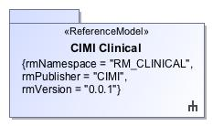

1. CIMI Clinical

|  |  |
| --- | --- |
| **Name** | CIMI Clinical |
| **Qualified Name** | CIMI Clinical |

# **Package CIMI Clinical::ClinicalStatement**

|  |  |
| --- | --- |
| **Name** | ClinicalStatement |
| **Qualified Name** | CIMI Clinical::ClinicalStatement |

## **Class** **ClinicalStatement**

The documentation of clinical information about a subject of information such as a patient or a relative of the patient, asserted by a particular source, recorded, and potentially verified. The ClinicalStatement class provides the core pattern for more specific clinical statement archetypes, such as a statement that a finding has been found in a patient or that a procedure has been proposed by a clinical decision support system.The ClinicalStatement pattern defines the core attributes common to most clinical statements and specifies a composition pattern that encourage model component reuse and better alignment with the SNOMED CT Concept Model. A clinical statement is composed of the StatementTopic class (grouping of attributes for capturing information about a procedure or a clinical finding) and the StatementContext class (grouping of attributes providing the context for the statement topic such as whether a procedure was performed, requested, not performed or whether a finding is suspected present or absent in the patient). At the archetype level, the topic and context components are coordinated to form the clinical statement. For instance, the composition of the ProcedureTopic with the NotPerformed context indicates that the given procedure was not performed.

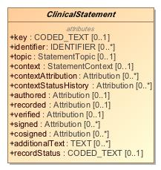

1. ClinicalStatement

|  |  |
| --- | --- |
| **Name** | ClinicalStatement |
| **Qualified Name** | CIMI Clinical::ClinicalStatement::ClinicalStatement |
| **Visibility** | public |
| **Abstract** | true |
| **Base Classifier** | * ENTRY |
| **Realized Interface** |  |

### **Attribute Detail**

#### additionalText

Unstructured notes appended to a clinical statement.

|  |  |
| --- | --- |
| **Type** | TEXT |
| **Default Value** |  |
| **Visibility** | public |
| **Multiplicity** | 0..* |

#### authored

Provenance information specific to the assertion being made (e.g., the author(s), when authored, the location where the assertion was made, etc...).

|  |  |
| --- | --- |
| **Type** | Attribution |
| **Default Value** |  |
| **Visibility** | public |
| **Multiplicity** | 0..1 |

#### context

Attribute aligns with the SNOMED CT Situation with Explicit Context Concept Model context attributes 'Finding context (attribute)' (SCTID: 408729009) and 'Procedure context (attribute)' (SCTID: 408730004). The range of this attribute is a structure (StatementContext) rather than a value set. The context of the clinical statement must align with the range specified by the SWEC Concept Model. For instance, if the 'context' attribute's meaning is bound to 'Finding context', then the context may not be a specialization of the ActionContext statement context. Instead, it should be a specialization of the FindingContext statement context.

|  |  |
| --- | --- |
| **Type** | StatementContext |
| **Default Value** |  |
| **Visibility** | public |
| **Multiplicity** | 0..1 |

#### contextAttribution

The attribution for the given context such as the who, what, when, where, how (e.g., origination mode) responsible for proposing, planning, ordering and authorizing, etc... Note that one may also use provenance if provenance information is preferred to be external to the resource.The contextAttribution attribute is intended to be constrained appropriately within CIMI archetypes.

|  |  |
| --- | --- |
| **Type** | Attribution |
| **Default Value** |  |
| **Visibility** | public |
| **Multiplicity** | 0..* |

#### contextStatusHistory

A record of the states for an action in a specified action context, e.g., an order may evolve from draft to placed to in progress to completed or canceled.The use of Attribution rather than a simple code for status supports the consistent capture of additional metadata associated with the specified status. For instance, if the proposal was declined, who declined it, when was it declined, and so on ...

|  |  |
| --- | --- |
| **Type** | Attribution |
| **Default Value** |  |
| **Visibility** | public |
| **Multiplicity** | 0..* |

#### cosigned

Provenance information specific to the cosigning of the clinical statement.

|  |  |
| --- | --- |
| **Type** | Attribution |
| **Default Value** |  |
| **Visibility** | public |
| **Multiplicity** | 0..* |

#### identifier

The unique identifier(s) of this clinical statement. It must be provided if user wants it returned as part of any output, otherwise it will be auto-generated, if needed, by the system serving the record. An identifier does not need to be the actual identifier of the source system.

|  |  |
| --- | --- |
| **Type** | IDENTIFIER |
| **Default Value** |  |
| **Visibility** | public |
| **Multiplicity** | 0..* |

#### key

The 'key' attribute is an optional attribute allowing the coding of some of the information represented by the clinical statement. The range of this attribute (i.e., allowable codes assigned as a value for this attribute) must derive from and conform with the SNOMED CT Situation with Explicit Context (SWEC) concept hierarchies defined in SNOMED CT. Note that this attribute may consist of precoordinated codes (not recommended) or SNOMED CT expressions.

|  |  |
| --- | --- |
| **Type** | CODED_TEXT |
| **Default Value** |  |
| **Visibility** | public |
| **Multiplicity** | 0..1 |

#### recorded

Provenance information specific to the recording of the clinical statement (e.g., when recorded, where recorded, etc...).

|  |  |
| --- | --- |
| **Type** | Attribution |
| **Default Value** |  |
| **Visibility** | public |
| **Multiplicity** | 0..1 |

#### recordStatus

Concept indicating the state of this record. E.g., 'entered in error'.

|  |  |
| --- | --- |
| **Type** | CODED_TEXT |
| **Default Value** |  |
| **Visibility** | public |
| **Multiplicity** | 0..1 |

#### signed

Provenance information specific to the signing of the clinical statement.

|  |  |
| --- | --- |
| **Type** | Attribution |
| **Default Value** |  |
| **Visibility** | public |
| **Multiplicity** | 0..* |

#### topic

Attribute aligns with the SNOMED CT Situation with Explicit Context (SWEC) Concept Model attributes 'Associated finding (attribute)' (SCTID: 246090004) and 'Associated procedure (attribute)' (SCTID: 363589002). The range of this attribute is a structure (StatementTopic) rather than a value set. The topic of the clinical statement must align with the range specified by the SWEC Concept Model. For instance, if the 'topic' attribute's meaning is bound to 'Associated finding', then the topic may not be a specialization of the Act statement topic.

|  |  |
| --- | --- |
| **Type** | StatementTopic |
| **Default Value** |  |
| **Visibility** | public |
| **Multiplicity** | 0..1 |

#### verified

Provenance information specific to the verification process associated with this statement (e.g., verifier, verification method, when verified, etc...).

|  |  |
| --- | --- |
| **Type** | Attribution |
| **Default Value** |  |
| **Visibility** | public |
| **Multiplicity** | 0..1 |

### **Relation Detail**

#### Association

|  |  |
| --- | --- |
| **Name** |  |
| **Related Element** | * Provenance |

|  |  |
| --- | --- |
| **Name** |  |
| **Related Element** | * EvaluationResult |

|  |  |
| --- | --- |
| **Name** |  |
| **Related Element** | * Assertion |

|  |  |
| --- | --- |
| **Name** |  |
| **Related Element** | * Assertion |

|  |  |
| --- | --- |
| **Name** |  |
| **Related Element** | * Procedure |

|  |  |
| --- | --- |
| **Name** |  |
| **Related Element** | * ClinicalStatementAssociation |

#### Generalization

|  |  |
| --- | --- |
| **Name** |  |
| **Related Element** | * ENTRY |

|  |  |
| --- | --- |
| **Name** |  |
| **Related Element** | * IndivisibleClinicalStatement |

|  |  |
| --- | --- |
| **Name** |  |
| **Related Element** | * CompoundClinicalStatement |

## **Class** **CompoundClinicalStatement**

Clinical statement representing information whose components may have an independent existence outside of the composition. For instance, a laboratory panel.A composite clinical statement may be composed of both indivisible clinical statements or composite clinical statements with arbitrary nesting. Nesting rules can be specified as constraints at the archetype level.

1917427250.jpg

1. CompoundClinicalStatement

|  |  |
| --- | --- |
| **Name** | CompoundClinicalStatement |
| **Qualified Name** | CIMI Clinical::ClinicalStatement::CompoundClinicalStatement |
| **Visibility** | public |
| **Abstract** | false |
| **Base Classifier** | * ClinicalStatement * COMPOUND_ENTRY |
| **Realized Interface** |  |

### **Relation Detail**

#### Generalization

|  |  |
| --- | --- |
| **Name** |  |
| **Related Element** | * COMPOUND_ENTRY |

|  |  |
| --- | --- |
| **Name** |  |
| **Related Element** | * ClinicalStatement |

## **Class** **IndivisibleClinicalStatement**

Clinical statement representing the smallest unit of information capable of having an independent existence. For instance, a standalone hematocrit lab observation. An indivisible clinical statement may also be represented as part of a composite clinical statement such as a panel.

269038031.jpg

1. IndivisibleClinicalStatement

|  |  |
| --- | --- |
| **Name** | IndivisibleClinicalStatement |
| **Qualified Name** | CIMI Clinical::ClinicalStatement::IndivisibleClinicalStatement |
| **Visibility** | public |
| **Abstract** | false |
| **Base Classifier** | * ClinicalStatement * INDIVISIBLE_ENTRY |
| **Realized Interface** |  |

### **Relation Detail**

#### Generalization

|  |  |
| --- | --- |
| **Name** |  |
| **Related Element** | * INDIVISIBLE_ENTRY |

|  |  |
| --- | --- |
| **Name** |  |
| **Related Element** | * ClinicalStatement |

# **Package CIMI Clinical::Data Structure**

|  |  |
| --- | --- |
| **Name** | Data Structure |
| **Qualified Name** | CIMI Clinical::Data Structure |

## **Class** **Absent**

2060831585.jpg

1. Absent

|  |  |
| --- | --- |
| **Name** | Absent |
| **Qualified Name** | CIMI Clinical::Data Structure::Absent |
| **Visibility** | public |
| **Abstract** | false |
| **Base Classifier** | * PresenceAbsenceContext |
| **Realized Interface** |  |

### **Relation Detail**

#### Generalization

|  |  |
| --- | --- |
| **Name** |  |
| **Related Element** | * PresenceAbsenceContext |

## **Class** **Accreditation**

Type supporting the capture of accreditation information.

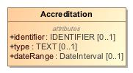

1. Accreditation

|  |  |
| --- | --- |
| **Name** | Accreditation |
| **Qualified Name** | CIMI Clinical::Data Structure::Accreditation |
| **Visibility** | public |
| **Abstract** | false |
| **Base Classifier** | * CLUSTER |
| **Realized Interface** |  |

### **Attribute Detail**

#### dateRange

The period of validity for the accreditation.IS THIS CORRECT?

|  |  |
| --- | --- |
| **Type** | DateInterval |
| **Default Value** |  |
| **Visibility** | public |
| **Multiplicity** | 0..1 |

#### identifier

An identifier for the accreditation.

|  |  |
| --- | --- |
| **Type** | IDENTIFIER |
| **Default Value** |  |
| **Visibility** | public |
| **Multiplicity** | 0..1 |

#### type

The type of accreditation.

|  |  |
| --- | --- |
| **Type** | TEXT |
| **Default Value** |  |
| **Visibility** | public |
| **Multiplicity** | 0..1 |

### **Relation Detail**

#### Generalization

|  |  |
| --- | --- |
| **Name** |  |
| **Related Element** | * CLUSTER |

## **Class** **Act**

Description of a healthcare action, independent of action context.

-518662276.jpg

1. Act

|  |  |
| --- | --- |
| **Name** | Act |
| **Qualified Name** | CIMI Clinical::Data Structure::Act |
| **Visibility** | public |
| **Abstract** | true |
| **Base Classifier** | * StatementTopic |
| **Realized Interface** |  |

### **Relation Detail**

#### Generalization

|  |  |
| --- | --- |
| **Name** |  |
| **Related Element** | * StatementTopic |

|  |  |
| --- | --- |
| **Name** |  |
| **Related Element** | * Procedure |

## **Class** **ActionContext**

The ActionContext class aligns with the SNOMED Situations with Explicit Context and provides the context for the Act topic of a clinical statement. For instance, a statement about a procedure may specify that the procedure has been proposed, ordered, planned, performed or possibly not performed.

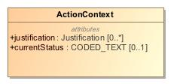

1. ActionContext

|  |  |
| --- | --- |
| **Name** | ActionContext |
| **Qualified Name** | CIMI Clinical::Data Structure::ActionContext |
| **Visibility** | public |
| **Abstract** | false |
| **Base Classifier** | * StatementContext |
| **Realized Interface** |  |

### **Attribute Detail**

#### currentStatus

The latest status of an action within the specified context. An action may be interpretable within a specific context such as whether it is planned, ordered, or performed. Moreover, within each of these context, an action may have a set of allowable states in which it can exist. For instance, a proposal may be rejected or an order may be signed, canceled or superceded by another order. It is expected that set of such states will vary based on the type of action context. The status code must coincide with the activity code of one of the attribution elements of statusHistory.

|  |  |
| --- | --- |
| **Type** | CODED_TEXT |
| **Default Value** |  |
| **Visibility** | public |
| **Multiplicity** | 0..1 |

#### justification

Reason or justification for the action. Reasons may also be specified for not performing an action.

|  |  |
| --- | --- |
| **Type** | Justification |
| **Default Value** |  |
| **Visibility** | public |
| **Multiplicity** | 0..* |

### **Relation Detail**

#### Generalization

|  |  |
| --- | --- |
| **Name** |  |
| **Related Element** | * Plan |

|  |  |
| --- | --- |
| **Name** |  |
| **Related Element** | * ProposalAgainst |

|  |  |
| --- | --- |
| **Name** |  |
| **Related Element** | * Performance |

|  |  |
| --- | --- |
| **Name** |  |
| **Related Element** | * StatementContext |

|  |  |
| --- | --- |
| **Name** |  |
| **Related Element** | * NotPerformance |

|  |  |
| --- | --- |
| **Name** |  |
| **Related Element** | * Proposal |

|  |  |
| --- | --- |
| **Name** |  |
| **Related Element** | * Order |

## **Class** **ActorName**

The name of an actor - typically either the name of a person or of an organization.

800985597.jpg

1. ActorName

|  |  |
| --- | --- |
| **Name** | ActorName |
| **Qualified Name** | CIMI Clinical::Data Structure::ActorName |
| **Visibility** | public |
| **Abstract** | true |
| **Base Classifier** | * PartyName |
| **Realized Interface** |  |

### **Relation Detail**

#### Generalization

|  |  |
| --- | --- |
| **Name** |  |
| **Related Element** | * PartyName |

|  |  |
| --- | --- |
| **Name** |  |
| **Related Element** | * PersonName |

|  |  |
| --- | --- |
| **Name** |  |
| **Related Element** | * OrganizationName |

## **Class** **Address**

Type representing an address.

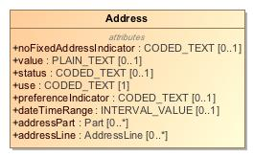

1. Address

|  |  |
| --- | --- |
| **Name** | Address |
| **Qualified Name** | CIMI Clinical::Data Structure::Address |
| **Visibility** | public |
| **Abstract** | false |
| **Base Classifier** | * CLUSTER |
| **Realized Interface** |  |

### **Attribute Detail**

#### addressLine

An address line.

|  |  |
| --- | --- |
| **Type** | AddressLine |
| **Default Value** |  |
| **Visibility** | public |
| **Multiplicity** | 0..* |

#### addressPart

An address component that is not an address line.

|  |  |
| --- | --- |
| **Type** | Part |
| **Default Value** |  |
| **Visibility** | public |
| **Multiplicity** | 0..* |

#### dateTimeRange

Period when address was in effect.

|  |  |
| --- | --- |
| **Type** | INTERVAL_VALUE |
| **Default Value** |  |
| **Visibility** | public |
| **Multiplicity** | 0..1 |

#### noFixedAddressIndicator

Code indicating if person has no fixed address.

|  |  |
| --- | --- |
| **Type** | CODED_TEXT |
| **Default Value** |  |
| **Visibility** | public |
| **Multiplicity** | 0..1 |

#### preferenceIndicator

Code indicating whether this address is preferred.

|  |  |
| --- | --- |
| **Type** | CODED_TEXT |
| **Default Value** |  |
| **Visibility** | public |
| **Multiplicity** | 0..1 |

#### status

NEED DEFINITION AND EXAMPLES

|  |  |
| --- | --- |
| **Type** | CODED_TEXT |
| **Default Value** |  |
| **Visibility** | public |
| **Multiplicity** | 0..1 |

#### use

Code indicating use preference for this address.

|  |  |
| --- | --- |
| **Type** | CODED_TEXT |
| **Default Value** |  |
| **Visibility** | public |
| **Multiplicity** | 1 |

#### value

NEED DEFINITION

|  |  |
| --- | --- |
| **Type** | PLAIN_TEXT |
| **Default Value** |  |
| **Visibility** | public |
| **Multiplicity** | 0..1 |

### **Relation Detail**

#### Generalization

|  |  |
| --- | --- |
| **Name** |  |
| **Related Element** | * CLUSTER |

## **Class** **AddressLine**

An address line.

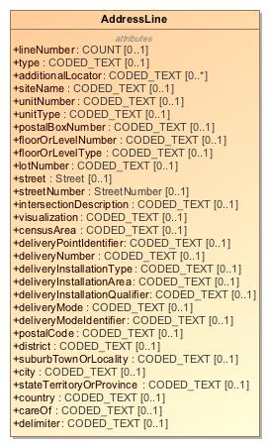

1. AddressLine

|  |  |
| --- | --- |
| **Name** | AddressLine |
| **Qualified Name** | CIMI Clinical::Data Structure::AddressLine |
| **Visibility** | public |
| **Abstract** | false |
| **Base Classifier** | * CLUSTER |
| **Realized Interface** |  |

### **Attribute Detail**

#### additionalLocator

NEED DEFINITION

|  |  |
| --- | --- |
| **Type** | CODED_TEXT |
| **Default Value** |  |
| **Visibility** | public |
| **Multiplicity** | 0..* |

#### careOf

Care of information.

|  |  |
| --- | --- |
| **Type** | CODED_TEXT |
| **Default Value** |  |
| **Visibility** | public |
| **Multiplicity** | 0..1 |

#### censusArea

The census area.

|  |  |
| --- | --- |
| **Type** | CODED_TEXT |
| **Default Value** |  |
| **Visibility** | public |
| **Multiplicity** | 0..1 |

#### city

The city code.

|  |  |
| --- | --- |
| **Type** | CODED_TEXT |
| **Default Value** |  |
| **Visibility** | public |
| **Multiplicity** | 0..1 |

#### country

The country

|  |  |
| --- | --- |
| **Type** | CODED_TEXT |
| **Default Value** |  |
| **Visibility** | public |
| **Multiplicity** | 0..1 |

#### delimiter

NEED DEFINITION

|  |  |
| --- | --- |
| **Type** | CODED_TEXT |
| **Default Value** |  |
| **Visibility** | public |
| **Multiplicity** | 0..1 |

#### deliveryInstallationArea

NEED DEFINITION

|  |  |
| --- | --- |
| **Type** | CODED_TEXT |
| **Default Value** |  |
| **Visibility** | public |
| **Multiplicity** | 0..1 |

#### deliveryInstallationQualifier

NEED DEFINITION

|  |  |
| --- | --- |
| **Type** | CODED_TEXT |
| **Default Value** |  |
| **Visibility** | public |
| **Multiplicity** | 0..1 |

#### deliveryInstallationType

NEED DEFINITION

|  |  |
| --- | --- |
| **Type** | CODED_TEXT |
| **Default Value** |  |
| **Visibility** | public |
| **Multiplicity** | 0..1 |

#### deliveryMode

NEED DEFINITION

|  |  |
| --- | --- |
| **Type** | CODED_TEXT |
| **Default Value** |  |
| **Visibility** | public |
| **Multiplicity** | 0..1 |

#### deliveryModeIdentifier

NEED DEFINITION

|  |  |
| --- | --- |
| **Type** | CODED_TEXT |
| **Default Value** |  |
| **Visibility** | public |
| **Multiplicity** | 0..1 |

#### deliveryNumber

The delivery number.

|  |  |
| --- | --- |
| **Type** | CODED_TEXT |
| **Default Value** |  |
| **Visibility** | public |
| **Multiplicity** | 0..1 |

#### deliveryPointIdentifier

The delivery point identifier.

|  |  |
| --- | --- |
| **Type** | CODED_TEXT |
| **Default Value** |  |
| **Visibility** | public |
| **Multiplicity** | 0..1 |

#### district

The district code.

|  |  |
| --- | --- |
| **Type** | CODED_TEXT |
| **Default Value** |  |
| **Visibility** | public |
| **Multiplicity** | 0..1 |

#### floorOrLevelNumber

The floor or level of the residence or business.

|  |  |
| --- | --- |
| **Type** | CODED_TEXT |
| **Default Value** |  |
| **Visibility** | public |
| **Multiplicity** | 0..1 |

#### floorOrLevelType

The type of floor or level.

|  |  |
| --- | --- |
| **Type** | CODED_TEXT |
| **Default Value** |  |
| **Visibility** | public |
| **Multiplicity** | 0..1 |

#### intersectionDescription

Information about the nearest intersection.

|  |  |
| --- | --- |
| **Type** | CODED_TEXT |
| **Default Value** |  |
| **Visibility** | public |
| **Multiplicity** | 0..1 |

#### lineNumber

The number of this address line in a multi-line address.

|  |  |
| --- | --- |
| **Type** | COUNT |
| **Default Value** |  |
| **Visibility** | public |
| **Multiplicity** | 0..1 |

#### lotNumber

The number of the lot.

|  |  |
| --- | --- |
| **Type** | CODED_TEXT |
| **Default Value** |  |
| **Visibility** | public |
| **Multiplicity** | 0..1 |

#### postalBoxNumber

A P.O. Box number.

|  |  |
| --- | --- |
| **Type** | CODED_TEXT |
| **Default Value** |  |
| **Visibility** | public |
| **Multiplicity** | 0..1 |

#### postalCode

The postal or zip code.

|  |  |
| --- | --- |
| **Type** | CODED_TEXT |
| **Default Value** |  |
| **Visibility** | public |
| **Multiplicity** | 0..1 |

#### siteName

The name of the site.

|  |  |
| --- | --- |
| **Type** | CODED_TEXT |
| **Default Value** |  |
| **Visibility** | public |
| **Multiplicity** | 0..1 |

#### stateTerritoryOrProvince

The state or territory or province code.

|  |  |
| --- | --- |
| **Type** | CODED_TEXT |
| **Default Value** |  |
| **Visibility** | public |
| **Multiplicity** | 0..1 |

#### street

Information about the street.

|  |  |
| --- | --- |
| **Type** | Street |
| **Default Value** |  |
| **Visibility** | public |
| **Multiplicity** | 0..1 |

#### streetNumber

The number of the location on the street.

|  |  |
| --- | --- |
| **Type** | StreetNumber |
| **Default Value** |  |
| **Visibility** | public |
| **Multiplicity** | 0..1 |

#### suburbTownOrLocality

The suburb, town, or locality code.

|  |  |
| --- | --- |
| **Type** | CODED_TEXT |
| **Default Value** |  |
| **Visibility** | public |
| **Multiplicity** | 0..1 |

#### type

NEED DEFINITION

|  |  |
| --- | --- |
| **Type** | CODED_TEXT |
| **Default Value** |  |
| **Visibility** | public |
| **Multiplicity** | 0..1 |

#### unitNumber

The number of the unit.

|  |  |
| --- | --- |
| **Type** | CODED_TEXT |
| **Default Value** |  |
| **Visibility** | public |
| **Multiplicity** | 0..1 |

#### unitType

The type of unit.

|  |  |
| --- | --- |
| **Type** | CODED_TEXT |
| **Default Value** |  |
| **Visibility** | public |
| **Multiplicity** | 0..1 |

#### visualization

NEED DEFINITION

|  |  |
| --- | --- |
| **Type** | CODED_TEXT |
| **Default Value** |  |
| **Visibility** | public |
| **Multiplicity** | 0..1 |

### **Relation Detail**

#### Generalization

|  |  |
| --- | --- |
| **Name** |  |
| **Related Element** | * CLUSTER |

## **Class** **AdvanceDirective**

Type supporting the capture of information regarding a patient advance directive.

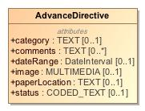

1. AdvanceDirective

|  |  |
| --- | --- |
| **Name** | AdvanceDirective |
| **Qualified Name** | CIMI Clinical::Data Structure::AdvanceDirective |
| **Visibility** | public |
| **Abstract** | false |
| **Base Classifier** | * CLUSTER |
| **Realized Interface** |  |

### **Attribute Detail**

#### category

NEED DEFINITION

|  |  |
| --- | --- |
| **Type** | TEXT |
| **Default Value** |  |
| **Visibility** | public |
| **Multiplicity** | 0..1 |

#### comments

Additional notes or instructions concerning the directive.

|  |  |
| --- | --- |
| **Type** | TEXT |
| **Default Value** |  |
| **Visibility** | public |
| **Multiplicity** | 0..* |

#### dateRange

NEED DEFINITION

|  |  |
| --- | --- |
| **Type** | DateInterval |
| **Default Value** |  |
| **Visibility** | public |
| **Multiplicity** | 0..1 |

#### image

The actual directive document

|  |  |
| --- | --- |
| **Type** | MULTIMEDIA |
| **Default Value** |  |
| **Visibility** | public |
| **Multiplicity** | 0..1 |

#### paperLocation

NEED DEFINITION

|  |  |
| --- | --- |
| **Type** | TEXT |
| **Default Value** |  |
| **Visibility** | public |
| **Multiplicity** | 0..1 |

#### status

NEED DEFINITION WITH EXAMPLES

|  |  |
| --- | --- |
| **Type** | CODED_TEXT |
| **Default Value** |  |
| **Visibility** | public |
| **Multiplicity** | 0..1 |

### **Relation Detail**

#### Generalization

|  |  |
| --- | --- |
| **Name** |  |
| **Related Element** | * CLUSTER |

## **Class** **Age**

Type for the capture of age-related information.

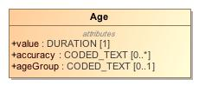

1. Age

|  |  |
| --- | --- |
| **Name** | Age |
| **Qualified Name** | CIMI Clinical::Data Structure::Age |
| **Visibility** | public |
| **Abstract** | false |
| **Base Classifier** | * CLUSTER |
| **Realized Interface** |  |

### **Attribute Detail**

#### accuracy

The accuracy of the age data.

|  |  |
| --- | --- |
| **Type** | CODED_TEXT |
| **Default Value** |  |
| **Visibility** | public |
| **Multiplicity** | 0..* |

#### ageGroup

Code for the age group - e.g., neonatal, infant, pre-adolescent, etc...

|  |  |
| --- | --- |
| **Type** | CODED_TEXT |
| **Default Value** |  |
| **Visibility** | public |
| **Multiplicity** | 0..1 |

#### value

The age of the entity.

|  |  |
| --- | --- |
| **Type** | DURATION |
| **Default Value** |  |
| **Visibility** | public |
| **Multiplicity** | 1 |

### **Relation Detail**

#### Generalization

|  |  |
| --- | --- |
| **Name** |  |
| **Related Element** | * CLUSTER |

## **Class** **AnatomicalLocation**

A part of the body.

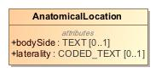

1. AnatomicalLocation

|  |  |
| --- | --- |
| **Name** | AnatomicalLocation |
| **Qualified Name** | CIMI Clinical::Data Structure::AnatomicalLocation |
| **Visibility** | public |
| **Abstract** | false |
| **Base Classifier** | * MaterialEntity |
| **Realized Interface** |  |

### **Attribute Detail**

#### bodySide

The body side.

|  |  |
| --- | --- |
| **Type** | TEXT |
| **Default Value** |  |
| **Visibility** | public |
| **Multiplicity** | 0..1 |

#### laterality

The laterality of the site.

|  |  |
| --- | --- |
| **Type** | CODED_TEXT |
| **Default Value** |  |
| **Visibility** | public |
| **Multiplicity** | 0..1 |

### **Relation Detail**

#### Generalization

|  |  |
| --- | --- |
| **Name** |  |
| **Related Element** | * MaterialEntity |

## **Class** **Assertion**

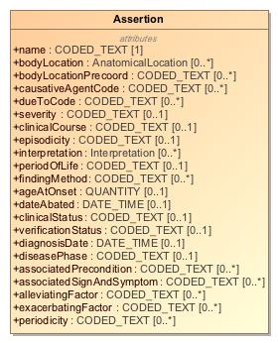

1. Assertion

|  |  |
| --- | --- |
| **Name** | Assertion |
| **Qualified Name** | CIMI Clinical::Data Structure::Assertion |
| **Visibility** | public |
| **Abstract** | false |
| **Base Classifier** | * Finding |
| **Realized Interface** |  |

### **Attribute Detail**

#### ageAtOnset

The age of the patient or subject at onset of the Condition. Note that this property could potentially be derived.

|  |  |
| --- | --- |
| **Type** | QUANTITY |
| **Default Value** |  |
| **Visibility** | public |
| **Multiplicity** | 0..1 |

#### alleviatingFactor

The action or intervention which makes a symptom less severe. Examples of data from the value set may include: rest, heat, ice, etc. [TO ADDRESS: we may need a semantic scope: are these substances or procedures? Procedures, with the assumption that if you put in a substance it means “application (procedure)”?

|  |  |
| --- | --- |
| **Type** | CODED_TEXT |
| **Default Value** |  |
| **Visibility** | public |
| **Multiplicity** | 0..* |

#### associatedPrecondition

Previously existing conditions or states that could affect a measurement or assesment. For example; a patients weight taken while clothed, a patients height with or without shoes, a patients blood pressure taken while standing or lying down.

|  |  |
| --- | --- |
| **Type** | CODED_TEXT |
| **Default Value** |  |
| **Visibility** | public |
| **Multiplicity** | 0..* |

#### associatedSignAndSymptom

Physical observations captured by a clinician or subjective conditions experienced by a patient that are related to a medical condition.

|  |  |
| --- | --- |
| **Type** | CODED_TEXT |
| **Default Value** |  |
| **Visibility** | public |
| **Multiplicity** | 0..* |

#### bodyLocation

The body site affected by a condition.

|  |  |
| --- | --- |
| **Type** | AnatomicalLocation |
| **Default Value** |  |
| **Visibility** | public |
| **Multiplicity** | 0..* |

#### bodyLocationPrecoord

The body site affected by a condition.

|  |  |
| --- | --- |
| **Type** | CODED_TEXT |
| **Default Value** |  |
| **Visibility** | public |
| **Multiplicity** | 0..* |

#### causativeAgent

|  |  |
| --- | --- |
| **Type** | ClinicalStatement |
| **Default Value** |  |
| **Visibility** | public |
| **Multiplicity** | 0..* |

#### causativeAgentCode

An exogenous physical substance or force that causes the disease. It does not include vectors, e.g. a mosquito that transmits malaria.

|  |  |
| --- | --- |
| **Type** | CODED_TEXT |
| **Default Value** |  |
| **Visibility** | public |
| **Multiplicity** | 0..* |

#### clinicalCourse

Both the course and onset of a disease. Many conditions with an acute (sudden) onset also have an acute (short duration) course. Few diseases with a chronic (long - term) course would need to have their onset sub-divided into rapid or gradual subtypes, and thus there is no clear need for separating the rapidity of onset from the duration of a disease; based on testing by implementers and modelers, a single attribute with values that combine these meanings has clearly been more reproducibleand useful than two attributes that attempt to separate the meanings.

|  |  |
| --- | --- |
| **Type** | CODED_TEXT |
| **Default Value** |  |
| **Visibility** | public |
| **Multiplicity** | 0..1 |

#### clinicalStatus

The physiological state of the condition with respect to whether it is actually of concern. Values may typicall include: Active, Relapse, Remission, Resolved, Confirmed, Ruled out, Unknown

|  |  |
| --- | --- |
| **Type** | CODED_TEXT |
| **Default Value** |  |
| **Visibility** | public |
| **Multiplicity** | 0..1 |

#### dateAbated

Date, if known, when clinical finding abated.

|  |  |
| --- | --- |
| **Type** | DATE_TIME |
| **Default Value** |  |
| **Visibility** | public |
| **Multiplicity** | 0..1 |

#### diagnosisDate

Date and time the health problem was diagnosed. Added for Public Health Reporting Initiative, 10/5/2012.

|  |  |
| --- | --- |
| **Type** | DATE_TIME |
| **Default Value** |  |
| **Visibility** | public |
| **Multiplicity** | 0..1 |

#### diseasePhase

The physiological state of a condition that develops over time. For instance, Incubation period (exposed, asymptomatic), Prodromal (symptoms but not full disease breakout), Acute (full manifestation of disease), Convalescent

|  |  |
| --- | --- |
| **Type** | CODED_TEXT |
| **Default Value** |  |
| **Visibility** | public |
| **Multiplicity** | 0..1 |

#### dueTo

This attribute is used to relate a |Clinical finding| directly to its cause. If a clinical finding merely predisposes to or worsens another disorder, rather than causing it directly, then the more general attribute | ASSOCIATED WITH | is used instead.

|  |  |
| --- | --- |
| **Type** | ClinicalStatement |
| **Default Value** |  |
| **Visibility** | public |
| **Multiplicity** | 0..* |

#### dueToCode

|  |  |
| --- | --- |
| **Type** | CODED_TEXT |
| **Default Value** |  |
| **Visibility** | public |
| **Multiplicity** | 0..* |

#### episodicity

TO DISCUSS: Do we need this? (STAN)|EPISODICITY| is used to represent episodes of care provided by a physician or other care provider, typically a general practitioner, not episodes of disease experienced by the patient. See EPISODICITY no longer modeled in active content (7.1), regarding the origin of the attribute. For example, asthma with |EPISODICITY|=|first episode | represents the first time the patient presents to their health care provider with asthma. EPISODICITY is not used to model any concepts pre-coordinated in the International Release but it can still be used in post-coordination as a qualifier.

|  |  |
| --- | --- |
| **Type** | CODED_TEXT |
| **Default Value** |  |
| **Visibility** | public |
| **Multiplicity** | 0..1 |

#### exacerbatingFactor

An action or intervention which makes a symptom more severe.

|  |  |
| --- | --- |
| **Type** | CODED_TEXT |
| **Default Value** |  |
| **Visibility** | public |
| **Multiplicity** | 0..* |

#### findingMethod

The means by which a clinical finding is determined.[Ask Susan about this - we don't have informer in the model]. This attribute is frequently used in conjunction with |FINDING INFORMER|. Findings that specify that they were determined by examination of the patient (e.g. |On examination - ankle clonus (finding)|) should have a value for both |FINDING METHOD|and | FINDING INFORMER |.

|  |  |
| --- | --- |
| **Type** | CODED_TEXT |
| **Default Value** |  |
| **Visibility** | public |
| **Multiplicity** | 0..* |

#### interpretation

This attribute refers to the entity being evaluated or interpreted, when an evaluation, interpretation or “judgment” is intrinsic to the meaning of a concept. This attribute is usually grouped with the | HAS INTERPRETATION | attribute.

|  |  |
| --- | --- |
| **Type** | Interpretation |
| **Default Value** |  |
| **Visibility** | public |
| **Multiplicity** | 0..* |

#### name

Concept representing a clinical finding.

|  |  |
| --- | --- |
| **Type** | CODED_TEXT |
| **Default Value** |  |
| **Visibility** | public |
| **Multiplicity** | 1 |

#### periodicity

The length of time from one occurrence to the next (e.g., intermittent, weekly, continuous).

|  |  |
| --- | --- |
| **Type** | CODED_TEXT |
| **Default Value** |  |
| **Visibility** | public |
| **Multiplicity** | 0..* |

#### periodOfLife

This attribute provides information about the underlying pathological process for a disorder, but only when the results of that process are not structural and cannot be represented by the |ASSOCIATED MORPHOLOGY| attribute.The values |Infectious process (qualifier value)| and its subtype |Parasitic process (qualifier value)| are included in the range for | PATHOLOGICAL PROCESS |. These were added to accommodate the change in the modeling of concepts in the |Infectious disease (disorder)| subhierarchy where the infectious aspect of the disease is represented using |PATHOLOGICAL PROCESS|.

|  |  |
| --- | --- |
| **Type** | CODED_TEXT |
| **Default Value** |  |
| **Visibility** | public |
| **Multiplicity** | 0..1 |

#### severity

Intensity of a symptom or condition. The criteria for this value differ by condition.

|  |  |
| --- | --- |
| **Type** | CODED_TEXT |
| **Default Value** |  |
| **Visibility** | public |
| **Multiplicity** | 0..1 |

#### verificationStatus

The state of knowledge concerning the presence of a putative condition; e.g., confirmed, refuted, provisional, suspected.

|  |  |
| --- | --- |
| **Type** | CODED_TEXT |
| **Default Value** |  |
| **Visibility** | public |
| **Multiplicity** | 0..1 |

### **Relation Detail**

#### Association

|  |  |
| --- | --- |
| **Name** |  |
| **Related Element** | * ClinicalStatement |

|  |  |
| --- | --- |
| **Name** |  |
| **Related Element** | * ClinicalStatement |

#### Generalization

|  |  |
| --- | --- |
| **Name** |  |
| **Related Element** | * Finding |

## **Class** **Attribution**

Attribution provides a formal pattern and reusable structure for attributes of a record that describes an activity in a process involved in producing, delivering or otherwise influencing that resource. Attribution provides a critical foundation for assessing authenticity, enabling trust, and allowing reproducibility. Provenance assertions are a form of contextual metadata and can themselves become important records with their own provenance. Provenance statement indicates clinical significance in terms of confidence in authenticity, reliability, and trustworthiness, integrity, and stage in lifecycle (e.g. Document Completion - has the artifact been legally authenticated), all of which may impact security, privacy, and trust policies.Attribution provides a common reference model pattern that may be included directly within a clinical statement (e.g., the metadata associated with the recording of a clinical statement in a system) or within the Provenance pattern when it is preferrable to have such information external to but referencing the clinical statement (see Provenance). Note that, when included directly within a clinical statement, updates made to attribution attribute values will result in a versioning change in the instance. When part of the Provenance class, updates to provenance do not result in an update of the clinical statement referenced by the Provenance class (see Provenance.target).

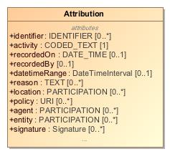

1. Attribution

|  |  |
| --- | --- |
| **Name** | Attribution |
| **Qualified Name** | CIMI Clinical::Data Structure::Attribution |
| **Visibility** | public |
| **Abstract** | false |
| **Base Classifier** | * CLUSTER |
| **Realized Interface** |  |

### **Attribute Detail**

#### activity

An activity is something that occurs over a period of time and acts upon or with entities; it may include asserting, recording, verifying, consuming, processing, transforming, modifying, relocating, using, or generating entities.

|  |  |
| --- | --- |
| **Type** | CODED_TEXT |
| **Default Value** |  |
| **Visibility** | public |
| **Multiplicity** | 1 |

#### agent

The agent in an activity for which it can be assigned some degree of responsibility for the activity taking place. The agent comprises both the party involved and its role.

|  |  |
| --- | --- |
| **Type** | PARTICIPATION |
| **Default Value** |  |
| **Visibility** | public |
| **Multiplicity** | 0..* |

#### associatedActivity

|  |  |
| --- | --- |
| **Type** | Attribution |
| **Default Value** |  |
| **Visibility** | public |
| **Multiplicity** | 0..1 |

#### datetime

TODO:The point-in-time when the activity occurred? ORThe instant of time at which the activity was recorded?

|  |  |
| --- | --- |
| **Type** | DATE_TIME |
| **Default Value** |  |
| **Visibility** | public |
| **Multiplicity** | 0..1 |

#### datetimeRange

The period during which the activity occurred.

|  |  |
| --- | --- |
| **Type** | DateTimeInterval |
| **Default Value** |  |
| **Visibility** | public |
| **Multiplicity** | 0..1 |

#### duration

TODO: How is that different from DatetimeRange.

|  |  |
| --- | --- |
| **Type** | DURATION |
| **Default Value** |  |
| **Visibility** | public |
| **Multiplicity** | 0..1 |

#### entity

An entity used in this activity.

|  |  |
| --- | --- |
| **Type** | PARTICIPATION |
| **Default Value** |  |
| **Visibility** | public |
| **Multiplicity** | 0..* |

#### identifier

|  |  |
| --- | --- |
| **Type** | IDENTIFIER |
| **Default Value** |  |
| **Visibility** | public |
| **Multiplicity** | 0..* |

#### location

Where the activity occurred, if relevant.

|  |  |
| --- | --- |
| **Type** | PARTICIPATION |
| **Default Value** |  |
| **Visibility** | public |
| **Multiplicity** | 0..* |

#### method

This component captures what method used in Attribution models. For instance, in Verified, it captures how verification is achieved (verbal, written, telephone, etc.).

|  |  |
| --- | --- |
| **Type** | DATA_VALUE |
| **Default Value** |  |
| **Visibility** | public |
| **Multiplicity** | 0..1 |

#### policy

Policy or plan the activity was defined by. Typically, a single activity may have multiple applicable policy documents, such as patient consent, guarantor funding, etc.

|  |  |
| --- | --- |
| **Type** | URI |
| **Default Value** |  |
| **Visibility** | public |
| **Multiplicity** | 0..* |

#### previousActivity

|  |  |
| --- | --- |
| **Type** | Attribution |
| **Default Value** |  |
| **Visibility** | public |
| **Multiplicity** | 0..1 |

#### reason

The reason that the activity was taking place.

|  |  |
| --- | --- |
| **Type** | TEXT |
| **Default Value** |  |
| **Visibility** | public |
| **Multiplicity** | 0..* |

#### recordedBy

|  |  |
| --- | --- |
| **Type** |  |
| **Default Value** |  |
| **Visibility** | public |
| **Multiplicity** | 0..1 |

#### recordedOn

The instant of time at which the activity was recorded.

|  |  |
| --- | --- |
| **Type** | DATE_TIME |
| **Default Value** |  |
| **Visibility** | public |
| **Multiplicity** | 0..1 |

#### signature

A digital signature on the target Reference(s). The signer should match a Provenance.agent. The purpose of the signature is indicated.

|  |  |
| --- | --- |
| **Type** | Signature |
| **Default Value** |  |
| **Visibility** | public |
| **Multiplicity** | 0..* |

#### status

|  |  |
| --- | --- |
| **Type** | CODED_TEXT |
| **Default Value** |  |
| **Visibility** | public |
| **Multiplicity** | 0..1 |

#### subsequentActivity

|  |  |
| --- | --- |
| **Type** | Attribution |
| **Default Value** |  |
| **Visibility** | public |
| **Multiplicity** | 0..1 |

#### timing

|  |  |
| --- | --- |
| **Type** | DATA_VALUE |
| **Default Value** |  |
| **Visibility** | public |
| **Multiplicity** | 0..* |

#### timingOffset

|  |  |
| --- | --- |
| **Type** | DURATION |
| **Default Value** |  |
| **Visibility** | public |
| **Multiplicity** | 0..1 |

#### timingOffsetOrigin

|  |  |
| --- | --- |
| **Type** | DATE_TIME |
| **Default Value** |  |
| **Visibility** | public |
| **Multiplicity** | 0..1 |

### **Relation Detail**

#### Generalization

|  |  |
| --- | --- |
| **Name** |  |
| **Related Element** | * CLUSTER |

|  |  |
| --- | --- |
| **Name** |  |
| **Related Element** | * SpecimenCollection |

## **Class** **BiometricData**

Type supporting the capture of biometric information.

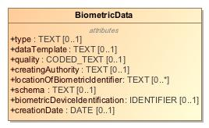

1. BiometricData

|  |  |
| --- | --- |
| **Name** | BiometricData |
| **Qualified Name** | CIMI Clinical::Data Structure::BiometricData |
| **Visibility** | public |
| **Abstract** | false |
| **Base Classifier** | * CLUSTER |
| **Realized Interface** |  |

### **Attribute Detail**

#### biometricDeviceIdentification

Identifier for the device used in the capture of the biometric information.

|  |  |
| --- | --- |
| **Type** | IDENTIFIER |
| **Default Value** |  |
| **Visibility** | public |
| **Multiplicity** | 0..1 |

#### creatingAuthority

The creating authority.

|  |  |
| --- | --- |
| **Type** | TEXT |
| **Default Value** |  |
| **Visibility** | public |
| **Multiplicity** | 0..1 |

#### creationDate

The date the biometric data was captured.

|  |  |
| --- | --- |
| **Type** | DATE |
| **Default Value** |  |
| **Visibility** | public |
| **Multiplicity** | 0..1 |

#### dataTemplate

NEED DEFINITION

|  |  |
| --- | --- |
| **Type** | TEXT |
| **Default Value** |  |
| **Visibility** | public |
| **Multiplicity** | 0..1 |

#### locationOfBiometricIdentifier

NEED DEFINITION

|  |  |
| --- | --- |
| **Type** | TEXT |
| **Default Value** |  |
| **Visibility** | public |
| **Multiplicity** | 0..* |

#### quality

The quality of the biometric information capture.

|  |  |
| --- | --- |
| **Type** | CODED_TEXT |
| **Default Value** |  |
| **Visibility** | public |
| **Multiplicity** | 0..1 |

#### schema

NEED DEFINITION

|  |  |
| --- | --- |
| **Type** | TEXT |
| **Default Value** |  |
| **Visibility** | public |
| **Multiplicity** | 0..1 |

#### type

Type of biometric used.

|  |  |
| --- | --- |
| **Type** | TEXT |
| **Default Value** |  |
| **Visibility** | public |
| **Multiplicity** | 0..1 |

### **Relation Detail**

#### Generalization

|  |  |
| --- | --- |
| **Name** |  |
| **Related Element** | * CLUSTER |

## **Class** **BirthData**

Type supporting the capture of birth-related information.

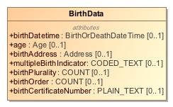

1. BirthData

|  |  |
| --- | --- |
| **Name** | BirthData |
| **Qualified Name** | CIMI Clinical::Data Structure::BirthData |
| **Visibility** | public |
| **Abstract** | false |
| **Base Classifier** | * CLUSTER |
| **Realized Interface** |  |

### **Attribute Detail**

#### age

NEED DEFINITION

|  |  |
| --- | --- |
| **Type** | Age |
| **Default Value** |  |
| **Visibility** | public |
| **Multiplicity** | 0..1 |

#### birthAddress

Address where birth occurred.

|  |  |
| --- | --- |
| **Type** | Address |
| **Default Value** |  |
| **Visibility** | public |
| **Multiplicity** | 0..1 |

#### birthCertificateNumber

The birth certificate number associated with this birth.

|  |  |
| --- | --- |
| **Type** | PLAIN_TEXT |
| **Default Value** |  |
| **Visibility** | public |
| **Multiplicity** | 0..1 |

#### birthDatetime

When the birth occurred.

|  |  |
| --- | --- |
| **Type** | BirthOrDeathDateTime |
| **Default Value** |  |
| **Visibility** | public |
| **Multiplicity** | 0..1 |

#### birthOrder

Integer indicating the sequence number of this birth.

|  |  |
| --- | --- |
| **Type** | COUNT |
| **Default Value** |  |
| **Visibility** | public |
| **Multiplicity** | 0..1 |

#### birthPlurality

NEED DEFINITION

|  |  |
| --- | --- |
| **Type** | COUNT |
| **Default Value** |  |
| **Visibility** | public |
| **Multiplicity** | 0..1 |

#### multipleBirthIndicator

Indicates whether the birth event was a multiple birth event.

|  |  |
| --- | --- |
| **Type** | CODED_TEXT |
| **Default Value** |  |
| **Visibility** | public |
| **Multiplicity** | 0..1 |

### **Relation Detail**

#### Generalization

|  |  |
| --- | --- |
| **Name** |  |
| **Related Element** | * CLUSTER |

## **Class** **BirthOrDeathDateTime**

Type for the capture of birth and death time.

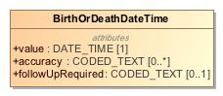

1. BirthOrDeathDateTime

|  |  |
| --- | --- |
| **Name** | BirthOrDeathDateTime |
| **Qualified Name** | CIMI Clinical::Data Structure::BirthOrDeathDateTime |
| **Visibility** | public |
| **Abstract** | false |
| **Base Classifier** | * CLUSTER |
| **Realized Interface** |  |

### **Attribute Detail**

#### accuracy

The accuracy of the date.

|  |  |
| --- | --- |
| **Type** | CODED_TEXT |
| **Default Value** |  |
| **Visibility** | public |
| **Multiplicity** | 0..* |

#### followUpRequired

NEED DEFINITION

|  |  |
| --- | --- |
| **Type** | CODED_TEXT |
| **Default Value** |  |
| **Visibility** | public |
| **Multiplicity** | 0..1 |

#### value

The birth or death time.

|  |  |
| --- | --- |
| **Type** | DATE_TIME |
| **Default Value** |  |
| **Visibility** | public |
| **Multiplicity** | 1 |

### **Relation Detail**

#### Generalization

|  |  |
| --- | --- |
| **Name** |  |
| **Related Element** | * CLUSTER |

## **Class** **Citizenship**

Type supporting the capture of citizenship information.

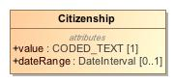

1. Citizenship

|  |  |
| --- | --- |
| **Name** | Citizenship |
| **Qualified Name** | CIMI Clinical::Data Structure::Citizenship |
| **Visibility** | public |
| **Abstract** | false |
| **Base Classifier** | * CLUSTER |
| **Realized Interface** |  |

### **Attribute Detail**

#### dateRange

The period when the citizenship was held.

|  |  |
| --- | --- |
| **Type** | DateInterval |
| **Default Value** |  |
| **Visibility** | public |
| **Multiplicity** | 0..1 |

#### value

Code representing the country of citizenship.

|  |  |
| --- | --- |
| **Type** | CODED_TEXT |
| **Default Value** |  |
| **Visibility** | public |
| **Multiplicity** | 1 |

### **Relation Detail**

#### Generalization

|  |  |
| --- | --- |
| **Name** |  |
| **Related Element** | * CLUSTER |

## **Class** **ClinicalStatementAssociation**

Association class used to represent the relationship between a class and one or more clinical statements where the relationship is qualified by one or more attributes.

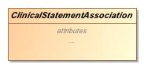

1. ClinicalStatementAssociation

|  |  |
| --- | --- |
| **Name** | ClinicalStatementAssociation |
| **Qualified Name** | CIMI Clinical::Data Structure::ClinicalStatementAssociation |
| **Visibility** | public |
| **Abstract** | true |
| **Base Classifier** | * ASSOCIATION_CLASS |
| **Realized Interface** |  |

### **Attribute Detail**

#### relationshipCode

|  |  |
| --- | --- |
| **Type** | TEXT |
| **Default Value** |  |
| **Visibility** | public |
| **Multiplicity** | 1 |

#### target

|  |  |
| --- | --- |
| **Type** | ClinicalStatement |
| **Default Value** |  |
| **Visibility** | public |
| **Multiplicity** | 1..* |

### **Relation Detail**

#### Association

|  |  |
| --- | --- |
| **Name** |  |
| **Related Element** | * ClinicalStatement |

#### Generalization

|  |  |
| --- | --- |
| **Name** |  |
| **Related Element** | * ASSOCIATION_CLASS |

|  |  |
| --- | --- |
| **Name** |  |
| **Related Element** | * Justification |

|  |  |
| --- | --- |
| **Name** |  |
| **Related Element** | * Provenance |

|  |  |
| --- | --- |
| **Name** |  |
| **Related Element** | * Interpretation |

## **Class** **ContactInformation**

Represents contact details such as an emergency contact or contact information for a next-of-kin.

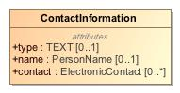

1. ContactInformation

|  |  |
| --- | --- |
| **Name** | ContactInformation |
| **Qualified Name** | CIMI Clinical::Data Structure::ContactInformation |
| **Visibility** | public |
| **Abstract** | false |
| **Base Classifier** | * CLUSTER |
| **Realized Interface** |  |

### **Attribute Detail**

#### contact

The contact information for this person.

|  |  |
| --- | --- |
| **Type** | ElectronicContact |
| **Default Value** |  |
| **Visibility** | public |
| **Multiplicity** | 0..* |

#### name

The name of the person to contact.

|  |  |
| --- | --- |
| **Type** | PersonName |
| **Default Value** |  |
| **Visibility** | public |
| **Multiplicity** | 0..1 |

#### type

The type of contact information - e.g., an emergency contact.

|  |  |
| --- | --- |
| **Type** | TEXT |
| **Default Value** |  |
| **Visibility** | public |
| **Multiplicity** | 0..1 |

### **Relation Detail**

#### Generalization

|  |  |
| --- | --- |
| **Name** |  |
| **Related Element** | * CLUSTER |

## **Class** **DeathData**

Information of about a death event.

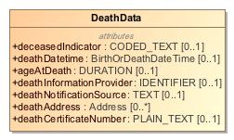

1. DeathData

|  |  |
| --- | --- |
| **Name** | DeathData |
| **Qualified Name** | CIMI Clinical::Data Structure::DeathData |
| **Visibility** | public |
| **Abstract** | false |
| **Base Classifier** | * CLUSTER |
| **Realized Interface** |  |

### **Attribute Detail**

#### ageAtDeath

The age of the person when they expired.

|  |  |
| --- | --- |
| **Type** | DURATION |
| **Default Value** |  |
| **Visibility** | public |
| **Multiplicity** | 0..1 |

#### deathAddress

Address where the patient expired.

|  |  |
| --- | --- |
| **Type** | Address |
| **Default Value** |  |
| **Visibility** | public |
| **Multiplicity** | 0..* |

#### deathCertificateNumber

The death certificate number.

|  |  |
| --- | --- |
| **Type** | PLAIN_TEXT |
| **Default Value** |  |
| **Visibility** | public |
| **Multiplicity** | 0..1 |

#### deathDatetime

The time of death to the level of granularity known.

|  |  |
| --- | --- |
| **Type** | BirthOrDeathDateTime |
| **Default Value** |  |
| **Visibility** | public |
| **Multiplicity** | 0..1 |

#### deathInformationProvider

Identifier for the entity that provided information about the deceased status of the person.

|  |  |
| --- | --- |
| **Type** | IDENTIFIER |
| **Default Value** |  |
| **Visibility** | public |
| **Multiplicity** | 0..1 |

#### deathNotificationSource

NEED DEFINITION - HOW DOES IT DIFFER FROM PROVIDER?

|  |  |
| --- | --- |
| **Type** | TEXT |
| **Default Value** |  |
| **Visibility** | public |
| **Multiplicity** | 0..1 |

#### deceasedIndicator

Code indicating whether the patient is deceased.

|  |  |
| --- | --- |
| **Type** | CODED_TEXT |
| **Default Value** |  |
| **Visibility** | public |
| **Multiplicity** | 0..1 |

### **Relation Detail**

#### Generalization

|  |  |
| --- | --- |
| **Name** |  |
| **Related Element** | * CLUSTER |

## **Class** **Device**

This resource identifies an instance or a type of a manufactured item that is used in the provision of healthcare without being substantially changed through that activity. The device may be a medical or non-medical device. Medical devices includes durable (reusable) medical equipment, implantable devices, as well as disposable equipment used for diagnostic, treatment, and research for healthcare and public health. Non-medical devices may include items such as a machine, cellphone, computer, application, etc.

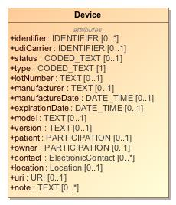

1. Device

|  |  |
| --- | --- |
| **Name** | Device |
| **Qualified Name** | CIMI Clinical::Data Structure::Device |
| **Visibility** | public |
| **Abstract** | false |
| **Base Classifier** | * MaterialEntity |
| **Realized Interface** |  |

### **Attribute Detail**

#### contact

Contact details for an organization or a particular human that is responsible for the device.

|  |  |
| --- | --- |
| **Type** | ElectronicContact |
| **Default Value** |  |
| **Visibility** | public |
| **Multiplicity** | 0..* |

#### expirationDate

The date and time beyond which this device is no longer valid or should not be used (if applicable).

|  |  |
| --- | --- |
| **Type** | DATE_TIME |
| **Default Value** |  |
| **Visibility** | public |
| **Multiplicity** | 0..1 |

#### identifier

Unique instance identifiers assigned to a device by manufacturers other organizations or owners.

|  |  |
| --- | --- |
| **Type** | IDENTIFIER |
| **Default Value** |  |
| **Visibility** | public |
| **Multiplicity** | 0..* |

#### location

The place where the device can be found.

|  |  |
| --- | --- |
| **Type** | Location |
| **Default Value** |  |
| **Visibility** | public |
| **Multiplicity** | 0..1 |

#### lotNumber

Lot number assigned by the manufacturer.

|  |  |
| --- | --- |
| **Type** | TEXT |
| **Default Value** |  |
| **Visibility** | public |
| **Multiplicity** | 0..1 |

#### manufactureDate

The date and time when the device was manufactured.

|  |  |
| --- | --- |
| **Type** | DATE_TIME |
| **Default Value** |  |
| **Visibility** | public |
| **Multiplicity** | 0..1 |

#### manufacturer

A name of the manufacturer.

|  |  |
| --- | --- |
| **Type** | TEXT |
| **Default Value** |  |
| **Visibility** | public |
| **Multiplicity** | 0..1 |

#### model

The "model" is an identifier assigned by the manufacturer to identify the product by its type. This number is shared by the all devices sold as the same type.

|  |  |
| --- | --- |
| **Type** | TEXT |
| **Default Value** |  |
| **Visibility** | public |
| **Multiplicity** | 0..1 |

#### note

Descriptive information, usage information or implantation information that is not captured in an existing element.

|  |  |
| --- | --- |
| **Type** | TEXT |
| **Default Value** |  |
| **Visibility** | public |
| **Multiplicity** | 0..* |

#### owner

A party that is responsible for the provision and ongoing maintenance of the device.

|  |  |
| --- | --- |
| **Type** | PARTICIPATION |
| **Default Value** |  |
| **Visibility** | public |
| **Multiplicity** | 0..1 |

#### patient

Patient information, If the device is affixed to a person.

|  |  |
| --- | --- |
| **Type** | PARTICIPATION |
| **Default Value** |  |
| **Visibility** | public |
| **Multiplicity** | 0..1 |

#### status

Status of the Device availability.

|  |  |
| --- | --- |
| **Type** | CODED_TEXT |
| **Default Value** |  |
| **Visibility** | public |
| **Multiplicity** | 0..1 |

#### type

Code or identifier to identify a kind of device.

|  |  |
| --- | --- |
| **Type** | CODED_TEXT |
| **Default Value** |  |
| **Visibility** | public |
| **Multiplicity** | 1 |

#### udiCarrier

Unique device identifier (UDI) barcode or rfid string assigned to device label or package.

|  |  |
| --- | --- |
| **Type** | IDENTIFIER |
| **Default Value** |  |
| **Visibility** | public |
| **Multiplicity** | 0..1 |

#### uri

A network address on which the device may be contacted directly.

|  |  |
| --- | --- |
| **Type** | URI |
| **Default Value** |  |
| **Visibility** | public |
| **Multiplicity** | 0..1 |

#### version

The version of the device, if the device has multiple releases under the same model, or if the device is software or carries firmware.

|  |  |
| --- | --- |
| **Type** | TEXT |
| **Default Value** |  |
| **Visibility** | public |
| **Multiplicity** | 0..1 |

### **Relation Detail**

#### Generalization

|  |  |
| --- | --- |
| **Name** |  |
| **Related Element** | * MaterialEntity |

## **Class** **ElectronicContact**

Data structure representing an electronic contact such as an email address.

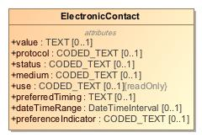

1. ElectronicContact

|  |  |
| --- | --- |
| **Name** | ElectronicContact |
| **Qualified Name** | CIMI Clinical::Data Structure::ElectronicContact |
| **Visibility** | public |
| **Abstract** | false |
| **Base Classifier** | * CLUSTER |
| **Realized Interface** |  |

### **Attribute Detail**

#### dateTimeRange

Time period when the contact point was/is in use

|  |  |
| --- | --- |
| **Type** | DateTimeInterval |
| **Default Value** |  |
| **Visibility** | public |
| **Multiplicity** | 0..1 |

#### medium

NEED A DEFINITION:The mime type for the communication.

|  |  |
| --- | --- |
| **Type** | CODED_TEXT |
| **Default Value** |  |
| **Visibility** | public |
| **Multiplicity** | 0..1 |

#### preferenceIndicator

Code indicating whether the contact information is preferred.

|  |  |
| --- | --- |
| **Type** | CODED_TEXT |
| **Default Value** |  |
| **Visibility** | public |
| **Multiplicity** | 0..1 |

#### preferredTiming

NEED DEFINITION

|  |  |
| --- | --- |
| **Type** | TEXT |
| **Default Value** |  |
| **Visibility** | public |
| **Multiplicity** | 0..1 |

#### protocol

Telecommunications form for contact point - what communications system is required to make use of the contact.

|  |  |
| --- | --- |
| **Type** | CODED_TEXT |
| **Default Value** |  |
| **Visibility** | public |
| **Multiplicity** | 0..1 |

#### status

NEED A DEFINITION

|  |  |
| --- | --- |
| **Type** | CODED_TEXT |
| **Default Value** |  |
| **Visibility** | public |
| **Multiplicity** | 0..1 |

#### use

Identifies the purpose for the contact point.

|  |  |
| --- | --- |
| **Type** | CODED_TEXT |
| **Default Value** |  |
| **Visibility** | public |
| **Multiplicity** | 0..1 |

#### value

The electronic contact address.

|  |  |
| --- | --- |
| **Type** | TEXT |
| **Default Value** |  |
| **Visibility** | public |
| **Multiplicity** | 0..1 |

### **Relation Detail**

#### Generalization

|  |  |
| --- | --- |
| **Name** |  |
| **Related Element** | * CLUSTER |

## **Class** **Entitlement**

NEED DEFINITION

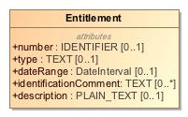

1. Entitlement

|  |  |
| --- | --- |
| **Name** | Entitlement |
| **Qualified Name** | CIMI Clinical::Data Structure::Entitlement |
| **Visibility** | public |
| **Abstract** | false |
| **Base Classifier** | * CLUSTER |
| **Realized Interface** |  |

### **Attribute Detail**

#### dateRange

NEED DEFINITION

|  |  |
| --- | --- |
| **Type** | DateInterval |
| **Default Value** |  |
| **Visibility** | public |
| **Multiplicity** | 0..1 |

#### description

NEED DEFINITION

|  |  |
| --- | --- |
| **Type** | PLAIN_TEXT |
| **Default Value** |  |
| **Visibility** | public |
| **Multiplicity** | 0..1 |

#### identificationComment

NEED DEFINITION

|  |  |
| --- | --- |
| **Type** | TEXT |
| **Default Value** |  |
| **Visibility** | public |
| **Multiplicity** | 0..* |

#### number

NEED DEFINITION

|  |  |
| --- | --- |
| **Type** | IDENTIFIER |
| **Default Value** |  |
| **Visibility** | public |
| **Multiplicity** | 0..1 |

#### type

NEED DEFINITION

|  |  |
| --- | --- |
| **Type** | TEXT |
| **Default Value** |  |
| **Visibility** | public |
| **Multiplicity** | 0..1 |

### **Relation Detail**

#### Generalization

|  |  |
| --- | --- |
| **Name** |  |
| **Related Element** | * CLUSTER |

## **Class** **EvaluationResult**

The outcome of an evaluation of a characteristic. This model holds a "question" in the key and holds a value in the result. This value is further qualified through the model's properties.

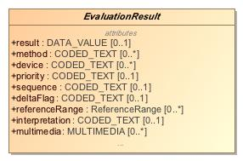

1. EvaluationResult

|  |  |
| --- | --- |
| **Name** | EvaluationResult |
| **Qualified Name** | CIMI Clinical::Data Structure::EvaluationResult |
| **Visibility** | public |
| **Abstract** | true |
| **Base Classifier** | * Finding |
| **Realized Interface** |  |

### **Attribute Detail**

#### conclusions

|  |  |
| --- | --- |
| **Type** | CODED_TEXT |
| **Default Value** |  |
| **Visibility** | public |
| **Multiplicity** | 0..* |

#### deltaFlag

Flag indicating whether there was a significant change from previous results.

|  |  |
| --- | --- |
| **Type** | CODED_TEXT |
| **Default Value** |  |
| **Visibility** | public |
| **Multiplicity** | 0..1 |

#### device

The device used to evaluate the characteristic such as the type of blood pressure cuff used on a patient.

|  |  |
| --- | --- |
| **Type** | CODED_TEXT |
| **Default Value** |  |
| **Visibility** | public |
| **Multiplicity** | 0..* |

#### evaluationProcedure

|  |  |
| --- | --- |
| **Type** | ClinicalStatement |
| **Default Value** |  |
| **Visibility** | public |
| **Multiplicity** |  |

#### interpretation

A clinical judgment about the significance of an evaluation result.Interpretation is used to clarify data from measurements and other evaluations. For example, if a measured analyte is greater than a predetermined threshold the interpretation could be Positive, or if a measurement is lower than a normal physiological range the interpretation could be low or critical low. Some values include normal, abnormal, panic high, panic low, ...Interpretation may also be used to indicate whether or not the result is outside the range for the patient.

|  |  |
| --- | --- |
| **Type** | CODED_TEXT |
| **Default Value** |  |
| **Visibility** | public |
| **Multiplicity** | 0..1 |

#### method

Used to record the means by which a measurement, evaluation, or assessment was made.

|  |  |
| --- | --- |
| **Type** | CODED_TEXT |
| **Default Value** |  |
| **Visibility** | public |
| **Multiplicity** | 0..* |

#### multimedia

Associated media produced during the evaluation such as an X-ray.

|  |  |
| --- | --- |
| **Type** | MULTIMEDIA |
| **Default Value** |  |
| **Visibility** | public |
| **Multiplicity** | 0..* |

#### priority

The urgency of the evaluation result. To reviewers: should we retain this attribute in the model.

|  |  |
| --- | --- |
| **Type** | CODED_TEXT |
| **Default Value** |  |
| **Visibility** | public |
| **Multiplicity** | 0..1 |

#### referenceRange

The range for the measurement.

|  |  |
| --- | --- |
| **Type** | ReferenceRange |
| **Default Value** |  |
| **Visibility** | public |
| **Multiplicity** | 0..* |

#### result

The unqualified value of the evaluation.

|  |  |
| --- | --- |
| **Type** | DATA_VALUE |
| **Default Value** |  |
| **Visibility** | public |
| **Multiplicity** | 0..1 |

#### sequence

Sequence is a number placed onto the data which refers to the order it occurred in or needs to be retrieved by.

|  |  |
| --- | --- |
| **Type** | CODED_TEXT |
| **Default Value** |  |
| **Visibility** | public |
| **Multiplicity** | 0..1 |

### **Relation Detail**

#### Association

|  |  |
| --- | --- |
| **Name** |  |
| **Related Element** | * ClinicalStatement |

#### Generalization

|  |  |
| --- | --- |
| **Name** |  |
| **Related Element** | * Finding |

|  |  |
| --- | --- |
| **Name** |  |
| **Related Element** | * LaboratoryTestResult |

|  |  |
| --- | --- |
| **Name** |  |
| **Related Element** | * PhysicalEvaluationResult |

## **Class** **Finding**

The characteristics looked for in medical investigations or diagnostics and the outcome.

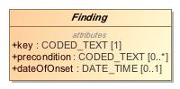

1. Finding

|  |  |
| --- | --- |
| **Name** | Finding |
| **Qualified Name** | CIMI Clinical::Data Structure::Finding |
| **Visibility** | public |
| **Abstract** | true |
| **Base Classifier** | * StatementTopic |
| **Realized Interface** |  |

### **Attribute Detail**

#### dateOfOnset

Date or time when the characteristic was first observed.When the asserted condition began manifesting. This property may have a broad precision (e.g., a year rather than a date).Set of values bounded by low and highIf present, low SHALL have a lower value than high

|  |  |
| --- | --- |
| **Type** | DATE_TIME |
| **Default Value** |  |
| **Visibility** | public |
| **Multiplicity** | 0..1 |

#### key

The conceptual classification of the thing being observed

|  |  |
| --- | --- |
| **Type** | CODED_TEXT |
| **Default Value** |  |
| **Visibility** | public |
| **Multiplicity** | 1 |

#### precondition

Describes the previously existing conditions or states that could effect a measurement or assesment. For example; a patients weight taken while clothed, a patients height with or without shoes, a patients blood pressure taken while standing or lying down.Precondition aligns with the SNOMED CT Observable model attribute 704326004 |Precondition (attribute)|

|  |  |
| --- | --- |
| **Type** | CODED_TEXT |
| **Default Value** |  |
| **Visibility** | public |
| **Multiplicity** | 0..* |

### **Relation Detail**

#### Generalization

|  |  |
| --- | --- |
| **Name** |  |
| **Related Element** | * EvaluationResult |

|  |  |
| --- | --- |
| **Name** |  |
| **Related Element** | * StatementTopic |

|  |  |
| --- | --- |
| **Name** |  |
| **Related Element** | * Assertion |

## **Class** **FindingContext**

The FindingContext class aligns with the SNOMED Situations with Explicit Context for findings and provides the context for the EvaluationResult and Assertion topics of a clinical statement. For instance, a statement about findings may state that the finding was observed present or absent.

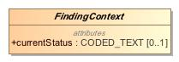

1. FindingContext

|  |  |
| --- | --- |
| **Name** | FindingContext |
| **Qualified Name** | CIMI Clinical::Data Structure::FindingContext |
| **Visibility** | public |
| **Abstract** | true |
| **Base Classifier** | * StatementContext |
| **Realized Interface** |  |

### **Attribute Detail**

#### currentStatus

Current state of the evaluation (e.g., pending, complete, partial)

|  |  |
| --- | --- |
| **Type** | CODED_TEXT |
| **Default Value** |  |
| **Visibility** | public |
| **Multiplicity** | 0..1 |

### **Relation Detail**

#### Generalization

|  |  |
| --- | --- |
| **Name** |  |
| **Related Element** | * StatementContext |

|  |  |
| --- | --- |
| **Name** |  |
| **Related Element** | * PresenceAbsenceContext |

|  |  |
| --- | --- |
| **Name** |  |
| **Related Element** | * Goal |

|  |  |
| --- | --- |
| **Name** |  |
| **Related Element** | * Risk |

## **Class** **Goal**

-1588381498.jpg

1. Goal

|  |  |
| --- | --- |
| **Name** | Goal |
| **Qualified Name** | CIMI Clinical::Data Structure::Goal |
| **Visibility** | public |
| **Abstract** | false |
| **Base Classifier** | * FindingContext |
| **Realized Interface** |  |

### **Relation Detail**

#### Generalization

|  |  |
| --- | --- |
| **Name** |  |
| **Related Element** | * FindingContext |

## **Class** **Industry**

Type representing an industry.

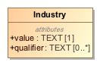

1. Industry

|  |  |
| --- | --- |
| **Name** | Industry |
| **Qualified Name** | CIMI Clinical::Data Structure::Industry |
| **Visibility** | public |
| **Abstract** | false |
| **Base Classifier** | * CLUSTER |
| **Realized Interface** |  |

### **Attribute Detail**

#### qualifier

NEED DEFINITION HERE

|  |  |
| --- | --- |
| **Type** | TEXT |
| **Default Value** |  |
| **Visibility** | public |
| **Multiplicity** | 0..* |

#### value

The industry name.

|  |  |
| --- | --- |
| **Type** | TEXT |
| **Default Value** |  |
| **Visibility** | public |
| **Multiplicity** | 1 |

### **Relation Detail**

#### Generalization

|  |  |
| --- | --- |
| **Name** |  |
| **Related Element** | * CLUSTER |

## **Class** **Ingredient**

A components that go to make up the described item.

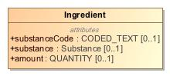

1. Ingredient

|  |  |
| --- | --- |
| **Name** | Ingredient |
| **Qualified Name** | CIMI Clinical::Data Structure::Ingredient |
| **Visibility** | public |
| **Abstract** | false |
| **Base Classifier** | * CLUSTER |
| **Realized Interface** |  |

### **Attribute Detail**

#### amount

The amount of the component item.

|  |  |
| --- | --- |
| **Type** | QUANTITY |
| **Default Value** |  |
| **Visibility** | public |
| **Multiplicity** | 0..1 |

#### substance

Identifies a component item.

|  |  |
| --- | --- |
| **Type** | Substance |
| **Default Value** |  |
| **Visibility** | public |
| **Multiplicity** | 0..1 |

#### substanceCode

Identifies a component items

|  |  |
| --- | --- |
| **Type** | CODED_TEXT |
| **Default Value** |  |
| **Visibility** | public |
| **Multiplicity** | 0..1 |

### **Relation Detail**

#### Generalization

|  |  |
| --- | --- |
| **Name** |  |
| **Related Element** | * CLUSTER |

## **Class** **Interpretation**

The interpretation provided by the containing type for the set of clinical statements that comprise the target of the relationship. For instance, Assertion.interpretation can be interpreted as follows: the assertion interprets the set of clinical statements specified as the range of Assertion.interpretation.target and the interpretation is specified by the Assertion.interpretation.hasInterpretation code.

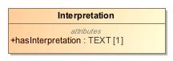

1. Interpretation

|  |  |
| --- | --- |
| **Name** | Interpretation |
| **Qualified Name** | CIMI Clinical::Data Structure::Interpretation |
| **Visibility** | public |
| **Abstract** | false |
| **Base Classifier** | * ClinicalStatementAssociation |
| **Realized Interface** |  |

### **Attribute Detail**

#### hasInterpretation

Narrative or code representing the interpretation assigned by the containing class on the set of clinical statements that comprise the target of the relationship.

|  |  |
| --- | --- |
| **Type** | TEXT |
| **Default Value** |  |
| **Visibility** | public |
| **Multiplicity** | 1 |

### **Relation Detail**

#### Generalization

|  |  |
| --- | --- |
| **Name** |  |
| **Related Element** | * ClinicalStatementAssociation |

## **Class** **Justification**

Asserted clinical justification to perform or not perform an act such as a diagnostic test, a medication treatment, or a procedure.The justification can be specified as a code or as a clinical statement, e.g., code for diabetes (ICD-9-CM 250.0) or a Condition occurrence statement (with diabetes code) documented elsewhere in a patient's record.

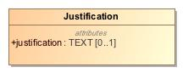

1. Justification

|  |  |
| --- | --- |
| **Name** | Justification |
| **Qualified Name** | CIMI Clinical::Data Structure::Justification |
| **Visibility** | public |
| **Abstract** | false |
| **Base Classifier** | * ClinicalStatementAssociation |
| **Realized Interface** |  |

### **Attribute Detail**

#### justification

A code representing the justification. Typically, the code is for a condition that is suspected or is observed in a patient.

|  |  |
| --- | --- |
| **Type** | TEXT |
| **Default Value** |  |
| **Visibility** | public |
| **Multiplicity** | 0..1 |

### **Relation Detail**

#### Generalization

|  |  |
| --- | --- |
| **Name** |  |
| **Related Element** | * ClinicalStatementAssociation |

## **Class** **KnownOrSuspectedPresent**

-1627835627.jpg

1. KnownOrSuspectedPresent

|  |  |
| --- | --- |
| **Name** | KnownOrSuspectedPresent |
| **Qualified Name** | CIMI Clinical::Data Structure::KnownOrSuspectedPresent |
| **Visibility** | public |
| **Abstract** | false |
| **Base Classifier** | * PresenceAbsenceContext |
| **Realized Interface** |  |

### **Relation Detail**

#### Generalization

|  |  |
| --- | --- |
| **Name** |  |
| **Related Element** | * PresenceAbsenceContext |

## **Class** **LaboratoryProcedure**

Specialization of Procedure that represents a procedure performed on a collected specimen such as a blood panel or a biopsy

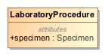

1. LaboratoryProcedure

|  |  |
| --- | --- |
| **Name** | LaboratoryProcedure |
| **Qualified Name** | CIMI Clinical::Data Structure::LaboratoryProcedure |
| **Visibility** | public |
| **Abstract** | false |
| **Base Classifier** | * Procedure |
| **Realized Interface** |  |

### **Attribute Detail**

#### specimen

Tissues, objects, or samples taken from the patient during the procedure including biopsies, aspiration fluid, or other samples sent for pathological analysis.

|  |  |
| --- | --- |
| **Type** | Specimen |
| **Default Value** |  |
| **Visibility** | public |
| **Multiplicity** |  |

### **Relation Detail**

#### Generalization

|  |  |
| --- | --- |
| **Name** |  |
| **Related Element** | * Procedure |

## **Class** **LaboratoryTestResult**

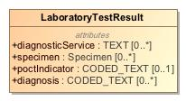

1. LaboratoryTestResult

|  |  |
| --- | --- |
| **Name** | LaboratoryTestResult |
| **Qualified Name** | CIMI Clinical::Data Structure::LaboratoryTestResult |
| **Visibility** | public |
| **Abstract** | false |
| **Base Classifier** | * EvaluationResult |
| **Realized Interface** |  |

### **Attribute Detail**

#### diagnosis

A condition for which the lab result is pathoneumonic. The lab result is sufficient to assert the diagnosis.

|  |  |
| --- | --- |
| **Type** | CODED_TEXT |
| **Default Value** |  |
| **Visibility** | public |
| **Multiplicity** | 0..* |

#### diagnosticService

NEED DEFINITION OR REMOVE (STAN?)

|  |  |
| --- | --- |
| **Type** | TEXT |
| **Default Value** |  |
| **Visibility** | public |
| **Multiplicity** | 0..* |

#### poctIndicator

NEED DEFINITION OR REMOVE (STAN?)

|  |  |
| --- | --- |
| **Type** | CODED_TEXT |
| **Default Value** |  |
| **Visibility** | public |
| **Multiplicity** | 0..1 |

#### specimen

The specimen used for the analysis.

|  |  |
| --- | --- |
| **Type** | Specimen |
| **Default Value** |  |
| **Visibility** | public |
| **Multiplicity** | 0..* |

### **Relation Detail**

#### Generalization

|  |  |
| --- | --- |
| **Name** |  |
| **Related Element** | * EvaluationResult |

## **Class** **Language**

Type representing proficiency in a language.

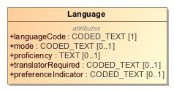

1. Language

|  |  |
| --- | --- |
| **Name** | Language |
| **Qualified Name** | CIMI Clinical::Data Structure::Language |
| **Visibility** | public |
| **Abstract** | false |
| **Base Classifier** | * CLUSTER |
| **Realized Interface** |  |

### **Attribute Detail**

#### languageCode

ISO code representing the language name.

|  |  |
| --- | --- |
| **Type** | CODED_TEXT |
| **Default Value** |  |
| **Visibility** | public |
| **Multiplicity** | 1 |

#### mode

NEED DEFINITION

|  |  |
| --- | --- |
| **Type** | CODED_TEXT |
| **Default Value** |  |
| **Visibility** | public |
| **Multiplicity** | 0..1 |

#### preferenceIndicator

Code indicating whether the language is preferred for communication.

|  |  |
| --- | --- |
| **Type** | CODED_TEXT |
| **Default Value** |  |
| **Visibility** | public |
| **Multiplicity** | 0..1 |

#### proficiency

Degree of fluency in the language.

|  |  |
| --- | --- |
| **Type** | TEXT |
| **Default Value** |  |
| **Visibility** | public |
| **Multiplicity** | 0..1 |

#### translatorRequired

Code indicating need for translator.

|  |  |
| --- | --- |
| **Type** | CODED_TEXT |
| **Default Value** |  |
| **Visibility** | public |
| **Multiplicity** | 0..1 |

### **Relation Detail**

#### Generalization

|  |  |
| --- | --- |
| **Name** |  |
| **Related Element** | * CLUSTER |

## **Class** **Location**

Data structure representing a geographical location such as a location on a map.

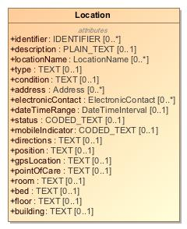

1. Location

|  |  |
| --- | --- |
| **Name** | Location |
| **Qualified Name** | CIMI Clinical::Data Structure::Location |
| **Visibility** | public |
| **Abstract** | false |
| **Base Classifier** | * CLUSTER |
| **Realized Interface** |  |

### **Attribute Detail**

#### address

The addresses associated with this location.

|  |  |
| --- | --- |
| **Type** | Address |
| **Default Value** |  |
| **Visibility** | public |
| **Multiplicity** | 0..* |

#### bed

The bed at the specified location, floor, and room - E.g., 10 West Bed 2

|  |  |
| --- | --- |
| **Type** | TEXT |
| **Default Value** |  |
| **Visibility** | public |
| **Multiplicity** | 0..1 |

#### building

The building at the specified location.

|  |  |
| --- | --- |
| **Type** | TEXT |
| **Default Value** |  |
| **Visibility** | public |
| **Multiplicity** | 0..1 |

#### condition

NEED DEFINITION HERE

|  |  |
| --- | --- |
| **Type** | TEXT |
| **Default Value** |  |
| **Visibility** | public |
| **Multiplicity** | 0..1 |

#### dateTimeRange

The interval of time when this location is relevant or available.

|  |  |
| --- | --- |
| **Type** | DateTimeInterval |
| **Default Value** |  |
| **Visibility** | public |
| **Multiplicity** | 0..1 |

#### description

A narrative describing the location.

|  |  |
| --- | --- |
| **Type** | PLAIN_TEXT |
| **Default Value** |  |
| **Visibility** | public |
| **Multiplicity** | 0..1 |

#### directions

NEED A DEFINITION FOR THISHow to get there?How to use the resource?

|  |  |
| --- | --- |
| **Type** | TEXT |
| **Default Value** |  |
| **Visibility** | public |
| **Multiplicity** | 0..1 |

#### electronicContact

Contact information associated with this location - for instance, contact information to reserve the location.

|  |  |
| --- | --- |
| **Type** | ElectronicContact |
| **Default Value** |  |
| **Visibility** | public |
| **Multiplicity** | 0..* |

#### floor

The floor at the specified location.

|  |  |
| --- | --- |
| **Type** | TEXT |
| **Default Value** |  |
| **Visibility** | public |
| **Multiplicity** | 0..1 |

#### gpsLocation

The location's geospatial coordinates such as latitude and longitude.

|  |  |
| --- | --- |
| **Type** | TEXT |
| **Default Value** |  |
| **Visibility** | public |
| **Multiplicity** | 0..1 |

#### identifier

The identifier of the location.

|  |  |
| --- | --- |
| **Type** | IDENTIFIER |
| **Default Value** |  |
| **Visibility** | public |
| **Multiplicity** | 0..* |

#### locationName

Names associated with this location. E.g., 10 West

|  |  |
| --- | --- |
| **Type** | LocationName |
| **Default Value** |  |
| **Visibility** | public |
| **Multiplicity** | 0..* |

#### mobileIndicator

NEED A DEFINITION FOR THIS

|  |  |
| --- | --- |
| **Type** | CODED_TEXT |
| **Default Value** |  |
| **Visibility** | public |
| **Multiplicity** | 0..1 |

#### pointOfCare

The care setting at the location.

|  |  |
| --- | --- |
| **Type** | TEXT |
| **Default Value** |  |
| **Visibility** | public |
| **Multiplicity** | 0..1 |

#### position

NEED A DEFINITION FOR THIS.

|  |  |
| --- | --- |
| **Type** | TEXT |
| **Default Value** |  |
| **Visibility** | public |
| **Multiplicity** | 0..1 |

#### room

The room at the specified location and floor - E.g., 10 West

|  |  |
| --- | --- |
| **Type** | TEXT |
| **Default Value** |  |
| **Visibility** | public |
| **Multiplicity** | 0..1 |

#### status

A code representing the status of the location.

|  |  |
| --- | --- |
| **Type** | CODED_TEXT |
| **Default Value** |  |
| **Visibility** | public |
| **Multiplicity** | 0..1 |

#### type

The location's category.

|  |  |
| --- | --- |
| **Type** | TEXT |
| **Default Value** |  |
| **Visibility** | public |
| **Multiplicity** | 0..1 |

### **Relation Detail**

#### Generalization

|  |  |
| --- | --- |
| **Name** |  |
| **Related Element** | * CLUSTER |

## **Class** **LocationName**

Data structure capturing the name of a location

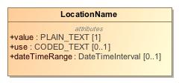

1. LocationName

|  |  |
| --- | --- |
| **Name** | LocationName |
| **Qualified Name** | CIMI Clinical::Data Structure::LocationName |
| **Visibility** | public |
| **Abstract** | false |
| **Base Classifier** | * CLUSTER |
| **Realized Interface** |  |

### **Attribute Detail**

#### dateTimeRange

Time period when name was/is in use

|  |  |
| --- | --- |
| **Type** | DateTimeInterval |
| **Default Value** |  |
| **Visibility** | public |
| **Multiplicity** | 0..1 |

#### use

Identifies the purpose for this name.

|  |  |
| --- | --- |
| **Type** | CODED_TEXT |
| **Default Value** |  |
| **Visibility** | public |
| **Multiplicity** | 0..1 |

#### value

The location's name

|  |  |
| --- | --- |
| **Type** | PLAIN_TEXT |
| **Default Value** |  |
| **Visibility** | public |
| **Multiplicity** | 1 |

### **Relation Detail**

#### Generalization

|  |  |
| --- | --- |
| **Name** |  |
| **Related Element** | * CLUSTER |

## **Class** **MaterialEntity**

Root class for material entities such as anatomical locations, devices, and substances.

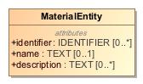

1. MaterialEntity

|  |  |
| --- | --- |
| **Name** | MaterialEntity |
| **Qualified Name** | CIMI Clinical::Data Structure::MaterialEntity |
| **Visibility** | public |
| **Abstract** | false |
| **Base Classifier** | * CLUSTER |
| **Realized Interface** |  |

### **Attribute Detail**

#### description

A description of the entity.

|  |  |
| --- | --- |
| **Type** | TEXT |
| **Default Value** |  |
| **Visibility** | public |
| **Multiplicity** | 0..* |

#### identifier

An identifier for the material entity.

|  |  |
| --- | --- |
| **Type** | IDENTIFIER |
| **Default Value** |  |
| **Visibility** | public |
| **Multiplicity** | 0..* |

#### name

The name or code of the entity.

|  |  |
| --- | --- |
| **Type** | TEXT |
| **Default Value** |  |
| **Visibility** | public |
| **Multiplicity** | 0..1 |

### **Relation Detail**

#### Generalization

|  |  |
| --- | --- |
| **Name** |  |
| **Related Element** | * Medication |

|  |  |
| --- | --- |
| **Name** |  |
| **Related Element** | * CLUSTER |

|  |  |
| --- | --- |
| **Name** |  |
| **Related Element** | * Specimen |

|  |  |
| --- | --- |
| **Name** |  |
| **Related Element** | * Substance |

|  |  |
| --- | --- |
| **Name** |  |
| **Related Element** | * Device |

|  |  |
| --- | --- |
| **Name** |  |
| **Related Element** | * AnatomicalLocation |

## **Class** **Medication**

Class representing a medication. It covers the ingredients and the packaging for a medication.

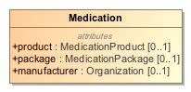

1. Medication

|  |  |
| --- | --- |
| **Name** | Medication |
| **Qualified Name** | CIMI Clinical::Data Structure::Medication |
| **Visibility** | public |
| **Abstract** | false |
| **Base Classifier** | * MaterialEntity |
| **Realized Interface** |  |

### **Attribute Detail**

#### manufacturer

Describes the details of the manufacturer of the substance.

|  |  |
| --- | --- |
| **Type** | Organization |
| **Default Value** |  |
| **Visibility** | public |
| **Multiplicity** | 0..1 |

#### package

Information that only applies to medication packages (not products).

|  |  |
| --- | --- |
| **Type** | MedicationPackage |
| **Default Value** |  |
| **Visibility** | public |
| **Multiplicity** | 0..1 |

#### product

Information that only applies to medication products (not packages).

|  |  |
| --- | --- |
| **Type** | MedicationProduct |
| **Default Value** |  |
| **Visibility** | public |
| **Multiplicity** | 0..1 |

### **Relation Detail**

#### Generalization

|  |  |
| --- | --- |
| **Name** |  |
| **Related Element** | * MaterialEntity |

## **Class** **MedicationPackage**

A package for a medication.

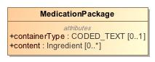

1. MedicationPackage

|  |  |
| --- | --- |
| **Name** | MedicationPackage |
| **Qualified Name** | CIMI Clinical::Data Structure::MedicationPackage |
| **Visibility** | public |
| **Abstract** | false |
| **Base Classifier** | * UnitOfDistribution |
| **Realized Interface** |  |

### **Attribute Detail**

#### containerType

The kind of container that this package comes as.

|  |  |
| --- | --- |
| **Type** | CODED_TEXT |
| **Default Value** |  |
| **Visibility** | public |
| **Multiplicity** | 0..1 |

#### content

The set of medication ingredients

|  |  |
| --- | --- |
| **Type** | Ingredient |
| **Default Value** |  |
| **Visibility** | public |
| **Multiplicity** | 0..* |

### **Relation Detail**

#### Generalization

|  |  |
| --- | --- |
| **Name** |  |
| **Related Element** | * UnitOfDistribution |

## **Class** **MedicationProduct**

Information that only applies to medication products (not packages).

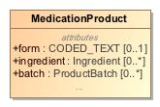

1. MedicationProduct

|  |  |
| --- | --- |
| **Name** | MedicationProduct |
| **Qualified Name** | CIMI Clinical::Data Structure::MedicationProduct |
| **Visibility** | public |
| **Abstract** | false |
| **Base Classifier** | * CLUSTER |
| **Realized Interface** |  |

### **Attribute Detail**

#### amount

|  |  |
| --- | --- |
| **Type** | QUANTITY |
| **Default Value** |  |
| **Visibility** | public |
| **Multiplicity** | 0..1 |

#### batch

Information about a group of medication produced or packaged from one production run.

|  |  |
| --- | --- |
| **Type** | ProductBatch |
| **Default Value** |  |
| **Visibility** | public |
| **Multiplicity** | 0..* |

#### form

Describes the form of the item. Powder; tablets; capsule.

|  |  |
| --- | --- |
| **Type** | CODED_TEXT |
| **Default Value** |  |
| **Visibility** | public |
| **Multiplicity** | 0..1 |

#### ingredient

Identifies a particular constituent of interest in the product.

|  |  |
| --- | --- |
| **Type** | Ingredient |
| **Default Value** |  |
| **Visibility** | public |
| **Multiplicity** | 0..* |

### **Relation Detail**

#### Generalization

|  |  |
| --- | --- |
| **Name** |  |
| **Related Element** | * CLUSTER |

## **Class** **NotCompleted**

A record that a clinical act was initiated by not completed.

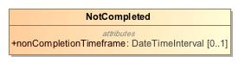

1. NotCompleted

|  |  |
| --- | --- |
| **Name** | NotCompleted |
| **Qualified Name** | CIMI Clinical::Data Structure::NotCompleted |
| **Visibility** | public |
| **Abstract** | false |
| **Base Classifier** | * Performance |
| **Realized Interface** |  |

### **Attribute Detail**

#### nonCompletionTimeframe

The time interval considered when the action was not completed.

|  |  |
| --- | --- |
| **Type** | DateTimeInterval |
| **Default Value** |  |
| **Visibility** | public |
| **Multiplicity** | 0..1 |

### **Relation Detail**

#### Generalization

|  |  |
| --- | --- |
| **Name** |  |
| **Related Element** | * Performance |

## **Class** **NotPerformance**

A record that a clinical act was not performed and/or never initiated. Do not use this context if the act was initiated or started but aborted or cancelled. Use the NotPerformed context instead.

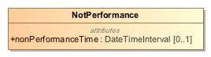

1. NotPerformance

|  |  |
| --- | --- |
| **Name** | NotPerformance |
| **Qualified Name** | CIMI Clinical::Data Structure::NotPerformance |
| **Visibility** | public |
| **Abstract** | false |
| **Base Classifier** | * ActionContext |
| **Realized Interface** |  |

### **Attribute Detail**

#### nonPerformanceTime

The time period during which the act was not performed.

|  |  |
| --- | --- |
| **Type** | DateTimeInterval |
| **Default Value** |  |
| **Visibility** | public |
| **Multiplicity** | 0..1 |

### **Relation Detail**

#### Generalization

|  |  |
| --- | --- |
| **Name** |  |
| **Related Element** | * ActionContext |

## **Class** **Occupation**

Type representing a professional occupation.

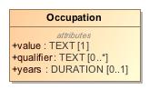

1. Occupation

|  |  |
| --- | --- |
| **Name** | Occupation |
| **Qualified Name** | CIMI Clinical::Data Structure::Occupation |
| **Visibility** | public |
| **Abstract** | false |
| **Base Classifier** | * CLUSTER |
| **Realized Interface** |  |

### **Attribute Detail**

#### qualifier

NEED DEFINITION

|  |  |
| --- | --- |
| **Type** | TEXT |
| **Default Value** |  |
| **Visibility** | public |
| **Multiplicity** | 0..* |

#### value

Text or code naming the occupation.

|  |  |
| --- | --- |
| **Type** | TEXT |
| **Default Value** |  |
| **Visibility** | public |
| **Multiplicity** | 1 |

#### years

.Years performing this occupation.

|  |  |
| --- | --- |
| **Type** | DURATION |
| **Default Value** |  |
| **Visibility** | public |
| **Multiplicity** | 0..1 |

### **Relation Detail**

#### Generalization

|  |  |
| --- | --- |
| **Name** |  |
| **Related Element** | * CLUSTER |

## **Class** **Order**

An instruction by a healthcare provider to another healthcare provider to perform some act.

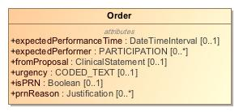

1. Order

|  |  |
| --- | --- |
| **Name** | Order |
| **Qualified Name** | CIMI Clinical::Data Structure::Order |
| **Visibility** | public |
| **Abstract** | false |
| **Base Classifier** | * ActionContext |
| **Realized Interface** |  |

### **Attribute Detail**

#### expectedPerformanceTime

Time when the ordered act is expected to be performed.

|  |  |
| --- | --- |
| **Type** | DateTimeInterval |
| **Default Value** |  |
| **Visibility** | public |
| **Multiplicity** | 0..1 |

#### expectedPerformer

Persons who are expected to or intended to perform this action, e.g., the person who will perform the surgery.

|  |  |
| --- | --- |
| **Type** | PARTICIPATION |
| **Default Value** |  |
| **Visibility** | public |
| **Multiplicity** | 0..* |

#### fromProposal

Identifies a proposal that led to this order.

|  |  |
| --- | --- |
| **Type** | ClinicalStatement |
| **Default Value** |  |
| **Visibility** | public |
| **Multiplicity** | 0..1 |

#### isPRN

Indicates whether the act being ordered should be performed only if needed, i.e., when a certain condition occurs. The condition can be described in the attribute prnReason.

|  |  |
| --- | --- |
| **Type** | Boolean |
| **Default Value** |  |
| **Visibility** | public |
| **Multiplicity** | 0..1 |

#### prnReason

The ordered act should be performed if the indicated conditions occur, e.g.., shortness of breath, SpO2 less than x%, insomnia, nausea.

|  |  |
| --- | --- |
| **Type** | Justification |
| **Default Value** |  |
| **Visibility** | public |
| **Multiplicity** | 0..* |

#### urgency

Characterizes how quickly the action must be initiated. Includes concepts such as stat, urgent, routine.

|  |  |
| --- | --- |
| **Type** | CODED_TEXT |
| **Default Value** |  |
| **Visibility** | public |
| **Multiplicity** | 0..1 |

### **Relation Detail**

#### Generalization

|  |  |
| --- | --- |
| **Name** |  |
| **Related Element** | * ActionContext |

## **Class** **OrganizationName**

The name of an organization.

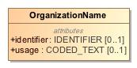

1. OrganizationName

|  |  |
| --- | --- |
| **Name** | OrganizationName |
| **Qualified Name** | CIMI Clinical::Data Structure::OrganizationName |
| **Visibility** | public |
| **Abstract** | false |
| **Base Classifier** | * ActorName |
| **Realized Interface** |  |

### **Attribute Detail**

#### identifier

An identifier for the organization.

|  |  |
| --- | --- |
| **Type** | IDENTIFIER |
| **Default Value** |  |
| **Visibility** | public |
| **Multiplicity** | 0..1 |

#### usage

Code indicating when the name is used.

|  |  |
| --- | --- |
| **Type** | CODED_TEXT |
| **Default Value** |  |
| **Visibility** | public |
| **Multiplicity** | 0..1 |

### **Relation Detail**

#### Generalization

|  |  |
| --- | --- |
| **Name** |  |
| **Related Element** | * ActorName |

## **Class** **Part**

A component of a name or an address.

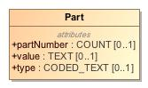

1. Part

|  |  |
| --- | --- |
| **Name** | Part |
| **Qualified Name** | CIMI Clinical::Data Structure::Part |
| **Visibility** | public |
| **Abstract** | false |
| **Base Classifier** | * CLUSTER |
| **Realized Interface** |  |

### **Attribute Detail**

#### partNumber

The position of the part in the overall structure.

|  |  |
| --- | --- |
| **Type** | COUNT |
| **Default Value** |  |
| **Visibility** | public |
| **Multiplicity** | 0..1 |

#### type

The type of the part - e.g., 'given name' or 'street number'.

|  |  |
| --- | --- |
| **Type** | CODED_TEXT |
| **Default Value** |  |
| **Visibility** | public |
| **Multiplicity** | 0..1 |

#### value

The value of the given part - e.g., a given name such as 'John'.

|  |  |
| --- | --- |
| **Type** | TEXT |
| **Default Value** |  |
| **Visibility** | public |
| **Multiplicity** | 0..1 |

### **Relation Detail**

#### Generalization

|  |  |
| --- | --- |
| **Name** |  |
| **Related Element** | * CLUSTER |

## **Class** **PartyName**

Abstract supertype for the name of a party.

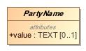

1. PartyName

|  |  |
| --- | --- |
| **Name** | PartyName |
| **Qualified Name** | CIMI Clinical::Data Structure::PartyName |
| **Visibility** | public |
| **Abstract** | true |
| **Base Classifier** | * CLUSTER |
| **Realized Interface** |  |

### **Attribute Detail**

#### value

|  |  |
| --- | --- |
| **Type** | TEXT |
| **Default Value** |  |
| **Visibility** | public |
| **Multiplicity** | 0..1 |

### **Relation Detail**

#### Generalization

|  |  |
| --- | --- |
| **Name** |  |
| **Related Element** | * CLUSTER |

|  |  |
| --- | --- |
| **Name** |  |
| **Related Element** | * ActorName |

## **Class** **Performance**

The actual performance or execution of a healthcare-related action, e.g., 3rd dose of Hepatitis B vaccine administered on Dec 4th 2012, appendectomy performed today.

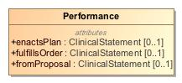

1. Performance

|  |  |
| --- | --- |
| **Name** | Performance |
| **Qualified Name** | CIMI Clinical::Data Structure::Performance |
| **Visibility** | public |
| **Abstract** | false |
| **Base Classifier** | * ActionContext |
| **Realized Interface** |  |

### **Attribute Detail**

#### enactsPlan

Identifies a plan that is partly or wholly enacted by the performance of this act

|  |  |
| --- | --- |
| **Type** | ClinicalStatement |
| **Default Value** |  |
| **Visibility** | public |
| **Multiplicity** | 0..1 |

#### fromProposal

Identifies a proposal that led to this order.

|  |  |
| --- | --- |
| **Type** | ClinicalStatement |
| **Default Value** |  |
| **Visibility** | public |
| **Multiplicity** | 0..1 |

#### fulfillsOrder

Identifies an order that is partly or wholly filled by the performance of this act

|  |  |
| --- | --- |
| **Type** | ClinicalStatement |
| **Default Value** |  |
| **Visibility** | public |
| **Multiplicity** | 0..1 |

### **Relation Detail**

#### Generalization

|  |  |
| --- | --- |
| **Name** |  |
| **Related Element** | * NotCompleted |

|  |  |
| --- | --- |
| **Name** |  |
| **Related Element** | * ActionContext |

## **Class** **Person**

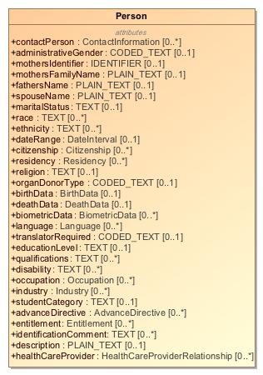

1. Person

|  |  |
| --- | --- |
| **Name** | Person |
| **Qualified Name** | CIMI Clinical::Data Structure::Person |
| **Visibility** | public |
| **Abstract** | false |
| **Base Classifier** | * Actor |
| **Realized Interface** |  |

### **Attribute Detail**

#### administrativeGender

|  |  |
| --- | --- |
| **Type** | CODED_TEXT |
| **Default Value** |  |
| **Visibility** | public |
| **Multiplicity** | 0..1 |

#### advanceDirective

|  |  |
| --- | --- |
| **Type** | AdvanceDirective |
| **Default Value** |  |
| **Visibility** | public |
| **Multiplicity** | 0..* |

#### biometricData

|  |  |
| --- | --- |
| **Type** | BiometricData |
| **Default Value** |  |
| **Visibility** | public |
| **Multiplicity** | 0..* |

#### birthData

|  |  |
| --- | --- |
| **Type** | BirthData |
| **Default Value** |  |
| **Visibility** | public |
| **Multiplicity** | 0..1 |

#### citizenship

|  |  |
| --- | --- |
| **Type** | Citizenship |
| **Default Value** |  |
| **Visibility** | public |
| **Multiplicity** | 0..* |

#### contactPerson

|  |  |
| --- | --- |
| **Type** | ContactInformation |
| **Default Value** |  |
| **Visibility** | public |
| **Multiplicity** | 0..* |

#### dateRange

|  |  |
| --- | --- |
| **Type** | DateInterval |
| **Default Value** |  |
| **Visibility** | public |
| **Multiplicity** | 0..1 |

#### deathData

|  |  |
| --- | --- |
| **Type** | DeathData |
| **Default Value** |  |
| **Visibility** | public |
| **Multiplicity** | 0..1 |

#### description

|  |  |
| --- | --- |
| **Type** | PLAIN_TEXT |
| **Default Value** |  |
| **Visibility** | public |
| **Multiplicity** | 0..1 |

#### disability

|  |  |
| --- | --- |
| **Type** | TEXT |
| **Default Value** |  |
| **Visibility** | public |
| **Multiplicity** | 0..* |

#### educationLevel

|  |  |
| --- | --- |
| **Type** | TEXT |
| **Default Value** |  |
| **Visibility** | public |
| **Multiplicity** | 0..1 |

#### entitlement

|  |  |
| --- | --- |
| **Type** | Entitlement |
| **Default Value** |  |
| **Visibility** | public |
| **Multiplicity** | 0..* |

#### ethnicity

|  |  |
| --- | --- |
| **Type** | TEXT |
| **Default Value** |  |
| **Visibility** | public |
| **Multiplicity** | 0..* |

#### fathersName

|  |  |
| --- | --- |
| **Type** | PLAIN_TEXT |
| **Default Value** |  |
| **Visibility** | public |
| **Multiplicity** | 0..1 |

#### healthCareProvider

|  |  |
| --- | --- |
| **Type** | HealthCareProviderRelationship |
| **Default Value** |  |
| **Visibility** | public |
| **Multiplicity** | 0..* |

#### identificationComment

|  |  |
| --- | --- |
| **Type** | TEXT |
| **Default Value** |  |
| **Visibility** | public |
| **Multiplicity** | 0..* |

#### industry

|  |  |
| --- | --- |
| **Type** | Industry |
| **Default Value** |  |
| **Visibility** | public |
| **Multiplicity** | 0..* |

#### language

|  |  |
| --- | --- |
| **Type** | Language |
| **Default Value** |  |
| **Visibility** | public |
| **Multiplicity** | 0..* |

#### maritalStatus

|  |  |
| --- | --- |
| **Type** | TEXT |
| **Default Value** |  |
| **Visibility** | public |
| **Multiplicity** | 0..1 |

#### mothersFamilyName

|  |  |
| --- | --- |
| **Type** | PLAIN_TEXT |
| **Default Value** |  |
| **Visibility** | public |
| **Multiplicity** | 0..1 |

#### mothersIdentifier

|  |  |
| --- | --- |
| **Type** | IDENTIFIER |
| **Default Value** |  |
| **Visibility** | public |
| **Multiplicity** | 0..1 |

#### occupation

|  |  |
| --- | --- |
| **Type** | Occupation |
| **Default Value** |  |
| **Visibility** | public |
| **Multiplicity** | 0..* |

#### organDonorType

|  |  |
| --- | --- |
| **Type** | CODED_TEXT |
| **Default Value** |  |
| **Visibility** | public |
| **Multiplicity** | 0..1 |

#### qualifications

|  |  |
| --- | --- |
| **Type** | TEXT |
| **Default Value** |  |
| **Visibility** | public |
| **Multiplicity** | 0..* |

#### race

|  |  |
| --- | --- |
| **Type** | TEXT |
| **Default Value** |  |
| **Visibility** | public |
| **Multiplicity** | 0..* |

#### religion

|  |  |
| --- | --- |
| **Type** | TEXT |
| **Default Value** |  |
| **Visibility** | public |
| **Multiplicity** | 0..1 |

#### residency

|  |  |
| --- | --- |
| **Type** | Residency |
| **Default Value** |  |
| **Visibility** | public |
| **Multiplicity** | 0..* |

#### spouseName

|  |  |
| --- | --- |
| **Type** | PLAIN_TEXT |
| **Default Value** |  |
| **Visibility** | public |
| **Multiplicity** | 0..1 |

#### studentCategory

|  |  |
| --- | --- |
| **Type** | TEXT |
| **Default Value** |  |
| **Visibility** | public |
| **Multiplicity** | 0..1 |

#### translatorRequired

|  |  |
| --- | --- |
| **Type** | CODED_TEXT |
| **Default Value** |  |
| **Visibility** | public |
| **Multiplicity** | 0..1 |

### **Relation Detail**

#### Generalization

|  |  |
| --- | --- |
| **Name** |  |
| **Related Element** | * Actor |

## **Class** **PersonName**

The generic representation of the name of a person. The name of a person can vary greatly across cultures and countries.

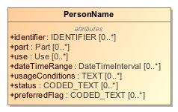

1. PersonName

|  |  |
| --- | --- |
| **Name** | PersonName |
| **Qualified Name** | CIMI Clinical::Data Structure::PersonName |
| **Visibility** | public |
| **Abstract** | false |
| **Base Classifier** | * ActorName |
| **Realized Interface** |  |

### **Attribute Detail**

#### dateTimeRange

Time period when the name was used.

|  |  |
| --- | --- |
| **Type** | DateTimeInterval |
| **Default Value** |  |
| **Visibility** | public |
| **Multiplicity** | 0..* |

#### identifier

An identifier for the name.

|  |  |
| --- | --- |
| **Type** | IDENTIFIER |
| **Default Value** |  |
| **Visibility** | public |
| **Multiplicity** | 0..* |

#### part

|  |  |
| --- | --- |
| **Type** | Part |
| **Default Value** |  |
| **Visibility** | public |
| **Multiplicity** | 0..* |

#### preferredFlag

Code indicating the preference associated with the use of this name.

|  |  |
| --- | --- |
| **Type** | CODED_TEXT |
| **Default Value** |  |
| **Visibility** | public |
| **Multiplicity** | 0..* |

#### status

NEED DEFINITION

|  |  |
| --- | --- |
| **Type** | CODED_TEXT |
| **Default Value** |  |
| **Visibility** | public |
| **Multiplicity** | 0..* |

#### usageConditions

NEED DEFINITION AND EXAMPLE

|  |  |
| --- | --- |
| **Type** | TEXT |
| **Default Value** |  |
| **Visibility** | public |
| **Multiplicity** | 0..* |

#### use

Context of use

|  |  |
| --- | --- |
| **Type** | Use |
| **Default Value** |  |
| **Visibility** | public |
| **Multiplicity** | 0..* |

### **Relation Detail**

#### Generalization

|  |  |
| --- | --- |
| **Name** |  |
| **Related Element** | * PersonNameDetailed |

|  |  |
| --- | --- |
| **Name** |  |
| **Related Element** | * ActorName |

## **Class** **PersonNameDetailed**

NEED TO CONSIDER REFACTORING THIS CLASS

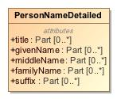

1. PersonNameDetailed

|  |  |
| --- | --- |
| **Name** | PersonNameDetailed |
| **Qualified Name** | CIMI Clinical::Data Structure::PersonNameDetailed |
| **Visibility** | public |
| **Abstract** | false |
| **Base Classifier** | * PersonName |
| **Realized Interface** |  |

### **Attribute Detail**

#### familyName

The person's surname (family name).

|  |  |
| --- | --- |
| **Type** | Part |
| **Default Value** |  |
| **Visibility** | public |
| **Multiplicity** | 0..* |

#### givenName

The person's given name - e.g., John

|  |  |
| --- | --- |
| **Type** | Part |
| **Default Value** |  |
| **Visibility** | public |
| **Multiplicity** | 0..* |

#### middleName

The person's middle name.

|  |  |
| --- | --- |
| **Type** | Part |
| **Default Value** |  |
| **Visibility** | public |
| **Multiplicity** | 0..* |

#### suffix

The suffix for the name.

|  |  |
| --- | --- |
| **Type** | Part |
| **Default Value** |  |
| **Visibility** | public |
| **Multiplicity** | 0..* |

#### title

The person's title - e.g., Dr, Mr, etc...

|  |  |
| --- | --- |
| **Type** | Part |
| **Default Value** |  |
| **Visibility** | public |
| **Multiplicity** | 0..* |

### **Relation Detail**

#### Generalization

|  |  |
| --- | --- |
| **Name** |  |
| **Related Element** | * PersonName |

## **Class** **PhysicalEvaluationResult**

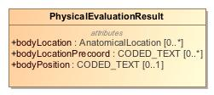

1. PhysicalEvaluationResult

|  |  |
| --- | --- |
| **Name** | PhysicalEvaluationResult |
| **Qualified Name** | CIMI Clinical::Data Structure::PhysicalEvaluationResult |
| **Visibility** | public |
| **Abstract** | false |
| **Base Classifier** | * EvaluationResult |
| **Realized Interface** |  |

### **Attribute Detail**

#### bodyLocation

Captures the post-coordinated location on the body where the characteristic was observed

|  |  |
| --- | --- |
| **Type** | AnatomicalLocation |
| **Default Value** |  |
| **Visibility** | public |
| **Multiplicity** | 0..* |

#### bodyLocationPrecoord

Captures the pre-coordinated body location information, for example pre-coordinating body side left with body location hand to make left hand .

|  |  |
| --- | --- |
| **Type** | CODED_TEXT |
| **Default Value** |  |
| **Visibility** | public |
| **Multiplicity** | 0..* |

#### bodyPosition

Captures the position of the body when an observation is done. E.g., supine, prone, etc...

|  |  |
| --- | --- |
| **Type** | CODED_TEXT |
| **Default Value** |  |
| **Visibility** | public |
| **Multiplicity** | 0..1 |

### **Relation Detail**

#### Generalization

|  |  |
| --- | --- |
| **Name** |  |
| **Related Element** | * EvaluationResult |

## **Class** **Plan**

Description of action that is planned to be performed. Typically, this would include a time at which the action is scheduled to be performed.

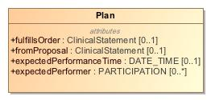

1. Plan

|  |  |
| --- | --- |
| **Name** | Plan |
| **Qualified Name** | CIMI Clinical::Data Structure::Plan |
| **Visibility** | public |
| **Abstract** | false |
| **Base Classifier** | * ActionContext |
| **Realized Interface** |  |

### **Attribute Detail**

#### expectedPerformanceTime

The time when the action is expected to be performed.

|  |  |
| --- | --- |
| **Type** | DATE_TIME |
| **Default Value** |  |
| **Visibility** | public |
| **Multiplicity** | 0..1 |

#### expectedPerformer

Persons who are expected to or intended to perform this action, e.g., the person who will perform the surgery.

|  |  |
| --- | --- |
| **Type** | PARTICIPATION |
| **Default Value** |  |
| **Visibility** | public |
| **Multiplicity** | 0..* |

#### fromProposal

Identifies a proposal that contributed to this planned action.

|  |  |
| --- | --- |
| **Type** | ClinicalStatement |
| **Default Value** |  |
| **Visibility** | public |
| **Multiplicity** | 0..1 |

#### fulfillsOrder

Identifies an order that is partly or wholly filled by the performance of this act

|  |  |
| --- | --- |
| **Type** | ClinicalStatement |
| **Default Value** |  |
| **Visibility** | public |
| **Multiplicity** | 0..1 |

### **Relation Detail**

#### Generalization

|  |  |
| --- | --- |
| **Name** |  |
| **Related Element** | * ActionContext |

## **Class** **PresenceAbsenceContext**

-419274319.jpg

1. PresenceAbsenceContext

|  |  |
| --- | --- |
| **Name** | PresenceAbsenceContext |
| **Qualified Name** | CIMI Clinical::Data Structure::PresenceAbsenceContext |
| **Visibility** | public |
| **Abstract** | true |
| **Base Classifier** | * FindingContext |
| **Realized Interface** |  |

### **Relation Detail**

#### Generalization

|  |  |
| --- | --- |
| **Name** |  |
| **Related Element** | * KnownOrSuspectedPresent |

|  |  |
| --- | --- |
| **Name** |  |
| **Related Element** | * FindingContext |

|  |  |
| --- | --- |
| **Name** |  |
| **Related Element** | * Absent |

## **Class** **Procedure**

An action intended to treat, cure, or restore function or structure such as surgical and physical rehabilitation procedures.

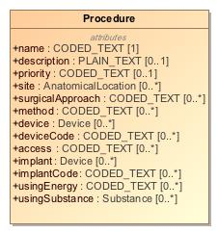

1. Procedure

|  |  |
| --- | --- |
| **Name** | Procedure |
| **Qualified Name** | CIMI Clinical::Data Structure::Procedure |
| **Visibility** | public |
| **Abstract** | false |
| **Base Classifier** | * Act |
| **Realized Interface** |  |

### **Attribute Detail**

#### access

The route used to access the site of a procedure. It is used to distinguish open, closed, and percutaneous procedures.

|  |  |
| --- | --- |
| **Type** | CODED_TEXT |
| **Default Value** |  |
| **Visibility** | public |
| **Multiplicity** | 0..* |

#### description

An account of the procedure in narrative form.

|  |  |
| --- | --- |
| **Type** | PLAIN_TEXT |
| **Default Value** |  |
| **Visibility** | public |
| **Multiplicity** | 0..1 |

#### device

Instrument, apparatus, appliance, software, material, or other article - whether used alone or in combination, associated with the performance of the procedure. For instance, an endoscope.Note that this differs from an implant which remains in the body after the procedure is performed.

|  |  |
| --- | --- |
| **Type** | Device |
| **Default Value** |  |
| **Visibility** | public |
| **Multiplicity** | 0..* |

#### deviceCode

Concept representing instrument, apparatus, appliance, software, material, or other article - whether used alone or in combination, associated with the performance of the procedure. For instance, an endoscope.Note that this differs from an implant which remains in the body after the procedure is performed.

|  |  |
| --- | --- |
| **Type** | CODED_TEXT |
| **Default Value** |  |
| **Visibility** | public |
| **Multiplicity** | 0..* |

#### findings

Records clinically significant observations confirmed or discovered during the procedure or surgery. For example, "Necrotic left ovarian cyst was discovered"

|  |  |
| --- | --- |
| **Type** | ClinicalStatement |
| **Default Value** |  |
| **Visibility** | public |
| **Multiplicity** | 0..* |

#### implant

Something placed in a person's body or on its surface during the procedure and remains postoperatively. E.g., stents, tubes, artificial joints, and drains.

|  |  |
| --- | --- |
| **Type** | Device |
| **Default Value** |  |
| **Visibility** | public |
| **Multiplicity** | 0..* |

#### implantCode

Concept representing something placed in a person's body or on its surface during the procedure and remains postoperatively. E.g., stents, tubes, artificial joints, and drains.

|  |  |
| --- | --- |
| **Type** | CODED_TEXT |
| **Default Value** |  |
| **Visibility** | public |
| **Multiplicity** | 0..* |

#### method

Technique or way of accomplishing the procedure. E.g., endoscopic, arthroscopic, etc...

|  |  |
| --- | --- |
| **Type** | CODED_TEXT |
| **Default Value** |  |
| **Visibility** | public |
| **Multiplicity** | 0..* |

#### name

Concept representing the type of procedure performed.

|  |  |
| --- | --- |
| **Type** | CODED_TEXT |
| **Default Value** |  |
| **Visibility** | public |
| **Multiplicity** | 1 |

#### priority

Priority assigned to a procedure.

|  |  |
| --- | --- |
| **Type** | CODED_TEXT |
| **Default Value** |  |
| **Visibility** | public |
| **Multiplicity** | 0..1 |

#### site

Anatomical location of the procedure.

|  |  |
| --- | --- |
| **Type** | AnatomicalLocation |
| **Default Value** |  |
| **Visibility** | public |
| **Multiplicity** | 0..* |

#### surgicalApproach

The technique used to reach the site of the procedure. Approaches may be through the skin or mucous membrane, through an orifice or external.

|  |  |
| --- | --- |
| **Type** | CODED_TEXT |
| **Default Value** |  |
| **Visibility** | public |
| **Multiplicity** | 0..* |

#### usingEnergy

The energy used to execute the procedure. E.g., gamma rays.

|  |  |
| --- | --- |
| **Type** | CODED_TEXT |
| **Default Value** |  |
| **Visibility** | public |
| **Multiplicity** | 0..* |

#### usingSubstance

Substance used to execute the action of a procedure. E.g., radiographic contrast media.

|  |  |
| --- | --- |
| **Type** | Substance |
| **Default Value** |  |
| **Visibility** | public |
| **Multiplicity** | 0..* |

### **Relation Detail**

#### Association

|  |  |
| --- | --- |
| **Name** |  |
| **Related Element** | * ClinicalStatement |

#### Generalization

|  |  |
| --- | --- |
| **Name** |  |
| **Related Element** | * Act |

|  |  |
| --- | --- |
| **Name** |  |
| **Related Element** | * LaboratoryProcedure |

## **Class** **ProductBatch**

Information about a group of medication produced or packaged from one production run.

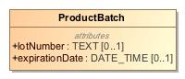

1. ProductBatch

|  |  |
| --- | --- |
| **Name** | ProductBatch |
| **Qualified Name** | CIMI Clinical::Data Structure::ProductBatch |
| **Visibility** | public |
| **Abstract** | false |
| **Base Classifier** | * CLUSTER |
| **Realized Interface** |  |

### **Attribute Detail**

#### expirationDate

When this specific batch of product will expire.

|  |  |
| --- | --- |
| **Type** | DATE_TIME |
| **Default Value** |  |
| **Visibility** | public |
| **Multiplicity** | 0..1 |

#### lotNumber

The assigned lot number of a batch of the specified product.

|  |  |
| --- | --- |
| **Type** | TEXT |
| **Default Value** |  |
| **Visibility** | public |
| **Multiplicity** | 0..1 |

### **Relation Detail**

#### Generalization

|  |  |
| --- | --- |
| **Name** |  |
| **Related Element** | * CLUSTER |

## **Class** **Proposal**

An offer or a suggestion to perform a healthcare act. A recommendation to a provider is an example of proposal made by a CDS system. A proposal must be accepted by an entity in order for it to be performed.

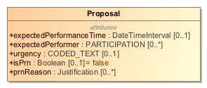

1. Proposal

|  |  |
| --- | --- |
| **Name** | Proposal |
| **Qualified Name** | CIMI Clinical::Data Structure::Proposal |
| **Visibility** | public |
| **Abstract** | false |
| **Base Classifier** | * ActionContext |
| **Realized Interface** |  |

### **Attribute Detail**

#### expectedPerformanceTime

The time when the proposed action is expected to be performed.

|  |  |
| --- | --- |
| **Type** | DateTimeInterval |
| **Default Value** |  |
| **Visibility** | public |
| **Multiplicity** | 0..1 |

#### expectedPerformer

Persons who are expected to or intended to perform this action, e.g., the person who will perform the surgery.

|  |  |
| --- | --- |
| **Type** | PARTICIPATION |
| **Default Value** |  |
| **Visibility** | public |
| **Multiplicity** | 0..* |

#### isPrn

Indicates whether the act being proposed should be performed only if needed, i.e., when a certain condition occurs. The condition can be described in the attribute prnReason.

|  |  |
| --- | --- |
| **Type** | Boolean |
| **Default Value** | false |
| **Visibility** | public |
| **Multiplicity** | 0..1 |

#### prnReason

The proposed act must be performed if the indicated conditions occur, e.g.., shortness of breath, SpO2 less than x%, insomnia, nausea.

|  |  |
| --- | --- |
| **Type** | Justification |
| **Default Value** |  |
| **Visibility** | public |
| **Multiplicity** | 0..* |

#### urgency

Characterizes how quickly the proposed act must be initiated. Includes concepts such as stat, urgent, routine.

|  |  |
| --- | --- |
| **Type** | CODED_TEXT |
| **Default Value** |  |
| **Visibility** | public |
| **Multiplicity** | 0..1 |

### **Relation Detail**

#### Generalization

|  |  |
| --- | --- |
| **Name** |  |
| **Related Element** | * ActionContext |

## **Class** **ProposalAgainst**

Concept represents a recommendation from a clinical decision support system or advice from a consultation to not perform an act.

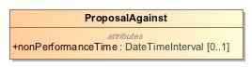

1. ProposalAgainst

|  |  |
| --- | --- |
| **Name** | ProposalAgainst |
| **Qualified Name** | CIMI Clinical::Data Structure::ProposalAgainst |
| **Visibility** | public |
| **Abstract** | false |
| **Base Classifier** | * ActionContext |
| **Realized Interface** |  |

### **Attribute Detail**

#### nonPerformanceTime

The time period during which the act should not be performed.

|  |  |
| --- | --- |
| **Type** | DateTimeInterval |
| **Default Value** |  |
| **Visibility** | public |
| **Multiplicity** | 0..1 |

### **Relation Detail**

#### Generalization

|  |  |
| --- | --- |
| **Name** |  |
| **Related Element** | * ActionContext |

## **Class** **Provenance**

The Provenance pattern supports the attachment of attribution information to one or more clinical statements and is not part of the clinical statements themselves.The attachment of provenance information to a clinical statement in this manner does not impact the versioning of the clinical statement target since attribution information is external to the statement.

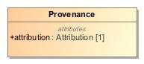

1. Provenance

|  |  |
| --- | --- |
| **Name** | Provenance |
| **Qualified Name** | CIMI Clinical::Data Structure::Provenance |
| **Visibility** | public |
| **Abstract** | false |
| **Base Classifier** | * ClinicalStatementAssociation |
| **Realized Interface** |  |

### **Attribute Detail**

#### attribution

The activity provenance details. Refer to the Attribution class.

|  |  |
| --- | --- |
| **Type** | Attribution |
| **Default Value** |  |
| **Visibility** | public |
| **Multiplicity** | 1 |

#### target

The clinical statement that were generated or updated by the activity described. A provenance can point to more than one target if multiple resources were created/updated by the same activity.

|  |  |
| --- | --- |
| **Type** | ClinicalStatement |
| **Default Value** |  |
| **Visibility** | public |
| **Multiplicity** | 1..* |

### **Relation Detail**

#### Association

|  |  |
| --- | --- |
| **Name** |  |
| **Related Element** | * ClinicalStatement |

#### Generalization

|  |  |
| --- | --- |
| **Name** |  |
| **Related Element** | * ClinicalStatementAssociation |

## **Class** **Qualification**

A professional qualificationNEED A BETTER DEFINITION

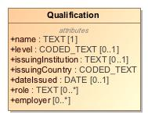

1. Qualification

|  |  |
| --- | --- |
| **Name** | Qualification |
| **Qualified Name** | CIMI Clinical::Data Structure::Qualification |
| **Visibility** | public |
| **Abstract** | false |
| **Base Classifier** | * CLUSTER |
| **Realized Interface** |  |

### **Attribute Detail**

#### dateIssued

The date the qualification was issued.

|  |  |
| --- | --- |
| **Type** | DATE |
| **Default Value** |  |
| **Visibility** | public |
| **Multiplicity** | 0..1 |

#### employer

NEED A DEFINITION

|  |  |
| --- | --- |
| **Type** |  |
| **Default Value** |  |
| **Visibility** | public |
| **Multiplicity** | 0..* |

#### issuingCountry

The issuing country where the qualification is valid.

|  |  |
| --- | --- |
| **Type** | CODED_TEXT |
| **Default Value** |  |
| **Visibility** | public |
| **Multiplicity** |  |

#### issuingInstitution

The organization responsible for issuing the qualification.

|  |  |
| --- | --- |
| **Type** | TEXT |
| **Default Value** |  |
| **Visibility** | public |
| **Multiplicity** | 0..1 |

#### level

The level of the qualification

|  |  |
| --- | --- |
| **Type** | CODED_TEXT |
| **Default Value** |  |
| **Visibility** | public |
| **Multiplicity** | 0..1 |

#### name

The name of the qualification

|  |  |
| --- | --- |
| **Type** | TEXT |
| **Default Value** |  |
| **Visibility** | public |
| **Multiplicity** | 1 |

#### role

The roles where the qualification applies. IS THIS CORRECT?

|  |  |
| --- | --- |
| **Type** | TEXT |
| **Default Value** |  |
| **Visibility** | public |
| **Multiplicity** | 0..* |

### **Relation Detail**

#### Generalization

|  |  |
| --- | --- |
| **Name** |  |
| **Related Element** | * CLUSTER |

## **Class** **QualitativeReferenceRange**

A qualitative reference range specified by a code.

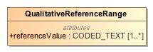

1. QualitativeReferenceRange

|  |  |
| --- | --- |
| **Name** | QualitativeReferenceRange |
| **Qualified Name** | CIMI Clinical::Data Structure::QualitativeReferenceRange |
| **Visibility** | public |
| **Abstract** | false |
| **Base Classifier** | * ReferenceRange |
| **Realized Interface** |  |

### **Attribute Detail**

#### referenceValue

Code representing the reference range.

|  |  |
| --- | --- |
| **Type** | CODED_TEXT |
| **Default Value** |  |
| **Visibility** | public |
| **Multiplicity** | 1..* |

### **Relation Detail**

#### Generalization

|  |  |
| --- | --- |
| **Name** |  |
| **Related Element** | * ReferenceRange |

## **Class** **QuantitativeReferenceRange**

A reference range specifying a quantity interval.

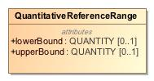

1. QuantitativeReferenceRange

|  |  |
| --- | --- |
| **Name** | QuantitativeReferenceRange |
| **Qualified Name** | CIMI Clinical::Data Structure::QuantitativeReferenceRange |
| **Visibility** | public |
| **Abstract** | false |
| **Base Classifier** | * ReferenceRange |
| **Realized Interface** |  |

### **Attribute Detail**

#### lowerBound

The reference range's lower bound. Values outside the lower bound lie outside the reference range.

|  |  |
| --- | --- |
| **Type** | QUANTITY |
| **Default Value** |  |
| **Visibility** | public |
| **Multiplicity** | 0..1 |

#### upperBound

The reference range's upper bound. Values outside the upper bound lie outside the reference range.

|  |  |
| --- | --- |
| **Type** | QUANTITY |
| **Default Value** |  |
| **Visibility** | public |
| **Multiplicity** | 0..1 |

### **Relation Detail**

#### Generalization

|  |  |
| --- | --- |
| **Name** |  |
| **Related Element** | * ReferenceRange |

## **Class** **ReferenceRange**

A reference range for the specific instance after lookup from, say, a reference range table given specific criteria. Note that this reference range is not definitional in nature but rather refers to the reference range considered for the given observation for a subject.

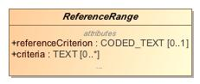

1. ReferenceRange

|  |  |
| --- | --- |
| **Name** | ReferenceRange |
| **Qualified Name** | CIMI Clinical::Data Structure::ReferenceRange |
| **Visibility** | public |
| **Abstract** | true |
| **Base Classifier** | * CLUSTER |
| **Realized Interface** |  |

### **Attribute Detail**

#### criteria

The specific criteria that apply for the given reference range. For instance, reference ranges may be specified in a lookup table based on a set of criteria. If a row in this table is selected as the applicable reference range for a measurement, 'criteria' lists the specific criteria for that row in the table.

|  |  |
| --- | --- |
| **Type** | TEXT |
| **Default Value** |  |
| **Visibility** | public |
| **Multiplicity** | 0..* |

#### narrative

|  |  |
| --- | --- |
| **Type** | TEXT |
| **Default Value** |  |
| **Visibility** | public |
| **Multiplicity** | 0..1 |

#### referenceCriterion

Indicates whether the given range is normal, critically high, ...

|  |  |
| --- | --- |
| **Type** | CODED_TEXT |
| **Default Value** |  |
| **Visibility** | public |
| **Multiplicity** | 0..1 |

### **Relation Detail**

#### Generalization

|  |  |
| --- | --- |
| **Name** |  |
| **Related Element** | * QuantitativeReferenceRange |

|  |  |
| --- | --- |
| **Name** |  |
| **Related Element** | * CLUSTER |

|  |  |
| --- | --- |
| **Name** |  |
| **Related Element** | * QualitativeReferenceRange |

## **Class** **Registration**

NEED DEFINITION

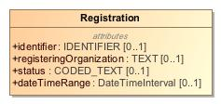

1. Registration

|  |  |
| --- | --- |
| **Name** | Registration |
| **Qualified Name** | CIMI Clinical::Data Structure::Registration |
| **Visibility** | public |
| **Abstract** | false |
| **Base Classifier** | * CLUSTER |
| **Realized Interface** |  |

### **Attribute Detail**

#### dateTimeRange

NEED DEFINITION

|  |  |
| --- | --- |
| **Type** | DateTimeInterval |
| **Default Value** |  |
| **Visibility** | public |
| **Multiplicity** | 0..1 |

#### identifier

NEED DEFINITION

|  |  |
| --- | --- |
| **Type** | IDENTIFIER |
| **Default Value** |  |
| **Visibility** | public |
| **Multiplicity** | 0..1 |

#### registeringOrganization

NEED DEFINITION

|  |  |
| --- | --- |
| **Type** | TEXT |
| **Default Value** |  |
| **Visibility** | public |
| **Multiplicity** | 0..1 |

#### status

NEED DEFINITION

|  |  |
| --- | --- |
| **Type** | CODED_TEXT |
| **Default Value** |  |
| **Visibility** | public |
| **Multiplicity** | 0..1 |

### **Relation Detail**

#### Generalization

|  |  |
| --- | --- |
| **Name** |  |
| **Related Element** | * CLUSTER |

## **Class** **Residency**

Type supporting the capture of residency information.

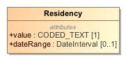

1. Residency

|  |  |
| --- | --- |
| **Name** | Residency |
| **Qualified Name** | CIMI Clinical::Data Structure::Residency |
| **Visibility** | public |
| **Abstract** | false |
| **Base Classifier** | * CLUSTER |
| **Realized Interface** |  |

### **Attribute Detail**

#### dateRange

Period when residency was in effect.

|  |  |
| --- | --- |
| **Type** | DateInterval |
| **Default Value** |  |
| **Visibility** | public |
| **Multiplicity** | 0..1 |

#### value

Residency code.

|  |  |
| --- | --- |
| **Type** | CODED_TEXT |
| **Default Value** |  |
| **Visibility** | public |
| **Multiplicity** | 1 |

### **Relation Detail**

#### Generalization

|  |  |
| --- | --- |
| **Name** |  |
| **Related Element** | * CLUSTER |

## **Class** **Risk**

-67184742.jpg

1. Risk

|  |  |
| --- | --- |
| **Name** | Risk |
| **Qualified Name** | CIMI Clinical::Data Structure::Risk |
| **Visibility** | public |
| **Abstract** | false |
| **Base Classifier** | * FindingContext |
| **Realized Interface** |  |

### **Relation Detail**

#### Generalization

|  |  |
| --- | --- |
| **Name** |  |
| **Related Element** | * FindingContext |

## **Class** **Signature**

A digital signature along with supporting context. The signature may be electronic/cryptographic in nature, or a graphical image representing a hand-written signature, or a signature process. Different Signature approaches have different utilities.

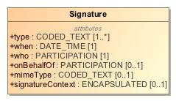

1. Signature

|  |  |
| --- | --- |
| **Name** | Signature |
| **Qualified Name** | CIMI Clinical::Data Structure::Signature |
| **Visibility** | public |
| **Abstract** | false |
| **Base Classifier** | * CLUSTER |
| **Realized Interface** |  |

### **Attribute Detail**

#### mimeType

A mime type that indicates the technical format of the signature. Important mime types are application/signature+xml for X ML DigSig, application/jwt for JWT, and image/* for a graphical image of a signature, etc.

|  |  |
| --- | --- |
| **Type** | CODED_TEXT |
| **Default Value** |  |
| **Visibility** | public |
| **Multiplicity** | 0..1 |

#### onBehalfOf

A reference to an application-usable description of the identity that is represented by the signature.

|  |  |
| --- | --- |
| **Type** | PARTICIPATION |
| **Default Value** |  |
| **Visibility** | public |
| **Multiplicity** | 0..1 |

#### signatureContext

The base64 encoding of the Signature content. When signature is not recorded electronically this element would be empty.

|  |  |
| --- | --- |
| **Type** | ENCAPSULATED |
| **Default Value** |  |
| **Visibility** | public |
| **Multiplicity** | 0..1 |

#### type

An indication of the reason that the entity signed this document. This may be explicitly included as part of the signature information and can be used when determining accountability for various actions concerning the document.

|  |  |
| --- | --- |
| **Type** | CODED_TEXT |
| **Default Value** |  |
| **Visibility** | public |
| **Multiplicity** | 1..* |

#### when

When the digital signature was signed.

|  |  |
| --- | --- |
| **Type** | DATE_TIME |
| **Default Value** |  |
| **Visibility** | public |
| **Multiplicity** | 1 |

#### who

A reference to an application-usable description of the identity that signed (e.g. the signature used their private key).

|  |  |
| --- | --- |
| **Type** | PARTICIPATION |
| **Default Value** |  |
| **Visibility** | public |
| **Multiplicity** | 1 |

### **Relation Detail**

#### Generalization

|  |  |
| --- | --- |
| **Name** |  |
| **Related Element** | * CLUSTER |

## **Class** **Specimen**

Sample for analysis

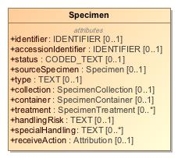

1. Specimen

|  |  |
| --- | --- |
| **Name** | Specimen |
| **Qualified Name** | CIMI Clinical::Data Structure::Specimen |
| **Visibility** | public |
| **Abstract** | false |
| **Base Classifier** | * MaterialEntity |
| **Realized Interface** |  |

### **Attribute Detail**

#### accessionIdentifier

Identifier assigned by the lab

|  |  |
| --- | --- |
| **Type** | IDENTIFIER |
| **Default Value** |  |
| **Visibility** | public |
| **Multiplicity** | 0..1 |

#### collection

Attribution information about the specimen collection activity.

|  |  |
| --- | --- |
| **Type** | SpecimenCollection |
| **Default Value** |  |
| **Visibility** | public |
| **Multiplicity** | 0..1 |

#### container

Information about the vessel holding the specimen.

|  |  |
| --- | --- |
| **Type** | SpecimenContainer |
| **Default Value** |  |
| **Visibility** | public |
| **Multiplicity** | 0..1 |

#### handlingRisk

Cautions on the handling of this specimen.

|  |  |
| --- | --- |
| **Type** | TEXT |
| **Default Value** |  |
| **Visibility** | public |
| **Multiplicity** | 0..1 |

#### identifier

Identifier for the specimen.

|  |  |
| --- | --- |
| **Type** | IDENTIFIER |
| **Default Value** |  |
| **Visibility** | public |
| **Multiplicity** | 0..1 |

#### receiveAction

Attribution information associated with receiving the specimen.

|  |  |
| --- | --- |
| **Type** | Attribution |
| **Default Value** |  |
| **Visibility** | public |
| **Multiplicity** | 0..1 |

#### sourceSpecimen

Identifier for the source specimen from which this specimen was derived.

|  |  |
| --- | --- |
| **Type** | Specimen |
| **Default Value** |  |
| **Visibility** | public |
| **Multiplicity** | 0..1 |

#### specialHandling

Information about the proper handling of the specimen.

|  |  |
| --- | --- |
| **Type** | TEXT |
| **Default Value** |  |
| **Visibility** | public |
| **Multiplicity** | 0..* |

#### status

Code indicating the status of the specimen. E.g., available, unavailable, unsatisfactory

|  |  |
| --- | --- |
| **Type** | CODED_TEXT |
| **Default Value** |  |
| **Visibility** | public |
| **Multiplicity** | 0..1 |

#### treatment

Treatment and processing step details

|  |  |
| --- | --- |
| **Type** | SpecimenTreatment |
| **Default Value** |  |
| **Visibility** | public |
| **Multiplicity** | 0..* |

#### type

Kind of material that forms the specimen

|  |  |
| --- | --- |
| **Type** | TEXT |
| **Default Value** |  |
| **Visibility** | public |
| **Multiplicity** | 0..1 |

### **Relation Detail**

#### Generalization

|  |  |
| --- | --- |
| **Name** |  |
| **Related Element** | * MaterialEntity |

## **Class** **SpecimenCollection**

Attribution specific to the collection of a specimen.

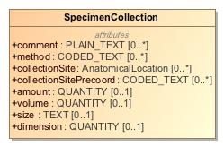

1. SpecimenCollection

|  |  |
| --- | --- |
| **Name** | SpecimenCollection |
| **Qualified Name** | CIMI Clinical::Data Structure::SpecimenCollection |
| **Visibility** | public |
| **Abstract** | false |
| **Base Classifier** | * Attribution |
| **Realized Interface** |  |

### **Attribute Detail**

#### amount

The quantity of specimen collected

|  |  |
| --- | --- |
| **Type** | QUANTITY |
| **Default Value** |  |
| **Visibility** | public |
| **Multiplicity** | 0..1 |

#### collectionSite

Anatomical collection site as a post-coordinated body site.

|  |  |
| --- | --- |
| **Type** | AnatomicalLocation |
| **Default Value** |  |
| **Visibility** | public |
| **Multiplicity** | 0..* |

#### collectionSitePrecoord

Anatomical collection site as a precoordinated code.

|  |  |
| --- | --- |
| **Type** | CODED_TEXT |
| **Default Value** |  |
| **Visibility** | public |
| **Multiplicity** | 0..* |

#### comment

Specimen collection notes.

|  |  |
| --- | --- |
| **Type** | PLAIN_TEXT |
| **Default Value** |  |
| **Visibility** | public |
| **Multiplicity** | 0..* |

#### dimension

The dimension of the collected specimen.

|  |  |
| --- | --- |
| **Type** | QUANTITY |
| **Default Value** |  |
| **Visibility** | public |
| **Multiplicity** | 0..1 |

#### method

Technique used to perform collection. E.g., sputum, finger stick.

|  |  |
| --- | --- |
| **Type** | CODED_TEXT |
| **Default Value** |  |
| **Visibility** | public |
| **Multiplicity** | 0..* |

#### size

The size of the collected specimen.

|  |  |
| --- | --- |
| **Type** | TEXT |
| **Default Value** |  |
| **Visibility** | public |
| **Multiplicity** | 0..1 |

#### volume

The volume of the collected specimen

|  |  |
| --- | --- |
| **Type** | QUANTITY |
| **Default Value** |  |
| **Visibility** | public |
| **Multiplicity** | 0..1 |

### **Relation Detail**

#### Generalization

|  |  |
| --- | --- |
| **Name** |  |
| **Related Element** | * Attribution |

## **Class** **SpecimenContainer**

Direct container of specimen (tube/slide, etc.)

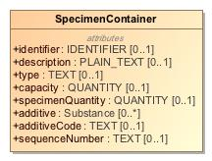

1. SpecimenContainer

|  |  |
| --- | --- |
| **Name** | SpecimenContainer |
| **Qualified Name** | CIMI Clinical::Data Structure::SpecimenContainer |
| **Visibility** | public |
| **Abstract** | false |
| **Base Classifier** | * CLUSTER |
| **Realized Interface** |  |

### **Attribute Detail**

#### additive

Additive associated with container.

|  |  |
| --- | --- |
| **Type** | Substance |
| **Default Value** |  |
| **Visibility** | public |
| **Multiplicity** | 0..* |

#### additiveCode

Additive associated with container.

|  |  |
| --- | --- |
| **Type** | TEXT |
| **Default Value** |  |
| **Visibility** | public |
| **Multiplicity** | 0..1 |

#### capacity

Container volume or size.

|  |  |
| --- | --- |
| **Type** | QUANTITY |
| **Default Value** |  |
| **Visibility** | public |
| **Multiplicity** | 0..1 |

#### description

Textual description of the container

|  |  |
| --- | --- |
| **Type** | PLAIN_TEXT |
| **Default Value** |  |
| **Visibility** | public |
| **Multiplicity** | 0..1 |

#### identifier

An identifier for the vessel containing the specimen.

|  |  |
| --- | --- |
| **Type** | IDENTIFIER |
| **Default Value** |  |
| **Visibility** | public |
| **Multiplicity** | 0..1 |

#### sequenceNumber

The sequence number for this specimen in a collection of specimens.

|  |  |
| --- | --- |
| **Type** | TEXT |
| **Default Value** |  |
| **Visibility** | public |
| **Multiplicity** | 0..1 |

#### specimenQuantity

Quantity of specimen within container.

|  |  |
| --- | --- |
| **Type** | QUANTITY |
| **Default Value** |  |
| **Visibility** | public |
| **Multiplicity** | 0..1 |

#### type

Kind of container holding the specimen - e.g. a vial or well.

|  |  |
| --- | --- |
| **Type** | TEXT |
| **Default Value** |  |
| **Visibility** | public |
| **Multiplicity** | 0..1 |

### **Relation Detail**

#### Generalization

|  |  |
| --- | --- |
| **Name** |  |
| **Related Element** | * CLUSTER |

## **Class** **SpecimenTreatment**

Treatment performed on the specimen.

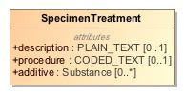

1. SpecimenTreatment

|  |  |
| --- | --- |
| **Name** | SpecimenTreatment |
| **Qualified Name** | CIMI Clinical::Data Structure::SpecimenTreatment |
| **Visibility** | public |
| **Abstract** | false |
| **Base Classifier** | * CLUSTER |
| **Realized Interface** |  |

### **Attribute Detail**

#### additive

|  |  |
| --- | --- |
| **Type** | Substance |
| **Default Value** |  |
| **Visibility** | public |
| **Multiplicity** | 0..* |

#### description

|  |  |
| --- | --- |
| **Type** | PLAIN_TEXT |
| **Default Value** |  |
| **Visibility** | public |
| **Multiplicity** | 0..1 |

#### procedure

|  |  |
| --- | --- |
| **Type** | CODED_TEXT |
| **Default Value** |  |
| **Visibility** | public |
| **Multiplicity** | 0..1 |

### **Relation Detail**

#### Generalization

|  |  |
| --- | --- |
| **Name** |  |
| **Related Element** | * CLUSTER |

## **Class** **StatementContext**

Compositional and reusable grouping of clinical statement attributes that provides the context for the topic of a clinical statement. The StatementContext class aligns with the SNOMED CT Situations with Explicit Context. The StatementContext provides the expressivity required to specify that an act was performed or not performed or that a finding was asserted to be present or absent for the given subject of information. It also often holds provenance information relevant to the context of the clinical statement. It is important to note that by default the context applies to the conjunction of the attribute specified in the statement. For instance, if a clinical statement has a topic describing a rash on left arm and a context of 'absent', then the statement states that the subject of interest did not have a rash on the left arm but might have had one on the right arm.

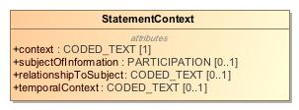

1. StatementContext

|  |  |
| --- | --- |
| **Name** | StatementContext |
| **Qualified Name** | CIMI Clinical::Data Structure::StatementContext |
| **Visibility** | public |
| **Abstract** | false |
| **Base Classifier** | * VIRTUAL_CLUSTER |
| **Realized Interface** |  |

### **Attribute Detail**

#### context

Attribute aligns with the SNOMED CT Situation with Explicit Context (SWEC) Concept Model context attributes: 'Finding context (attribute)' (SCTID: 408729009) and 'Procedure context (attribute)' (SCTID: 408730004). The range allowed for this attribute shall be consistent with the SNOMED CT concept model specification for SWEC.

|  |  |
| --- | --- |
| **Type** | CODED_TEXT |
| **Default Value** |  |
| **Visibility** | public |
| **Multiplicity** | 1 |

#### relationshipToSubject

|  |  |
| --- | --- |
| **Type** | CODED_TEXT |
| **Default Value** |  |
| **Visibility** | public |
| **Multiplicity** | 0..1 |

#### subjectOfInformation

The entity being described by this statement. The entity may be animate (a patient, a relative of the patient, a veterinary patient, a cohort) or inanimate (a well, a geographical location). The subject of information is constrained in archetypes. This attribute aligns with the SNOMED CT Situation with Explicit Context (SWEC) and is bound to the SNOMED attribute: 'Subject relationship context (attribute)' (SCTID: 408732007).

|  |  |
| --- | --- |
| **Type** | PARTICIPATION |
| **Default Value** |  |
| **Visibility** | public |
| **Multiplicity** | 0..1 |

#### temporalContext

Code indicating whether the topic is prospective or retrospective. E.g., action occurred in the past. This attribute is aligned with the SNOMED Situation With Explicit Context temporal context attribute.

|  |  |
| --- | --- |
| **Type** | CODED_TEXT |
| **Default Value** |  |
| **Visibility** | public |
| **Multiplicity** | 0..1 |

### **Relation Detail**

#### Generalization

|  |  |
| --- | --- |
| **Name** |  |
| **Related Element** | * VIRTUAL_CLUSTER |

|  |  |
| --- | --- |
| **Name** |  |
| **Related Element** | * ActionContext |

|  |  |
| --- | --- |
| **Name** |  |
| **Related Element** | * FindingContext |

## **Class** **StatementTopic**

Compositional and reusable grouping of clinical statement attributes that make up the clinical focus of the statement. StatementTopic class attributes are aligned with SNOMED CT Concept Model attributes when such an overlap exists. Note that this class does not include contextual attributes such as the nature of the action (ordered, proposed, planned, etc...), the nature of the patient state being described (e.g., present, suspected present, absent), and the provenance of this information (the who, when, where, how, why of the information recorded).

649213548.jpg

1. StatementTopic

|  |  |
| --- | --- |
| **Name** | StatementTopic |
| **Qualified Name** | CIMI Clinical::Data Structure::StatementTopic |
| **Visibility** | public |
| **Abstract** | true |
| **Base Classifier** | * VIRTUAL_CLUSTER |
| **Realized Interface** |  |

### **Relation Detail**

#### Generalization

|  |  |
| --- | --- |
| **Name** |  |
| **Related Element** | * VIRTUAL_CLUSTER |

|  |  |
| --- | --- |
| **Name** |  |
| **Related Element** | * Act |

|  |  |
| --- | --- |
| **Name** |  |
| **Related Element** | * Finding |

## **Class** **Street**

The name of a street.

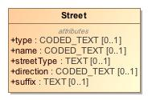

1. Street

|  |  |
| --- | --- |
| **Name** | Street |
| **Qualified Name** | CIMI Clinical::Data Structure::Street |
| **Visibility** | public |
| **Abstract** | false |
| **Base Classifier** | * CLUSTER |
| **Realized Interface** |  |

### **Attribute Detail**

#### direction

Direction code such as N, S, W, NE, etc...

|  |  |
| --- | --- |
| **Type** | CODED_TEXT |
| **Default Value** |  |
| **Visibility** | public |
| **Multiplicity** | 0..1 |

#### name

Name of the street from a list of names maintained by an organization such as the US Postal Service.

|  |  |
| --- | --- |
| **Type** | CODED_TEXT |
| **Default Value** |  |
| **Visibility** | public |
| **Multiplicity** | 0..1 |

#### streetType

The type of street - Court, Lane, Street, Road, Circle, etc...

|  |  |
| --- | --- |
| **Type** | TEXT |
| **Default Value** |  |
| **Visibility** | public |
| **Multiplicity** | 0..1 |

#### suffix

NEED DEFINITION

|  |  |
| --- | --- |
| **Type** | TEXT |
| **Default Value** |  |
| **Visibility** | public |
| **Multiplicity** | 0..1 |

#### type

NEED DEFINITIONHow does this differ from streetType?

|  |  |
| --- | --- |
| **Type** | CODED_TEXT |
| **Default Value** |  |
| **Visibility** | public |
| **Multiplicity** | 0..1 |

### **Relation Detail**

#### Generalization

|  |  |
| --- | --- |
| **Name** |  |
| **Related Element** | * CLUSTER |

## **Class** **StreetNumber**

The number of a residence in a street.

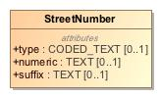

1. StreetNumber

|  |  |
| --- | --- |
| **Name** | StreetNumber |
| **Qualified Name** | CIMI Clinical::Data Structure::StreetNumber |
| **Visibility** | public |
| **Abstract** | false |
| **Base Classifier** | * CLUSTER |
| **Realized Interface** |  |

### **Attribute Detail**

#### numeric

The street number.

|  |  |
| --- | --- |
| **Type** | TEXT |
| **Default Value** |  |
| **Visibility** | public |
| **Multiplicity** | 0..1 |

#### suffix

NEED DEFINITION

|  |  |
| --- | --- |
| **Type** | TEXT |
| **Default Value** |  |
| **Visibility** | public |
| **Multiplicity** | 0..1 |

#### type

Type of street number.NEED DEFINITION AND EXAMPLES

|  |  |
| --- | --- |
| **Type** | CODED_TEXT |
| **Default Value** |  |
| **Visibility** | public |
| **Multiplicity** | 0..1 |

### **Relation Detail**

#### Generalization

|  |  |
| --- | --- |
| **Name** |  |
| **Related Element** | * CLUSTER |

## **Class** **Substance**

A homogeneous material with a definite composition.

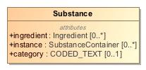

1. Substance

|  |  |
| --- | --- |
| **Name** | Substance |
| **Qualified Name** | CIMI Clinical::Data Structure::Substance |
| **Visibility** | public |
| **Abstract** | false |
| **Base Classifier** | * MaterialEntity |
| **Realized Interface** |  |

### **Attribute Detail**

#### category

A code that classifies the general type of substance. This is used for searching, sorting and display purposes.

|  |  |
| --- | --- |
| **Type** | CODED_TEXT |
| **Default Value** |  |
| **Visibility** | public |
| **Multiplicity** | 0..1 |

#### ingredient

A substance can be composed of other substances.

|  |  |
| --- | --- |
| **Type** | Ingredient |
| **Default Value** |  |
| **Visibility** | public |
| **Multiplicity** | 0..* |

#### instance

Substance may be used to describe a kind of substance, or a specific package/container of the substance: an instance.

|  |  |
| --- | --- |
| **Type** | SubstanceContainer |
| **Default Value** |  |
| **Visibility** | public |
| **Multiplicity** | 0..* |

### **Relation Detail**

#### Generalization

|  |  |
| --- | --- |
| **Name** |  |
| **Related Element** | * MaterialEntity |

## **Class** **SubstanceContainer**

A specific package/container of the substance.

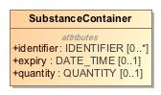

1. SubstanceContainer

|  |  |
| --- | --- |
| **Name** | SubstanceContainer |
| **Qualified Name** | CIMI Clinical::Data Structure::SubstanceContainer |
| **Visibility** | public |
| **Abstract** | false |
| **Base Classifier** | * UnitOfDistribution |
| **Realized Interface** |  |

### **Attribute Detail**

#### expiry

When no longer valid to use.

|  |  |
| --- | --- |
| **Type** | DATE_TIME |
| **Default Value** |  |
| **Visibility** | public |
| **Multiplicity** | 0..1 |

#### identifier

Identifier of the package/container

|  |  |
| --- | --- |
| **Type** | IDENTIFIER |
| **Default Value** |  |
| **Visibility** | public |
| **Multiplicity** | 0..* |

#### quantity

Amount of substance in the package.

|  |  |
| --- | --- |
| **Type** | QUANTITY |
| **Default Value** |  |
| **Visibility** | public |
| **Multiplicity** | 0..1 |

### **Relation Detail**

#### Generalization

|  |  |
| --- | --- |
| **Name** |  |
| **Related Element** | * UnitOfDistribution |

## **Class** **UnitOfDistribution**

Abstract class representing a substance container or package.

-843691960.jpg

1. UnitOfDistribution

|  |  |
| --- | --- |
| **Name** | UnitOfDistribution |
| **Qualified Name** | CIMI Clinical::Data Structure::UnitOfDistribution |
| **Visibility** | public |
| **Abstract** | true |
| **Base Classifier** | * CLUSTER |
| **Realized Interface** |  |

### **Relation Detail**

#### Generalization

|  |  |
| --- | --- |
| **Name** |  |
| **Related Element** | * CLUSTER |

|  |  |
| --- | --- |
| **Name** |  |
| **Related Element** | * SubstanceContainer |

|  |  |
| --- | --- |
| **Name** |  |
| **Related Element** | * MedicationPackage |

## **Class** **Use**

Structure capturing usage preferences for, say, a name, an address, or contact information.

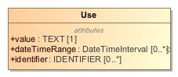

1. Use

|  |  |
| --- | --- |
| **Name** | Use |
| **Qualified Name** | CIMI Clinical::Data Structure::Use |
| **Visibility** | public |
| **Abstract** | false |
| **Base Classifier** | * CLUSTER |
| **Realized Interface** |  |

### **Attribute Detail**

#### dateTimeRange

Period when the use is in effect.

|  |  |
| --- | --- |
| **Type** | DateTimeInterval |
| **Default Value** |  |
| **Visibility** | public |
| **Multiplicity** | 0..* |

#### identifier

An identifier for the use.

|  |  |
| --- | --- |
| **Type** | IDENTIFIER |
| **Default Value** |  |
| **Visibility** | public |
| **Multiplicity** | 0..* |

#### value

A code for the use.

|  |  |
| --- | --- |
| **Type** | TEXT |
| **Default Value** |  |
| **Visibility** | public |
| **Multiplicity** | 1 |

### **Relation Detail**

#### Generalization

|  |  |
| --- | --- |
| **Name** |  |
| **Related Element** | * CLUSTER |

# **Package CIMI Clinical::Participation**

|  |  |
| --- | --- |
| **Name** | Participation |
| **Qualified Name** | CIMI Clinical::Participation |

## **Class** **SubjectOfInformation**

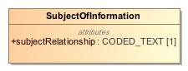

1. SubjectOfInformation

|  |  |
| --- | --- |
| **Name** | SubjectOfInformation |
| **Qualified Name** | CIMI Clinical::Participation::SubjectOfInformation |
| **Visibility** | public |
| **Abstract** | false |
| **Base Classifier** | * PARTICIPATION |
| **Realized Interface** |  |

### **Attribute Detail**

#### subjectRelationship

|  |  |
| --- | --- |
| **Type** | CODED_TEXT |
| **Default Value** |  |
| **Visibility** | public |
| **Multiplicity** | 1 |

### **Relation Detail**

#### Generalization

|  |  |
| --- | --- |
| **Name** |  |
| **Related Element** | * PARTICIPATION |

# **Package CIMI Clinical::Party**

|  |  |
| --- | --- |
| **Name** | Party |
| **Qualified Name** | CIMI Clinical::Party |

## **Class** **Actor**

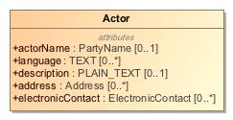

1. Actor

|  |  |
| --- | --- |
| **Name** | Actor |
| **Qualified Name** | CIMI Clinical::Party::Actor |
| **Visibility** | public |
| **Abstract** | false |
| **Base Classifier** | * ACTOR |
| **Realized Interface** |  |

### **Attribute Detail**

#### actorName

|  |  |
| --- | --- |
| **Type** | PartyName |
| **Default Value** |  |
| **Visibility** | public |
| **Multiplicity** | 0..1 |

#### address

|  |  |
| --- | --- |
| **Type** | Address |
| **Default Value** |  |
| **Visibility** | public |
| **Multiplicity** | 0..* |

#### description

|  |  |
| --- | --- |
| **Type** | PLAIN_TEXT |
| **Default Value** |  |
| **Visibility** | public |
| **Multiplicity** | 0..1 |

#### electronicContact

|  |  |
| --- | --- |
| **Type** | ElectronicContact |
| **Default Value** |  |
| **Visibility** | public |
| **Multiplicity** | 0..* |

#### language

|  |  |
| --- | --- |
| **Type** | TEXT |
| **Default Value** |  |
| **Visibility** | public |
| **Multiplicity** | 0..* |

### **Relation Detail**

#### Generalization

|  |  |
| --- | --- |
| **Name** |  |
| **Related Element** | * Person |

|  |  |
| --- | --- |
| **Name** |  |
| **Related Element** | * ACTOR |

|  |  |
| --- | --- |
| **Name** |  |
| **Related Element** | * Organization |

## **Class** **HealthCareConsumerRole**

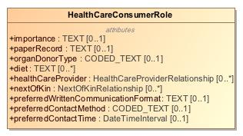

1. HealthCareConsumerRole

|  |  |
| --- | --- |
| **Name** | HealthCareConsumerRole |
| **Qualified Name** | CIMI Clinical::Party::HealthCareConsumerRole |
| **Visibility** | public |
| **Abstract** | false |
| **Base Classifier** | * Role |
| **Realized Interface** |  |

### **Attribute Detail**

#### diet

|  |  |
| --- | --- |
| **Type** | TEXT |
| **Default Value** |  |
| **Visibility** | public |
| **Multiplicity** | 0..* |

#### healthCareProvider

|  |  |
| --- | --- |
| **Type** | HealthCareProviderRelationship |
| **Default Value** |  |
| **Visibility** | public |
| **Multiplicity** | 0..* |

#### importance

|  |  |
| --- | --- |
| **Type** | TEXT |
| **Default Value** |  |
| **Visibility** | public |
| **Multiplicity** | 0..1 |

#### nextOfKin

|  |  |
| --- | --- |
| **Type** | NextOfKinRelationship |
| **Default Value** |  |
| **Visibility** | public |
| **Multiplicity** | 0..* |

#### organDonorType

|  |  |
| --- | --- |
| **Type** | CODED_TEXT |
| **Default Value** |  |
| **Visibility** | public |
| **Multiplicity** | 0..1 |

#### paperRecord

|  |  |
| --- | --- |
| **Type** | TEXT |
| **Default Value** |  |
| **Visibility** | public |
| **Multiplicity** | 0..1 |

#### preferredContactMethod

|  |  |
| --- | --- |
| **Type** | CODED_TEXT |
| **Default Value** |  |
| **Visibility** | public |
| **Multiplicity** | 0..1 |

#### preferredContactTime

|  |  |
| --- | --- |
| **Type** | DateTimeInterval |
| **Default Value** |  |
| **Visibility** | public |
| **Multiplicity** | 0..1 |

#### preferredWrittenCommunicationFormat

|  |  |
| --- | --- |
| **Type** | TEXT |
| **Default Value** |  |
| **Visibility** | public |
| **Multiplicity** | 0..1 |

### **Relation Detail**

#### Generalization

|  |  |
| --- | --- |
| **Name** |  |
| **Related Element** | * Role |

## **Class** **HealthCareProviderIndividualRole**

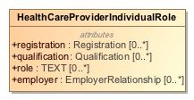

1. HealthCareProviderIndividualRole

|  |  |
| --- | --- |
| **Name** | HealthCareProviderIndividualRole |
| **Qualified Name** | CIMI Clinical::Party::HealthCareProviderIndividualRole |
| **Visibility** | public |
| **Abstract** | false |
| **Base Classifier** | * HealthCareProviderRole |
| **Realized Interface** |  |

### **Attribute Detail**

#### employer

|  |  |
| --- | --- |
| **Type** | EmployerRelationship |
| **Default Value** |  |
| **Visibility** | public |
| **Multiplicity** | 0..* |

#### qualification

|  |  |
| --- | --- |
| **Type** | Qualification |
| **Default Value** |  |
| **Visibility** | public |
| **Multiplicity** | 0..* |

#### registration

|  |  |
| --- | --- |
| **Type** | Registration |
| **Default Value** |  |
| **Visibility** | public |
| **Multiplicity** | 0..* |

#### role

|  |  |
| --- | --- |
| **Type** | TEXT |
| **Default Value** |  |
| **Visibility** | public |
| **Multiplicity** | 0..* |

### **Relation Detail**

#### Generalization

|  |  |
| --- | --- |
| **Name** |  |
| **Related Element** | * HealthCareProviderRole |

## **Class** **HealthCareProviderOrganizationRole**

-365779988.jpg

1. HealthCareProviderOrganizationRole

|  |  |
| --- | --- |
| **Name** | HealthCareProviderOrganizationRole |
| **Qualified Name** | CIMI Clinical::Party::HealthCareProviderOrganizationRole |
| **Visibility** | public |
| **Abstract** | false |
| **Base Classifier** | * HealthCareProviderRole |
| **Realized Interface** |  |

### **Relation Detail**

#### Generalization

|  |  |
| --- | --- |
| **Name** |  |
| **Related Element** | * HealthCareProviderRole |

## **Class** **HealthCareProviderRole**

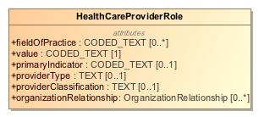

1. HealthCareProviderRole

|  |  |
| --- | --- |
| **Name** | HealthCareProviderRole |
| **Qualified Name** | CIMI Clinical::Party::HealthCareProviderRole |
| **Visibility** | public |
| **Abstract** | false |
| **Base Classifier** | * Role |
| **Realized Interface** |  |

### **Attribute Detail**

#### fieldOfPractice

|  |  |
| --- | --- |
| **Type** | CODED_TEXT |
| **Default Value** |  |
| **Visibility** | public |
| **Multiplicity** | 0..* |

#### organizationRelationship

|  |  |
| --- | --- |
| **Type** | OrganizationRelationship |
| **Default Value** |  |
| **Visibility** | public |
| **Multiplicity** | 0..* |

#### primaryIndicator

|  |  |
| --- | --- |
| **Type** | CODED_TEXT |
| **Default Value** |  |
| **Visibility** | public |
| **Multiplicity** | 0..1 |

#### providerClassification

|  |  |
| --- | --- |
| **Type** | TEXT |
| **Default Value** |  |
| **Visibility** | public |
| **Multiplicity** | 0..1 |

#### providerType

|  |  |
| --- | --- |
| **Type** | TEXT |
| **Default Value** |  |
| **Visibility** | public |
| **Multiplicity** | 0..1 |

#### value

|  |  |
| --- | --- |
| **Type** | CODED_TEXT |
| **Default Value** |  |
| **Visibility** | public |
| **Multiplicity** | 1 |

### **Relation Detail**

#### Generalization

|  |  |
| --- | --- |
| **Name** |  |
| **Related Element** | * Role |

|  |  |
| --- | --- |
| **Name** |  |
| **Related Element** | * HealthCareProviderOrganizationRole |

|  |  |
| --- | --- |
| **Name** |  |
| **Related Element** | * HealthCareProviderIndividualRole |

## **Class** **Organization**

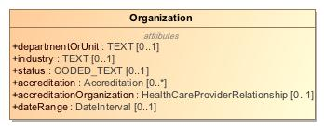

1. Organization

|  |  |
| --- | --- |
| **Name** | Organization |
| **Qualified Name** | CIMI Clinical::Party::Organization |
| **Visibility** | public |
| **Abstract** | false |
| **Base Classifier** | * Actor |
| **Realized Interface** |  |

### **Attribute Detail**

#### accreditation

|  |  |
| --- | --- |
| **Type** | Accreditation |
| **Default Value** |  |
| **Visibility** | public |
| **Multiplicity** | 0..* |

#### accreditationOrganization

|  |  |
| --- | --- |
| **Type** | HealthCareProviderRelationship |
| **Default Value** |  |
| **Visibility** | public |
| **Multiplicity** | 0..1 |

#### dateRange

|  |  |
| --- | --- |
| **Type** | DateInterval |
| **Default Value** |  |
| **Visibility** | public |
| **Multiplicity** | 0..1 |

#### departmentOrUnit

|  |  |
| --- | --- |
| **Type** | TEXT |
| **Default Value** |  |
| **Visibility** | public |
| **Multiplicity** | 0..1 |

#### industry

|  |  |
| --- | --- |
| **Type** | TEXT |
| **Default Value** |  |
| **Visibility** | public |
| **Multiplicity** | 0..1 |

#### status

|  |  |
| --- | --- |
| **Type** | CODED_TEXT |
| **Default Value** |  |
| **Visibility** | public |
| **Multiplicity** | 0..1 |

### **Relation Detail**

#### Generalization

|  |  |
| --- | --- |
| **Name** |  |
| **Related Element** | * Actor |

## **Class** **Role**

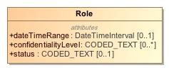

1. Role

|  |  |
| --- | --- |
| **Name** | Role |
| **Qualified Name** | CIMI Clinical::Party::Role |
| **Visibility** | public |
| **Abstract** | false |
| **Base Classifier** | * ROLE |
| **Realized Interface** |  |

### **Attribute Detail**

#### confidentialityLevel

|  |  |
| --- | --- |
| **Type** | CODED_TEXT |
| **Default Value** |  |
| **Visibility** | public |
| **Multiplicity** | 0..* |

#### dateTimeRange

|  |  |
| --- | --- |
| **Type** | DateTimeInterval |
| **Default Value** |  |
| **Visibility** | public |
| **Multiplicity** | 0..1 |

#### status

|  |  |
| --- | --- |
| **Type** | CODED_TEXT |
| **Default Value** |  |
| **Visibility** | public |
| **Multiplicity** | 0..1 |

### **Relation Detail**

#### Generalization

|  |  |
| --- | --- |
| **Name** |  |
| **Related Element** | * HealthCareProviderRole |

|  |  |
| --- | --- |
| **Name** |  |
| **Related Element** | * ROLE |

|  |  |
| --- | --- |
| **Name** |  |
| **Related Element** | * HealthCareConsumerRole |

# **Package CIMI Clinical::Redefined Datatypes**

|  |  |
| --- | --- |
| **Name** | Redefined Datatypes |
| **Qualified Name** | CIMI Clinical::Redefined Datatypes |

## **Class** **DateInterval**

-1813324537.jpg

1. DateInterval

|  |  |
| --- | --- |
| **Name** | DateInterval |
| **Qualified Name** | CIMI Clinical::Redefined Datatypes::DateInterval |
| **Visibility** | public |
| **Abstract** | false |
| **Base Classifier** |  |
| **Realized Interface** |  |

### **Relation Detail**

#### Template Binding

|  |  |
| --- | --- |
| **Name** |  |
| **Related Element** |  |

## **Class** **DateTimeInterval**

620812094.jpg

1. DateTimeInterval

|  |  |
| --- | --- |
| **Name** | DateTimeInterval |
| **Qualified Name** | CIMI Clinical::Redefined Datatypes::DateTimeInterval |
| **Visibility** | public |
| **Abstract** | false |
| **Base Classifier** |  |
| **Realized Interface** |  |

### **Relation Detail**

#### Template Binding

|  |  |
| --- | --- |
| **Name** |  |
| **Related Element** |  |

# **Package CIMI Clinical::Relationship**

|  |  |
| --- | --- |
| **Name** | Relationship |
| **Qualified Name** | CIMI Clinical::Relationship |

## **Class** **EmployerRelationship**

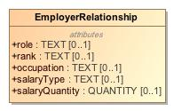

1. EmployerRelationship

|  |  |
| --- | --- |
| **Name** | EmployerRelationship |
| **Qualified Name** | CIMI Clinical::Relationship::EmployerRelationship |
| **Visibility** | public |
| **Abstract** | false |
| **Base Classifier** | * OrganizationRelationship |
| **Realized Interface** |  |

### **Attribute Detail**

#### occupation

|  |  |
| --- | --- |
| **Type** | TEXT |
| **Default Value** |  |
| **Visibility** | public |
| **Multiplicity** | 0..1 |

#### rank

|  |  |
| --- | --- |
| **Type** | TEXT |
| **Default Value** |  |
| **Visibility** | public |
| **Multiplicity** | 0..1 |

#### role

|  |  |
| --- | --- |
| **Type** | TEXT |
| **Default Value** |  |
| **Visibility** | public |
| **Multiplicity** | 0..1 |

#### salaryQuantity

|  |  |
| --- | --- |
| **Type** | QUANTITY |
| **Default Value** |  |
| **Visibility** | public |
| **Multiplicity** | 0..1 |

#### salaryType

|  |  |
| --- | --- |
| **Type** | TEXT |
| **Default Value** |  |
| **Visibility** | public |
| **Multiplicity** | 0..1 |

### **Relation Detail**

#### Generalization

|  |  |
| --- | --- |
| **Name** |  |
| **Related Element** | * OrganizationRelationship |

## **Class** **HealthCareProviderRelationship**

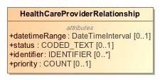

1. HealthCareProviderRelationship

|  |  |
| --- | --- |
| **Name** | HealthCareProviderRelationship |
| **Qualified Name** | CIMI Clinical::Relationship::HealthCareProviderRelationship |
| **Visibility** | public |
| **Abstract** | false |
| **Base Classifier** | * PartyRelationship |
| **Realized Interface** |  |

### **Attribute Detail**

#### datetimeRange

|  |  |
| --- | --- |
| **Type** | DateTimeInterval |
| **Default Value** |  |
| **Visibility** | public |
| **Multiplicity** | 0..1 |

#### identifier

|  |  |
| --- | --- |
| **Type** | IDENTIFIER |
| **Default Value** |  |
| **Visibility** | public |
| **Multiplicity** | 0..* |

#### priority

|  |  |
| --- | --- |
| **Type** | COUNT |
| **Default Value** |  |
| **Visibility** | public |
| **Multiplicity** | 0..1 |

#### status

|  |  |
| --- | --- |
| **Type** | CODED_TEXT |
| **Default Value** |  |
| **Visibility** | public |
| **Multiplicity** | 0..1 |

### **Relation Detail**

#### Generalization

|  |  |
| --- | --- |
| **Name** |  |
| **Related Element** | * PartyRelationship |

## **Class** **NextOfKinRelationship**

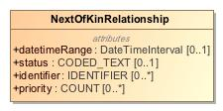

1. NextOfKinRelationship

|  |  |
| --- | --- |
| **Name** | NextOfKinRelationship |
| **Qualified Name** | CIMI Clinical::Relationship::NextOfKinRelationship |
| **Visibility** | public |
| **Abstract** | false |
| **Base Classifier** | * PartyRelationship |
| **Realized Interface** |  |

### **Attribute Detail**

#### datetimeRange

|  |  |
| --- | --- |
| **Type** | DateTimeInterval |
| **Default Value** |  |
| **Visibility** | public |
| **Multiplicity** | 0..1 |

#### identifier

|  |  |
| --- | --- |
| **Type** | IDENTIFIER |
| **Default Value** |  |
| **Visibility** | public |
| **Multiplicity** | 0..* |

#### priority

|  |  |
| --- | --- |
| **Type** | COUNT |
| **Default Value** |  |
| **Visibility** | public |
| **Multiplicity** | 0..* |

#### status

|  |  |
| --- | --- |
| **Type** | CODED_TEXT |
| **Default Value** |  |
| **Visibility** | public |
| **Multiplicity** | 0..1 |

### **Relation Detail**

#### Generalization

|  |  |
| --- | --- |
| **Name** |  |
| **Related Element** | * PartyRelationship |

## **Class** **OrganizationRelationship**

528355621.jpg

1. OrganizationRelationship

|  |  |
| --- | --- |
| **Name** | OrganizationRelationship |
| **Qualified Name** | CIMI Clinical::Relationship::OrganizationRelationship |
| **Visibility** | public |
| **Abstract** | false |
| **Base Classifier** | * PartyRelationship |
| **Realized Interface** |  |

### **Relation Detail**

#### Generalization

|  |  |
| --- | --- |
| **Name** |  |
| **Related Element** | * PartyRelationship |

|  |  |
| --- | --- |
| **Name** |  |
| **Related Element** | * EmployerRelationship |

## **Class** **PartyRelationship**

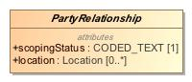

1. PartyRelationship

|  |  |
| --- | --- |
| **Name** | PartyRelationship |
| **Qualified Name** | CIMI Clinical::Relationship::PartyRelationship |
| **Visibility** | public |
| **Abstract** | true |
| **Base Classifier** | * PARTY_RELATIONSHIP |
| **Realized Interface** |  |

### **Attribute Detail**

#### location

|  |  |
| --- | --- |
| **Type** | Location |
| **Default Value** |  |
| **Visibility** | public |
| **Multiplicity** | 0..* |

#### scopingStatus

|  |  |
| --- | --- |
| **Type** | CODED_TEXT |
| **Default Value** |  |
| **Visibility** | public |
| **Multiplicity** | 1 |

### **Relation Detail**

#### Generalization

|  |  |
| --- | --- |
| **Name** |  |
| **Related Element** | * HealthCareProviderRelationship |

|  |  |
| --- | --- |
| **Name** |  |
| **Related Element** | * OrganizationRelationship |

|  |  |
| --- | --- |
| **Name** |  |
| **Related Element** | * NextOfKinRelationship |

|  |  |
| --- | --- |
| **Name** |  |
| **Related Element** | * PARTY_RELATIONSHIP |

## **Class** **SubjectOfInformation**

|  |  |
| --- | --- |
| **Name** | SubjectOfInformation |
| **Qualified Name** | CIMI Clinical::Relationship::SubjectOfInformation |
| **Visibility** | public |
| **Abstract** | false |
| **Base Classifier** |  |
| **Realized Interface** |  |

# **Package CIMI Foundation RM**

|  |  |
| --- | --- |
| **Name** | CIMI Foundation RM |
| **Qualified Name** | CIMI Foundation RM |

# **Package CIMI Foundation RM::Foundation**

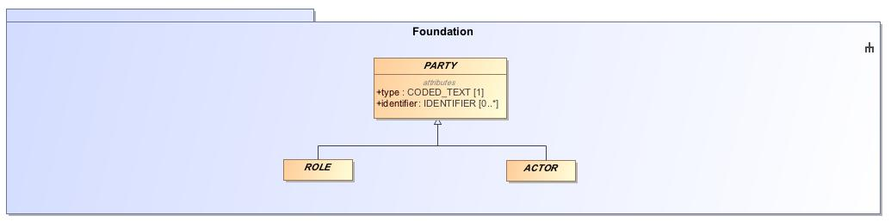

1. Foundation

|  |  |
| --- | --- |
| **Name** | Foundation |
| **Qualified Name** | CIMI Foundation RM::Foundation |

## **Class** **CLUSTER**

Abstract class representing a dependent structure in a model such as an address or an entity.

-1131665416.jpg

1. CLUSTER

|  |  |
| --- | --- |
| **Name** | CLUSTER |
| **Qualified Name** | CIMI Foundation RM::Foundation::CLUSTER |
| **Visibility** | public |
| **Abstract** | true |
| **Base Classifier** | * LOCATABLE |
| **Realized Interface** |  |

### **Relation Detail**

#### Generalization

|  |  |
| --- | --- |
| **Name** |  |
| **Related Element** | * Address |

|  |  |
| --- | --- |
| **Name** |  |
| **Related Element** | * DeathData |

|  |  |
| --- | --- |
| **Name** |  |
| **Related Element** | * LocationName |

|  |  |
| --- | --- |
| **Name** |  |
| **Related Element** | * Language |

|  |  |
| --- | --- |
| **Name** |  |
| **Related Element** | * ProductBatch |

|  |  |
| --- | --- |
| **Name** |  |
| **Related Element** | * MaterialEntity |

|  |  |
| --- | --- |
| **Name** |  |
| **Related Element** | * Age |

|  |  |
| --- | --- |
| **Name** |  |
| **Related Element** | * Citizenship |

|  |  |
| --- | --- |
| **Name** |  |
| **Related Element** | * UnitOfDistribution |

|  |  |
| --- | --- |
| **Name** |  |
| **Related Element** | * StreetNumber |

|  |  |
| --- | --- |
| **Name** |  |
| **Related Element** | * SpecimenContainer |

|  |  |
| --- | --- |
| **Name** |  |
| **Related Element** | * Residency |

|  |  |
| --- | --- |
| **Name** |  |
| **Related Element** | * MedicationProduct |

|  |  |
| --- | --- |
| **Name** |  |
| **Related Element** | * VIRTUAL_CLUSTER |

|  |  |
| --- | --- |
| **Name** |  |
| **Related Element** | * Entitlement |

|  |  |
| --- | --- |
| **Name** |  |
| **Related Element** | * Street |

|  |  |
| --- | --- |
| **Name** |  |
| **Related Element** | * ElectronicContact |

|  |  |
| --- | --- |
| **Name** |  |
| **Related Element** | * AdvanceDirective |

|  |  |
| --- | --- |
| **Name** |  |
| **Related Element** | * Location |

|  |  |
| --- | --- |
| **Name** |  |
| **Related Element** | * Registration |

|  |  |
| --- | --- |
| **Name** |  |
| **Related Element** | * BirthOrDeathDateTime |

|  |  |
| --- | --- |
| **Name** |  |
| **Related Element** | * Signature |

|  |  |
| --- | --- |
| **Name** |  |
| **Related Element** | * BirthData |

|  |  |
| --- | --- |
| **Name** |  |
| **Related Element** | * ReferenceRange |

|  |  |
| --- | --- |
| **Name** |  |
| **Related Element** | * Ingredient |

|  |  |
| --- | --- |
| **Name** |  |
| **Related Element** | * Part |

|  |  |
| --- | --- |
| **Name** |  |
| **Related Element** | * SpecimenTreatment |

|  |  |
| --- | --- |
| **Name** |  |
| **Related Element** | * LOCATABLE |

|  |  |
| --- | --- |
| **Name** |  |
| **Related Element** | * Qualification |

|  |  |
| --- | --- |
| **Name** |  |
| **Related Element** | * Industry |

|  |  |
| --- | --- |
| **Name** |  |
| **Related Element** | * Accreditation |

|  |  |
| --- | --- |
| **Name** |  |
| **Related Element** | * PartyName |

|  |  |
| --- | --- |
| **Name** |  |
| **Related Element** | * Use |

|  |  |
| --- | --- |
| **Name** |  |
| **Related Element** | * Attribution |

|  |  |
| --- | --- |
| **Name** |  |
| **Related Element** | * AddressLine |

|  |  |
| --- | --- |
| **Name** |  |
| **Related Element** | * ContactInformation |

|  |  |
| --- | --- |
| **Name** |  |
| **Related Element** | * BiometricData |

|  |  |
| --- | --- |
| **Name** |  |
| **Related Element** | * Occupation |

## **Class** **COMPOSITION**

A composition is considered the unit of modification of the record, the unit of transmission in record extracts, and the unit of attestation by authorising clinicians. In this latter sense, it may be considered equivalent to a signed document.

1012610853.jpg

1. COMPOSITION

|  |  |
| --- | --- |
| **Name** | COMPOSITION |
| **Qualified Name** | CIMI Foundation RM::Foundation::COMPOSITION |
| **Visibility** | public |
| **Abstract** | false |
| **Base Classifier** | * LOCATABLE |
| **Realized Interface** |  |

### **Attribute Detail**

#### content

|  |  |
| --- | --- |
| **Type** | CONTENT |
| **Default Value** |  |
| **Visibility** | public |
| **Multiplicity** | 0..* |

### **Relation Detail**

#### Association

|  |  |
| --- | --- |
| **Name** |  |
| **Related Element** | * CONTENT |

#### Generalization

|  |  |
| --- | --- |
| **Name** |  |
| **Related Element** | * LOCATABLE |

## **Class** **COMPOUND_ENTRY**

An composite entry composed of other ENTRY components. COMPOUND_ENTRYs can be arbitrarily nested and can be treated as a unit (e.g., a complex medication orderable).

1902245445.jpg

1. COMPOUND_ENTRY

|  |  |
| --- | --- |
| **Name** | COMPOUND_ENTRY |
| **Qualified Name** | CIMI Foundation RM::Foundation::COMPOUND_ENTRY |
| **Visibility** | public |
| **Abstract** | false |
| **Base Classifier** | * ENTRY |
| **Realized Interface** |  |

### **Attribute Detail**

#### entry

|  |  |
| --- | --- |
| **Type** | ENTRY |
| **Default Value** |  |
| **Visibility** | public |
| **Multiplicity** | 0..* |

### **Relation Detail**

#### Association

|  |  |
| --- | --- |
| **Name** |  |
| **Related Element** | * ENTRY |

#### Generalization

|  |  |
| --- | --- |
| **Name** |  |
| **Related Element** | * CompoundClinicalStatement |

|  |  |
| --- | --- |
| **Name** |  |
| **Related Element** | * ENTRY |

## **Class** **CONTENT**

Abstract ancestor of all concrete content types. A unit of content that makes up a composition - e.g., a clinical statement in a patient record, a simple or composite action is a knowledge document.

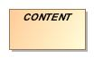

1. CONTENT

|  |  |
| --- | --- |
| **Name** | CONTENT |
| **Qualified Name** | CIMI Foundation RM::Foundation::CONTENT |
| **Visibility** | public |
| **Abstract** | true |
| **Base Classifier** | * LOCATABLE |
| **Realized Interface** |  |

### **Relation Detail**

#### Association

|  |  |
| --- | --- |
| **Name** |  |
| **Related Element** | * COMPOSITION |

|  |  |
| --- | --- |
| **Name** |  |
| **Related Element** | * SECTION |

#### Generalization

|  |  |
| --- | --- |
| **Name** |  |
| **Related Element** | * LOCATABLE |

|  |  |
| --- | --- |
| **Name** |  |
| **Related Element** | * SECTION |

|  |  |
| --- | --- |
| **Name** |  |
| **Related Element** | * ENTRY |

## **Class** **ENTRY**

The abstract parent of all ENTRY subtypes. An ENTRY is the root of a logical item of hard clinical information created in the clinical statement context, within a clinical session or of clinical knowledge in a knowledge artifact. With regards to clinical information entries, there can be numerous such contexts in a clinical session. Observations and other Entry types only ever document information captured/created in the event documented by the enclosing Composition.An ENTRY is also the minimal unit of information any query should return, since a whole ENTRY (including subparts) records spatial structure, timing information, and contextual information, as well as the subject and generator of the information.



1. ENTRY

|  |  |
| --- | --- |
| **Name** | ENTRY |
| **Qualified Name** | CIMI Foundation RM::Foundation::ENTRY |
| **Visibility** | public |
| **Abstract** | true |
| **Base Classifier** | * CONTENT |
| **Realized Interface** |  |

### **Relation Detail**

#### Association

|  |  |
| --- | --- |
| **Name** |  |
| **Related Element** | * COMPOUND_ENTRY |

#### Generalization

|  |  |
| --- | --- |
| **Name** |  |
| **Related Element** | * ClinicalStatement |

|  |  |
| --- | --- |
| **Name** |  |
| **Related Element** | * CONTENT |

|  |  |
| --- | --- |
| **Name** |  |
| **Related Element** | * COMPOUND_ENTRY |

|  |  |
| --- | --- |
| **Name** |  |
| **Related Element** | * INDIVISIBLE_ENTRY |

## **Class** **INDIVISIBLE_ENTRY**

An ENTRY representing an atomic unit of information that is identifiable and can be referenced independently of a parent context such as a specific hematocrit measurement viewed in isolation of its parent panel.

602669907.jpg

1. INDIVISIBLE_ENTRY

|  |  |
| --- | --- |
| **Name** | INDIVISIBLE_ENTRY |
| **Qualified Name** | CIMI Foundation RM::Foundation::INDIVISIBLE_ENTRY |
| **Visibility** | public |
| **Abstract** | false |
| **Base Classifier** | * ENTRY |
| **Realized Interface** |  |

### **Relation Detail**

#### Generalization

|  |  |
| --- | --- |
| **Name** |  |
| **Related Element** | * IndivisibleClinicalStatement |

|  |  |
| --- | --- |
| **Name** |  |
| **Related Element** | * ENTRY |

## **Class** **SECTION**

Represents a heading in a heading structure, or section tree . Can also be used to represent a collection of entries without metadata. (For collections of entries with shared metadata, use COMPOUND _ENTRY instead). Created according to archetyped structures for typical headings such as SOAP, physical examination, but also pathology result heading structures. Should not be used instead of ENTRY hierarchical structures.

1368420154.jpg

1. SECTION

|  |  |
| --- | --- |
| **Name** | SECTION |
| **Qualified Name** | CIMI Foundation RM::Foundation::SECTION |
| **Visibility** | public |
| **Abstract** | false |
| **Base Classifier** | * CONTENT |
| **Realized Interface** |  |

### **Attribute Detail**

#### content

|  |  |
| --- | --- |
| **Type** | CONTENT |
| **Default Value** |  |
| **Visibility** | public |
| **Multiplicity** | 0..* |

### **Relation Detail**

#### Association

|  |  |
| --- | --- |
| **Name** |  |
| **Related Element** | * CONTENT |

#### Generalization

|  |  |
| --- | --- |
| **Name** |  |
| **Related Element** | * CONTENT |

## **Class** **VIRTUAL_CLUSTER**

A dependent model structure designed to support attribute reuse but which may be ignored by tooling such as code generators. This allows grouping of attributes to be used in a number of compositional structures in order to encourage pattern reuse and consistency but which can be structurally flattened in a derived artifact (e.g., a java class representing the composition). An example of this pattern is the CIMI Clinical Statement pattern which combines statement context and topic to build the set of relevant clinical statements.

180855662.jpg

1. VIRTUAL_CLUSTER

|  |  |
| --- | --- |
| **Name** | VIRTUAL_CLUSTER |
| **Qualified Name** | CIMI Foundation RM::Foundation::VIRTUAL_CLUSTER |
| **Visibility** | public |
| **Abstract** | true |
| **Base Classifier** | * CLUSTER |
| **Realized Interface** |  |

### **Relation Detail**

#### Generalization

|  |  |
| --- | --- |
| **Name** |  |
| **Related Element** | * StatementContext |

|  |  |
| --- | --- |
| **Name** |  |
| **Related Element** | * CLUSTER |

|  |  |
| --- | --- |
| **Name** |  |
| **Related Element** | * StatementTopic |

# **Package CIMI Foundation RM::Party**

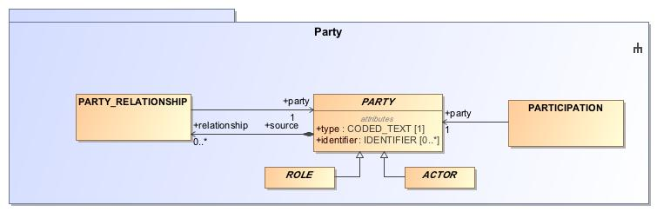

1. Party

|  |  |
| --- | --- |
| **Name** | Party |
| **Qualified Name** | CIMI Foundation RM::Party |

## **Class** **ACTOR**

Entity involved in an activity. Typically a specific person or organization.

-523561844.jpg

1. ACTOR

|  |  |
| --- | --- |
| **Name** | ACTOR |
| **Qualified Name** | CIMI Foundation RM::Party::ACTOR |
| **Visibility** | public |
| **Abstract** | true |
| **Base Classifier** | * PARTY |
| **Realized Interface** |  |

### **Relation Detail**

#### Generalization

|  |  |
| --- | --- |
| **Name** |  |
| **Related Element** | * Actor |

|  |  |
| --- | --- |
| **Name** |  |
| **Related Element** | * PARTY |

## **Class** **PARTICIPATION**

Model of a participation of a Party (any Actor or Role) in an activity. Used to represent any participation of a Party in some activity, which is not explicitly in the model, e.g. assisting nurse. Can be used to record past or future participations. Should not be used in place of more permanent relationships between demographic entities.

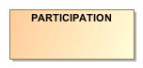

1. PARTICIPATION

|  |  |
| --- | --- |
| **Name** | PARTICIPATION |
| **Qualified Name** | CIMI Foundation RM::Party::PARTICIPATION |
| **Visibility** | public |
| **Abstract** | false |
| **Base Classifier** | * ASSOCIATION_CLASS |
| **Realized Interface** |  |

### **Attribute Detail**

#### party

|  |  |
| --- | --- |
| **Type** | PARTY |
| **Default Value** |  |
| **Visibility** | public |
| **Multiplicity** | 1 |

### **Relation Detail**

#### Association

|  |  |
| --- | --- |
| **Name** |  |
| **Related Element** | * PARTY |

#### Generalization

|  |  |
| --- | --- |
| **Name** |  |
| **Related Element** | * SubjectOfInformation |

|  |  |
| --- | --- |
| **Name** |  |
| **Related Element** | * ASSOCIATION_CLASS |

## **Class** **PARTY**

A party involved in an activity. PARTY has two specializations: ACTOR and ROLE.

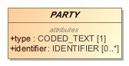

1. PARTY

|  |  |
| --- | --- |
| **Name** | PARTY |
| **Qualified Name** | CIMI Foundation RM::Party::PARTY |
| **Visibility** | public |
| **Abstract** | true |
| **Base Classifier** | * LOCATABLE |
| **Realized Interface** |  |

### **Attribute Detail**

#### identifier

An identifier for the party.

|  |  |
| --- | --- |
| **Type** | IDENTIFIER |
| **Default Value** |  |
| **Visibility** | public |
| **Multiplicity** | 0..* |

#### relationship

Party relationship(s) associated with this party. E.g., the roles an actor may play.

|  |  |
| --- | --- |
| **Type** | PARTY_RELATIONSHIP |
| **Default Value** |  |
| **Visibility** | public |
| **Multiplicity** | 0..* |

#### type

Code for the party.

|  |  |
| --- | --- |
| **Type** | CODED_TEXT |
| **Default Value** |  |
| **Visibility** | public |
| **Multiplicity** | 1 |

### **Relation Detail**

#### Association

|  |  |
| --- | --- |
| **Name** |  |
| **Related Element** | * PARTY_RELATIONSHIP |

|  |  |
| --- | --- |
| **Name** |  |
| **Related Element** | * PARTY_RELATIONSHIP |

|  |  |
| --- | --- |
| **Name** |  |
| **Related Element** | * PARTICIPATION |

#### Generalization

|  |  |
| --- | --- |
| **Name** |  |
| **Related Element** | * ROLE |

|  |  |
| --- | --- |
| **Name** |  |
| **Related Element** | * LOCATABLE |

|  |  |
| --- | --- |
| **Name** |  |
| **Related Element** | * ACTOR |

## **Class** **PARTY_RELATIONSHIP**

Association class relating two parties such as the association of an actor with one or more roles.

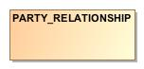

1. PARTY_RELATIONSHIP

|  |  |
| --- | --- |
| **Name** | PARTY_RELATIONSHIP |
| **Qualified Name** | CIMI Foundation RM::Party::PARTY_RELATIONSHIP |
| **Visibility** | public |
| **Abstract** | false |
| **Base Classifier** | * ASSOCIATION_CLASS |
| **Realized Interface** |  |

### **Attribute Detail**

#### party

The party target of the relationship.

|  |  |
| --- | --- |
| **Type** | PARTY |
| **Default Value** |  |
| **Visibility** | public |
| **Multiplicity** | 1 |

### **Relation Detail**

#### Association

|  |  |
| --- | --- |
| **Name** |  |
| **Related Element** | * PARTY |

|  |  |
| --- | --- |
| **Name** |  |
| **Related Element** | * PARTY |

#### Generalization

|  |  |
| --- | --- |
| **Name** |  |
| **Related Element** | * ASSOCIATION_CLASS |

|  |  |
| --- | --- |
| **Name** |  |
| **Related Element** | * PartyRelationship |

## **Class** **ROLE**

Capacity in which an actor is involved in an activity. For instance, 'attending physician'.

756348037.jpg

1. ROLE

|  |  |
| --- | --- |
| **Name** | ROLE |
| **Qualified Name** | CIMI Foundation RM::Party::ROLE |
| **Visibility** | public |
| **Abstract** | true |
| **Base Classifier** | * PARTY |
| **Realized Interface** |  |

### **Relation Detail**

#### Generalization

|  |  |
| --- | --- |
| **Name** |  |
| **Related Element** | * PARTY |

|  |  |
| --- | --- |
| **Name** |  |
| **Related Element** | * Role |

# **Package CIMI Reference Model**

|  |  |
| --- | --- |
| **Name** | CIMI Reference Model |
| **Qualified Name** | CIMI Reference Model |

# **Package CIMI Reference Model::Core**

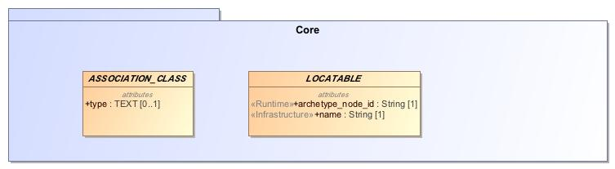

1. Core

|  |  |
| --- | --- |
| **Name** | Core |
| **Qualified Name** | CIMI Reference Model::Core |

## **Class** **ARCHETYPED**

Archetypes act as the configuration basis for the particular structures of instances defined by the reference model. To enable archetypes to be used to create valid data, key classes in the reference model act as root points for archetyping; accordingly, these classes have the archetype_details attribute set.An instance of the class ARCHETYPED contains the relevant archetype identification information, allowing generating archetypes to be matched up with data instances.

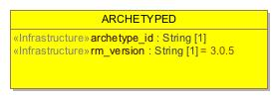

1. ARCHETYPED

|  |  |
| --- | --- |
| **Name** | ARCHETYPED |
| **Qualified Name** | CIMI Reference Model::Core::ARCHETYPED |
| **Visibility** | public |
| **Abstract** | false |
| **Base Classifier** |  |
| **Realized Interface** |  |

### **Attribute Detail**

#### archetype_id

Globally unique archetype identifier.

|  |  |
| --- | --- |
| **Type** | String |
| **Default Value** |  |
| **Visibility** | public |
| **Multiplicity** | 1 |

#### rm_version

Version of the CIMI reference model used to create this object. Expressed in terms of the release version string, e.g. 1.0 , 1.2.4 .

|  |  |
| --- | --- |
| **Type** | String |
| **Default Value** | 3.0.5 |
| **Visibility** | public |
| **Multiplicity** | 1 |

### **Relation Detail**

#### Association

|  |  |
| --- | --- |
| **Name** |  |
| **Related Element** | * LOCATABLE |

## **Class** **ASSOCIATION_CLASS**

Abstract parent type for an association class.

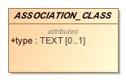

1. ASSOCIATION_CLASS

|  |  |
| --- | --- |
| **Name** | ASSOCIATION_CLASS |
| **Qualified Name** | CIMI Reference Model::Core::ASSOCIATION_CLASS |
| **Visibility** | public |
| **Abstract** | true |
| **Base Classifier** |  |
| **Realized Interface** |  |

### **Attribute Detail**

#### type

The type of the association.

|  |  |
| --- | --- |
| **Type** | TEXT |
| **Default Value** |  |
| **Visibility** | public |
| **Multiplicity** | 0..1 |

### **Relation Detail**

#### Generalization

|  |  |
| --- | --- |
| **Name** |  |
| **Related Element** | * ClinicalStatementAssociation |

|  |  |
| --- | --- |
| **Name** |  |
| **Related Element** | * PARTY_RELATIONSHIP |

|  |  |
| --- | --- |
| **Name** |  |
| **Related Element** | * PARTICIPATION |

## **Class** **LOCATABLE**

Most classes in the CIMI reference model inherit from the LOCATABLE class, which defines the idea of 'locatability in an archetyped structure'. LOCATABLE defines a runtime name and an archetype_node_id. The archetype_node_id is the standardised semantic code for a node and comes from the corresponding node in the archetype used to create the data. The only exception is at archetype root points in data, where archetype_node_id carries the archetype identifier in string form rather than an interior node id from an archetype. LOCATABLE also provides the attribute archetype_details, which is non-Void for archetype root points in data, and carries meta-data relevant to root points. The name attribute carries a name created at runtime. The 'meaning' of any node is derived formally from the archetype by obtaining the text value for the archetype_node_id code from the archetype ontology section, in the language required.

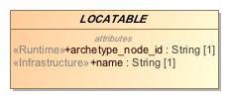

1. LOCATABLE

|  |  |
| --- | --- |
| **Name** | LOCATABLE |
| **Qualified Name** | CIMI Reference Model::Core::LOCATABLE |
| **Visibility** | public |
| **Abstract** | true |
| **Base Classifier** |  |
| **Realized Interface** |  |

### **Attribute Detail**

#### archetype_details

LOCATABLE also provides the attribute Archetype_details, which is non-Void for archetype root points in data, and carries meta-data relevant to root points.

|  |  |
| --- | --- |
| **Type** | ARCHETYPED |
| **Default Value** |  |
| **Visibility** | public |
| **Multiplicity** | 0..1 |

#### archetype_node_id

The standardised semantic code for a node and comes from the corresponding node in the archetype used to create the data. The only exception is at archetype root points in data, where archetype_node_id carries the archetype identifier in string form rather than an interior node id from an archetype.

|  |  |
| --- | --- |
| **Type** | String |
| **Default Value** |  |
| **Visibility** | public |
| **Multiplicity** | 1 |

#### name

A name created at runtime

|  |  |
| --- | --- |
| **Type** | String |
| **Default Value** |  |
| **Visibility** | public |
| **Multiplicity** | 1 |

### **Relation Detail**

#### Association

|  |  |
| --- | --- |
| **Name** |  |
| **Related Element** | * ARCHETYPED |

#### Generalization

|  |  |
| --- | --- |
| **Name** |  |
| **Related Element** | * CONTENT |

|  |  |
| --- | --- |
| **Name** |  |
| **Related Element** | * PARTY |

|  |  |
| --- | --- |
| **Name** |  |
| **Related Element** | * CLUSTER |

|  |  |
| --- | --- |
| **Name** |  |
| **Related Element** | * COMPOSITION |

# **Package CIMI Reference Model::Data Value Types**

|  |  |
| --- | --- |
| **Name** | Data Value Types |
| **Qualified Name** | CIMI Reference Model::Data Value Types |

## **Class** **AMOUNT**

Abstract class defining the concept of relative quantified amounts. For relative quantities, the +' and -' operators are defined.

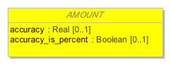

1. AMOUNT

|  |  |
| --- | --- |
| **Name** | AMOUNT |
| **Qualified Name** | CIMI Reference Model::Data Value Types::AMOUNT |
| **Visibility** | public |
| **Abstract** | true |
| **Base Classifier** | * QUANTIFIED |
| **Realized Interface** |  |

### **Attribute Detail**

#### accuracy

Accuracy of measurement, expressed either as a half-range percent value (accuracy_is_percent = True) or a half-range quantity. A value of 0 means that accuracy is 100%, i.e. no error.A value of unknown_accuracy_value means that accuracy was not recorded.

|  |  |
| --- | --- |
| **Type** | Real |
| **Default Value** |  |
| **Visibility** | public |
| **Multiplicity** | 0..1 |

#### accuracy_is_percent

If True, indicates that when this object was created, accuracy was recorded as a percent value; if False, as an absolute quantity value.

|  |  |
| --- | --- |
| **Type** | Boolean |
| **Default Value** |  |
| **Visibility** | public |
| **Multiplicity** | 0..1 |

### **Relation Detail**

#### Generalization

|  |  |
| --- | --- |
| **Name** |  |
| **Related Element** | * COUNT |

|  |  |
| --- | --- |
| **Name** |  |
| **Related Element** | * QUANTIFIED |

|  |  |
| --- | --- |
| **Name** |  |
| **Related Element** | * QUANTITY |

|  |  |
| --- | --- |
| **Name** |  |
| **Related Element** | * PROPORTION |

## **Class** **CODED_TEXT**

A text item whose value must be the rubric from a controlled terminology, the key (i.e. the code') of which is the code attribute. In other words: a CODED_TEXT is a combination of a CODE_PHRASE (effectively a code) and the rubric of that term, from a terminology service, in the language in which the data was authored.Since CODED_TEXT is a subtype of TEXT, it can be used in place of it, effectively allowing the type TEXT to mean a text item, which may optionally be coded.Misuse: If the intention is to represent a term code attached in some way to a fragment of plain text, CODED_TEXT should not be used.

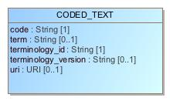

1. CODED_TEXT

|  |  |
| --- | --- |
| **Name** | CODED_TEXT |
| **Qualified Name** | CIMI Reference Model::Data Value Types::CODED_TEXT |
| **Visibility** | public |
| **Abstract** | false |
| **Base Classifier** | * TEXT |
| **Realized Interface** |  |

### **Attribute Detail**

#### code

The identifier of a concept in a terminology.

|  |  |
| --- | --- |
| **Type** | String |
| **Default Value** |  |
| **Visibility** | public |
| **Multiplicity** | 1 |

#### term

The preferred textual rendition of the code attribute.

|  |  |
| --- | --- |
| **Type** | String |
| **Default Value** |  |
| **Visibility** | public |
| **Multiplicity** | 0..1 |

#### terminology_id

The terminology that provides the namespace for the code attribute.

|  |  |
| --- | --- |
| **Type** | String |
| **Default Value** |  |
| **Visibility** | public |
| **Multiplicity** | 1 |

#### terminology_version

The version of the terminology where the concept exists.

|  |  |
| --- | --- |
| **Type** | String |
| **Default Value** |  |
| **Visibility** | public |
| **Multiplicity** | 0..1 |

#### uri

A URI representation for the identifier of the concept represented by CODED_TEXT.

|  |  |
| --- | --- |
| **Type** | URI |
| **Default Value** |  |
| **Visibility** | public |
| **Multiplicity** | 0..1 |

### **Relation Detail**

#### Association

|  |  |
| --- | --- |
| **Name** |  |
| **Related Element** | * TERM_MAPPING |

#### Generalization

|  |  |
| --- | --- |
| **Name** |  |
| **Related Element** | * TEXT |

## **Class** **COUNT**

Countable quantities. Used for countable types such as pregnancies and steps (taken by a physiotherapy patient), number of cigarettes smoked in a day.Misuse: Not to be used for amounts of physical entities (which all have units).

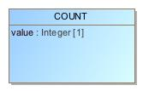

1. COUNT

|  |  |
| --- | --- |
| **Name** | COUNT |
| **Qualified Name** | CIMI Reference Model::Data Value Types::COUNT |
| **Visibility** | public |
| **Abstract** | false |
| **Base Classifier** | * AMOUNT |
| **Realized Interface** |  |

### **Attribute Detail**

#### value

|  |  |
| --- | --- |
| **Type** | Integer |
| **Default Value** |  |
| **Visibility** | public |
| **Multiplicity** | 1 |

### **Relation Detail**

#### Generalization

|  |  |
| --- | --- |
| **Name** |  |
| **Related Element** | * AMOUNT |

## **Class** **DATA_VALUE**

Serves as a common ancestor of all CIMI complex types.

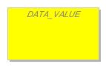

1. DATA_VALUE

|  |  |
| --- | --- |
| **Name** | DATA_VALUE |
| **Qualified Name** | CIMI Reference Model::Data Value Types::DATA_VALUE |
| **Visibility** | public |
| **Abstract** | true |
| **Base Classifier** |  |
| **Realized Interface** |  |

### **Relation Detail**

#### Generalization

|  |  |
| --- | --- |
| **Name** |  |
| **Related Element** | * URI_VALUE |

|  |  |
| --- | --- |
| **Name** |  |
| **Related Element** | * ENCAPSULATED |

|  |  |
| --- | --- |
| **Name** |  |
| **Related Element** | * ORDERED_VALUE |

|  |  |
| --- | --- |
| **Name** |  |
| **Related Element** | * TEXT |

|  |  |
| --- | --- |
| **Name** |  |
| **Related Element** | * IDENTIFIER |

|  |  |
| --- | --- |
| **Name** |  |
| **Related Element** | * INTERVAL_VALUE |

|  |  |
| --- | --- |
| **Name** |  |
| **Related Element** | * YESNO |

## **Class** **DATE**

Represents an absolute point in time, as measured on the Gregorian calendar, and specified only to the day. Semantics defined by ISO 8601. Used for recording dates in real world time. The partial form is used for approximate birth dates, dates of death, etc.

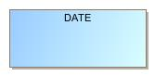

1. DATE

|  |  |
| --- | --- |
| **Name** | DATE |
| **Qualified Name** | CIMI Reference Model::Data Value Types::DATE |
| **Visibility** | public |
| **Abstract** | false |
| **Base Classifier** | * DATE_TIME |
| **Realized Interface** |  |

### **Relation Detail**

#### Generalization

|  |  |
| --- | --- |
| **Name** |  |
| **Related Element** | * DATE_TIME |

## **Class** **DATE_TIME**

Represents an absolute point in time, specified to the second. Semantics defined by ISO 8601.Used for recording a precise point in real world time, and for approximate time stamps, e.g. the origin of a HISTORY in an OBSERVATION which is only partially known.

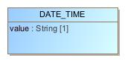

1. DATE_TIME

|  |  |
| --- | --- |
| **Name** | DATE_TIME |
| **Qualified Name** | CIMI Reference Model::Data Value Types::DATE_TIME |
| **Visibility** | public |
| **Abstract** | false |
| **Base Classifier** | * QUANTIFIED |
| **Realized Interface** |  |

### **Attribute Detail**

#### value

ISO8601 date/time string.

|  |  |
| --- | --- |
| **Type** | String |
| **Default Value** |  |
| **Visibility** | public |
| **Multiplicity** | 1 |

### **Relation Detail**

#### Generalization

|  |  |
| --- | --- |
| **Name** |  |
| **Related Element** | * QUANTIFIED |

|  |  |
| --- | --- |
| **Name** |  |
| **Related Element** | * TIME |

|  |  |
| --- | --- |
| **Name** |  |
| **Related Element** | * DATE |

## **Class** **DURATION**

Represents a period of time with respect to a notional point in time, which is not specified. A sign may be used to indicate the duration is backwards in time rather than forwards.NOTEa deviation from ISO8601 is supported, allowing the W' designator to be mixed with other designators. See assumed types section in the Support IM.Used for recording the duration of something in the real world, particularly when there is a need a) to represent the duration in customary format, i.e. days, hours, minutes etc, and b) if it will be used in computational operations with date/time quantities, i.e. additions, subtractions etc.Misuse: Durations cannot be used to represent points in time, or intervals of time.

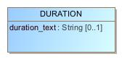

1. DURATION

|  |  |
| --- | --- |
| **Name** | DURATION |
| **Qualified Name** | CIMI Reference Model::Data Value Types::DURATION |
| **Visibility** | public |
| **Abstract** | false |
| **Base Classifier** | * QUANTITY |
| **Realized Interface** |  |

### **Attribute Detail**

#### duration_text

ISO8601 duration string.

|  |  |
| --- | --- |
| **Type** | String |
| **Default Value** |  |
| **Visibility** | public |
| **Multiplicity** | 0..1 |

### **Operation Detail**

#### is_strictly_comparable_to

|  |  |
| --- | --- |
| **Type** |  |
| **Visibility** | public |
| **Is Abstract** | false |
| **Parameter** | * in other : |

### **Relation Detail**

#### Generalization

|  |  |
| --- | --- |
| **Name** |  |
| **Related Element** | * QUANTITY |

## **Class** **EHR_URI**

A EHR_URI is a URI which has the scheme name 'ehr', and which can only reference items in EHRs.Used to reference items in an EHR, which may be the same as the current EHR (containing this link), or another.

1658395172.jpg

1. EHR_URI

|  |  |
| --- | --- |
| **Name** | EHR_URI |
| **Qualified Name** | CIMI Reference Model::Data Value Types::EHR_URI |
| **Visibility** | public |
| **Abstract** | false |
| **Base Classifier** | * URI_VALUE |
| **Realized Interface** |  |

### **Relation Detail**

#### Generalization

|  |  |
| --- | --- |
| **Name** |  |
| **Related Element** | * URI_VALUE |

## **Class** **ENCAPSULATED**

Abstract class defining the common meta-data of all types of encapsulated data.

-357038799.jpg

1. ENCAPSULATED

|  |  |
| --- | --- |
| **Name** | ENCAPSULATED |
| **Qualified Name** | CIMI Reference Model::Data Value Types::ENCAPSULATED |
| **Visibility** | public |
| **Abstract** | true |
| **Base Classifier** | * DATA_VALUE |
| **Realized Interface** |  |

### **Relation Detail**

#### Generalization

|  |  |
| --- | --- |
| **Name** |  |
| **Related Element** | * DATA_VALUE |

|  |  |
| --- | --- |
| **Name** |  |
| **Related Element** | * MULTIMEDIA |

|  |  |
| --- | --- |
| **Name** |  |
| **Related Element** | * PARSABLE |

## **Class** **IDENTIFIER**

Type for representing identifiers of real-world entities. Typical identifiers include drivers licence number, social security number, veterans affairs number, prescription id, order id, and so on.

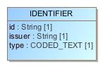

1. IDENTIFIER

|  |  |
| --- | --- |
| **Name** | IDENTIFIER |
| **Qualified Name** | CIMI Reference Model::Data Value Types::IDENTIFIER |
| **Visibility** | public |
| **Abstract** | false |
| **Base Classifier** | * DATA_VALUE |
| **Realized Interface** |  |

### **Attribute Detail**

#### id

The identifier value. Often structured, according to the definition of the issuing authority’s rules.

|  |  |
| --- | --- |
| **Type** | String |
| **Default Value** |  |
| **Visibility** | public |
| **Multiplicity** | 1 |

#### issuer

Optional organisation that assigned the id to the item being identified.

|  |  |
| --- | --- |
| **Type** | String |
| **Default Value** |  |
| **Visibility** | public |
| **Multiplicity** | 1 |

#### type

Optional identifier type, such as prescription, or Social Security Number. One day a controlled vocabulary might be possible for this.

|  |  |
| --- | --- |
| **Type** | CODED_TEXT |
| **Default Value** |  |
| **Visibility** | public |
| **Multiplicity** | 1 |

### **Relation Detail**

#### Generalization

|  |  |
| --- | --- |
| **Name** |  |
| **Related Element** | * DATA_VALUE |

## **Class** **INTERVAL_VALUE**

Generic class defining an interval (i.e. range) of a comparable type. An interval is a contiguous subrange of a comparable base type. Used to define intervals of dates, times, quantities (whose units match) and so on. The type parameter, T, must be a descendant of the type ORDERED_VALUE, which is necessary (but not sufficient) for instances to be compared (strictly_comparable is also needed).The basic semantics are derived from the class Interval<T>, described in the support RM.

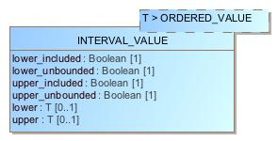

1. INTERVAL_VALUE

|  |  |
| --- | --- |
| **Name** | INTERVAL_VALUE |
| **Qualified Name** | CIMI Reference Model::Data Value Types::INTERVAL_VALUE |
| **Visibility** | public |
| **Abstract** | false |
| **Base Classifier** | * DATA_VALUE |
| **Realized Interface** |  |

### **Attribute Detail**

#### lower

The interval's lower bound. Values outside the lower bound lie outside the range specified by this interval.

|  |  |
| --- | --- |
| **Type** | T |
| **Default Value** |  |
| **Visibility** | public |
| **Multiplicity** | 0..1 |

#### lower_included

True if the lower bound of the interval is included. False otherwise.

|  |  |
| --- | --- |
| **Type** | Boolean |
| **Default Value** |  |
| **Visibility** | public |
| **Multiplicity** | 1 |

#### lower_unbounded

True if the interval does not specify a lower bound. False otherwise.

|  |  |
| --- | --- |
| **Type** | Boolean |
| **Default Value** |  |
| **Visibility** | public |
| **Multiplicity** | 1 |

#### upper

The reference range's upper bound. Values outside the upper bound lie outside the range specified by this interval.

|  |  |
| --- | --- |
| **Type** | T |
| **Default Value** |  |
| **Visibility** | public |
| **Multiplicity** | 0..1 |

#### upper_included

True if the upper bound of the interval is included. Otherwise, false.

|  |  |
| --- | --- |
| **Type** | Boolean |
| **Default Value** |  |
| **Visibility** | public |
| **Multiplicity** | 1 |

#### upper_unbounded

True if the upper bound is unspecified. False otherwise.

|  |  |
| --- | --- |
| **Type** | Boolean |
| **Default Value** |  |
| **Visibility** | public |
| **Multiplicity** | 1 |

### **Relation Detail**

#### Generalization

|  |  |
| --- | --- |
| **Name** |  |
| **Related Element** | * DATA_VALUE |

## **Class** **MULTIMEDIA**

A specialisation of DV_ENCAPSULATED for audiovisual and biosignal types. Includes further metadata relating to multimedia types which are not applicable to other subtypes of DV_ENCAPSULATED.

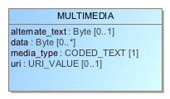

1. MULTIMEDIA

|  |  |
| --- | --- |
| **Name** | MULTIMEDIA |
| **Qualified Name** | CIMI Reference Model::Data Value Types::MULTIMEDIA |
| **Visibility** | public |
| **Abstract** | false |
| **Base Classifier** | * ENCAPSULATED |
| **Realized Interface** |  |

### **Attribute Detail**

#### alternate_text

Text to display in lieu of multimedia display/replay.

|  |  |
| --- | --- |
| **Type** | Byte |
| **Default Value** |  |
| **Visibility** | public |
| **Multiplicity** | 0..1 |

#### data

The actual data found at uri, if supplied inline.

|  |  |
| --- | --- |
| **Type** | Byte |
| **Default Value** |  |
| **Visibility** | public |
| **Multiplicity** | 0..* |

#### media_type

Data media type coded from openEHR code set media types (interface for the IANA MIME types code set).

|  |  |
| --- | --- |
| **Type** | CODED_TEXT |
| **Default Value** |  |
| **Visibility** | public |
| **Multiplicity** | 1 |

#### uri

URI reference to electronic information stored outside the record as a file, database entry etc, if supplied as a reference.

|  |  |
| --- | --- |
| **Type** | URI_VALUE |
| **Default Value** |  |
| **Visibility** | public |
| **Multiplicity** | 0..1 |

### **Relation Detail**

#### Generalization

|  |  |
| --- | --- |
| **Name** |  |
| **Related Element** | * ENCAPSULATED |

## **Class** **ORDERED_VALUE**

Abstract class defining the concept of ordered values, which includes ordinals as well as true quantities.

1872616523.jpg

1. ORDERED_VALUE

|  |  |
| --- | --- |
| **Name** | ORDERED_VALUE |
| **Qualified Name** | CIMI Reference Model::Data Value Types::ORDERED_VALUE |
| **Visibility** | public |
| **Abstract** | true |
| **Base Classifier** | * DATA_VALUE |
| **Realized Interface** |  |

### **Relation Detail**

#### Generalization

|  |  |
| --- | --- |
| **Name** |  |
| **Related Element** | * QUANTIFIED |

|  |  |
| --- | --- |
| **Name** |  |
| **Related Element** | * DATA_VALUE |

|  |  |
| --- | --- |
| **Name** |  |
| **Related Element** | * ORDINAL |

## **Class** **ORDINAL**

Models rankings and scores, e.g. pain, Apgar values, etc, where there is a) implied ordering, b) no implication that the distance between each value is constant, and c) the total number of values is finite. Note that although the term ordinal' in mathematics means natural numbers only, here any integer is allowed, since negative and zero values are often used by medical professionals for values around a neutral point. Examples of sets of ordinal values:-3, -2, -1, 0, 1, 2, 3  — reflex response values0, 1, 2  — Apgar valuesThis class is used for recording any clinical datum which is customarily recorded using symbolic values. Example: the results on a urinalysis strip, e.g. {neg, trace, , , } are used for leucocytes, protein, nitrites etc; for non-haemolysed blood {neg, trace, moderate}; for haemolysed blood small, moderate, large}.

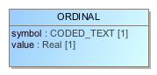

1. ORDINAL

|  |  |
| --- | --- |
| **Name** | ORDINAL |
| **Qualified Name** | CIMI Reference Model::Data Value Types::ORDINAL |
| **Visibility** | public |
| **Abstract** | false |
| **Base Classifier** | * ORDERED_VALUE |
| **Realized Interface** |  |

### **Attribute Detail**

#### symbol

Coded textual representation of this value in the enumeration, which may be strings made from + symbols, or other enumerations of terms such as mild , moderate , severe , or even the same number series as the values, e.g. 1 , 2 , 3 . Codes come from archetype.

|  |  |
| --- | --- |
| **Type** | CODED_TEXT |
| **Default Value** |  |
| **Visibility** | public |
| **Multiplicity** | 1 |

#### value

Value in ordered enumeration of values. Any integer value can be used.

|  |  |
| --- | --- |
| **Type** | Real |
| **Default Value** |  |
| **Visibility** | public |
| **Multiplicity** | 1 |

### **Relation Detail**

#### Generalization

|  |  |
| --- | --- |
| **Name** |  |
| **Related Element** | * ORDERED_VALUE |

## **Class** **PARSABLE**

Encapsulated data expressed as a parsable String. The internal model of the data item is not described in the openEHR model in common with other encapsulated types, but in this case, the form of the data is assumed to be plaintext, rather than compressed or other types of large binary data.

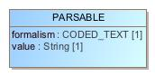

1. PARSABLE

|  |  |
| --- | --- |
| **Name** | PARSABLE |
| **Qualified Name** | CIMI Reference Model::Data Value Types::PARSABLE |
| **Visibility** | public |
| **Abstract** | false |
| **Base Classifier** | * ENCAPSULATED |
| **Realized Interface** |  |

### **Attribute Detail**

#### formalism

Name of the formalism, e.g. GLIF 1.0 , Proforma etc.

|  |  |
| --- | --- |
| **Type** | CODED_TEXT |
| **Default Value** |  |
| **Visibility** | public |
| **Multiplicity** | 1 |

#### value

The string, which may validly be empty in some syntaxes.

|  |  |
| --- | --- |
| **Type** | String |
| **Default Value** |  |
| **Visibility** | public |
| **Multiplicity** | 1 |

### **Relation Detail**

#### Generalization

|  |  |
| --- | --- |
| **Name** |  |
| **Related Element** | * ENCAPSULATED |

## **Class** **PLAIN_TEXT**

Plain text potentially with simple formatting

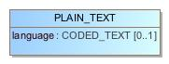

1. PLAIN_TEXT

|  |  |
| --- | --- |
| **Name** | PLAIN_TEXT |
| **Qualified Name** | CIMI Reference Model::Data Value Types::PLAIN_TEXT |
| **Visibility** | public |
| **Abstract** | false |
| **Base Classifier** | * TEXT |
| **Realized Interface** |  |

### **Attribute Detail**

#### language

|  |  |
| --- | --- |
| **Type** | CODED_TEXT |
| **Default Value** |  |
| **Visibility** | public |
| **Multiplicity** | 0..1 |

### **Relation Detail**

#### Generalization

|  |  |
| --- | --- |
| **Name** |  |
| **Related Element** | * TEXT |

## **Class** **PROPORTION**

Models a ratio of values, i.e. where the numerator and denominator are both pure numbers. The valid_proportion_kind property of the PROPORTION_KIND class is used to control the type attribute to be one of a defined set.Used for recording titers (e.g. 1:128), concentration ratios, e.g. Na:K (unitary denominator), albumin:creatinine ratio, and percentages, e.g. red cell distirbution width (RDW).Misuse: Should not be used to represent things like blood pressure which are often written using a '/' character, giving the misleading impression that the item is a ratio, when in fact it is a structured value. Similarly, visual acuity, often written as (e.g.) “6/24” in clinical notes is not a ratio but an ordinal (which includes non-numeric symbols like CF = count fingers etc). Should not be used for formulations.

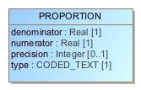

1. PROPORTION

|  |  |
| --- | --- |
| **Name** | PROPORTION |
| **Qualified Name** | CIMI Reference Model::Data Value Types::PROPORTION |
| **Visibility** | public |
| **Abstract** | false |
| **Base Classifier** | * AMOUNT |
| **Realized Interface** |  |

### **Attribute Detail**

#### denominator

Denominator of ratio.

|  |  |
| --- | --- |
| **Type** | Real |
| **Default Value** |  |
| **Visibility** | public |
| **Multiplicity** | 1 |

#### numerator

Numerator of ratio.

|  |  |
| --- | --- |
| **Type** | Real |
| **Default Value** |  |
| **Visibility** | public |
| **Multiplicity** | 1 |

#### precision

Precision to which the numerator and denominator values of the proportion are expressed, in terms of number of decimal places. The value 0 implies an integral quantity. The value -1 implies no limit, i.e. any number of decimal places.

|  |  |
| --- | --- |
| **Type** | Integer |
| **Default Value** |  |
| **Visibility** | public |
| **Multiplicity** | 0..1 |

#### type

Indicates semantic type of proportion, including percent, unitary etc.

|  |  |
| --- | --- |
| **Type** | CODED_TEXT |
| **Default Value** |  |
| **Visibility** | public |
| **Multiplicity** | 1 |

### **Relation Detail**

#### Generalization

|  |  |
| --- | --- |
| **Name** |  |
| **Related Element** | * AMOUNT |

## **Class** **QUANTIFIED**

Abstract class defining the concept of true quantified values, i.e. values which are not only ordered, but which have a precise magnitude.

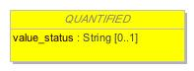

1. QUANTIFIED

|  |  |
| --- | --- |
| **Name** | QUANTIFIED |
| **Qualified Name** | CIMI Reference Model::Data Value Types::QUANTIFIED |
| **Visibility** | public |
| **Abstract** | true |
| **Base Classifier** | * ORDERED_VALUE |
| **Realized Interface** |  |

### **Attribute Detail**

#### value_status

Optional status of magnitude with values:= : magnitude is a point value< : value is < magnitude> : value is > magnitude\<= : value is <= magnitude>= : value is >= magnitude~ : value is approximately magnitudeIf not present, meaning is = .

|  |  |
| --- | --- |
| **Type** | String |
| **Default Value** |  |
| **Visibility** | public |
| **Multiplicity** | 0..1 |

### **Relation Detail**

#### Dependency

|  |  |
| --- | --- |
| **Name** |  |
| **Related Element** | * QuantifiedValueStatusEnum |

#### Generalization

|  |  |
| --- | --- |
| **Name** |  |
| **Related Element** | * DATE_TIME |

|  |  |
| --- | --- |
| **Name** |  |
| **Related Element** | * ORDERED_VALUE |

|  |  |
| --- | --- |
| **Name** |  |
| **Related Element** | * AMOUNT |

## **Class** **QUANTITY**

Quantitified type representing scientific quantities, i.e. quantities expressed as a magnitude and units. Units were inspired by the Unified Code for Units of Measure (UCUM), developed by Gunther Schadow and Clement J. McDonald of The Regenstrief Institute.Can also be used for time durations, where it is more convenient to treat these as simply a number of seconds rather than days, months, years.

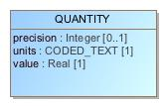

1. QUANTITY

|  |  |
| --- | --- |
| **Name** | QUANTITY |
| **Qualified Name** | CIMI Reference Model::Data Value Types::QUANTITY |
| **Visibility** | public |
| **Abstract** | false |
| **Base Classifier** | * AMOUNT |
| **Realized Interface** |  |

### **Attribute Detail**

#### precision

Precision to which the value of the quantity is expressed, in terms of number of decimal places. The value 0 implies an integral quantity. The value -1 implies no limit, i.e. any number of decimal places.

|  |  |
| --- | --- |
| **Type** | Integer |
| **Default Value** |  |
| **Visibility** | public |
| **Multiplicity** | 0..1 |

#### units

Units, expressed expressed as codes (generally UCUM), e.g. "kg/m2", “mm[Hg]", "ms-1", "km/h". Implemented accordingly in subtypes.

|  |  |
| --- | --- |
| **Type** | CODED_TEXT |
| **Default Value** |  |
| **Visibility** | public |
| **Multiplicity** | 1 |

#### value

Numeric magnitude of the quantity.

|  |  |
| --- | --- |
| **Type** | Real |
| **Default Value** |  |
| **Visibility** | public |
| **Multiplicity** | 1 |

### **Relation Detail**

#### Generalization

|  |  |
| --- | --- |
| **Name** |  |
| **Related Element** | * AMOUNT |

|  |  |
| --- | --- |
| **Name** |  |
| **Related Element** | * DURATION |

## **Class** **TERM_MAPPING**

Represents a coded term mapped to a TEXT, and the relative match of the target term with respect to the mapped item. Plain or coded text items may appear in the EHR for which one or mappings in alternative terminologies are required. Mappings are only used to enable computer processing, so they can only be instances of CODED_TEXT. Used for adding classification terms (e.g. adding ICD classifiers to SNOMED descriptive terms), or mapping into equivalents in other terminologies (e.g. across nursing vocabularies).

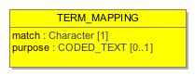

1. TERM_MAPPING

|  |  |
| --- | --- |
| **Name** | TERM_MAPPING |
| **Qualified Name** | CIMI Reference Model::Data Value Types::TERM_MAPPING |
| **Visibility** | public |
| **Abstract** | false |
| **Base Classifier** |  |
| **Realized Interface** |  |

### **Attribute Detail**

#### match

The relative match of the target term with respect to the mapped text item. Result meanings:'>': the mapping is to a broader term e.g. orginal text = arbovirus infection , target = viral infection'=': the mapping is to a (supposedly) equivalent to the original item'<': the mapping is to a narrower term. e.g. original text = diabetes , mapping = diabetes mellitus .'?': the kind of mapping is unknown.The first three values are taken from the ISO standards 2788 ( Guide to Establishment and development of monolingual thesauri ) and 5964 ( Guide to Establishment and development of multilingual thesauri ).

|  |  |
| --- | --- |
| **Type** | Character |
| **Default Value** |  |
| **Visibility** | public |
| **Multiplicity** | 1 |

#### purpose

|  |  |
| --- | --- |
| **Type** | CODED_TEXT |
| **Default Value** |  |
| **Visibility** | public |
| **Multiplicity** | 0..1 |

#### target

|  |  |
| --- | --- |
| **Type** | CODED_TEXT |
| **Default Value** |  |
| **Visibility** | public |
| **Multiplicity** | 1 |

### **Relation Detail**

#### Association

|  |  |
| --- | --- |
| **Name** |  |
| **Related Element** | * CODED_TEXT |

|  |  |
| --- | --- |
| **Name** |  |
| **Related Element** | * TEXT |

#### Dependency

|  |  |
| --- | --- |
| **Name** |  |
| **Related Element** | * TermMappingMatchEnum |

## **Class** **TEXT**

Abstract parent for text and coded text item, which may contain any amount of legal characters arranged as e.g. words, sentences etc (i.e. one TEXT may be more than one word). Visual formatting and hyperlinks may be included.

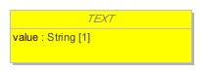

1. TEXT

|  |  |
| --- | --- |
| **Name** | TEXT |
| **Qualified Name** | CIMI Reference Model::Data Value Types::TEXT |
| **Visibility** | public |
| **Abstract** | true |
| **Base Classifier** | * DATA_VALUE |
| **Realized Interface** |  |

### **Attribute Detail**

#### mapping

|  |  |
| --- | --- |
| **Type** | TERM_MAPPING |
| **Default Value** |  |
| **Visibility** | public |
| **Multiplicity** | 0..* |

#### value

Displayable rendition of the item, regardless of its underlying structure. For CODED_TEXT, this is the rubric of the complete term as provided by the terminology service. No carriage returns, line feeds, or other non-printing characters permitted.

|  |  |
| --- | --- |
| **Type** | String |
| **Default Value** |  |
| **Visibility** | public |
| **Multiplicity** | 1 |

### **Relation Detail**

#### Association

|  |  |
| --- | --- |
| **Name** |  |
| **Related Element** | * TERM_MAPPING |

#### Generalization

|  |  |
| --- | --- |
| **Name** |  |
| **Related Element** | * PLAIN_TEXT |

|  |  |
| --- | --- |
| **Name** |  |
| **Related Element** | * CODED_TEXT |

|  |  |
| --- | --- |
| **Name** |  |
| **Related Element** | * DATA_VALUE |

## **Class** **TIME**

Represents an absolute point in time from an origin usually interpreted as meaning the start of the current day, specified to a fraction of a second. Semantics defined by ISO 8601.Used for recording real world times, rather than scientifically measured fine amounts of time. The partial form is used for approximate times of events and substance administrations.

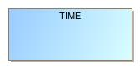

1. TIME

|  |  |
| --- | --- |
| **Name** | TIME |
| **Qualified Name** | CIMI Reference Model::Data Value Types::TIME |
| **Visibility** | public |
| **Abstract** | false |
| **Base Classifier** | * DATE_TIME |
| **Realized Interface** |  |

### **Relation Detail**

#### Generalization

|  |  |
| --- | --- |
| **Name** |  |
| **Related Element** | * DATE_TIME |

## **Class** **URI_VALUE**

A reference to an object which conforms to the Universal Resource Identifier (URI) standard. See "Universal Resource Identifiers in WWW" by Tim Berners-Lee at http://www.ietf.org/rfc/rfc3986.txt. This is a World-Wide Web RFC for global identification of resources. See http://www.w3.org/Addressing for a starting point on URIs.

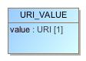

1. URI_VALUE

|  |  |
| --- | --- |
| **Name** | URI_VALUE |
| **Qualified Name** | CIMI Reference Model::Data Value Types::URI_VALUE |
| **Visibility** | public |
| **Abstract** | false |
| **Base Classifier** | * DATA_VALUE |
| **Realized Interface** |  |

### **Attribute Detail**

#### value

Value of URI

|  |  |
| --- | --- |
| **Type** | URI |
| **Default Value** |  |
| **Visibility** | public |
| **Multiplicity** | 1 |

### **Relation Detail**

#### Generalization

|  |  |
| --- | --- |
| **Name** |  |
| **Related Element** | * DATA_VALUE |

|  |  |
| --- | --- |
| **Name** |  |
| **Related Element** | * EHR_URI |

## **Class** **YESNO**

Items which are truly boolean data, such as true/false or yes/no answers. For such data, it is important to devise the meanings (usually questions in subjective data) carefully, so that the only allowed results are in fact true or false.Misuse: The DV_BOOLEAN class should not be used as a replacement for naively modelled enumerated types such as male/female etc. Such values should be coded, and in any case the enumeration often has more than two values.

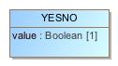

1. YESNO

|  |  |
| --- | --- |
| **Name** | YESNO |
| **Qualified Name** | CIMI Reference Model::Data Value Types::YESNO |
| **Visibility** | public |
| **Abstract** | false |
| **Base Classifier** | * DATA_VALUE |
| **Realized Interface** |  |

### **Attribute Detail**

#### value

The boolean value for the type.

|  |  |
| --- | --- |
| **Type** | Boolean |
| **Default Value** |  |
| **Visibility** | public |
| **Multiplicity** | 1 |

### **Relation Detail**

#### Generalization

|  |  |
| --- | --- |
| **Name** |  |
| **Related Element** | * DATA_VALUE |

## **Enumeration** **QuantifiedValueStatusEnum**



1. QuantifiedValueStatusEnum

|  |  |
| --- | --- |
| **Name** | QuantifiedValueStatusEnum |
| **Qualified Name** | CIMI Reference Model::Data Value Types::QuantifiedValueStatusEnum |
| **Visibility** | public |
| **Base Classifier** |  |

### **Relation Detail**

#### Dependency

|  |  |
| --- | --- |
| **Name** |  |
| **Related Element** | * QUANTIFIED |

## **Enumeration** **TermMappingMatchEnum**

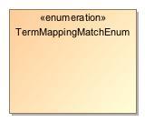

1. TermMappingMatchEnum

|  |  |
| --- | --- |
| **Name** | TermMappingMatchEnum |
| **Qualified Name** | CIMI Reference Model::Data Value Types::TermMappingMatchEnum |
| **Visibility** | public |
| **Base Classifier** |  |

### **Relation Detail**

#### Dependency

|  |  |
| --- | --- |
| **Name** |  |
| **Related Element** | * TERM_MAPPING |

# **Package CIMI Reference Model::Primitive Types**

|  |  |
| --- | --- |
| **Name** | Primitive Types |
| **Qualified Name** | CIMI Reference Model::Primitive Types |

## **Class** **Any**

1784429252.jpg

1. Any

|  |  |
| --- | --- |
| **Name** | Any |
| **Qualified Name** | CIMI Reference Model::Primitive Types::Any |
| **Visibility** | public |
| **Abstract** | false |
| **Base Classifier** |  |
| **Realized Interface** |  |

## **Class** **Array**

2000638326.jpg

1. Array

|  |  |
| --- | --- |
| **Name** | Array |
| **Qualified Name** | CIMI Reference Model::Primitive Types::Array |
| **Visibility** | public |
| **Abstract** | false |
| **Base Classifier** |  |
| **Realized Interface** |  |

## **Class** **List**

874879303.jpg

1. List

|  |  |
| --- | --- |
| **Name** | List |
| **Qualified Name** | CIMI Reference Model::Primitive Types::List |
| **Visibility** | public |
| **Abstract** | false |
| **Base Classifier** |  |
| **Realized Interface** |  |

# **Appendix A: Diagram**

## **CIMI Core Model**

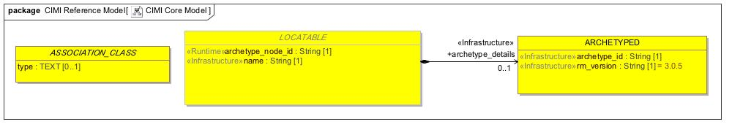

1. CIMI Core Model

## **CIMI Data Value Types**

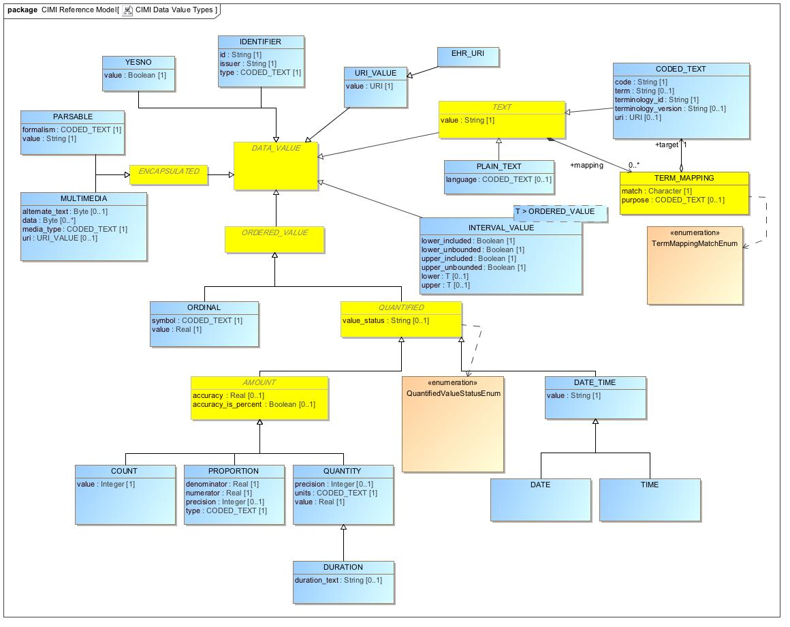

1. CIMI Data Value Types

## **CIMI Primitive Types**

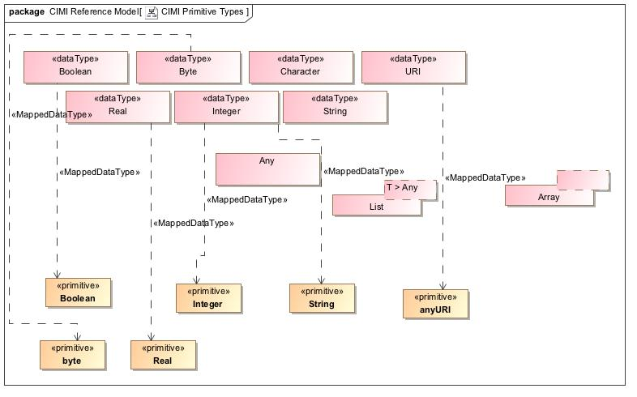

1. CIMI Primitive Types

## **ClinicalStatement**

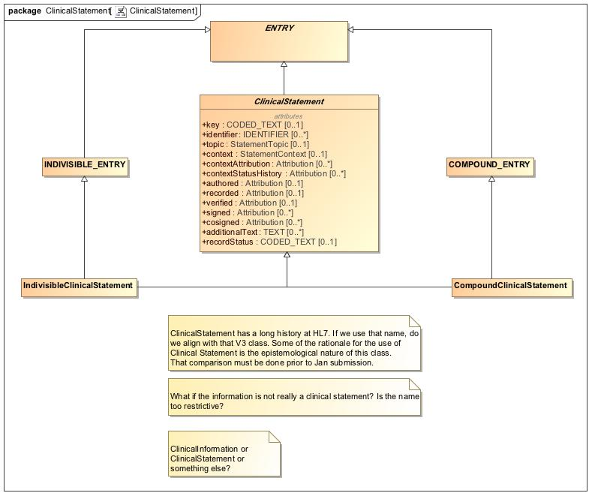

1. ClinicalStatement

## **Context - Action**

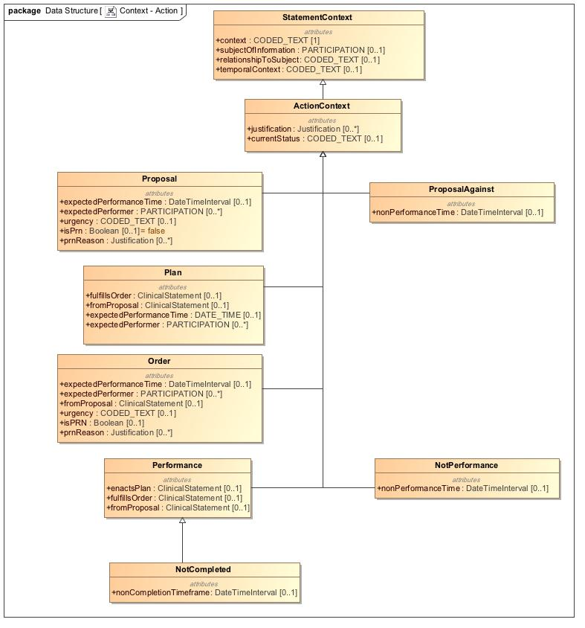

1. Context - Action

## **Context - Finding**

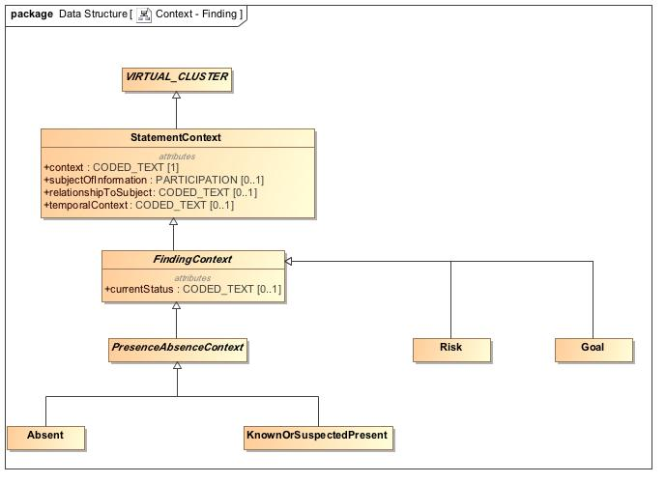

1. Context - Finding

## **Context -Core**

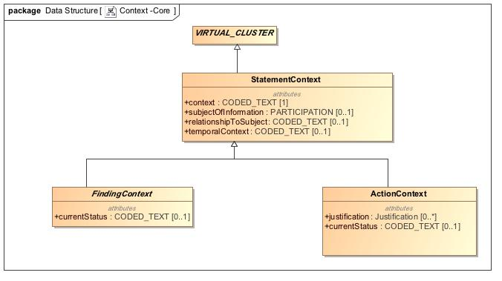

1. Context -Core

## **Data Structure - Address**

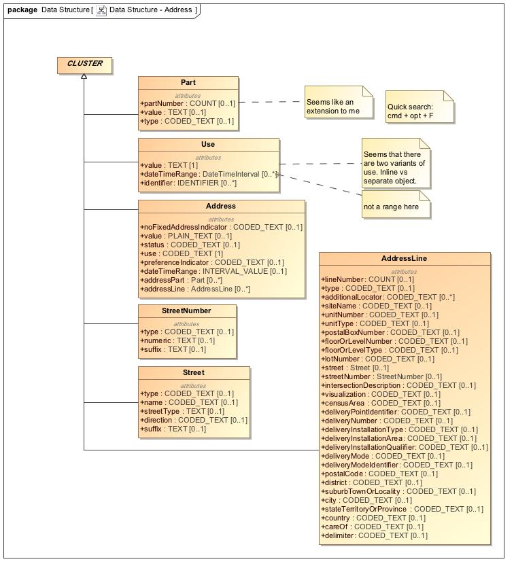

1. Data Structure - Address

## **Data Structure - Material Entity**

The weight of the specimen.

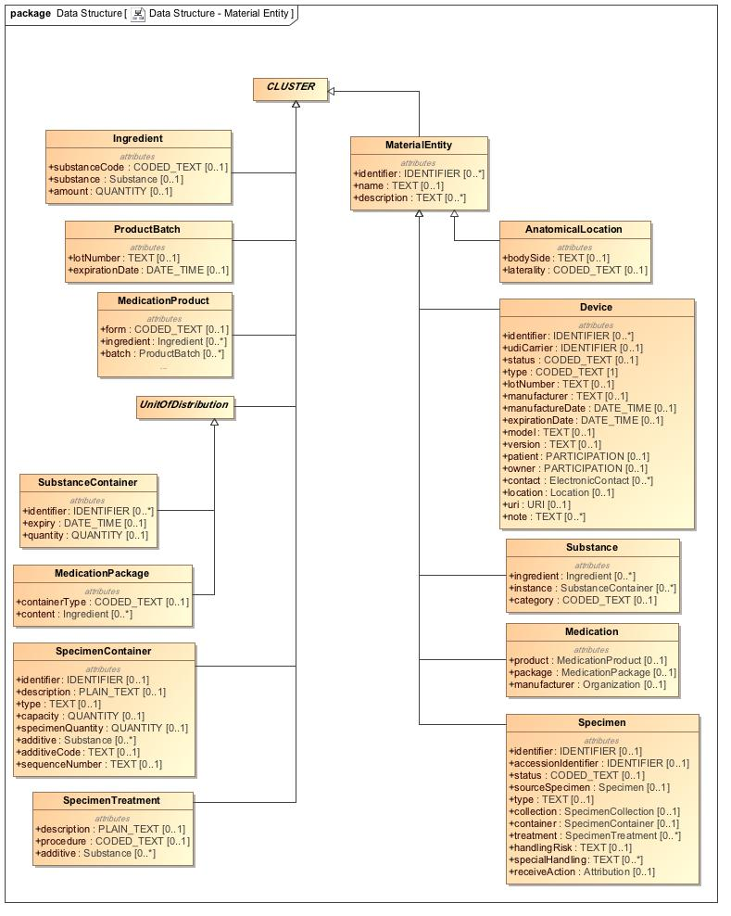

1. Data Structure - Material Entity

## **Data Structure - Other**

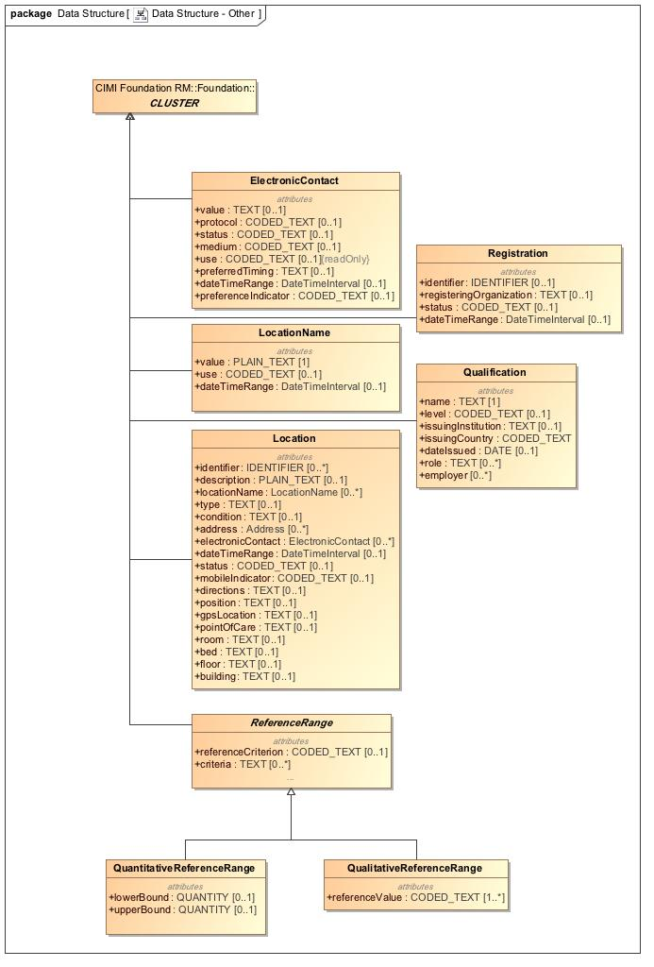

1. Data Structure - Other

## **Data Structure - Party**

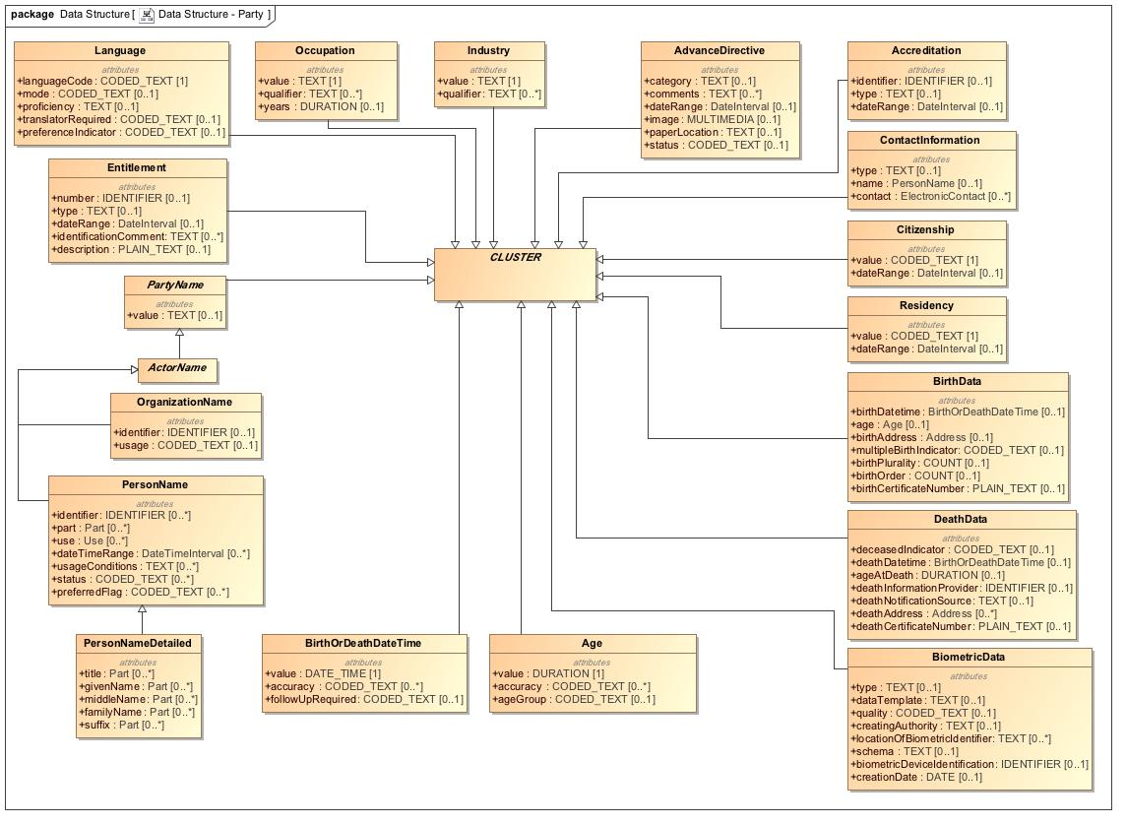

1. Data Structure - Party

## **Foundation**

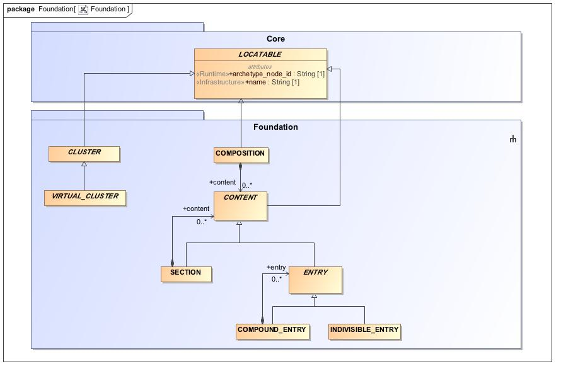

1. Foundation

## **Participation**

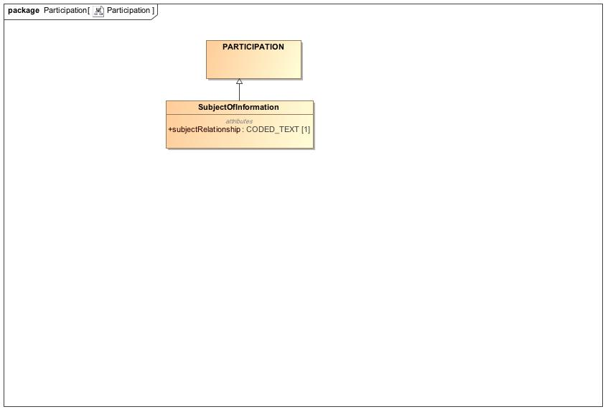

1. Participation

## **Party**

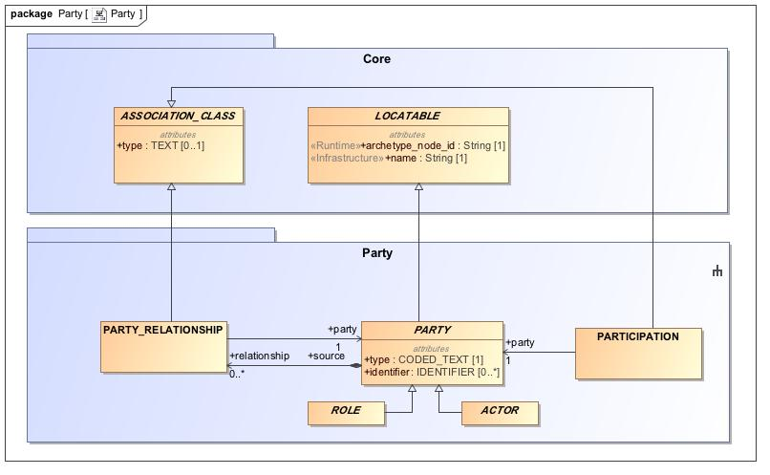

1. Party

## **Party - Specializations**

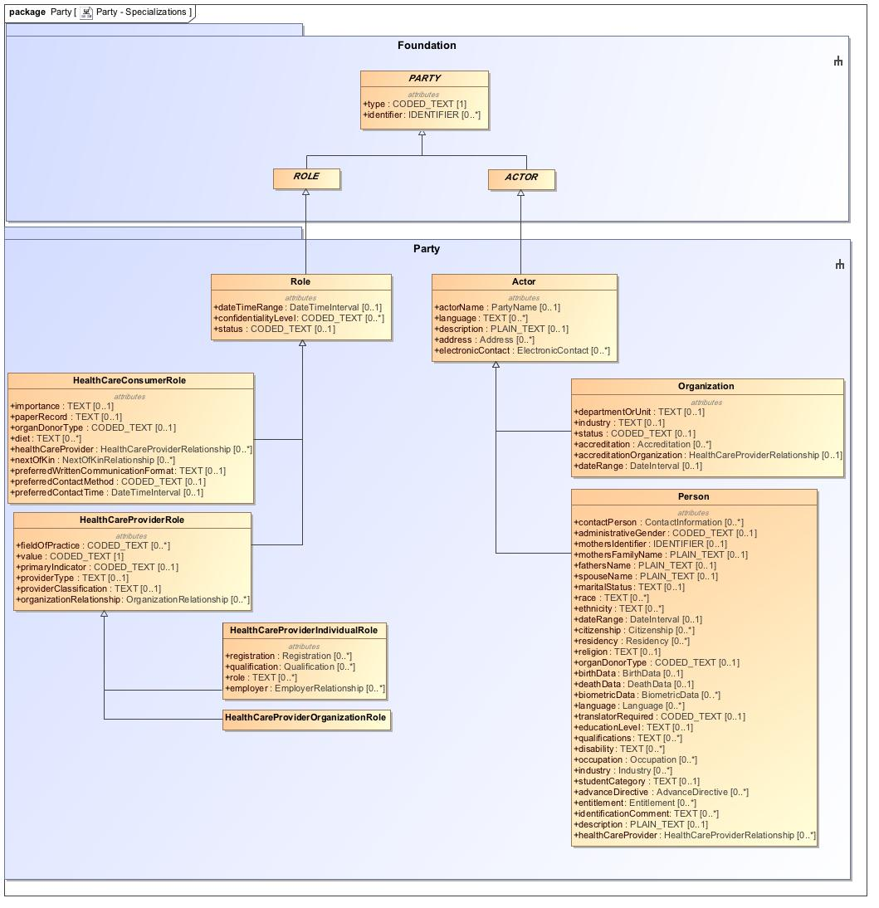

1. Party - Specializations

## **Provenance**

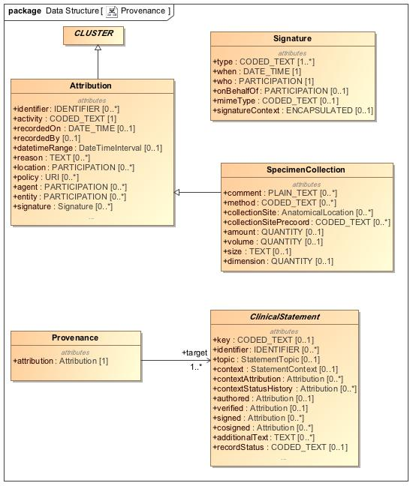

1. Provenance

## **Redefined Intervals**

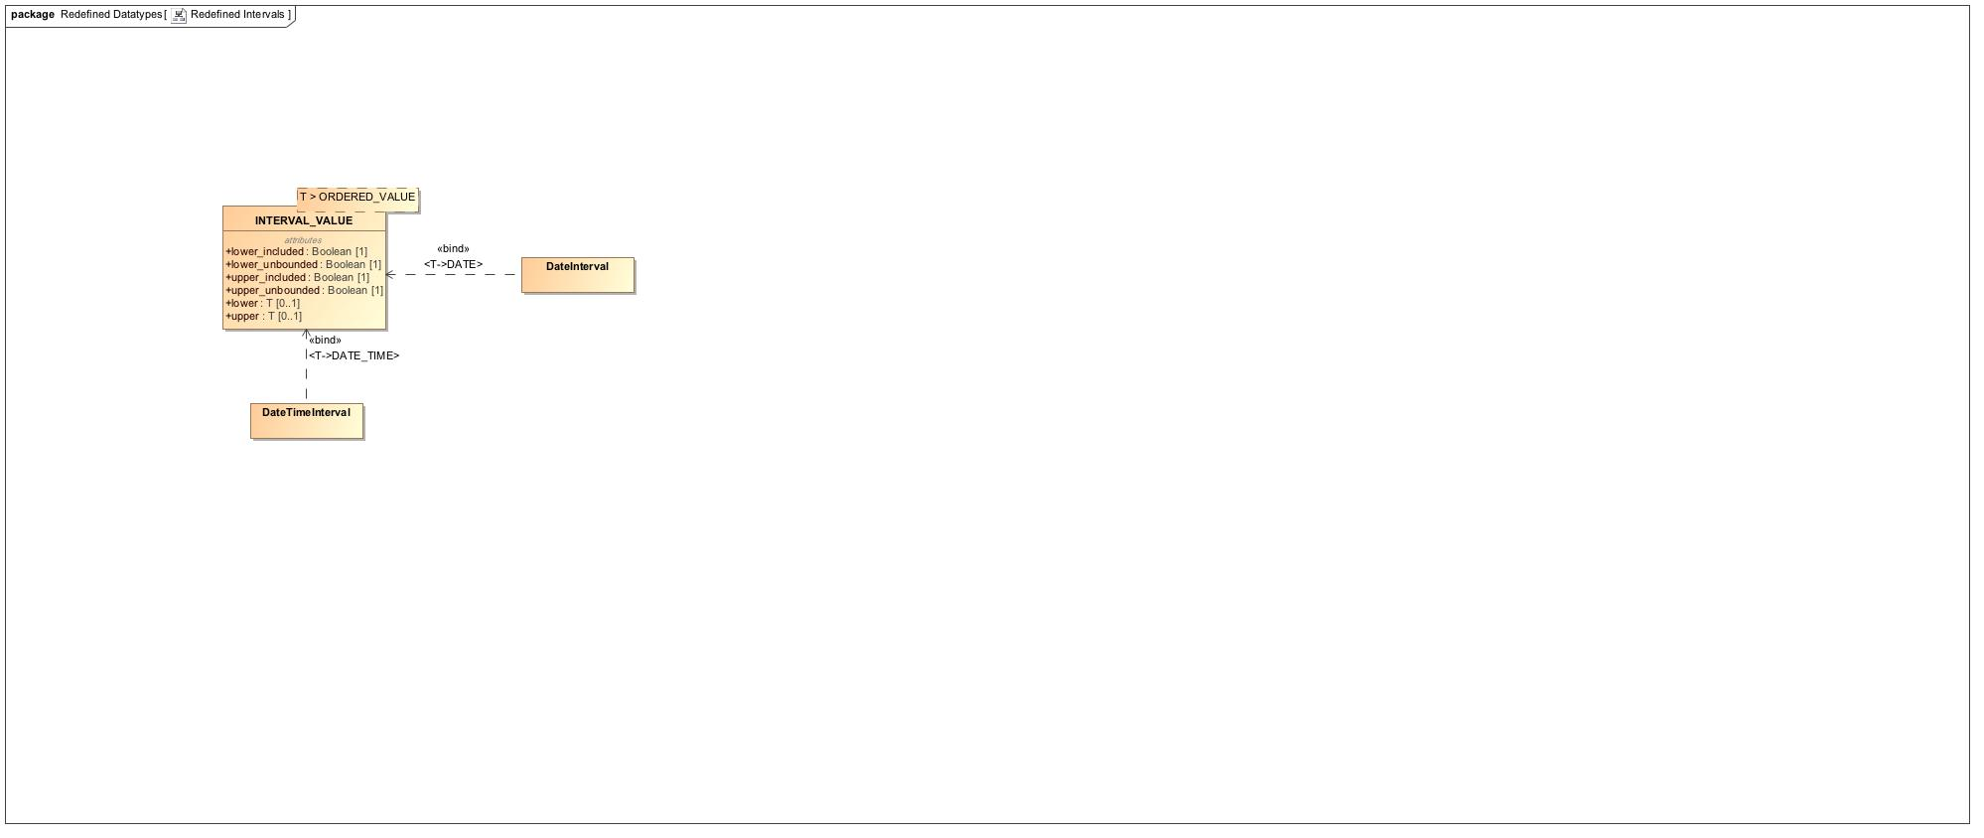

1. Redefined Intervals

## **RelatedClinicalStatement**

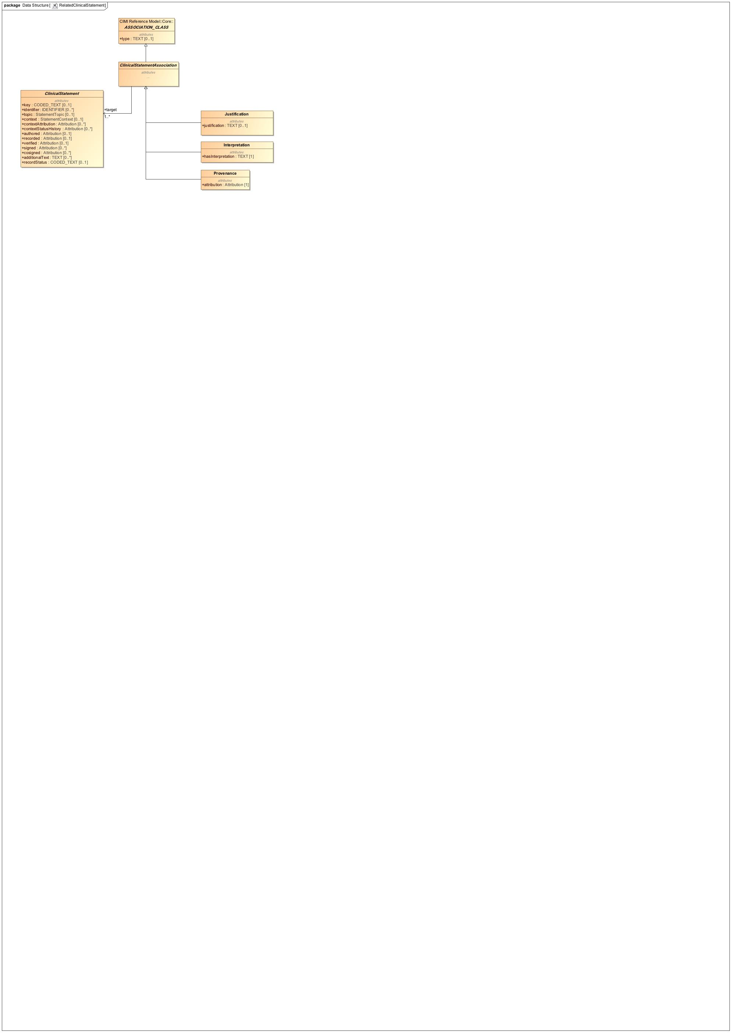

1. RelatedClinicalStatement

## **Relationship**

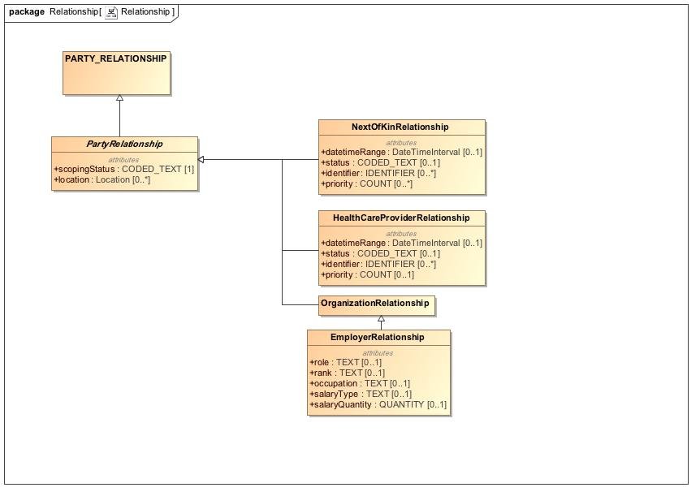

1. Relationship

## **Topic - Act**

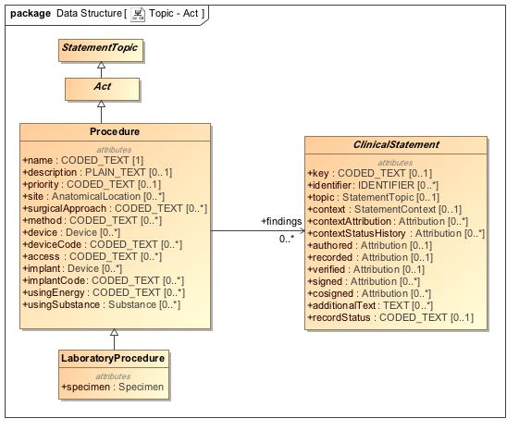

1. Topic - Act

## **Topic - Assertion**

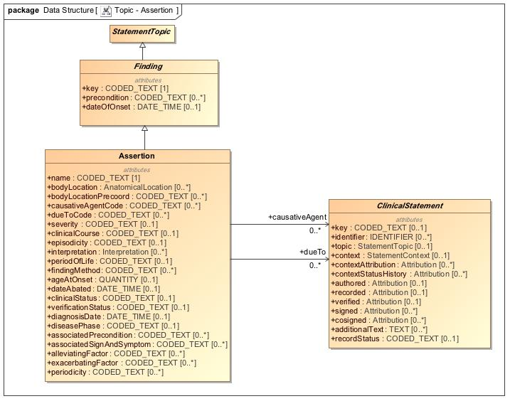

1. Topic - Assertion

## **Topic - Core**

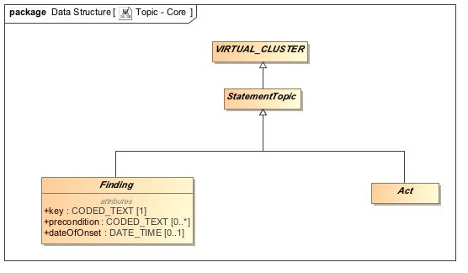

1. Topic - Core

## **Topic - Evaluation**

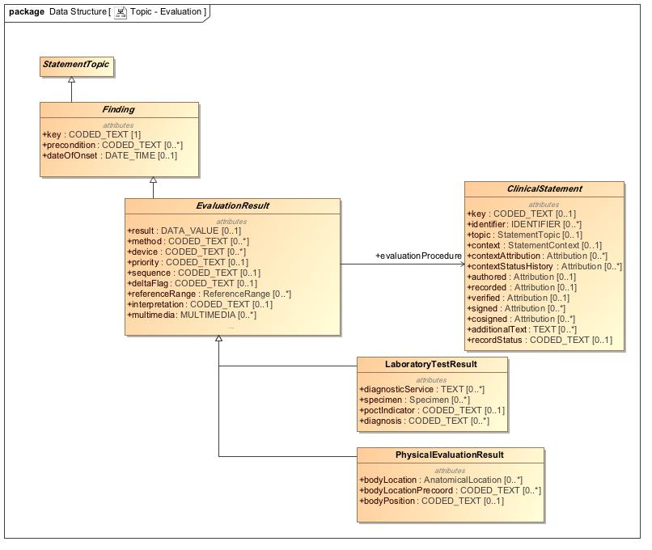

1. Topic - Evaluation

## **Virtual Cluster - Core**

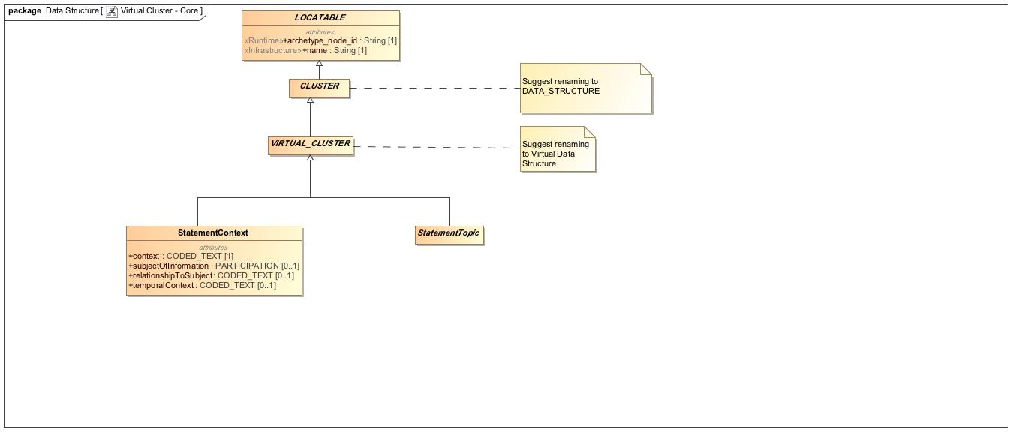

1. Virtual Cluster - Core