CIMI RM Clinical v3.0.5

The CIMI Reference Model

Author: Claude Nanjo

Revision: 0.1

|  |  |
| --- | --- |
| OpenCIMI.org |  |
| TBD | November 14, 2016 |

# 

# **Package CIMI Clinical::ClinicalStatement**

|  |  |
| --- | --- |
| **Name** | ClinicalStatement |
| **Qualified Name** | CIMI Clinical::ClinicalStatement |

## **Class** **ClinicalStatement**

The documentation of clinical information about a subject of information such as a patient or a relative of the patient, asserted by a particular source, recorded, and potentially verified. The ClinicalStatement class provides the core pattern for more specific clinical statement archetypes, such as a statement that a finding has been found in a patient or that a procedure has been proposed by a clinical decision support system.  
  
The ClinicalStatement pattern defines the core attributes common to most clinical statements and specifies a composition pattern that encourage model component reuse and better alignment with the SNOMED CT Concept Model.   
  
A clinical statement is composed of the StatementTopic class (grouping of attributes for capturing information about a procedure or a clinical finding) and the StatementContext class (grouping of attributes providing the context for the statement topic such as whether a procedure was performed, requested, not performed or whether a finding is suspected present or absent in the patient). At the archetype level, the topic and context components are coordinated to form the clinical statement. For instance, the composition of the ProcedureTopic with the NotPerformed context indicates that the given procedure was not performed.

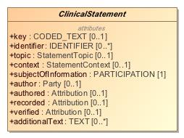

1. ClinicalStatement

|  |  |
| --- | --- |
| **Name** | ClinicalStatement |
| **Qualified Name** | CIMI Clinical::ClinicalStatement::ClinicalStatement |
| **Visibility** | public |
| **Abstract** | true |
| **Base Classifier** | * ENTRY |
| **Realized Interface** |  |

### **Attribute Detail**

#### additionalText

Unstructured notes appended to a clinical statement.

|  |  |
| --- | --- |
| **Type** | TEXT |
| **Default Value** |  |
| **Visibility** | public |
| **Multiplicity** | 0..* |
| **Definition** | Unstructured notes appended to a clinical statement. |

#### associatedWith

|  |  |
| --- | --- |
| **Type** | ClinicalStatement |
| **Default Value** |  |
| **Visibility** | public |
| **Multiplicity** | 0..* |
| **Definition** |  |

#### author

|  |  |
| --- | --- |
| **Type** | Party |
| **Default Value** |  |
| **Visibility** | public |
| **Multiplicity** | 0..1 |
| **Definition** |  |

#### authored

Provenance information specific to the assertion being made (e.g., the author(s), when authored, the location where the assertion was made, etc...).

|  |  |
| --- | --- |
| **Type** | Attribution |
| **Default Value** |  |
| **Visibility** | public |
| **Multiplicity** | 0..1 |
| **Definition** | Provenance information specific to the assertion being made (e.g., the author(s), when authored, the location where the assertion was made, etc...). |

#### context

Attribute aligned with the SNOMED CT Situation with Explicit Context Concept Model context attributes 'Finding context (attribute)' (SCTID: 408729009) and 'Procedure context (attribute)' (SCTID: 408730004). The range of this attribute is a structure (StatementContext) rather than a value set. Nevertheless, the context of the clinical statement must align with the range specified by the SWEC Concept Model. For instance, if the 'context' attribute's meaning is bound to 'Finding context', then the context may not be a specialization of the ActionContext statement context.

|  |  |
| --- | --- |
| **Type** | StatementContext |
| **Default Value** |  |
| **Visibility** | public |
| **Multiplicity** | 0..1 |
| **Definition** | Attribute aligned with the SNOMED CT Situation with Explicit Context Concept Model context attributes 'Finding context (attribute)' (SCTID: 408729009) and 'Procedure context (attribute)' (SCTID: 408730004). The range of this attribute is a structure (StatementContext) rather than a value set. Nevertheless, the context of the clinical statement must align with the range specified by the SWEC Concept Model. For instance, if the 'context' attribute's meaning is bound to 'Finding context', then the context may not be a specialization of the ActionContext statement context. |

#### identifier

The unique identifier(s) of this clinical statement. It must be provided if user wants it returned as part of any output, otherwise it will be auto-generated, if needed, by the system serving the record. An identifier does not need to be the actual identifier of the source system.

|  |  |
| --- | --- |
| **Type** | IDENTIFIER |
| **Default Value** |  |
| **Visibility** | public |
| **Multiplicity** | 0..* |
| **Definition** | The unique identifier(s) of this clinical statement. It must be provided if user wants it returned as part of any output, otherwise it will be auto-generated, if needed, by the system serving the record. An identifier does not need to be the actual identifier of the source system. |

#### key

The 'key' attribute is an optional attribute allowing the coding of some of the information represented by the clinical statement. The range of this attribute (i.e., allowable codes assigned as a value for this attribute) must derive from and conform with the SNOMED CT Situation with Explicit Context (SWEC) concept hierarchies defined in SNOMED CT. Note that this attribute may consist of precoordinated codes (not recommended) or SNOMED CT expressions.

|  |  |
| --- | --- |
| **Type** | CODED_TEXT |
| **Default Value** |  |
| **Visibility** | public |
| **Multiplicity** | 0..1 |
| **Definition** | The 'key' attribute is an optional attribute allowing the coding of some of the information represented by the clinical statement. The range of this attribute (i.e., allowable codes assigned as a value for this attribute) must derive from and conform with the SNOMED CT Situation with Explicit Context (SWEC) concept hierarchies defined in SNOMED CT. Note that this attribute may consist of precoordinated codes (not recommended) or SNOMED CT expressions. |

#### recorded

Provenance information specific to the recording of the clinical statement (e.g., when recorded, where recorded, etc...).

|  |  |
| --- | --- |
| **Type** | Attribution |
| **Default Value** |  |
| **Visibility** | public |
| **Multiplicity** | 0..1 |
| **Definition** | Provenance information specific to the recording of the clinical statement (e.g., when recorded, where recorded, etc...). |

#### subjectOfInformation

The entity being described by this statement. The entity may be animate (a patient, a relative of the patient, a veterinary patient, a cohort) or inanimate (a well, a geographical location). The subject of information is constrained in archetypes.   
  
This attribute aligns with the SNOMED CT Situation with Explicit Context (SWEC) and is bound to the SNOMED attribute: 'Subject relationship context (attribute)' (SCTID: 408732007).

|  |  |
| --- | --- |
| **Type** | PARTICIPATION |
| **Default Value** |  |
| **Visibility** | public |
| **Multiplicity** | 1 |
| **Definition** | The entity being described by this statement. The entity may be animate (a patient, a relative of the patient, a veterinary patient, a cohort) or inanimate (a well, a geographical location). The subject of information is constrained in archetypes.   This attribute aligns with the SNOMED CT Situation with Explicit Context (SWEC) and is bound to the SNOMED attribute: 'Subject relationship context (attribute)' (SCTID: 408732007). |

#### topic

Attribute aligned with the SNOMED CT Situation with Explicit Context (SWEC) Concept Model attributes 'Associated finding (attribute)' (SCTID: 246090004) and 'Associated procedure (attribute)' (SCTID: 363589002). The range of this attribute is a structure (StatementTopic) rather than a value set. Nevertheless, the topic of the clinical statement must align with the range specified by the SWEC Concept Model. For instance, if the 'topic' attribute's meaning is bound to 'Associated finding', then the topic may not be a specialization of the Act statement topic.

|  |  |
| --- | --- |
| **Type** | StatementTopic |
| **Default Value** |  |
| **Visibility** | public |
| **Multiplicity** | 0..1 |
| **Definition** | Attribute aligned with the SNOMED CT Situation with Explicit Context (SWEC) Concept Model attributes 'Associated finding (attribute)' (SCTID: 246090004) and 'Associated procedure (attribute)' (SCTID: 363589002). The range of this attribute is a structure (StatementTopic) rather than a value set. Nevertheless, the topic of the clinical statement must align with the range specified by the SWEC Concept Model. For instance, if the 'topic' attribute's meaning is bound to 'Associated finding', then the topic may not be a specialization of the Act statement topic. |

#### verified

Provenance information specific to the verification process associated with this statement (e.g., verifier, verification method, when verified, etc...).

|  |  |
| --- | --- |
| **Type** | Attribution |
| **Default Value** |  |
| **Visibility** | public |
| **Multiplicity** | 0..1 |
| **Definition** | Provenance information specific to the verification process associated with this statement (e.g., verifier, verification method, when verified, etc...). |

### **Relation Detail**

#### Association

|  |  |
| --- | --- |
| **Name** |  |
| **Related Element** | * Assertion |

|  |  |
| --- | --- |
| **Name** |  |
| **Related Element** |  |

|  |  |
| --- | --- |
| **Name** |  |
| **Related Element** | * RelatedClinicalStatement |

|  |  |
| --- | --- |
| **Name** |  |
| **Related Element** | * Mapping |

|  |  |
| --- | --- |
| **Name** |  |
| **Related Element** | * Provenance |

|  |  |
| --- | --- |
| **Name** |  |
| **Related Element** | * Mapping |

#### Generalization

|  |  |
| --- | --- |
| **Name** |  |
| **Related Element** | * IndivisibleClinicalStatement |

|  |  |
| --- | --- |
| **Name** |  |
| **Related Element** | * ENTRY |

|  |  |
| --- | --- |
| **Name** |  |
| **Related Element** | * CompoundClinicalStatement |

## **Class** **CompoundClinicalStatement**

Clinical statement representing information whose components may have an independent existence outside of the composition. For instance, a laboratory panel.  
  
A composite clinical statement may be composed of both indivisible clinical statements or composite clinical statements with arbitrary nesting. Nesting rules can be specified as constraints at the archetype level.

1917427250.jpg

1. CompoundClinicalStatement

|  |  |
| --- | --- |
| **Name** | CompoundClinicalStatement |
| **Qualified Name** | CIMI Clinical::ClinicalStatement::CompoundClinicalStatement |
| **Visibility** | public |
| **Abstract** | false |
| **Base Classifier** | * ClinicalStatement * COMPOUND_ENTRY |
| **Realized Interface** |  |

### **Relation Detail**

#### Generalization

|  |  |
| --- | --- |
| **Name** |  |
| **Related Element** | * COMPOUND_ENTRY |

|  |  |
| --- | --- |
| **Name** |  |
| **Related Element** | * ClinicalStatement |

## **Class** **IndivisibleClinicalStatement**

Clinical statement representing the smallest unit of information capable of having an independent existence. For instance, a standalone hematocrit lab observation.   
  
An indivisible clinical statement may also be represented as part of a composite clinical statement such as a panel.

269038031.jpg

1. IndivisibleClinicalStatement

|  |  |
| --- | --- |
| **Name** | IndivisibleClinicalStatement |
| **Qualified Name** | CIMI Clinical::ClinicalStatement::IndivisibleClinicalStatement |
| **Visibility** | public |
| **Abstract** | false |
| **Base Classifier** | * ClinicalStatement * INDIVISIBLE_ENTRY |
| **Realized Interface** |  |

### **Relation Detail**

#### Generalization

|  |  |
| --- | --- |
| **Name** |  |
| **Related Element** | * ClinicalStatement |

|  |  |
| --- | --- |
| **Name** |  |
| **Related Element** | * INDIVISIBLE_ENTRY |

## **Class** **Provenance**

The Provenance pattern supports the attachment of attribution information to one or more clinical statements and is not part of the clinical statements themselves.  
  
The attachment of provenance information to a clinical statement in this manner does not impact the versioning of the clinical statement target since attribution information is external to the statement.

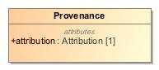

1. Provenance

|  |  |
| --- | --- |
| **Name** | Provenance |
| **Qualified Name** | CIMI Clinical::Data Structure::Provenance |
| **Visibility** | public |
| **Abstract** | false |
| **Base Classifier** | * CLUSTER |
| **Realized Interface** |  |

### **Attribute Detail**

#### attribution

The activity provenance details. Refer to the Attribution class.

|  |  |
| --- | --- |
| **Type** | Attribution |
| **Default Value** |  |
| **Visibility** | public |
| **Multiplicity** | 1 |
| **Definition** | The activity provenance details. Refer to the Attribution class. |

#### target

The clinical statement that were generated or updated by the activity described. A provenance can point to more than one target if multiple resources were created/updated by the same activity.

|  |  |
| --- | --- |
| **Type** | ClinicalStatement |
| **Default Value** |  |
| **Visibility** | public |
| **Multiplicity** | 1..* |
| **Definition** | The clinical statement that were generated or updated by the activity described. A provenance can point to more than one target if multiple resources were created/updated by the same activity. |

### **Relation Detail**

#### Association

|  |  |
| --- | --- |
| **Name** |  |
| **Related Element** | * ClinicalStatement |

#### Generalization

|  |  |
| --- | --- |
| **Name** |  |
| **Related Element** | * CLUSTER |

## **Class** **Signature**

A digital signature along with supporting context. The signature may be electronic/cryptographic in nature, or a graphical image representing a hand-written signature, or a signature process. Different Signature approaches have different utilities.

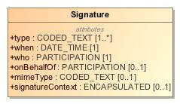

1. Signature

|  |  |
| --- | --- |
| **Name** | Signature |
| **Qualified Name** | CIMI Clinical::Data Structure::Signature |
| **Visibility** | public |
| **Abstract** | false |
| **Base Classifier** | * CLUSTER |
| **Realized Interface** |  |

### **Attribute Detail**

#### mimeType

A mime type that indicates the technical format of the signature. Important mime types are application/signature+xml for X ML DigSig, application/jwt for JWT, and image/* for a graphical image of a signature, etc.

|  |  |
| --- | --- |
| **Type** | CODED_TEXT |
| **Default Value** |  |
| **Visibility** | public |
| **Multiplicity** | 0..1 |
| **Definition** | A mime type that indicates the technical format of the signature. Important mime types are application/signature+xml for X ML DigSig, application/jwt for JWT, and image/* for a graphical image of a signature, etc. |

#### onBehalfOf

A reference to an application-usable description of the identity that is represented by the signature.

|  |  |
| --- | --- |
| **Type** | PARTICIPATION |
| **Default Value** |  |
| **Visibility** | public |
| **Multiplicity** | 0..1 |
| **Definition** | A reference to an application-usable description of the identity that is represented by the signature. |

#### signatureContext

The base64 encoding of the Signature content. When signature is not recorded electronically this element would be empty.

|  |  |
| --- | --- |
| **Type** | ENCAPSULATED |
| **Default Value** |  |
| **Visibility** | public |
| **Multiplicity** | 0..1 |
| **Definition** | The base64 encoding of the Signature content. When signature is not recorded electronically this element would be empty. |

#### type

An indication of the reason that the entity signed this document. This may be explicitly included as part of the signature information and can be used when determining accountability for various actions concerning the document.

|  |  |
| --- | --- |
| **Type** | CODED_TEXT |
| **Default Value** |  |
| **Visibility** | public |
| **Multiplicity** | 1..* |
| **Definition** | An indication of the reason that the entity signed this document. This may be explicitly included as part of the signature information and can be used when determining accountability for various actions concerning the document. |

#### when

When the digital signature was signed.

|  |  |
| --- | --- |
| **Type** | DATE_TIME |
| **Default Value** |  |
| **Visibility** | public |
| **Multiplicity** | 1 |
| **Definition** | When the digital signature was signed. |

#### who

A reference to an application-usable description of the identity that signed (e.g. the signature used their private key).

|  |  |
| --- | --- |
| **Type** | PARTICIPATION |
| **Default Value** |  |
| **Visibility** | public |
| **Multiplicity** | 1 |
| **Definition** | A reference to an application-usable description of the identity that signed (e.g. the signature used their private key). |

### **Relation Detail**

#### Generalization

|  |  |
| --- | --- |
| **Name** |  |
| **Related Element** | * CLUSTER |

# **Appendix A: Diagram**

## **ClinicalStatement**

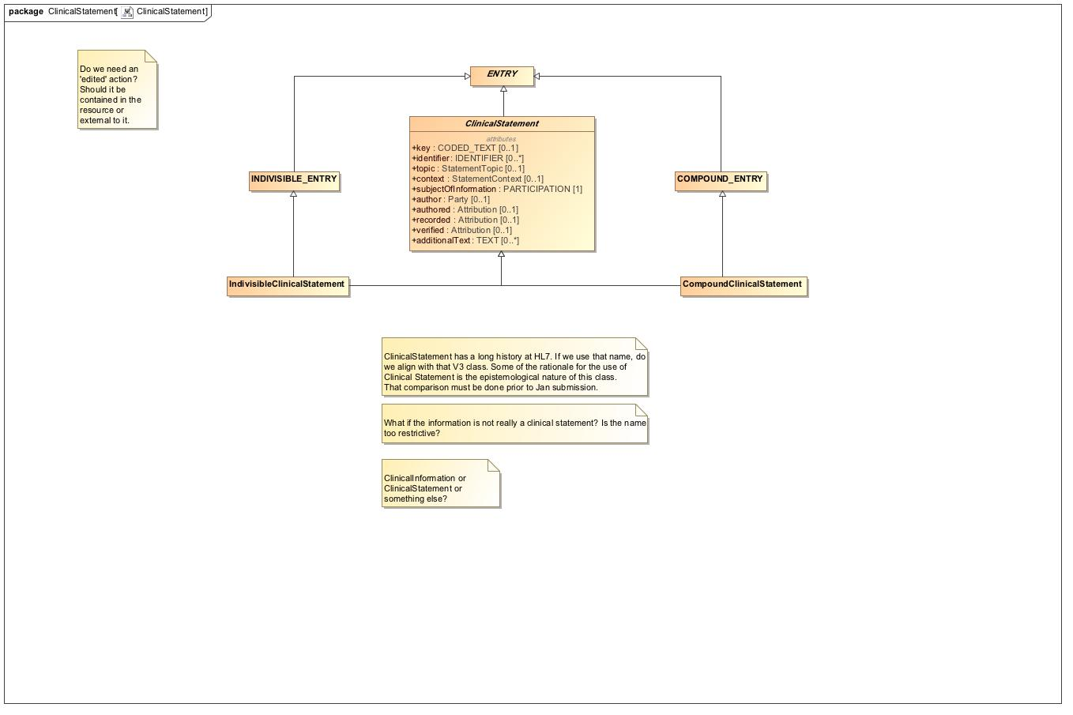

1. ClinicalStatement

## **ClinicalStatement - Relationships**

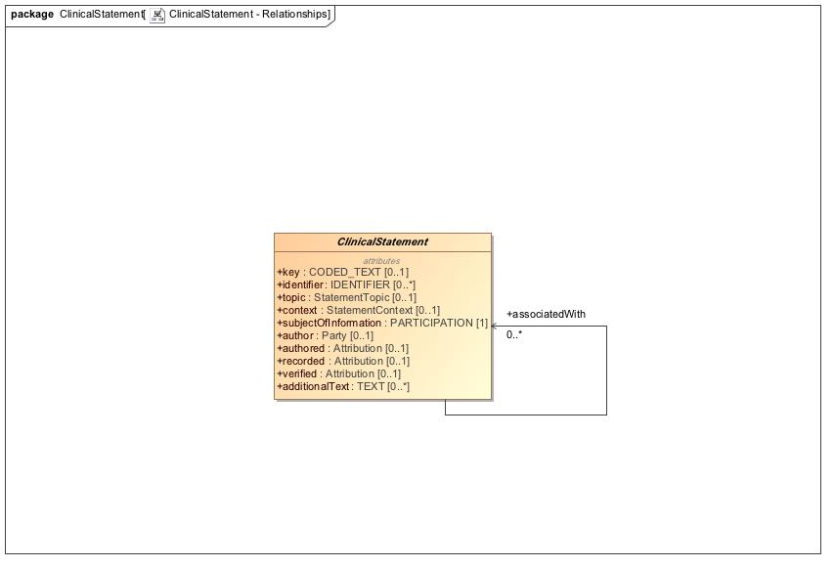

1. ClinicalStatement - Relationships

## **Provenance**

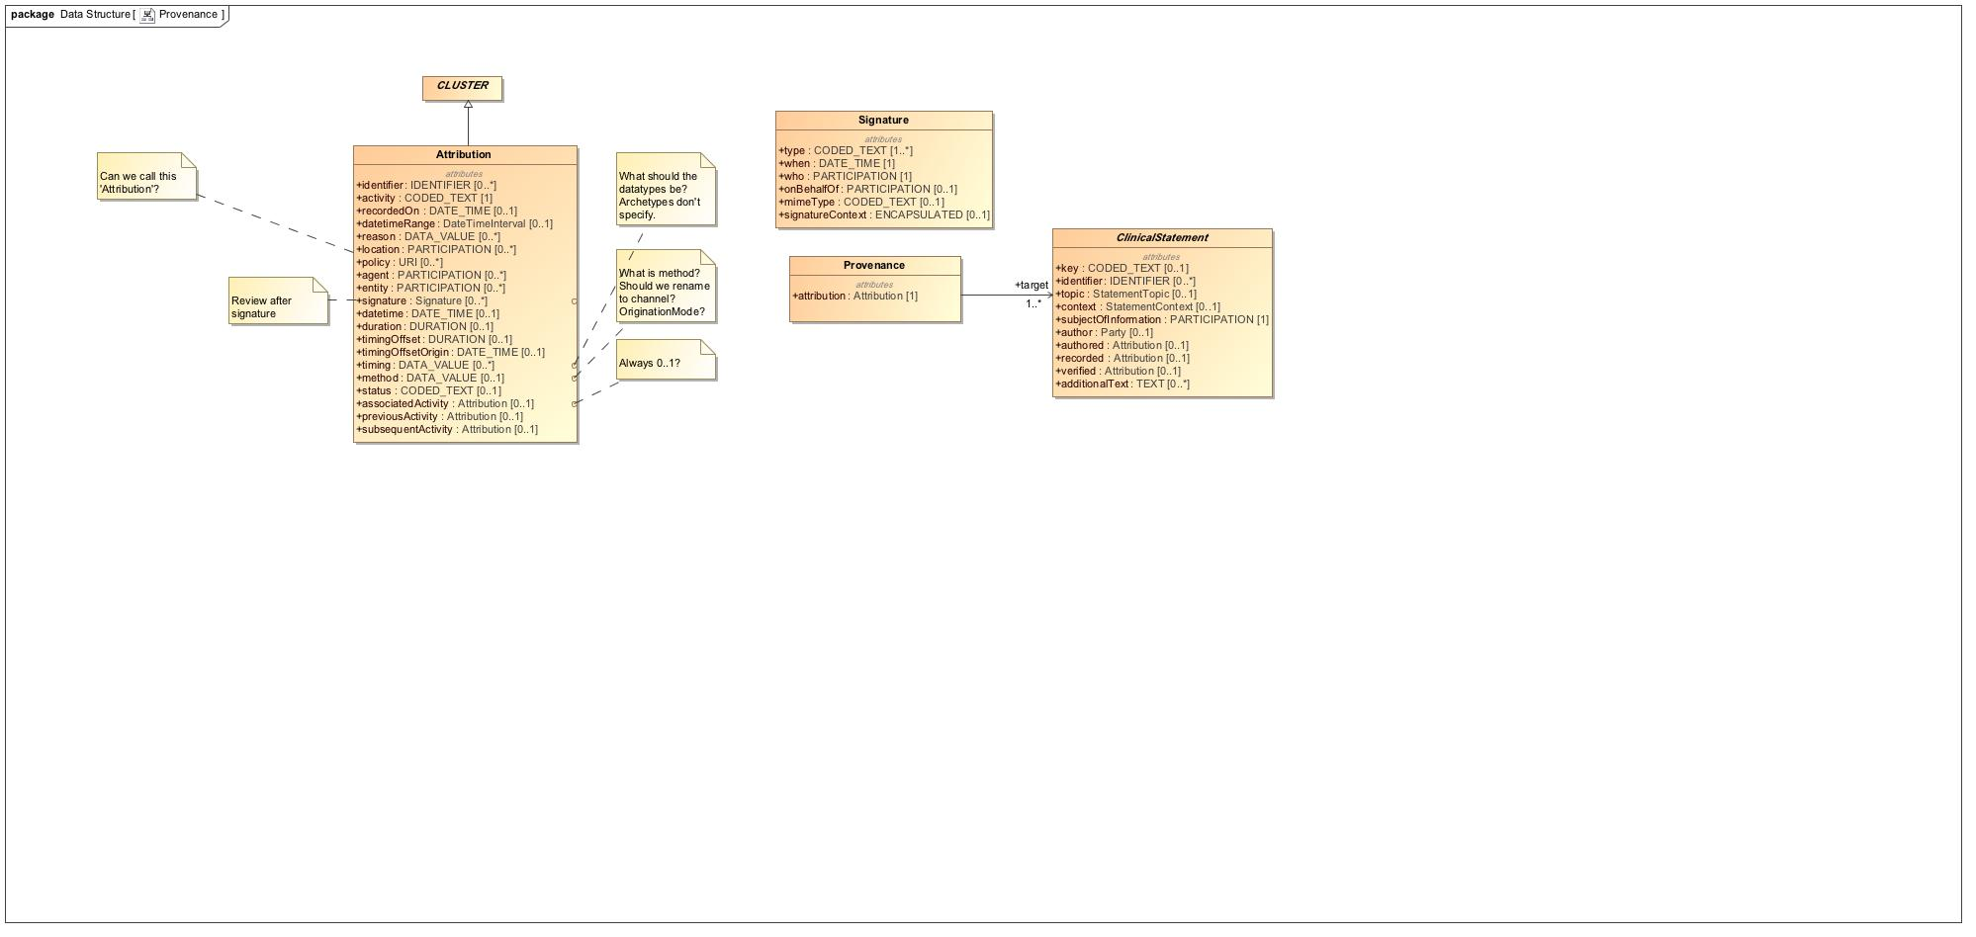

1. Provenance