CIMI RM Clinical v3.0.5

The CIMI Reference Model

Author: Claude Nanjo

Revision: 0.1

|  |  |
| --- | --- |
| OpenCIMI.org |  |
| TBD | November 13, 2016 |

**Approval**

|  |
| --- |
| The original of this document is approved and signed by:  Name:  Surname:  Title:  Date:  Signature: |

**Revision History**

|  |  |  |  |
| --- | --- | --- | --- |
| **Revision** | **Date** | **Description** | **Author** |
| 0.2 | <date 2> | <release> | <Author name> |
| 0.1 | <date 1> | <draft> | <Author name> |
|  |  |  |  |

| Table of Contents |
| --- |
| Introduction 1  **Purpose** 1  **Scope** 1  **Overview** 1  Package CIMI Clinical 2  Package CIMI Clinical::ClinicalStatement 2  **Class ClinicalStatement** 2  **Attribute Detail** 2  additionalText 2  associatedWith 3  authored 3  context 3  identifier 3  key 3  recorded 3  subjectOfInformation 3  topic 3  verified 4  **Relation Detail** 4  Association 4  Generalization 4  **Class CompoundClinicalStatement** 4  **Relation Detail** 5  Generalization 5  **Class IndivisibleClinicalStatement** 5  **Relation Detail** 5  Generalization 5  Package CIMI Clinical::Data Structure 5  **Class Absent** 5  **Relation Detail** 6  Generalization 6  **Class Act** 6  **Relation Detail** 6  Generalization 6  **Class Action** 6  **Attribute Detail** 7  associatedActivity 7  datetime 7  datetimeRange 7  duration 7  identifier 8  location 8  method 8  performer 8  previousAction 8  reason 8  recordedOn 8  signature 9  status 9  subsequentAction 9  timing 9  timingOffset 9  timingOffsetOrigin 9  type 9  **Relation Detail** 9  Generalization 9  **Class ActionContext** 10  **Attribute Detail** 10  contextSource 10  currentStatus 10  justification 11  statusHistory 11  **Relation Detail** 11  Generalization 11  **Class ActionSet** 11  **Attribute Detail** 12  actions 12  **Relation Detail** 12  Generalization 12  **Class ActorName** 12  **Relation Detail** 12  Generalization 12  **Class Address** 13  **Attribute Detail** 13  addressLine 13  addressPart 13  dateTimeRange 13  noFixedAddressIndicator 13  preferenceIndicator 14  status 14  use 14  value 14  **Relation Detail** 14  Generalization 14  **Class AddressLine** 14  **Attribute Detail** 15  additionalLocator 15  careOf 15  censusArea 15  city 16  country 16  delimiter 16  deliveryInstallationArea 16  deliveryInstallationQualifier 16  deliveryInstallationType 16  deliveryMode 16  deliveryModeIdentifier 16  deliveryNumber 17  deliveryPointIdentifier 17  district 17  floorOrLevelNumber 17  floorOrLevelType 17  intersectionDescription 17  lineNumber 17  lotNumber 17  postalBoxNumber 18  postalCode 18  siteName 18  stateTerritoryOrProvince 18  street 18  streetNumber 18  suburbTownOrLocality 18  type 18  unitNumber 19  unitType 19  visualization 19  **Relation Detail** 19  Generalization 19  **Class AnatomicalLocation** 19  **Attribute Detail** 19  bodySide 19  laterality 20  **Relation Detail** 20  Generalization 20  **Class Assertion** 20  **Attribute Detail** 20  ageAtOnset 21  alleviatingFactor 21  associatedPrecondition 21  associatedSignAndSymptom 21  bodyLocation 21  bodyLocationPrecoord 22  causativeAgent 22  clinicalCourse 22  clinicalStatus 22  dateAbated 23  dateOfOnset 23  diagnosisDate 23  diseasePhase 23  dueTo 23  dueToCode 24  episodicity 24  exacerbatingFactor 24  findingMethod 24  hasDefinitionalManifestation 25  interpretation 25  name 25  periodicity 26  periodOfLife 26  severity 26  verificationStatus 27  **Relation Detail** 27  Association 27  Generalization 28  **Class Device** 28  **Relation Detail** 28  Generalization 28  **Class ElectronicContact** 28  **Attribute Detail** 28  dateTimeRange 29  medium 29  preferenceIndicator 29  preferredTiming 29  protocol 29  status 29  use 29  value 29  **Relation Detail** 30  Generalization 30  **Class Encounter** 30  **Attribute Detail** 30  hospitalService 30  patientClass 30  **Relation Detail** 30  Generalization 30  **Class EvaluationResult** 30  **Attribute Detail** 31  conclusions 31  deltaFlag 31  interpretation 31  method 31  precondition 32  priority 32  reason 32  referenceRange 32  result 32  sequence 32  signalFlag 32  status 33  **Relation Detail** 33  Generalization 33  **Class Finding** 33  **Attribute Detail** 33  key 33  **Relation Detail** 33  Generalization 33  **Class FindingContext** 34  **Relation Detail** 34  Generalization 34  **Class Interpretation** 34  **Attribute Detail** 35  hasInterpretation 35  **Relation Detail** 35  Generalization 35  **Class Justification** 35  **Attribute Detail** 35  justification 35  **Relation Detail** 35  Generalization 36  **Class KnownOrSuspectedPresent** 36  **Relation Detail** 36  Generalization 36  **Class LaboratoryProcedure** 36  **Attribute Detail** 36  specimen 36  **Relation Detail** 37  Generalization 37  **Class LaboratoryTestResult** 37  **Attribute Detail** 37  diagnosis 37  diagnosticService 37  poctIndicator 37  specimen 38  **Relation Detail** 38  Generalization 38  **Class Location** 38  **Attribute Detail** 38  address 38  bed 38  building 39  condition 39  dateTimeRange 39  description 39  directions 39  electronicContact 39  floor 39  gpsLocation 39  identifier 40  locationName 40  mobileIndicator 40  pointOfCare 40  position 40  room 40  status 40  type 40  **Relation Detail** 41  Generalization 41  **Class LocationName** 41  **Attribute Detail** 41  dateTimeRange 41  use 41  value 41  **Relation Detail** 41  Generalization 42  **Class Mapping** 42  **Attribute Detail** 42  source 42  target 42  **Relation Detail** 42  Association 42  **Class MaterialEntity** 42  **Attribute Detail** 43  description 43  identifier 43  name 43  **Relation Detail** 43  Generalization 43  **Class NotCompleted** 44  **Relation Detail** 44  Generalization 44  **Class NotPerformed** 44  **Attribute Detail** 44  nonPerformanceTime 45  **Relation Detail** 45  Generalization 45  **Class Ordered** 45  **Attribute Detail** 45  expectedPerformanceTime 45  expectedPerformer 46  fromProposal 46  isPRN 46  prnReason 46  urgency 46  **Relation Detail** 47  Generalization 47  **Class OrganizationName** 47  **Attribute Detail** 47  identifier 47  usage 47  **Relation Detail** 47  Generalization 47  **Class Part** 47  **Attribute Detail** 48  partNumber 48  type 48  value 48  **Relation Detail** 48  Generalization 48  **Class PartyName** 48  **Attribute Detail** 49  value 49  **Relation Detail** 49  Generalization 49  **Class Performed** 49  **Attribute Detail** 49  actionPerformed 50  enactsPlan 50  fromProposal 50  fulfillsOrder 50  performanceTime 50  performedBy 51  **Relation Detail** 51  Generalization 51  **Class PersonName** 51  **Attribute Detail** 51  dateTimeRange 52  identifier 52  part 52  preferredFlag 52  status 52  usageConditions 52  use 52  **Relation Detail** 52  Generalization 52  **Class PersonNameDetailed** 53  **Attribute Detail** 53  familyName 53  givenName 53  middleName 53  suffix 53  title 53  **Relation Detail** 54  Generalization 54  **Class PhysicalEvaluationResult** 54  **Attribute Detail** 54  bodyLocation 54  bodyLocationPrecoord 54  bodyPosition 54  **Relation Detail** 54  Generalization 55  **Class Planned** 55  **Attribute Detail** 55  expectedPerformanceTime 55  expectedPerformer 55  fromProposal 56  fulfillsOrder 56  **Relation Detail** 56  Generalization 56  **Class PresenceAbsenceContext** 56  **Relation Detail** 56  Generalization 56  **Class Procedure** 57  **Attribute Detail** 57  access 57  description 57  device 57  deviceCode 58  findings 58  implantCodes 58  implants 58  method 58  name 58  priority 59  site 59  surgicalApproach 59  usingEnergy 59  usingSubstance 59  **Relation Detail** 59  Generalization 59  **Class Proposed** 60  **Attribute Detail** 60  expectedPerformanceTime 60  expectedPerformer 60  isPrn 60  prnReason 61  urgency 61  **Relation Detail** 61  Generalization 61  **Class ProposedAgainst** 61  **Attribute Detail** 62  nonPerformanceTime 62  **Relation Detail** 62  Generalization 62  **Class Provenance** 62  **Attribute Detail** 62  attribution 62  target 62  **Relation Detail** 62  Association 63  Generalization 63  **Class Qualification** 63  **Attribute Detail** 63  dateIssued 63  employer 63  issuingCountry 63  issuingInstitution 64  level 64  name 64  role 64  **Relation Detail** 64  Generalization 64  **Class QualitativeReferenceRange** 64  **Attribute Detail** 64  referenceValue 65  **Relation Detail** 65  Generalization 65  **Class QuantitativeReferenceRange** 65  **Attribute Detail** 65  lowerBound 65  upperBound 65  **Relation Detail** 65  Generalization 65  **Class ReferenceRange** 66  **Attribute Detail** 66  criteria 66  narrative 66  referenceCriterion 66  **Relation Detail** 66  Generalization 66  **Class Registration** 67  **Attribute Detail** 67  dateTimeRange 67  identifier 67  registeringOrganization 67  status 67  **Relation Detail** 67  Generalization 68  **Class RelatedClinicalStatement** 68  **Attribute Detail** 68  relationshipCode 68  target 68  **Relation Detail** 68  Association 68  Generalization 68  **Class Risk** 69  **Relation Detail** 69  Generalization 69  **Class Signature** 69  **Attribute Detail** 69  mimeType 69  signatureContext 70  type 70  when 70  **Relation Detail** 70  Generalization 70  **Class Specimen** 70  **Attribute Detail** 71  collectAction 71  containerIdentifier 71  receiveAction 71  sequenceNumber 71  sourceSpecimen 71  specialHandling 71  specimenAdditive 71  specimenDescription 71  specimenDimension 72  specimenHandlingRisk 72  specimenIdentifier 72  specimenSize 72  specimenType 72  specimenVolume 72  specimenWeight 72  **Relation Detail** 72  Generalization 72  **Class SpecimenCollection** 73  **Attribute Detail** 73  collectionBodySite 73  collectionDescription 73  collectionPriority 73  **Relation Detail** 73  Generalization 73  **Class StatementContext** 73  **Attribute Detail** 74  context 74  **Relation Detail** 74  Generalization 74  **Class StatementTopic** 74  **Relation Detail** 75  Generalization 75  **Class Street** 75  **Attribute Detail** 75  direction 75  name 75  streetType 75  suffix 76  type 76  **Relation Detail** 76  Generalization 76  **Class StreetNumber** 76  **Attribute Detail** 76  numeric 76  suffix 76  type 77  **Relation Detail** 77  Generalization 77  **Class Substance** 77  **Relation Detail** 77  Generalization 77  **Class Use** 77  **Attribute Detail** 78  dateTimeRange 78  identifier 78  value 78  **Relation Detail** 78  Generalization 78  Package CIMI Clinical::Participation 78  **Class SubjectOfInformation** 78  **Attribute Detail** 79  subjectRelationship 79  **Relation Detail** 79  Generalization 79  Package CIMI Clinical::Party 79  **Class HealthCareConsumerRole** 79  **Attribute Detail** 79  diet 79  healthCareProvider 80  importance 80  nextOfKin 80  organDonorType 80  paperRecord 80  **Relation Detail** 80  Generalization 80  **Class HealthCareProviderIndividualRole** 80  **Attribute Detail** 81  employer 81  qualification 81  registration 81  role 81  **Relation Detail** 81  Generalization 81  **Class HealthCareProviderOrganizationRole** 81  **Relation Detail** 82  Generalization 82  **Class HealthCareProviderRole** 82  **Attribute Detail** 82  fieldOfPractice 82  organizationRelationship 82  primaryIndicator 82  providerClassification 83  providerType 83  value 83  **Relation Detail** 83  Generalization 83  **Class Party** 83  **Attribute Detail** 84  address 84  electronicContact 84  identifier 84  name 84  partyType 84  relationship 84  **Relation Detail** 84  Generalization 84  **Class PersonRole** 85  **Attribute Detail** 85  preferredContactMethod 85  preferredContactTime 85  preferredWrittenCommunicationFormat 85  **Relation Detail** 85  Generalization 85  **Class Role** 85  **Attribute Detail** 86  confidentialityLevel 86  dateTimeRange 86  roleType 86  status 86  **Relation Detail** 86  Generalization 86  Package CIMI Clinical::Redefined Datatypes 87  **Class DateInterval** 87  **Relation Detail** 87  Template Binding 87  **Class DateTimeInterval** 87  **Relation Detail** 87  Template Binding 87  Package CIMI Clinical::Relationship 88  **Class EmployerRelationship** 88  **Attribute Detail** 88  occupation 88  rank 88  role 88  salaryQuantity 88  salaryType 89  **Relation Detail** 89  Generalization 89  **Class HealthCareProviderRelationship** 89  **Attribute Detail** 89  datetimeRange 89  identifier 89  priority 90  status 90  **Relation Detail** 90  Generalization 90  **Class NextOfKinRelationship** 90  **Attribute Detail** 90  datetimeRange 90  identifier 90  priority 91  status 91  **Relation Detail** 91  Generalization 91  **Class OrganizationRelationship** 91  **Relation Detail** 91  Generalization 91  **Class PartyRelationship** 91  **Attribute Detail** 92  location 92  scopingStatus 92  **Relation Detail** 92  Generalization 92  **Class SubjectOfInformation** 92  Package CIMI Foundation RM 93  Package CIMI Foundation RM::Foundation 93  **Class CLUSTER** 93  **Attribute Detail** 94  participation 94  **Relation Detail** 94  Association 94  Generalization 94  **Class COMPOSITION** 95  **Attribute Detail** 95  content 95  participation 96  **Relation Detail** 96  Association 96  Generalization 96  **Class COMPOUND_ENTRY** 96  **Attribute Detail** 96  entry 96  **Relation Detail** 96  Association 96  Generalization 97  **Class CONTENT** 97  **Relation Detail** 97  Association 97  Generalization 97  **Class ENTRY** 97  **Attribute Detail** 98  participation 98  **Relation Detail** 98  Association 98  Generalization 98  **Class INDIVISIBLE_ENTRY** 98  **Relation Detail** 99  Generalization 99  **Class SECTION** 99  **Attribute Detail** 99  content 99  **Relation Detail** 99  Association 99  Generalization 99  **Class VIRTUAL_CLUSTER** 100  **Relation Detail** 100  Generalization 100  Package CIMI Reference Model 100  Package CIMI Reference Model::Core 100  **Class ARCHETYPED** 101  **Attribute Detail** 101  archetype_id 101  rm_version 101  **Relation Detail** 101  Association 101  **Class ELEMENT** 101  **Attribute Detail** 102  null_flavor 102  value 102  **Relation Detail** 102  Generalization 102  **Class ITEM** 102  **Relation Detail** 102  Association 102  Generalization 103  **Class ITEM_GROUP** 103  **Attribute Detail** 103  item 103  participation 103  **Relation Detail** 103  Association 103  Generalization 104  **Class LINK** 104  **Attribute Detail** 104  details 104  meaning 104  target 104  **Relation Detail** 104  Association 104  **Class LOCATABLE** 105  **Attribute Detail** 105  archetype_details 105  archetype_node_id 105  link 105  name 105  **Relation Detail** 105  Association 106  Generalization 106  **Class PARTICIPATION** 106  **Attribute Detail** 106  details 107  party 107  type 107  **Relation Detail** 107  Association 107  Generalization 107  Package CIMI Reference Model::Data Value Types 107  **Class AMOUNT** 108  **Attribute Detail** 108  accuracy 108  accuracy_is_percent 108  **Relation Detail** 108  Generalization 108  **Class CODED_TEXT** 108  **Attribute Detail** 109  code 109  term 109  terminology_id 109  terminology_version 109  uri 109  **Relation Detail** 109  Association 110  Generalization 110  **Class COUNT** 110  **Attribute Detail** 110  value 110  **Relation Detail** 110  Generalization 110  **Class DATA_VALUE** 110  **Relation Detail** 111  Generalization 111  **Class DATE** 111  **Relation Detail** 111  Generalization 112  **Class DATE_TIME** 112  **Attribute Detail** 112  value 112  **Relation Detail** 112  Generalization 112  **Class DURATION** 112  **Attribute Detail** 113  duration_text 113  **Operation Detail** 113  is_strictly_comparable_to 113  **Relation Detail** 113  Generalization 113  **Class EHR_URI** 113  **Relation Detail** 113  Generalization 113  **Class ENCAPSULATED** 114  **Relation Detail** 114  Generalization 114  **Class IDENTIFIER** 114  **Attribute Detail** 114  id 114  issuer 115  type 115  **Relation Detail** 115  Generalization 115  **Class INTERVAL_VALUE** 115  **Attribute Detail** 115  lower 115  lower_included 116  lower_unbounded 116  upper 116  upper_included 116  upper_unbounded 116  **Relation Detail** 116  Generalization 116  **Class MULTIMEDIA** 116  **Attribute Detail** 117  alternate_text 117  data 117  media_type 117  uri 117  **Relation Detail** 117  Generalization 117  **Class ORDERED_VALUE** 117  **Relation Detail** 118  Generalization 118  **Class ORDINAL** 118  **Attribute Detail** 118  symbol 118  value 118  **Relation Detail** 118  Generalization 118  **Class PARSABLE** 119  **Attribute Detail** 119  formalism 119  value 119  **Relation Detail** 119  Generalization 119  **Class PLAIN_TEXT** 119  **Attribute Detail** 120  language 120  **Relation Detail** 120  Generalization 120  **Class PROPORTION** 120  **Attribute Detail** 120  denominator 120  numerator 120  precision 121  type 121  **Relation Detail** 121  Generalization 121  **Class QUANTIFIED** 121  **Attribute Detail** 121  value_status 121  **Relation Detail** 121  Dependency 121  Generalization 122  **Class QUANTITY** 122  **Attribute Detail** 122  precision 122  units 122  value 122  **Relation Detail** 122  Generalization 123  **Class TERM_MAPPING** 123  **Attribute Detail** 123  match 123  purpose 123  target 123  **Relation Detail** 123  Association 123  Dependency 124  **Class TEXT** 124  **Attribute Detail** 124  mapping 124  value 124  **Relation Detail** 124  Association 124  Generalization 124  **Class TIME** 125  **Relation Detail** 125  Generalization 125  **Class URI_VALUE** 125  **Attribute Detail** 125  value 125  **Relation Detail** 126  Generalization 126  **Class YESNO** 126  **Attribute Detail** 126  value 126  **Relation Detail** 126  Generalization 126  **Enumeration QuantifiedValueStatusEnum** 126  **Relation Detail** 127  Dependency 127  **Enumeration TermMappingMatchEnum** 127  **Relation Detail** 127  Dependency 127  Package CIMI Reference Model::Party 127  **Class ACTOR** 128  **Attribute Detail** 128  role 128  type 128  **Relation Detail** 128  Association 128  Generalization 128  **Class PARTY** 128  **Attribute Detail** 129  details 129  relationship 129  **Relation Detail** 129  Association 129  Generalization 129  **Class PARTY_RELATIONSHIP** 130  **Attribute Detail** 130  details 130  target 130  type 130  **Relation Detail** 130  Association 130  Generalization 131  **Class ROLE** 131  **Attribute Detail** 131  type 131  **Relation Detail** 131  Association 131  Generalization 131  Package CIMI Reference Model::Primitive Types 131  **Class Any** 132  **Class Array** 132  **Class List** 132  Appendix A: Diagram 133  **CIMI Core Model** 133  **CIMI Data Value Types** 133  **CIMI Party Model** 134  **CIMI Primitive Types** 134  **ClinicalStatement** 134  **ClinicalStatement - Relationships** 135  **Context - Action** 136  **Context - Action HSPC** 137  **Context - Finding** 138  **Context -Core** 138  **Data Structure - Address** 139  **Data Structure - Material Entity** 140  **Data Structure - Other** 142  **Data Structure - Party** 143  **Foundation** 144  **Participation** 144  **Party** 145  **Provenance** 146  **Redefined Intervals** 147  **RelatedClinicalStatement** 147  **Relationship** 148  **Topic - Act** 149  **Topic - Assertion** 149  **Topic - Assertion HSPC** 150  **Topic - Core** 150  **Topic - Evaluation** 151  **Virtual Cluster - Core** 151 |

| Table of Figures |
| --- |
| Figure 1. CIMI Clinical 2  Figure 2. ClinicalStatement 2  Figure 3. CompoundClinicalStatement 4  Figure 4. IndivisibleClinicalStatement 5  Figure 5. Absent 5  Figure 6. Act 6  Figure 7. Action 7  Figure 8. ActionContext 10  Figure 9. ActionSet 12  Figure 10. ActorName 12  Figure 11. Address 13  Figure 12. AddressLine 15  Figure 13. AnatomicalLocation 19  Figure 14. Assertion 20  Figure 15. Device 28  Figure 16. ElectronicContact 28  Figure 17. Encounter 30  Figure 18. EvaluationResult 31  Figure 19. Finding 33  Figure 20. FindingContext 34  Figure 21. Interpretation 34  Figure 22. Justification 35  Figure 23. KnownOrSuspectedPresent 36  Figure 24. LaboratoryProcedure 36  Figure 25. LaboratoryTestResult 37  Figure 26. Location 38  Figure 27. LocationName 41  Figure 28. Mapping 42  Figure 29. MaterialEntity 43  Figure 30. NotCompleted 44  Figure 31. NotPerformed 44  Figure 32. Ordered 45  Figure 33. OrganizationName 47  Figure 34. Part 48  Figure 35. PartyName 48  Figure 36. Performed 49  Figure 37. PersonName 51  Figure 38. PersonNameDetailed 53  Figure 39. PhysicalEvaluationResult 54  Figure 40. Planned 55  Figure 41. PresenceAbsenceContext 56  Figure 42. Procedure 57  Figure 43. Proposed 60  Figure 44. ProposedAgainst 61  Figure 45. Provenance 62  Figure 46. Qualification 63  Figure 47. QualitativeReferenceRange 64  Figure 48. QuantitativeReferenceRange 65  Figure 49. ReferenceRange 66  Figure 50. Registration 67  Figure 51. RelatedClinicalStatement 68  Figure 52. Risk 69  Figure 53. Signature 69  Figure 54. Specimen 70  Figure 55. SpecimenCollection 73  Figure 56. StatementContext 74  Figure 57. StatementTopic 74  Figure 58. Street 75  Figure 59. StreetNumber 76  Figure 60. Substance 77  Figure 61. Use 77  Figure 62. SubjectOfInformation 78  Figure 63. HealthCareConsumerRole 79  Figure 64. HealthCareProviderIndividualRole 81  Figure 65. HealthCareProviderOrganizationRole 81  Figure 66. HealthCareProviderRole 82  Figure 67. Party 83  Figure 68. PersonRole 85  Figure 69. Role 86  Figure 70. DateInterval 87  Figure 71. DateTimeInterval 87  Figure 72. EmployerRelationship 88  Figure 73. HealthCareProviderRelationship 89  Figure 74. NextOfKinRelationship 90  Figure 75. OrganizationRelationship 91  Figure 76. PartyRelationship 92  Figure 77. CIMI Foundation RM 93  Figure 78. Foundation 93  Figure 79. CLUSTER 93  Figure 80. COMPOSITION 95  Figure 81. COMPOUND_ENTRY 96  Figure 82. CONTENT 97  Figure 83. ENTRY 98  Figure 84. INDIVISIBLE_ENTRY 98  Figure 85. SECTION 99  Figure 86. VIRTUAL_CLUSTER 100  Figure 87. Core 101  Figure 88. ARCHETYPED 101  Figure 89. ELEMENT 102  Figure 90. ITEM 102  Figure 91. ITEM_GROUP 103  Figure 92. LINK 104  Figure 93. LOCATABLE 105  Figure 94. PARTICIPATION 106  Figure 95. AMOUNT 108  Figure 96. CODED_TEXT 109  Figure 97. COUNT 110  Figure 98. DATA_VALUE 111  Figure 99. DATE 111  Figure 100. DATE_TIME 112  Figure 101. DURATION 112  Figure 102. EHR_URI 113  Figure 103. ENCAPSULATED 114  Figure 104. IDENTIFIER 114  Figure 105. INTERVAL_VALUE 115  Figure 106. MULTIMEDIA 116  Figure 107. ORDERED_VALUE 117  Figure 108. ORDINAL 118  Figure 109. PARSABLE 119  Figure 110. PLAIN_TEXT 119  Figure 111. PROPORTION 120  Figure 112. QUANTIFIED 121  Figure 113. QUANTITY 122  Figure 114. TERM_MAPPING 123  Figure 115. TEXT 124  Figure 116. TIME 125  Figure 117. URI_VALUE 125  Figure 118. YESNO 126  Figure 119. QuantifiedValueStatusEnum 127  Figure 120. TermMappingMatchEnum 127  Figure 121. ACTOR 128  Figure 122. PARTY 129  Figure 123. PARTY_RELATIONSHIP 130  Figure 124. ROLE 131  Figure 125. Any 132  Figure 126. Array 132  Figure 127. List 132  Figure 128. CIMI Core Model 133  Figure 129. CIMI Data Value Types 133  Figure 130. CIMI Party Model 134  Figure 131. CIMI Primitive Types 134  Figure 132. ClinicalStatement 135  Figure 133. ClinicalStatement - Relationships 135  Figure 134. Context - Action 137  Figure 135. Context - Action HSPC 138  Figure 136. Context - Finding 138  Figure 137. Context -Core 139  Figure 138. Data Structure - Address 140  Figure 139. Data Structure - Material Entity 141  Figure 140. Data Structure - Other 143  Figure 141. Data Structure - Party 144  Figure 142. Foundation 144  Figure 143. Participation 145  Figure 144. Party 146  Figure 145. Provenance 146  Figure 146. Redefined Intervals 147  Figure 147. RelatedClinicalStatement 148  Figure 148. Relationship 149  Figure 149. Topic - Act 149  Figure 150. Topic - Assertion 150  Figure 151. Topic - Assertion HSPC 150  Figure 152. Topic - Core 151  Figure 153. Topic - Evaluation 151  Figure 154. Virtual Cluster - Core 152 |

# **Introduction**

## **Purpose**

This document defines the formal specification of classes that comprise the CIMI reference model. This model is used to generate the CIMI Reference Model Basic Metamodel file (BMM).

## **Scope**

This document is intended to be used as the normative specification of the CIMI Reference Model

## **Overview**

This document provides a list of all packages with a summary for each. Each package has a section that contains a list of its classes, interfaces and enumeration type, with a summary for each. Class and Interface contains description, summary tables, detailed member descriptions, and relation table.

# **Package CIMI Clinical**

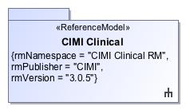

1. CIMI Clinical

|  |  |
| --- | --- |
| **Name** | CIMI Clinical |
| **Qualified Name** | CIMI Clinical |

# **Package CIMI Clinical::ClinicalStatement**

|  |  |
| --- | --- |
| **Name** | ClinicalStatement |
| **Qualified Name** | CIMI Clinical::ClinicalStatement |

## **Class** **ClinicalStatement**

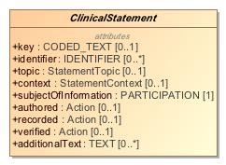

1. ClinicalStatement

|  |  |
| --- | --- |
| **Name** | ClinicalStatement |
| **Qualified Name** | CIMI Clinical::ClinicalStatement::ClinicalStatement |
| **Visibility** | public |
| **Abstract** | true |
| **Base Classifier** | * ENTRY |
| **Realized Interface** |  |

### **Attribute Detail**

#### additionalText

|  |  |
| --- | --- |
| **Type** | TEXT |
| **Default Value** |  |
| **Visibility** | public |
| **Multiplicity** | 0..* |
| **Definition** |  |

#### associatedWith

|  |  |
| --- | --- |
| **Type** | ClinicalStatement |
| **Default Value** |  |
| **Visibility** | public |
| **Multiplicity** | 0..* |
| **Definition** |  |

#### authored

|  |  |
| --- | --- |
| **Type** | Action |
| **Default Value** |  |
| **Visibility** | public |
| **Multiplicity** | 0..1 |
| **Definition** |  |

#### context

|  |  |
| --- | --- |
| **Type** | StatementContext |
| **Default Value** |  |
| **Visibility** | public |
| **Multiplicity** | 0..1 |
| **Definition** |  |

#### identifier

|  |  |
| --- | --- |
| **Type** | IDENTIFIER |
| **Default Value** |  |
| **Visibility** | public |
| **Multiplicity** | 0..* |
| **Definition** |  |

#### key

|  |  |
| --- | --- |
| **Type** | CODED_TEXT |
| **Default Value** |  |
| **Visibility** | public |
| **Multiplicity** | 0..1 |
| **Definition** |  |

#### recorded

|  |  |
| --- | --- |
| **Type** | Action |
| **Default Value** |  |
| **Visibility** | public |
| **Multiplicity** | 0..1 |
| **Definition** |  |

#### subjectOfInformation

|  |  |
| --- | --- |
| **Type** | PARTICIPATION |
| **Default Value** |  |
| **Visibility** | public |
| **Multiplicity** | 1 |
| **Definition** |  |

#### topic

|  |  |
| --- | --- |
| **Type** | StatementTopic |
| **Default Value** |  |
| **Visibility** | public |
| **Multiplicity** | 0..1 |
| **Definition** |  |

#### verified

|  |  |
| --- | --- |
| **Type** | Action |
| **Default Value** |  |
| **Visibility** | public |
| **Multiplicity** | 0..1 |
| **Definition** |  |

### **Relation Detail**

#### Association

|  |  |
| --- | --- |
| **Name** |  |
| **Related Element** | * Assertion |

|  |  |
| --- | --- |
| **Name** |  |
| **Related Element** |  |

|  |  |
| --- | --- |
| **Name** |  |
| **Related Element** | * Mapping |

|  |  |
| --- | --- |
| **Name** |  |
| **Related Element** | * RelatedClinicalStatement |

|  |  |
| --- | --- |
| **Name** |  |
| **Related Element** | * Mapping |

|  |  |
| --- | --- |
| **Name** |  |
| **Related Element** | * Provenance |

#### Generalization

|  |  |
| --- | --- |
| **Name** |  |
| **Related Element** | * CompoundClinicalStatement |

|  |  |
| --- | --- |
| **Name** |  |
| **Related Element** | * ENTRY |

|  |  |
| --- | --- |
| **Name** |  |
| **Related Element** | * IndivisibleClinicalStatement |

## **Class** **CompoundClinicalStatement**

1917427250.jpg

1. CompoundClinicalStatement

|  |  |
| --- | --- |
| **Name** | CompoundClinicalStatement |
| **Qualified Name** | CIMI Clinical::ClinicalStatement::CompoundClinicalStatement |
| **Visibility** | public |
| **Abstract** | false |
| **Base Classifier** | * ClinicalStatement * COMPOUND_ENTRY |
| **Realized Interface** |  |

### **Relation Detail**

#### Generalization

|  |  |
| --- | --- |
| **Name** |  |
| **Related Element** | * ClinicalStatement |

|  |  |
| --- | --- |
| **Name** |  |
| **Related Element** | * COMPOUND_ENTRY |

## **Class** **IndivisibleClinicalStatement**

269038031.jpg

1. IndivisibleClinicalStatement

|  |  |
| --- | --- |
| **Name** | IndivisibleClinicalStatement |
| **Qualified Name** | CIMI Clinical::ClinicalStatement::IndivisibleClinicalStatement |
| **Visibility** | public |
| **Abstract** | false |
| **Base Classifier** | * ClinicalStatement * INDIVISIBLE_ENTRY |
| **Realized Interface** |  |

### **Relation Detail**

#### Generalization

|  |  |
| --- | --- |
| **Name** |  |
| **Related Element** | * INDIVISIBLE_ENTRY |

|  |  |
| --- | --- |
| **Name** |  |
| **Related Element** | * ClinicalStatement |

# **Package CIMI Clinical::Data Structure**

|  |  |
| --- | --- |
| **Name** | Data Structure |
| **Qualified Name** | CIMI Clinical::Data Structure |

## **Class** **Absent**

2060831585.jpg

1. Absent

|  |  |
| --- | --- |
| **Name** | Absent |
| **Qualified Name** | CIMI Clinical::Data Structure::Absent |
| **Visibility** | public |
| **Abstract** | false |
| **Base Classifier** | * PresenceAbsenceContext |
| **Realized Interface** |  |

### **Relation Detail**

#### Generalization

|  |  |
| --- | --- |
| **Name** |  |
| **Related Element** | * PresenceAbsenceContext |

## **Class** **Act**

-518662276.jpg

1. Act

|  |  |
| --- | --- |
| **Name** | Act |
| **Qualified Name** | CIMI Clinical::Data Structure::Act |
| **Visibility** | public |
| **Abstract** | true |
| **Base Classifier** | * StatementTopic |
| **Realized Interface** |  |

### **Relation Detail**

#### Generalization

|  |  |
| --- | --- |
| **Name** |  |
| **Related Element** | * Procedure |

|  |  |
| --- | --- |
| **Name** |  |
| **Related Element** | * StatementTopic |

## **Class** **Action**

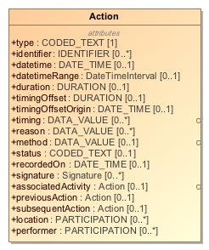

1. Action

|  |  |
| --- | --- |
| **Name** | Action |
| **Qualified Name** | CIMI Clinical::Data Structure::Action |
| **Visibility** | public |
| **Abstract** | false |
| **Base Classifier** | * CLUSTER |
| **Realized Interface** |  |

### **Attribute Detail**

#### associatedActivity

|  |  |
| --- | --- |
| **Type** | Action |
| **Default Value** |  |
| **Visibility** | public |
| **Multiplicity** | 0..1 |
| **Definition** |  |

#### datetime

|  |  |
| --- | --- |
| **Type** | DATE_TIME |
| **Default Value** |  |
| **Visibility** | public |
| **Multiplicity** | 0..1 |
| **Definition** |  |

#### datetimeRange

|  |  |
| --- | --- |
| **Type** | DateTimeInterval |
| **Default Value** |  |
| **Visibility** | public |
| **Multiplicity** | 0..1 |
| **Definition** |  |

#### duration

|  |  |
| --- | --- |
| **Type** | DURATION |
| **Default Value** |  |
| **Visibility** | public |
| **Multiplicity** | 0..1 |
| **Definition** |  |

#### identifier

|  |  |
| --- | --- |
| **Type** | IDENTIFIER |
| **Default Value** |  |
| **Visibility** | public |
| **Multiplicity** | 0..* |
| **Definition** |  |

#### location

|  |  |
| --- | --- |
| **Type** | PARTICIPATION |
| **Default Value** |  |
| **Visibility** | public |
| **Multiplicity** | 0..* |
| **Definition** |  |

#### method

This component captures what method used in Attribution models.   
   
For instance, in Verified, it captures how verification is achieved (verbal, written, telephone, etc.).

|  |  |
| --- | --- |
| **Type** | DATA_VALUE |
| **Default Value** |  |
| **Visibility** | public |
| **Multiplicity** | 0..1 |
| **Definition** | This component captures what method used in Attribution models.    For instance, in Verified, it captures how verification is achieved (verbal, written, telephone, etc.). |

#### performer

|  |  |
| --- | --- |
| **Type** | PARTICIPATION |
| **Default Value** |  |
| **Visibility** | public |
| **Multiplicity** | 0..* |
| **Definition** |  |

#### previousAction

|  |  |
| --- | --- |
| **Type** | Action |
| **Default Value** |  |
| **Visibility** | public |
| **Multiplicity** | 0..1 |
| **Definition** |  |

#### reason

|  |  |
| --- | --- |
| **Type** | DATA_VALUE |
| **Default Value** |  |
| **Visibility** | public |
| **Multiplicity** | 0..* |
| **Definition** |  |

#### recordedOn

|  |  |
| --- | --- |
| **Type** | DATE_TIME |
| **Default Value** |  |
| **Visibility** | public |
| **Multiplicity** | 0..1 |
| **Definition** |  |

#### signature

|  |  |
| --- | --- |
| **Type** | Signature |
| **Default Value** |  |
| **Visibility** | public |
| **Multiplicity** | 0..* |
| **Definition** |  |

#### status

|  |  |
| --- | --- |
| **Type** | CODED_TEXT |
| **Default Value** |  |
| **Visibility** | public |
| **Multiplicity** | 0..1 |
| **Definition** |  |

#### subsequentAction

|  |  |
| --- | --- |
| **Type** | Action |
| **Default Value** |  |
| **Visibility** | public |
| **Multiplicity** | 0..1 |
| **Definition** |  |

#### timing

|  |  |
| --- | --- |
| **Type** | DATA_VALUE |
| **Default Value** |  |
| **Visibility** | public |
| **Multiplicity** | 0..* |
| **Definition** |  |

#### timingOffset

|  |  |
| --- | --- |
| **Type** | DURATION |
| **Default Value** |  |
| **Visibility** | public |
| **Multiplicity** | 0..1 |
| **Definition** |  |

#### timingOffsetOrigin

|  |  |
| --- | --- |
| **Type** | DATE_TIME |
| **Default Value** |  |
| **Visibility** | public |
| **Multiplicity** | 0..1 |
| **Definition** |  |

#### type

|  |  |
| --- | --- |
| **Type** | CODED_TEXT |
| **Default Value** |  |
| **Visibility** | public |
| **Multiplicity** | 1 |
| **Definition** |  |

### **Relation Detail**

#### Generalization

|  |  |
| --- | --- |
| **Name** |  |
| **Related Element** | * CLUSTER |

|  |  |
| --- | --- |
| **Name** |  |
| **Related Element** | * Encounter |

|  |  |
| --- | --- |
| **Name** |  |
| **Related Element** | * SpecimenCollection |

## **Class** **ActionContext**

The ActionContext class aligns with the SNOMED Situations with Explicit Context and provides the context for the topic of a clinical statement. For instance, a statement about a procedure may specify that the procedure has been proposed, ordered, planned, performed or possibly not performed. Note that the action context provides the expressivity required to specify that an act was not done. By default, the negation applies to the conjunction of the stated attribute in the instance.

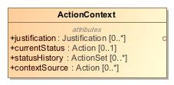

1. ActionContext

|  |  |
| --- | --- |
| **Name** | ActionContext |
| **Qualified Name** | CIMI Clinical::Data Structure::ActionContext |
| **Visibility** | public |
| **Abstract** | false |
| **Base Classifier** | * StatementContext |
| **Realized Interface** |  |

### **Attribute Detail**

#### contextSource

The source for the context such as the who, what, when, where, how (e.g., origination mode) responsible for proposing, planning, ordering and authorizing, etc... Note that one may also use provenance if provenance information is preferred to be external to the resource.

|  |  |
| --- | --- |
| **Type** | Action |
| **Default Value** |  |
| **Visibility** | public |
| **Multiplicity** | 0..* |
| **Definition** | The source for the context such as the who, what, when, where, how (e.g., origination mode) responsible for proposing, planning, ordering and authorizing, etc... Note that one may also use provenance if provenance information is preferred to be external to the resource. |

#### currentStatus

The status of an action. It is expected that the range of values for statusCode (i.e., the value set) will vary by the subtypes of Action. For example, Proposal might have one of its status value as Declined.

|  |  |
| --- | --- |
| **Type** | Action |
| **Default Value** |  |
| **Visibility** | public |
| **Multiplicity** | 0..1 |
| **Definition** | The status of an action. It is expected that the range of values for statusCode (i.e., the value set) will vary by the subtypes of Action. For example, Proposal might have one of its status value as Declined. |

#### justification

Reason or justification for the action. Reasons may also be specified for not performing an action.

|  |  |
| --- | --- |
| **Type** | Justification |
| **Default Value** |  |
| **Visibility** | public |
| **Multiplicity** | 0..* |
| **Definition** | Reason or justification for the action. Reasons may also be specified for not performing an action. |

#### statusHistory

The past statuses of this action, e.g., an order may evolve from draft to placed to in progress to completed or canceled.

|  |  |
| --- | --- |
| **Type** | ActionSet |
| **Default Value** |  |
| **Visibility** | public |
| **Multiplicity** | 0..* |
| **Definition** | The past statuses of this action, e.g., an order may evolve from draft to placed to in progress to completed or canceled. |

### **Relation Detail**

#### Generalization

|  |  |
| --- | --- |
| **Name** |  |
| **Related Element** | * StatementContext |

|  |  |
| --- | --- |
| **Name** |  |
| **Related Element** | * ProposedAgainst |

|  |  |
| --- | --- |
| **Name** |  |
| **Related Element** | * Ordered |

|  |  |
| --- | --- |
| **Name** |  |
| **Related Element** | * Proposed |

|  |  |
| --- | --- |
| **Name** |  |
| **Related Element** | * Performed |

|  |  |
| --- | --- |
| **Name** |  |
| **Related Element** | * Planned |

|  |  |
| --- | --- |
| **Name** |  |
| **Related Element** | * NotPerformed |

## **Class** **ActionSet**

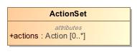

1. ActionSet

|  |  |
| --- | --- |
| **Name** | ActionSet |
| **Qualified Name** | CIMI Clinical::Data Structure::ActionSet |
| **Visibility** | public |
| **Abstract** | false |
| **Base Classifier** | * CLUSTER |
| **Realized Interface** |  |

### **Attribute Detail**

#### actions

|  |  |
| --- | --- |
| **Type** | Action |
| **Default Value** |  |
| **Visibility** | public |
| **Multiplicity** | 0..* |
| **Definition** |  |

### **Relation Detail**

#### Generalization

|  |  |
| --- | --- |
| **Name** |  |
| **Related Element** | * CLUSTER |

## **Class** **ActorName**

800985597.jpg

1. ActorName

|  |  |
| --- | --- |
| **Name** | ActorName |
| **Qualified Name** | CIMI Clinical::Data Structure::ActorName |
| **Visibility** | public |
| **Abstract** | true |
| **Base Classifier** | * PartyName |
| **Realized Interface** |  |

### **Relation Detail**

#### Generalization

|  |  |
| --- | --- |
| **Name** |  |
| **Related Element** | * PartyName |

|  |  |
| --- | --- |
| **Name** |  |
| **Related Element** | * OrganizationName |

|  |  |
| --- | --- |
| **Name** |  |
| **Related Element** | * PersonName |

## **Class** **Address**

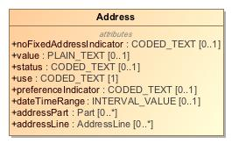

1. Address

|  |  |
| --- | --- |
| **Name** | Address |
| **Qualified Name** | CIMI Clinical::Data Structure::Address |
| **Visibility** | public |
| **Abstract** | false |
| **Base Classifier** | * CLUSTER |
| **Realized Interface** |  |

### **Attribute Detail**

#### addressLine

|  |  |
| --- | --- |
| **Type** | AddressLine |
| **Default Value** |  |
| **Visibility** | public |
| **Multiplicity** | 0..* |
| **Definition** |  |

#### addressPart

|  |  |
| --- | --- |
| **Type** | Part |
| **Default Value** |  |
| **Visibility** | public |
| **Multiplicity** | 0..* |
| **Definition** |  |

#### dateTimeRange

|  |  |
| --- | --- |
| **Type** | INTERVAL_VALUE |
| **Default Value** |  |
| **Visibility** | public |
| **Multiplicity** | 0..1 |
| **Definition** |  |

#### noFixedAddressIndicator

|  |  |
| --- | --- |
| **Type** | CODED_TEXT |
| **Default Value** |  |
| **Visibility** | public |
| **Multiplicity** | 0..1 |
| **Definition** |  |

#### preferenceIndicator

|  |  |
| --- | --- |
| **Type** | CODED_TEXT |
| **Default Value** |  |
| **Visibility** | public |
| **Multiplicity** | 0..1 |
| **Definition** |  |

#### status

|  |  |
| --- | --- |
| **Type** | CODED_TEXT |
| **Default Value** |  |
| **Visibility** | public |
| **Multiplicity** | 0..1 |
| **Definition** |  |

#### use

|  |  |
| --- | --- |
| **Type** | CODED_TEXT |
| **Default Value** |  |
| **Visibility** | public |
| **Multiplicity** | 1 |
| **Definition** |  |

#### value

|  |  |
| --- | --- |
| **Type** | PLAIN_TEXT |
| **Default Value** |  |
| **Visibility** | public |
| **Multiplicity** | 0..1 |
| **Definition** |  |

### **Relation Detail**

#### Generalization

|  |  |
| --- | --- |
| **Name** |  |
| **Related Element** | * CLUSTER |

## **Class** **AddressLine**

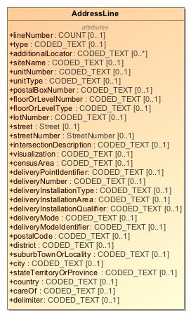

1. AddressLine

|  |  |
| --- | --- |
| **Name** | AddressLine |
| **Qualified Name** | CIMI Clinical::Data Structure::AddressLine |
| **Visibility** | public |
| **Abstract** | false |
| **Base Classifier** | * CLUSTER |
| **Realized Interface** |  |

### **Attribute Detail**

#### additionalLocator

|  |  |
| --- | --- |
| **Type** | CODED_TEXT |
| **Default Value** |  |
| **Visibility** | public |
| **Multiplicity** | 0..* |
| **Definition** |  |

#### careOf

|  |  |
| --- | --- |
| **Type** | CODED_TEXT |
| **Default Value** |  |
| **Visibility** | public |
| **Multiplicity** | 0..1 |
| **Definition** |  |

#### censusArea

|  |  |
| --- | --- |
| **Type** | CODED_TEXT |
| **Default Value** |  |
| **Visibility** | public |
| **Multiplicity** | 0..1 |
| **Definition** |  |

#### city

|  |  |
| --- | --- |
| **Type** | CODED_TEXT |
| **Default Value** |  |
| **Visibility** | public |
| **Multiplicity** | 0..1 |
| **Definition** |  |

#### country

|  |  |
| --- | --- |
| **Type** | CODED_TEXT |
| **Default Value** |  |
| **Visibility** | public |
| **Multiplicity** | 0..1 |
| **Definition** |  |

#### delimiter

|  |  |
| --- | --- |
| **Type** | CODED_TEXT |
| **Default Value** |  |
| **Visibility** | public |
| **Multiplicity** | 0..1 |
| **Definition** |  |

#### deliveryInstallationArea

|  |  |
| --- | --- |
| **Type** | CODED_TEXT |
| **Default Value** |  |
| **Visibility** | public |
| **Multiplicity** | 0..1 |
| **Definition** |  |

#### deliveryInstallationQualifier

|  |  |
| --- | --- |
| **Type** | CODED_TEXT |
| **Default Value** |  |
| **Visibility** | public |
| **Multiplicity** | 0..1 |
| **Definition** |  |

#### deliveryInstallationType

|  |  |
| --- | --- |
| **Type** | CODED_TEXT |
| **Default Value** |  |
| **Visibility** | public |
| **Multiplicity** | 0..1 |
| **Definition** |  |

#### deliveryMode

|  |  |
| --- | --- |
| **Type** | CODED_TEXT |
| **Default Value** |  |
| **Visibility** | public |
| **Multiplicity** | 0..1 |
| **Definition** |  |

#### deliveryModeIdentifier

|  |  |
| --- | --- |
| **Type** | CODED_TEXT |
| **Default Value** |  |
| **Visibility** | public |
| **Multiplicity** | 0..1 |
| **Definition** |  |

#### deliveryNumber

|  |  |
| --- | --- |
| **Type** | CODED_TEXT |
| **Default Value** |  |
| **Visibility** | public |
| **Multiplicity** | 0..1 |
| **Definition** |  |

#### deliveryPointIdentifier

|  |  |
| --- | --- |
| **Type** | CODED_TEXT |
| **Default Value** |  |
| **Visibility** | public |
| **Multiplicity** | 0..1 |
| **Definition** |  |

#### district

|  |  |
| --- | --- |
| **Type** | CODED_TEXT |
| **Default Value** |  |
| **Visibility** | public |
| **Multiplicity** | 0..1 |
| **Definition** |  |

#### floorOrLevelNumber

|  |  |
| --- | --- |
| **Type** | CODED_TEXT |
| **Default Value** |  |
| **Visibility** | public |
| **Multiplicity** | 0..1 |
| **Definition** |  |

#### floorOrLevelType

|  |  |
| --- | --- |
| **Type** | CODED_TEXT |
| **Default Value** |  |
| **Visibility** | public |
| **Multiplicity** | 0..1 |
| **Definition** |  |

#### intersectionDescription

|  |  |
| --- | --- |
| **Type** | CODED_TEXT |
| **Default Value** |  |
| **Visibility** | public |
| **Multiplicity** | 0..1 |
| **Definition** |  |

#### lineNumber

|  |  |
| --- | --- |
| **Type** | COUNT |
| **Default Value** |  |
| **Visibility** | public |
| **Multiplicity** | 0..1 |
| **Definition** |  |

#### lotNumber

|  |  |
| --- | --- |
| **Type** | CODED_TEXT |
| **Default Value** |  |
| **Visibility** | public |
| **Multiplicity** | 0..1 |
| **Definition** |  |

#### postalBoxNumber

|  |  |
| --- | --- |
| **Type** | CODED_TEXT |
| **Default Value** |  |
| **Visibility** | public |
| **Multiplicity** | 0..1 |
| **Definition** |  |

#### postalCode

|  |  |
| --- | --- |
| **Type** | CODED_TEXT |
| **Default Value** |  |
| **Visibility** | public |
| **Multiplicity** | 0..1 |
| **Definition** |  |

#### siteName

|  |  |
| --- | --- |
| **Type** | CODED_TEXT |
| **Default Value** |  |
| **Visibility** | public |
| **Multiplicity** | 0..1 |
| **Definition** |  |

#### stateTerritoryOrProvince

|  |  |
| --- | --- |
| **Type** | CODED_TEXT |
| **Default Value** |  |
| **Visibility** | public |
| **Multiplicity** | 0..1 |
| **Definition** |  |

#### street

|  |  |
| --- | --- |
| **Type** | Street |
| **Default Value** |  |
| **Visibility** | public |
| **Multiplicity** | 0..1 |
| **Definition** |  |

#### streetNumber

|  |  |
| --- | --- |
| **Type** | StreetNumber |
| **Default Value** |  |
| **Visibility** | public |
| **Multiplicity** | 0..1 |
| **Definition** |  |

#### suburbTownOrLocality

|  |  |
| --- | --- |
| **Type** | CODED_TEXT |
| **Default Value** |  |
| **Visibility** | public |
| **Multiplicity** | 0..1 |
| **Definition** |  |

#### type

|  |  |
| --- | --- |
| **Type** | CODED_TEXT |
| **Default Value** |  |
| **Visibility** | public |
| **Multiplicity** | 0..1 |
| **Definition** |  |

#### unitNumber

|  |  |
| --- | --- |
| **Type** | CODED_TEXT |
| **Default Value** |  |
| **Visibility** | public |
| **Multiplicity** | 0..1 |
| **Definition** |  |

#### unitType

|  |  |
| --- | --- |
| **Type** | CODED_TEXT |
| **Default Value** |  |
| **Visibility** | public |
| **Multiplicity** | 0..1 |
| **Definition** |  |

#### visualization

|  |  |
| --- | --- |
| **Type** | CODED_TEXT |
| **Default Value** |  |
| **Visibility** | public |
| **Multiplicity** | 0..1 |
| **Definition** |  |

### **Relation Detail**

#### Generalization

|  |  |
| --- | --- |
| **Name** |  |
| **Related Element** | * CLUSTER |

## **Class** **AnatomicalLocation**

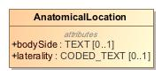

1. AnatomicalLocation

|  |  |
| --- | --- |
| **Name** | AnatomicalLocation |
| **Qualified Name** | CIMI Clinical::Data Structure::AnatomicalLocation |
| **Visibility** | public |
| **Abstract** | false |
| **Base Classifier** | * MaterialEntity |
| **Realized Interface** |  |

### **Attribute Detail**

#### bodySide

|  |  |
| --- | --- |
| **Type** | TEXT |
| **Default Value** |  |
| **Visibility** | public |
| **Multiplicity** | 0..1 |
| **Definition** |  |

#### laterality

|  |  |
| --- | --- |
| **Type** | CODED_TEXT |
| **Default Value** |  |
| **Visibility** | public |
| **Multiplicity** | 0..1 |
| **Definition** |  |

### **Relation Detail**

#### Generalization

|  |  |
| --- | --- |
| **Name** |  |
| **Related Element** | * MaterialEntity |

## **Class** **Assertion**

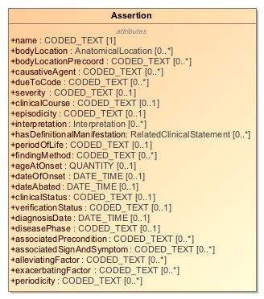

1. Assertion

|  |  |
| --- | --- |
| **Name** | Assertion |
| **Qualified Name** | CIMI Clinical::Data Structure::Assertion |
| **Visibility** | public |
| **Abstract** | false |
| **Base Classifier** | * Finding |
| **Realized Interface** |  |

### **Attribute Detail**

#### ageAtOnset

The age of the patient or subject at onset of the Condition. Note that this property could potentially be derived.

|  |  |
| --- | --- |
| **Type** | QUANTITY |
| **Default Value** |  |
| **Visibility** | public |
| **Multiplicity** | 0..1 |
| **Definition** | The age of the patient or subject at onset of the Condition. Note that this property could potentially be derived. |

#### alleviatingFactor

AlleviatingFactor this CEM model captures the action or intervention which makes a symptom less prevalent. Examples of data from the value set may include: rest, heat, ice, etc.

|  |  |
| --- | --- |
| **Type** | CODED_TEXT |
| **Default Value** |  |
| **Visibility** | public |
| **Multiplicity** | 0..* |
| **Definition** | AlleviatingFactor this CEM model captures the action or intervention which makes a symptom less prevalent. Examples of data from the value set may include: rest, heat, ice, etc. |

#### associatedPrecondition

AssociatedPrecondition describes the previously existing conditions or states that could effect a measurement or assesment. For example; a patients weight taken while clothed, a patients height with or without shoes, a patients blood pressure taken while standing or lying down.

|  |  |
| --- | --- |
| **Type** | CODED_TEXT |
| **Default Value** |  |
| **Visibility** | public |
| **Multiplicity** | 0..* |
| **Definition** | AssociatedPrecondition describes the previously existing conditions or states that could effect a measurement or assesment. For example; a patients weight taken while clothed, a patients height with or without shoes, a patients blood pressure taken while standing or lying down. |

#### associatedSignAndSymptom

AssociatedSignAndSymptom is a component which captures the accompanying physical observations captured by a clinician or subjective conditions experienced by a patient that are related to a medical condition.

|  |  |
| --- | --- |
| **Type** | CODED_TEXT |
| **Default Value** |  |
| **Visibility** | public |
| **Multiplicity** | 0..* |
| **Definition** | AssociatedSignAndSymptom is a component which captures the accompanying physical observations captured by a clinician or subjective conditions experienced by a patient that are related to a medical condition. |

#### bodyLocation

This attribute specifies the body site affected by a condition.

|  |  |
| --- | --- |
| **Type** | AnatomicalLocation |
| **Default Value** |  |
| **Visibility** | public |
| **Multiplicity** | 0..* |
| **Definition** | This attribute specifies the body site affected by a condition. |

#### bodyLocationPrecoord

This attribute specifies the body site affected by a condition.

|  |  |
| --- | --- |
| **Type** | CODED_TEXT |
| **Default Value** |  |
| **Visibility** | public |
| **Multiplicity** | 0..* |
| **Definition** | This attribute specifies the body site affected by a condition. |

#### causativeAgent

This attribute identifies the direct causative agent of a disease. It does not include vectors, e.g. a mosquito that transmits malaria.

|  |  |
| --- | --- |
| **Type** | CODED_TEXT |
| **Default Value** |  |
| **Visibility** | public |
| **Multiplicity** | 0..* |
| **Definition** | This attribute identifies the direct causative agent of a disease. It does not include vectors, e.g. a mosquito that transmits malaria. |

#### clinicalCourse

This attribute is used to represent both the course and onset of a disease. Many conditions with an acute (sudden) onset also have an acute (short duration) course. Few diseases with a chronic (long - term) course would need to have their onset sub-divided into rapid or gradual subtypes, and thus there is no clear need for separating the rapidity of onset from the duration of a disease; based on testing by implementers and modelers, a single attribute with values that combine these meanings has clearly been more reproducible  
and useful than two attributes that attempt to separate the meanings.

|  |  |
| --- | --- |
| **Type** | CODED_TEXT |
| **Default Value** |  |
| **Visibility** | public |
| **Multiplicity** | 0..1 |
| **Definition** | This attribute is used to represent both the course and onset of a disease. Many conditions with an acute (sudden) onset also have an acute (short duration) course. Few diseases with a chronic (long - term) course would need to have their onset sub-divided into rapid or gradual subtypes, and thus there is no clear need for separating the rapidity of onset from the duration of a disease; based on testing by implementers and modelers, a single attribute with values that combine these meanings has clearly been more reproducible and useful than two attributes that attempt to separate the meanings. |

#### clinicalStatus

Active  
Relapse  
Remission  
Resolved  
Confirmed,   
Error??  
Ruled out  
Unknown

|  |  |
| --- | --- |
| **Type** | CODED_TEXT |
| **Default Value** |  |
| **Visibility** | public |
| **Multiplicity** | 0..1 |
| **Definition** | Active Relapse Remission Resolved Confirmed,  Error?? Ruled out Unknown |

#### dateAbated

Date, if known, when clinical finding abated.

|  |  |
| --- | --- |
| **Type** | DATE_TIME |
| **Default Value** |  |
| **Visibility** | public |
| **Multiplicity** | 0..1 |
| **Definition** | Date, if known, when clinical finding abated. |

#### dateOfOnset

Set of values bounded by low and high  
If present, low SHALL have a lower value than high

|  |  |
| --- | --- |
| **Type** | DATE_TIME |
| **Default Value** |  |
| **Visibility** | public |
| **Multiplicity** | 0..1 |
| **Definition** | Set of values bounded by low and high If present, low SHALL have a lower value than high |

#### diagnosisDate

Date and time the health problem was diagnosed. Added for Public Health Reporting Initiative, 10/5/2012.

|  |  |
| --- | --- |
| **Type** | DATE_TIME |
| **Default Value** |  |
| **Visibility** | public |
| **Multiplicity** | 0..1 |
| **Definition** | Date and time the health problem was diagnosed. Added for Public Health Reporting Initiative, 10/5/2012. |

#### diseasePhase

Incubation period (exposed, asymptomatic)  
Prodromal (symptoms but not full disease breakout)  
Acute (full manifestation of disease)  
Convalescent

|  |  |
| --- | --- |
| **Type** | CODED_TEXT |
| **Default Value** |  |
| **Visibility** | public |
| **Multiplicity** | 0..1 |
| **Definition** | Incubation period (exposed, asymptomatic) Prodromal (symptoms but not full disease breakout) Acute (full manifestation of disease) Convalescent |

#### dueTo

This attribute is used to relate a |Clinical finding| directly to its cause. If a clinical finding merely predisposes to or worsens another disorder, rather than causing it directly, then the more general attribute | ASSOCIATED WITH | is used instead.

|  |  |
| --- | --- |
| **Type** | ClinicalStatement |
| **Default Value** |  |
| **Visibility** | public |
| **Multiplicity** | 0..* |
| **Definition** | This attribute is used to relate a |Clinical finding| directly to its cause. If a clinical finding merely predisposes to or worsens another disorder, rather than causing it directly, then the more general attribute | ASSOCIATED WITH | is used instead. |

#### dueToCode

|  |  |
| --- | --- |
| **Type** | CODED_TEXT |
| **Default Value** |  |
| **Visibility** | public |
| **Multiplicity** | 0..* |
| **Definition** |  |

#### episodicity

|EPISODICITY| is used to represent episodes of care provided by a physician or other care provider, typically a general practitioner, not episodes of disease experienced by the patient. See EPISODICITY no longer modeled in active content (7.1), regarding the origin of the attribute. For example, asthma with |EPISODICITY|=|  
first episode | represents the first time the patient presents to their health care provider with asthma. EPISODICITY is not used to model any concepts pre-coordinated in the International Release but it can still be used in post-coordination as a qualifier.

|  |  |
| --- | --- |
| **Type** | CODED_TEXT |
| **Default Value** |  |
| **Visibility** | public |
| **Multiplicity** | 0..1 |
| **Definition** | |EPISODICITY| is used to represent episodes of care provided by a physician or other care provider, typically a general practitioner, not episodes of disease experienced by the patient. See EPISODICITY no longer modeled in active content (7.1), regarding the origin of the attribute. For example, asthma with |EPISODICITY|=| first episode | represents the first time the patient presents to their health care provider with asthma. EPISODICITY is not used to model any concepts pre-coordinated in the International Release but it can still be used in post-coordination as a qualifier. |

#### exacerbatingFactor

ExacerbatingFactor model is a component model. This model holds a question in the code and holds a coded value (CD) answer from the value set referred to in data. For example, in the ExacerbatingFactor model the question is What is the exacerbating factor? and the coded answer from the ExacerbatingFactor VALUESET set can be activity, etc. ExacerbatingFactor by definition means an action, object, or something that makes a condition or problem worse.

|  |  |
| --- | --- |
| **Type** | CODED_TEXT |
| **Default Value** |  |
| **Visibility** | public |
| **Multiplicity** | 0..* |
| **Definition** | ExacerbatingFactor model is a component model. This model holds a question in the code and holds a coded value (CD) answer from the value set referred to in data. For example, in the ExacerbatingFactor model the question is What is the exacerbating factor? and the coded answer from the ExacerbatingFactor VALUESET set can be activity, etc. ExacerbatingFactor by definition means an action, object, or something that makes a condition or problem worse. |

#### findingMethod

This attribute specifies the means by which a clinical finding was determined.This attribute is frequently used in conjunction with |FINDING INFORMER|. Findings that specify that they were determined by examination of the patient (e.g. |On examination - ankle clonus (finding)|) should have a value for both |FINDING METHOD|  
and | FINDING INFORMER |.

|  |  |
| --- | --- |
| **Type** | CODED_TEXT |
| **Default Value** |  |
| **Visibility** | public |
| **Multiplicity** | 0..* |
| **Definition** | This attribute specifies the means by which a clinical finding was determined.This attribute is frequently used in conjunction with |FINDING INFORMER|. Findings that specify that they were determined by examination of the patient (e.g. |On examination - ankle clonus (finding)|) should have a value for both |FINDING METHOD| and | FINDING INFORMER |. |

#### hasDefinitionalManifestation

This attribute provides information about the underlying pathological process for a disorder, but only when the results of that process are not structural and cannot be represented by the |ASSOCIATED MORPHOLOGY| attribute.  
The values |Infectious process (qualifier value)| and its subtype |Parasitic process (qualifier value)| are included in the range for | PATHOLOGICAL PROCESS |. These were added to accommodate the change in the modeling of concepts in the |Infectious disease (disorder)| subhierarchy where the infectious aspect of the disease is represented using |PATHOLOGICAL PROCESS|.

|  |  |
| --- | --- |
| **Type** | RelatedClinicalStatement |
| **Default Value** |  |
| **Visibility** | public |
| **Multiplicity** | 0..* |
| **Definition** | This attribute provides information about the underlying pathological process for a disorder, but only when the results of that process are not structural and cannot be represented by the |ASSOCIATED MORPHOLOGY| attribute. The values |Infectious process (qualifier value)| and its subtype |Parasitic process (qualifier value)| are included in the range for | PATHOLOGICAL PROCESS |. These were added to accommodate the change in the modeling of concepts in the |Infectious disease (disorder)| subhierarchy where the infectious aspect of the disease is represented using |PATHOLOGICAL PROCESS|. |

#### interpretation

This attribute refers to the entity being evaluated or interpreted, when an evaluation, interpretation or “judgment” is intrinsic to the meaning of a concept. This attribute is usually grouped with the | HAS INTERPRETATION | attribute.

|  |  |
| --- | --- |
| **Type** | Interpretation |
| **Default Value** |  |
| **Visibility** | public |
| **Multiplicity** | 0..* |
| **Definition** | This attribute refers to the entity being evaluated or interpreted, when an evaluation, interpretation or “judgment” is intrinsic to the meaning of a concept. This attribute is usually grouped with the | HAS INTERPRETATION | attribute. |

#### name

|  |  |
| --- | --- |
| **Type** | CODED_TEXT |
| **Default Value** |  |
| **Visibility** | public |
| **Multiplicity** | 1 |
| **Definition** |  |

#### periodicity

Periodicity, the length of time from one occurrence to the next (e.g., intermittent, weekly, continuous).

|  |  |
| --- | --- |
| **Type** | CODED_TEXT |
| **Default Value** |  |
| **Visibility** | public |
| **Multiplicity** | 0..* |
| **Definition** | Periodicity, the length of time from one occurrence to the next (e.g., intermittent, weekly, continuous). |

#### periodOfLife

This attribute provides information about the underlying pathological process for a disorder, but only when the results of that process are not structural and cannot be represented by the |ASSOCIATED MORPHOLOGY| attribute.  
The values |Infectious process (qualifier value)| and its subtype |Parasitic process (qualifier value)| are included in the range for | PATHOLOGICAL PROCESS |. These were added to accommodate the change in the modeling of concepts in the |Infectious disease (disorder)| subhierarchy where the infectious aspect of the disease is represented using |PATHOLOGICAL PROCESS|.

|  |  |
| --- | --- |
| **Type** | CODED_TEXT |
| **Default Value** |  |
| **Visibility** | public |
| **Multiplicity** | 0..1 |
| **Definition** | This attribute provides information about the underlying pathological process for a disorder, but only when the results of that process are not structural and cannot be represented by the |ASSOCIATED MORPHOLOGY| attribute. The values |Infectious process (qualifier value)| and its subtype |Parasitic process (qualifier value)| are included in the range for | PATHOLOGICAL PROCESS |. These were added to accommodate the change in the modeling of concepts in the |Infectious disease (disorder)| subhierarchy where the infectious aspect of the disease is represented using |PATHOLOGICAL PROCESS|. |

#### severity

This attribute is used to subclass a |Clinical finding| concept according to its severity; however, caution is  
encouraged because this use is said to be relative. By relative, it is meant that it is incorrect to assume that  
the same degree of disease intensity or hazard is implied for all |Clinical finding| to which this attribute is  
applied. There are three reasons.  
First, “severe” could be interpreted differently depending on what other values are available to choose for severity.Thus severity is relative to the other values in the value set presented to users. Consider the different meaning of severity in each of the following three sets of values:  
• mild / moderate / severe  
• minimal / mild / moderate / severe / very severe  
• mild / mild to moderate / moderate / moderate to severe / severe / life threatening / fatal  
Second, the severity is defined relative to the expected degree of intensity or hazard of the |Clinical finding| that is being qualified. A common cold has a baseline intensity or hazard much less than that of a more serious disease like lupus erythematosus or pneumonia; thus a severe cold might be considered less intense or hazardous than a mild pneumonia.  
Third, some disorders that are life-threatening do not ordinarily have a severity assigned to them. Cancer, for example, is generally not subclassed according to mild, moderate and severe types, but rather is subclassed according to stage or grade.

|  |  |
| --- | --- |
| **Type** | CODED_TEXT |
| **Default Value** |  |
| **Visibility** | public |
| **Multiplicity** | 0..1 |
| **Definition** | This attribute is used to subclass a |Clinical finding| concept according to its severity; however, caution is encouraged because this use is said to be relative. By relative, it is meant that it is incorrect to assume that the same degree of disease intensity or hazard is implied for all |Clinical finding| to which this attribute is applied. There are three reasons. First, “severe” could be interpreted differently depending on what other values are available to choose for severity.Thus severity is relative to the other values in the value set presented to users. Consider the different meaning of severity in each of the following three sets of values: • mild / moderate / severe • minimal / mild / moderate / severe / very severe • mild / mild to moderate / moderate / moderate to severe / severe / life threatening / fatal Second, the severity is defined relative to the expected degree of intensity or hazard of the |Clinical finding| that is being qualified. A common cold has a baseline intensity or hazard much less than that of a more serious disease like lupus erythematosus or pneumonia; thus a severe cold might be considered less intense or hazardous than a mild pneumonia. Third, some disorders that are life-threatening do not ordinarily have a severity assigned to them. Cancer, for example, is generally not subclassed according to mild, moderate and severe types, but rather is subclassed according to stage or grade. |

#### verificationStatus

The verification status to support or decline the clinical status of the condition or diagnosis.  
Provisional This is a tentative diagnosis - still a candidate that is under consideration.   
Differential One of a set of potential (and typically mutually exclusive) diagnosis asserted to further guide the diagnostic process and preliminary treatment.   
Confirmed There is sufficient diagnostic and/or clinical evidence to treat this as a confirmed condition.   
Refuted This condition has been ruled out by diagnostic and clinical evidence.   
entered-in-error Entered In Error The statement was entered in error and is not valid.   
Unknown The condition status is unknown. Note that "unknown" is a value of last resort and every attempt should be made to provide a meaningful value other than "unknown".

|  |  |
| --- | --- |
| **Type** | CODED_TEXT |
| **Default Value** |  |
| **Visibility** | public |
| **Multiplicity** | 0..1 |
| **Definition** | The verification status to support or decline the clinical status of the condition or diagnosis. Provisional This is a tentative diagnosis - still a candidate that is under consideration.  Differential One of a set of potential (and typically mutually exclusive) diagnosis asserted to further guide the diagnostic process and preliminary treatment.  Confirmed There is sufficient diagnostic and/or clinical evidence to treat this as a confirmed condition.  Refuted This condition has been ruled out by diagnostic and clinical evidence.  entered-in-error Entered In Error The statement was entered in error and is not valid.  Unknown The condition status is unknown. Note that "unknown" is a value of last resort and every attempt should be made to provide a meaningful value other than "unknown". |

### **Relation Detail**

#### Association

|  |  |
| --- | --- |
| **Name** |  |
| **Related Element** | * ClinicalStatement |

#### Generalization

|  |  |
| --- | --- |
| **Name** |  |
| **Related Element** | * Finding |

## **Class** **Device**

1541390522.jpg

1. Device

|  |  |
| --- | --- |
| **Name** | Device |
| **Qualified Name** | CIMI Clinical::Data Structure::Device |
| **Visibility** | public |
| **Abstract** | false |
| **Base Classifier** | * MaterialEntity |
| **Realized Interface** |  |

### **Relation Detail**

#### Generalization

|  |  |
| --- | --- |
| **Name** |  |
| **Related Element** | * MaterialEntity |

## **Class** **ElectronicContact**

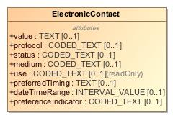

1. ElectronicContact

|  |  |
| --- | --- |
| **Name** | ElectronicContact |
| **Qualified Name** | CIMI Clinical::Data Structure::ElectronicContact |
| **Visibility** | public |
| **Abstract** | false |
| **Base Classifier** | * CLUSTER |
| **Realized Interface** |  |

### **Attribute Detail**

#### dateTimeRange

|  |  |
| --- | --- |
| **Type** | INTERVAL_VALUE |
| **Default Value** |  |
| **Visibility** | public |
| **Multiplicity** | 0..1 |
| **Definition** |  |

#### medium

|  |  |
| --- | --- |
| **Type** | CODED_TEXT |
| **Default Value** |  |
| **Visibility** | public |
| **Multiplicity** | 0..1 |
| **Definition** |  |

#### preferenceIndicator

|  |  |
| --- | --- |
| **Type** | CODED_TEXT |
| **Default Value** |  |
| **Visibility** | public |
| **Multiplicity** | 0..1 |
| **Definition** |  |

#### preferredTiming

|  |  |
| --- | --- |
| **Type** | TEXT |
| **Default Value** |  |
| **Visibility** | public |
| **Multiplicity** | 0..1 |
| **Definition** |  |

#### protocol

|  |  |
| --- | --- |
| **Type** | CODED_TEXT |
| **Default Value** |  |
| **Visibility** | public |
| **Multiplicity** | 0..1 |
| **Definition** |  |

#### status

|  |  |
| --- | --- |
| **Type** | CODED_TEXT |
| **Default Value** |  |
| **Visibility** | public |
| **Multiplicity** | 0..1 |
| **Definition** |  |

#### use

|  |  |
| --- | --- |
| **Type** | CODED_TEXT |
| **Default Value** |  |
| **Visibility** | public |
| **Multiplicity** | 0..1 |
| **Definition** |  |

#### value

|  |  |
| --- | --- |
| **Type** | TEXT |
| **Default Value** |  |
| **Visibility** | public |
| **Multiplicity** | 0..1 |
| **Definition** |  |

### **Relation Detail**

#### Generalization

|  |  |
| --- | --- |
| **Name** |  |
| **Related Element** | * CLUSTER |

## **Class** **Encounter**

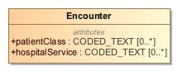

1. Encounter

|  |  |
| --- | --- |
| **Name** | Encounter |
| **Qualified Name** | CIMI Clinical::Data Structure::Encounter |
| **Visibility** | public |
| **Abstract** | false |
| **Base Classifier** | * Action |
| **Realized Interface** |  |

### **Attribute Detail**

#### hospitalService

|  |  |
| --- | --- |
| **Type** | CODED_TEXT |
| **Default Value** |  |
| **Visibility** | public |
| **Multiplicity** | 0..* |
| **Definition** |  |

#### patientClass

|  |  |
| --- | --- |
| **Type** | CODED_TEXT |
| **Default Value** |  |
| **Visibility** | public |
| **Multiplicity** | 0..* |
| **Definition** |  |

### **Relation Detail**

#### Generalization

|  |  |
| --- | --- |
| **Name** |  |
| **Related Element** | * Action |

## **Class** **EvaluationResult**

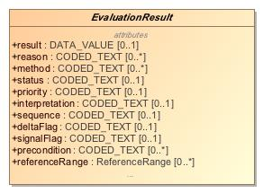

1. EvaluationResult

|  |  |
| --- | --- |
| **Name** | EvaluationResult |
| **Qualified Name** | CIMI Clinical::Data Structure::EvaluationResult |
| **Visibility** | public |
| **Abstract** | true |
| **Base Classifier** | * Finding |
| **Realized Interface** |  |

### **Attribute Detail**

#### conclusions

|  |  |
| --- | --- |
| **Type** | CODED_TEXT |
| **Default Value** |  |
| **Visibility** | public |
| **Multiplicity** | 0..* |
| **Definition** |  |

#### deltaFlag

Flag indicating whether there was a significant change from previous results

|  |  |
| --- | --- |
| **Type** | CODED_TEXT |
| **Default Value** |  |
| **Visibility** | public |
| **Multiplicity** | 0..1 |
| **Definition** | Flag indicating whether there was a significant change from previous results |

#### interpretation

Normal, abnormal, panic high, panic low, ...

|  |  |
| --- | --- |
| **Type** | CODED_TEXT |
| **Default Value** |  |
| **Visibility** | public |
| **Multiplicity** | 0..1 |
| **Definition** | Normal, abnormal, panic high, panic low, ... |

#### method

|  |  |
| --- | --- |
| **Type** | CODED_TEXT |
| **Default Value** |  |
| **Visibility** | public |
| **Multiplicity** | 0..* |
| **Definition** |  |

#### precondition

|  |  |
| --- | --- |
| **Type** | CODED_TEXT |
| **Default Value** |  |
| **Visibility** | public |
| **Multiplicity** | 0..* |
| **Definition** |  |

#### priority

|  |  |
| --- | --- |
| **Type** | CODED_TEXT |
| **Default Value** |  |
| **Visibility** | public |
| **Multiplicity** | 0..1 |
| **Definition** |  |

#### reason

|  |  |
| --- | --- |
| **Type** | CODED_TEXT |
| **Default Value** |  |
| **Visibility** | public |
| **Multiplicity** | 0..* |
| **Definition** |  |

#### referenceRange

|  |  |
| --- | --- |
| **Type** | ReferenceRange |
| **Default Value** |  |
| **Visibility** | public |
| **Multiplicity** | 0..* |
| **Definition** |  |

#### result

|  |  |
| --- | --- |
| **Type** | DATA_VALUE |
| **Default Value** |  |
| **Visibility** | public |
| **Multiplicity** | 0..1 |
| **Definition** |  |

#### sequence

|  |  |
| --- | --- |
| **Type** | CODED_TEXT |
| **Default Value** |  |
| **Visibility** | public |
| **Multiplicity** | 0..1 |
| **Definition** |  |

#### signalFlag

A code that indicates whether or not the result is outside the 'signal' range for this patient.  
  
Flag indicating whether this is a significant result that requires further attention (?)

|  |  |
| --- | --- |
| **Type** | CODED_TEXT |
| **Default Value** |  |
| **Visibility** | public |
| **Multiplicity** | 0..1 |
| **Definition** | A code that indicates whether or not the result is outside the 'signal' range for this patient.  Flag indicating whether this is a significant result that requires further attention (?) |

#### status

|  |  |
| --- | --- |
| **Type** | CODED_TEXT |
| **Default Value** |  |
| **Visibility** | public |
| **Multiplicity** | 0..1 |
| **Definition** |  |

### **Relation Detail**

#### Generalization

|  |  |
| --- | --- |
| **Name** |  |
| **Related Element** | * PhysicalEvaluationResult |

|  |  |
| --- | --- |
| **Name** |  |
| **Related Element** | * LaboratoryTestResult |

|  |  |
| --- | --- |
| **Name** |  |
| **Related Element** | * Finding |

## **Class** **Finding**

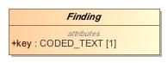

1. Finding

|  |  |
| --- | --- |
| **Name** | Finding |
| **Qualified Name** | CIMI Clinical::Data Structure::Finding |
| **Visibility** | public |
| **Abstract** | true |
| **Base Classifier** | * StatementTopic |
| **Realized Interface** |  |

### **Attribute Detail**

#### key

|  |  |
| --- | --- |
| **Type** | CODED_TEXT |
| **Default Value** |  |
| **Visibility** | public |
| **Multiplicity** | 1 |
| **Definition** |  |

### **Relation Detail**

#### Generalization

|  |  |
| --- | --- |
| **Name** |  |
| **Related Element** | * Assertion |

|  |  |
| --- | --- |
| **Name** |  |
| **Related Element** | * StatementTopic |

|  |  |
| --- | --- |
| **Name** |  |
| **Related Element** | * EvaluationResult |

## **Class** **FindingContext**

The FindingContext class aligns with the SNOMED Situations with Explicit Context for findings and provides the context for the topic of a clinical statement. For instance, a statement about findings may state that the finding was observed present or absent. By default, the negation applies to the conjunction of the stated attribute in the instance.

-1823786466.jpg

1. FindingContext

|  |  |
| --- | --- |
| **Name** | FindingContext |
| **Qualified Name** | CIMI Clinical::Data Structure::FindingContext |
| **Visibility** | public |
| **Abstract** | true |
| **Base Classifier** | * StatementContext |
| **Realized Interface** |  |

### **Relation Detail**

#### Generalization

|  |  |
| --- | --- |
| **Name** |  |
| **Related Element** | * StatementContext |

|  |  |
| --- | --- |
| **Name** |  |
| **Related Element** | * Risk |

|  |  |
| --- | --- |
| **Name** |  |
| **Related Element** | * PresenceAbsenceContext |

## **Class** **Interpretation**

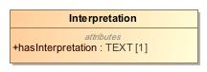

1. Interpretation

|  |  |
| --- | --- |
| **Name** | Interpretation |
| **Qualified Name** | CIMI Clinical::Data Structure::Interpretation |
| **Visibility** | public |
| **Abstract** | false |
| **Base Classifier** | * RelatedClinicalStatement |
| **Realized Interface** |  |

### **Attribute Detail**

#### hasInterpretation

|  |  |
| --- | --- |
| **Type** | TEXT |
| **Default Value** |  |
| **Visibility** | public |
| **Multiplicity** | 1 |
| **Definition** |  |

### **Relation Detail**

#### Generalization

|  |  |
| --- | --- |
| **Name** |  |
| **Related Element** | * RelatedClinicalStatement |

## **Class** **Justification**

Asserted clinical justification to perform or not perform an act such as a diagnostic test, a medication treatment, or a procedure.  
  
The justification can be specified as a code or as a clinical statement, e.g., code for diabetes (ICD-9-CM 250.0) or a Condition occurrence statement (with diabetes code) documented elsewhere in a patient's record.

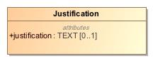

1. Justification

|  |  |
| --- | --- |
| **Name** | Justification |
| **Qualified Name** | CIMI Clinical::Data Structure::Justification |
| **Visibility** | public |
| **Abstract** | false |
| **Base Classifier** | * RelatedClinicalStatement |
| **Realized Interface** |  |

### **Attribute Detail**

#### justification

A code representing the justification. Typically, the code is for a condition that is suspected or is observed in a patient.

|  |  |
| --- | --- |
| **Type** | TEXT |
| **Default Value** |  |
| **Visibility** | public |
| **Multiplicity** | 0..1 |
| **Definition** | A code representing the justification. Typically, the code is for a condition that is suspected or is observed in a patient. |

### **Relation Detail**

#### Generalization

|  |  |
| --- | --- |
| **Name** |  |
| **Related Element** | * RelatedClinicalStatement |

## **Class** **KnownOrSuspectedPresent**

-1627835627.jpg

1. KnownOrSuspectedPresent

|  |  |
| --- | --- |
| **Name** | KnownOrSuspectedPresent |
| **Qualified Name** | CIMI Clinical::Data Structure::KnownOrSuspectedPresent |
| **Visibility** | public |
| **Abstract** | false |
| **Base Classifier** | * PresenceAbsenceContext |
| **Realized Interface** |  |

### **Relation Detail**

#### Generalization

|  |  |
| --- | --- |
| **Name** |  |
| **Related Element** | * PresenceAbsenceContext |

## **Class** **LaboratoryProcedure**

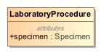

1. LaboratoryProcedure

|  |  |
| --- | --- |
| **Name** | LaboratoryProcedure |
| **Qualified Name** | CIMI Clinical::Data Structure::LaboratoryProcedure |
| **Visibility** | public |
| **Abstract** | false |
| **Base Classifier** | * Procedure |
| **Realized Interface** |  |

### **Attribute Detail**

#### specimen

Tissues, objects, or samples taken from the patient during the procedure including biopsies, aspiration fluid, or other samples sent for pathological analysis.

|  |  |
| --- | --- |
| **Type** | Specimen |
| **Default Value** |  |
| **Visibility** | public |
| **Multiplicity** |  |
| **Definition** | Tissues, objects, or samples taken from the patient during the procedure including biopsies, aspiration fluid, or other samples sent for pathological analysis. |

### **Relation Detail**

#### Generalization

|  |  |
| --- | --- |
| **Name** |  |
| **Related Element** | * Procedure |

## **Class** **LaboratoryTestResult**

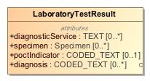

1. LaboratoryTestResult

|  |  |
| --- | --- |
| **Name** | LaboratoryTestResult |
| **Qualified Name** | CIMI Clinical::Data Structure::LaboratoryTestResult |
| **Visibility** | public |
| **Abstract** | false |
| **Base Classifier** | * EvaluationResult |
| **Realized Interface** |  |

### **Attribute Detail**

#### diagnosis

Lab result that is pathoneumonic for a disease

|  |  |
| --- | --- |
| **Type** | CODED_TEXT |
| **Default Value** |  |
| **Visibility** | public |
| **Multiplicity** | 0..* |
| **Definition** | Lab result that is pathoneumonic for a disease |

#### diagnosticService

|  |  |
| --- | --- |
| **Type** | TEXT |
| **Default Value** |  |
| **Visibility** | public |
| **Multiplicity** | 0..* |
| **Definition** |  |

#### poctIndicator

|  |  |
| --- | --- |
| **Type** | CODED_TEXT |
| **Default Value** |  |
| **Visibility** | public |
| **Multiplicity** | 0..1 |
| **Definition** |  |

#### specimen

|  |  |
| --- | --- |
| **Type** | Specimen |
| **Default Value** |  |
| **Visibility** | public |
| **Multiplicity** | 0..* |
| **Definition** |  |

### **Relation Detail**

#### Generalization

|  |  |
| --- | --- |
| **Name** |  |
| **Related Element** | * EvaluationResult |

## **Class** **Location**

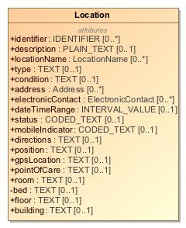

1. Location

|  |  |
| --- | --- |
| **Name** | Location |
| **Qualified Name** | CIMI Clinical::Data Structure::Location |
| **Visibility** | public |
| **Abstract** | false |
| **Base Classifier** | * CLUSTER |
| **Realized Interface** |  |

### **Attribute Detail**

#### address

|  |  |
| --- | --- |
| **Type** | Address |
| **Default Value** |  |
| **Visibility** | public |
| **Multiplicity** | 0..* |
| **Definition** |  |

#### bed

|  |  |
| --- | --- |
| **Type** | TEXT |
| **Default Value** |  |
| **Visibility** | private |
| **Multiplicity** | 0..1 |
| **Definition** |  |

#### building

|  |  |
| --- | --- |
| **Type** | TEXT |
| **Default Value** |  |
| **Visibility** | public |
| **Multiplicity** | 0..1 |
| **Definition** |  |

#### condition

|  |  |
| --- | --- |
| **Type** | TEXT |
| **Default Value** |  |
| **Visibility** | public |
| **Multiplicity** | 0..1 |
| **Definition** |  |

#### dateTimeRange

|  |  |
| --- | --- |
| **Type** | INTERVAL_VALUE |
| **Default Value** |  |
| **Visibility** | public |
| **Multiplicity** | 0..1 |
| **Definition** |  |

#### description

|  |  |
| --- | --- |
| **Type** | PLAIN_TEXT |
| **Default Value** |  |
| **Visibility** | public |
| **Multiplicity** | 0..1 |
| **Definition** |  |

#### directions

|  |  |
| --- | --- |
| **Type** | TEXT |
| **Default Value** |  |
| **Visibility** | public |
| **Multiplicity** | 0..1 |
| **Definition** |  |

#### electronicContact

|  |  |
| --- | --- |
| **Type** | ElectronicContact |
| **Default Value** |  |
| **Visibility** | public |
| **Multiplicity** | 0..* |
| **Definition** |  |

#### floor

|  |  |
| --- | --- |
| **Type** | TEXT |
| **Default Value** |  |
| **Visibility** | public |
| **Multiplicity** | 0..1 |
| **Definition** |  |

#### gpsLocation

|  |  |
| --- | --- |
| **Type** | TEXT |
| **Default Value** |  |
| **Visibility** | public |
| **Multiplicity** | 0..1 |
| **Definition** |  |

#### identifier

|  |  |
| --- | --- |
| **Type** | IDENTIFIER |
| **Default Value** |  |
| **Visibility** | public |
| **Multiplicity** | 0..* |
| **Definition** |  |

#### locationName

|  |  |
| --- | --- |
| **Type** | LocationName |
| **Default Value** |  |
| **Visibility** | public |
| **Multiplicity** | 0..* |
| **Definition** |  |

#### mobileIndicator

|  |  |
| --- | --- |
| **Type** | CODED_TEXT |
| **Default Value** |  |
| **Visibility** | public |
| **Multiplicity** | 0..1 |
| **Definition** |  |

#### pointOfCare

|  |  |
| --- | --- |
| **Type** | TEXT |
| **Default Value** |  |
| **Visibility** | public |
| **Multiplicity** | 0..1 |
| **Definition** |  |

#### position

|  |  |
| --- | --- |
| **Type** | TEXT |
| **Default Value** |  |
| **Visibility** | public |
| **Multiplicity** | 0..1 |
| **Definition** |  |

#### room

|  |  |
| --- | --- |
| **Type** | TEXT |
| **Default Value** |  |
| **Visibility** | public |
| **Multiplicity** | 0..1 |
| **Definition** |  |

#### status

|  |  |
| --- | --- |
| **Type** | CODED_TEXT |
| **Default Value** |  |
| **Visibility** | public |
| **Multiplicity** | 0..1 |
| **Definition** |  |

#### type

|  |  |
| --- | --- |
| **Type** | TEXT |
| **Default Value** |  |
| **Visibility** | public |
| **Multiplicity** | 0..1 |
| **Definition** |  |

### **Relation Detail**

#### Generalization

|  |  |
| --- | --- |
| **Name** |  |
| **Related Element** | * CLUSTER |

## **Class** **LocationName**

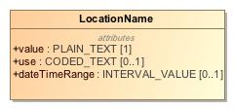

1. LocationName

|  |  |
| --- | --- |
| **Name** | LocationName |
| **Qualified Name** | CIMI Clinical::Data Structure::LocationName |
| **Visibility** | public |
| **Abstract** | false |
| **Base Classifier** | * CLUSTER |
| **Realized Interface** |  |

### **Attribute Detail**

#### dateTimeRange

|  |  |
| --- | --- |
| **Type** | INTERVAL_VALUE |
| **Default Value** |  |
| **Visibility** | public |
| **Multiplicity** | 0..1 |
| **Definition** |  |

#### use

|  |  |
| --- | --- |
| **Type** | CODED_TEXT |
| **Default Value** |  |
| **Visibility** | public |
| **Multiplicity** | 0..1 |
| **Definition** |  |

#### value

|  |  |
| --- | --- |
| **Type** | PLAIN_TEXT |
| **Default Value** |  |
| **Visibility** | public |
| **Multiplicity** | 1 |
| **Definition** |  |

### **Relation Detail**

#### Generalization

|  |  |
| --- | --- |
| **Name** |  |
| **Related Element** | * CLUSTER |

## **Class** **Mapping**

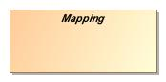

1. Mapping

|  |  |
| --- | --- |
| **Name** | Mapping |
| **Qualified Name** | CIMI Clinical::Data Structure::Mapping |
| **Visibility** | public |
| **Abstract** | true |
| **Base Classifier** |  |
| **Realized Interface** |  |

### **Attribute Detail**

#### source

|  |  |
| --- | --- |
| **Type** | ClinicalStatement |
| **Default Value** |  |
| **Visibility** | public |
| **Multiplicity** | 1 |
| **Definition** |  |

#### target

|  |  |
| --- | --- |
| **Type** | ClinicalStatement |
| **Default Value** |  |
| **Visibility** | public |
| **Multiplicity** | 1 |
| **Definition** |  |

### **Relation Detail**

#### Association

|  |  |
| --- | --- |
| **Name** |  |
| **Related Element** | * ClinicalStatement |

|  |  |
| --- | --- |
| **Name** |  |
| **Related Element** | * ClinicalStatement |

## **Class** **MaterialEntity**

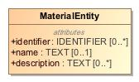

1. MaterialEntity

|  |  |
| --- | --- |
| **Name** | MaterialEntity |
| **Qualified Name** | CIMI Clinical::Data Structure::MaterialEntity |
| **Visibility** | public |
| **Abstract** | false |
| **Base Classifier** | * CLUSTER |
| **Realized Interface** |  |

### **Attribute Detail**

#### description

|  |  |
| --- | --- |
| **Type** | TEXT |
| **Default Value** |  |
| **Visibility** | public |
| **Multiplicity** | 0..* |
| **Definition** |  |

#### identifier

|  |  |
| --- | --- |
| **Type** | IDENTIFIER |
| **Default Value** |  |
| **Visibility** | public |
| **Multiplicity** | 0..* |
| **Definition** |  |

#### name

|  |  |
| --- | --- |
| **Type** | TEXT |
| **Default Value** |  |
| **Visibility** | public |
| **Multiplicity** | 0..1 |
| **Definition** |  |

### **Relation Detail**

#### Generalization

|  |  |
| --- | --- |
| **Name** |  |
| **Related Element** | * AnatomicalLocation |

|  |  |
| --- | --- |
| **Name** |  |
| **Related Element** | * Device |

|  |  |
| --- | --- |
| **Name** |  |
| **Related Element** | * Substance |

|  |  |
| --- | --- |
| **Name** |  |
| **Related Element** | * Specimen |

|  |  |
| --- | --- |
| **Name** |  |
| **Related Element** | * CLUSTER |

## **Class** **NotCompleted**

A record that a clinical act was initiated by not completed.

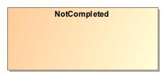

1. NotCompleted

|  |  |
| --- | --- |
| **Name** | NotCompleted |
| **Qualified Name** | CIMI Clinical::Data Structure::NotCompleted |
| **Visibility** | public |
| **Abstract** | false |
| **Base Classifier** | * Performed |
| **Realized Interface** |  |

### **Relation Detail**

#### Generalization

|  |  |
| --- | --- |
| **Name** |  |
| **Related Element** | * Performed |

## **Class** **NotPerformed**

A record that a clinical act was not performed and/or never initiated. Do not use this context if the act was initiated or started but aborted or cancelled. Use the NotPerformed context instead.

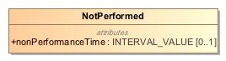

1. NotPerformed

|  |  |
| --- | --- |
| **Name** | NotPerformed |
| **Qualified Name** | CIMI Clinical::Data Structure::NotPerformed |
| **Visibility** | public |
| **Abstract** | false |
| **Base Classifier** | * ActionContext |
| **Realized Interface** |  |

### **Attribute Detail**

#### nonPerformanceTime

The time period during which the act was not performed.

|  |  |
| --- | --- |
| **Type** | INTERVAL_VALUE |
| **Default Value** |  |
| **Visibility** | public |
| **Multiplicity** | 0..1 |
| **Definition** | The time period during which the act was not performed. |

### **Relation Detail**

#### Generalization

|  |  |
| --- | --- |
| **Name** |  |
| **Related Element** | * ActionContext |

## **Class** **Ordered**

An instruction by a healthcare provider to another healthcare provider to perform some act.

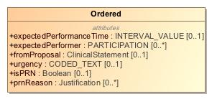

1. Ordered

|  |  |
| --- | --- |
| **Name** | Ordered |
| **Qualified Name** | CIMI Clinical::Data Structure::Ordered |
| **Visibility** | public |
| **Abstract** | false |
| **Base Classifier** | * ActionContext |
| **Realized Interface** |  |

### **Attribute Detail**

#### expectedPerformanceTime

Time when the ordered act is expected to be performed.

|  |  |
| --- | --- |
| **Type** | INTERVAL_VALUE |
| **Default Value** |  |
| **Visibility** | public |
| **Multiplicity** | 0..1 |
| **Definition** | Time when the ordered act is expected to be performed. |

#### expectedPerformer

Persons who are expected to or intended to perform this action, e.g., the person who will perform the surgery.

|  |  |
| --- | --- |
| **Type** | PARTICIPATION |
| **Default Value** |  |
| **Visibility** | public |
| **Multiplicity** | 0..* |
| **Definition** | Persons who are expected to or intended to perform this action, e.g., the person who will perform the surgery. |

#### fromProposal

Identifies a proposal that led to this order.

|  |  |
| --- | --- |
| **Type** | ClinicalStatement |
| **Default Value** |  |
| **Visibility** | public |
| **Multiplicity** | 0..1 |
| **Definition** | Identifies a proposal that led to this order. |

#### isPRN

Indicates whether the act being ordered should be performed only if needed, i.e., when a certain condition occurs. The condition can be described in the attribute prnReason.

|  |  |
| --- | --- |
| **Type** | Boolean |
| **Default Value** |  |
| **Visibility** | public |
| **Multiplicity** | 0..1 |
| **Definition** | Indicates whether the act being ordered should be performed only if needed, i.e., when a certain condition occurs. The condition can be described in the attribute prnReason. |

#### prnReason

The ordered act should be performed if the indicated conditions occur, e.g.., shortness of breath, SpO2 less than x%, insomnia, nausea.

|  |  |
| --- | --- |
| **Type** | Justification |
| **Default Value** |  |
| **Visibility** | public |
| **Multiplicity** | 0..* |
| **Definition** | The ordered act should be performed if the indicated conditions occur, e.g.., shortness of breath, SpO2 less than x%, insomnia, nausea. |

#### urgency

Characterizes how quickly the action must be initiated. Includes concepts such as stat, urgent, routine.

|  |  |
| --- | --- |
| **Type** | CODED_TEXT |
| **Default Value** |  |
| **Visibility** | public |
| **Multiplicity** | 0..1 |
| **Definition** | Characterizes how quickly the action must be initiated. Includes concepts such as stat, urgent, routine. |

### **Relation Detail**

#### Generalization

|  |  |
| --- | --- |
| **Name** |  |
| **Related Element** | * ActionContext |

## **Class** **OrganizationName**

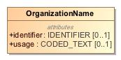

1. OrganizationName

|  |  |
| --- | --- |
| **Name** | OrganizationName |
| **Qualified Name** | CIMI Clinical::Data Structure::OrganizationName |
| **Visibility** | public |
| **Abstract** | false |
| **Base Classifier** | * ActorName |
| **Realized Interface** |  |

### **Attribute Detail**

#### identifier

|  |  |
| --- | --- |
| **Type** | IDENTIFIER |
| **Default Value** |  |
| **Visibility** | public |
| **Multiplicity** | 0..1 |
| **Definition** |  |

#### usage

|  |  |
| --- | --- |
| **Type** | CODED_TEXT |
| **Default Value** |  |
| **Visibility** | public |
| **Multiplicity** | 0..1 |
| **Definition** |  |

### **Relation Detail**

#### Generalization

|  |  |
| --- | --- |
| **Name** |  |
| **Related Element** | * ActorName |

## **Class** **Part**

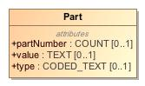

1. Part

|  |  |
| --- | --- |
| **Name** | Part |
| **Qualified Name** | CIMI Clinical::Data Structure::Part |
| **Visibility** | public |
| **Abstract** | false |
| **Base Classifier** | * CLUSTER |
| **Realized Interface** |  |

### **Attribute Detail**

#### partNumber

|  |  |
| --- | --- |
| **Type** | COUNT |
| **Default Value** |  |
| **Visibility** | public |
| **Multiplicity** | 0..1 |
| **Definition** |  |

#### type

|  |  |
| --- | --- |
| **Type** | CODED_TEXT |
| **Default Value** |  |
| **Visibility** | public |
| **Multiplicity** | 0..1 |
| **Definition** |  |

#### value

|  |  |
| --- | --- |
| **Type** | TEXT |
| **Default Value** |  |
| **Visibility** | public |
| **Multiplicity** | 0..1 |
| **Definition** |  |

### **Relation Detail**

#### Generalization

|  |  |
| --- | --- |
| **Name** |  |
| **Related Element** | * CLUSTER |

## **Class** **PartyName**

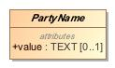

1. PartyName

|  |  |
| --- | --- |
| **Name** | PartyName |
| **Qualified Name** | CIMI Clinical::Data Structure::PartyName |
| **Visibility** | public |
| **Abstract** | true |
| **Base Classifier** | * CLUSTER |
| **Realized Interface** |  |

### **Attribute Detail**

#### value

|  |  |
| --- | --- |
| **Type** | TEXT |
| **Default Value** |  |
| **Visibility** | public |
| **Multiplicity** | 0..1 |
| **Definition** |  |

### **Relation Detail**

#### Generalization

|  |  |
| --- | --- |
| **Name** |  |
| **Related Element** | * ActorName |

|  |  |
| --- | --- |
| **Name** |  |
| **Related Element** | * CLUSTER |

## **Class** **Performed**

The actual performance or execution of a healthcare-related action, e.g., 3rd dose of Hepatitis B vaccine administered on Dec 4th 2012, appendectomy performed today.

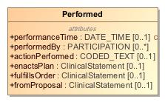

1. Performed

|  |  |
| --- | --- |
| **Name** | Performed |
| **Qualified Name** | CIMI Clinical::Data Structure::Performed |
| **Visibility** | public |
| **Abstract** | false |
| **Base Classifier** | * ActionContext |
| **Realized Interface** |  |

### **Attribute Detail**

#### actionPerformed

The component of a composite action that was performed. For instance, the fulfillment of a prescription may result in both a substance administration event and a dispense event, thus resulting in two action being performed.

|  |  |
| --- | --- |
| **Type** | CODED_TEXT |
| **Default Value** |  |
| **Visibility** | public |
| **Multiplicity** | 0..1 |
| **Definition** | The component of a composite action that was performed. For instance, the fulfillment of a prescription may result in both a substance administration event and a dispense event, thus resulting in two action being performed. |

#### enactsPlan

Identifies a plan that is partly or wholly enacted by the performance of this act

|  |  |
| --- | --- |
| **Type** | ClinicalStatement |
| **Default Value** |  |
| **Visibility** | public |
| **Multiplicity** | 0..1 |
| **Definition** | Identifies a plan that is partly or wholly enacted by the performance of this act |

#### fromProposal

Identifies a proposal that led to this order.

|  |  |
| --- | --- |
| **Type** | ClinicalStatement |
| **Default Value** |  |
| **Visibility** | public |
| **Multiplicity** | 0..1 |
| **Definition** | Identifies a proposal that led to this order. |

#### fulfillsOrder

Identifies an order that is partly or wholly filled by the performance of this act

|  |  |
| --- | --- |
| **Type** | ClinicalStatement |
| **Default Value** |  |
| **Visibility** | public |
| **Multiplicity** | 0..1 |
| **Definition** | Identifies an order that is partly or wholly filled by the performance of this act |

#### performanceTime

The overall time period in which the action is performed. This may be different than the scheduled time or the expected performance time.

|  |  |
| --- | --- |
| **Type** | DATE_TIME |
| **Default Value** |  |
| **Visibility** | public |
| **Multiplicity** | 0..1 |
| **Definition** | The overall time period in which the action is performed. This may be different than the scheduled time or the expected performance time. |

#### performedBy

Persons who perform this action, e.g., the person who administered the medication, performed the surgery.   
  
A performance may have many participants In comparison, an order or a plan typically has one participant. Hence, in performance many participants can be described along with their specific roles.

|  |  |
| --- | --- |
| **Type** | PARTICIPATION |
| **Default Value** |  |
| **Visibility** | public |
| **Multiplicity** | 0..* |
| **Definition** | Persons who perform this action, e.g., the person who administered the medication, performed the surgery.   A performance may have many participants In comparison, an order or a plan typically has one participant. Hence, in performance many participants can be described along with their specific roles. |

### **Relation Detail**

#### Generalization

|  |  |
| --- | --- |
| **Name** |  |
| **Related Element** | * NotCompleted |

|  |  |
| --- | --- |
| **Name** |  |
| **Related Element** | * ActionContext |

## **Class** **PersonName**

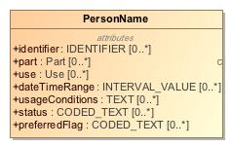

1. PersonName

|  |  |
| --- | --- |
| **Name** | PersonName |
| **Qualified Name** | CIMI Clinical::Data Structure::PersonName |
| **Visibility** | public |
| **Abstract** | false |
| **Base Classifier** | * ActorName |
| **Realized Interface** |  |

### **Attribute Detail**

#### dateTimeRange

|  |  |
| --- | --- |
| **Type** | INTERVAL_VALUE |
| **Default Value** |  |
| **Visibility** | public |
| **Multiplicity** | 0..* |
| **Definition** |  |

#### identifier

|  |  |
| --- | --- |
| **Type** | IDENTIFIER |
| **Default Value** |  |
| **Visibility** | public |
| **Multiplicity** | 0..* |
| **Definition** |  |

#### part

|  |  |
| --- | --- |
| **Type** | Part |
| **Default Value** |  |
| **Visibility** | public |
| **Multiplicity** | 0..* |
| **Definition** |  |

#### preferredFlag

|  |  |
| --- | --- |
| **Type** | CODED_TEXT |
| **Default Value** |  |
| **Visibility** | public |
| **Multiplicity** | 0..* |
| **Definition** |  |

#### status

|  |  |
| --- | --- |
| **Type** | CODED_TEXT |
| **Default Value** |  |
| **Visibility** | public |
| **Multiplicity** | 0..* |
| **Definition** |  |

#### usageConditions

|  |  |
| --- | --- |
| **Type** | TEXT |
| **Default Value** |  |
| **Visibility** | public |
| **Multiplicity** | 0..* |
| **Definition** |  |

#### use

|  |  |
| --- | --- |
| **Type** | Use |
| **Default Value** |  |
| **Visibility** | public |
| **Multiplicity** | 0..* |
| **Definition** |  |

### **Relation Detail**

#### Generalization

|  |  |
| --- | --- |
| **Name** |  |
| **Related Element** | * ActorName |

|  |  |
| --- | --- |
| **Name** |  |
| **Related Element** | * PersonNameDetailed |

## **Class** **PersonNameDetailed**

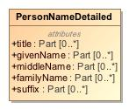

1. PersonNameDetailed

|  |  |
| --- | --- |
| **Name** | PersonNameDetailed |
| **Qualified Name** | CIMI Clinical::Data Structure::PersonNameDetailed |
| **Visibility** | public |
| **Abstract** | false |
| **Base Classifier** | * PersonName |
| **Realized Interface** |  |

### **Attribute Detail**

#### familyName

|  |  |
| --- | --- |
| **Type** | Part |
| **Default Value** |  |
| **Visibility** | public |
| **Multiplicity** | 0..* |
| **Definition** |  |

#### givenName

|  |  |
| --- | --- |
| **Type** | Part |
| **Default Value** |  |
| **Visibility** | public |
| **Multiplicity** | 0..* |
| **Definition** |  |

#### middleName

|  |  |
| --- | --- |
| **Type** | Part |
| **Default Value** |  |
| **Visibility** | public |
| **Multiplicity** | 0..* |
| **Definition** |  |

#### suffix

|  |  |
| --- | --- |
| **Type** | Part |
| **Default Value** |  |
| **Visibility** | public |
| **Multiplicity** | 0..* |
| **Definition** |  |

#### title

|  |  |
| --- | --- |
| **Type** | Part |
| **Default Value** |  |
| **Visibility** | public |
| **Multiplicity** | 0..* |
| **Definition** |  |

### **Relation Detail**

#### Generalization

|  |  |
| --- | --- |
| **Name** |  |
| **Related Element** | * PersonName |

## **Class** **PhysicalEvaluationResult**

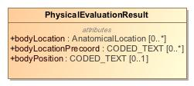

1. PhysicalEvaluationResult

|  |  |
| --- | --- |
| **Name** | PhysicalEvaluationResult |
| **Qualified Name** | CIMI Clinical::Data Structure::PhysicalEvaluationResult |
| **Visibility** | public |
| **Abstract** | false |
| **Base Classifier** | * EvaluationResult |
| **Realized Interface** |  |

### **Attribute Detail**

#### bodyLocation

|  |  |
| --- | --- |
| **Type** | AnatomicalLocation |
| **Default Value** |  |
| **Visibility** | public |
| **Multiplicity** | 0..* |
| **Definition** |  |

#### bodyLocationPrecoord

|  |  |
| --- | --- |
| **Type** | CODED_TEXT |
| **Default Value** |  |
| **Visibility** | public |
| **Multiplicity** | 0..* |
| **Definition** |  |

#### bodyPosition

|  |  |
| --- | --- |
| **Type** | CODED_TEXT |
| **Default Value** |  |
| **Visibility** | public |
| **Multiplicity** | 0..1 |
| **Definition** |  |

### **Relation Detail**

#### Generalization

|  |  |
| --- | --- |
| **Name** |  |
| **Related Element** | * EvaluationResult |

## **Class** **Planned**

Description of action that is planned to be performed. Typically, this would include a time at which the action is scheduled to be performed.

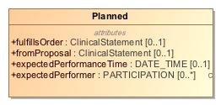

1. Planned

|  |  |
| --- | --- |
| **Name** | Planned |
| **Qualified Name** | CIMI Clinical::Data Structure::Planned |
| **Visibility** | public |
| **Abstract** | false |
| **Base Classifier** | * ActionContext |
| **Realized Interface** |  |

### **Attribute Detail**

#### expectedPerformanceTime

The time when the action is expected to be performed.

|  |  |
| --- | --- |
| **Type** | DATE_TIME |
| **Default Value** |  |
| **Visibility** | public |
| **Multiplicity** | 0..1 |
| **Definition** | The time when the action is expected to be performed. |

#### expectedPerformer

Persons who are expected to or intended to perform this action, e.g., the person who will perform the surgery.

|  |  |
| --- | --- |
| **Type** | PARTICIPATION |
| **Default Value** |  |
| **Visibility** | public |
| **Multiplicity** | 0..* |
| **Definition** | Persons who are expected to or intended to perform this action, e.g., the person who will perform the surgery. |

#### fromProposal

Identifies a proposal that led to this order.

|  |  |
| --- | --- |
| **Type** | ClinicalStatement |
| **Default Value** |  |
| **Visibility** | public |
| **Multiplicity** | 0..1 |
| **Definition** | Identifies a proposal that led to this order. |

#### fulfillsOrder

Identifies an order that is partly or wholly filled by the performance of this act

|  |  |
| --- | --- |
| **Type** | ClinicalStatement |
| **Default Value** |  |
| **Visibility** | public |
| **Multiplicity** | 0..1 |
| **Definition** | Identifies an order that is partly or wholly filled by the performance of this act |

### **Relation Detail**

#### Generalization

|  |  |
| --- | --- |
| **Name** |  |
| **Related Element** | * ActionContext |

## **Class** **PresenceAbsenceContext**

-419274319.jpg

1. PresenceAbsenceContext

|  |  |
| --- | --- |
| **Name** | PresenceAbsenceContext |
| **Qualified Name** | CIMI Clinical::Data Structure::PresenceAbsenceContext |
| **Visibility** | public |
| **Abstract** | true |
| **Base Classifier** | * FindingContext |
| **Realized Interface** |  |

### **Relation Detail**

#### Generalization

|  |  |
| --- | --- |
| **Name** |  |
| **Related Element** | * Absent |

|  |  |
| --- | --- |
| **Name** |  |
| **Related Element** | * KnownOrSuspectedPresent |

|  |  |
| --- | --- |
| **Name** |  |
| **Related Element** | * FindingContext |

## **Class** **Procedure**

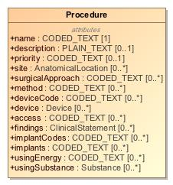

1. Procedure

|  |  |
| --- | --- |
| **Name** | Procedure |
| **Qualified Name** | CIMI Clinical::Data Structure::Procedure |
| **Visibility** | public |
| **Abstract** | false |
| **Base Classifier** | * Act |
| **Realized Interface** |  |

### **Attribute Detail**

#### access

The route used to access the site of a procedure. It is used to distinguish  
open, closed, and percutaneous procedures.

|  |  |
| --- | --- |
| **Type** | CODED_TEXT |
| **Default Value** |  |
| **Visibility** | public |
| **Multiplicity** | 0..* |
| **Definition** | The route used to access the site of a procedure. It is used to distinguish open, closed, and percutaneous procedures. |

#### description

|  |  |
| --- | --- |
| **Type** | PLAIN_TEXT |
| **Default Value** |  |
| **Visibility** | public |
| **Multiplicity** | 0..1 |
| **Definition** |  |

#### device

Device associated with the procedure.

|  |  |
| --- | --- |
| **Type** | Device |
| **Default Value** |  |
| **Visibility** | public |
| **Multiplicity** | 0..* |
| **Definition** | Device associated with the procedure. |

#### deviceCode

Code for device associated with the procedure.

|  |  |
| --- | --- |
| **Type** | CODED_TEXT |
| **Default Value** |  |
| **Visibility** | public |
| **Multiplicity** | 0..* |
| **Definition** | Code for device associated with the procedure. |

#### findings

Records clinically significant observations confirmed or discovered during the procedure or surgery. For example, "Necrotic left ovarian cyst was discovered and removed." - ONC S&I Clinical Element Data Dictionary (CEDD), March 2012.

|  |  |
| --- | --- |
| **Type** | ClinicalStatement |
| **Default Value** |  |
| **Visibility** | public |
| **Multiplicity** | 0..* |
| **Definition** | Records clinically significant observations confirmed or discovered during the procedure or surgery. For example, "Necrotic left ovarian cyst was discovered and removed." - ONC S&I Clinical Element Data Dictionary (CEDD), March 2012. |

#### implantCodes

Materials placed during the procedure including stents, tubes, and drains.

|  |  |
| --- | --- |
| **Type** | CODED_TEXT |
| **Default Value** |  |
| **Visibility** | public |
| **Multiplicity** | 0..* |
| **Definition** | Materials placed during the procedure including stents, tubes, and drains. |

#### implants

Materials placed during the procedure including stents, tubes, and drains.

|  |  |
| --- | --- |
| **Type** | CODED_TEXT |
| **Default Value** |  |
| **Visibility** | public |
| **Multiplicity** | 0..* |
| **Definition** | Materials placed during the procedure including stents, tubes, and drains. |

#### method

Action being performed to accomplish the procedure.

|  |  |
| --- | --- |
| **Type** | CODED_TEXT |
| **Default Value** |  |
| **Visibility** | public |
| **Multiplicity** | 0..* |
| **Definition** | Action being performed to accomplish the procedure. |

#### name

A clinical procedure perfored on a subject, most often a patient.

|  |  |
| --- | --- |
| **Type** | CODED_TEXT |
| **Default Value** |  |
| **Visibility** | public |
| **Multiplicity** | 1 |
| **Definition** | A clinical procedure perfored on a subject, most often a patient. |

#### priority

Priority assigned to a procedure.

|  |  |
| --- | --- |
| **Type** | CODED_TEXT |
| **Default Value** |  |
| **Visibility** | public |
| **Multiplicity** | 0..1 |
| **Definition** | Priority assigned to a procedure. |

#### site

Anatomical location of the procedure.

|  |  |
| --- | --- |
| **Type** | AnatomicalLocation |
| **Default Value** |  |
| **Visibility** | public |
| **Multiplicity** | 0..* |
| **Definition** | Anatomical location of the procedure. |

#### surgicalApproach

The technique used to reach the site of the procedure. Approaches may be through the skin or mucous membrane, through an orifice or external.

|  |  |
| --- | --- |
| **Type** | CODED_TEXT |
| **Default Value** |  |
| **Visibility** | public |
| **Multiplicity** | 0..* |
| **Definition** | The technique used to reach the site of the procedure. Approaches may be through the skin or mucous membrane, through an orifice or external. |

#### usingEnergy

The energy used to execute the procedure.

|  |  |
| --- | --- |
| **Type** | CODED_TEXT |
| **Default Value** |  |
| **Visibility** | public |
| **Multiplicity** | 0..* |
| **Definition** | The energy used to execute the procedure. |

#### usingSubstance

Substance used to execute the action of a procedure.

|  |  |
| --- | --- |
| **Type** | Substance |
| **Default Value** |  |
| **Visibility** | public |
| **Multiplicity** | 0..* |
| **Definition** | Substance used to execute the action of a procedure. |

### **Relation Detail**

#### Generalization

|  |  |
| --- | --- |
| **Name** |  |
| **Related Element** | * LaboratoryProcedure |

|  |  |
| --- | --- |
| **Name** |  |
| **Related Element** | * Act |

## **Class** **Proposed**

An offer or a suggestion to perform a healthcare act. A recommendation to a provider is an example of proposal made by a CDS system. A proposal must be accepted by an entity in order for it to be performed.

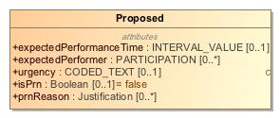

1. Proposed

|  |  |
| --- | --- |
| **Name** | Proposed |
| **Qualified Name** | CIMI Clinical::Data Structure::Proposed |
| **Visibility** | public |
| **Abstract** | false |
| **Base Classifier** | * ActionContext |
| **Realized Interface** |  |

### **Attribute Detail**

#### expectedPerformanceTime

The time when the action is expected to be performed.

|  |  |
| --- | --- |
| **Type** | INTERVAL_VALUE |
| **Default Value** |  |
| **Visibility** | public |
| **Multiplicity** | 0..1 |
| **Definition** | The time when the action is expected to be performed. |

#### expectedPerformer

Persons who are expected to or intended to perform this action, e.g., the person who will perform the surgery.

|  |  |
| --- | --- |
| **Type** | PARTICIPATION |
| **Default Value** |  |
| **Visibility** | public |
| **Multiplicity** | 0..* |
| **Definition** | Persons who are expected to or intended to perform this action, e.g., the person who will perform the surgery. |

#### isPrn

Indicates whether the act being proposed should be performed only if needed, i.e., when a certain condition occurs. The condition can be described in the attribute prnReason.

|  |  |
| --- | --- |
| **Type** | Boolean |
| **Default Value** | false |
| **Visibility** | public |
| **Multiplicity** | 0..1 |
| **Definition** | Indicates whether the act being proposed should be performed only if needed, i.e., when a certain condition occurs. The condition can be described in the attribute prnReason. |

#### prnReason

The proposed act must be performed if the indicated conditions occur, e.g.., shortness of breath, SpO2 less than x%, insomnia, nausea.

|  |  |
| --- | --- |
| **Type** | Justification |
| **Default Value** |  |
| **Visibility** | public |
| **Multiplicity** | 0..* |
| **Definition** | The proposed act must be performed if the indicated conditions occur, e.g.., shortness of breath, SpO2 less than x%, insomnia, nausea. |

#### urgency

Characterizes how quickly the proposed act must be initiated. Includes concepts such as stat, urgent, routine.

|  |  |
| --- | --- |
| **Type** | CODED_TEXT |
| **Default Value** |  |
| **Visibility** | public |
| **Multiplicity** | 0..1 |
| **Definition** | Characterizes how quickly the proposed act must be initiated. Includes concepts such as stat, urgent, routine. |

### **Relation Detail**

#### Generalization

|  |  |
| --- | --- |
| **Name** |  |
| **Related Element** | * ActionContext |

## **Class** **ProposedAgainst**

Concept represents a recommendation from a clinical decision support system or advice from a consultation to not perform an act.

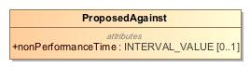

1. ProposedAgainst

|  |  |
| --- | --- |
| **Name** | ProposedAgainst |
| **Qualified Name** | CIMI Clinical::Data Structure::ProposedAgainst |
| **Visibility** | public |
| **Abstract** | false |
| **Base Classifier** | * ActionContext |
| **Realized Interface** |  |

### **Attribute Detail**

#### nonPerformanceTime

The time period during which the act should not be performed.

|  |  |
| --- | --- |
| **Type** | INTERVAL_VALUE |
| **Default Value** |  |
| **Visibility** | public |
| **Multiplicity** | 0..1 |
| **Definition** | The time period during which the act should not be performed. |

### **Relation Detail**

#### Generalization

|  |  |
| --- | --- |
| **Name** |  |
| **Related Element** | * ActionContext |

## **Class** **Provenance**

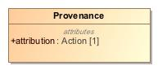

1. Provenance

|  |  |
| --- | --- |
| **Name** | Provenance |
| **Qualified Name** | CIMI Clinical::Data Structure::Provenance |
| **Visibility** | public |
| **Abstract** | false |
| **Base Classifier** | * CLUSTER |
| **Realized Interface** |  |

### **Attribute Detail**

#### attribution

|  |  |
| --- | --- |
| **Type** | Action |
| **Default Value** |  |
| **Visibility** | public |
| **Multiplicity** | 1 |
| **Definition** |  |

#### target

|  |  |
| --- | --- |
| **Type** | ClinicalStatement |
| **Default Value** |  |
| **Visibility** | public |
| **Multiplicity** | 1..* |
| **Definition** |  |

### **Relation Detail**

#### Association

|  |  |
| --- | --- |
| **Name** |  |
| **Related Element** | * ClinicalStatement |

#### Generalization

|  |  |
| --- | --- |
| **Name** |  |
| **Related Element** | * CLUSTER |

## **Class** **Qualification**

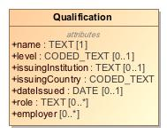

1. Qualification

|  |  |
| --- | --- |
| **Name** | Qualification |
| **Qualified Name** | CIMI Clinical::Data Structure::Qualification |
| **Visibility** | public |
| **Abstract** | false |
| **Base Classifier** | * CLUSTER |
| **Realized Interface** |  |

### **Attribute Detail**

#### dateIssued

|  |  |
| --- | --- |
| **Type** | DATE |
| **Default Value** |  |
| **Visibility** | public |
| **Multiplicity** | 0..1 |
| **Definition** |  |

#### employer

|  |  |
| --- | --- |
| **Type** |  |
| **Default Value** |  |
| **Visibility** | public |
| **Multiplicity** | 0..* |
| **Definition** |  |

#### issuingCountry

|  |  |
| --- | --- |
| **Type** | CODED_TEXT |
| **Default Value** |  |
| **Visibility** | public |
| **Multiplicity** |  |
| **Definition** |  |

#### issuingInstitution

|  |  |
| --- | --- |
| **Type** | TEXT |
| **Default Value** |  |
| **Visibility** | public |
| **Multiplicity** | 0..1 |
| **Definition** |  |

#### level

|  |  |
| --- | --- |
| **Type** | CODED_TEXT |
| **Default Value** |  |
| **Visibility** | public |
| **Multiplicity** | 0..1 |
| **Definition** |  |

#### name

|  |  |
| --- | --- |
| **Type** | TEXT |
| **Default Value** |  |
| **Visibility** | public |
| **Multiplicity** | 1 |
| **Definition** |  |

#### role

|  |  |
| --- | --- |
| **Type** | TEXT |
| **Default Value** |  |
| **Visibility** | public |
| **Multiplicity** | 0..* |
| **Definition** |  |

### **Relation Detail**

#### Generalization

|  |  |
| --- | --- |
| **Name** |  |
| **Related Element** | * CLUSTER |

## **Class** **QualitativeReferenceRange**

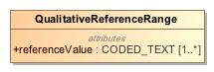

1. QualitativeReferenceRange

|  |  |
| --- | --- |
| **Name** | QualitativeReferenceRange |
| **Qualified Name** | CIMI Clinical::Data Structure::QualitativeReferenceRange |
| **Visibility** | public |
| **Abstract** | false |
| **Base Classifier** | * ReferenceRange |
| **Realized Interface** |  |

### **Attribute Detail**

#### referenceValue

|  |  |
| --- | --- |
| **Type** | CODED_TEXT |
| **Default Value** |  |
| **Visibility** | public |
| **Multiplicity** | 1..* |
| **Definition** |  |

### **Relation Detail**

#### Generalization

|  |  |
| --- | --- |
| **Name** |  |
| **Related Element** | * ReferenceRange |

## **Class** **QuantitativeReferenceRange**

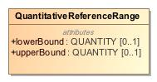

1. QuantitativeReferenceRange

|  |  |
| --- | --- |
| **Name** | QuantitativeReferenceRange |
| **Qualified Name** | CIMI Clinical::Data Structure::QuantitativeReferenceRange |
| **Visibility** | public |
| **Abstract** | false |
| **Base Classifier** | * ReferenceRange |
| **Realized Interface** |  |

### **Attribute Detail**

#### lowerBound

|  |  |
| --- | --- |
| **Type** | QUANTITY |
| **Default Value** |  |
| **Visibility** | public |
| **Multiplicity** | 0..1 |
| **Definition** |  |

#### upperBound

|  |  |
| --- | --- |
| **Type** | QUANTITY |
| **Default Value** |  |
| **Visibility** | public |
| **Multiplicity** | 0..1 |
| **Definition** |  |

### **Relation Detail**

#### Generalization

|  |  |
| --- | --- |
| **Name** |  |
| **Related Element** | * ReferenceRange |

## **Class** **ReferenceRange**

A reference range for the specific instance after lookup from, say, a reference range table given specific criteria. Note that this reference range is not definitional in nature but rather refers to the reference range considered for the given observation for a subject.

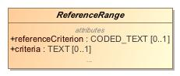

1. ReferenceRange

|  |  |
| --- | --- |
| **Name** | ReferenceRange |
| **Qualified Name** | CIMI Clinical::Data Structure::ReferenceRange |
| **Visibility** | public |
| **Abstract** | true |
| **Base Classifier** | * CLUSTER |
| **Realized Interface** |  |

### **Attribute Detail**

#### criteria

|  |  |
| --- | --- |
| **Type** | TEXT |
| **Default Value** |  |
| **Visibility** | public |
| **Multiplicity** | 0..1 |
| **Definition** |  |

#### narrative

|  |  |
| --- | --- |
| **Type** | TEXT |
| **Default Value** |  |
| **Visibility** | public |
| **Multiplicity** | 0..1 |
| **Definition** |  |

#### referenceCriterion

Indicates whether the given range is normal, critically high, ...

|  |  |
| --- | --- |
| **Type** | CODED_TEXT |
| **Default Value** |  |
| **Visibility** | public |
| **Multiplicity** | 0..1 |
| **Definition** | Indicates whether the given range is normal, critically high, ... |

### **Relation Detail**

#### Generalization

|  |  |
| --- | --- |
| **Name** |  |
| **Related Element** | * QualitativeReferenceRange |

|  |  |
| --- | --- |
| **Name** |  |
| **Related Element** | * QuantitativeReferenceRange |

|  |  |
| --- | --- |
| **Name** |  |
| **Related Element** | * CLUSTER |

## **Class** **Registration**

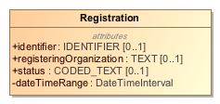

1. Registration

|  |  |
| --- | --- |
| **Name** | Registration |
| **Qualified Name** | CIMI Clinical::Data Structure::Registration |
| **Visibility** | public |
| **Abstract** | false |
| **Base Classifier** | * CLUSTER |
| **Realized Interface** |  |

### **Attribute Detail**

#### dateTimeRange

|  |  |
| --- | --- |
| **Type** | DateTimeInterval |
| **Default Value** |  |
| **Visibility** | private |
| **Multiplicity** |  |
| **Definition** |  |

#### identifier

|  |  |
| --- | --- |
| **Type** | IDENTIFIER |
| **Default Value** |  |
| **Visibility** | public |
| **Multiplicity** | 0..1 |
| **Definition** |  |

#### registeringOrganization

|  |  |
| --- | --- |
| **Type** | TEXT |
| **Default Value** |  |
| **Visibility** | public |
| **Multiplicity** | 0..1 |
| **Definition** |  |

#### status

|  |  |
| --- | --- |
| **Type** | CODED_TEXT |
| **Default Value** |  |
| **Visibility** | public |
| **Multiplicity** | 0..1 |
| **Definition** |  |

### **Relation Detail**

#### Generalization

|  |  |
| --- | --- |
| **Name** |  |
| **Related Element** | * CLUSTER |

## **Class** **RelatedClinicalStatement**

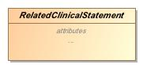

1. RelatedClinicalStatement

|  |  |
| --- | --- |
| **Name** | RelatedClinicalStatement |
| **Qualified Name** | CIMI Clinical::Data Structure::RelatedClinicalStatement |
| **Visibility** | public |
| **Abstract** | true |
| **Base Classifier** | * CLUSTER |
| **Realized Interface** |  |

### **Attribute Detail**

#### relationshipCode

|  |  |
| --- | --- |
| **Type** | TEXT |
| **Default Value** |  |
| **Visibility** | public |
| **Multiplicity** | 1 |
| **Definition** |  |

#### target

|  |  |
| --- | --- |
| **Type** | ClinicalStatement |
| **Default Value** |  |
| **Visibility** | public |
| **Multiplicity** | 1..* |
| **Definition** |  |

### **Relation Detail**

#### Association

|  |  |
| --- | --- |
| **Name** |  |
| **Related Element** | * ClinicalStatement |

#### Generalization

|  |  |
| --- | --- |
| **Name** |  |
| **Related Element** | * Justification |

|  |  |
| --- | --- |
| **Name** |  |
| **Related Element** | * CLUSTER |

|  |  |
| --- | --- |
| **Name** |  |
| **Related Element** | * Interpretation |

## **Class** **Risk**

-67184742.jpg

1. Risk

|  |  |
| --- | --- |
| **Name** | Risk |
| **Qualified Name** | CIMI Clinical::Data Structure::Risk |
| **Visibility** | public |
| **Abstract** | false |
| **Base Classifier** | * FindingContext |
| **Realized Interface** |  |

### **Relation Detail**

#### Generalization

|  |  |
| --- | --- |
| **Name** |  |
| **Related Element** | * FindingContext |

## **Class** **Signature**

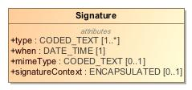

1. Signature

|  |  |
| --- | --- |
| **Name** | Signature |
| **Qualified Name** | CIMI Clinical::Data Structure::Signature |
| **Visibility** | public |
| **Abstract** | false |
| **Base Classifier** | * CLUSTER |
| **Realized Interface** |  |

### **Attribute Detail**

#### mimeType

|  |  |
| --- | --- |
| **Type** | CODED_TEXT |
| **Default Value** |  |
| **Visibility** | public |
| **Multiplicity** | 0..1 |
| **Definition** |  |

#### signatureContext

|  |  |
| --- | --- |
| **Type** | ENCAPSULATED |
| **Default Value** |  |
| **Visibility** | public |
| **Multiplicity** | 0..1 |
| **Definition** |  |

#### type

|  |  |
| --- | --- |
| **Type** | CODED_TEXT |
| **Default Value** |  |
| **Visibility** | public |
| **Multiplicity** | 1..* |
| **Definition** |  |

#### when

|  |  |
| --- | --- |
| **Type** | DATE_TIME |
| **Default Value** |  |
| **Visibility** | public |
| **Multiplicity** | 1 |
| **Definition** |  |

### **Relation Detail**

#### Generalization

|  |  |
| --- | --- |
| **Name** |  |
| **Related Element** | * CLUSTER |

## **Class** **Specimen**

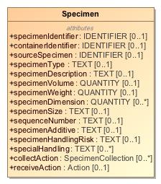

1. Specimen

|  |  |
| --- | --- |
| **Name** | Specimen |
| **Qualified Name** | CIMI Clinical::Data Structure::Specimen |
| **Visibility** | public |
| **Abstract** | false |
| **Base Classifier** | * MaterialEntity |
| **Realized Interface** |  |

### **Attribute Detail**

#### collectAction

|  |  |
| --- | --- |
| **Type** | SpecimenCollection |
| **Default Value** |  |
| **Visibility** | public |
| **Multiplicity** | 0..* |
| **Definition** |  |

#### containerIdentifier

|  |  |
| --- | --- |
| **Type** | IDENTIFIER |
| **Default Value** |  |
| **Visibility** | public |
| **Multiplicity** | 0..1 |
| **Definition** |  |

#### receiveAction

|  |  |
| --- | --- |
| **Type** | Action |
| **Default Value** |  |
| **Visibility** | public |
| **Multiplicity** | 0..1 |
| **Definition** |  |

#### sequenceNumber

|  |  |
| --- | --- |
| **Type** | TEXT |
| **Default Value** |  |
| **Visibility** | public |
| **Multiplicity** | 0..1 |
| **Definition** |  |

#### sourceSpecimen

|  |  |
| --- | --- |
| **Type** | IDENTIFIER |
| **Default Value** |  |
| **Visibility** | public |
| **Multiplicity** | 0..1 |
| **Definition** |  |

#### specialHandling

|  |  |
| --- | --- |
| **Type** | TEXT |
| **Default Value** |  |
| **Visibility** | public |
| **Multiplicity** | 0..* |
| **Definition** |  |

#### specimenAdditive

|  |  |
| --- | --- |
| **Type** | TEXT |
| **Default Value** |  |
| **Visibility** | public |
| **Multiplicity** | 0..1 |
| **Definition** |  |

#### specimenDescription

|  |  |
| --- | --- |
| **Type** | TEXT |
| **Default Value** |  |
| **Visibility** | public |
| **Multiplicity** | 0..1 |
| **Definition** |  |

#### specimenDimension

|  |  |
| --- | --- |
| **Type** | QUANTITY |
| **Default Value** |  |
| **Visibility** | public |
| **Multiplicity** | 0..* |
| **Definition** |  |

#### specimenHandlingRisk

|  |  |
| --- | --- |
| **Type** | TEXT |
| **Default Value** |  |
| **Visibility** | public |
| **Multiplicity** | 0..1 |
| **Definition** |  |

#### specimenIdentifier

|  |  |
| --- | --- |
| **Type** | IDENTIFIER |
| **Default Value** |  |
| **Visibility** | public |
| **Multiplicity** | 0..1 |
| **Definition** |  |

#### specimenSize

|  |  |
| --- | --- |
| **Type** | TEXT |
| **Default Value** |  |
| **Visibility** | public |
| **Multiplicity** | 0..1 |
| **Definition** |  |

#### specimenType

|  |  |
| --- | --- |
| **Type** | TEXT |
| **Default Value** |  |
| **Visibility** | public |
| **Multiplicity** | 0..1 |
| **Definition** |  |

#### specimenVolume

|  |  |
| --- | --- |
| **Type** | QUANTITY |
| **Default Value** |  |
| **Visibility** | public |
| **Multiplicity** | 0..1 |
| **Definition** |  |

#### specimenWeight

|  |  |
| --- | --- |
| **Type** | QUANTITY |
| **Default Value** |  |
| **Visibility** | public |
| **Multiplicity** | 0..1 |
| **Definition** |  |

### **Relation Detail**

#### Generalization

|  |  |
| --- | --- |
| **Name** |  |
| **Related Element** | * MaterialEntity |

## **Class** **SpecimenCollection**

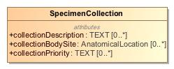

1. SpecimenCollection

|  |  |
| --- | --- |
| **Name** | SpecimenCollection |
| **Qualified Name** | CIMI Clinical::Data Structure::SpecimenCollection |
| **Visibility** | public |
| **Abstract** | false |
| **Base Classifier** | * Action |
| **Realized Interface** |  |

### **Attribute Detail**

#### collectionBodySite

|  |  |
| --- | --- |
| **Type** | AnatomicalLocation |
| **Default Value** |  |
| **Visibility** | public |
| **Multiplicity** | 0..* |
| **Definition** |  |

#### collectionDescription

|  |  |
| --- | --- |
| **Type** | TEXT |
| **Default Value** |  |
| **Visibility** | public |
| **Multiplicity** | 0..* |
| **Definition** |  |

#### collectionPriority

|  |  |
| --- | --- |
| **Type** | TEXT |
| **Default Value** |  |
| **Visibility** | public |
| **Multiplicity** | 0..* |
| **Definition** |  |

### **Relation Detail**

#### Generalization

|  |  |
| --- | --- |
| **Name** |  |
| **Related Element** | * Action |

## **Class** **StatementContext**

The StatementContext class aligns with the SNOMED Situations with Explicit Context and provides the context for the topic of a clinical statement. Note that the action context provides the expressivity required to specify that an act was not done or a finding was observed to be absent. By default, the negation applies to the conjunction of the stated attribute in the instance.

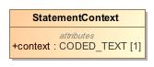

1. StatementContext

|  |  |
| --- | --- |
| **Name** | StatementContext |
| **Qualified Name** | CIMI Clinical::Data Structure::StatementContext |
| **Visibility** | public |
| **Abstract** | false |
| **Base Classifier** | * VIRTUAL_CLUSTER |
| **Realized Interface** |  |

### **Attribute Detail**

#### context

The SNOMED 'Context value' code that most closely aligns with the contextual intent of the clinical statement.

|  |  |
| --- | --- |
| **Type** | CODED_TEXT |
| **Default Value** |  |
| **Visibility** | public |
| **Multiplicity** | 1 |
| **Definition** | The SNOMED 'Context value' code that most closely aligns with the contextual intent of the clinical statement. |

### **Relation Detail**

#### Generalization

|  |  |
| --- | --- |
| **Name** |  |
| **Related Element** | * ActionContext |

|  |  |
| --- | --- |
| **Name** |  |
| **Related Element** | * FindingContext |

|  |  |
| --- | --- |
| **Name** |  |
| **Related Element** | * VIRTUAL_CLUSTER |

## **Class** **StatementTopic**

-1713950916.jpg

1. StatementTopic

|  |  |
| --- | --- |
| **Name** | StatementTopic |
| **Qualified Name** | CIMI Clinical::Data Structure::StatementTopic |
| **Visibility** | public |
| **Abstract** | true |
| **Base Classifier** | * VIRTUAL_CLUSTER |
| **Realized Interface** |  |

### **Relation Detail**

#### Generalization

|  |  |
| --- | --- |
| **Name** |  |
| **Related Element** | * VIRTUAL_CLUSTER |

|  |  |
| --- | --- |
| **Name** |  |
| **Related Element** | * Act |

|  |  |
| --- | --- |
| **Name** |  |
| **Related Element** | * Finding |

## **Class** **Street**

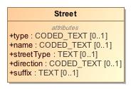

1. Street

|  |  |
| --- | --- |
| **Name** | Street |
| **Qualified Name** | CIMI Clinical::Data Structure::Street |
| **Visibility** | public |
| **Abstract** | false |
| **Base Classifier** | * CLUSTER |
| **Realized Interface** |  |

### **Attribute Detail**

#### direction

|  |  |
| --- | --- |
| **Type** | CODED_TEXT |
| **Default Value** |  |
| **Visibility** | public |
| **Multiplicity** | 0..1 |
| **Definition** |  |

#### name

|  |  |
| --- | --- |
| **Type** | CODED_TEXT |
| **Default Value** |  |
| **Visibility** | public |
| **Multiplicity** | 0..1 |
| **Definition** |  |

#### streetType

|  |  |
| --- | --- |
| **Type** | TEXT |
| **Default Value** |  |
| **Visibility** | public |
| **Multiplicity** | 0..1 |
| **Definition** |  |

#### suffix

|  |  |
| --- | --- |
| **Type** | TEXT |
| **Default Value** |  |
| **Visibility** | public |
| **Multiplicity** | 0..1 |
| **Definition** |  |

#### type

|  |  |
| --- | --- |
| **Type** | CODED_TEXT |
| **Default Value** |  |
| **Visibility** | public |
| **Multiplicity** | 0..1 |
| **Definition** |  |

### **Relation Detail**

#### Generalization

|  |  |
| --- | --- |
| **Name** |  |
| **Related Element** | * CLUSTER |

## **Class** **StreetNumber**

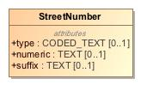

1. StreetNumber

|  |  |
| --- | --- |
| **Name** | StreetNumber |
| **Qualified Name** | CIMI Clinical::Data Structure::StreetNumber |
| **Visibility** | public |
| **Abstract** | false |
| **Base Classifier** | * CLUSTER |
| **Realized Interface** |  |

### **Attribute Detail**

#### numeric

|  |  |
| --- | --- |
| **Type** | TEXT |
| **Default Value** |  |
| **Visibility** | public |
| **Multiplicity** | 0..1 |
| **Definition** |  |

#### suffix

|  |  |
| --- | --- |
| **Type** | TEXT |
| **Default Value** |  |
| **Visibility** | public |
| **Multiplicity** | 0..1 |
| **Definition** |  |

#### type

|  |  |
| --- | --- |
| **Type** | CODED_TEXT |
| **Default Value** |  |
| **Visibility** | public |
| **Multiplicity** | 0..1 |
| **Definition** |  |

### **Relation Detail**

#### Generalization

|  |  |
| --- | --- |
| **Name** |  |
| **Related Element** | * CLUSTER |

## **Class** **Substance**

-787057121.jpg

1. Substance

|  |  |
| --- | --- |
| **Name** | Substance |
| **Qualified Name** | CIMI Clinical::Data Structure::Substance |
| **Visibility** | public |
| **Abstract** | false |
| **Base Classifier** | * MaterialEntity |
| **Realized Interface** |  |

### **Relation Detail**

#### Generalization

|  |  |
| --- | --- |
| **Name** |  |
| **Related Element** | * MaterialEntity |

## **Class** **Use**

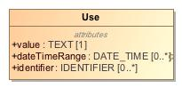

1. Use

|  |  |
| --- | --- |
| **Name** | Use |
| **Qualified Name** | CIMI Clinical::Data Structure::Use |
| **Visibility** | public |
| **Abstract** | false |
| **Base Classifier** | * CLUSTER |
| **Realized Interface** |  |

### **Attribute Detail**

#### dateTimeRange

|  |  |
| --- | --- |
| **Type** | DATE_TIME |
| **Default Value** |  |
| **Visibility** | public |
| **Multiplicity** | 0..* |
| **Definition** |  |

#### identifier

|  |  |
| --- | --- |
| **Type** | IDENTIFIER |
| **Default Value** |  |
| **Visibility** | public |
| **Multiplicity** | 0..* |
| **Definition** |  |

#### value

|  |  |
| --- | --- |
| **Type** | TEXT |
| **Default Value** |  |
| **Visibility** | public |
| **Multiplicity** | 1 |
| **Definition** |  |

### **Relation Detail**

#### Generalization

|  |  |
| --- | --- |
| **Name** |  |
| **Related Element** | * CLUSTER |

# **Package CIMI Clinical::Participation**

|  |  |
| --- | --- |
| **Name** | Participation |
| **Qualified Name** | CIMI Clinical::Participation |

## **Class** **SubjectOfInformation**

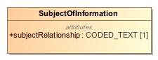

1. SubjectOfInformation

|  |  |
| --- | --- |
| **Name** | SubjectOfInformation |
| **Qualified Name** | CIMI Clinical::Participation::SubjectOfInformation |
| **Visibility** | public |
| **Abstract** | false |
| **Base Classifier** | * PARTICIPATION |
| **Realized Interface** |  |

### **Attribute Detail**

#### subjectRelationship

|  |  |
| --- | --- |
| **Type** | CODED_TEXT |
| **Default Value** |  |
| **Visibility** | public |
| **Multiplicity** | 1 |
| **Definition** |  |

### **Relation Detail**

#### Generalization

|  |  |
| --- | --- |
| **Name** |  |
| **Related Element** | * PARTICIPATION |

# **Package CIMI Clinical::Party**

|  |  |
| --- | --- |
| **Name** | Party |
| **Qualified Name** | CIMI Clinical::Party |

## **Class** **HealthCareConsumerRole**

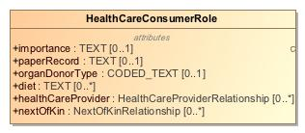

1. HealthCareConsumerRole

|  |  |
| --- | --- |
| **Name** | HealthCareConsumerRole |
| **Qualified Name** | CIMI Clinical::Party::HealthCareConsumerRole |
| **Visibility** | public |
| **Abstract** | false |
| **Base Classifier** | * PersonRole |
| **Realized Interface** |  |

### **Attribute Detail**

#### diet

|  |  |
| --- | --- |
| **Type** | TEXT |
| **Default Value** |  |
| **Visibility** | public |
| **Multiplicity** | 0..* |
| **Definition** |  |

#### healthCareProvider

|  |  |
| --- | --- |
| **Type** | HealthCareProviderRelationship |
| **Default Value** |  |
| **Visibility** | public |
| **Multiplicity** | 0..* |
| **Definition** |  |

#### importance

|  |  |
| --- | --- |
| **Type** | TEXT |
| **Default Value** |  |
| **Visibility** | public |
| **Multiplicity** | 0..1 |
| **Definition** |  |

#### nextOfKin

|  |  |
| --- | --- |
| **Type** | NextOfKinRelationship |
| **Default Value** |  |
| **Visibility** | public |
| **Multiplicity** | 0..* |
| **Definition** |  |

#### organDonorType

|  |  |
| --- | --- |
| **Type** | CODED_TEXT |
| **Default Value** |  |
| **Visibility** | public |
| **Multiplicity** | 0..1 |
| **Definition** |  |

#### paperRecord

|  |  |
| --- | --- |
| **Type** | TEXT |
| **Default Value** |  |
| **Visibility** | public |
| **Multiplicity** | 0..1 |
| **Definition** |  |

### **Relation Detail**

#### Generalization

|  |  |
| --- | --- |
| **Name** |  |
| **Related Element** | * PersonRole |

## **Class** **HealthCareProviderIndividualRole**

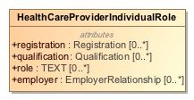

1. HealthCareProviderIndividualRole

|  |  |
| --- | --- |
| **Name** | HealthCareProviderIndividualRole |
| **Qualified Name** | CIMI Clinical::Party::HealthCareProviderIndividualRole |
| **Visibility** | public |
| **Abstract** | false |
| **Base Classifier** | * HealthCareProviderRole |
| **Realized Interface** |  |

### **Attribute Detail**

#### employer

|  |  |
| --- | --- |
| **Type** | EmployerRelationship |
| **Default Value** |  |
| **Visibility** | public |
| **Multiplicity** | 0..* |
| **Definition** |  |

#### qualification

|  |  |
| --- | --- |
| **Type** | Qualification |
| **Default Value** |  |
| **Visibility** | public |
| **Multiplicity** | 0..* |
| **Definition** |  |

#### registration

|  |  |
| --- | --- |
| **Type** | Registration |
| **Default Value** |  |
| **Visibility** | public |
| **Multiplicity** | 0..* |
| **Definition** |  |

#### role

|  |  |
| --- | --- |
| **Type** | TEXT |
| **Default Value** |  |
| **Visibility** | public |
| **Multiplicity** | 0..* |
| **Definition** |  |

### **Relation Detail**

#### Generalization

|  |  |
| --- | --- |
| **Name** |  |
| **Related Element** | * HealthCareProviderRole |

## **Class** **HealthCareProviderOrganizationRole**

-365779988.jpg

1. HealthCareProviderOrganizationRole

|  |  |
| --- | --- |
| **Name** | HealthCareProviderOrganizationRole |
| **Qualified Name** | CIMI Clinical::Party::HealthCareProviderOrganizationRole |
| **Visibility** | public |
| **Abstract** | false |
| **Base Classifier** | * HealthCareProviderRole |
| **Realized Interface** |  |

### **Relation Detail**

#### Generalization

|  |  |
| --- | --- |
| **Name** |  |
| **Related Element** | * HealthCareProviderRole |

## **Class** **HealthCareProviderRole**

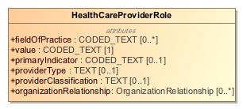

1. HealthCareProviderRole

|  |  |
| --- | --- |
| **Name** | HealthCareProviderRole |
| **Qualified Name** | CIMI Clinical::Party::HealthCareProviderRole |
| **Visibility** | public |
| **Abstract** | false |
| **Base Classifier** | * Role |
| **Realized Interface** |  |

### **Attribute Detail**

#### fieldOfPractice

|  |  |
| --- | --- |
| **Type** | CODED_TEXT |
| **Default Value** |  |
| **Visibility** | public |
| **Multiplicity** | 0..* |
| **Definition** |  |

#### organizationRelationship

|  |  |
| --- | --- |
| **Type** | OrganizationRelationship |
| **Default Value** |  |
| **Visibility** | public |
| **Multiplicity** | 0..* |
| **Definition** |  |

#### primaryIndicator

|  |  |
| --- | --- |
| **Type** | CODED_TEXT |
| **Default Value** |  |
| **Visibility** | public |
| **Multiplicity** | 0..1 |
| **Definition** |  |

#### providerClassification

|  |  |
| --- | --- |
| **Type** | TEXT |
| **Default Value** |  |
| **Visibility** | public |
| **Multiplicity** | 0..1 |
| **Definition** |  |

#### providerType

|  |  |
| --- | --- |
| **Type** | TEXT |
| **Default Value** |  |
| **Visibility** | public |
| **Multiplicity** | 0..1 |
| **Definition** |  |

#### value

|  |  |
| --- | --- |
| **Type** | CODED_TEXT |
| **Default Value** |  |
| **Visibility** | public |
| **Multiplicity** | 1 |
| **Definition** |  |

### **Relation Detail**

#### Generalization

|  |  |
| --- | --- |
| **Name** |  |
| **Related Element** | * HealthCareProviderOrganizationRole |

|  |  |
| --- | --- |
| **Name** |  |
| **Related Element** | * Role |

|  |  |
| --- | --- |
| **Name** |  |
| **Related Element** | * HealthCareProviderIndividualRole |

## **Class** **Party**

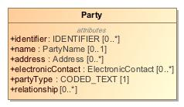

1. Party

|  |  |
| --- | --- |
| **Name** | Party |
| **Qualified Name** | CIMI Clinical::Party::Party |
| **Visibility** | public |
| **Abstract** | false |
| **Base Classifier** | * PARTY |
| **Realized Interface** |  |

### **Attribute Detail**

#### address

|  |  |
| --- | --- |
| **Type** | Address |
| **Default Value** |  |
| **Visibility** | public |
| **Multiplicity** | 0..* |
| **Definition** |  |

#### electronicContact

|  |  |
| --- | --- |
| **Type** | ElectronicContact |
| **Default Value** |  |
| **Visibility** | public |
| **Multiplicity** | 0..* |
| **Definition** |  |

#### identifier

|  |  |
| --- | --- |
| **Type** | IDENTIFIER |
| **Default Value** |  |
| **Visibility** | public |
| **Multiplicity** | 0..* |
| **Definition** |  |

#### name

|  |  |
| --- | --- |
| **Type** | PartyName |
| **Default Value** |  |
| **Visibility** | public |
| **Multiplicity** | 0..1 |
| **Definition** |  |

#### partyType

|  |  |
| --- | --- |
| **Type** | CODED_TEXT |
| **Default Value** |  |
| **Visibility** | public |
| **Multiplicity** | 1 |
| **Definition** |  |

#### relationship

|  |  |
| --- | --- |
| **Type** |  |
| **Default Value** |  |
| **Visibility** | public |
| **Multiplicity** | 0..* |
| **Definition** |  |

### **Relation Detail**

#### Generalization

|  |  |
| --- | --- |
| **Name** |  |
| **Related Element** | * PARTY |

|  |  |
| --- | --- |
| **Name** |  |
| **Related Element** | * Role |

## **Class** **PersonRole**

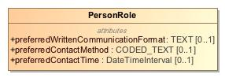

1. PersonRole

|  |  |
| --- | --- |
| **Name** | PersonRole |
| **Qualified Name** | CIMI Clinical::Party::PersonRole |
| **Visibility** | public |
| **Abstract** | false |
| **Base Classifier** | * Role |
| **Realized Interface** |  |

### **Attribute Detail**

#### preferredContactMethod

|  |  |
| --- | --- |
| **Type** | CODED_TEXT |
| **Default Value** |  |
| **Visibility** | public |
| **Multiplicity** | 0..1 |
| **Definition** |  |

#### preferredContactTime

|  |  |
| --- | --- |
| **Type** | DateTimeInterval |
| **Default Value** |  |
| **Visibility** | public |
| **Multiplicity** | 0..1 |
| **Definition** |  |

#### preferredWrittenCommunicationFormat

|  |  |
| --- | --- |
| **Type** | TEXT |
| **Default Value** |  |
| **Visibility** | public |
| **Multiplicity** | 0..1 |
| **Definition** |  |

### **Relation Detail**

#### Generalization

|  |  |
| --- | --- |
| **Name** |  |
| **Related Element** | * Role |

|  |  |
| --- | --- |
| **Name** |  |
| **Related Element** | * HealthCareConsumerRole |

## **Class** **Role**

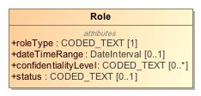

1. Role

|  |  |
| --- | --- |
| **Name** | Role |
| **Qualified Name** | CIMI Clinical::Party::Role |
| **Visibility** | public |
| **Abstract** | false |
| **Base Classifier** | * Party |
| **Realized Interface** |  |

### **Attribute Detail**

#### confidentialityLevel

|  |  |
| --- | --- |
| **Type** | CODED_TEXT |
| **Default Value** |  |
| **Visibility** | public |
| **Multiplicity** | 0..* |
| **Definition** |  |

#### dateTimeRange

|  |  |
| --- | --- |
| **Type** | DateInterval |
| **Default Value** |  |
| **Visibility** | public |
| **Multiplicity** | 0..1 |
| **Definition** |  |

#### roleType

|  |  |
| --- | --- |
| **Type** | CODED_TEXT |
| **Default Value** |  |
| **Visibility** | public |
| **Multiplicity** | 1 |
| **Definition** |  |

#### status

|  |  |
| --- | --- |
| **Type** | CODED_TEXT |
| **Default Value** |  |
| **Visibility** | public |
| **Multiplicity** | 0..1 |
| **Definition** |  |

### **Relation Detail**

#### Generalization

|  |  |
| --- | --- |
| **Name** |  |
| **Related Element** | * HealthCareProviderRole |

|  |  |
| --- | --- |
| **Name** |  |
| **Related Element** | * Party |

|  |  |
| --- | --- |
| **Name** |  |
| **Related Element** | * PersonRole |

# **Package CIMI Clinical::Redefined Datatypes**

|  |  |
| --- | --- |
| **Name** | Redefined Datatypes |
| **Qualified Name** | CIMI Clinical::Redefined Datatypes |

## **Class** **DateInterval**

-1813324537.jpg

1. DateInterval

|  |  |
| --- | --- |
| **Name** | DateInterval |
| **Qualified Name** | CIMI Clinical::Redefined Datatypes::DateInterval |
| **Visibility** | public |
| **Abstract** | false |
| **Base Classifier** |  |
| **Realized Interface** |  |

### **Relation Detail**

#### Template Binding

|  |  |
| --- | --- |
| **Name** |  |
| **Related Element** |  |

## **Class** **DateTimeInterval**

620812094.jpg

1. DateTimeInterval

|  |  |
| --- | --- |
| **Name** | DateTimeInterval |
| **Qualified Name** | CIMI Clinical::Redefined Datatypes::DateTimeInterval |
| **Visibility** | public |
| **Abstract** | false |
| **Base Classifier** |  |
| **Realized Interface** |  |

### **Relation Detail**

#### Template Binding

|  |  |
| --- | --- |
| **Name** |  |
| **Related Element** |  |

# **Package CIMI Clinical::Relationship**

|  |  |
| --- | --- |
| **Name** | Relationship |
| **Qualified Name** | CIMI Clinical::Relationship |

## **Class** **EmployerRelationship**

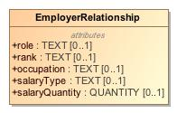

1. EmployerRelationship

|  |  |
| --- | --- |
| **Name** | EmployerRelationship |
| **Qualified Name** | CIMI Clinical::Relationship::EmployerRelationship |
| **Visibility** | public |
| **Abstract** | false |
| **Base Classifier** | * OrganizationRelationship |
| **Realized Interface** |  |

### **Attribute Detail**

#### occupation

|  |  |
| --- | --- |
| **Type** | TEXT |
| **Default Value** |  |
| **Visibility** | public |
| **Multiplicity** | 0..1 |
| **Definition** |  |

#### rank

|  |  |
| --- | --- |
| **Type** | TEXT |
| **Default Value** |  |
| **Visibility** | public |
| **Multiplicity** | 0..1 |
| **Definition** |  |

#### role

|  |  |
| --- | --- |
| **Type** | TEXT |
| **Default Value** |  |
| **Visibility** | public |
| **Multiplicity** | 0..1 |
| **Definition** |  |

#### salaryQuantity

|  |  |
| --- | --- |
| **Type** | QUANTITY |
| **Default Value** |  |
| **Visibility** | public |
| **Multiplicity** | 0..1 |
| **Definition** |  |

#### salaryType

|  |  |
| --- | --- |
| **Type** | TEXT |
| **Default Value** |  |
| **Visibility** | public |
| **Multiplicity** | 0..1 |
| **Definition** |  |

### **Relation Detail**

#### Generalization

|  |  |
| --- | --- |
| **Name** |  |
| **Related Element** | * OrganizationRelationship |

## **Class** **HealthCareProviderRelationship**

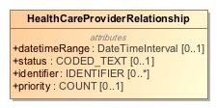

1. HealthCareProviderRelationship

|  |  |
| --- | --- |
| **Name** | HealthCareProviderRelationship |
| **Qualified Name** | CIMI Clinical::Relationship::HealthCareProviderRelationship |
| **Visibility** | public |
| **Abstract** | false |
| **Base Classifier** | * PartyRelationship |
| **Realized Interface** |  |

### **Attribute Detail**

#### datetimeRange

|  |  |
| --- | --- |
| **Type** | DateTimeInterval |
| **Default Value** |  |
| **Visibility** | public |
| **Multiplicity** | 0..1 |
| **Definition** |  |

#### identifier

|  |  |
| --- | --- |
| **Type** | IDENTIFIER |
| **Default Value** |  |
| **Visibility** | public |
| **Multiplicity** | 0..* |
| **Definition** |  |

#### priority

|  |  |
| --- | --- |
| **Type** | COUNT |
| **Default Value** |  |
| **Visibility** | public |
| **Multiplicity** | 0..1 |
| **Definition** |  |

#### status

|  |  |
| --- | --- |
| **Type** | CODED_TEXT |
| **Default Value** |  |
| **Visibility** | public |
| **Multiplicity** | 0..1 |
| **Definition** |  |

### **Relation Detail**

#### Generalization

|  |  |
| --- | --- |
| **Name** |  |
| **Related Element** | * PartyRelationship |

## **Class** **NextOfKinRelationship**

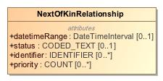

1. NextOfKinRelationship

|  |  |
| --- | --- |
| **Name** | NextOfKinRelationship |
| **Qualified Name** | CIMI Clinical::Relationship::NextOfKinRelationship |
| **Visibility** | public |
| **Abstract** | false |
| **Base Classifier** | * PartyRelationship |
| **Realized Interface** |  |

### **Attribute Detail**

#### datetimeRange

|  |  |
| --- | --- |
| **Type** | DateTimeInterval |
| **Default Value** |  |
| **Visibility** | public |
| **Multiplicity** | 0..1 |
| **Definition** |  |

#### identifier

|  |  |
| --- | --- |
| **Type** | IDENTIFIER |
| **Default Value** |  |
| **Visibility** | public |
| **Multiplicity** | 0..* |
| **Definition** |  |

#### priority

|  |  |
| --- | --- |
| **Type** | COUNT |
| **Default Value** |  |
| **Visibility** | public |
| **Multiplicity** | 0..* |
| **Definition** |  |

#### status

|  |  |
| --- | --- |
| **Type** | CODED_TEXT |
| **Default Value** |  |
| **Visibility** | public |
| **Multiplicity** | 0..1 |
| **Definition** |  |

### **Relation Detail**

#### Generalization

|  |  |
| --- | --- |
| **Name** |  |
| **Related Element** | * PartyRelationship |

## **Class** **OrganizationRelationship**

528355621.jpg

1. OrganizationRelationship

|  |  |
| --- | --- |
| **Name** | OrganizationRelationship |
| **Qualified Name** | CIMI Clinical::Relationship::OrganizationRelationship |
| **Visibility** | public |
| **Abstract** | false |
| **Base Classifier** | * PartyRelationship |
| **Realized Interface** |  |

### **Relation Detail**

#### Generalization

|  |  |
| --- | --- |
| **Name** |  |
| **Related Element** | * PartyRelationship |

|  |  |
| --- | --- |
| **Name** |  |
| **Related Element** | * EmployerRelationship |

## **Class** **PartyRelationship**

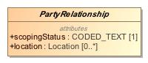

1. PartyRelationship

|  |  |
| --- | --- |
| **Name** | PartyRelationship |
| **Qualified Name** | CIMI Clinical::Relationship::PartyRelationship |
| **Visibility** | public |
| **Abstract** | true |
| **Base Classifier** | * PARTY_RELATIONSHIP |
| **Realized Interface** |  |

### **Attribute Detail**

#### location

|  |  |
| --- | --- |
| **Type** | Location |
| **Default Value** |  |
| **Visibility** | public |
| **Multiplicity** | 0..* |
| **Definition** |  |

#### scopingStatus

|  |  |
| --- | --- |
| **Type** | CODED_TEXT |
| **Default Value** |  |
| **Visibility** | public |
| **Multiplicity** | 1 |
| **Definition** |  |

### **Relation Detail**

#### Generalization

|  |  |
| --- | --- |
| **Name** |  |
| **Related Element** | * NextOfKinRelationship |

|  |  |
| --- | --- |
| **Name** |  |
| **Related Element** | * OrganizationRelationship |

|  |  |
| --- | --- |
| **Name** |  |
| **Related Element** | * PARTY_RELATIONSHIP |

|  |  |
| --- | --- |
| **Name** |  |
| **Related Element** | * HealthCareProviderRelationship |

## **Class** **SubjectOfInformation**

|  |  |
| --- | --- |
| **Name** | SubjectOfInformation |
| **Qualified Name** | CIMI Clinical::Relationship::SubjectOfInformation |
| **Visibility** | public |
| **Abstract** | false |
| **Base Classifier** |  |
| **Realized Interface** |  |

# **Package CIMI Foundation RM**

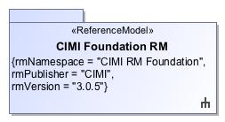

1. CIMI Foundation RM

|  |  |
| --- | --- |
| **Name** | CIMI Foundation RM |
| **Qualified Name** | CIMI Foundation RM |

# **Package CIMI Foundation RM::Foundation**

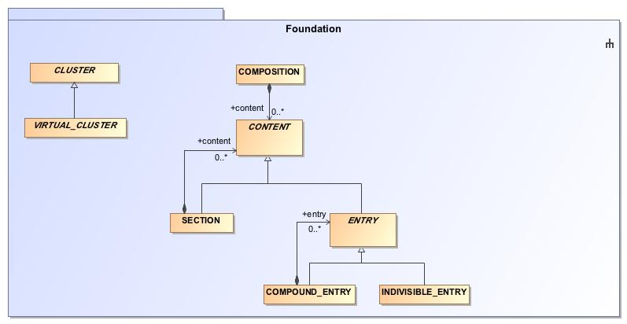

1. Foundation

|  |  |
| --- | --- |
| **Name** | Foundation |
| **Qualified Name** | CIMI Foundation RM::Foundation |

## **Class** **CLUSTER**

1509604747.jpg

1. CLUSTER

|  |  |
| --- | --- |
| **Name** | CLUSTER |
| **Qualified Name** | CIMI Foundation RM::Foundation::CLUSTER |
| **Visibility** | public |
| **Abstract** | true |
| **Base Classifier** | * LOCATABLE |
| **Realized Interface** |  |

### **Attribute Detail**

#### participation

|  |  |
| --- | --- |
| **Type** | PARTICIPATION |
| **Default Value** |  |
| **Visibility** | public |
| **Multiplicity** |  |
| **Definition** |  |

### **Relation Detail**

#### Association

|  |  |
| --- | --- |
| **Name** |  |
| **Related Element** | * PARTICIPATION |

#### Generalization

|  |  |
| --- | --- |
| **Name** |  |
| **Related Element** | * LocationName |

|  |  |
| --- | --- |
| **Name** |  |
| **Related Element** | * ElectronicContact |

|  |  |
| --- | --- |
| **Name** |  |
| **Related Element** | * Street |

|  |  |
| --- | --- |
| **Name** |  |
| **Related Element** | * Action |

|  |  |
| --- | --- |
| **Name** |  |
| **Related Element** | * LOCATABLE |

|  |  |
| --- | --- |
| **Name** |  |
| **Related Element** | * Address |

|  |  |
| --- | --- |
| **Name** |  |
| **Related Element** | * RelatedClinicalStatement |

|  |  |
| --- | --- |
| **Name** |  |
| **Related Element** | * Location |

|  |  |
| --- | --- |
| **Name** |  |
| **Related Element** | * AddressLine |

|  |  |
| --- | --- |
| **Name** |  |
| **Related Element** | * Signature |

|  |  |
| --- | --- |
| **Name** |  |
| **Related Element** | * VIRTUAL_CLUSTER |

|  |  |
| --- | --- |
| **Name** |  |
| **Related Element** | * MaterialEntity |

|  |  |
| --- | --- |
| **Name** |  |
| **Related Element** | * StreetNumber |

|  |  |
| --- | --- |
| **Name** |  |
| **Related Element** | * Provenance |

|  |  |
| --- | --- |
| **Name** |  |
| **Related Element** | * PartyName |

|  |  |
| --- | --- |
| **Name** |  |
| **Related Element** | * Use |

|  |  |
| --- | --- |
| **Name** |  |
| **Related Element** | * ReferenceRange |

|  |  |
| --- | --- |
| **Name** |  |
| **Related Element** | * Qualification |

|  |  |
| --- | --- |
| **Name** |  |
| **Related Element** | * ActionSet |

|  |  |
| --- | --- |
| **Name** |  |
| **Related Element** | * Registration |

|  |  |
| --- | --- |
| **Name** |  |
| **Related Element** | * Part |

## **Class** **COMPOSITION**

1012610853.jpg

1. COMPOSITION

|  |  |
| --- | --- |
| **Name** | COMPOSITION |
| **Qualified Name** | CIMI Foundation RM::Foundation::COMPOSITION |
| **Visibility** | public |
| **Abstract** | false |
| **Base Classifier** | * LOCATABLE |
| **Realized Interface** |  |

### **Attribute Detail**

#### content

|  |  |
| --- | --- |
| **Type** | CONTENT |
| **Default Value** |  |
| **Visibility** | public |
| **Multiplicity** | 0..* |
| **Definition** |  |

#### participation

|  |  |
| --- | --- |
| **Type** | PARTICIPATION |
| **Default Value** |  |
| **Visibility** | public |
| **Multiplicity** | 0..* |
| **Definition** |  |

### **Relation Detail**

#### Association

|  |  |
| --- | --- |
| **Name** |  |
| **Related Element** | * CONTENT |

|  |  |
| --- | --- |
| **Name** |  |
| **Related Element** | * PARTICIPATION |

#### Generalization

|  |  |
| --- | --- |
| **Name** |  |
| **Related Element** | * LOCATABLE |

## **Class** **COMPOUND_ENTRY**

-786303411.jpg

1. COMPOUND_ENTRY

|  |  |
| --- | --- |
| **Name** | COMPOUND_ENTRY |
| **Qualified Name** | CIMI Foundation RM::Foundation::COMPOUND_ENTRY |
| **Visibility** | public |
| **Abstract** | false |
| **Base Classifier** | * ENTRY |
| **Realized Interface** |  |

### **Attribute Detail**

#### entry

|  |  |
| --- | --- |
| **Type** | ENTRY |
| **Default Value** |  |
| **Visibility** | public |
| **Multiplicity** | 0..* |
| **Definition** |  |

### **Relation Detail**

#### Association

|  |  |
| --- | --- |
| **Name** |  |
| **Related Element** | * ENTRY |

#### Generalization

|  |  |
| --- | --- |
| **Name** |  |
| **Related Element** | * ENTRY |

|  |  |
| --- | --- |
| **Name** |  |
| **Related Element** | * CompoundClinicalStatement |

## **Class** **CONTENT**

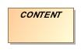

1. CONTENT

|  |  |
| --- | --- |
| **Name** | CONTENT |
| **Qualified Name** | CIMI Foundation RM::Foundation::CONTENT |
| **Visibility** | public |
| **Abstract** | true |
| **Base Classifier** | * LOCATABLE |
| **Realized Interface** |  |

### **Relation Detail**

#### Association

|  |  |
| --- | --- |
| **Name** |  |
| **Related Element** | * SECTION |

|  |  |
| --- | --- |
| **Name** |  |
| **Related Element** | * COMPOSITION |

#### Generalization

|  |  |
| --- | --- |
| **Name** |  |
| **Related Element** | * LOCATABLE |

|  |  |
| --- | --- |
| **Name** |  |
| **Related Element** | * ENTRY |

|  |  |
| --- | --- |
| **Name** |  |
| **Related Element** | * SECTION |

## **Class** **ENTRY**

795160522.jpg

1. ENTRY

|  |  |
| --- | --- |
| **Name** | ENTRY |
| **Qualified Name** | CIMI Foundation RM::Foundation::ENTRY |
| **Visibility** | public |
| **Abstract** | true |
| **Base Classifier** | * CONTENT |
| **Realized Interface** |  |

### **Attribute Detail**

#### participation

|  |  |
| --- | --- |
| **Type** | PARTICIPATION |
| **Default Value** |  |
| **Visibility** | public |
| **Multiplicity** | 0..* |
| **Definition** |  |

### **Relation Detail**

#### Association

|  |  |
| --- | --- |
| **Name** |  |
| **Related Element** | * COMPOUND_ENTRY |

|  |  |
| --- | --- |
| **Name** |  |
| **Related Element** | * PARTICIPATION |

#### Generalization

|  |  |
| --- | --- |
| **Name** |  |
| **Related Element** | * COMPOUND_ENTRY |

|  |  |
| --- | --- |
| **Name** |  |
| **Related Element** | * INDIVISIBLE_ENTRY |

|  |  |
| --- | --- |
| **Name** |  |
| **Related Element** | * ClinicalStatement |

|  |  |
| --- | --- |
| **Name** |  |
| **Related Element** | * CONTENT |

## **Class** **INDIVISIBLE_ENTRY**

1295820635.jpg

1. INDIVISIBLE_ENTRY

|  |  |
| --- | --- |
| **Name** | INDIVISIBLE_ENTRY |
| **Qualified Name** | CIMI Foundation RM::Foundation::INDIVISIBLE_ENTRY |
| **Visibility** | public |
| **Abstract** | false |
| **Base Classifier** | * ENTRY |
| **Realized Interface** |  |

### **Relation Detail**

#### Generalization

|  |  |
| --- | --- |
| **Name** |  |
| **Related Element** | * ENTRY |

|  |  |
| --- | --- |
| **Name** |  |
| **Related Element** | * IndivisibleClinicalStatement |

## **Class** **SECTION**

1368420154.jpg

1. SECTION

|  |  |
| --- | --- |
| **Name** | SECTION |
| **Qualified Name** | CIMI Foundation RM::Foundation::SECTION |
| **Visibility** | public |
| **Abstract** | false |
| **Base Classifier** | * CONTENT |
| **Realized Interface** |  |

### **Attribute Detail**

#### content

|  |  |
| --- | --- |
| **Type** | CONTENT |
| **Default Value** |  |
| **Visibility** | public |
| **Multiplicity** | 0..* |
| **Definition** |  |

### **Relation Detail**

#### Association

|  |  |
| --- | --- |
| **Name** |  |
| **Related Element** | * CONTENT |

#### Generalization

|  |  |
| --- | --- |
| **Name** |  |
| **Related Element** | * CONTENT |

## **Class** **VIRTUAL_CLUSTER**

895402206.jpg

1. VIRTUAL_CLUSTER

|  |  |
| --- | --- |
| **Name** | VIRTUAL_CLUSTER |
| **Qualified Name** | CIMI Foundation RM::Foundation::VIRTUAL_CLUSTER |
| **Visibility** | public |
| **Abstract** | true |
| **Base Classifier** | * CLUSTER |
| **Realized Interface** |  |

### **Relation Detail**

#### Generalization

|  |  |
| --- | --- |
| **Name** |  |
| **Related Element** | * StatementTopic |

|  |  |
| --- | --- |
| **Name** |  |
| **Related Element** | * StatementContext |

|  |  |
| --- | --- |
| **Name** |  |
| **Related Element** | * CLUSTER |

# **Package CIMI Reference Model**

|  |  |
| --- | --- |
| **Name** | CIMI Reference Model |
| **Qualified Name** | CIMI Reference Model |

# **Package CIMI Reference Model::Core**

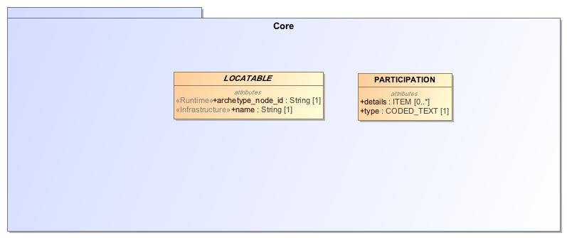

1. Core

|  |  |
| --- | --- |
| **Name** | Core |
| **Qualified Name** | CIMI Reference Model::Core |

## **Class** **ARCHETYPED**

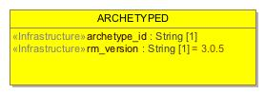

1. ARCHETYPED

|  |  |
| --- | --- |
| **Name** | ARCHETYPED |
| **Qualified Name** | CIMI Reference Model::Core::ARCHETYPED |
| **Visibility** | public |
| **Abstract** | false |
| **Base Classifier** |  |
| **Realized Interface** |  |

### **Attribute Detail**

#### archetype_id

|  |  |
| --- | --- |
| **Type** | String |
| **Default Value** |  |
| **Visibility** | public |
| **Multiplicity** | 1 |
| **Definition** |  |

#### rm_version

|  |  |
| --- | --- |
| **Type** | String |
| **Default Value** | 3.0.5 |
| **Visibility** | public |
| **Multiplicity** | 1 |
| **Definition** |  |

### **Relation Detail**

#### Association

|  |  |
| --- | --- |
| **Name** |  |
| **Related Element** | * LOCATABLE |

## **Class** **ELEMENT**

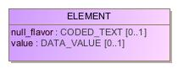

1. ELEMENT

|  |  |
| --- | --- |
| **Name** | ELEMENT |
| **Qualified Name** | CIMI Reference Model::Core::ELEMENT |
| **Visibility** | public |
| **Abstract** | false |
| **Base Classifier** | * ITEM |
| **Realized Interface** |  |

### **Attribute Detail**

#### null_flavor

|  |  |
| --- | --- |
| **Type** | CODED_TEXT |
| **Default Value** |  |
| **Visibility** | public |
| **Multiplicity** | 0..1 |
| **Definition** |  |

#### value

|  |  |
| --- | --- |
| **Type** | DATA_VALUE |
| **Default Value** |  |
| **Visibility** | public |
| **Multiplicity** | 0..1 |
| **Definition** |  |

### **Relation Detail**

#### Generalization

|  |  |
| --- | --- |
| **Name** |  |
| **Related Element** | * ITEM |

## **Class** **ITEM**

-1273539873.jpg

1. ITEM

|  |  |
| --- | --- |
| **Name** | ITEM |
| **Qualified Name** | CIMI Reference Model::Core::ITEM |
| **Visibility** | public |
| **Abstract** | true |
| **Base Classifier** | * LOCATABLE |
| **Realized Interface** |  |

### **Relation Detail**

#### Association

|  |  |
| --- | --- |
| **Name** |  |
| **Related Element** | * ITEM_GROUP |

#### Generalization

|  |  |
| --- | --- |
| **Name** |  |
| **Related Element** | * LOCATABLE |

|  |  |
| --- | --- |
| **Name** |  |
| **Related Element** | * ELEMENT |

|  |  |
| --- | --- |
| **Name** |  |
| **Related Element** | * ITEM_GROUP |

## **Class** **ITEM_GROUP**



1. ITEM_GROUP

|  |  |
| --- | --- |
| **Name** | ITEM_GROUP |
| **Qualified Name** | CIMI Reference Model::Core::ITEM_GROUP |
| **Visibility** | public |
| **Abstract** | false |
| **Base Classifier** | * ITEM |
| **Realized Interface** |  |

### **Attribute Detail**

#### item

|  |  |
| --- | --- |
| **Type** | ITEM |
| **Default Value** |  |
| **Visibility** | public |
| **Multiplicity** | 1..* |
| **Definition** |  |

#### participation

|  |  |
| --- | --- |
| **Type** | PARTICIPATION |
| **Default Value** |  |
| **Visibility** | public |
| **Multiplicity** | 0..* |
| **Definition** |  |

### **Relation Detail**

#### Association

|  |  |
| --- | --- |
| **Name** |  |
| **Related Element** | * ITEM |

|  |  |
| --- | --- |
| **Name** |  |
| **Related Element** | * PARTICIPATION |

#### Generalization

|  |  |
| --- | --- |
| **Name** |  |
| **Related Element** | * ITEM |

## **Class** **LINK**

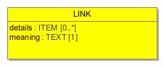

1. LINK

|  |  |
| --- | --- |
| **Name** | LINK |
| **Qualified Name** | CIMI Reference Model::Core::LINK |
| **Visibility** | public |
| **Abstract** | false |
| **Base Classifier** |  |
| **Realized Interface** |  |

### **Attribute Detail**

#### details

|  |  |
| --- | --- |
| **Type** | ITEM |
| **Default Value** |  |
| **Visibility** | public |
| **Multiplicity** | 0..* |
| **Definition** |  |

#### meaning

|  |  |
| --- | --- |
| **Type** | TEXT |
| **Default Value** |  |
| **Visibility** | public |
| **Multiplicity** | 1 |
| **Definition** |  |

#### target

|  |  |
| --- | --- |
| **Type** | LOCATABLE |
| **Default Value** |  |
| **Visibility** | public |
| **Multiplicity** | 1 |
| **Definition** |  |

### **Relation Detail**

#### Association

|  |  |
| --- | --- |
| **Name** |  |
| **Related Element** | * LOCATABLE |

|  |  |
| --- | --- |
| **Name** |  |
| **Related Element** | * LOCATABLE |

## **Class** **LOCATABLE**

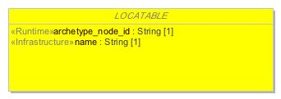

1. LOCATABLE

|  |  |
| --- | --- |
| **Name** | LOCATABLE |
| **Qualified Name** | CIMI Reference Model::Core::LOCATABLE |
| **Visibility** | public |
| **Abstract** | true |
| **Base Classifier** |  |
| **Realized Interface** |  |

### **Attribute Detail**

#### archetype_details

|  |  |
| --- | --- |
| **Type** | ARCHETYPED |
| **Default Value** |  |
| **Visibility** | public |
| **Multiplicity** | 0..1 |
| **Definition** |  |

#### archetype_node_id

|  |  |
| --- | --- |
| **Type** | String |
| **Default Value** |  |
| **Visibility** | public |
| **Multiplicity** | 1 |
| **Definition** |  |

#### link

|  |  |
| --- | --- |
| **Type** | LINK |
| **Default Value** |  |
| **Visibility** | public |
| **Multiplicity** | 0..* |
| **Definition** |  |

#### name

|  |  |
| --- | --- |
| **Type** | String |
| **Default Value** |  |
| **Visibility** | public |
| **Multiplicity** | 1 |
| **Definition** |  |

### **Relation Detail**

#### Association

|  |  |
| --- | --- |
| **Name** |  |
| **Related Element** | * ARCHETYPED |

|  |  |
| --- | --- |
| **Name** |  |
| **Related Element** | * LINK |

|  |  |
| --- | --- |
| **Name** |  |
| **Related Element** | * LINK |

#### Generalization

|  |  |
| --- | --- |
| **Name** |  |
| **Related Element** | * PARTY |

|  |  |
| --- | --- |
| **Name** |  |
| **Related Element** | * CONTENT |

|  |  |
| --- | --- |
| **Name** |  |
| **Related Element** | * CLUSTER |

|  |  |
| --- | --- |
| **Name** |  |
| **Related Element** | * ITEM |

|  |  |
| --- | --- |
| **Name** |  |
| **Related Element** | * PARTICIPATION |

|  |  |
| --- | --- |
| **Name** |  |
| **Related Element** | * PARTY_RELATIONSHIP |

|  |  |
| --- | --- |
| **Name** |  |
| **Related Element** | * COMPOSITION |

## **Class** **PARTICIPATION**

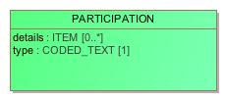

1. PARTICIPATION

|  |  |
| --- | --- |
| **Name** | PARTICIPATION |
| **Qualified Name** | CIMI Reference Model::Core::PARTICIPATION |
| **Visibility** | public |
| **Abstract** | false |
| **Base Classifier** | * LOCATABLE |
| **Realized Interface** |  |

### **Attribute Detail**

#### details

|  |  |
| --- | --- |
| **Type** | ITEM |
| **Default Value** |  |
| **Visibility** | public |
| **Multiplicity** | 0..* |
| **Definition** |  |

#### party

|  |  |
| --- | --- |
| **Type** | PARTY |
| **Default Value** |  |
| **Visibility** | public |
| **Multiplicity** | 1 |
| **Definition** |  |

#### type

|  |  |
| --- | --- |
| **Type** | CODED_TEXT |
| **Default Value** |  |
| **Visibility** | public |
| **Multiplicity** | 1 |
| **Definition** |  |

### **Relation Detail**

#### Association

|  |  |
| --- | --- |
| **Name** |  |
| **Related Element** | * CLUSTER |

|  |  |
| --- | --- |
| **Name** |  |
| **Related Element** | * PARTY |

|  |  |
| --- | --- |
| **Name** |  |
| **Related Element** | * COMPOSITION |

|  |  |
| --- | --- |
| **Name** |  |
| **Related Element** | * ITEM_GROUP |

|  |  |
| --- | --- |
| **Name** |  |
| **Related Element** | * ENTRY |

#### Generalization

|  |  |
| --- | --- |
| **Name** |  |
| **Related Element** | * LOCATABLE |

|  |  |
| --- | --- |
| **Name** |  |
| **Related Element** | * SubjectOfInformation |

# **Package CIMI Reference Model::Data Value Types**

|  |  |
| --- | --- |
| **Name** | Data Value Types |
| **Qualified Name** | CIMI Reference Model::Data Value Types |

## **Class** **AMOUNT**

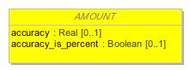

1. AMOUNT

|  |  |
| --- | --- |
| **Name** | AMOUNT |
| **Qualified Name** | CIMI Reference Model::Data Value Types::AMOUNT |
| **Visibility** | public |
| **Abstract** | true |
| **Base Classifier** | * QUANTIFIED |
| **Realized Interface** |  |

### **Attribute Detail**

#### accuracy

|  |  |
| --- | --- |
| **Type** | Real |
| **Default Value** |  |
| **Visibility** | public |
| **Multiplicity** | 0..1 |
| **Definition** |  |

#### accuracy_is_percent

|  |  |
| --- | --- |
| **Type** | Boolean |
| **Default Value** |  |
| **Visibility** | public |
| **Multiplicity** | 0..1 |
| **Definition** |  |

### **Relation Detail**

#### Generalization

|  |  |
| --- | --- |
| **Name** |  |
| **Related Element** | * COUNT |

|  |  |
| --- | --- |
| **Name** |  |
| **Related Element** | * QUANTITY |

|  |  |
| --- | --- |
| **Name** |  |
| **Related Element** | * QUANTIFIED |

|  |  |
| --- | --- |
| **Name** |  |
| **Related Element** | * PROPORTION |

## **Class** **CODED_TEXT**

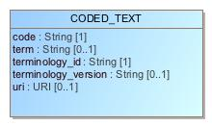

1. CODED_TEXT

|  |  |
| --- | --- |
| **Name** | CODED_TEXT |
| **Qualified Name** | CIMI Reference Model::Data Value Types::CODED_TEXT |
| **Visibility** | public |
| **Abstract** | false |
| **Base Classifier** | * TEXT |
| **Realized Interface** |  |

### **Attribute Detail**

#### code

|  |  |
| --- | --- |
| **Type** | String |
| **Default Value** |  |
| **Visibility** | public |
| **Multiplicity** | 1 |
| **Definition** |  |

#### term

|  |  |
| --- | --- |
| **Type** | String |
| **Default Value** |  |
| **Visibility** | public |
| **Multiplicity** | 0..1 |
| **Definition** |  |

#### terminology_id

|  |  |
| --- | --- |
| **Type** | String |
| **Default Value** |  |
| **Visibility** | public |
| **Multiplicity** | 1 |
| **Definition** |  |

#### terminology_version

|  |  |
| --- | --- |
| **Type** | String |
| **Default Value** |  |
| **Visibility** | public |
| **Multiplicity** | 0..1 |
| **Definition** |  |

#### uri

|  |  |
| --- | --- |
| **Type** | URI |
| **Default Value** |  |
| **Visibility** | public |
| **Multiplicity** | 0..1 |
| **Definition** |  |

### **Relation Detail**

#### Association

|  |  |
| --- | --- |
| **Name** |  |
| **Related Element** | * TERM_MAPPING |

#### Generalization

|  |  |
| --- | --- |
| **Name** |  |
| **Related Element** | * TEXT |

## **Class** **COUNT**

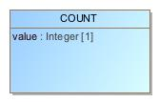

1. COUNT

|  |  |
| --- | --- |
| **Name** | COUNT |
| **Qualified Name** | CIMI Reference Model::Data Value Types::COUNT |
| **Visibility** | public |
| **Abstract** | false |
| **Base Classifier** | * AMOUNT |
| **Realized Interface** |  |

### **Attribute Detail**

#### value

|  |  |
| --- | --- |
| **Type** | Integer |
| **Default Value** |  |
| **Visibility** | public |
| **Multiplicity** | 1 |
| **Definition** |  |

### **Relation Detail**

#### Generalization

|  |  |
| --- | --- |
| **Name** |  |
| **Related Element** | * AMOUNT |

## **Class** **DATA_VALUE**

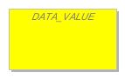

1. DATA_VALUE

|  |  |
| --- | --- |
| **Name** | DATA_VALUE |
| **Qualified Name** | CIMI Reference Model::Data Value Types::DATA_VALUE |
| **Visibility** | public |
| **Abstract** | true |
| **Base Classifier** |  |
| **Realized Interface** |  |

### **Relation Detail**

#### Generalization

|  |  |
| --- | --- |
| **Name** |  |
| **Related Element** | * ENCAPSULATED |

|  |  |
| --- | --- |
| **Name** |  |
| **Related Element** | * ORDERED_VALUE |

|  |  |
| --- | --- |
| **Name** |  |
| **Related Element** | * TEXT |

|  |  |
| --- | --- |
| **Name** |  |
| **Related Element** | * INTERVAL_VALUE |

|  |  |
| --- | --- |
| **Name** |  |
| **Related Element** | * URI_VALUE |

|  |  |
| --- | --- |
| **Name** |  |
| **Related Element** | * IDENTIFIER |

|  |  |
| --- | --- |
| **Name** |  |
| **Related Element** | * YESNO |

## **Class** **DATE**

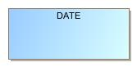

1. DATE

|  |  |
| --- | --- |
| **Name** | DATE |
| **Qualified Name** | CIMI Reference Model::Data Value Types::DATE |
| **Visibility** | public |
| **Abstract** | false |
| **Base Classifier** | * DATE_TIME |
| **Realized Interface** |  |

### **Relation Detail**

#### Generalization

|  |  |
| --- | --- |
| **Name** |  |
| **Related Element** | * DATE_TIME |

## **Class** **DATE_TIME**

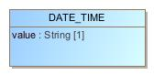

1. DATE_TIME

|  |  |
| --- | --- |
| **Name** | DATE_TIME |
| **Qualified Name** | CIMI Reference Model::Data Value Types::DATE_TIME |
| **Visibility** | public |
| **Abstract** | false |
| **Base Classifier** | * QUANTIFIED |
| **Realized Interface** |  |

### **Attribute Detail**

#### value

|  |  |
| --- | --- |
| **Type** | String |
| **Default Value** |  |
| **Visibility** | public |
| **Multiplicity** | 1 |
| **Definition** |  |

### **Relation Detail**

#### Generalization

|  |  |
| --- | --- |
| **Name** |  |
| **Related Element** | * QUANTIFIED |

|  |  |
| --- | --- |
| **Name** |  |
| **Related Element** | * TIME |

|  |  |
| --- | --- |
| **Name** |  |
| **Related Element** | * DATE |

## **Class** **DURATION**

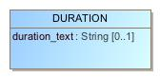

1. DURATION

|  |  |
| --- | --- |
| **Name** | DURATION |
| **Qualified Name** | CIMI Reference Model::Data Value Types::DURATION |
| **Visibility** | public |
| **Abstract** | false |
| **Base Classifier** | * QUANTITY |
| **Realized Interface** |  |

### **Attribute Detail**

#### duration_text

|  |  |
| --- | --- |
| **Type** | String |
| **Default Value** |  |
| **Visibility** | public |
| **Multiplicity** | 0..1 |
| **Definition** |  |

### **Operation Detail**

#### is_strictly_comparable_to

|  |  |
| --- | --- |
| **Type** |  |
| **Visibility** | public |
| **Is Abstract** | false |
| **Parameter** | * in other : |

### **Relation Detail**

#### Generalization

|  |  |
| --- | --- |
| **Name** |  |
| **Related Element** | * QUANTITY |

## **Class** **EHR_URI**

1658395172.jpg

1. EHR_URI

|  |  |
| --- | --- |
| **Name** | EHR_URI |
| **Qualified Name** | CIMI Reference Model::Data Value Types::EHR_URI |
| **Visibility** | public |
| **Abstract** | false |
| **Base Classifier** | * URI_VALUE |
| **Realized Interface** |  |

### **Relation Detail**

#### Generalization

|  |  |
| --- | --- |
| **Name** |  |
| **Related Element** | * URI_VALUE |

## **Class** **ENCAPSULATED**

-357038799.jpg

1. ENCAPSULATED

|  |  |
| --- | --- |
| **Name** | ENCAPSULATED |
| **Qualified Name** | CIMI Reference Model::Data Value Types::ENCAPSULATED |
| **Visibility** | public |
| **Abstract** | true |
| **Base Classifier** | * DATA_VALUE |
| **Realized Interface** |  |

### **Relation Detail**

#### Generalization

|  |  |
| --- | --- |
| **Name** |  |
| **Related Element** | * DATA_VALUE |

|  |  |
| --- | --- |
| **Name** |  |
| **Related Element** | * PARSABLE |

|  |  |
| --- | --- |
| **Name** |  |
| **Related Element** | * MULTIMEDIA |

## **Class** **IDENTIFIER**

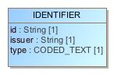

1. IDENTIFIER

|  |  |
| --- | --- |
| **Name** | IDENTIFIER |
| **Qualified Name** | CIMI Reference Model::Data Value Types::IDENTIFIER |
| **Visibility** | public |
| **Abstract** | false |
| **Base Classifier** | * DATA_VALUE |
| **Realized Interface** |  |

### **Attribute Detail**

#### id

|  |  |
| --- | --- |
| **Type** | String |
| **Default Value** |  |
| **Visibility** | public |
| **Multiplicity** | 1 |
| **Definition** |  |

#### issuer

|  |  |
| --- | --- |
| **Type** | String |
| **Default Value** |  |
| **Visibility** | public |
| **Multiplicity** | 1 |
| **Definition** |  |

#### type

|  |  |
| --- | --- |
| **Type** | CODED_TEXT |
| **Default Value** |  |
| **Visibility** | public |
| **Multiplicity** | 1 |
| **Definition** |  |

### **Relation Detail**

#### Generalization

|  |  |
| --- | --- |
| **Name** |  |
| **Related Element** | * DATA_VALUE |

## **Class** **INTERVAL_VALUE**

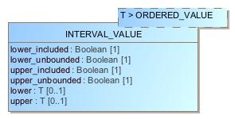

1. INTERVAL_VALUE

|  |  |
| --- | --- |
| **Name** | INTERVAL_VALUE |
| **Qualified Name** | CIMI Reference Model::Data Value Types::INTERVAL_VALUE |
| **Visibility** | public |
| **Abstract** | false |
| **Base Classifier** | * DATA_VALUE |
| **Realized Interface** |  |

### **Attribute Detail**

#### lower

|  |  |
| --- | --- |
| **Type** | T |
| **Default Value** |  |
| **Visibility** | public |
| **Multiplicity** | 0..1 |
| **Definition** |  |

#### lower_included

|  |  |
| --- | --- |
| **Type** | Boolean |
| **Default Value** |  |
| **Visibility** | public |
| **Multiplicity** | 1 |
| **Definition** |  |

#### lower_unbounded

|  |  |
| --- | --- |
| **Type** | Boolean |
| **Default Value** |  |
| **Visibility** | public |
| **Multiplicity** | 1 |
| **Definition** |  |

#### upper

|  |  |
| --- | --- |
| **Type** | T |
| **Default Value** |  |
| **Visibility** | public |
| **Multiplicity** | 0..1 |
| **Definition** |  |

#### upper_included

|  |  |
| --- | --- |
| **Type** | Boolean |
| **Default Value** |  |
| **Visibility** | public |
| **Multiplicity** | 1 |
| **Definition** |  |

#### upper_unbounded

|  |  |
| --- | --- |
| **Type** | Boolean |
| **Default Value** |  |
| **Visibility** | public |
| **Multiplicity** | 1 |
| **Definition** |  |

### **Relation Detail**

#### Generalization

|  |  |
| --- | --- |
| **Name** |  |
| **Related Element** | * DATA_VALUE |

## **Class** **MULTIMEDIA**

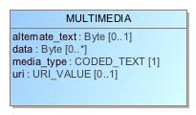

1. MULTIMEDIA

|  |  |
| --- | --- |
| **Name** | MULTIMEDIA |
| **Qualified Name** | CIMI Reference Model::Data Value Types::MULTIMEDIA |
| **Visibility** | public |
| **Abstract** | false |
| **Base Classifier** | * ENCAPSULATED |
| **Realized Interface** |  |

### **Attribute Detail**

#### alternate_text

|  |  |
| --- | --- |
| **Type** | Byte |
| **Default Value** |  |
| **Visibility** | public |
| **Multiplicity** | 0..1 |
| **Definition** |  |

#### data

|  |  |
| --- | --- |
| **Type** | Byte |
| **Default Value** |  |
| **Visibility** | public |
| **Multiplicity** | 0..* |
| **Definition** |  |

#### media_type

|  |  |
| --- | --- |
| **Type** | CODED_TEXT |
| **Default Value** |  |
| **Visibility** | public |
| **Multiplicity** | 1 |
| **Definition** |  |

#### uri

|  |  |
| --- | --- |
| **Type** | URI_VALUE |
| **Default Value** |  |
| **Visibility** | public |
| **Multiplicity** | 0..1 |
| **Definition** |  |

### **Relation Detail**

#### Generalization

|  |  |
| --- | --- |
| **Name** |  |
| **Related Element** | * ENCAPSULATED |

## **Class** **ORDERED_VALUE**

1872616523.jpg

1. ORDERED_VALUE

|  |  |
| --- | --- |
| **Name** | ORDERED_VALUE |
| **Qualified Name** | CIMI Reference Model::Data Value Types::ORDERED_VALUE |
| **Visibility** | public |
| **Abstract** | true |
| **Base Classifier** | * DATA_VALUE |
| **Realized Interface** |  |

### **Relation Detail**

#### Generalization

|  |  |
| --- | --- |
| **Name** |  |
| **Related Element** | * ORDINAL |

|  |  |
| --- | --- |
| **Name** |  |
| **Related Element** | * QUANTIFIED |

|  |  |
| --- | --- |
| **Name** |  |
| **Related Element** | * DATA_VALUE |

## **Class** **ORDINAL**

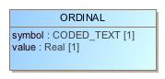

1. ORDINAL

|  |  |
| --- | --- |
| **Name** | ORDINAL |
| **Qualified Name** | CIMI Reference Model::Data Value Types::ORDINAL |
| **Visibility** | public |
| **Abstract** | false |
| **Base Classifier** | * ORDERED_VALUE |
| **Realized Interface** |  |

### **Attribute Detail**

#### symbol

|  |  |
| --- | --- |
| **Type** | CODED_TEXT |
| **Default Value** |  |
| **Visibility** | public |
| **Multiplicity** | 1 |
| **Definition** |  |

#### value

|  |  |
| --- | --- |
| **Type** | Real |
| **Default Value** |  |
| **Visibility** | public |
| **Multiplicity** | 1 |
| **Definition** |  |

### **Relation Detail**

#### Generalization

|  |  |
| --- | --- |
| **Name** |  |
| **Related Element** | * ORDERED_VALUE |

## **Class** **PARSABLE**

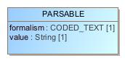

1. PARSABLE

|  |  |
| --- | --- |
| **Name** | PARSABLE |
| **Qualified Name** | CIMI Reference Model::Data Value Types::PARSABLE |
| **Visibility** | public |
| **Abstract** | false |
| **Base Classifier** | * ENCAPSULATED |
| **Realized Interface** |  |

### **Attribute Detail**

#### formalism

|  |  |
| --- | --- |
| **Type** | CODED_TEXT |
| **Default Value** |  |
| **Visibility** | public |
| **Multiplicity** | 1 |
| **Definition** |  |

#### value

|  |  |
| --- | --- |
| **Type** | String |
| **Default Value** |  |
| **Visibility** | public |
| **Multiplicity** | 1 |
| **Definition** |  |

### **Relation Detail**

#### Generalization

|  |  |
| --- | --- |
| **Name** |  |
| **Related Element** | * ENCAPSULATED |

## **Class** **PLAIN_TEXT**

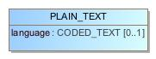

1. PLAIN_TEXT

|  |  |
| --- | --- |
| **Name** | PLAIN_TEXT |
| **Qualified Name** | CIMI Reference Model::Data Value Types::PLAIN_TEXT |
| **Visibility** | public |
| **Abstract** | false |
| **Base Classifier** | * TEXT |
| **Realized Interface** |  |

### **Attribute Detail**

#### language

|  |  |
| --- | --- |
| **Type** | CODED_TEXT |
| **Default Value** |  |
| **Visibility** | public |
| **Multiplicity** | 0..1 |
| **Definition** |  |

### **Relation Detail**

#### Generalization

|  |  |
| --- | --- |
| **Name** |  |
| **Related Element** | * TEXT |

## **Class** **PROPORTION**

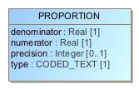

1. PROPORTION

|  |  |
| --- | --- |
| **Name** | PROPORTION |
| **Qualified Name** | CIMI Reference Model::Data Value Types::PROPORTION |
| **Visibility** | public |
| **Abstract** | false |
| **Base Classifier** | * AMOUNT |
| **Realized Interface** |  |

### **Attribute Detail**

#### denominator

|  |  |
| --- | --- |
| **Type** | Real |
| **Default Value** |  |
| **Visibility** | public |
| **Multiplicity** | 1 |
| **Definition** |  |

#### numerator

|  |  |
| --- | --- |
| **Type** | Real |
| **Default Value** |  |
| **Visibility** | public |
| **Multiplicity** | 1 |
| **Definition** |  |

#### precision

|  |  |
| --- | --- |
| **Type** | Integer |
| **Default Value** |  |
| **Visibility** | public |
| **Multiplicity** | 0..1 |
| **Definition** |  |

#### type

|  |  |
| --- | --- |
| **Type** | CODED_TEXT |
| **Default Value** |  |
| **Visibility** | public |
| **Multiplicity** | 1 |
| **Definition** |  |

### **Relation Detail**

#### Generalization

|  |  |
| --- | --- |
| **Name** |  |
| **Related Element** | * AMOUNT |

## **Class** **QUANTIFIED**

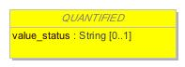

1. QUANTIFIED

|  |  |
| --- | --- |
| **Name** | QUANTIFIED |
| **Qualified Name** | CIMI Reference Model::Data Value Types::QUANTIFIED |
| **Visibility** | public |
| **Abstract** | true |
| **Base Classifier** | * ORDERED_VALUE |
| **Realized Interface** |  |

### **Attribute Detail**

#### value_status

|  |  |
| --- | --- |
| **Type** | String |
| **Default Value** |  |
| **Visibility** | public |
| **Multiplicity** | 0..1 |
| **Definition** |  |

### **Relation Detail**

#### Dependency

|  |  |
| --- | --- |
| **Name** |  |
| **Related Element** | * QuantifiedValueStatusEnum |

#### Generalization

|  |  |
| --- | --- |
| **Name** |  |
| **Related Element** | * ORDERED_VALUE |

|  |  |
| --- | --- |
| **Name** |  |
| **Related Element** | * DATE_TIME |

|  |  |
| --- | --- |
| **Name** |  |
| **Related Element** | * AMOUNT |

## **Class** **QUANTITY**

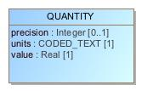

1. QUANTITY

|  |  |
| --- | --- |
| **Name** | QUANTITY |
| **Qualified Name** | CIMI Reference Model::Data Value Types::QUANTITY |
| **Visibility** | public |
| **Abstract** | false |
| **Base Classifier** | * AMOUNT |
| **Realized Interface** |  |

### **Attribute Detail**

#### precision

|  |  |
| --- | --- |
| **Type** | Integer |
| **Default Value** |  |
| **Visibility** | public |
| **Multiplicity** | 0..1 |
| **Definition** |  |

#### units

|  |  |
| --- | --- |
| **Type** | CODED_TEXT |
| **Default Value** |  |
| **Visibility** | public |
| **Multiplicity** | 1 |
| **Definition** |  |

#### value

|  |  |
| --- | --- |
| **Type** | Real |
| **Default Value** |  |
| **Visibility** | public |
| **Multiplicity** | 1 |
| **Definition** |  |

### **Relation Detail**

#### Generalization

|  |  |
| --- | --- |
| **Name** |  |
| **Related Element** | * DURATION |

|  |  |
| --- | --- |
| **Name** |  |
| **Related Element** | * AMOUNT |

## **Class** **TERM_MAPPING**

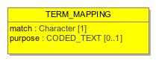

1. TERM_MAPPING

|  |  |
| --- | --- |
| **Name** | TERM_MAPPING |
| **Qualified Name** | CIMI Reference Model::Data Value Types::TERM_MAPPING |
| **Visibility** | public |
| **Abstract** | false |
| **Base Classifier** |  |
| **Realized Interface** |  |

### **Attribute Detail**

#### match

|  |  |
| --- | --- |
| **Type** | Character |
| **Default Value** |  |
| **Visibility** | public |
| **Multiplicity** | 1 |
| **Definition** |  |

#### purpose

|  |  |
| --- | --- |
| **Type** | CODED_TEXT |
| **Default Value** |  |
| **Visibility** | public |
| **Multiplicity** | 0..1 |
| **Definition** |  |

#### target

|  |  |
| --- | --- |
| **Type** | CODED_TEXT |
| **Default Value** |  |
| **Visibility** | public |
| **Multiplicity** | 1 |
| **Definition** |  |

### **Relation Detail**

#### Association

|  |  |
| --- | --- |
| **Name** |  |
| **Related Element** | * TEXT |

|  |  |
| --- | --- |
| **Name** |  |
| **Related Element** | * CODED_TEXT |

#### Dependency

|  |  |
| --- | --- |
| **Name** |  |
| **Related Element** | * TermMappingMatchEnum |

## **Class** **TEXT**

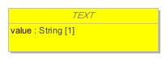

1. TEXT

|  |  |
| --- | --- |
| **Name** | TEXT |
| **Qualified Name** | CIMI Reference Model::Data Value Types::TEXT |
| **Visibility** | public |
| **Abstract** | true |
| **Base Classifier** | * DATA_VALUE |
| **Realized Interface** |  |

### **Attribute Detail**

#### mapping

|  |  |
| --- | --- |
| **Type** | TERM_MAPPING |
| **Default Value** |  |
| **Visibility** | public |
| **Multiplicity** | 0..* |
| **Definition** |  |

#### value

|  |  |
| --- | --- |
| **Type** | String |
| **Default Value** |  |
| **Visibility** | public |
| **Multiplicity** | 1 |
| **Definition** |  |

### **Relation Detail**

#### Association

|  |  |
| --- | --- |
| **Name** |  |
| **Related Element** | * TERM_MAPPING |

#### Generalization

|  |  |
| --- | --- |
| **Name** |  |
| **Related Element** | * CODED_TEXT |

|  |  |
| --- | --- |
| **Name** |  |
| **Related Element** | * DATA_VALUE |

|  |  |
| --- | --- |
| **Name** |  |
| **Related Element** | * PLAIN_TEXT |

## **Class** **TIME**

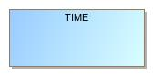

1. TIME

|  |  |
| --- | --- |
| **Name** | TIME |
| **Qualified Name** | CIMI Reference Model::Data Value Types::TIME |
| **Visibility** | public |
| **Abstract** | false |
| **Base Classifier** | * DATE_TIME |
| **Realized Interface** |  |

### **Relation Detail**

#### Generalization

|  |  |
| --- | --- |
| **Name** |  |
| **Related Element** | * DATE_TIME |

## **Class** **URI_VALUE**

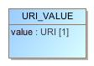

1. URI_VALUE

|  |  |
| --- | --- |
| **Name** | URI_VALUE |
| **Qualified Name** | CIMI Reference Model::Data Value Types::URI_VALUE |
| **Visibility** | public |
| **Abstract** | false |
| **Base Classifier** | * DATA_VALUE |
| **Realized Interface** |  |

### **Attribute Detail**

#### value

|  |  |
| --- | --- |
| **Type** | URI |
| **Default Value** |  |
| **Visibility** | public |
| **Multiplicity** | 1 |
| **Definition** |  |

### **Relation Detail**

#### Generalization

|  |  |
| --- | --- |
| **Name** |  |
| **Related Element** | * DATA_VALUE |

|  |  |
| --- | --- |
| **Name** |  |
| **Related Element** | * EHR_URI |

## **Class** **YESNO**

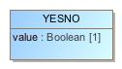

1. YESNO

|  |  |
| --- | --- |
| **Name** | YESNO |
| **Qualified Name** | CIMI Reference Model::Data Value Types::YESNO |
| **Visibility** | public |
| **Abstract** | false |
| **Base Classifier** | * DATA_VALUE |
| **Realized Interface** |  |

### **Attribute Detail**

#### value

|  |  |
| --- | --- |
| **Type** | Boolean |
| **Default Value** |  |
| **Visibility** | public |
| **Multiplicity** | 1 |
| **Definition** |  |

### **Relation Detail**

#### Generalization

|  |  |
| --- | --- |
| **Name** |  |
| **Related Element** | * DATA_VALUE |

## **Enumeration** **QuantifiedValueStatusEnum**



1. QuantifiedValueStatusEnum

|  |  |
| --- | --- |
| **Name** | QuantifiedValueStatusEnum |
| **Qualified Name** | CIMI Reference Model::Data Value Types::QuantifiedValueStatusEnum |
| **Visibility** | public |
| **Base Classifier** |  |

### **Relation Detail**

#### Dependency

|  |  |
| --- | --- |
| **Name** |  |
| **Related Element** | * QUANTIFIED |

## **Enumeration** **TermMappingMatchEnum**

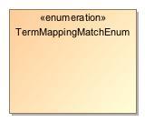

1. TermMappingMatchEnum

|  |  |
| --- | --- |
| **Name** | TermMappingMatchEnum |
| **Qualified Name** | CIMI Reference Model::Data Value Types::TermMappingMatchEnum |
| **Visibility** | public |
| **Base Classifier** |  |

### **Relation Detail**

#### Dependency

|  |  |
| --- | --- |
| **Name** |  |
| **Related Element** | * TERM_MAPPING |

# **Package CIMI Reference Model::Party**

|  |  |
| --- | --- |
| **Name** | Party |
| **Qualified Name** | CIMI Reference Model::Party |

## **Class** **ACTOR**

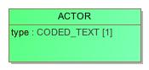

1. ACTOR

|  |  |
| --- | --- |
| **Name** | ACTOR |
| **Qualified Name** | CIMI Reference Model::Party::ACTOR |
| **Visibility** | public |
| **Abstract** | false |
| **Base Classifier** | * PARTY |
| **Realized Interface** |  |

### **Attribute Detail**

#### role

|  |  |
| --- | --- |
| **Type** | ROLE |
| **Default Value** |  |
| **Visibility** | public |
| **Multiplicity** | 0..* |
| **Definition** |  |

#### type

|  |  |
| --- | --- |
| **Type** | CODED_TEXT |
| **Default Value** |  |
| **Visibility** | public |
| **Multiplicity** | 1 |
| **Definition** |  |

### **Relation Detail**

#### Association

|  |  |
| --- | --- |
| **Name** |  |
| **Related Element** | * ROLE |

#### Generalization

|  |  |
| --- | --- |
| **Name** |  |
| **Related Element** | * PARTY |

## **Class** **PARTY**

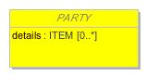

1. PARTY

|  |  |
| --- | --- |
| **Name** | PARTY |
| **Qualified Name** | CIMI Reference Model::Party::PARTY |
| **Visibility** | public |
| **Abstract** | true |
| **Base Classifier** | * LOCATABLE |
| **Realized Interface** |  |

### **Attribute Detail**

#### details

|  |  |
| --- | --- |
| **Type** | ITEM |
| **Default Value** |  |
| **Visibility** | public |
| **Multiplicity** | 0..* |
| **Definition** |  |

#### relationship

|  |  |
| --- | --- |
| **Type** | PARTY_RELATIONSHIP |
| **Default Value** |  |
| **Visibility** | public |
| **Multiplicity** | 0..* |
| **Definition** |  |

### **Relation Detail**

#### Association

|  |  |
| --- | --- |
| **Name** |  |
| **Related Element** | * PARTY_RELATIONSHIP |

|  |  |
| --- | --- |
| **Name** |  |
| **Related Element** | * PARTICIPATION |

|  |  |
| --- | --- |
| **Name** |  |
| **Related Element** | * PARTY_RELATIONSHIP |

#### Generalization

|  |  |
| --- | --- |
| **Name** |  |
| **Related Element** | * Party |

|  |  |
| --- | --- |
| **Name** |  |
| **Related Element** | * LOCATABLE |

|  |  |
| --- | --- |
| **Name** |  |
| **Related Element** | * ROLE |

|  |  |
| --- | --- |
| **Name** |  |
| **Related Element** | * ACTOR |

## **Class** **PARTY_RELATIONSHIP**

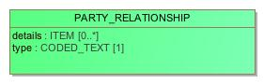

1. PARTY_RELATIONSHIP

|  |  |
| --- | --- |
| **Name** | PARTY_RELATIONSHIP |
| **Qualified Name** | CIMI Reference Model::Party::PARTY_RELATIONSHIP |
| **Visibility** | public |
| **Abstract** | false |
| **Base Classifier** | * LOCATABLE |
| **Realized Interface** |  |

### **Attribute Detail**

#### details

|  |  |
| --- | --- |
| **Type** | ITEM |
| **Default Value** |  |
| **Visibility** | public |
| **Multiplicity** | 0..* |
| **Definition** |  |

#### target

|  |  |
| --- | --- |
| **Type** | PARTY |
| **Default Value** |  |
| **Visibility** | public |
| **Multiplicity** | 1 |
| **Definition** |  |

#### type

|  |  |
| --- | --- |
| **Type** | CODED_TEXT |
| **Default Value** |  |
| **Visibility** | public |
| **Multiplicity** | 1 |
| **Definition** |  |

### **Relation Detail**

#### Association

|  |  |
| --- | --- |
| **Name** |  |
| **Related Element** | * PARTY |

|  |  |
| --- | --- |
| **Name** |  |
| **Related Element** | * PARTY |

#### Generalization

|  |  |
| --- | --- |
| **Name** |  |
| **Related Element** | * PartyRelationship |

|  |  |
| --- | --- |
| **Name** |  |
| **Related Element** | * LOCATABLE |

## **Class** **ROLE**

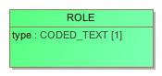

1. ROLE

|  |  |
| --- | --- |
| **Name** | ROLE |
| **Qualified Name** | CIMI Reference Model::Party::ROLE |
| **Visibility** | public |
| **Abstract** | false |
| **Base Classifier** | * PARTY |
| **Realized Interface** |  |

### **Attribute Detail**

#### type

|  |  |
| --- | --- |
| **Type** | CODED_TEXT |
| **Default Value** |  |
| **Visibility** | public |
| **Multiplicity** | 1 |
| **Definition** |  |

### **Relation Detail**

#### Association

|  |  |
| --- | --- |
| **Name** |  |
| **Related Element** | * ACTOR |

#### Generalization

|  |  |
| --- | --- |
| **Name** |  |
| **Related Element** | * PARTY |

# **Package CIMI Reference Model::Primitive Types**

|  |  |
| --- | --- |
| **Name** | Primitive Types |
| **Qualified Name** | CIMI Reference Model::Primitive Types |

## **Class** **Any**

1784429252.jpg

1. Any

|  |  |
| --- | --- |
| **Name** | Any |
| **Qualified Name** | CIMI Reference Model::Primitive Types::Any |
| **Visibility** | public |
| **Abstract** | false |
| **Base Classifier** |  |
| **Realized Interface** |  |

## **Class** **Array**

2000638326.jpg

1. Array

|  |  |
| --- | --- |
| **Name** | Array |
| **Qualified Name** | CIMI Reference Model::Primitive Types::Array |
| **Visibility** | public |
| **Abstract** | false |
| **Base Classifier** |  |
| **Realized Interface** |  |

## **Class** **List**

874879303.jpg

1. List

|  |  |
| --- | --- |
| **Name** | List |
| **Qualified Name** | CIMI Reference Model::Primitive Types::List |
| **Visibility** | public |
| **Abstract** | false |
| **Base Classifier** |  |
| **Realized Interface** |  |

# **Appendix A: Diagram**

## **CIMI Core Model**

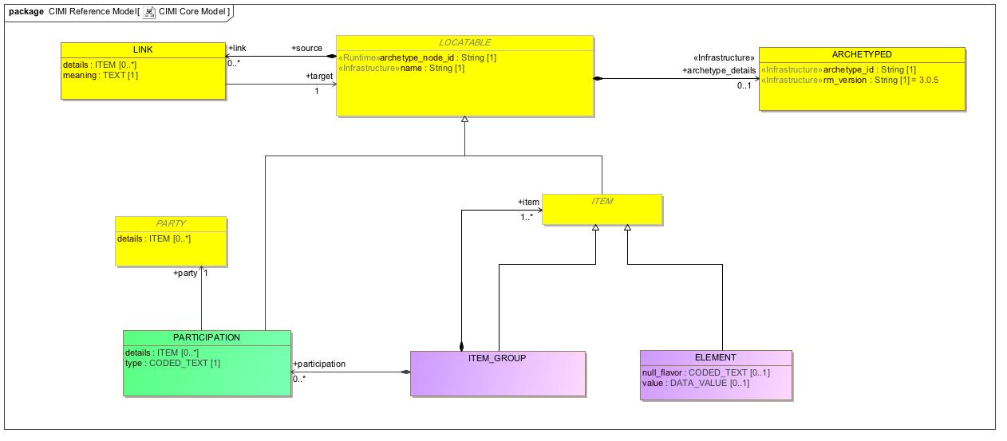

1. CIMI Core Model

## **CIMI Data Value Types**

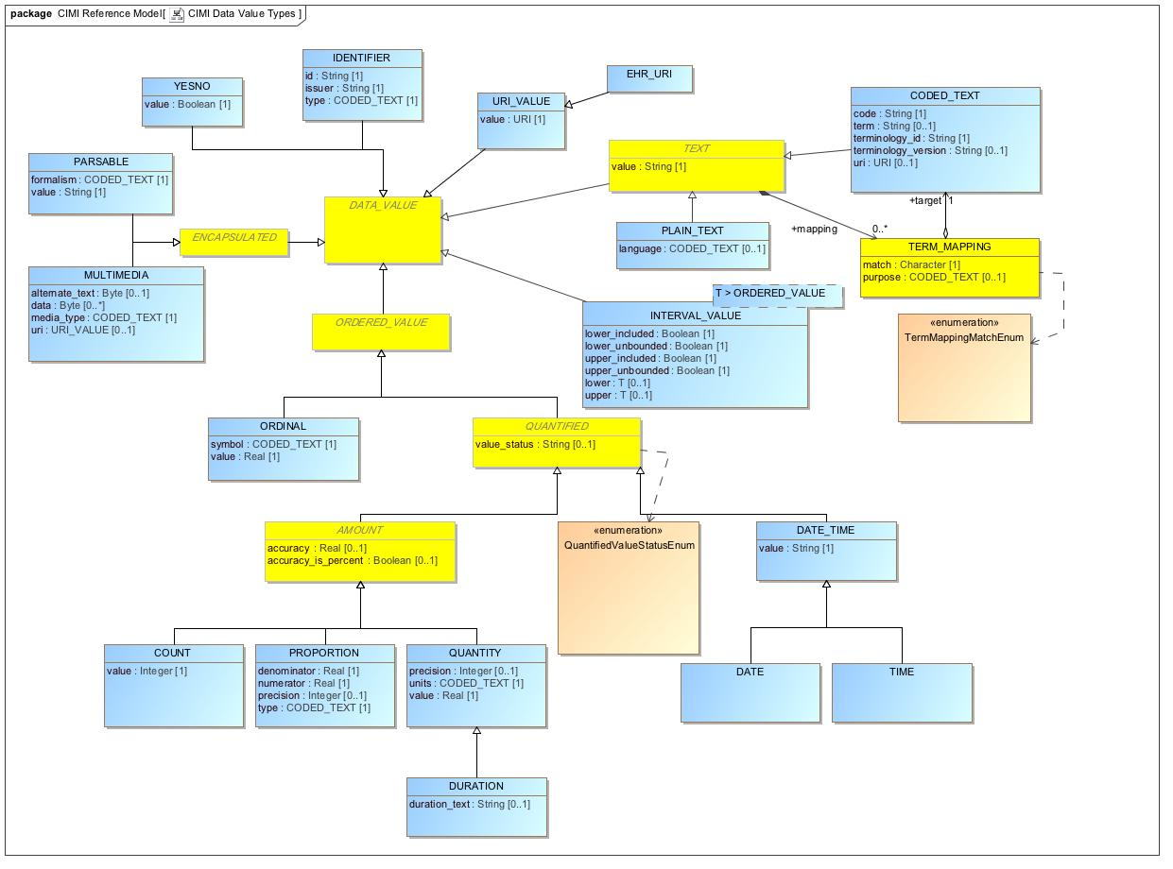

1. CIMI Data Value Types

## **CIMI Party Model**

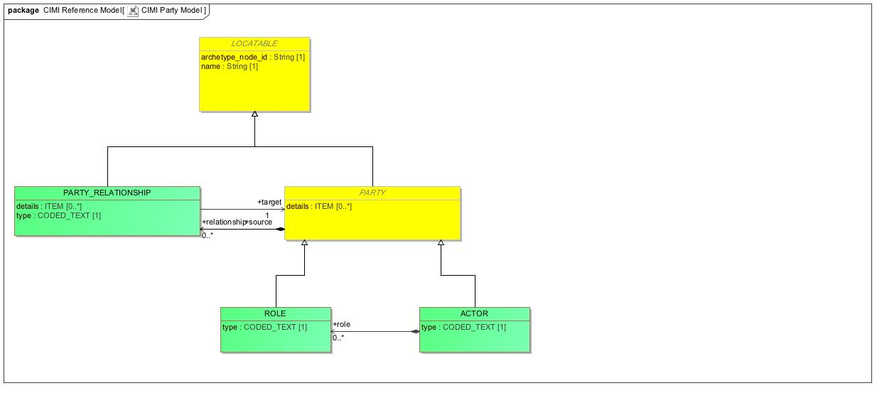

1. CIMI Party Model

## **CIMI Primitive Types**

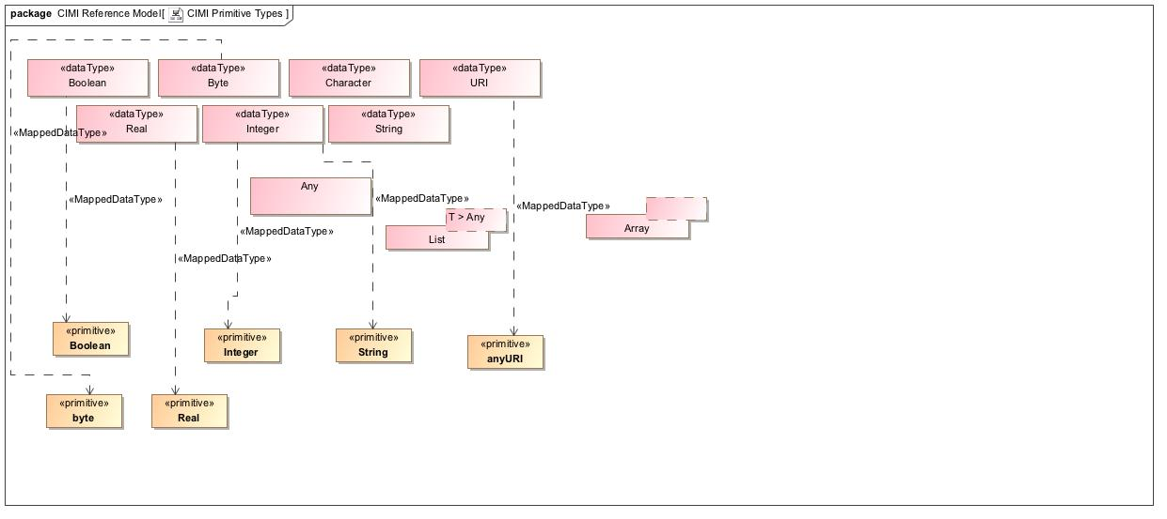

1. CIMI Primitive Types

## **ClinicalStatement**

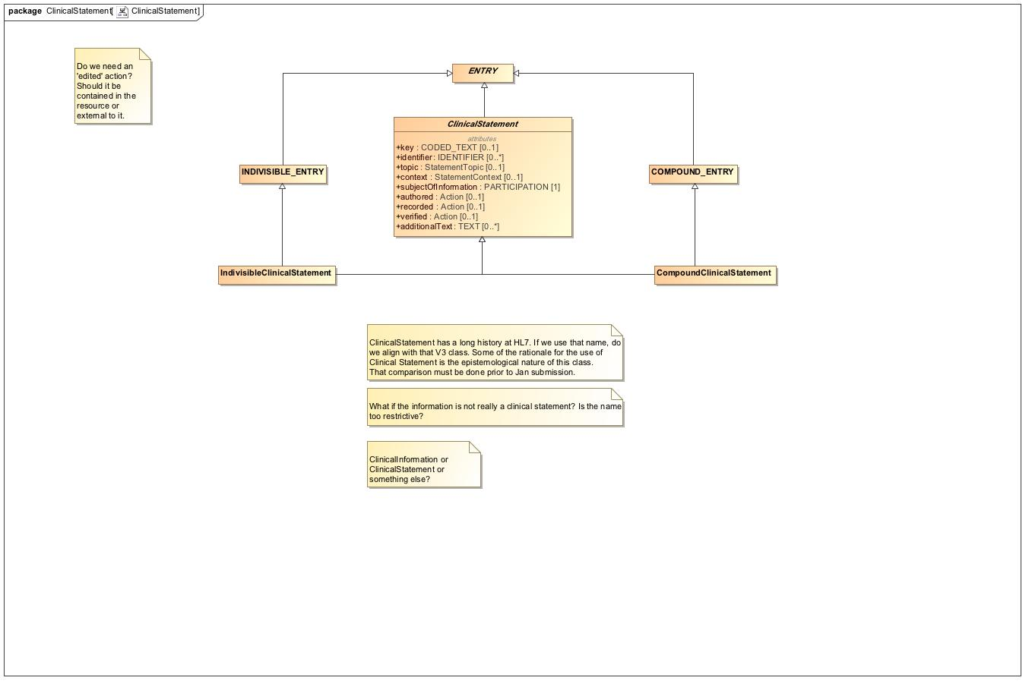

1. ClinicalStatement

## **ClinicalStatement - Relationships**

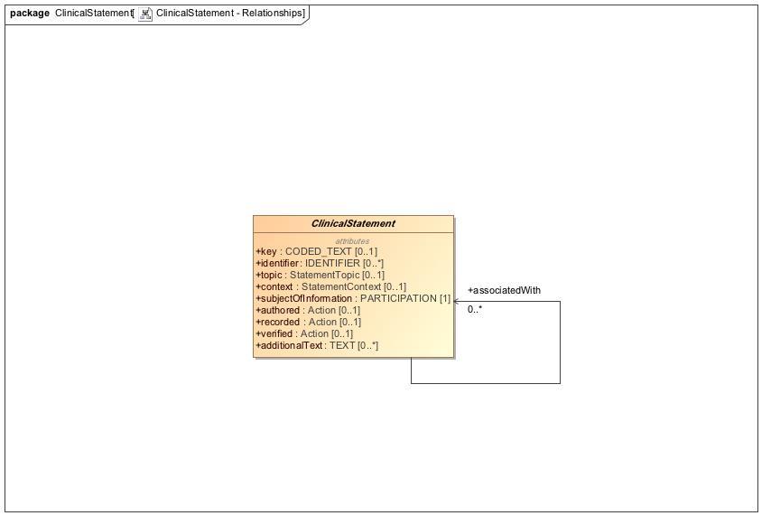

1. ClinicalStatement - Relationships

## **Context - Action**

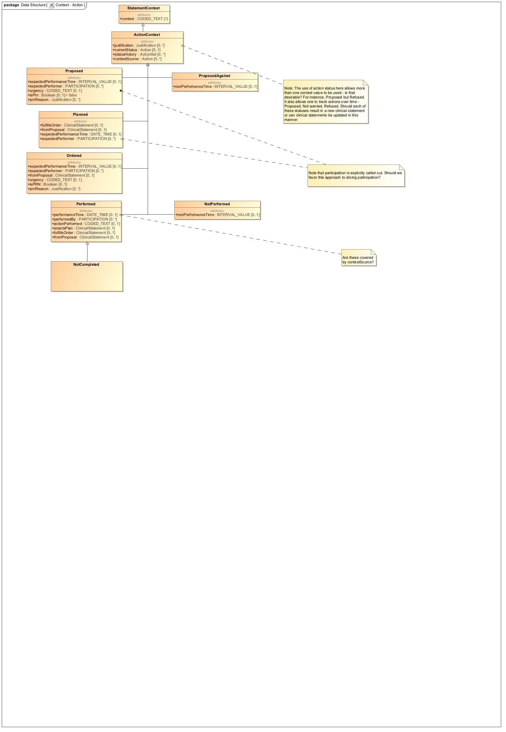

1. Context - Action

## **Context - Action HSPC**

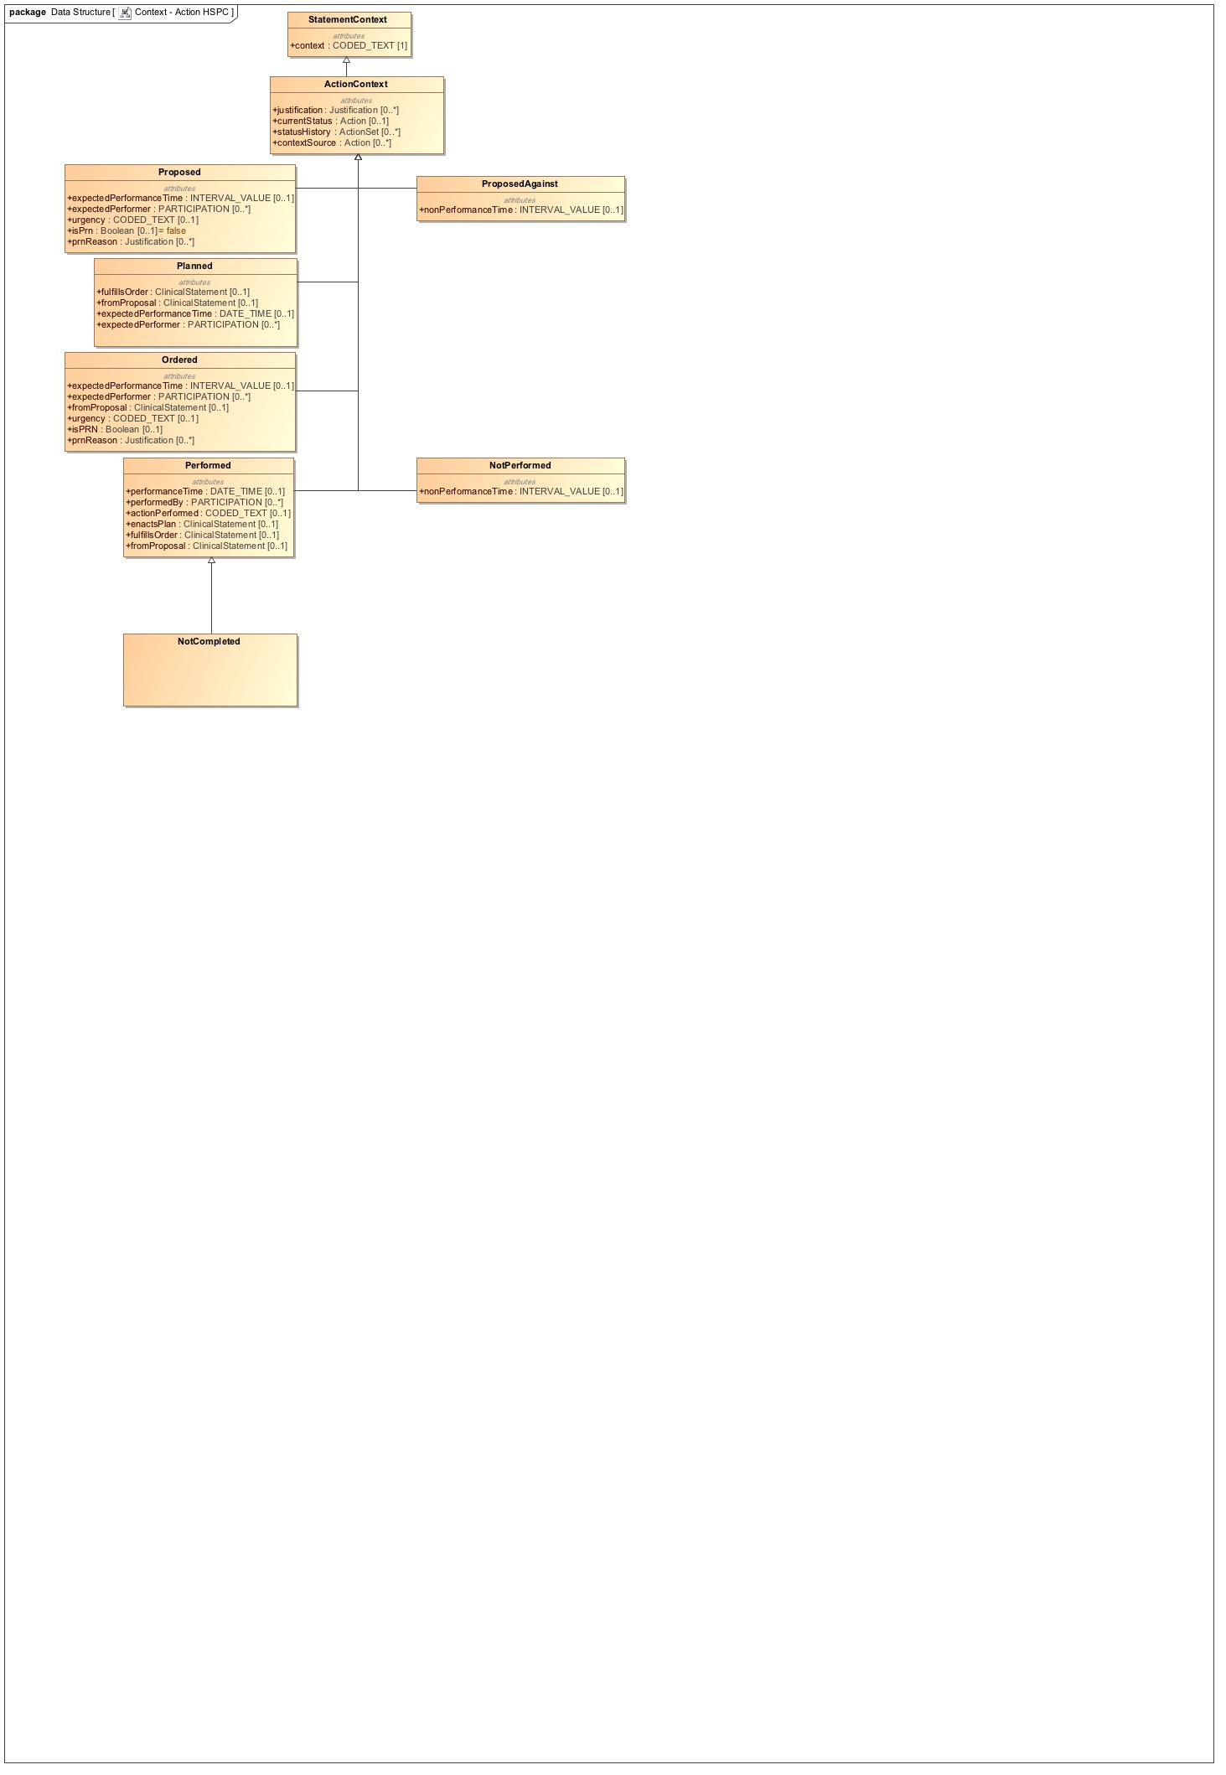

1. Context - Action HSPC

## **Context - Finding**

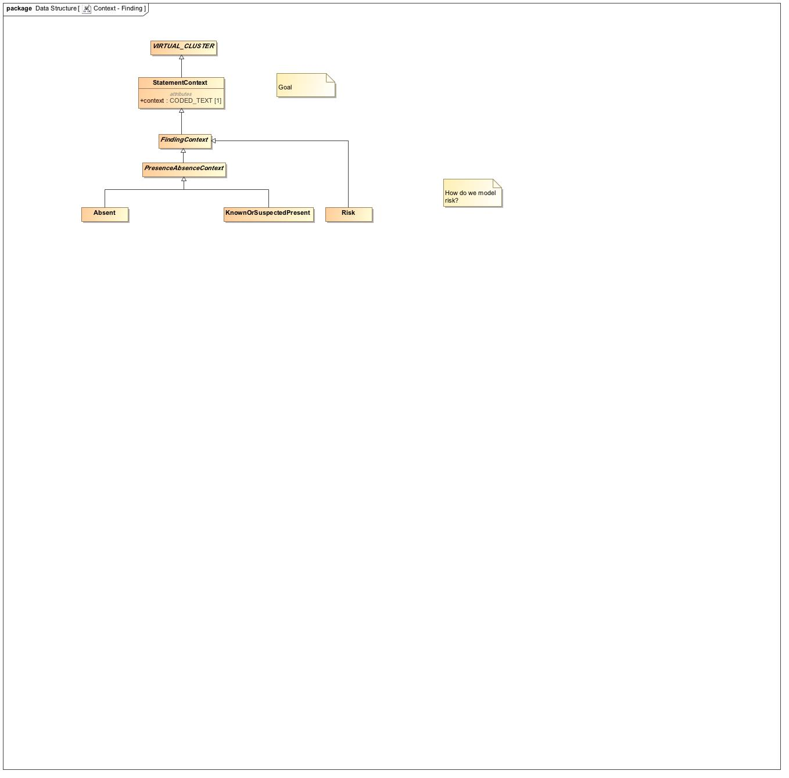

1. Context - Finding

## **Context -Core**

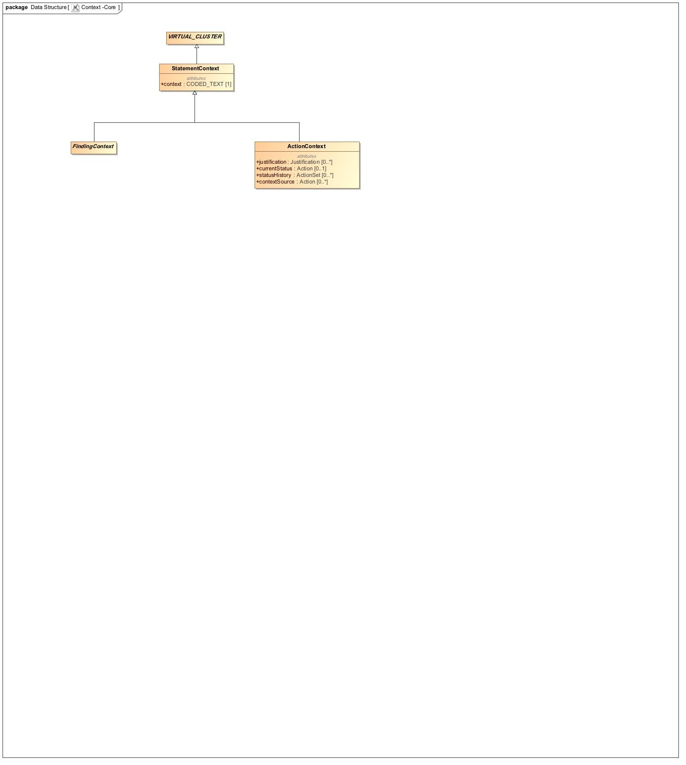

1. Context -Core

## **Data Structure - Address**

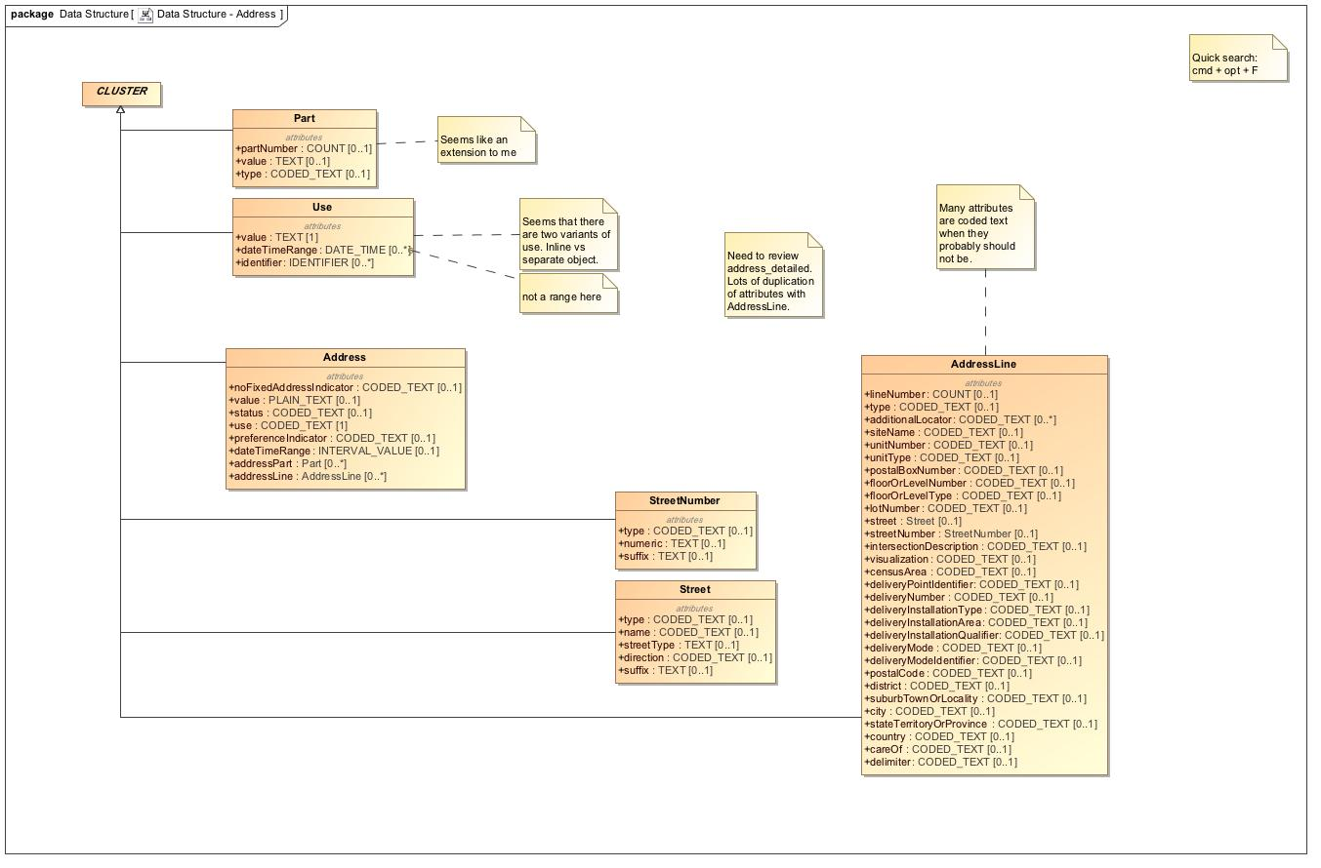

1. Data Structure - Address

## **Data Structure - Material Entity**

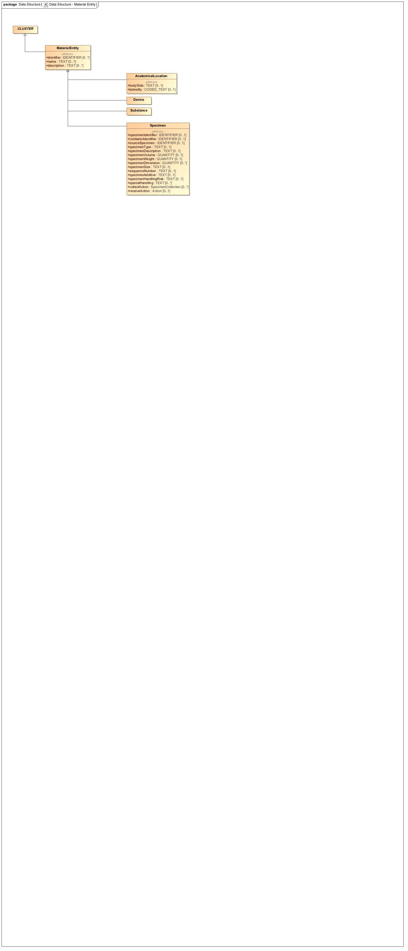

1. Data Structure - Material Entity

## **Data Structure - Other**

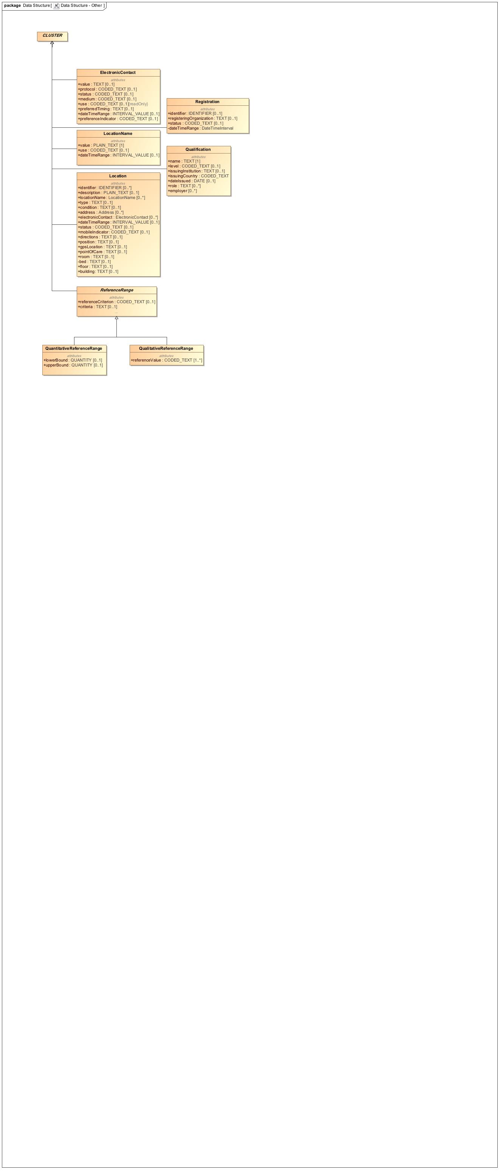

1. Data Structure - Other

## **Data Structure - Party**

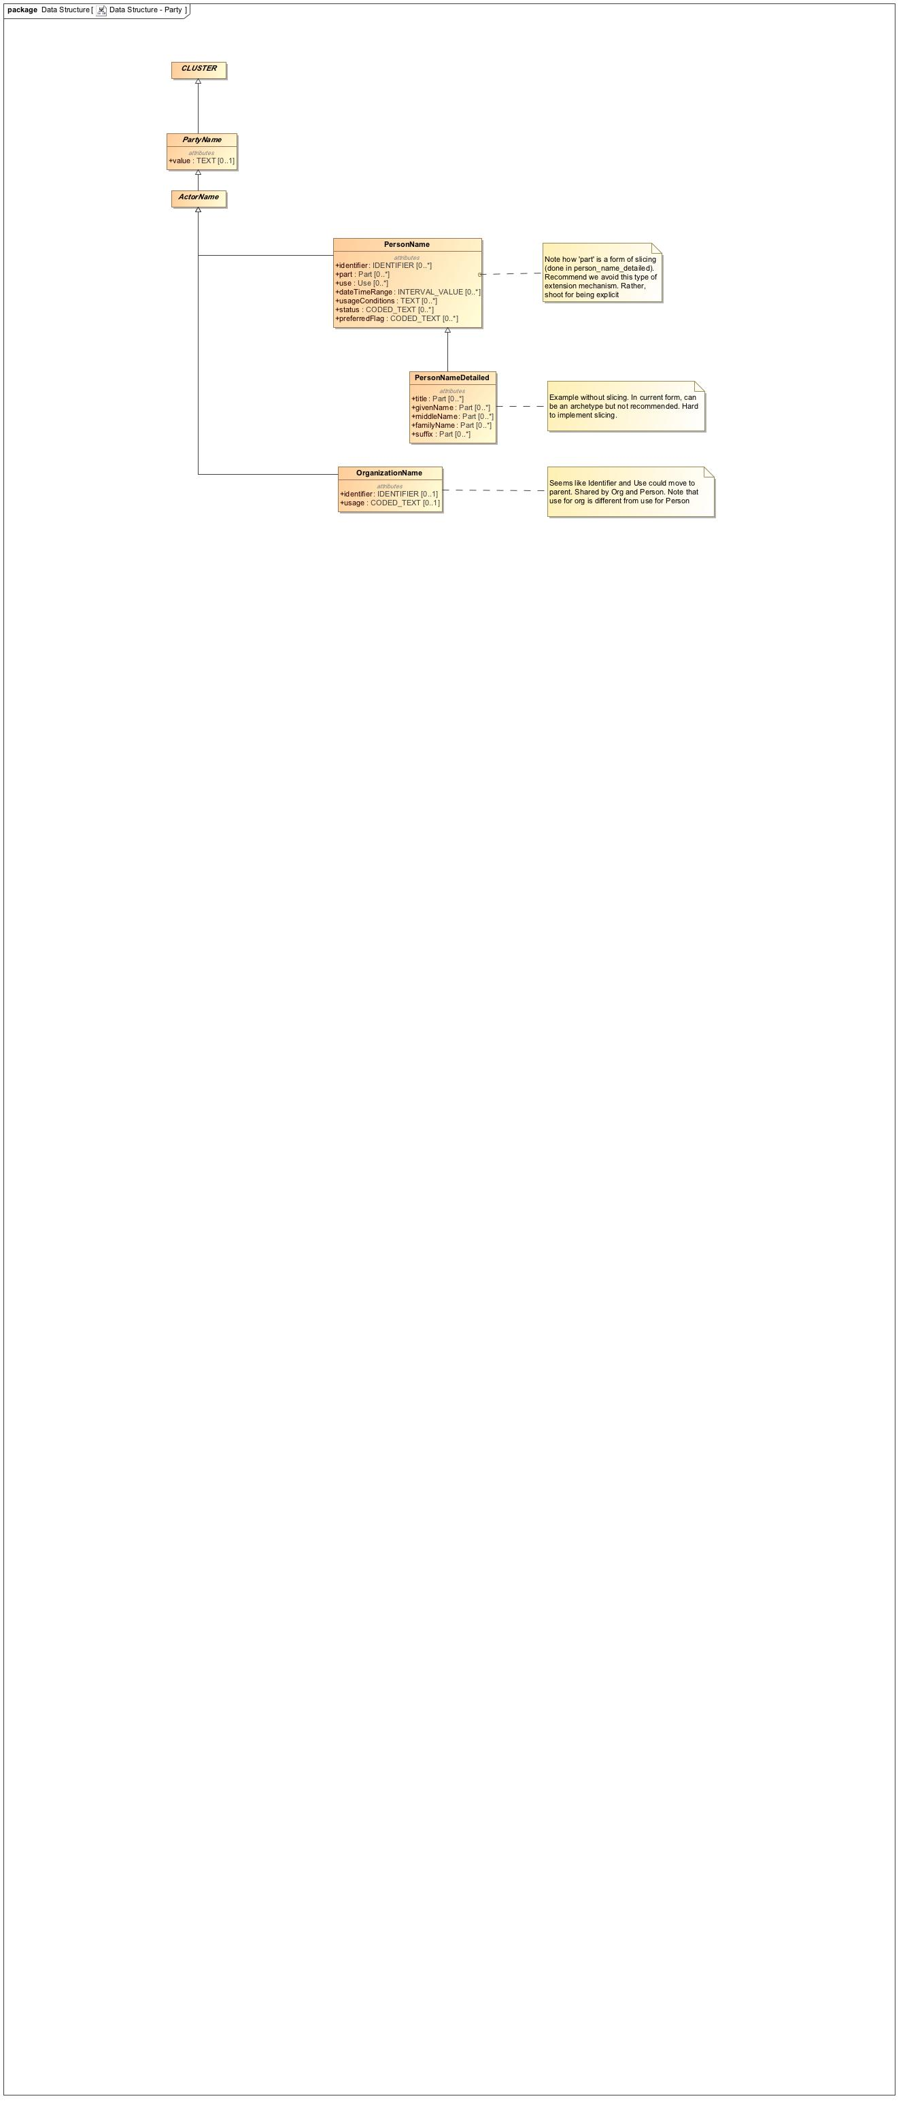

1. Data Structure - Party

## **Foundation**

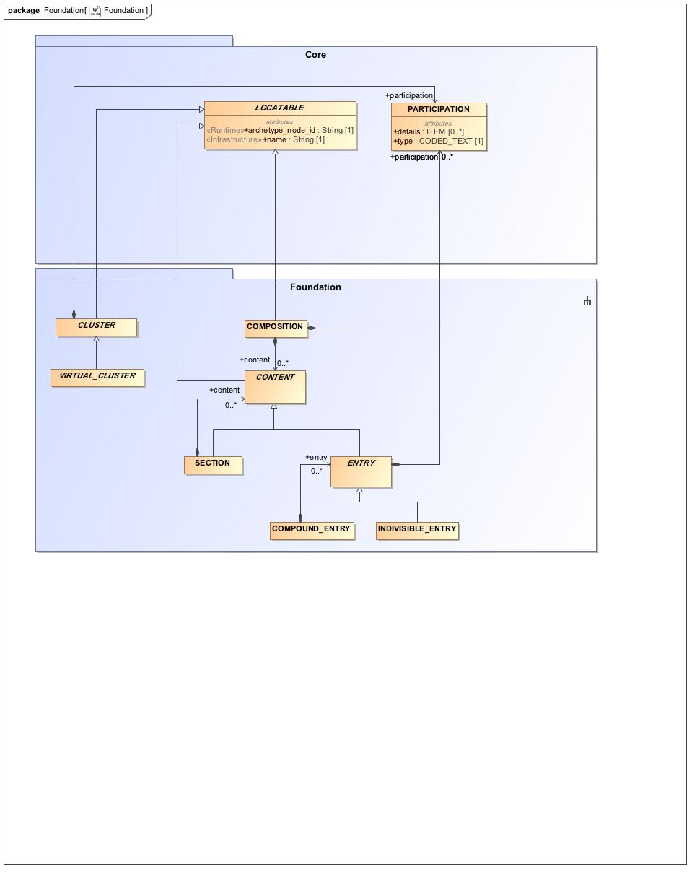

1. Foundation

## **Participation**

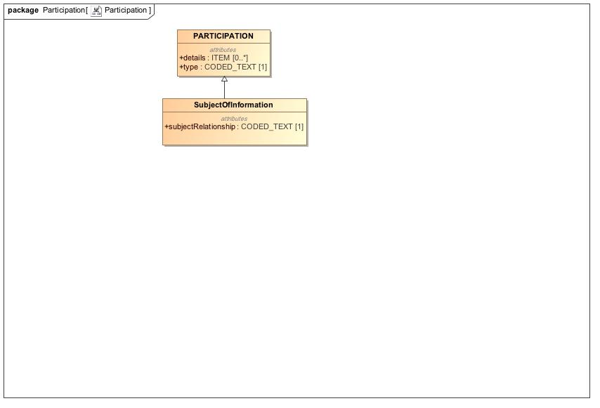

1. Participation

## **Party**

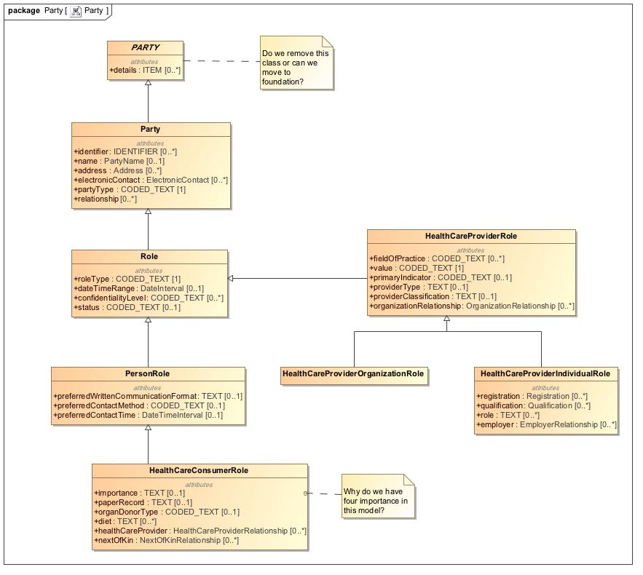

1. Party

## **Provenance**

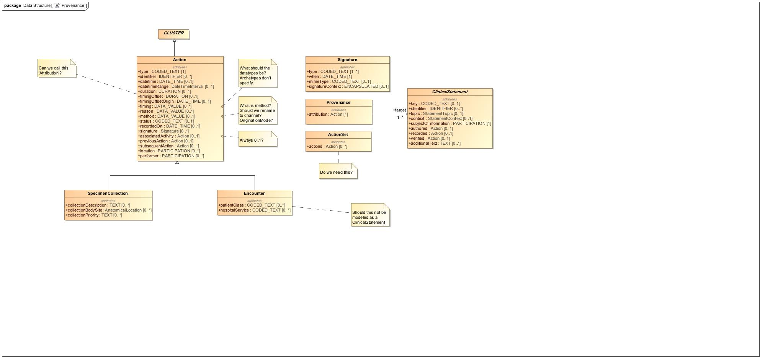

1. Provenance

## **Redefined Intervals**

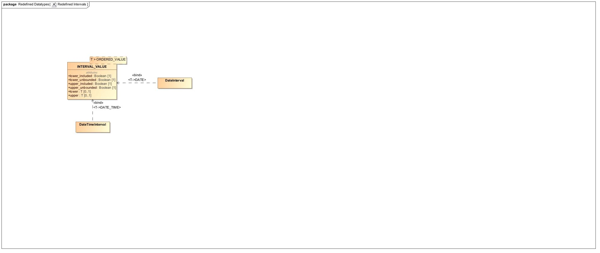

1. Redefined Intervals

## **RelatedClinicalStatement**

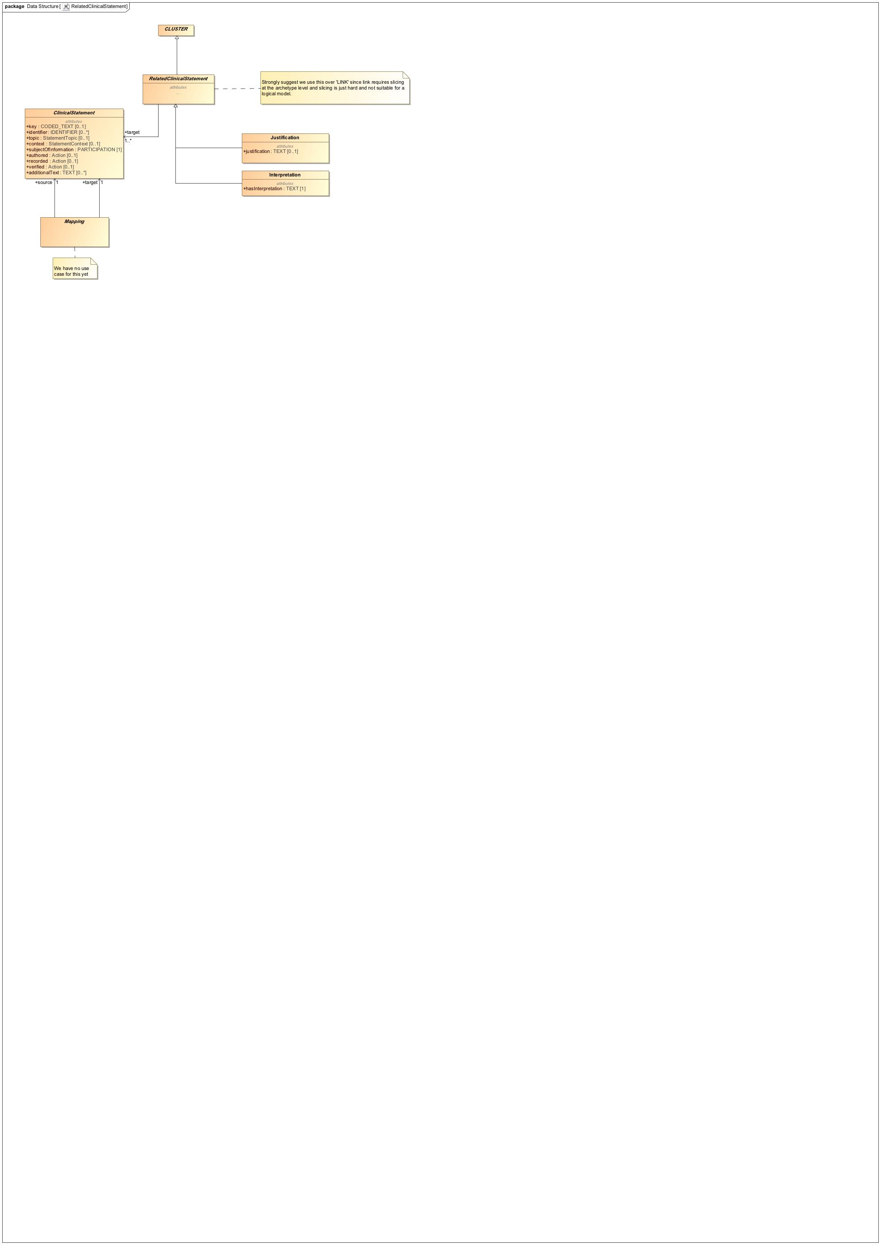

1. RelatedClinicalStatement

## **Relationship**

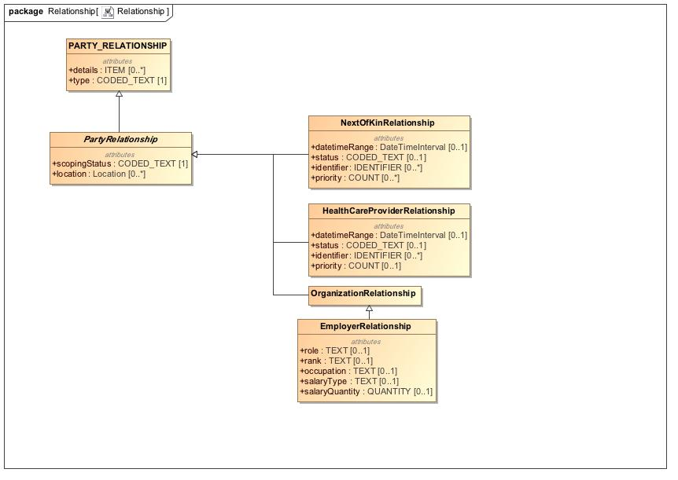

1. Relationship

## **Topic - Act**

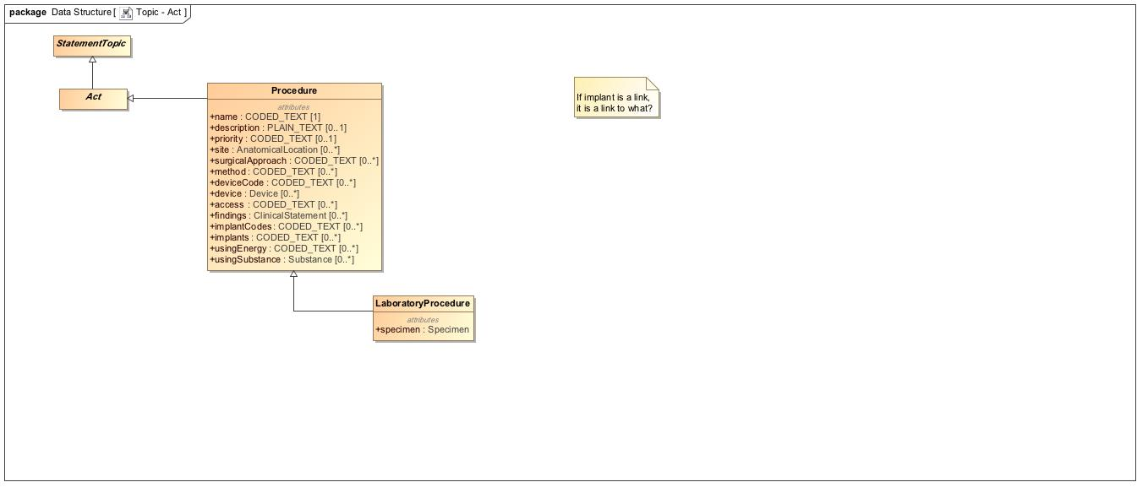

1. Topic - Act

## **Topic - Assertion**

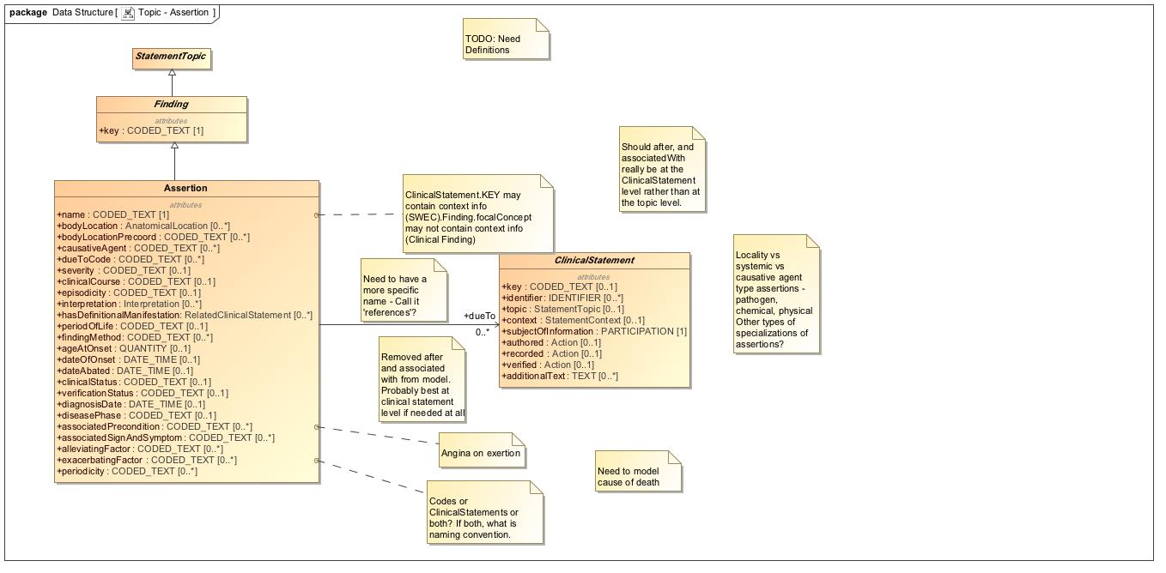

1. Topic - Assertion

## **Topic - Assertion HSPC**

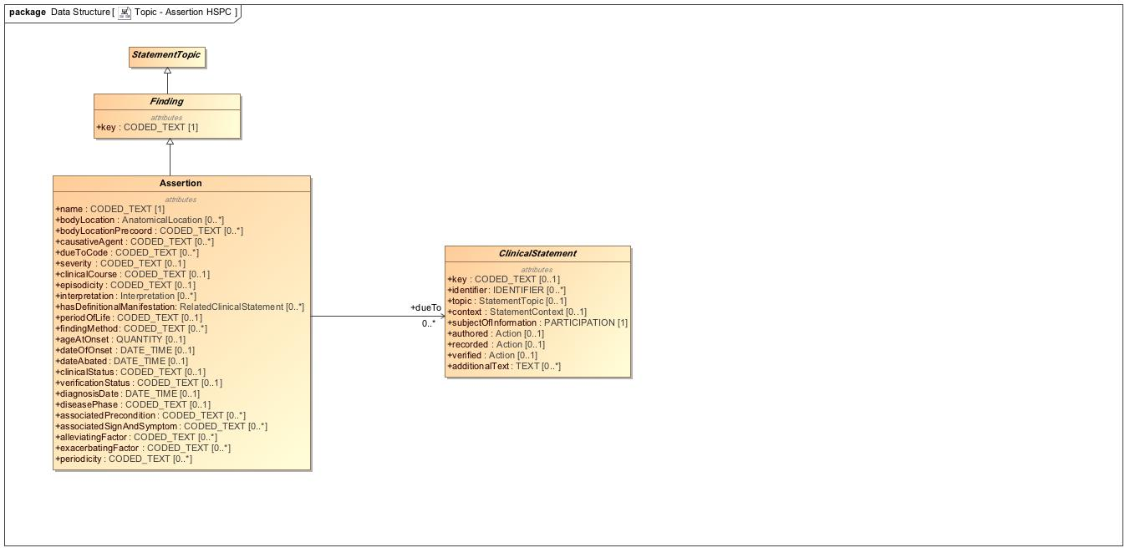

1. Topic - Assertion HSPC

## **Topic - Core**

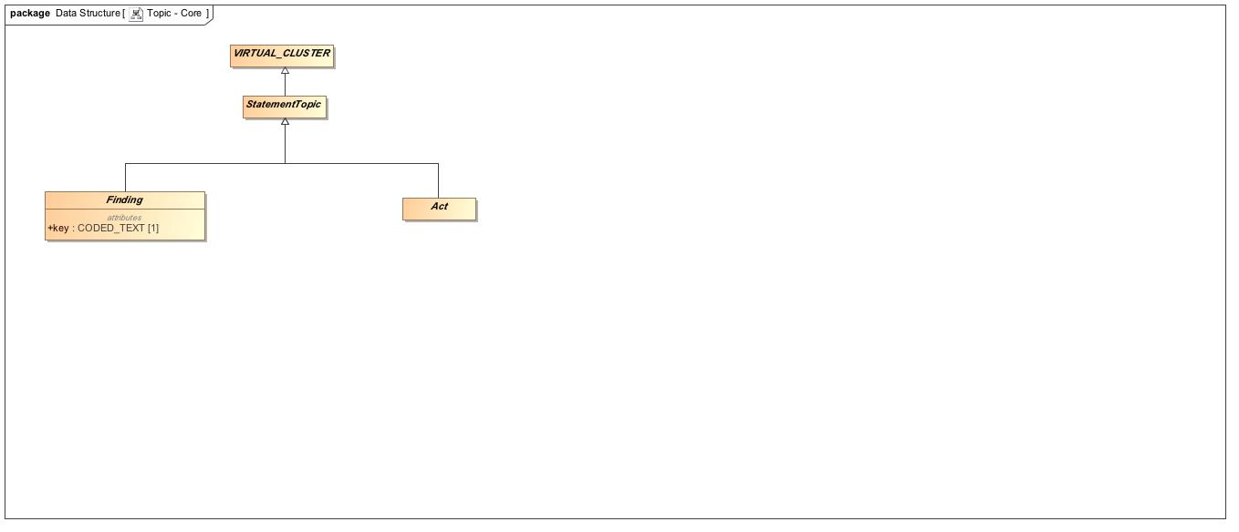

1. Topic - Core

## **Topic - Evaluation**

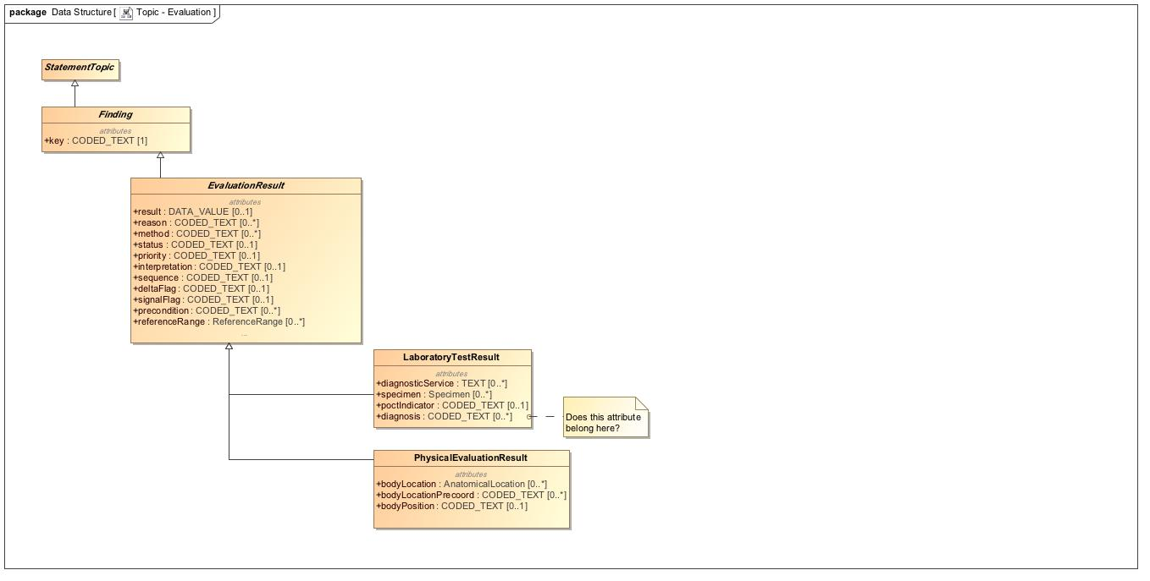

1. Topic - Evaluation

## **Virtual Cluster - Core**

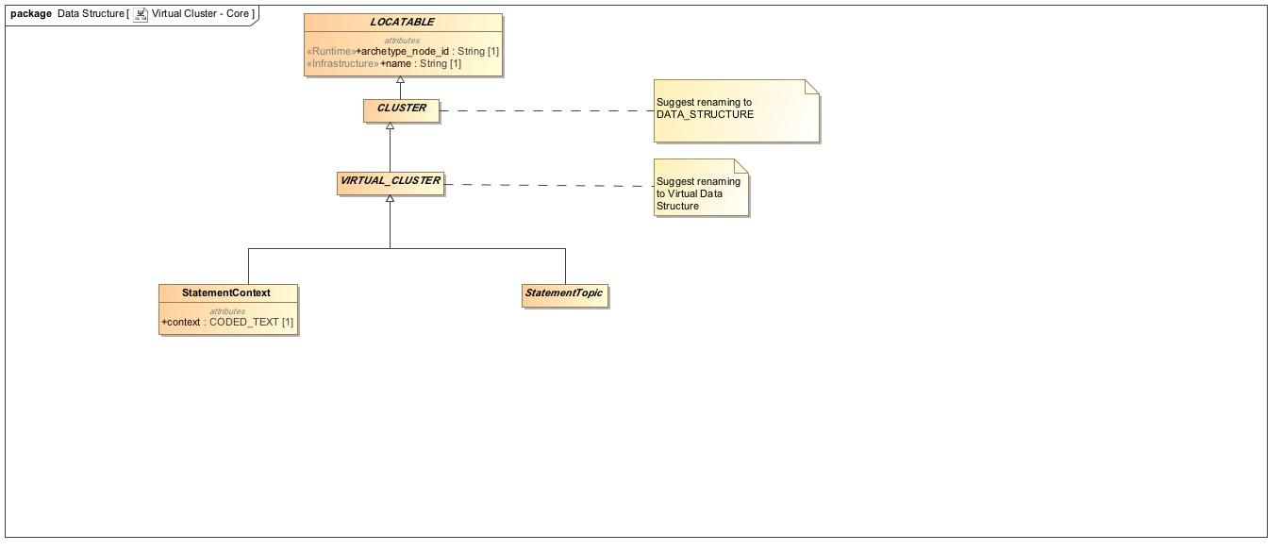

1. Virtual Cluster - Core