Review the following data flow diagram and description of Hamp Crafts’ current purchase and supply process for their brick-and-mortar store.

A text version is also available: [Module Three Assignment Data Flow Diagram Text Version](https://learn.snhu.edu/content/enforced/1426232-CS-255-H2973-OL-TRAD-UG.23EW2/course_documents/CS%20255%20Module%20Three%20Assignment%20Data%20Flow%20Diagram%20With%20Alternative%20Text.pdf?_&d2lSessionVal=fuxWzLo4BbBVSnFOKRr0lXK35&ou=1426232).

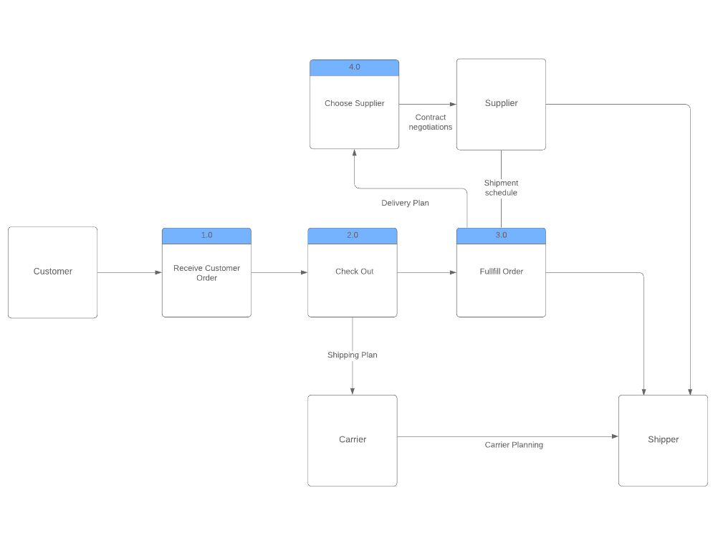

Hamp Crafts’ current purchase and supply process uses a local secure merchant account. All the transaction funds are collected and transferred to the company's primary business account within two business days. Employees are assigned to check the inventory system to ensure all orders are processed in a timely manner. Communication regarding inventory shortages or delays in delivery is a manual process for Hamp Crafts if a potential shortage occurs. Otherwise, the inventory specialist and order fulfillment team input information into the local database regarding order statuses and tracking of shipments.

# Describe Hamp Crafts’ current purchase and supply process by responding to the following prompts:

## Interpret the provided data flow diagram. What does it show? What does the current purchase and supply process entail?

The above diagram shows Hamp Craft’s current purchase and supply process. From the customer to the shipper, with each step listed between. It is a little difficult to explain in words, but the process goes something like this:

The **customer** makes an order. The customer’s order is received by **Hamp Crafts**. The order is checked out, where it may be directly sent to the **carrier** who then sends it to the **shipper** to deliver, OR a **supplier** is chosen, and the order is fulfilled by that **supplier**, who then sends it to the **shipper.**

## What are the data sources involved in the current process?

The data sources involved in Hamp Craft’s current process are:

The customer, providing data of what they need. Hamp Crafts, providing data of the process, this is where the customer would communicate with and get all of their information regarding arrival times from. The supplier, providing data of their stock to Hamp Crafts. The carrier and the shipper, providing data of the shipping process to Hamp Crafts.

For the new online storefront, Hamp Crafts’ owners want to ensure that customers can easily view products, pay for them, and receive confirmation of their orders. The owners want to be sure that any payments will be transferred to Hamp Crafts’ business account. You have also suggested adding an administrative backend to provide customer support, update customer information, and maintain the website.   
In order to add this functionality, you will need to consider Hamp Crafts’ current purchase and supply process. Then you will need to determine the additional requirements needed to support an online storefront by responding to the following prompts:

## What additional processes are necessary to integrate an online storefront?

Currently there are either in-store payment or catalog payment options. An online payment process will need to be added, this can include credit card payments and PayPal, ShopPay, Apple Pay or some other online payment option.

An automated inventory adjustment will need to be implemented. As orders are made, there should be live updated to the server of the remaining inventory. This would allow proper display of “out of stock” product.

Most online retailers have a cart. Clicking on this shows everything currently selected for order. It also allows the customer to adjust quantities and remove items they no longer need to order. A “shopping cart” would be necessary to add to the online storefront. To go along with this, user accounts would be necessary to see past orders, tracking information for them, and the opportunity to change shipping addresses and store payment information.

Administrator and employee accounts would be necessary to edit and adapt the products available on the site.

There are far more, of course. Implementing an entire online retail experience has many processes and features needed for it to run smoothly. This is why there are product browsing sites like Shopify and Etsy that make it easier to get an online store up and running.

## What additional data sources would the system need to access the products and inventory?

## What additional databases, if any, are needed to support the online storefront?

The inventory database would need to be adapted to the online store. This might include automating it so that product quantities are updated automatically to best reflect the current supplies in the warehouse.

An order database would need to be included. Current (unfulfilled) orders and past (fulfilled) orders will need to be included in a database. Even something as simple as storing the order number, current status, customer information, and the quantity of each of the items ordered should be enough.

# Finally, **determine how to integrate the new online storefront** into Hamp Crafts’ current purchase and supply process by responding to the following prompt:

## Would you recommend creating a separate new system for the online storefront or incorporating elements of the online storefront into the current process model? Explain your reasoning.

I think that the current system has a good base. Every step they currently take makes sense for their business. Implementation of the online part of their business should be relatively easy if they continue to use what they already have, simply adding the missing parts for the online store.