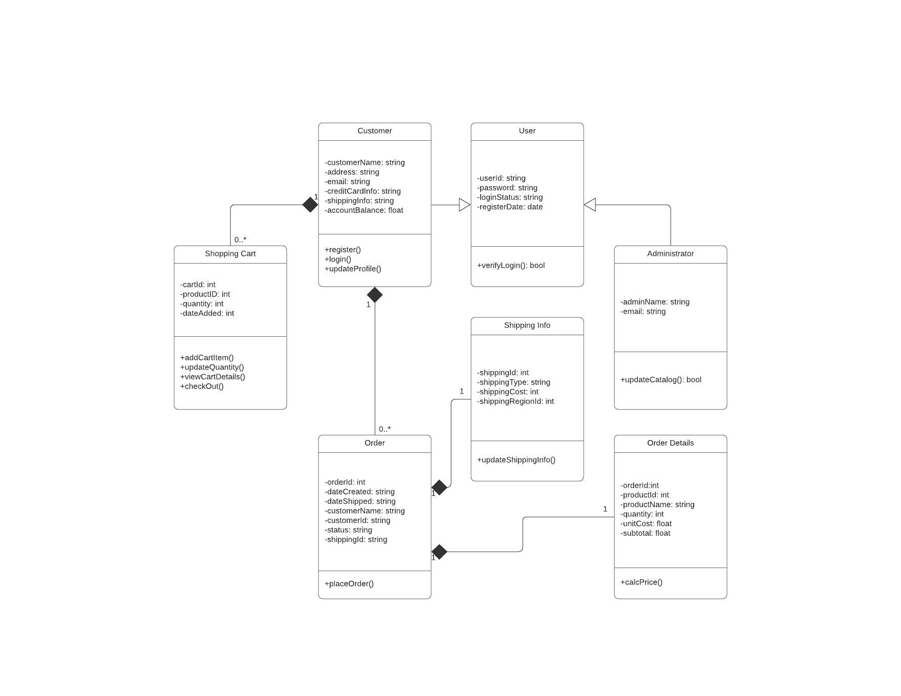

The UML diagram from the assignment guidelines.

# What are the different functions of the online storefront? How are they represented in this type of model?

The different functions of the online storefront are represented in the functions section of the UML diagram.

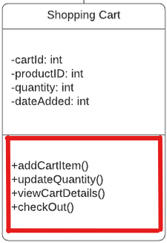

A single class from the UML diagram, in red, the functions for the class.

All the functions of the online storefront are represented in the table below:

|  |  |
| --- | --- |
| Class | Methods (all are public in this case) |
| Shopping Cart | addCartltem()  updateQuantity()  viewCartDetails()  checkOut() |
| Customer | register()  login()  updateProfile() |
| User | verifyLogin() |
| Administrator | updateCatalog() |
| Order | placeOrder() |
| Shipping Info | updateShippingInfo() |
| Order Details | calcPrice() |

# What are the different classes of “users” represented by this object model? What are the associations between these classes?

The different classes of "users" represented in this UML diagram are Customer and Administrator. Based on the relationship arrows, the Customer and Administrator classes inherit from the User super-class. This means that they have access to the same properties as the User class.

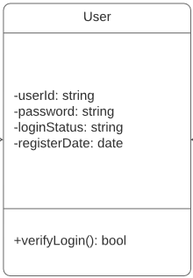

The user class and all its “properties”.

# How would the objects “use” their respective variables and functions?

Each of the variables are private to their respective classes. This means that no other class can directly change or access those variables. An example of how the User class might use its variables is when it uses the verifyLogin() method to check the userId and password to check against the database with the stored passwords.

# Does this object model capture all of Hamp Crafts’ desired functionality? Why or why not?

A table might be the best way to determine this:

|  |  |
| --- | --- |
| Requirements | Included in UML |
| Hamp crafts would like customers to be able to create an account with their shipping, billing, and contact information. | YES |
| For customer orders, hamp crafts would like to accept credit and debit cards for transactions. Hamp crafts plans on using an established credit card vendor service (e.g., square, shopify) to receive customer payments. Once a transaction is complete, the customer should receive a notification based on the information in their personal profile regarding order status and confirmation. | NO  I don’t see anything that would send a notification to the customer after an order. |
| On the administrative side of the online storefront, hamp crafts should receive an alert of the transaction. | NO  While there is an administrator side of the online storefront, I do not see anything that would send an alert of the transaction. There are parts of the system that will update the catalog and shipping info. |
| Customers should be able to check the status of their order any time online from their personal account profile under order history. | YES |
| The business owners also need an administrative back end for customer support and updates to customer information and the website. | NO  It does not appear that the administrator has any access to update the customer information. |

I do not believe that this object model captures all the required functionality. It does not have any kind of notification service nor do the admins have, well, administrative permissions.

# The above diagram uses a solid diamond shape to represent a form of aggregation. What type of aggregation does this represent? What does it imply about the relationship between the classes? Why is a solid diamond the appropriate choice here?

A solid black diamond represents a composition. This essentially means that the child class cannot exist without the parent class. In other words, if the parent class is deleted, so are all the child classes. From the above diagram, shipping info and order details cannot exist without an order, and an order cannot exist without a customer, lastly, a shopping cart cannot exist without a customer. A solid diamond is the appropriate choice because it makes sense in theory that none of these child classes can exist without the parent first being created. For example, it would make no sense for shipping details to exist without a customer first creating an order. If either the customer or the order is removed from the system (or never created in the first place), it makes no logical sense for shipping info to exist.