 C.S PROJECT

TYPERUNNER

Done by:

S . Jayanth Narayanan

C . Naveen kumar

XII - ’A’

CONTENTS

1. BONAFIDE CERTIFICATE
2. ACKNOWLEDGEMENT
3. ABOUT THE PROJECT
4. FLOW OF CONTROL
5. SYSTEM REQUIREMENTS
6. USER DEFINED FUCTIONS USED
7. SOURCE CODE
8. SCREENSHOTS
9. CONCLUSION



BONAFIDE CERTIFICATE

This is to certify that the project titled “TYPE RUNNER” is a bonafide record of the work done by **C.NAVEEN KUMAR, S.JAYANTH NARAYANAN** of class **XII-A** as a project in the Department of Computer Science in the academic year 2019-20 and has been submitted for the practical examination held at **THE HINDU SENIOR SECONDARY SCHOOL,**INDIRA NAGAR,CHENNAI-600020.

Roll no:

C . Naveen Kumar

S . Jayanth Narayanan

|  |
| --- |
|  |
|  |

INTERNAL EXAMINER EXTERNAL EXAMINER

ACKNOWLEDGEMENT

We take this opportunity to sincerely thank our Computer Science teacher **MRS.V.DHANALAKSHMI** for her guidance in presenting the project. Her encouragement in choosing this topic is highly acknowledgeable. The project really helped us to improve our understanding towards Computer Science and we learnt more and more techniques and knacks as the days passed by. We thank our Principal **MRS.PADMINI SRIRAM,** our Vice Principal **MRS.CHANDRA CHANDRASHEKARAN** for supporting us throughout the project. We would also like to thank the institute for giving us a wonderful opportunity to establish ourselves in Computer Science and culminating deep interest in the subject through this project. Also we would like to thank our Parents and Friends for supporting and guiding us during the course of this project.

ABOUT THE PROJECT

**ABOUT TYPING:**

Typing is something most of us will have to do a lot of in our jobs. Whether you work in an office or not, you will probably end up having to type on a computer keyboard on a weekly or even daily basis. Everyone is looking for ways to be more productive both in the workplace and at home, and typing faster is a simple way to get more done.

**USES OF TYPING:**

If you learn to double the speed you type, you can essentially get twice as much done in the same space of time. Employers might even want to ensure their employees are trained up in touch-typing due to the productivity boost it could lead to. And if you are an employee, you could learn how to increase your typing speed to impress your boss, or you can simply give yourself more time to spend on other things.

Another benefit of learning to type faster is that you will not have to look at the keyboard and think about where your fingers are going. Once you are typing fast, you will be able to look directly at the screen, and your fingers will type without you even thinking about the movements.

**AIM:**

This project will help students or other people to improve their typing speed and give us a bit more colour on how to type in various ways, and more faster.

SYSTEM REQUIREMENTS

**Operating system** : Windows 7, 8 and10.

**System Type** : 32/64-bit Operating

System (preferred)

**RAM**  : 512 MB

**Hard disk** : 3 MB required

**Minimum Processor** : INTEL 386 or higher

**Integrated Development Environment (IDE) and Complier Version.**

1. Turbo C++ version 4.5

( Borland International Inc. )

1. Turbo C++ version 3.2

FUNCTIONS USED

FUNCTIONS USED

**1.void codepix()**

**\***This function is used to display the cover page.

**2. void pg2()**

**\***This function is used to display menu.

**3. void about()**

**\***This function is used to display the about page.

**4. void instructions()**

**\***This function is used to display the instructions page.

**5. void quit()**

**\***This function is used to terminate the program.

**6. void logsin()**

**\***This function is used to display the login and signup page.

**7. void login1()**

**\***This function is used for accepting login details.

**8. void signup()**

**\***This function is used for creating new account.

**9. void sp3()**

**\***This function is used to display the name of the user.

**10. void pg4()**

**\***This function is used for displaying the contents of the game.

**11. void easy()**

**\***This function is used for the user to type in easy difficulty level.

**12. void medium()**

**\***This function is used for the user to type in medium difficulty level.

**13. void hard()**

**\***This function is used for the user to type in hard difficulty level.

**14. void leaderboard()**

**\***This function is used to display the leader board of the game.

**15. void store(int m)**

**\***This function is used to store the typing speed of the user.

FLOW OF CONTROL

start

|  |
| --- |
| codepix() |

stop

quit()

logsin()

11

2

1

instructions()

about()

3

4

logsin()

signup()

login1()

logsin()

6

5

4

3

2

1

medium()

quit()

playerdetails()

leaderboard()

hard()

easy()

pg4()

sp3()

SOURCE CODE

|  |
| --- |
| SOURCE CODE |

/*==========================================*/

/* HEADER FILES */

/*==========================================*/

#include<stdio.h>

#include<time.h>

#include<string.h>

#include<process.h>

#include<fstream.h>

#include<dos.h>

#include<graphics.h>

#include<conio.h>

/*=========================================*/

/* FUNCTION PROTOTYPES */

/*=========================================*/

void sp3();

void pg4();

void quit();

void instructions();

void pg2();

/* =========================================*/

/* GLOBAL VARIABLES */

/*=========================================*/

int key=1,flag=0,pal=0;

char u[20];

/* =========================================*/

/* CLASS DEFINITION */

/*=========================================*/

class login{

int clas,age;

char name[20],gender,hobby[20],password[20],username[20];

int pt;

public:

void read();

void disp();

char*rtnusernm()

{

return username;

}

char*rtnname()

{

return name;

}

char*rtnpass()

{

return password;

}

int rtnpt()

{

return pt;

}

void ptstore(int n)

{

pt=n;

}

};

login l;

/*==========================================*/

/* MEMBER FUNCTION DEFINITION */

/*==========================================*/

int l1(char username1[20])

{

int x=0;

ifstream f("detail.dat",ios::binary);

while(f.read((char*)&l,sizeof(l)))

{

if(strcmp(username1,l.rtnusernm())==0)

{

x++;

}

}

f.close();

if(x==0)

return 1;

else

return 0;

}

void login::read()

{

textcolor(6);

cprintf("Enter Name : ");

gets(name);

cprintf("Enter Age : ");

cin>>age;

cprintf("Enter Gender : ");

cin>>gender;

cprintf("Enter Class : ");

cin>>clas;

cprintf("Enter Hobby : ");

gets(hobby);

int b;

do{

cprintf("Enter Username : ");

cin>>username;

b=l1(username);

if(b==1)

break;

else if(b==-1)

{

textcolor(4);

cprintf("Wrong Program");

}

else

{

textcolor(7);

cout<<'\n';cprintf("Username already taken");cout<<'\n';

}

}while(1); textcolor(6);

cprintf("Enter Password : ");

cin>>password;

pt=0;

}

void login::disp()

{

pal++;

textcolor(9);

cprintf("Name : ");

cout<<name;

cout<<'\n';cprintf("Age : ");

cout<<age;

cout<<'\n';cprintf("Gender : ");

cout<<gender;

cout<<'\n';cprintf("Class : ");

cout<<clas;

cout<<'\n';cprintf("Hobby : ");

cout<<hobby;

cout<<'\n';cprintf("Points : ");

cout<<pt;

cout<<'\n';

}

void login1()

{

clrscr();

char username1[20],password1[20];

ifstream f("detail.dat",ios::binary);

f.read((char*)&l,sizeof(l));

do{textcolor(6);

cprintf("ENTER USERNAME : ");

cin>>username1;

cprintf("ENTER PASSWORD : ");

cin>>password1;

do

{

if(strcmp(username1,l.rtnusernm())==0)

{

if(strcmp(password1,l.rtnpass())==0)

{

f.close();

strcpy(u,l.rtnusernm());

sp3();

}

}

}while(f.read((char*)&l,sizeof(l)));

textcolor(4);

cout<<"\n\n";cprintf(" RE-ENTER");cout<<"\n\n";

f.close();

f.open("detail.dat",ios::binary);

flag++;

}

while(flag<=2);

}

void signup()

{

clrscr();

login s;

s.read();

if(flag!=3)

{

ofstream f2("detail.dat",ios::binary|ios::app);

f2.write((char*)&s,sizeof(s));

f2.close();

}

else

{ textcolor(4);

cout<<'\n';cout<<"NO MORE CHANCES";}

delay(2000);

instructions();

}

void store(int m)

{

ifstream f("detail.dat",ios::binary);

ofstream f1("temp.dat",ios::binary|ios::app);

login s;

int z=m;

while(f.read((char*)&s,sizeof(s)))

{

if(strcmp(u,s.rtnusernm())==0)

{

s.ptstore(z);

f1.write((char*)&s,sizeof(s));

}

else

f1.write((char*)&s,sizeof(s));

}

f.close();

f1.close();

if(remove("detail.dat")==0)

cout<<'\a';

if(rename("temp.dat","detail.dat")==0)

cout<<'\a';

}

void logsin()

{

int driver=DETECT,mode,key=1;

initgraph(&driver,&mode,"..\\bgi");

char ch;

while(1)

{

settextstyle(3,0,7);setcolor(11);

outtextxy(100,20,"TYPERUNNER");

if(key==2)

{

setcolor(4);

setlinestyle(1,2,3);

line(200,207,270,207);

}

if(key==1)

{

setcolor(4);

setlinestyle(1,2,3);

line(200,167,265,167);

}

settextstyle(3,0,3);

setcolor(1);

outtextxy(200,140,"LOGIN");

outtextxy(200,180,"SIGNUP");

{

ch=getch();

if(ch==13)

{

if(key==1) ch='s';

if(key==2) ch='d';

}

if(ch=='s')

{

cleardevice();

closegraph();

delay(10);

login1();

cout<<"LOGIN";

getch();

exit(0);

}

if(ch=='d')

{

cleardevice();

closegraph();

delay(10);

signup();

cout<<"SIGNUP";

getch();

exit(0);

}

if(ch==80)

{

key++;

if(key>2)

key=1;

}

if(ch==75)

{

key++;

if(key>2)

key=1;

}

if(ch==72)

{

key--;

if(key<=0)

key=2;

}

if(ch==77)

{

key--;

if(key<=0)

key=2;

}

cleardevice();

}

}

}

void easy()

{

clrscr();

char wr[20];

clock_t s,e;

gotoxy(25,1);

textbackground(7);

textcolor(4);

cprintf("TYPERUNNER");

char a[70],b[70];

ifstream f1("EASY.txt");

float k;

cout<<"\n";

int i=0;

while(f1>>wr)

{

i++;

cout<<wr<<" ";

if(i==10)

break;

}

f1.close();

getch();

s=clock();

textcolor(3);

ifstream f2("EASY.txt");

char word[20],word1[20];

int f=0,j=0,m=0,n=0;

cout<<"\n\n";

for(n=0;n<1;n++)

{

cout<<'\n';

gets(b);

for(int i=0;i<=strlen(b);i++)

{

if(b[i]!=' ' &&b[i]!='\0')

{

word[j++]=b[i];

}

else

{word[j]='\0';

j=0;

f2>>word1;

m++;

if(strcmp(word,word1)==0)

f++;

}

}

strcpy(b,"\0");

}

f2.close();

e=clock();

getch();

k=(e-s)/CLK_TCK;

cout<<int((m/k)*60);cprintf("wpm");

cout<<'\n';

if(m==f)

cprintf(" ALL WORDS ARE CORRECT ");

else

{

cout<<'\n'<<f;cprintf(" Words are correct ");}

int x,y;

x=int((f/k)*60);

if(x==0)

x=1;

store(x);

textcolor(5);

getch();

pg4();

}

void medium()

{

clrscr();

char wr[20];

clock_t s,e;

gotoxy(25,1);

textbackground(7);

textcolor(4);

cprintf("TYPERUNNER");

char a[70],b[70];

ifstream f1("EASY.txt");

float k;

cout<<"\n";

int i=0;

while(f1>>wr)

{

i++;

cout<<wr<<" ";

if(i==10||i==20)

cout<<'\n';

if(i==28)

break;

}

f1.close();

getch();

s=clock();

textcolor(3);

ifstream f2("EASY.txt");

char word[20],word1[20];

int f=0,j=0,m=0,n=0;

cout<<"\n\n";

for(n=0;n<3;n++)

{

cout<<'\n';

gets(b);

for(int i=0;i<=strlen(b);i++)

{

if(b[i]!=' ' &&b[i]!='\0')

{

word[j++]=b[i];

}

else

{

word[j]='\0';

j=0;

f2>>word1;

m++;

if(strcmp(word,word1)==0)

f++;

}

}

strcpy(b,"\0");

}

f2.close();

e=clock();

getch();

k=(e-s)/CLK_TCK;

cout<<int((m/k)*60);cprintf("wpm");

cout<<'\n';

if(m==f)

cprintf(" ALL WORD ARE COORECT ");

else

{

cout<<'\n'<<f;cprintf(" Words are correct ");

}

int x,y;

x=int((f/k)*60);

if(x==0)

x=1;

store(x);

textcolor(2);

getch();

pg4();

}

void hard()

{

clrscr();

char wr[20];

clock_t s,e;

gotoxy(25,1);

textbackground(7);

textcolor(4);

cprintf("TYPERUNNER");

char a[70],b[70];

ifstream f1("EASY.txt");

float k;

cout<<"\n";

int i=0;

while(f1>>wr)

{

i ++;

cout<<wr<<" ";

if(i==10||i==20||i==28||i==39)

cout<<'\n';

if(i==45)

break;

}

f1.close();

getch();

s=clock();

textcolor(3);

ifstream f2("EASY.txt");

char word[20],word1[20];

int f=0,j=0,m=0,n=0;

cout<<"\n\n";

for(n=0;n<5;n++)

{

cout<<'\n';

gets(b);

for(int i=0;i<=strlen(b);i++)

{

if(b[i]!=' ' &&b[i]!='\0')

{

word[j++]=b[i];

}

else

{

word[j]='\0';

j=0;

f2>>word1;

m++;

if(strcmp(word,word1)==0)

f++;

}

}

strcpy(b,"\0");

}

f2.close();

e=clock();

getch();

k=(e-s)/CLK_TCK;

cout<<int((m/k)*60);cprintf("wpm");

cout<<'\n';

if(m==f)

cprintf(" ALL WORDS ARE CORRECT ");

else

{

cout<<'\n'<<f;cprintf(" Words are correct ");

}

int x,y;

x=int((f/k)*60);

if(x==0)

x=1;

store(x);

textcolor(4);

getch();

pg4();

}

void playerdetails()

{

textcolor(5);

cprintf(" PLAYERDETAILS");

cout<<"\n\n\n";

char u[20];

login s;

ifstream f1("detail.dat",ios::binary);

f1.read((char*)&s,sizeof(s));

char ch;

do{

textcolor(14);

cprintf("Enter username : ");

cin>>u;

do{

if(strcmp(u,s.rtnusernm())==0)

{

s.disp();

break;

}

}while(f1.read((char*)&s,sizeof(s)));

if(pal==0)

{

textcolor(4);

cprintf("INVALID USERID");cout<<'\n';

}

f1.close();

f1.open("detail.dat",ios::binary);

cout<<'\n';

textcolor(2);

cprintf("If you want to continue enter 'y' ");cout<<'\n';

cprintf("ENTER : ");cin>>ch;

pal=0;

}while(ch=='y'||ch=='Y');

f1.close();

getch();

pg4();

}

void leaderboard()

{

int gd=DETECT,gm;

initgraph(&gd,&gm,"..\\bgi");

int a[50],i=0,k=0,j=0,temp=0,max=0;

char b[50][20],tempw[20];

login s;

ifstream f1("detail.dat",ios::binary);

while(f1.read((char*)&s,sizeof(s)))

{

a[i]=s.rtnpt();

strcpy(b[i],s.rtnusernm());

i++;

}

f1.close();

for(k=0;k<i-1;k++)

{

max=k;

for(j=k+1;j<i;j++)

if(a[j]>a[max])

max=j;

temp=a[k];strcpy(tempw,b[k]);

a[k]=a[max];strcpy(b[k],b[max]);

a[max]=temp;strcpy(b[max],tempw);

}

setcolor(9);

settextstyle(3,0,7);

outtextxy(100,20,"LEADERBOARD");

settextstyle(3,0,2);

i=0;int x=50,y=2;char q[5];

f1.open("detail.dat",ios::binary);

f1.read((char*)&s,sizeof(s));

do{

do{

if(strcmp(b[i],s.rtnusernm())==0)

{

settextstyle(3,0,2);

i++;

setcolor(i+1);

sprintf(tempw,"%s",s.rtnname());

outtextxy(10,100+x,tempw);

settextstyle(2,0,7);

gotoxy(45,9+y);cout<<s.rtnpt();outtextxy(373,100+x,"wpm");

break;

}

}while(f1.read((char*)&s,sizeof(s)));

x=x+50;

y=y+3;

f1.close();

f1.open("detail.dat",ios::binary);

}while(i<=4);

f1.close();

getch();

closegraph();

pg4();

}

void pg4()

{

int driver=DETECT,mode;

initgraph(&driver,&mode,"..\\bgi");

char ch;

while(1)

{

settextstyle(3,0,7);setcolor(11);

outtextxy(100,20,"TYPERUNNER");

settextstyle(3,0,3);

setcolor(12);

if(key==1)

{

setcolor(6);

setfillstyle(SOLID_FILL,15);

rectangle(136,116,215,138);

floodfill(197,127,6);

}

if(key==2)

{

setcolor(2);

setfillstyle(SOLID_FILL,15);

rectangle(136,146,230,168);

floodfill(203,157,2);

}

if(key==3)

{

setcolor(4);

setfillstyle(SOLID_FILL,15);

rectangle(136,176,215,198);

floodfill(213,197,4);

}

if(key==4)

{

setcolor(1);

setfillstyle(SOLID_FILL,15);

rectangle(136,206,206,228);

floodfill(191,217,1);

}

if(key==5)

{

setcolor(9);

setfillstyle(SOLID_FILL,15);

rectangle(136,236,310,258);

floodfill(307,255,9);

}

if(key==6)

{

setcolor(5);

setfillstyle(SOLID_FILL,15);

rectangle(136,266,325,288);

floodfill(323,285,5);

}

setcolor(5);

outtextxy(150,260,"PLAYERDETAILS");

setcolor(9);

outtextxy(150,230,"LEADERBOARD");

setcolor(1);

outtextxy(150,200,"QUIT");

setcolor(4);

outtextxy(150,170,"HARD");

setcolor(2);

outtextxy(150,140,"MEDIUM");

setcolor(6);

outtextxy(150,110,"EASY");

{

ch=getch();

if(ch==13)

{

if(key==1) ch='s';

if(key==2) ch='d';

if(key==3) ch='i';

if(key==4) ch='q';

if(key==5) ch='l';

if(key==6) ch='p';

}

if(ch=='p')

{

cleardevice();

closegraph();

delay(10);

playerdetails();

getch();

exit(0);

}

if(ch=='l')

{

cleardevice();

closegraph();

delay(10);

leaderboard();

getch();

exit(0);

}

if(ch=='q')

{

cleardevice();

closegraph();

delay(10);

quit();

getch();

exit(0);

}

if(ch=='s')

{

cleardevice();

closegraph();

delay(10);

easy();

getch();

exit(0);

}

if(ch=='d')

{

cleardevice();

closegraph();

delay(10);

medium();

getch();

exit(0);

}

if(ch=='i')

{

cleardevice();

closegraph();

delay(10);

hard();

getch();

exit(0);

}

if(ch==80)

{

key++;

if(key>6)

key=1;

}

if(ch==75)

{

key++;

if(key>6)

key=1;

}

if(ch==72)

{

key--;

if(key<=0)

key=6;

}

if(ch==77)

{

key--;

if(key<=0)

key=6;

}

cleardevice();

}

}

}

void sp3()

{

int driver=DETECT,mode,y=0;

initgraph(&driver,&mode,"..\\bgi");

settextstyle(3,0,7);setcolor(11);

outtextxy(100,20,"TYPERUNNER");

getch();

cleardevice();

setcolor(11);

settextstyle(3,0,7);

char b[20];

sprintf(b,"%s",l.rtnname());

for(y=0;y<542;y=y+2)

{

cleardevice();

settextstyle(3,0,7);setcolor(11);

outtextxy(100+y,20,"TYPERUNNER");

settextstyle(7,0,5);setcolor(2);

outtextxy(170,100,"WELCOME");setcolor(13);

outtextxy(170,170,b);setcolor(y);

outtextxy(75,240,"LET'S GO TYPE RUNNER");

delay(1);

}

pg4();

cout<<"DONE";

getch();

closegraph();

}

void instructions()

{

int gd=DETECT,gm;

initgraph(&gd,&gm,"..\\bgi");

setcolor(10);

settextstyle(1,0,5);

outtextxy(160,40,"INSTRUCTIONS");

settextstyle(3,0,1);

setcolor(1);

outtextxy(10,150,"YOU HAVE TO TYPE WITHIN A PARTICULAR LIMITED TIME.");

outtextxy(10,175,"YOU CAN TYPE AS FAST AS YOU CAN.");

outtextxy(10,195,"YOU CAN FINISH BY ENTERING THE TEXT DISPLAYED");

outtextxy(10,215,"FINISH IN LIMITED TIME WITH CORRECTED WORDS ");

getch();

closegraph();

pg2();

}

void about()

{

int gd=DETECT,gm;

initgraph(&gd,&gm,"..\\bgi");

setcolor(2);

settextstyle(1,0,5);

outtextxy(260,40,"ABOUT");

settextstyle(3,0,1);

setcolor(1);

outtextxy(10,150,"THIS PROGRAM IS ABOUT IMPROVING THE TYPING SPEED OF PROGRAMMERS.");

outtextxy(10,175,"PROGRAMMERS ARE OFTEN GIVEN VERY ADVANCED CODES. ");

outtextxy(10,195,"MANY COMPANIES WANT VERY FAST CODERS WITH BEST TYPING ABILITY ");

outtextxy(10,215,"YOU CAN CHECK YOUR TYPING SPEED USING THIS CODE. ");

setcolor(8);

outtextxy(10,245,"DONE BY -");

setcolor(11);

outtextxy(10,265,"JAYANTH AND NAVEEN");

getch();

closegraph();

pg2();

}

void quit()

{

exit(0);

}

void pg2()

{

int driver=DETECT,mode;

initgraph(&driver,&mode,"..\\bgi");

char ch;

while(1)

{

settextstyle(3,0,7);setcolor(11);

outtextxy(100,20,"TYPERUNNER");

settextstyle(3,0,3);

setcolor(12);

if(key==1)

{

setcolor(6);

setfillstyle(SOLID_FILL,15);

rectangle(136,116,300,138);

floodfill(238,127,6);

}

if(key==2)

{

setcolor(4);

setfillstyle(SOLID_FILL,15);

rectangle(136,146,230,168);

floodfill(203,157,4);

}

if(key==3)

{

setcolor(2);

setfillstyle(SOLID_FILL,15);

rectangle(136,176,310,198);

floodfill(243,197,2);

}

if(key==4)

{

setcolor(1);

setfillstyle(SOLID_FILL,15);

rectangle(136,206,206,228);

floodfill(191,217,1);

}

setcolor(1);

outtextxy(150,200,"QUIT");

setcolor(2);

outtextxy(150,170,"INSTRUCTIONS");

setcolor(4);

outtextxy(150,140,"ABOUT");

setcolor(6);

outtextxy(150,110,"START GAME");

{

ch=getch();

if(ch==13)

{

if(key==1) ch='s';

if(key==2) ch='d';

if(key==3) ch='i';

if(key==4) ch='q';

}

if(ch=='q')

{

cleardevice();

closegraph();

delay(10);

quit();

getch();

exit(0);

}

if(ch=='s')

{

cleardevice();

closegraph();

delay(10);

logsin();

getch();

exit(0);

}

if(ch=='d')

{

cleardevice();

closegraph();

delay(10);

about();

getch();

exit(0);

}

if(ch=='i')

{

cleardevice();

closegraph();

delay(10);

instructions();

getch();

exit(0);

}

if(ch==80)

{

key++;

if(key>4)

key=1;

}

if(ch==75)

{

key++;

if(key>4)

key=1;

}

if(ch==72)

{

key--;

if(key<=0)

key=4;

}

if(ch==77)

{

key--;

if(key<=0)

key=4;

}

cleardevice();

}

}

}

void codepix()

{

int gd=DETECT, gm;

initgraph(&gd,&gm, "..\\bgi");

setcolor(11);

settextstyle(8,0,8);

outtextxy(20,110,"TYPE RUNNER");

setcolor(7);

settextstyle(3,0,3);

outtextxy(170,300,"DONE BY : ");

setcolor(10);

settextstyle(3,0,2);

outtextxy(200,330,"JAYANTH AND NAVEEN");

getch();

closegraph();

pg2();

}

void main()

{

clrscr();

codepix();

}

SCREENSHOTS

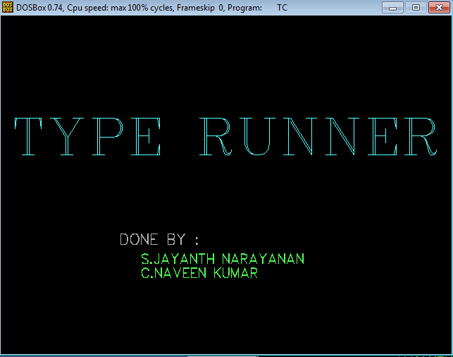

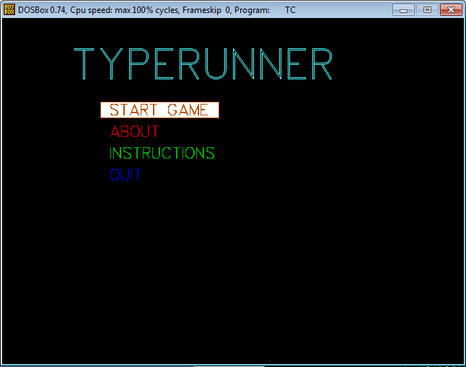

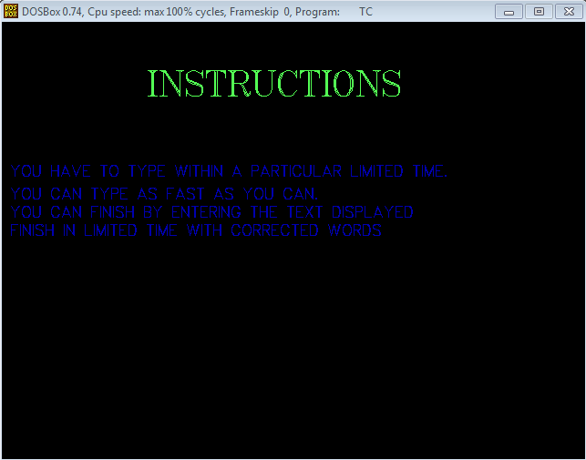

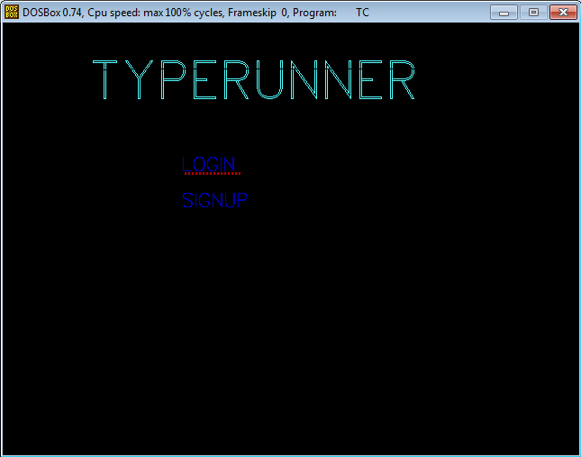

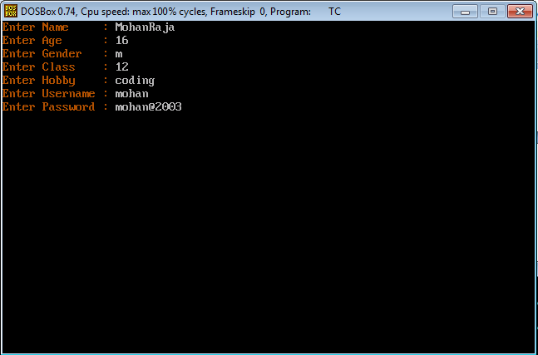

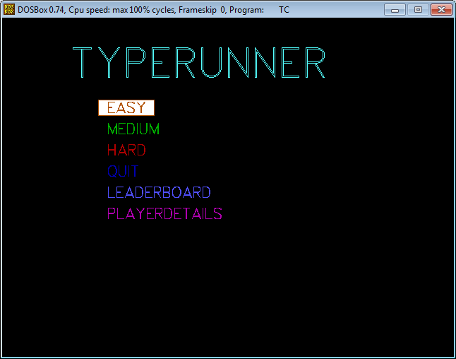

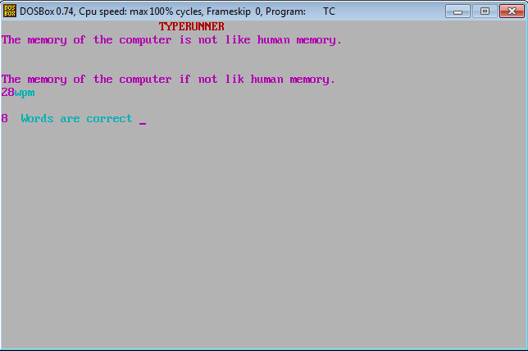

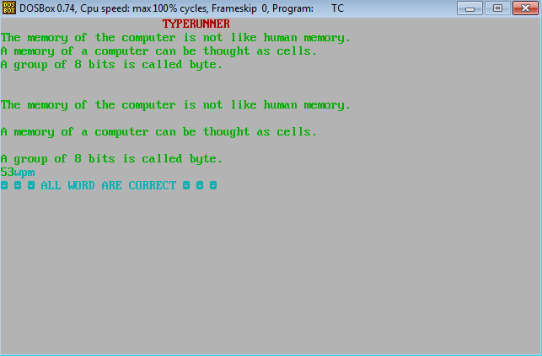

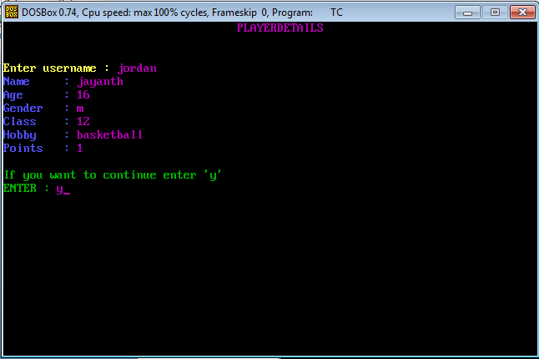

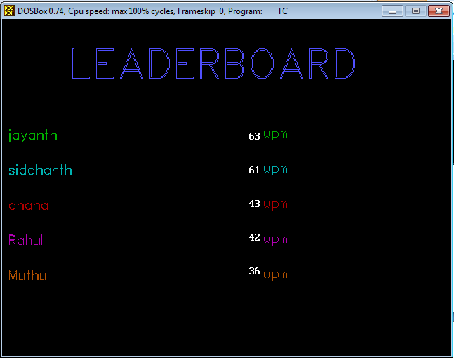

CONCLUSIONS

FROM THE VERY START TO THE VERY END, DOING THIS PROJECT WAS LESS OF A BURDEN AND MORE OF AN EXPERIENCE. WE LEARNT TO WORK AS A TEAM AND COLLOBORATE OUR IDEAS EFFECTIVELY. OVERALL IT WAS AN AMAZING EXPERIENCE.

WE LEARNT ABOUT SOME INTERESTING FEATURES OF C++ THIS PROJECT. WE COULD ALSO PRACTICALLY TEST OUR REAL WORLD SCENARIO THROUGH THIS PROJECT. WE REALIZED THAT TO GO AHEAD WITH THIS PROJECT AND TO MAKE IT A FULLY FUNCTIONING APPLICATION, ONE HAD TO BE VERY CAREFUL AND HAD TO KEEP EVERYTHING IN MIND WHILE DESIGNING IT. ONE ALSO HAD TO KEEP IN MIND THE USER INTERFACE AND OTHER METHOD TO MINIMIZE THE ERRORS AND THE CONSISTENCY OF INPUT AMONG MANY OTHERS.

WE REALIZED HOW IMPORTANT PARADIGM AND APPROACH WERE IMPORTANT WHILE SOLVING PROBLEMS WE CAME ACROSS OUR PROGRAMMING.

WE HAVE MADE SINCERE EFFORT TO MODEL THE REAL WORLD AS CLOSELY AS POSSIBLE THROUGH THIS PROJECT. WE HAVE WORKED SO HARD AND TRIED OUR BEST TO MAKE THIS PROJECT A SUCCESSFUL ONE.

THANK YOU