PROPASAL
with
Positive Bias in the Nested Design: Examined Subjective Rating on an Emotion Regulation Experiment

1. Introduction

1.1 Crossed design vs. Nested design
In a crossed design (see Figure 1, left panel), all levels of one factor occur with all levels of the other factor(s). In contrast, in a nested design (see Figure 1, right panel), the levels of a lower-level factor occur within a single level of a higher-level factor. Thus, lower-level units belong to one higher-level unit and are not shared across units. Nested designs are common in the social sciences, where data are often hierarchically structured. Because observations within the same higher-level unit may be correlated, analyses of nested data typically require statistical approaches that account for this dependency, such as multilevel modeling.
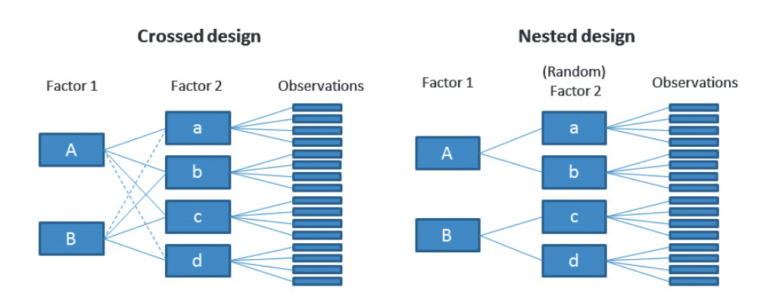
Figure 1 is from Schielzeth and Nakagawa (2013).

1.2 Experiment 1: nested design (main part)

1.2.1 Procedure
This study consisted of two sessions: a laboratory session and an online session. The lab session included the immediate and short-interval re-exposure phases. The online session for long-interval re-exposure was tested 1 week later. Each exposure phase comprised five blocks.

Immediate Exposure Phase
Each trial of the label-or-match intervention in the immediate exposure phase (Figure 2A) began with a fixation of 2000 ms, followed by a 3000 ms presentation of a target picture, during which participants observed the target picture. Subsequently, word pairs (affect labeling) or image pairs (affect matching) appeared below the target picture for selection, with no time limit for response. The task condition was indicated by whether word pairs or image pairs were presented on that trial. Participants selected the option that best reflected their emotional feelings by clicking the left mouse button to select the left picture or word and the right mouse button to select the right picture or word. After this selection, the previously labeled or matched target stimulus remained on screen while first the arousal and then the valence scales were presented underneath. Participants rated their feelings using these scales with no time limit.
This task consisted of four conditions with 160 trials in total (40 trials per condition), each presenting a picture from each of the four subsets for label negative, label neutral, match negative, and match neutral. These trials were divided into five blocks that each contained 8 trials from all four conditions. The trial order per block as well as the block order were randomly assigned for each participant. Additionally, each block included one affect labeling and one affect matching trial for one positive stimulus each, resulting in 34 trials per block and a total of 170 trials.

Short- and Long-interval Re-exposure Phases
Trials of the emotion rating blocks (Figure 2B) during the short- and long-interval phases began with a 1000-ms fixation period, followed by a 3000-ms presentation of the emotional target picture. Arousal and valence rating scales were again displayed until the participant responded with no time limit. This task consisted of six conditions with a total of 240 trials. Besides the images from the immediate phase, the short-interval phase included the short-interval new set, and the long-interval phase included the long-interval new set.

Table 1
Schematic illustration of the nested design for Experiment 1
Nested design
Factor 2
Intervention Condition
Factor 1  Picture Valence | affect labeling | affect matching | new for short-interval | new for long-interval
negative | Neg_Lab_1-40 | Neg_Mat_1-40 | Neg_newS_1-40 | Neg_newL_1-40
neutral | Neu_Lab_1-40 | Neu_Mat_1-40 | Neu_newS_1-40 | Neu_newL_1-40
Note. Affect labeling and affect matching are tested across all three re-exposure phases. The new short-interval condition occurs only during the short-interval phase, and the new long-interval condition occurs only during the long-interval phase.

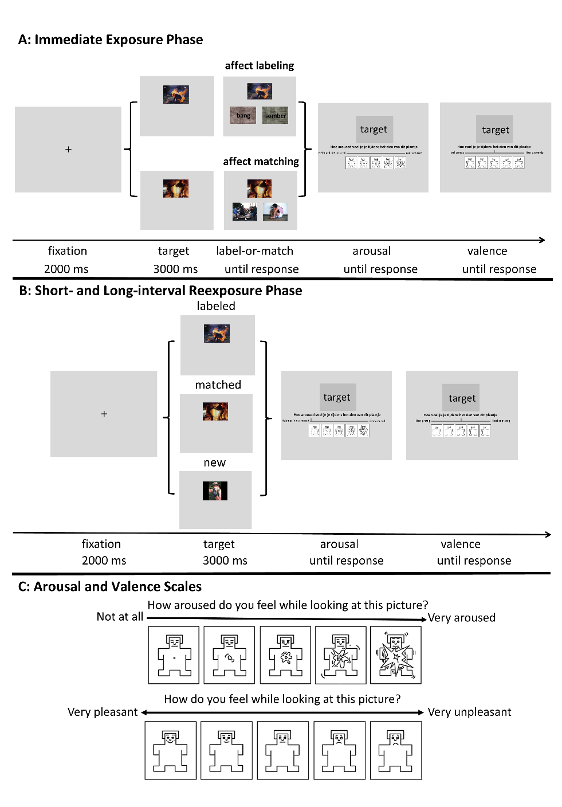
Note. The arousal scale (panel C, top) uses a slider starting from the left, where moving the slider further to the right indicates higher arousal. The valence scale (panel C, bottom) uses a slider that starts in the middle, with movement further to the left indicating a more pleasant rating, and movement further to the right indicating a more unpleasant or less pleasant rating.
Figure 2
Experiment 1: (A) Illustration of the sequence of events in a trial of the label-or-match task, followed by the emotion rating using the arousal and valence scales during the immediate exposure phase, and (B) the sequence of events in a trial of the emotion rating task using the arousal and valence scales in the short- and long-interval re-exposure phases.

1.3 Experiment 1: Results

1.3.1 ANOVA Analysis
To evaluate the down-regulation effect of affect labeling and whether it was present during all phases, we used mixed ANOVAs on arousal and valence scale scores including a between-subjects factor Group (HA, LA), and within-subject factors Picture Valence (negative, neutral), Intervention Condition (labeled and matched), and Phase (immediate, short-interval, long-interval).
Additionally, the response times for arousal and valence ratings were screened separately to remove outliers. Specifically, responses faster than 200 ms or slower than 5000 ms were considered to reflect ‘fast guesses’ or disengagement (Berger & Kiefer, 2021) and those trials were removed from the analysis. Although Group (HA, LA) was included as a factor in the analyses, no significant main effects or interactions involving Group were found. Therefore, group-related results are not further reported here.

Arousal Ratings
The arousal ratings (Figure 3, left-hand panels) showed significant main effects of Picture Valence, F(1, 48) = 184.817, p < .001, η2p = .794, Intervention Condition, F(1, 48) = 32.009, p < .001, η2p = .400, and Phase, F(2, 96, ε = .683) = 9.227, p < .001, η2p = .161. Significant two-way interactions were found for Picture Valence x Intervention Condition, F(1, 48)= 49.596, p < .001, η2p = .508; and Picture Valence x Phase, F(2,96, ε = .674) =4.781, p = .022, η2p = .091. Importantly, these effects were qualified by a significant three-way interaction of Picture Valence, Intervention Condition, and Phase, F(2, 96, ε = .945) = 7.128, p = .002, η2p = .129. No other interactions were found (all p-values > .124)
To unpack the three-way interaction, we tested whether the Intervention Condition x Phase interaction was significant for negative and neutral stimuli separately. This interaction was significant for negative stimuli, F(2, 98, ε = .983) = 6.501, p = .002, η2p = .117, but not for neutral stimuli (p = .265). Follow-up analyses were therefore focused on negative stimuli. Pairwise t-tests were used to compare affect labeling and affect matching at each phase. As hypothesized, for negative stimuli, affect labeling was associated with lower arousal ratings than affect matching across all phases (Figure 3, A, C, E): immediate, t(49) = 6.956, p < .001, d = .984; short-interval, t(49) = 7.078, p < .001, d = 1.001; long-interval, t(49) = 3.926, p < .001, d = .555. However, as can be seen, the effect size (proportional to t) is smaller for the long interval than for the other phases, as reflected in the interaction effect.

Valence Ratings
The valence ratings (Figure 3, right-hand panels) showed significant main effects of Picture Valence, F(1, 48) = 409.274, p < .001, η2p = .895, Intervention Condition, F(1, 48) = 78.656, p < .001, η2p = .621, and Phase, F(2, 96, ε = .683) = 6.753, p = .008, η2p = .123. Again, significant two-way interactions were found for Picture Valence x Intervention Condition, F(1, 48) = 21.755, p < .001, η2p = .312; and Picture Valence x Phase, F(2, 96, ε = .674) = 10.151, p < .001, η2p = .175. These effects were also qualified by a significant three-way interaction between Picture Valence, Intervention Condition, and Phase, F(2, 96, ε = .945) = 12.613, p < .001, η2p = .208. No other interactions were found (all p-values > .068).
To unpack the three-way interaction, we tested whether the Intervention Condition × Phase interaction was significant for negative and neutral stimuli separately. Again, the Intervention × Phase interaction was significant for negative stimuli, F(2, 98, ε = .921) = 14.281, p < .001, η2p = .226, but not for neutral (p = .152). Pairwise comparisons showed that participants reported lower unpleasantness ratings for negative stimuli immediately after labeling than after matching them (panel B), t(49) = 3.705, p < .001, d = .524. This effect persisted during short-interval re-exposure (panel D), t(49) = 7.402, p < .001, d = 1.047, but not during long-interval re-exposure (panel F, p = .133), as reflected in the interaction effect.
Figure 3
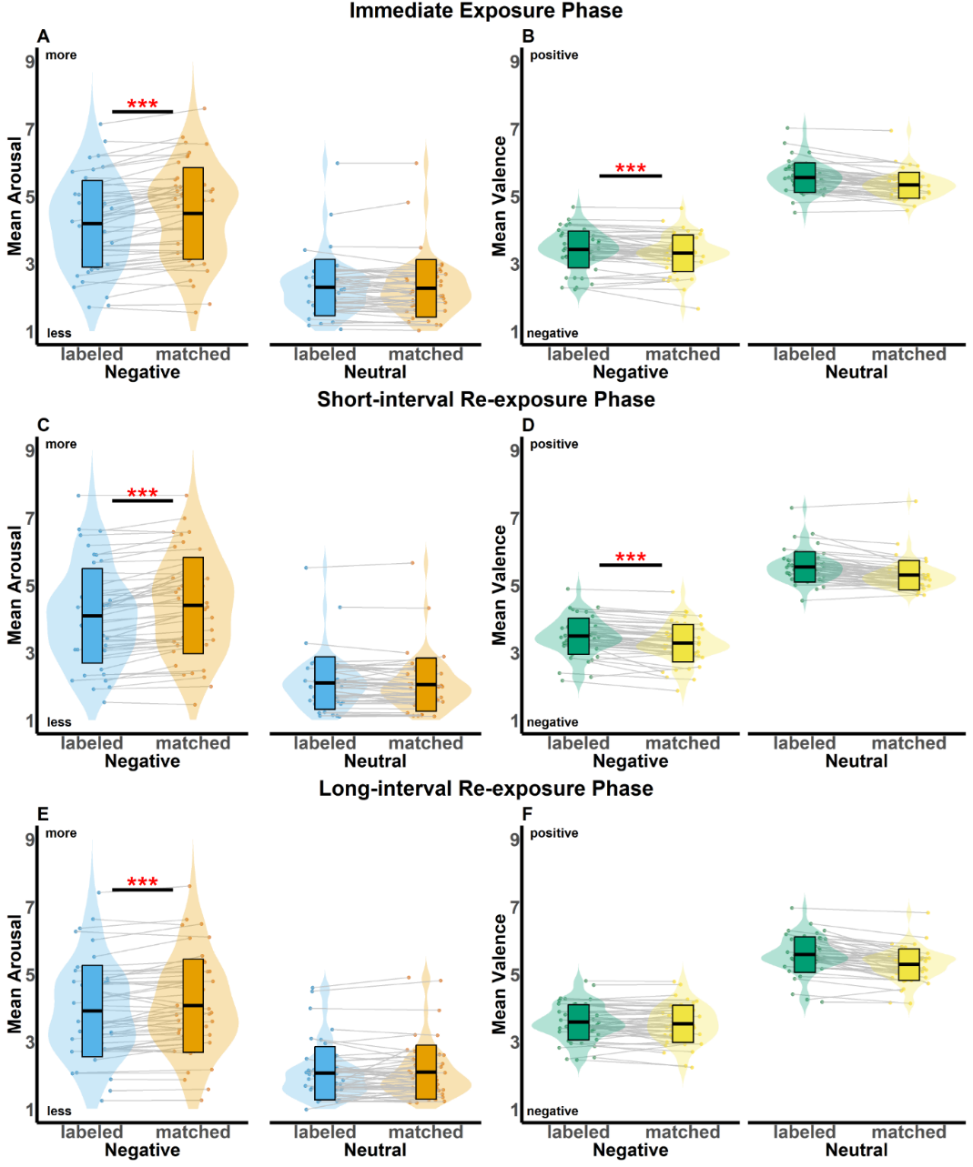
Experiment 1: Mean arousal (plot A, C, E) and valence (plot B, D, F) ratings, averaged across anxiety levels, as a function of Intervention Condition, Picture Valence, and Phase, comparing affect labeling and affect matching for negative and neutral stimuli during immediate (A, B), short-interval (C, D), and long-interval (re-)exposure (E, F) separately.

Note. The asterisks indicate significance levels: * p < .05,** p < .01, and *** p < .001. The black line in the middle of the box represents the mean value, while the bottom and top edges of the box indicate ±1 standard deviation (SD).

1.3.2 ANOVA Analysis with Baseline Correction
In the current study, the image sets were fixed for the labeling and matching conditions, respectively. Given that the image set was confounded with the Intervention Condition, we collected image ratings without any intervention as the baseline to control for image-level variability. Although the new norm data were not collected from the same participants as Experiment 1, the new norm data were obtained from a very comparable sample and were therefore considered an appropriate baseline. For each image, the mean rating from the new norm data was subtracted from the corresponding post-intervention rating, resulting in difference scores that were analyzed using mixed ANOVAs.
For arousal, a more positive difference score reflects relatively higher arousal, and a more negative score reflects relatively lower arousal. For valence difference scores, positive values indicate a shift toward a more positive (less negative) direction, whereas negative scores indicate a shift in a more negative (less positive) direction.

Arousal Difference Scores
For Experiment 1, the analysis of arousal difference scores showed significant main effects of Picture Valence, F(1, 48) = 12.076, p < .001, η2p = .201, Intervention Condition, F(1, 48) = 13.541, p < .001, η2p = .220, and Phase, F(2, 96, ε = .705) = 9.171, p < .001, η2p = .160. No interactions were found (all p-values > .060), in particular not with the effect of Intervention Condition (all p-values > .154).

Valence Difference Scores
Valence difference scores showed no main effects of Picture Valence, Intervention Condition, or Phase (all p-values > .139). Three two-way interactions were significant: Picture Valence × Phase, F(2, 96, ε = .760) = 12.988, p < .001, η2p = .213,Intervention Condition × Phase, F(2, 96, ε = .887) = 3.343, p = .046, η2p = .065, and Intervention Condition × Picture Valence, F(1, 48) = 5.791, p =.020, η2p = .108. Also, a three-way interaction Picture Valence × Intervention Condition× Phase was significant, F(2, 96, ε = .874) = 3.483, p =.041, η2p = .068.
Follow-up tests showed that the contrast between labeling and matching conditions was significant for negative stimuli only during the immediate exposure phase, t(48) = 3.148, p = .003, d = .161, and long-interval re-exposure phase, t(48) = 2.235, p = .030, d = .100. Relative to new norm ratings, affect matching showed a slightly greater shift towards more positive valence than affect labeling, although the difference was small.

Figure 8.
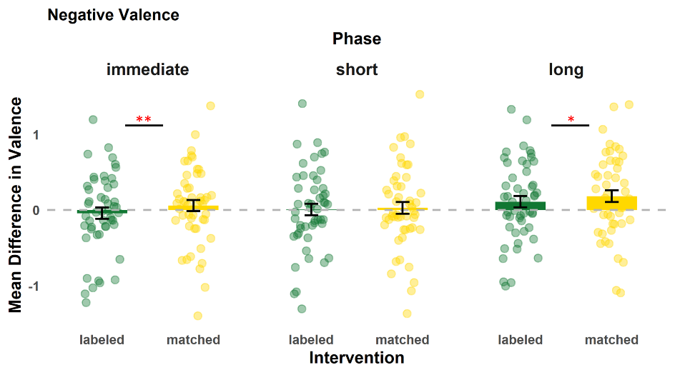
Baseline-corrected valence-difference scores for Experiment 1 for negative stimuli, averaged across anxiety levels as a function of Intervention Condition and Phase, comparing affect labeling and affect matching across immediate, short-interval, and long-interval re-exposure separately.
Note. Asterisks indicate significance levels: * p < .05,** p < .01, and *** p < .001. The bars represent the mean value, and the error bars indicate ±1 standard deviation (SD). Each circle represents a different score of the subjective level.

1.4 LMM models
The linear mixed-effects model (LMM) approach follows recommendations by (Schielzeth & Nakagawa, 2013) for accounting for stimulus-level variability. Specifically, images will be treated as a stimulus-level random effect so that variance attributable to the stimuli can be modeled explicitly.
In LMM, participants will be included as a random intercept to account for repeated measurements within individuals. Baseline image ratings will be included as a covariate provided that their inclusion does not lead to model convergence warnings.
Notably, images nested within intervention conditions will be included as a random intercept to account for stimulus-level variability.
$$lmer(Arousal\sim Intervention * Valence + baseline_{Arousal}+ (1 | Participant) + (1 | Intervention:Image)+data)$$
$$lmer(Valence\sim Intervention * Valence +baseline_{valence}+ (1 | Participant) + (1 | Intervention:Image)+data)$$

1.5 Bayesian Analysis

Experiment 2: Crossed design (if it is useful, we can use it)
In the second experiment (Experiment 2), we implemented a fully randomized stimulus assignment and included a feature labeling condition. However, subjective ratings did not differ significantly across the three conditions.
Although these null effects do not provide evidence of differences between conditions, they suggest that the effects observed in Experiment 1 may have been influenced by the design's nested structure. Specifically, the ANOVA used in Experiment 1 may have inflated the reported effects because it did not account for the variance associated with clustered observations. To address this issue, analyses that explicitly model hierarchical variance, such as multilevel modeling, are required.

Table 2
Schematic illustration of the nested design for Experiment 1
Crossed design
Factor 2
Intervention Condition
Factor 1  Picture Valence | affect labeling | affect matching | feature labeling
negative | x | x | x
neutral | x | x | x
Note. Affect labeling, affect matching, and feature labeling are tested across all three re-exposure phases.

