INF 286 Instructor: Tim McCord
Assignment #3 Last Name: Weyman First Name: Michael

Pass/Fail Requirement: All XHTML pages must use the following boilerplate code as their header. This is in turn facilitates validation as described later in the assignment.

<?xml version="1.0" encoding="UTF-8"?>
<!DOCTYPE html PUBLIC "-//W3C//DTD XHTML 1.0 Transitional//EN"
"http://www.w3.org/TR/xhtml1/DTD/xhtml1-transitional.dtd">

<html xmlns="http://www.w3.org/1999/xhtml">

Assignment 3: Configuring Color and Text with CSS

Problem 1 (20%)
Create an external style sheet ex3.css to format as follows:
- Document background color #FDFDF0 (White Orchid) (3%);
- Document text color of #0000FF (3%);
- Document family of Arial, Helvetica, or sans-serif (3%);
- Hyperlinks should have a background color of grey (#CFCFCF) (3%);
- <h1> elements should use the Palatino or Times New Roman (serif) font with black text color (3%).
- The news class should use red italic text (3%).
- Save it as ex3.css (1%);
- Submit this source code file (1%).

Problem 2 (15%)
Create a web page using an external style sheet:
- That includes an unordered list describing at least three advantages of using CSS (3%).
- The text CSS Advantages should be contained within <h1> tags (2%).
- This page should include a hyperlink to the W3C Web site (2%);
- Write the XHTML code so that one of the advantages is configured to be a class called news (4%);
- Place an email link to yourself on the Web page (2%);
- This web page should use the external style sheet called ex3.css (2%).
- Save the page as advantages.html
- Submit this source code file.

Problem 3 (15%)
Create a web page using an external style sheet:
- That includes an unordered list describing at least three disadvantages of using CSS (hint: you can search disadvantages of using CSS from online resources to supplement the text) (3%).
- The text CSS Disadvantages should be contained within <h1> tags (2%).
- This page should include a hyperlink to the W3C Web site (2%);
- Write the XHTML code so that one of the disadvantages is configured to be a class called news (4%);
- Place an email link to yourself on the Web page (2%);
- This web page should use the external style sheet called ex3.css (2%)
- Save the page as disadvantages.html
- Submit this source code file.

Problem 4 (10%)
Launch a browser and display both web pages created in Problem 1 and 2. Both of them use the formatting configured in ex3.css
- Paste the image of the browser window into the assignment WORD document here after you display advantage.html (Press Ctrl+PrintScreen key to capture the active window only) (5%);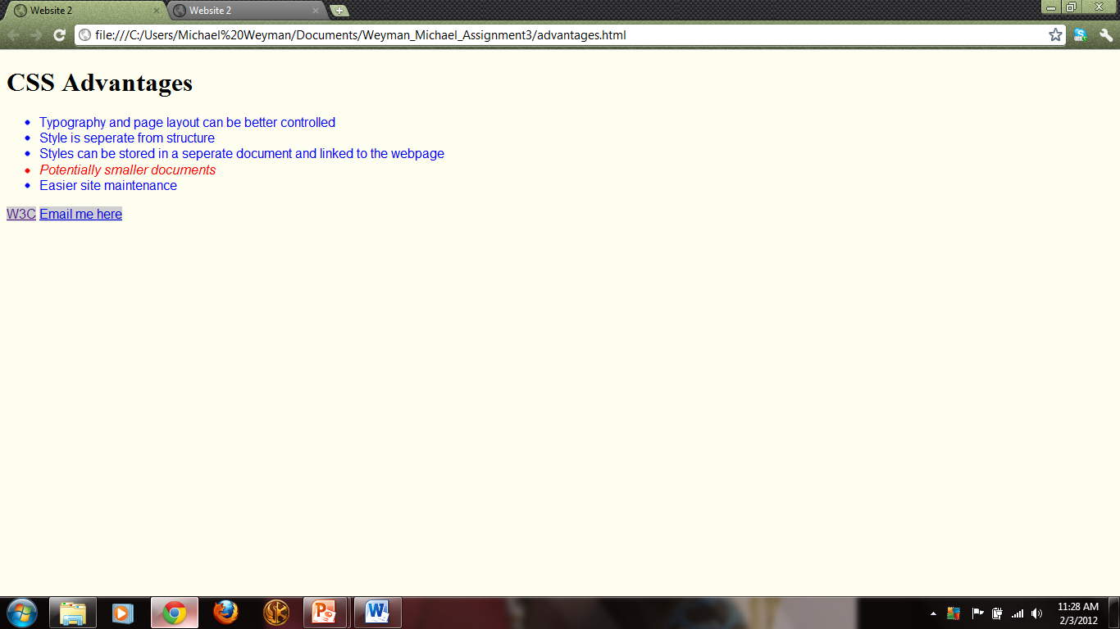
- Paste the image of the browser window into the assignment WORD document here after you display disadvantage.html (Press Ctrl+PrintScreen key to capture the active window only) (5%).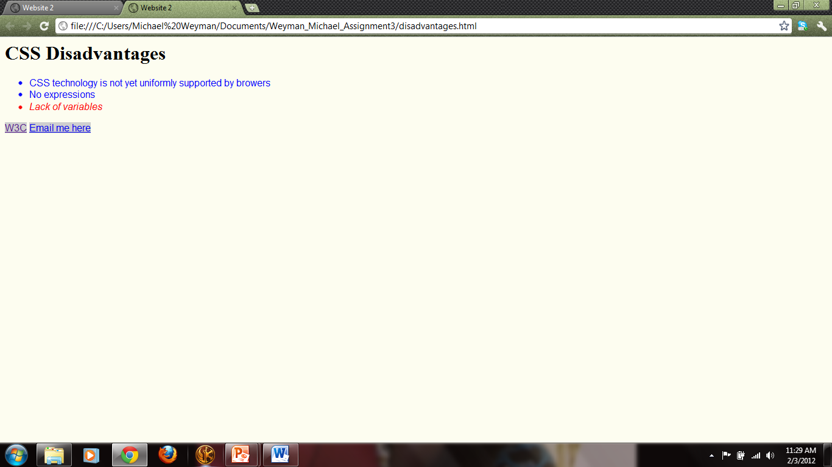

Problem 5 (20%)
Change the configuration of the external style sheet (ex3.css) created in Problem 3 to format as follows:
- Document background color of black (6%);
- Document text color of white (6%);
- <h1> text color of gray (#CCCCCC); (6%)
- Save the file as ex3_5.css (1%);
- Submit this source code file (1%) .

Problem 6 (10%)
Change the two web page files, advantages.html and disadvantages.html, so that they both use the formatting configured in ex3_5.css.
- Save these two files as advantages_6.html and disadvantages_6.html (5%);
- Submit these two XHTML files
- Display each of these two new Web pages in a Web browser, and paste the image into the assignment WORD document here (5%) (Press Ctrl+PrintScreen key to capture the active window only). 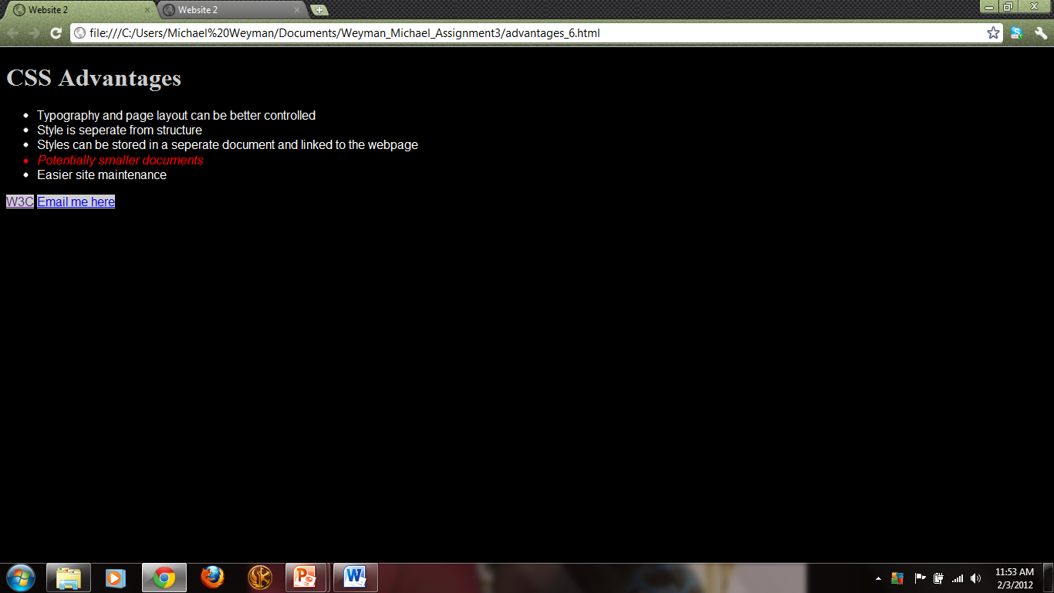
- 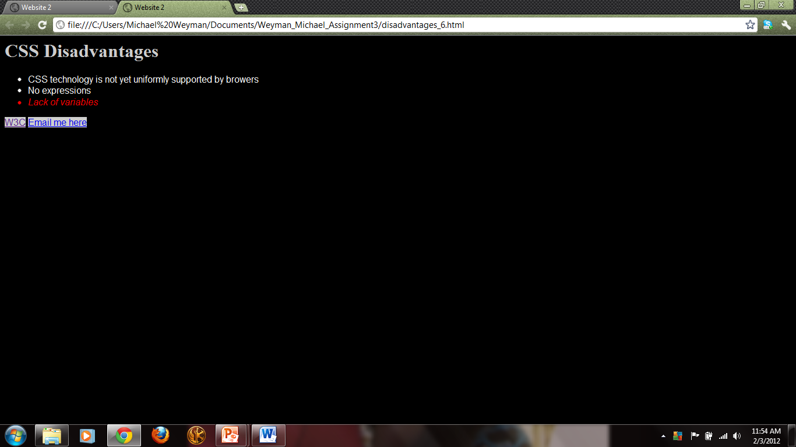

Problem 7 (10%)
Modify the advantages_6.html f to use an inline style:
- Change the <h1> text color to red and save the file as advantages_7.html (5%);
- Submit this file
- Display this file in a Web browser, and paste the image into the assignment WORD document here (5%) (Press Ctrl+PrintScreen key to capture the active window only). 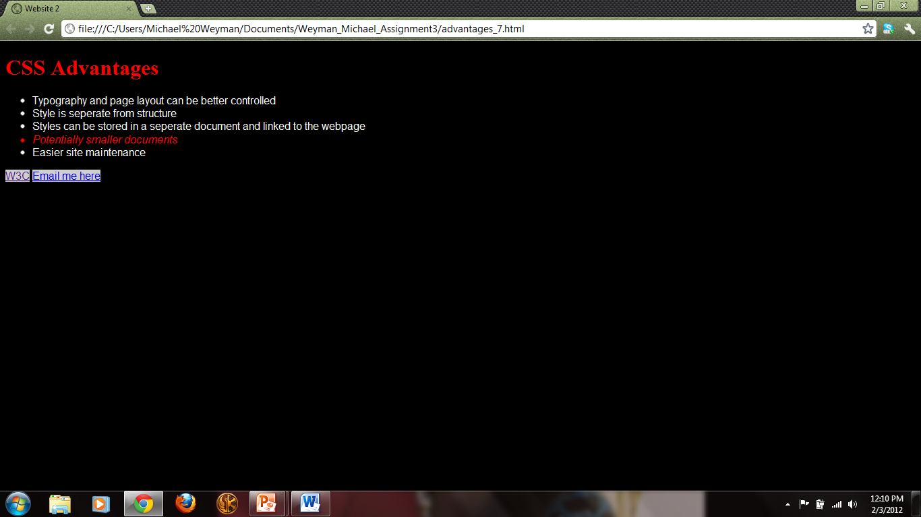

Your source code must be carefully indented using two white spaces as the increment, no tabs!!!
Additionally, all XHTML must be validated using the markup validation service offered by W3C at http://validator.w3.org and CSS Validation Service offered by W3C
http://jigsaw.w3.org/css-validator.

If it fails validation, even if it displays more or less correctly in IE, points may be deducted.
[I don’t check every page, but if there is an error, I check to see if the validator service would have found it for you. In my opinion, not taking advantage of easy, automated, and 100% free testing is one of the great sins of software development.]

To be accepted for grading, you must compress all your files into one zip file and modify its name as YourLastName_YourFirstName_Assignment3.zip, and submit the single zip file to Blackboard.

