INF 286-004 Instructor: Tim McCord
Assignment #4 Last Name: First Name:

Pass/Fail Requirement: All XHTML pages must use the following boilerplate code as their header. This is in turn facilitates validation as described later in the assignment.

<?xml version="1.0" encoding="UTF-8"?>
<!DOCTYPE html PUBLIC "-//W3C//DTD XHTML 1.0 Transitional//EN"
"http://www.w3.org/TR/xhtml1/DTD/xhtml1-transitional.dtd">

<html xmlns="http://www.w3.org/1999/xhtml">

Problem 1 (30%)
Write the XHTML code snippet to create an image hyperlink.
- The image is called family.jpg. (5%)
- It is 200 pixels high by 300 pixels wide. (10%)
- The image should link to a web page called family.html. (10%)
- There should be no border on the image. (5%)

Suppose that the web page document that contains your image hyperlink is named as index.html. The file family.jpg is in a folder called images. The files index.html, family.html and the images folder are in the same directory, c:\MyFolder (see picture below for their directory relationship).
Note: You are only responsible for the XHTML code for the image hyperlink (including the anchor tags and codes between the anchor tags), not the full page.
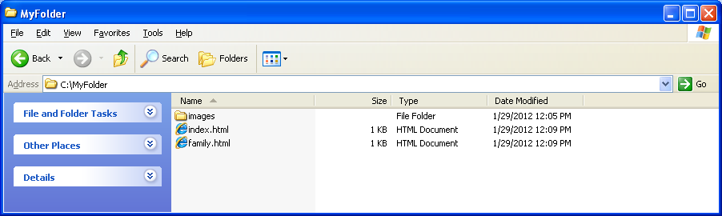

Problem 2 (30%)
- Create a file called hw42.html
- Use an embedded style to define h1, h2, and h3
- For h1 (10%):
  - use a border of size 3px, solid, color FF9900. Simple text for h1 is <h1>Here is an h1 heading</h1>
  - h1 should have padding of 5px;
- For h2 (10%):
  - use a border of size 5px, dotted and color #0033FF. Simple text for h2 is <h2>Here is an h2 heading</h2>
  - h2 should have padding of padding-top of 10px and padding-left of 5px
- For h3 (10%):
  - use a border of size 8px, dashed and color #00FFFF. Simple text for h3 is <h31>Here is an h3 heading</h3>
  - h3 should have padding of 5px for top/bottom and 20px for left/right;
- Save your file for inclusion in your submission zip file, load your file in a web browser, and paste the page display result here. 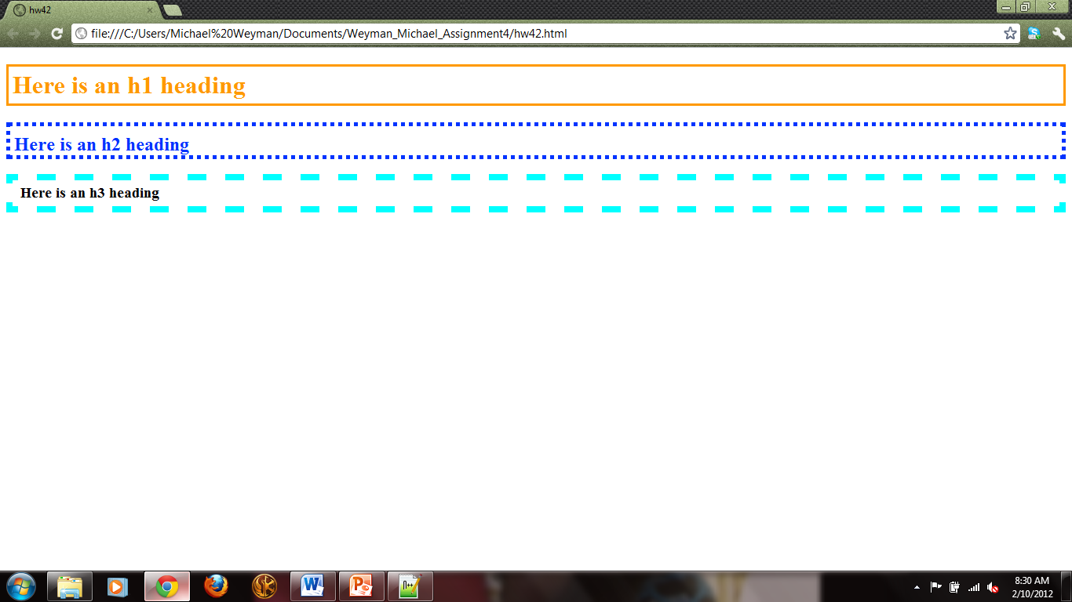

Problem 3 (10%)
- Save your hw42.html as hw43.html;
- Add a background image that you like to this page file so that it covers all the page background. You may use the nku_logo1.gif file if you wish.
- Save your file for inclusion in your submission zip file, load your file in a web browser, and paste the page display result here. 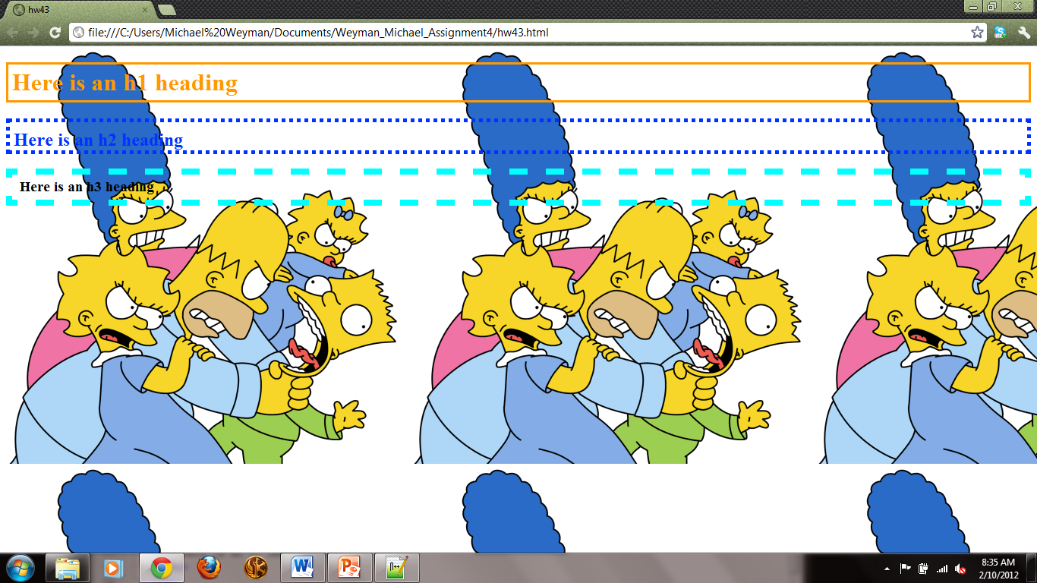

Problem 4 (30%)
- Create a file hw44.html
- Add nku_logo1.gif image to hw44.html so that:
  - When the visitor clicks the upper half of this image, the visitor will be directed to the NKU homepage (15%);
  - When the visitor clicks the lower half of this image, the visitor will be directed to your own homepage (15%);
- Save your file for inclusion in your submission zip file, load your file in a web browser, and paste the page display result here. 

Finally, please compress all your files including LastName_firstName_Assignment4.doc, hw42.html, hw43.html, hw44.html, and nku_logo1.gif into one zip file, and upload this zip file to BB.

