INF 286-004 Instructor: Tim McCord
Assignment #6 Last Name: Weyman First Name: Michael

Pass/Fail Requirement: All XHTML pages must use the following boilerplate code as their header. This is in turn facilitates validation as described later in the assignment.

<?xml version="1.0" encoding="UTF-8"?>
<!DOCTYPE html PUBLIC "-//W3C//DTD XHTML 1.0 Transitional//EN"
"http://www.w3.org/TR/xhtml1/DTD/xhtml1-transitional.dtd">

<html xmlns="http://www.w3.org/1999/xhtml">

HINT: Follow the textbook and examples from Chapter 7 if there are multiple ways to implement a given requirement.

Problem 1 (15%)
- Step 1: Write the XHTML to create a bookmark at the beginning of a Web page designated by “top”. Please write your code directly here in the WORD document (10%);
<a> id=”top” name=”top” ></a>
- Step 2: Write the XHTML to create an internal link to the bookmark designated by “top”, which you created in the last step. Please write your code directly here in the WORD document (5%);
<a href=”#top”> Back to the top</a>
- Note: Please do NOT write the entire Web page code, and please include (in this document) only the code for creating the bookmark and linking the bookmark created.

Problem 2 (10%)
- Write the XHTML to associate a Web page with an external style sheet named myprint.css to configure a printout. Please write your code directly here in the WORD document (5%);
<link rel=“stylesheet” href=“myprint.css” type=“text/css” media=“print” />
- Write the XHTML to associate a Web page with an external style sheet named myweb.css to configure the display of the Web page. Please write your code directly here in the WORD document (5%);
<link rel=“stylesheet” href=“myweb.css” type=“text/css” media=“screen” />
- Note: Please do NOT write the entire Web page code, and please include (in this document) only the code for creating the bookmark and linking the bookmark created.

Problem 3 (15%)
Please write the CSS to configure an image file named myimage.gif as the “bullet” in an unordered list.
- Note: Please do not write the entire Web page code, and please include only a section of code only for the purpose specified above.
CSS:
.navBar { list-style-image: url(myimage.gif); }

Problem 4 (10%)
Please write the CSS to configure an unordered list not to display a “bullet”.
- Note: Please do not write the entire Web page code, and please include only a section of code only for the purpose specified above.
CSS:
.navBar { list-style-type:none; }

Problem 5 (20%) Configuring printing for Hands-On Practice 7.3:
Using the files supplied with the assignment for the Hands-On Practice 7.3 as Problems_5-6-7.zip, please modify the code as specified as follows:
- Save the file of threecolumn.html as threecolumnprint.html.
- Modify the file threecolumnprint.html so that it links to an external style sheet called threecolumn.css instead of using embedded styles;
- Create a new CSS file, called myprint.css, which will prevent the navigation from displaying when the page is printed;
- Modify the threecolumnprint.html page to link to the file myprint.css.
- Paste the screen shot when the page threecolumnprint.html is normally displayed by a Web browser; 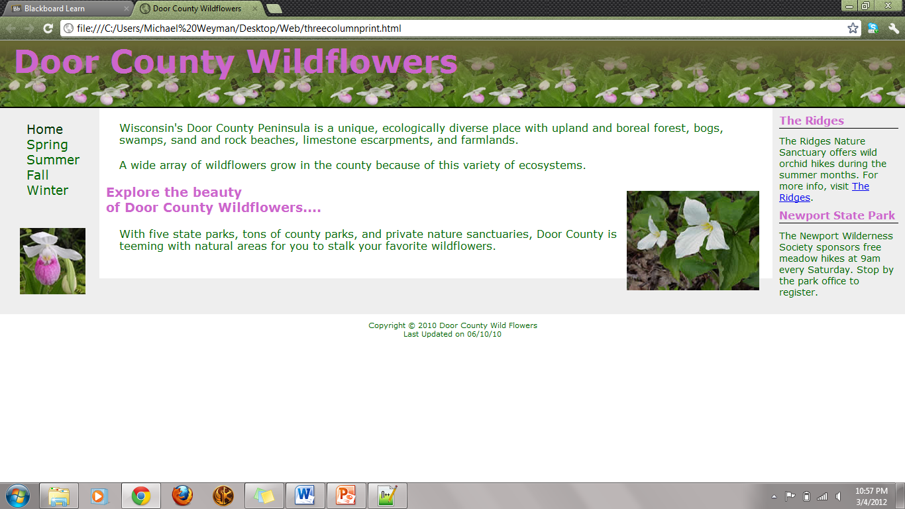
- Paste the screen shot when Print-Previewing the page threecolumnprint.html (if you use IE, you can click the menu File, and then choose Print Preview). 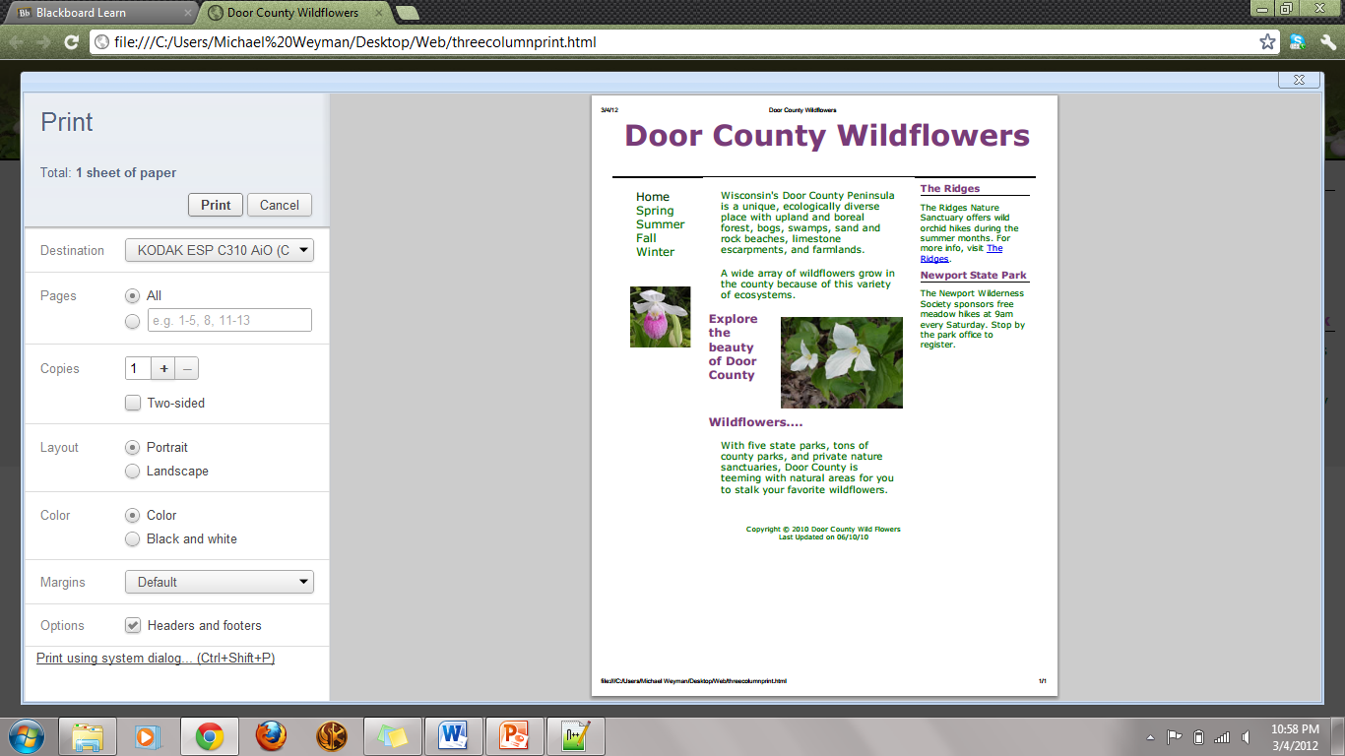
- Please submit the code and all other files in a folder named Problem5.

Problem 6 (10%) Modify the design of Hands-On Practice 7.3:
Using the files supplied with the assignment for the Hands-On Practice 7.3 as Problems_5-6-7.zip, please modify the code as specified as follows:
- Configure the style rules for threecolumn.html to display the page in the center of the Web page with blank margins on either side;
- Change the title of this Web page as “Problem 6 solution by Your Name”, e. g. “Problem 6 Solution by John Smith”;
- Paste the screen shot of your Web browser display result of this file; 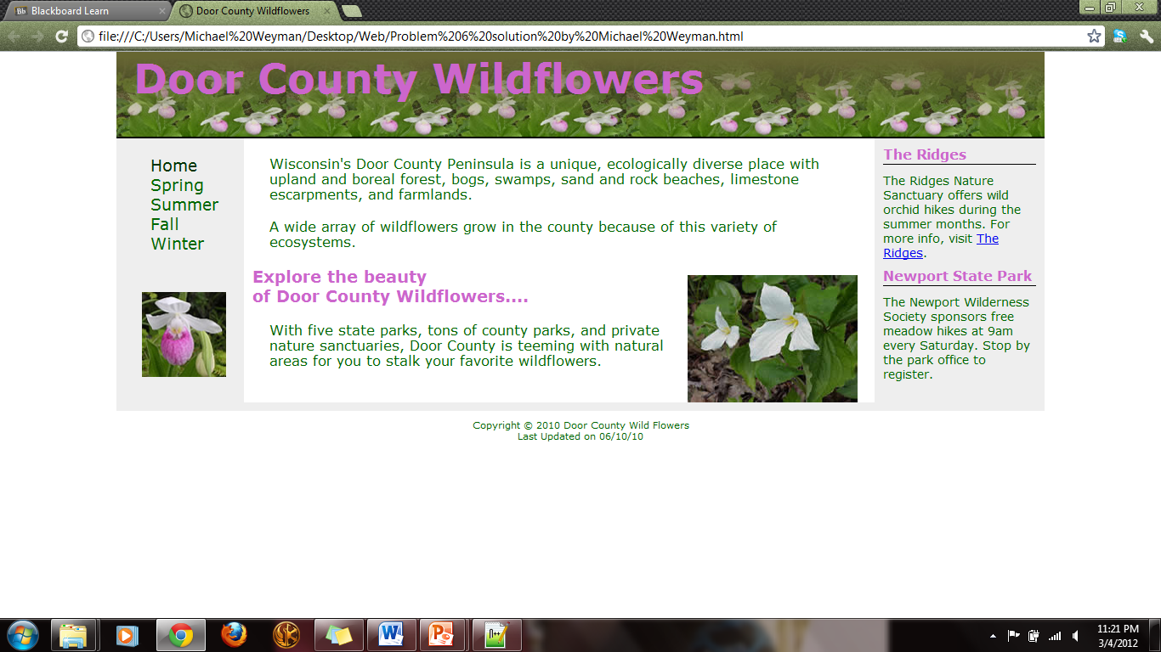
- Please submit the code and all other files in a folder named Problem6.
- Hint: Please refer to Chapter 5 on jello design.

Problem 7 (20%) Modify the design of Hands-On Practice 7.3:
Using the files supplied with the assignment for the Hands-On Practice 7.3 as Problems_5-6-7.zip, please modify the code as specified as follows:
- Use pseudo classes to configure the navigation links as a list of buttons;
- Paste the screen shot of your Web browser display result of this file;
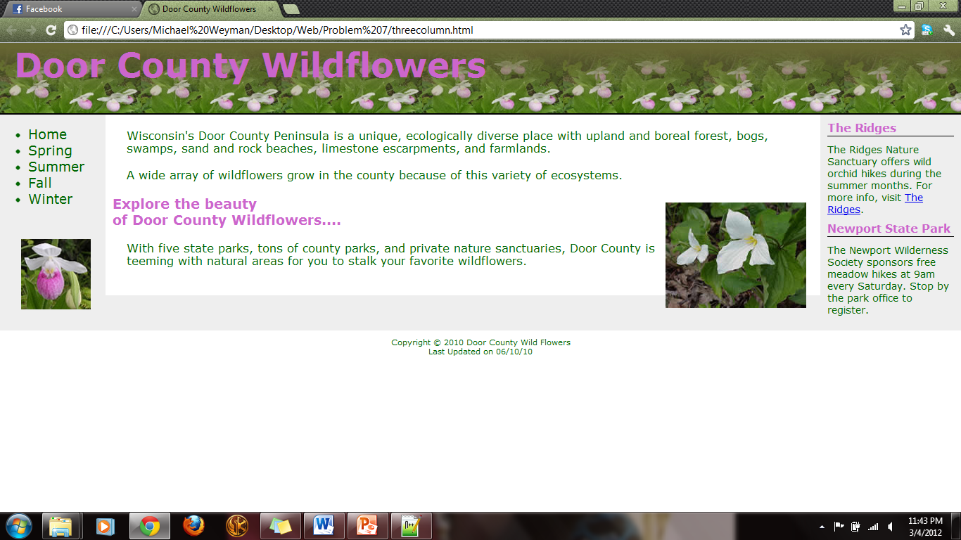
- Please submit the code the code and all other files in a folder named Problem7.
- Hint: Please refer to the button examples given in the lecture slides and the textbook.

Note:
- Please remember to rename your file as Lastname_Firstname_Assignment6.doc.
- Please place the word document and the other three folders all in a folder named YourLastName_YourFirstName_Assignment6 and compress this folder as YourLastName_YourFirstName_Assignment6.zip
- Submit YourLastName_YourFirstName_Assignment6.zip file to BB.

