INF 286-004 Instructor: Tim McCord
Assignment #1 Last Name: First Name:

Problem 1 (40%)
Start a web browser and go to http://visualroute.visualware.com/. This web site will show you the various paths a message takes when going from one host to another over the Internet. From the main page, click on the North American continent to select a server, and then find the pin that represents Cincinnati, OH on the map of the US. Click on that pin. This loads a Java applet into browser and it may take many seconds to load--be patient! In fact, the site can be a bit unpredictable, so you may want to try closing your browser and restarting, etc., if it does not cooperate.

Click on the Table tab. Enter the address www.uc.edu into the “Perform connection test to” box at the top and press the Start button. Watch the hops as they take place.
  - Copy and paste the computer screen here (Hint: Use Alt-PrintScreen in Windows to capture the active window, as opposed to the whole desktop).
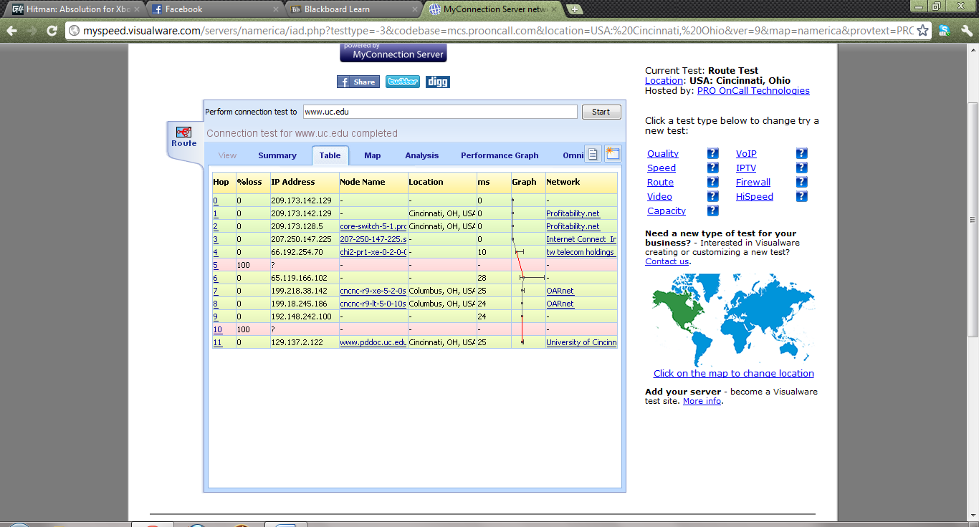
  - How many hops did it take? (Note that it counts from zero, so take that account)
12
  - Name 2 of the cities listed in the various hops (not all hops will have a city listed)?
Cincinnati
Columbus
  - How many total milliseconds did the test take?
25 ms
  - Click on the Analysis tab. Do you find anything unusual about the connection results? If so, what?
Yes, It detected firewalls on the route

Problem 2 (20%)
Use http://www.iana.org/domains/root/db/ to determine the country code for Israel. What is the country code?
.IL

Problem 3 (30%)
Given the URL, http://www.nku.edu/~csc/faculty.html, (this URL is faked and does not exist actually. So, do not try to open this URL) please answer the following questions:
- What is the protocol used here?
HTTP
- What is the Web server computer name used here?
www.
- What is the domain name used here?
Nku.edu
- What is the Web page file name?
Faculty.html
- Which folder is the Web page file located in?
~csc

Problem 4 (10%) Short answer questions. Please briefly and clearly answer each question below based on the reading.
What are the main purposes of the Domain Name System (DNS)? Provide a simple example (it does not need to be accurate information) of what it accomplishes.

Finally, please remember to rename your file as Lastname_Firstname_Assignment1.doc. For example, my name is Tim McCord. Then, my file would be renamed as MccCord_Tim_Assignment1.doc.

