Tiny Planet Image Creation

Objective :: To turn panoramic image into a sphere such that it looks like a tiny planet image.

Here, I give a prototype to create tiny planet images. Process can be divided into following steps:

1. Resize Image
2. Flip Image
3. Apply Transformation
4. **Resize Image :** Let input panoramic image is of size $r×c$ (generally for panorama images number of columns are greater than number of rows). Resize to $r×2πr$ size.

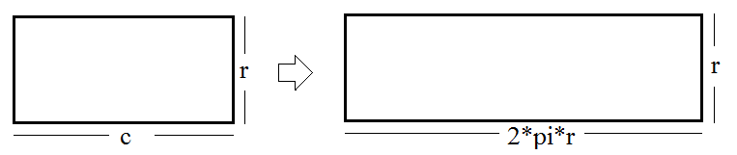

Figure 1 : (left) Input image and (right) Resized image

1. **Flip Image** **:** Flip resized image vertically ( or rotate it by 1800). This operation can be done while applying transformation to reduce execution time.
2. **Apply Transform :**  A row in the flat image is represented as an arc in the tiny planet image, such that the last row of the input image is getting mapped the center point of a tiny planet image.

Create the resultant image of size $2r×2r$. The values at each position are calculated using nearest neighbourhood interpolation (bi-linear or bi-cubic interpolation can be used to improve image quality).

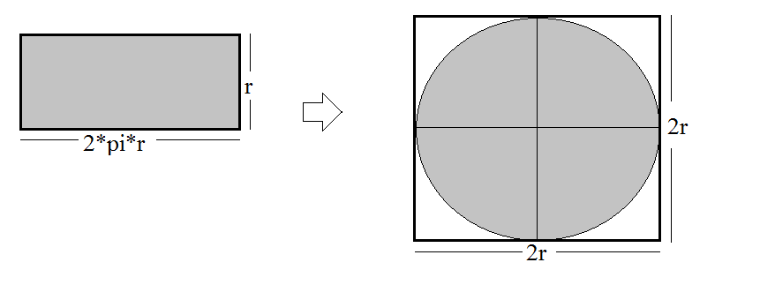

Figure 2 : (left) flipped image, (right) tiny planet image

In above image for the white strip, we don’t have any pixel value information. For the rest of the part pixel position mapping is given as,

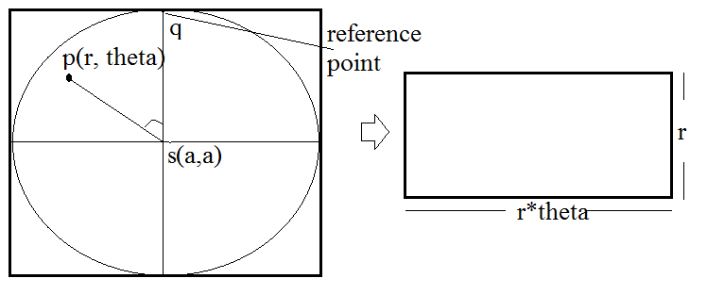

Figure 3 : Back Projection for interpolation

To calculate the pixel value of the resultant image, we find the corresponding position in the input image.

1. Map input image co-ordinate to corresponding polar co-ordinate.

For any pixel (x, y) and center (a,a),

r= $dist\left(\left(a,a\right),\left(x,y\right)\right)$

angle= $angle between \vec{sp} and \vec{sq}$

so,

$resImg\left(x,y\right)=inImg( m,r*angle)$

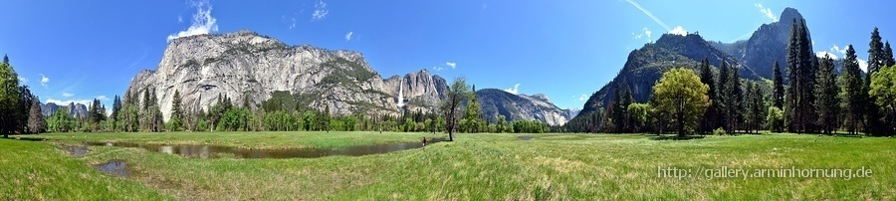

Figure 4: input image

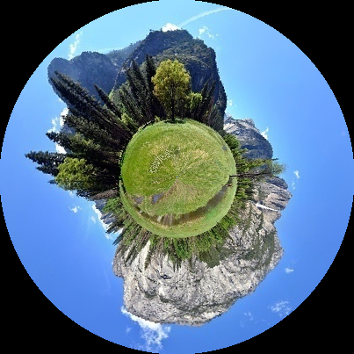

Figure 5 : Tiny Planet Image

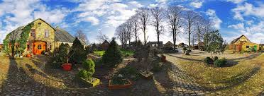

Figure 6 : Input image

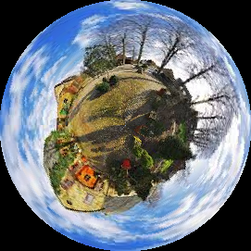

Figure 7 : Tiny Planet Image