**Startup Instructions for the RCM Scanner**

**Make sure you have the correct protective laser eyewear for the wavelength of light and power you are using. As of 7/14/22 the 785nm laser diode is in use.**

1. **Flip a light switch to illuminate the LASER ON sign outside of the lab door**

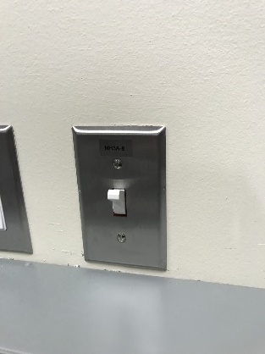

1. **Turn ON the power supply for the high voltage amplifier**. Voltage should read 12.3V, current 0.03A.

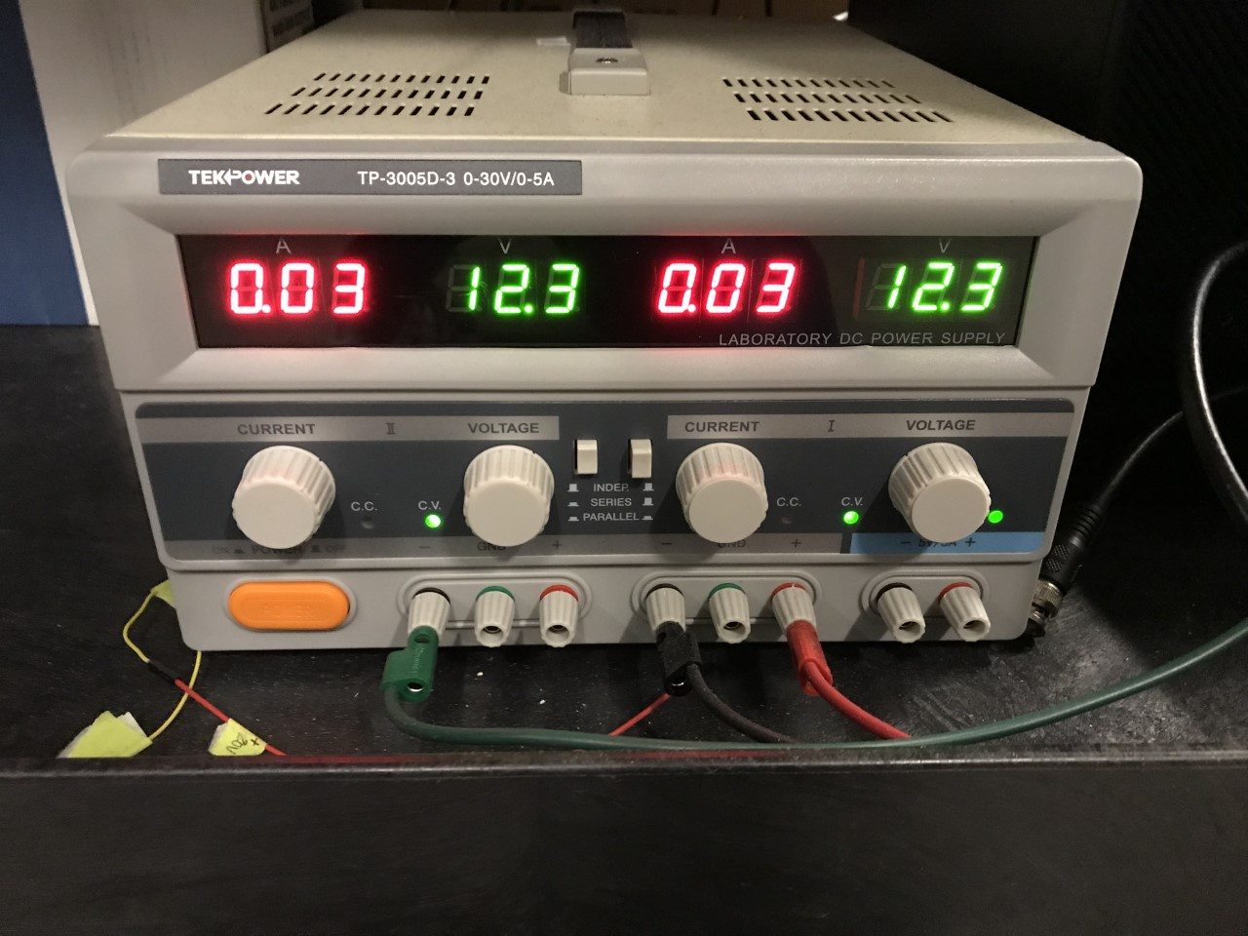

1. **Turn ON the power supply for the position sensitive detector**. The voltage should read 5V.

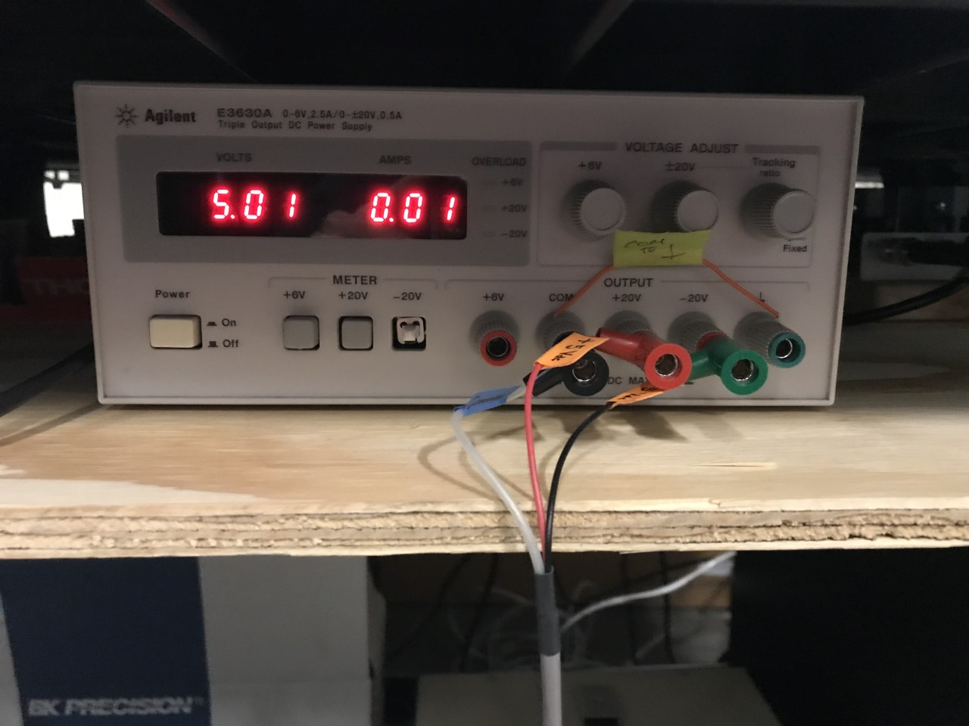

1. **Turn ON the photodiode.**

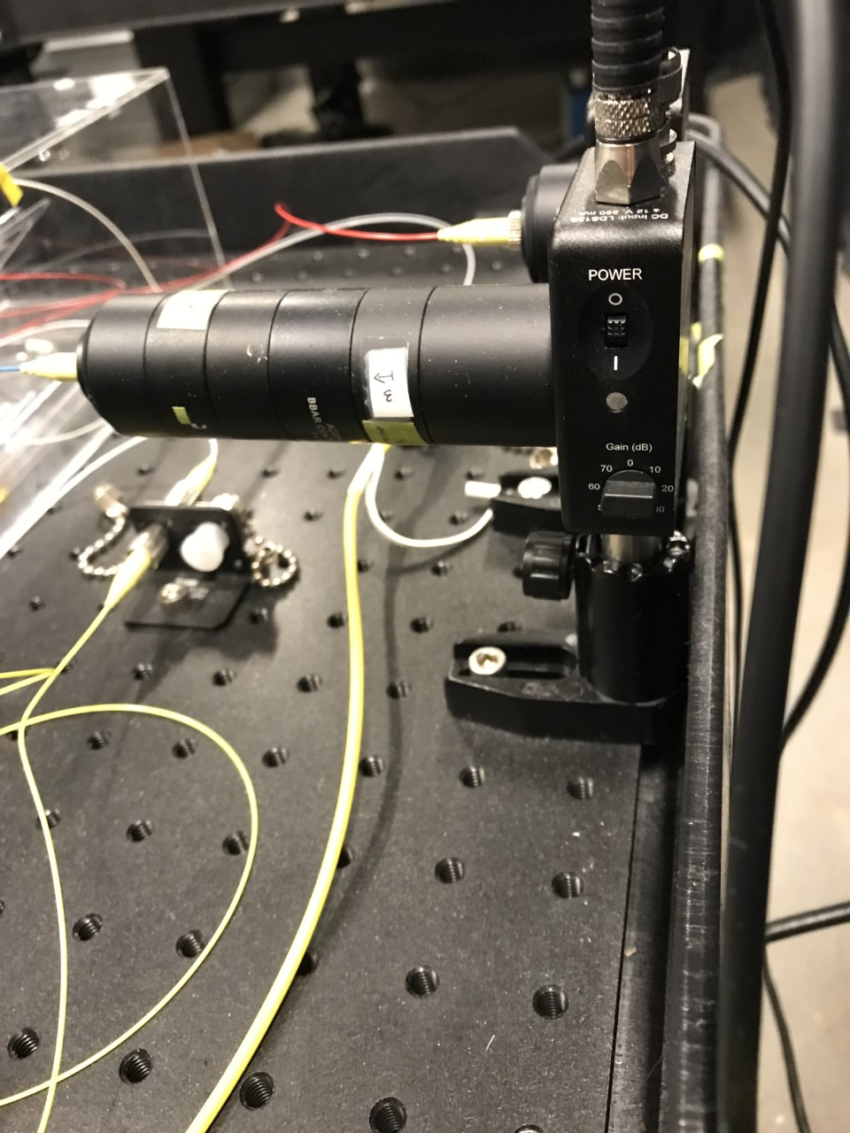

1. **Turn ON the power for the laser diode driver by selecting the power switch on the back of the driver unit.**

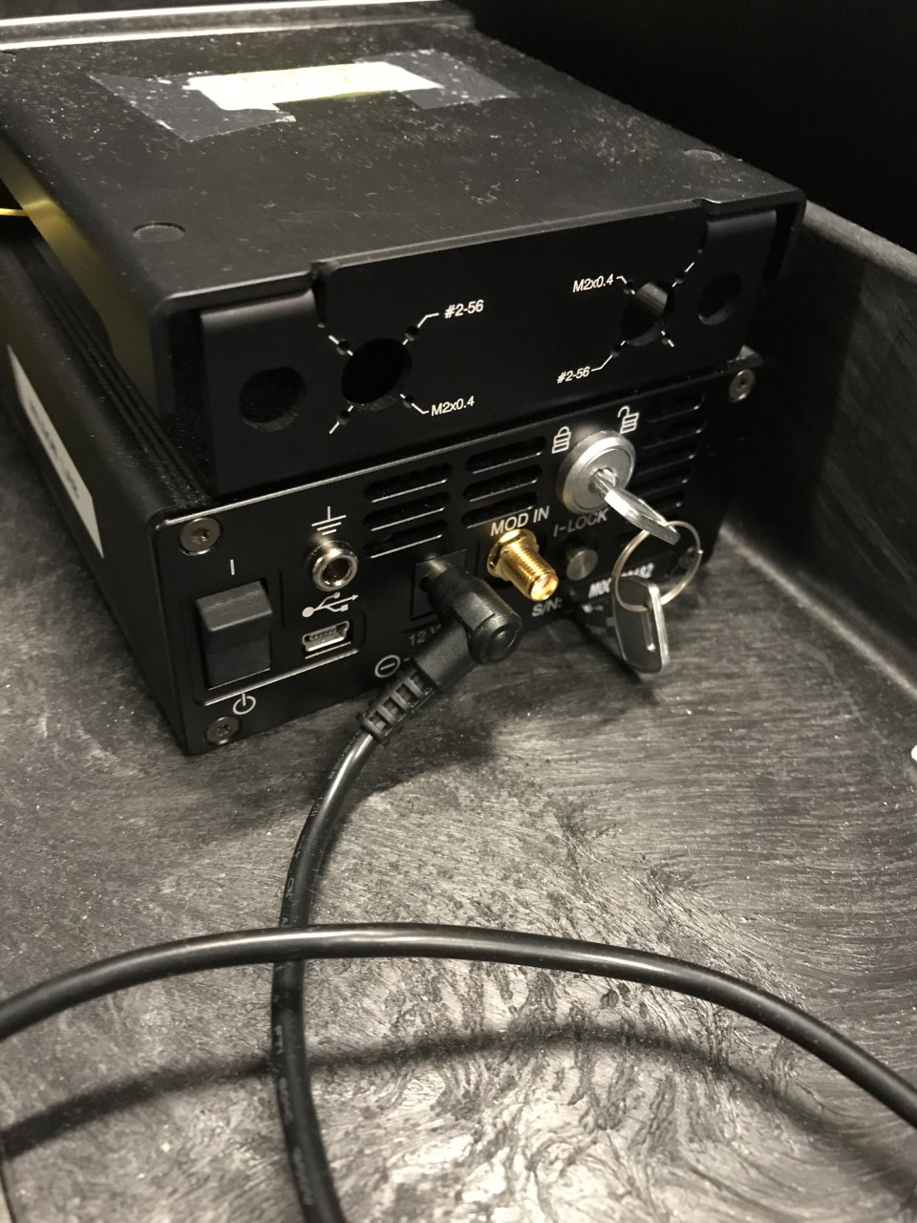

**Power Switch**

1. **Turn ON the TEC for the laser diode driver from the touch screen**. The temperature should be rise to settle at 25C.

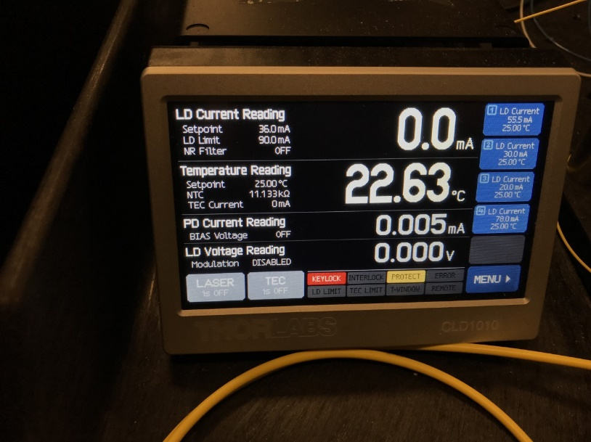 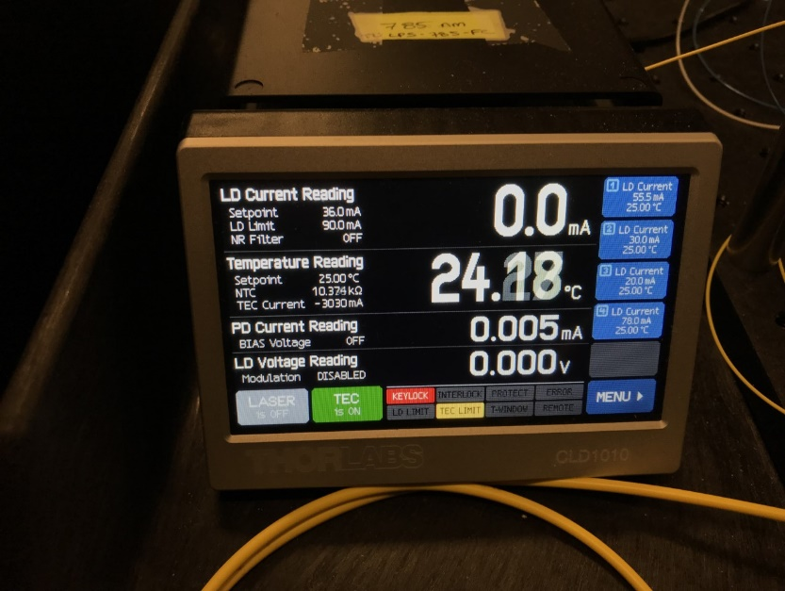

**TEC is ON**

**Select**

1. **Rotate the safety KEYLOCK on the back panel from LOCKED to UNLOCKED**. The red keylock light on the front of the driver will turn off when the key is rotated to the unlocked position. This is a safety mechanism to make sure the laser is not accidentally turned on when touching the screen.



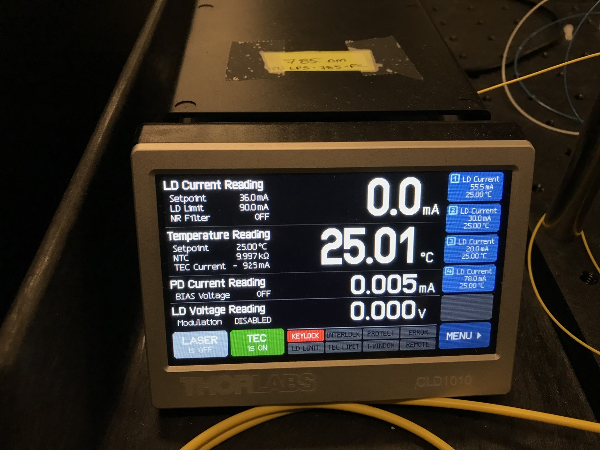

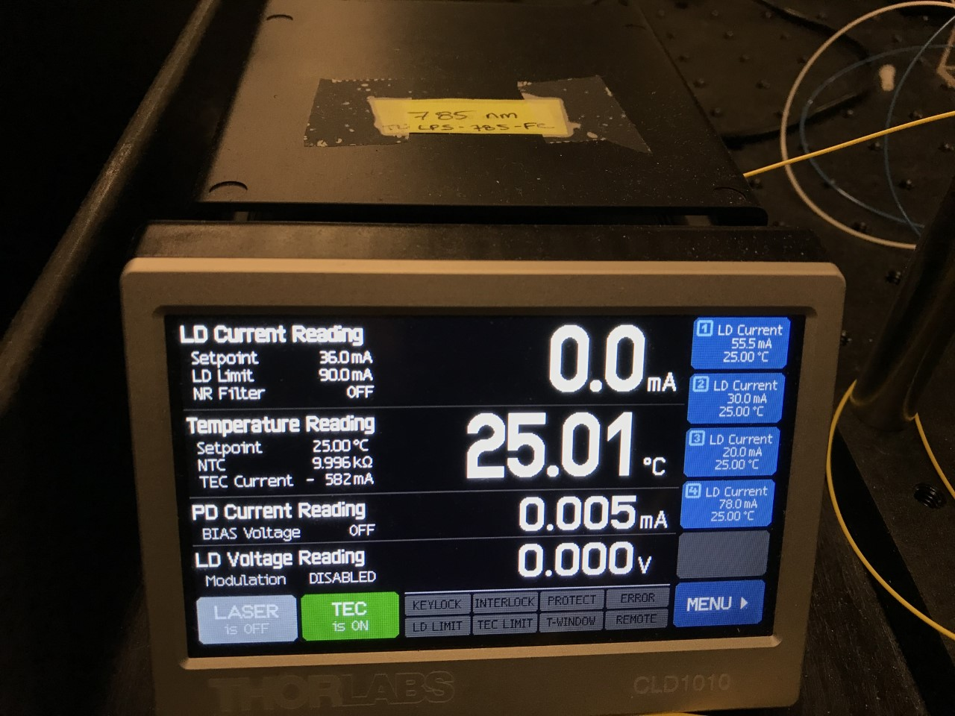

1. **Select the LASER button the screen to turn the laser output ON**. The current should be set to 36mA (but really should be set so that it is below the max limit on the measured current vs max output power curve.

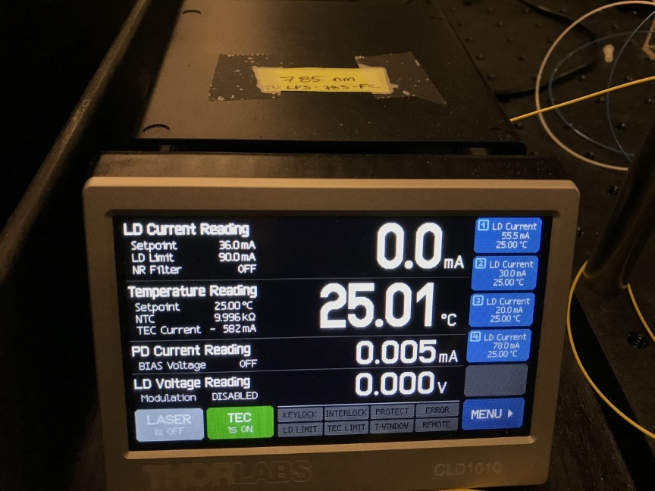 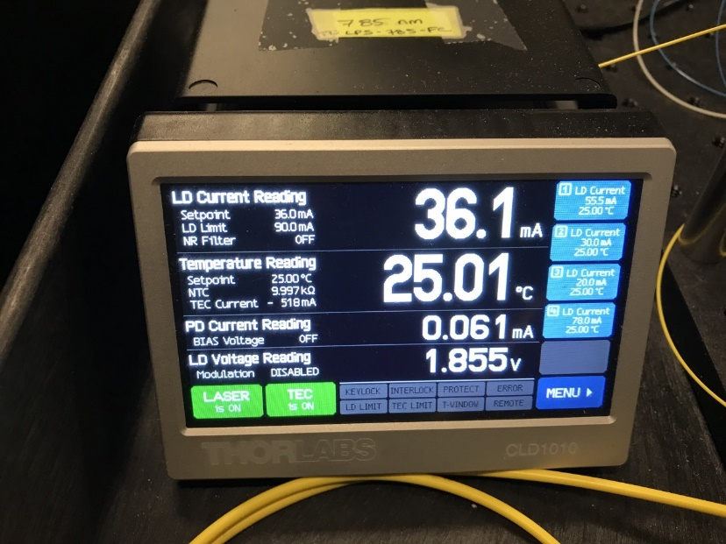

**LASER is ON**

**Select**

**Shutdown Procedure**

1. Turn OFF the Laser
2. Rotate the Keylock from the UNLOCKED position to LOCKED
3. Turn OFF the TEC
4. Power OFF the laser diode driver
5. Turn OFF the photodiode
6. Turn OFF the power supply for the position sensitive detector
7. Turn OFF the power supply for the high voltage amplifier
8. Switch off the light switch for the laser safety sign outside the lab door