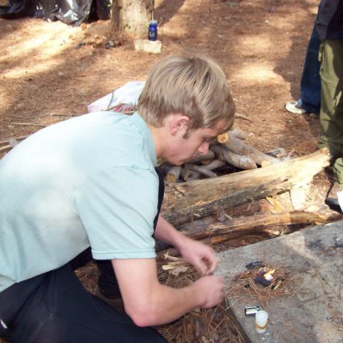
Troop 214 Parent News | Openings: Raiders
February 2009 | Games: Generic
http://www.bsatroop214.us | Service: Cobras
Harold Hodnett Scoutmaster | Program: Pack-Rangers

Key Events This Month | Key Events Next Month
March 7 - Troop Workday | March 13-15 – Aviation Campout

March 8 – Scout Sunday; Pack 214 Blue-and-Gold Banquet

February 21 – Merit Badge University

February 28-March 1 – Wilderness Survival Campout

Dates to Remember
February 2 – Troop Mtg 7 pm
February 5 – Roundtable
February 7 – Troop Workday
February 8 – Scout Sunday; Pack 214 Blue-and-Gold Banquet
February 9 – PLC 6:30 pm; Troop Mtg 7 pm; Troop Committee 7 pm
February 14 – Valentine’s Day
February 16 – President’s Day; WCPSS Teacher Workday; no Scout Mtg
February 21 – Merit Badge University, Highland United Methodist Church
February 23 – Troop Mtg 7 pm
February 28-March 1 – Wilderness Survival Campout
February 28 – Science MBU, NCSU

Latest News and Details About Upcoming Events
Troop Workday – Saturday February 7th is our annual troop workday. All Scouts are asked to plan to help out with this effort, and parents who are willing and able are welcome to come out and help as well. Times and additional details will be available at the February 2 meeting.
Scout Sunday - Sunday February 8th is Scout Sunday, and marks the 99th year of Scouting in the United States. The Scout Sunday tradition was started to make people in houses of worship aware of Scouting and to allow Scouts to live out their "Duty to God" pledge each week. We would like to have as many Scouts attend one of the Scout Sunday services as possible to show Benson Memorial what a strong troop we have, as well as to show our appreciation to our sponsoring organization. We need Scout volunteers to serve as volunteer ushers and scripture readers for both the 8:45 and 11am church services, as well as prepare refreshments to serve after the services. Details and sign-up opportunities will be available at the February 2 meeting. Parents of Troop 214 Scouts are also welcome to attend the services and get to know members our sponsoring organization.
Pack 214 Blue-and-Gold Banquet – Pack 214 will be holding their Blue-and-Gold Banquet the evening of February 8th. At this event, the second-year Webelos bridge over to Boy Scouts. Troop 214 will be welcoming at least one new full patrol of new Scouts from Pack 214 at this event. All Troop 214 Scouts and adults are welcome to attend and welcome our new Scouts.
Merit Badge University – Merit Badge University (MBU) will take place on February 21. Those who have registered for this event should have been informed of what class they have been placed in and should be working on their prerequisites! MBU will be held at Highland United Methodist Church on Ridge Road in Raleigh, which is located off Lake Boone Trail near Martin Middle School. Registration is at 8:15 – 9:00 am, with classes beginning promptly at 9:00. This is a well-attended event, so your Scout should plan to arrive early, as parking is tight and registration may take longer than anticipated. Questions about MBU should be directed to Ms. Margaret Heil at heil@csc.ncsu.edu.
Wilderness Survival Campout – The February campout theme is Snow/Extreme Cold Survival, with a Wilderness Survival campout in the North Carolina mountains planned for February 28-March 1. Fliers with details were distributed at the January 12th troop meeting, with lots more info forthcoming. The trip committee has decided to cut Friday night from the outing and extend it until Sunday afternoon. It takes hours to create snow shelters under the best conditions and we don't want to risk cold exposure issues Friday night; starting the campout on Saturday morning will give everyone ample time to create adequate and safe shelters. In addition, extending the campout into Sunday afternoon will allow ample time to finish all the Merit Badge requirements (for those who don't have the MB already). The committee has already planned a full month of informative programs, and is looking forward to another challenging adventure. Thanks to Joshua T., Josh J., Andy J., and Noah L. for their fine work planning the trip and the troop meeting programs. Please contact Mr. Stuart Thomas (sthomas@well.com) for more information.
NC State Merit Badge University – Those who are not participating in the Wilderness Survival Campout may be interested in taking part in an Occoneechee Council-sponsored Merit Badge University taking place on the NC State University campus on February 28. Offerings include science-based merit badges, such as Energy, Nuclear Science, Textiles, and Space Exploration, taught by leading experts in the fields! Fliers with information about the event are posted in the Scout Hut. Registration information and a full list of merit badge offerings are available on the Council website at http://www.ocscouts.org/news/news.php.
Summer Camp 2009 – Troop 214 will be attending Camp Durant (near Pinehurst) on July 5 – 11. The cost will be approximately $200, with installment payments due in February, March, and April. Merit badge course selections and parental consent forms will be due soon. While the 2009 Guide is not yet available, forms and some information about merit badge offerings can be found at: http://www.campdurant.com/Summer_Camp_Info_files/guide.pdf
Forms and links to the Camp Durant website will be available soon on the Troop 214 Website. Thanks to Mr. Bill Dvorak who has agreed to coordinate our troop’s summer camp attendance again this year, with assistance from Ms. Gayle Dilalla. Mr. Dvorak will be sending along more summer camp information as soon as it is available.
Aviation Campout – Planning is under way for the Aviation Campout for March 13-15th. This trip is scheduled to take us to the birthplace of aviation, Kill Devil Hills on the Outer Banks. Activities planned include a trip to the Wright Brothers Memorial and Jockeys' Ridge. More details will be forthcoming at future troop meetings.
Quote of the Month
For Valentine’s Day: “All love that has not friendship for its base, is like a mansion built upon sand.” – Ella Wheeler Wilcox

Joke of the Month – Some winter vocabulary:

- What do Eskimos get from sitting on the ice too long? Polariods
- What do you get when you cross a snowman with a vampire? Frostbite
- What do you call Santa’s Helpers? Subordinate Clauses

