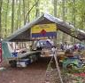
Troop 214 Parent News | Opening: Panthers
October 2009 | Game: Cobra
http://www.bsatroop214.us | Service: Moose
Harold Hodnett Scoutmaster

Key Events This Month | Key Events Next Month
Oct. 5 – Troop Elections | Nov. 13-15 - Campout
Oct. 9-11 – Council Camporee | Nov. 30 – Court of Honor

Oct. 31 – Popcorn Sales End

Dates to Remember
October 1 – Roundtable
October 3 – Jonathan Lyle’s Eagle Project; Scout Hut workday
October 4 – Eagle Court of Honor for Kyle Falkenbach, 6:30 pm
October 5 – PLC 6:30 pm; Troop Mtg 7 pm; Troop Committee 7 pm; Troop Elections
October 8 - OA Meeting
October 9-11 – Council Camporee
October 12 – Columbus Day; Troop Mtg 7 pm; Boards of Review
October 17-18 – OA Vigil Gathering
October 17 – OA Day of Service
October 19 –Troop Mtg 7 pm
October 23-25 – Troop Leadership Training Retreat
October 26 – Troop Mtg 7 pm
October 31 – Halloween; Popcorn sales end

Latest News and Details About Upcoming Events
Volunteer Opportunities – Next Saturday, October 3rd, you'll have two opportunities to help the troop out and get service hours. Jonathan Lyle will be conducting his Eagle project at Benson Church, and a second crew of volunteers will be there with paint brushes and sprayers, trying to finish up the painting of the Scout hut. Scouts and parents, please plan on setting aside some time on Saturday for these worthy projects. Both projects will get underway Saturday at 9am. For more information about Jonathan's Eagle project, please contact him at jlyle91@gmail.com. If you plan to help with painting and would like more information, please contact Mr. Livingston at monty.livingston@gmail.com.
Troop Elections – Troop elections are coming up on October 5. New leadership positions will also be appointed at this meeting. Please encourage your Scout to think about his advancement requirements in preparation for this important meeting.
Council Camporee –The Troop’s October campout will be to this year’s Occoneechee Council Camporee at Camp Reeves in Moore County. Scouts going to the Camporee should plan to meet at the Scout Hut at 5:30 on Friday, October 9, so that we may depart by 6 PM. In addition to your camping gear, bring a “bag dinner” to eat on the way down as we will not be stopping en route for dinner.
Troop Leadership Training – Troop Leadership Training (TLT) will be held Friday, October 23 through Sunday October 25 at Dr. Roberts’ beach house on Emerald Isle. TLT is a great learning experience, a lot of fun, and is required for any Scout in a leadership position to earn their “Trained” strip. Spaces for this trip will be limited and priority is given to newly elected leaders who have not gone before.
Popcorn Sales – Popcorn sales are ongoing - until October 31! If your Scout is taking orders, the delivery date will be November 13. Sellers can collect the money when the order is taken or when popcorn is delivered. Please have your customers make checks out to Troop 214.
If your Scout fills up an order form, he is eligible to receive free tickets to local sports team’s events (Hurricanes hockey, N.C. State basketball, and others). If your Scout wants to get tickets to one of the sports events, he needs to deliver, email, or fax a copy of the form to the council office. Be sure the Scout’s name and phone number are on it as well as the tickets he wants. Check out the council website news page (http://www.ocscouts.org/news/news.php) for additional details and to see what tickets are still available!
Ms. Olsen will be at the Monday night meetings during the sale period with more forms if needed, and she will be happy to answer any other questions you might have. She can also be reached by email (sjolsen@bellsouth.net) or by phone (870-7106).
Thanks for your participation and support!
Religious Emblems Programs – A Scout is reverent. He is reverent toward God, faithful in his religious duties, and respects the convictions of others in matters of custom and religion.
On September 28th, Troop 214 Chaplain’s Aid Matthew Fiely gave a presentation on the Religions Emblems program. To encourage members to grow stronger in their faith, religious groups have developed religious emblems programs that Scouts may pursue. The Boy Scouts of America has approved of these programs and allows the emblems to be worn on the official uniform. The various religious groups administer the programs. Check with your local council service center or contact the religious organization directly to obtain the curriculum booklets.
If you would like more information about Religious Emblems Programs, there are some resources available on the Scoutsource website, http://www.scouting.org/scoutsource/default.aspx:
- Review the Frequently Asked Questions about Religious Emblems Programs
- Learn How to Get Started on These Programs
- See our chart of Religious Emblems Programs
- Contact your local council service center or the appropriate religious organization (contact information is provided on the chart.)
Follow-up on Donation Request –The Troop is now the proud owner of our own LCD projector (complete with screen) – many thanks to Mr. Fiely for finding this for us! We are continuing to seek a donation or a good deal on a window air conditioner.
Troop Website Update – Photos from the August kayaking campout are now available on the Photo page of the troop website. Thanks to the Troop webmasters for maintaining this valuable resource for us!

Recent Highlights
OA Fall Fellowship – The Fall Fellowship was a weekend of cheerful service, fun, and brotherhood. Troop 214 participants included Joseph Heil, Mr. Liberty, Mr. Thomas, Joshua Thomas, Stephen Frein, Matthew Fiely, and Alex DiLalla. Two Troop 214 Scouts were elected into leadership positions for our chapter: Joshua Thomas now holds the position of Vice Chief of Communications and Alex DiLalla now holds the position of Vice Chief of Administration. Joshua Thomas and Mr. Thomas served as elangomats during The Ordeal.
Stream Cleanup – The Troop stream cleanup was conducted on Saturday, September 19th. A total
of 21 Scouts and adults participated in the event, including some Webelos Scouts and parents from Pack 214. A total of 15 large garbage bags were filled during the sweep, many at one location, dubbed the "hobo landfill". Afterwards, many participants went to Char Grill to enjoy some food and fellowship. Thanks to everyone who participated for a job well done!
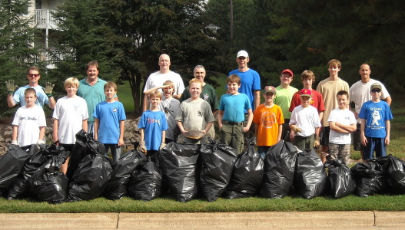

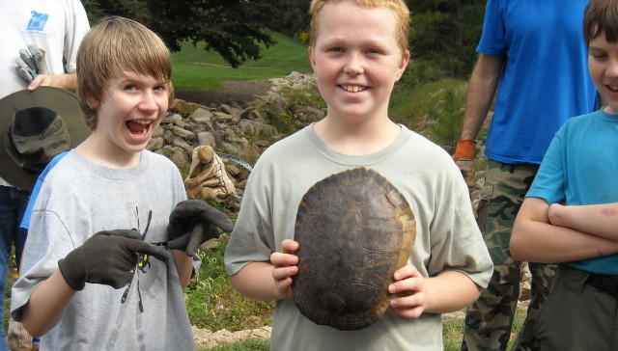

Backpacking Trek and Campout – The T214 September theme and campout was all about Backpacking. Joshua Thomas and Andy Jones delivered informative programs related to the theme during the weekly troop meetings, and helped plan the trek and campout. Mr. Thomas and Mr. Stammers served as trip advisors. Thanks to them for their service to the troop!
A small but spirited contingent of 14 headed out to Uwharrie National Forest on September 25th. We arrived and camped overnight at Yates Place campground. On Saturday morning everyone headed out for a trek plan that encompassed the Uwharrie Trail and Dutchman's Creek Trail. Both are rated as "difficult" hiking, because of some significant elevation changes resulting in sharp inclines and declines, as well as rocky trail surfaces. Everyone hiked together until lunchtime; after that the group split in half, with one crew headed on a longer afternoon trek plan than the other. The trail was very physically demanding here and there, but everyone hung tough and hiked on. One Scout was overheard saying, "This is the hardest thing I've ever done in Boy Scouts". But as hard as the trek was at times, everyone maintained great spirit throughout. There were lots of marching chants, song bites, and jokes shared on the trails.
Once each crew reached their desired spot to camp for Saturday night, we set up tents again and ate dinner. We had seen light rain off and on, but at around 8pm on Saturday the heavy stuff started coming down. After braving the heavier rain for a bit in individual rain gear, everyone on both crews decided to call it an early night. The rain fell all night and didn't start breaking until about 7am on Sunday morning. After breakfast and packing, we started our trek back to Yates Place and the vehicles. One crew took a slight detour where trail markings were lacking, but relocated themselves and the trail. There's nothing like getting lost to get in some advanced orienteering practice! The crew who took the longer trek plan ended up backpacking a little more than 12 miles. The crew on the shorter trek plan backpacked a little more than 8 miles.
Once everyone was back at base camp, a Scout's Own worship service was held, followed by the standard trip reflection amongst participants. All in all it was a great trip. Boy Scouting is a program with great emphasis on; the outdoors, camping, physical fitness, skills-building, team-building, and adventure. This backpacking campout had it all from that perspective; kudos to all who participated!
Quote of the Month
For Halloween: “Where there is no imagination there is no horror.” Sir Arthur Conan Doyle
Joke of the Month:
Riddles for Halloween:
Q: Who won the skeleton beauty contest?
A: No body.
Q: What do you get when you cross Bambi with a ghost?
A: Bamboo.
Q: What happened to the guy who didn’t pay his exorcist?
A: He was repossessed.
Q: What's the ratio of a pumpkin's circumference to its diameter?
A: Pumpkin pi.

