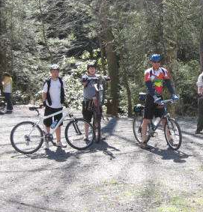
Troop 214 Parent News | Opening: Panthers
April 2010 | Game: Goats
http://www.bsatroop214.us | Service: Cobra
Harold Hodnett Scoutmaster

Key Events This Month | Key Events Next Month
April 12 – Troop Elections | May 14-15 – OA Inductions
April 16-18 – OA Conclave | May 22 - Troop 214 Merit Badge Institute
April 23-25 – Virginia Creeper Campout | May 28-30 – Backpacking Campout

Dates to Remember
April 1 - Roundtable
April 2 - Good Friday
April 4 - Easter Sunday
April 5 - Troop Meeting 7 pm
April 8 – OA Meeting
April 10 - Thomas Kweon's Eagle Project
April 12 - PLC 6:30 pm; Troop Meeting 7 pm; Troop Committee 7 pm; Troop Elections
April 16-17 – OA Conclave
April 19 – Troop Mtg 7 pm; Boards of Review
April 22 - Earth Day
April 23-25 – Virginia Creeper Campout
April 24 - Scout-O-Rama
April 26 - Troop Meeting 7 pm

Latest News and Details About Upcoming Events
Scheduling Notes – Please note that we are currently scheduled to have a Troop meeting next Monday, April 5, even though it is a WCPSS holiday for traditional calendar students. As always, any scheduling changes will be announced by email.
Eagle Project – Thomas Kweon's Eagle Project will be taking place at Jaycee Park on Saturday, April 10. We will be working from 8 am - 3 pm setting up post markers. Those coming to help will need work gloves and shoes, and those who have post-hole diggers and trowels are asked to bring them. Pizza and drinks will be provided. There are no other Troop activities currently planned that weekend, so all Scouts are encouraged to come on out, get some service hours, enjoy the great spring weather, and help Thomas with his project!
Troop Elections – Troop elections are scheduled to be held on Monday, April 12th. If your Scout wants to try his hand at being Senior Patrol Leader or Assistant Senior Patrol Leader, or needs a leadership position for rank advancement, now is the time to be thinking about it! Appointed leadership positions will be granted soon thereafter as well.
Troop 214 has traditionally offered a Troop Leadership Training retreat for Scouts newly elected to leadership positions that need training. Adult volunteers are needed to lead a retreat after the upcoming elections. If you are available and interested in spending a weekend at the beach working with our Scouts to develop their leadership skills, please contact Mr. Hodnett at hhodnett@nc.rr.com.
OA Conclave – Every year, Order of the Arrow members from throughout Section SR-7B gather together for the Cardinal Conclave. This year's event will be held April 16th-18th at Camp Boddie in Blounts Creek, NC. Conclave is a fantastic opportunity for Arrowmen young and old to gather together to see the best that Scouting has to offer. Last year there were over 1,000 Arrowmen in attendance, and this year may be even bigger! Several Troop 214 Scouts and adults have registered and are ready to take part in what will surely be another amazing Conclave experience. To see a small taste of what's in store, check out the short video from the 2009 event here: http://sr7b.org/Default.aspx?tabid=122
Virginia Creeper Campout – Troop 214 will be taking on the mountain biking challenge of the Virginia Creeper bike trail April 23 -25. Two rides will be available, a 17.5 mile all downhill ride and a challenging, rolling 50 mile loop. More details will be presented at upcoming Troop meetings, but bike rentals will be available for both Scouts and adults (if needed) and total expected cost will be just a little more than last year but still under $100 including bike rentals. Keep an eye out for emails about the training rides offered to prepare for this trip, including the 35 mile test through Umstead Park that is required for any Scout intending to complete the 50-mile loop. Mr. Bill Dvorak is the adult advisor for this trip; thanks to Mr. David Burdett, who has been planning and leading the training rides.
Jamboree – There is still time to sign up for the bus trip that the Occoneechee Council is organizing to Fort A.P. Hill, Virginia to visit the Jamboree on Friday July 30, 2010. The buses will depart from Raleigh at approximately 5:00 am and return the same day at approximately 11:00 pm. Participants will have about six hours at Fort A.P. Hill to observe and visit the expected 65,000 Scouts and Scouters participating in the Jamboree. The council has said they will take as many buses as they have people signed up to fill. The cost of $50 per person includes: round trip transportation fees, an ID lanyard, a custom designed Day Trip Souvenir item and dinner on the way home. For more information and registration forms, visit the Falls District website at http://www.fallsdistrict.org/index.php/articles/20100125_U5vEKI.php. The registration deadline is April 23.
Summer Camp – Troop 214 will be attending Camp Durant from July 4 to July 10 this year. A few reminders for Scouts and Scouters planning to attend:
- Cost is $210 per scout if paid in full by May 7, and will rise to $225 if paid after that. Merit badge schedules will not be reviewed by the Camp Durant planning staff until the scout has paid in full.
- Every Scout and adult who attends camp must have an annual health history completed prior to attending camp. Youth members and adults must have a Personal Health and Medical Record (Form 34605) completed by a parent, guardian or adult. All parts must be completed. This form requires a physical examination by a physician within the past 12 months plus a medical history.
- Adults 40 years and over may also use the newly revised BSA physical form. Military and athletic physicals are acceptable. Please complete a current medical history form for the past 12 months and attach a copy of the physical to the form.
- All medical forms will be kept on file with the camp Health Officer. A copy of the front and back of each person’s insurance card is also needed in case of an emergency trip to the hospital.
- Unless the Scoutmaster requests otherwise, the
Scoutmaster or another unit leader will be responsible for the administration of medication for the Scouts in his/her troop.
- Anyone arriving at camp without the proper medical form signed by a physician will not be allowed to participate in the camp program.
If you have questions about summer camp registration, please contact Mr. Bill Dvorak. If you have questions about the medical forms, please contact Ms. Janice Gold at janicegold@nc.rr.com.
Parent Volunteer Opportunity - Ms. Gold has graciously coordinated the collection of medical forms for summer camp for several years now. She would like someone to assist her this year and possibly take over this task for next year. Please contact her if you are interested.
Merit Badge Institute - The annual Troop 214 Merit Badge Institute will take place on Saturday, May 22 at Benson Memorial United Methodist Church. This year's MBI will offer eleven different merit badges, including four Eagle Required merit badges. Scouts who have signed up for this event are reminded to be working on their prerequisites. Scouts who haven't signed up are welcome to do so: signup sheets and prerequisites are on the Troop 214 website at:
http://www.bsatroop214.us/documents/documents.php?dir=MBI2010. Scouts who have questions should contact Mr. Jay Sprankle at j_sprankle@yahoo.com, or by telephone in the evenings at 787-3732.
Spring Court of Honor - The Troop is planning a Court of Honor for Sunday, May 23rd. These events are great opportunities both to recognize our Scouts for their accomplishments and for the Troop 214 family to come together for some good fellowship. Mark your calendars and stay tuned for details!
Backpacking Campout - The whitewater rafting campout originally scheduled for the weekend of May 28th has been cancelled. A backpacking campout that had been tentatively planned for earlier in the month will instead take place that weekend, May 28th-30th. The trek will be held in the Grayson Highlands/Mount Rogers VA vicinity, but details are still being worked out. Scouts should speak with Mr. Sam Fouse or Joshua Thomas if they would like more information or if they are interested in serving on the planning committee for this trip.
Eagle Court of Honor - Congratulations to Matt Boone, who passed his Eagle Board of Review on March 10 with flying colors! Matt's Eagle Court of Honor will take place at Benson Memorial Church on Sunday June 13 at 2:00 PM. All Troop 214 Scouts, families, and friends are invited to come join Matt and his family in celebrating his achievement.

Recent Highlights
Geology Camp Out – Troop 214 took twelve Scouts and five Leaders/Parents to the NC "High Country" the weekend of March 26-28 to finish up the Geology focus for the month. We camped at Grandfather Campground in Foscoe on Friday night, beneath a nearly full moon and the "face" of Grandfather Mountain looking down upon us. Saturday morning brought some frost, some wind, and a wind-chill temperature in the high teens! Our outfitter, River and Earth Adventures, met us at the campground with a shuttle van at 9am, and the Troop was on its way to Elizabethton, TN. Once the sun rose above the mountain tops, the temperature quickly climbed and rose to the mid-sixties. We stopped off at the outfitter's warehouse to get fitted for lighted helmnts and gloves, and donned disposable fabric coveralls provided by trip adult advisor, Mr. Mike Jones. We thought we were tough, but at the cave site we found several Florida State University college girls, who had spent the previous night just inside the cave! By 10:30am we were navigating such notable cave features as "Hobbit Hallway", "Fairy Ballroom", and "Devil's Staircase." While no climbing was necessary, scrambling and bouldering were required at some points on the cave trail. We also traversed an ankle-deep stream for the final half mile. After about four hours and a three mile loop, we returned to the entrance, a bit muddy and with wet feet, but all wearing smiles. REA served the Troop a sandwich lunch on-site, and afterwards we returned their gear to the warehouse. The Troop returned to the base camp at 5pm, and began dinner and campfire preparations, in between touch football games. Saturday night brought the leading edge of another cold front, and with it wind gusts up to 40 mph. A few tents were either inappropriate for mountaineering (high profile), or were improperly staked down, and became compromised by the wind, sending their occupants inside the church van for some of the night. Sunday morning the Troop again rose early, broke camp, ate breakfast, cleaned the camp site, and conducted a Scout's Own Service, followed by Scout's trip Reflections. By 9am the Troop was gem mining with REA in Boone. Geology Merit Badge candidates received help and additional instruction from Appalachian State geologist, Laura Seldomridge, as they assembled a rock and gem collection for their final MB requirement. The Troop departed Boone at 11:30am in the rain, and each vehicle stopped for a fast-food lunch along the way. We returned to the Scout Hut by 3pm, and beat the rain and subsequent "nasty" weather by several hours.
Stream Cleanup – Thanks to the hearty souls who came out for the Troop stream cleanup on Saturday morning, March 13th. The group gathered about 15 large garbage bags of trash! It was a good turn for the community, and afterwards, the volunteers celebrated with lunch at Char-Grill.
OA News – The Occoneechee Lodge held its annual Order of the Arrow Pow-Wow on March 19th-21st. Troop 214 youth was represented by Stephen Frein and Joshua Thomas, and Harold Liberty, Joseph Heil, and Stuart Thomas attended as adult OA members. Activities included training sessions for those Ordeal members who were planning to be tested on the Brotherhood Trail, Native American dance competitions, Ceremony Team competitions, the Brotherhood Trail, the Quest for the Golden Arrow competitions. The actual Pow-Wow consisted of Native American dancing and singing, patch trading, service projects, Cracker Barrel, the Vigil candidate overnighter, Lodge Council meeting, and of course a Sunday morning worship service.
Congratulations to Stephen Frein, who completed the Brotherhood Trail and has now sealed his membership as a Brotherhood member of the OA. Our Kato Hochuli chapter placed 3rd in the Quest for the Golden Arrow competitions amongst 12 chapters competing. We might have placed higher except we came in 2nd-to-last in one of the four competitions that was largely decided by the number of scouts competing, and unfortunately we had the fewest. But the weather and the weekend were great, and it was a great Pow-Wow.
Congratulations Mr. Liberty! – Troop 214 Scouter Mr. Harold Liberty was awarded the Silver Beaver Award by the Occoneechee Council at last month's Roundtable. According to Scouting.org, “The Silver Beaver Award is the council-level distinguished service award of the Boy Scouts of America. Recipients of this award are registered adult leaders who have made an impact on the lives of youth through service given to the council.The Silver Beaver is an award given to those who implement the Scouting program and perform community service through hard work, self sacrifice, dedication, and many years of service.In honor of Mr. Liberty's award, Troop 214 has sponsored a campership for one deserving scout to be able to attend Scout Camp this summer.

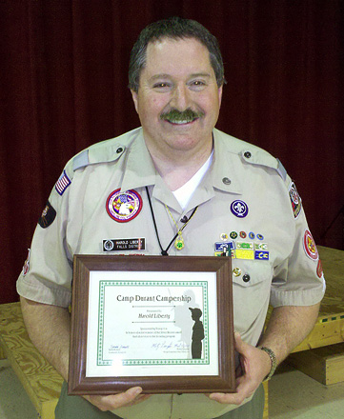

Another Troop 214 Eagle Scout! - Jake Joyner held his Eagle Scout Court of Honor on March 7 at Benson Memorial United Methodist Church. The ceremony contained an entertaining slide show with pictures from Jake’s scouting career. After the ceremony, a nice reception was held in the Fellowship Hall. At the top of the next column is a picture of Jake (at right) along with Scoutmaster Mr. Harold Hodnett.

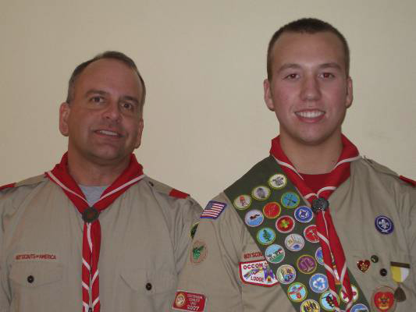

Quote of the Month
" Hoe while it is spring, and enjoy the best anticipations. It is not much matter if things do not turn out well." -- Charles Dudley Warner
Joke of the Month
Unwritten rules of gardening:
- The best way to garden is to put on a wide brimmed straw hat and some old clothes. And with a hoe in one hand and a cold drink in the other, tell somebody else where to dig.
- When weeding, the best way to make sure you are removing a weed and not a valuable plant is to pull on it. If it comes out of the ground easily, it is a valuable plant.
- A weed is a plant that has mastered every survival skill except for learning how to grow in rows.
- Spring does not arrive until the ice is out of the compost heap.
- Any self-respecting rock will break at least one shovel before accepting its new home.
- Gardening requires a lot of water, most of it in the form of perspiration.

Thanks to Matthew Hodnett, Troop 214 OA historian, Scoutmaster Mr. Harold Hodnett, and adult leaders Mr. Stuart Thomas and Ms. Janice Gold for assisting with this month’s newsletter.

