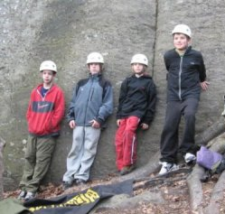  Troop 214 Parent News | Opening: Goats
March 2010 | Game: Chuck Norris
http://www.bsatroop214.us | Service: Rangers
Harold Hodnett Scoutmaster

Key Events This Month | Key Events Next Month
March 13 – Stream Cleanup | April 5 – Troop Elections
March 19-21 – OA Pow-wow | April 16-18 – OA Conclave
March 26-28 – Caving Campout | April 23-25 – Virginia Creeper Campout

Dates to Remember
March 1 - Troop Meeting; Registration Deadline
March 4 – Roundtable
March 7 - Adult Leader ("ASM") meeting
March 8 – PLC 6:30 pm; Troop Mtg 7 pm; Troop Committee 7 pm
March 11 – OA Meeting
March 13 - Stream Cleanup; Reptile and Amphibian Day, NC Museum of Natural Sciences
March 15 –Troop Mtg 7 pm; Boards of Review
March 17 - St. Patrick's Day
March 19-21 – OA Pow-wow
March 22 – Troop Mtg 7 pm; OA Elections; Merit Badge Institute sign-up deadline
March 26-28 – Caving Campout
March 27 - Religious Banquet
March 29 - Troop Meeting

Latest News and Details About Upcoming Events
Registration - All registration forms for the coming year were due at the March 1 meeting. If your Scout has not yet registered, please contact Mr. Jimmy Crawford as soon as possible at seeinsilver@nc.rr.com or on his cell phone at 919-614-5016. Thanks to Mr. Crawford for once again heading up this years' registration drive!

Stream Cleanup – Yes, it's time for spring cleaning of our adopted stream. Come join us for our semi-annual stream cleanup event on Saturday, March 13 from 9 am until around noon. We will meet on Forum Drive roughly behind the Six Forks Cinema theatres. We will sweep the stream in both directions and see how much trash and recyclables when can accumulate. This even is a great way to collect service hours and counts towards a conservation project for Camping merit badge, not to mention doing a good turn. Afterwards, we typically enjoy some food and fellowship at Char-Grill. Wear boots and clothes you don't mind getting wet and/or dirty, plus bring some gloves (and money for lunch, if you want to hang out afterwards). Adults as well as Scouts are invited to participate!
OA News – February has been a busy month for Troop 214 and the Order of the Arrow. Elections for new Ordeal Candidates take place annually in February and March and Troop 214 scouts have been helping to make the elections happen.
A few OA events are coming up in the near future that concern the troop and current OA members. From March 19-20, Pow-wow will be held at Camp Durant. Pow-wow is a fun competition-filled weekend for all the chapters in Lodge 104. For members who went through their ordeal during last spring inductions, this will be a chance to secure their brotherhood.
SR-7B Cardinal Conclave will be held at Camp Boddie (formerly Camp Bonner) from April 16-18. Conclave has been described by some OA members in Troop 214 as "the most amazing event ever". Conclave is a weekend of fun and games and brotherhood for the Southern Region. The cost for Pow-wow will be $20 and the cost for Conclave will be $35.
Finally, OA elections will be held for Troop 214 on March 22. To become a member of the OA, a Scout must be First Class or above, have camped 15 nights in the past 2 years (6 of those nights must include a summer camp), and be approved by his scoutmaster. The Scout must then have at least 50% of the troop vote for him. For the elections to be held more than half the troop needs to be present, so all scouts should come to elect their compatriots into the OA.
Merit Badge Institute - The annual Troop 214 Merit Badge Institute will take place on Saturday, May 22 at Benson Memorial United Methodist Church. Like Merit Badge University, this is an opportunity for Scouts to complete a merit badge in one day if the assigned prerequisites are completed. This year's MBI will offer eleven different merit badges, including four Eagle Required merit badges. Sign up sheets will be available March 1, and interested Scouts are asked to sign up by March 22. Scouts who have questions should contact Mr. Jay Sprankle at sprankle@nortel.com, or by telephone in the evenings at 787-3732.
Geology Campout and Merit Badge - Troop 214 will focus on Geology for the month of March, with interested Scouts having the option of earning the Geology Merit Badge. The Program segment of each Troop meeting this month will focus on requirements for the merit badge. New counselor Mike Jones will open the month at the March 1 meeting, with the basics of Geology. Local amateur geologist and Scout parent Craig Potter will share his geological collection with the Troop on March 8. On March 15, local civil engineer Keith Skinner will discuss his profession, and U.S. Geological Survey affiliate and Scout parent Curtis Weaver will review a Wake County geological map. Our final Program segment on March 22, will feature local expert caver Steve Simmons sharing a caving presentation and "squeeze box" demonstration.
An optional conclusion to the March merit badge program will a Geology Campout at Grandfather Campground in Boone on March 26-28. Those going on the trip will be departing Friday, March 26, no later than 6pm, and returning Sunday, March 28, no later than 5pm. River and Earth Adventures outfitter will lead the Troop on caving expedition to Worley's Cave in Elizabethton, TN on Saturday, and will offer a gem mining experience on Sunday. Trip costs and other details are still being finalized and will be available at meetings later in March. Scouts do not have to attend the camp out to complete the Geology merit badge. However, some additional "on own" work may be required.
The adult trip advisors for this trip are Mr. Mike Jones and Mr. John Willis, and the Scout trip committee member is Jonathan Weaver. The geology merit badge counselors are Mr. Stuart Thomas and Mr. Mike Jones.
Religious Banquet – Every year the Occoneechee Council Relationships Committee hosts a banquet for each boy in the Council who earned the religious award of his
particular denomination during the prior year. This year the banquet will be held on March 27th. Details are yet to be announced, but any Scout from Troop 214 who earned his religious award in 2009 can check the Occoneechee website at
https://www.doubleknot.com/registration/calendardetail.asp?ActivityKey=720803 for more details.
Troop Elections – Troop elections are scheduled to be held on Monday, April 5th. Up for grabs is the coveted title of Senior Patrol Leader, as well as individual Patrol Leaders. Appointed leadership positions will be granted soon thereafter as well. If you want or need a leadership position for rank advancement, now is the time to be thinking about it! More details to come at upcoming meetings.
Jamboree – The Occoneechee Council will lead a bus trip to Fort A.P. Hill, Virginia to visit the Jamboree on Friday July 30, 2010. This once-in-a-lifetime experience will depart from Raleigh at approximately 5:00 am and return the same day at approximately 11:00 pm. Visitors will have between 10 am and 4 pm to observe and visit the expected 65,000 Scouts and Scouters who will comprise the 100th Anniversary’s largest and best display of Boy Scouting in the United States.
The council has said they will take as many buses as they have people signed up to fill. Registered Occoneechee Council youth, adults and their family members, family and friends of the Occoneechee Jamboree Contingent members and Scouting alumni may participate. Youth 5 to 17 must be accompanied by an adult. The cost of $50 per person includes: round trip transportation fees, an ID lanyard, a custom designed Day Trip Souvenir item and dinner on the way home. For more information and registration forms, visit the Falls District website at http://www.fallsdistrict.org/index.php/articles/20100125_U5vEKI.php. The registration deadline is April 23.
Virginia Creeper Campout – The Troop 214 will be taking on the mountain biking challenge of the Virginia Creeper bike trail April 23 -25. Two rides will be available, a 17.5 mile all downhill ride and a challenging, rolling 50 mile loop. More details will be presented at upcoming Troop meetings, but bike rentals will be available for both Scouts and adults (if needed) and total expected cost will be just a little more than last year but still under $100 including bike rentals. Scouts will be able to start their Cycling merit badge in March, and at least four training rides will be offered culminating in a very difficult 35 mile test through Umstead Park that is required for any scout intending to complete the 50-mile loop. More details at the Scout meeting March 8. Mr. Bill Dvorak is the adult advisor for this trip.
Summer Camp – Yes, it’s already time to start preparing for Summer Camp 2010. Troop 214 will be attending Camp Durant from July 4 to July 10 this year. Cost is $210 per scout if paid in full by May 7, and just like last year merit badge schedules will not be reviewed by the Camp Durant planning staff until the scout has paid in full. The cost after May 7 rises to $225. Mr. Bill Dvorak is coordinating Troop 214's summer camp registration, and will hand out the 2010 Camp Durant Guide and discuss merit badge sign up starting March 8.

Recent Highlights
Washington DC Campout – Troop 214 took another great trip in February, to Washington DC. Nearly 30 Scouts and adult drivers descended upon the nation's capital.
We departed from the Scout Hut on Friday afternoon; four hours later we arrived at our Virginia camping location and got settled in for the night. Early Saturday morning we had breakfast at the campsite, and then headed to the Marine Corps base at Quantico. There we toured the FBI Academy, thanks to Mr. Mike Jones' brother Jeff, who is a FBI agent and arranged the tour for us. We got to see Hogan's Alley, which is a mock city built on the base that is used for agent training scenarios. Some agents were doing make-up training on Saturday due to the recent snow days in the area, so we got to see some mock shootouts (using low-velocity paint bullets in handguns). We toured the whole facility, and got a lot of information about law enforcement techniques, training, equipment, and careers. It was a great tour and a rare opportunity for the Scouts.
After lunch on the road, we headed to the Air & Space Museum Annex at Dulles. The place was amazing! It has over 300,000 square feet of floor space, and is over 100 feet high. There are over 300 large aircraft and space artifacts on display there, including such gems as the
SR-71 Blackbird, the French Concorde, and the Enterprise Space Shuttle.
We then went to DC proper, where we toured the Washington Monument, the World War II Memorial, the White House, the Boy Scout Memorial, and the Lincoln Memorial. We didn't make it to the Vietnam and Korean War Memorials as intended, because everyone was tired and hungry at that point. We just got our grub on and headed back to the campsite.
On Sunday morning we made breakfast and then had our Scout's Own worship service in a snow-covered wooded area in the campsite. We packed up our gear, but the trip wasn't over yet. Our final stop on the weekend tour was a trip to the Marine Corps Museum.
We saw an excellent and moving video about the history of the Marine Corps. Then we toured around all the impressive exhibits, including the Leatherneck gallery, the World War II gallery, the Vietnam gallery, and the Korean War gallery. We met a living veteran of the Iwo Jima invasion and battle. He was there directing visitors on a tour of the Iwo Jima exhibits, adding his impressive and fascinating experiences to it.
Finally we hit the long road back to Raleigh, stopping en route for lunch. All in all it was another great Troop 214 adventure, and a great experience for all the attending scouts and adults. Thanks very much to Mr. Thomas, who served as the adult advisor for this trip, Mr. Jones for arranging the visit to the FBI training facility, and all the adult chaperones who joined us on the trip.
Merit Badge University – Eight scouts from Troop 214 attended the Occoneechee Council Merit Badge University on Saturday February 27. Seven merit badges were completed, five of which were Eagle Required. Congratulations to Sean Colby, Seth Colby, Kenny Jones, Daniel Knapp, Matthew Kuwalik, & Rob Sprankle on completing their merit badges, and thanks to Mr. Jay Sprankle for serving as the Troop 214 coordinator for this event.
A Scout is Courteous – After our December trip to the Coast Guard air station, the adults felt like we needed to send a thank you to the air station and Chief Officer who made the trip happen and extended extraordinary hospitality to us. We decided to make a plaque, with a picture of the Troop taken on base, a thank you letter, and a Troop 214 patch (from the neckerchief). Mr. Sprankle made the plaque, Mr. Willis supplied the photograph, and Javier Castillo (Troop Scribe) wrote the thank you letter. Here is what the air station had to say:
"Mr. Hodnett, I want to say thank you and I am honored to receive the plaque from Troop 214. It was truly an honor to serve you and I am glad the troops enjoyed their time here. Again thank you for the honor, I will display it with pride. Signed, OSC Keith R Jarrell"
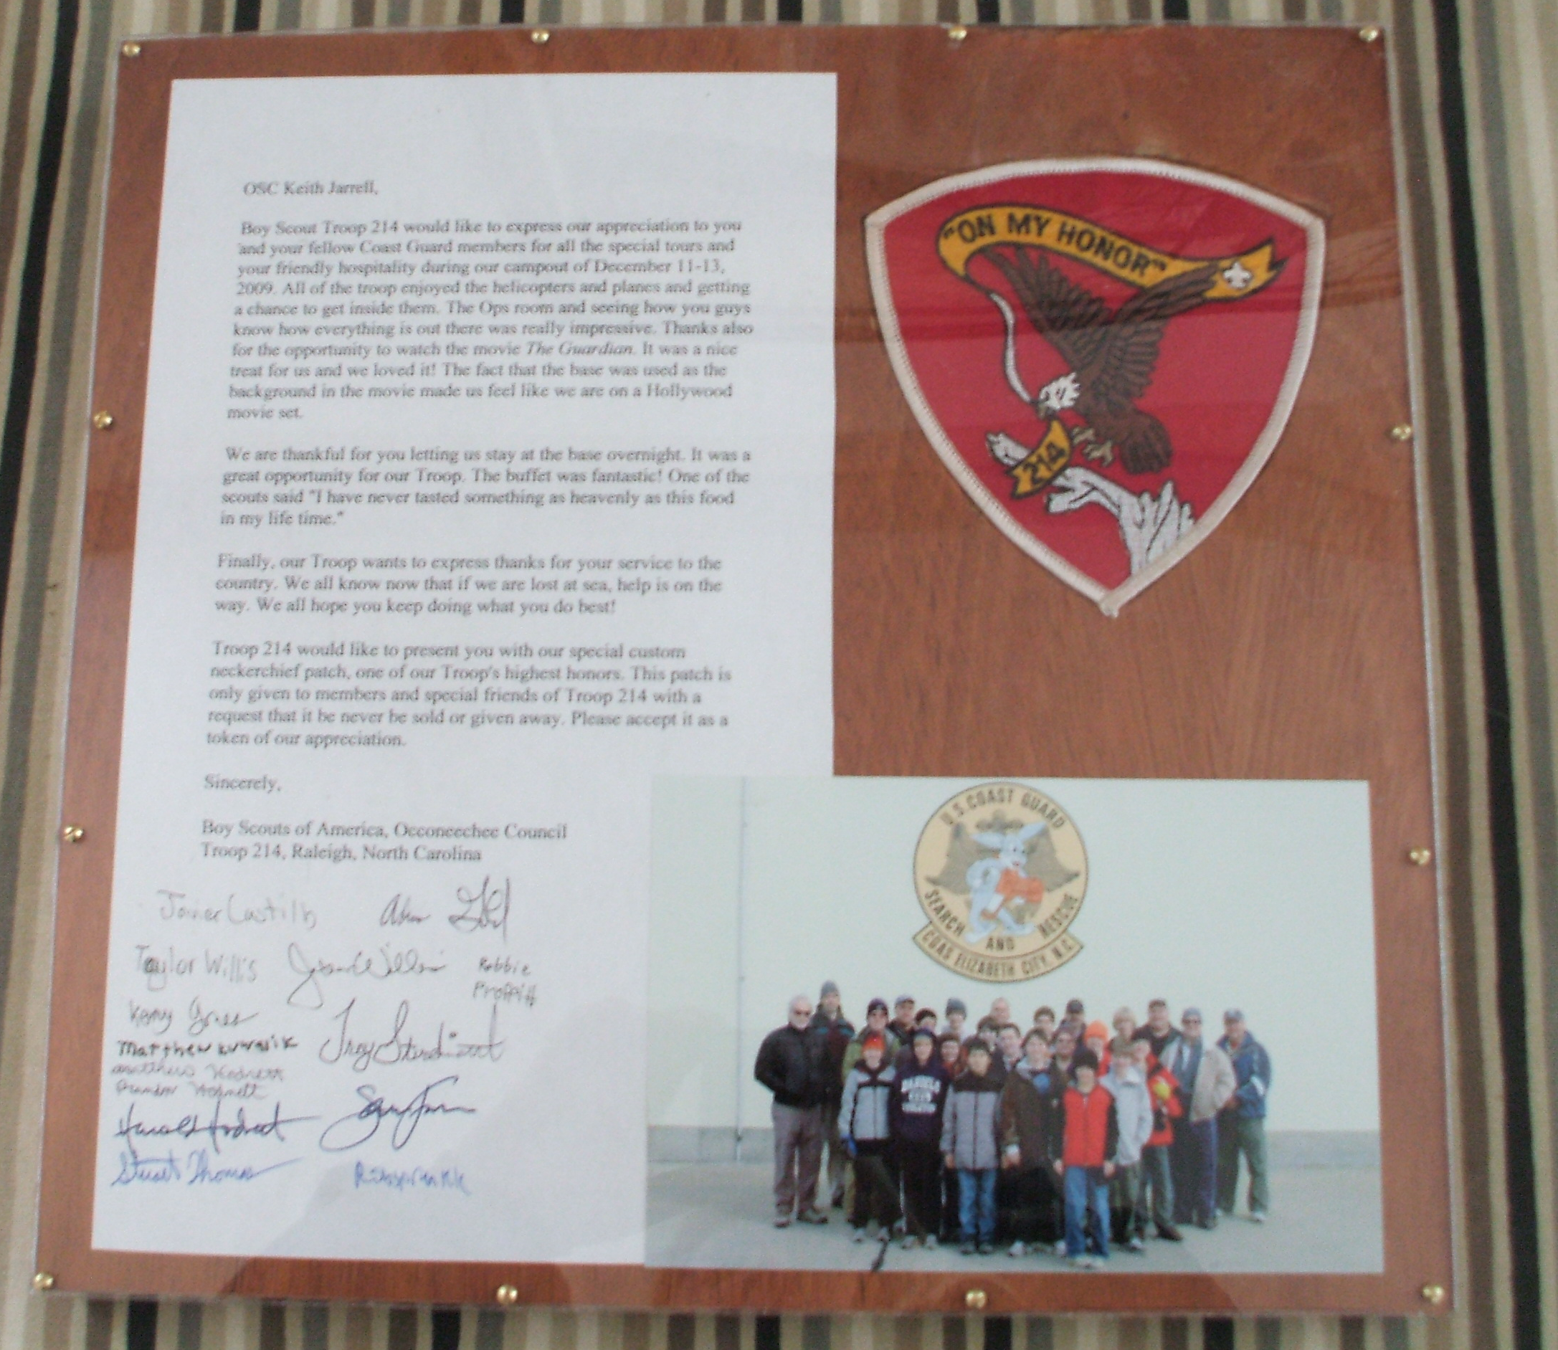
Quote of the Month
"A best friend is like a four leaf clover: hard to find and lucky to have." --Richard Cecil

Thanks to Alex Dilalla, Troop 214 OA representative, Scoutmaster Mr. Harold Hodnett, and adult leaders Mr. Stuart Thomas, Mr. Bill Dvorak, and Mr. Mike Jones for assisting with this month’s newsletter.

