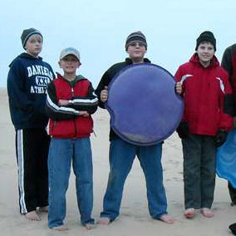
Troop 214 Parent News | Opening: Raiders
November 2010 | Game: Chucks
http://www.bsatroop214.us | Service: Generics
Harold Hodnett Scoutmaster

Key Events This Month | Key Events Next Month
Nov 12-14 - Backpacking Campout | Dec 4 - OA Winter Banquet
Nov 13 - Popcorn Orders Distribution | Dec 10-12 - Scout Skills Campout
Nov 19-21 - OA Leadership Weekend | Dec 13 - Court of Honor

Dates to Remember
November 1 – Troop Mtg 7 pm
November 2 - Popcorn money due to Council
November 4 - Roundtable
November 6 - University of Scouting; ASM Meeting (tentative)
November 7 - Jonathan Weaver's Eagle Court of Honor
November 8 - PLC 6:30; Troop Mtg 7 pm; Troop Committee 7 pm
November 11 - OA Meeting; Veteran's Day (WCPSS Holiday)
November 12-14 - Backpacking Campout
November 13 - Popcorn Order Distribution
November 15 - Troop Mtg 7 pm
Nov 19-21 - OA Leadership Development Weekend
November 22 - Troop Mtg 7 pm
November 25 - Thanksgiving (WCPSS Holidays Nov. 24-26)
November 30 - Popcorn Sales End

News and Details About Upcoming Events
Scheduling Note – An adult leader ("ASM") meeting is tentatively planned for Saturday November 6, time and location to be determined. All adults involved with the Troop are welcome to attend adult leader meetings; please contact Mr. Hodnett if you are interested.
Eagle Court of Honor – Please plan to join family and friends of Jonathan Weaver at his Eagle Court of Honor, to be held Sunday, November 7 at 2:30 pm. Weather permitting, the ceremony will be held in the outdoor chapel that Jonathan an others built for his Eagle project at Forest Hills Baptist Church--making this event that much more meaningful for all involved. Forest Hills Baptist Church is located on Dixie Trail near N.C. State University. A reception will follow the ceremony in the church dining hall.
OA Upcoming Events – The Kato Hochuli OA Chapter will have our meeting on November 11 (the second Thursday of the month as always). All meetings are held in Benson UMC’s youth center.
Lodge 104 has a couple of major events coming up. The Lodge 104 Lodge Leadership Development weekend is November 19-21 at Campbell University. The fee for the weekend is $25; the fee for those just coming on Saturday is $10. All Arrowmen are allowed to come down for Saturday and Arrowmen that have leadership positions should come down for the weekend. All Arrowmen should attend the Winter Banquet, which is December 4th at the Grand Lodge at Camp Durant. Patch auction at the Banquet starts at 5:30 pm and dinner starts at 6:00 pm. See Mr. Liberty at the November 11 chapter meeting to buy a ticket.
Backpacking Campout - The November campout is a backpacking trek of the Neusiok Trail. The Neusiok Trail is near Emerald Isle on the Outer Banks. It is a 20-mile trail through beach and marsh/swamp areas along the coast, and is part of the Mountains-to-Sea trail.
The troop contingent will be driving to Emerald Isle on Friday November 12th. We will overnight at Dr. Roberts' beach house, thanks to his ongoing generosity in allowing us to use those accommodations. At the crack of dawn on Saturday we will hit the trail. We will likely have a short trek crew and a long trek crew or two. The goal of the long trek crew(s) will be to hike the entire Neusiok Trail; the goal of the short trek crew will be to hike as far as they comfortably can. Each crew will hike nearly the entire day Saturday, camp overnight along the trail, and hike nearly the entire day on Sunday. That means we will have a late return to Raleigh (7:00pm estimate/goal).
Troop meeting programs have already begun to prepare scouts for the trek, and they will continue through November 15th. Contact Mr. Stuart Thomas or Jonathan Weaver with any questions about the campout.
Scout Skills Campout/Webelos Invitational –The Scout Skills campout will be December 10th-12th at Camp Durant. The planning committee is still finalizing details, but it appears that Cooking, Rocketry, Orienteering and other activities in addition to basic Scout skills (and advancement) will be offered. The Webelos Den from Pack 214 has been invited to join us, though most of the Webelos actually joined us at Camporee last month, and they have not confirmed (or declined). It will be a very fun, cheap, and action-packed weekend that you won't want to miss. We will have lots more details at upcoming meetings in November and in the December newsletter.
Fall Court of Honor – Our next Troop Court of Honor will be held in lieu of the Monday night meeting on Monday, December 13th. We will have ceremony in the church sanctuary, followed by a brief reception in the adjacent classrooms. Stay tuned for more details.
Website Updates – We have a few pictures from the September History/Aviation campout at the end of the newsletter, but check out the Troop website at http://www.bsatroop214.us/pictures.htm for the complete photo gallery!

Recent Highlights
Council Camporee – The Council Camporee was held at Camps Reeves and Durant on October 8th through the 10th. Troop 214 was the premier Troop there with not only the largest number of attendees, but also the largest number of registered adults on staff. It was an awesome event! Troop 214 invited and took the Webelos II den from Pack 214, and they had a great time. The Camporee was filled with activities for Scouts to participate in all day on Saturday. We drove down as a group and set up camp after dark on Friday night. The Webelos camped and cooked with the Scouts, and participated in all activities with them as well. Activities offered were numerous, including shooting sports, rocketry, cooking, patch trading, Brown Sea Island, Pioneering, and much more. Saturday was a very full day. Sunday morning, we got up, cooked our breakfast, cleaned up and packed up all of our gear, and headed out way before lunch time. The weather was absolutely perfect and there were no complaints from anyone participating.
Recent OA Activities – During our October OA meeting, elections were held for Chapter leadership positions, and Troop 214 is ruling Kato! Troop 214 Scouts that were elected to leadership positions were: Joshua Thomas as Chapter Chief, Javier Castillo as Vice Chief of Communication, Stephen Frein as Vice Chief of Administration, and Matthew Fiely as Vice Chief of Finance. Good luck to everyone in their new Chapter positions. Of course, Mr Liberty, Mr. Thomas, and Mr. Mike Jones will continue serving the Chapter as adult advisors.
Also, SPL Joshua Thomas and ASM Harold Liberty attended and were part of the very first graduating class of the Order of the Arrow, Southern Region, Section 7B's "Chapter Leadership Summit". Section 7B encompasses all OA chapters in all lodges in the state of NC. The training course was held at Camp Raven Knob over the Oct 22nd-23rd weekend. The Chapter Chief and Chapter Adviser Training was designed to assist chapter chiefs and advisors develop skills needed to be a successful chapter leader. The brand new course not only contained great training materials, but also included a special candlelight re-dedication ceremony officially written for the Order of the Arrow. The training weekend closed with a mountain-top hike to the summit of Raven Knob, where the closing graduation ceremony took place.
Troop Leadership Training Retreat - Our semi-annual Troop Leadership Training event was once again held at Dr. Roberts' beach house in Emerald Isle on October 22-24th. The weather was absolutely perfect and we had an enthusiastic bunch of Scouts attending. The course had several new twists this time, with updated materials, new games, a session on EDGE training by Stephen Frein, and presentations by Mr. Fox, Mr. Proffitt, and Mr. Hodnett. As usual, the "Old Goats" were the grubmasters for the weekend and provided all meals. We got a lot of beach time Saturday afternoon under sunny skies and a comfortable 75 degree temperature. Saturday night after dinner we had movie time and relaxed after a full day of learning and fun. Overall, it was one of the best TLT sessions we have ever had!
Quote of the Month
" I am still determined to be cheerful and happy, in whatever situation I may be; for I have also learned from experience that the greater part of our happiness or misery depends upon our dispositions, and not upon our circumstances."-- Martha Washington.
Joke of the Month
Martha Stewart will not be dining with us this Thanksgiving. I'm telling you in advance, so don't act surprised. Since Ms. Stewart won't be coming, I've made a few small changes:
- Our sidewalk will not be lined with homemade, paper bag luminaries. After a trial run, it was decided that no matter how cleverly done, rows of flaming lunch sacks do not have the desired welcoming effect.
- The dining table will not be covered with freshly laundered linens, heirloom china, or crystal goblets. If possible, we will use dishes that match and everyone will get a fork.
- Our centerpiece will not be the tower of fresh fruit and flowers that I promised. Instead we will be displaying a hedgehog-like decoration hand-crafted from the finest construction paper. The artist assures me it is a turkey.
- For safety reasons, the turkey will be carved in a private ceremony. I stress "private" meaning: Do not, under any circumstances, enter the kitchen to laugh at me. Do not send small, unsuspecting children to check on my progress. I have an electric knife. The turkey is unarmed. It stands to reason that I will eventually win. When I do, we will eat.
- I would like to take this opportunity to remind my young diners that "passing the rolls" is not a football play. Nor is it a request to bean your brother in the head with warm tasty bread.
- Before I forget, there is one last change. Instead of offering a choice between 12 different scrumptious desserts, we will be serving the traditional pumpkin pie, garnished with whipped cream and small fingerprints. You will still have a choice; take it or leave it.
Martha Stewart will not be dining with us this Thanksgiving. She probably won't come next year either. For this I am truly thankful. It is a good thing.
(Adapted from "My Little Sister's Jokes", http://www.emmitsburg.net)

Thanks to Scoutmaster Mr. Harold Hodnett, adult leaders Mr. Jay Sprankle, Mr. Stuart Thomas, and Mr. Mike Jones, and Troop 214 OA Representative Matthew Fiely for contributing to this month’s newsletter

Photos from September History/Aviation Campout
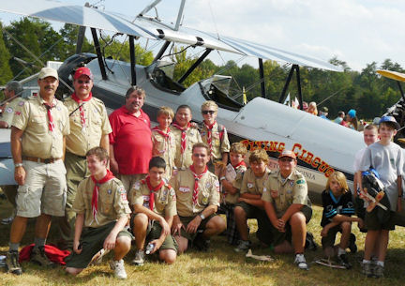
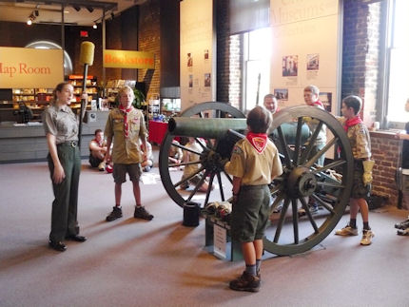
Thanks to Mr. Jones for sharing these: check out the Troop website for lots more!

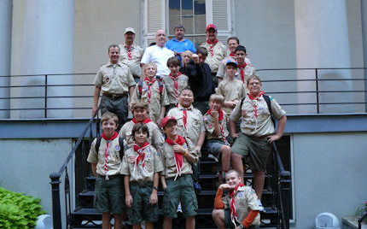

Photos from Troop Leadership Training
Thanks to Mr. Hodnett for sharing these!
