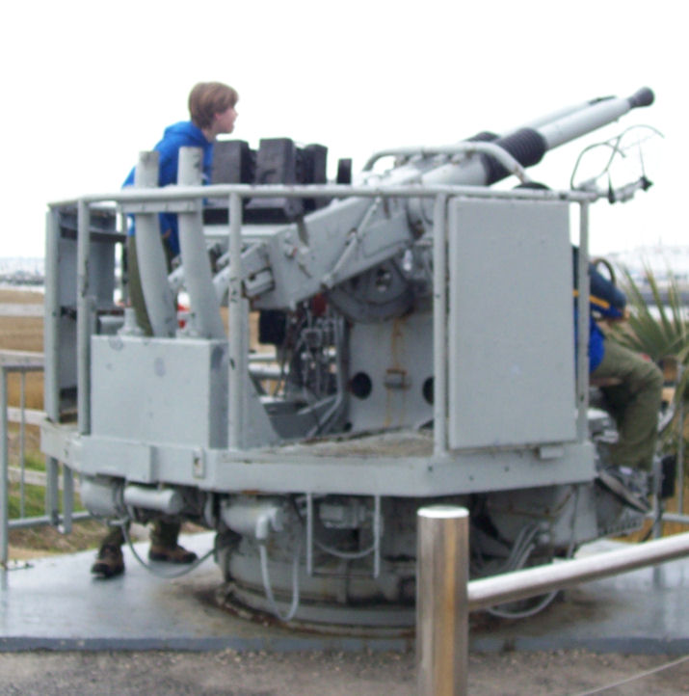
Troop 214 Parent News | Opening: Cobras
February 2011 | Game: Goats
http://www.bsatroop214.us | Service: Eagles
Harold Hodnett Scoutmaster

Key Events This Month | Key Events Next Month
Feb 5 - Troop Workday/Pack 214 Blue and Gold Banquet | Mar 6 - ASM Meeting
Feb 6 - Scout Sunday | Mar 11-13 - Tank History Campout
Feb 11-13 - USS Yorktown Campout | Mar 18-19 - OA Pow-wow

Dates to Remember
February 3 - Roundtable
February 5 - Troop Workday; Pack 214 Blue and Gold Banquet
February 6 - Scout Sunday
February 7 - PLC 6:30 pm; Troop Mtg 7 pm; Troop Committee 7 pm
February 10 - OA Meeting
February 11-13 - USS Yorktown Campout: departs 3 PM SHARP Friday Feb 11
February 14 - Valentine's Day; Troop Mtg
7 pm; Merit Badge Counselor Information Session 7 pm; Boards of Review
February 21 - Presidents' Day; WCPSS Holiday (no Troop Mtg)
February 26 - Merit Badge University
February 28 - Troop Mtg 7 pm

News and Details About Upcoming Events
Troop Workday - The Troop will hold a workday on February 5th to tidy up the Scout Hut in preparation for Scout Sunday. We will get started around 9 am. We could use as much help from Scouts and any available parents as we can get. Volunteers are asked to bring any of the following: rakes, window cleaning supplies, furniture dusting supplies, broom/dustpan, shop vac, mop/soap/bucket, picture-hanging tools and supplies, shovel, work gloves. Hopefully we'll have many hands to make the work light and be finished between noon and 1pm.
Pack 214 Blue and Gold Banquet – The Pack 214 Blue and Gold Banquet will be taking place the evening of Saturday, February 5. Webelo IIs from the Pack 214 Phoenix Patrol will be bridging to our troop at the conclusion of the ceremony. All Scouts and adults are invited to attend to extend them a warm Troop 214 welcome!
Scout Sunday - Scout Sunday is on February 6th. This is a good opportunity for Troop 214 Scouts and adults to meet members of our sponsoring organization, Benson Memorial United Methodist Church, and thank them for their support of our Troop. Scouts are asked to show up in Class A uniforms to attend the 8:45am and/or the 11:00am Worship Service at BMUMC. We also need Scouts to help cook and serve cobbler to BMUMC parishioners. Please see Peter Michaud, Mr. Hodnett, Mr. Mike Jones, or Mr. Stuart Thomas to volunteer.
Upcoming OA Events - The Kato Hochuli Chapter of the Order of the Arrow will have its monthly meeting on February 10, in the youth group room at the front of the Benson UMC.
Elections to OA are coming up. To be eligible for election to OA, you must be a registered Scout, have earned First Class rank, and have 15 nights of camping, five of which must be at Boy Scout summer camp. If a Scout is elected to OA by your Troop, he must then go through Ordeal in the spring or fall of that calendar year. OA members, please note that elections take a lot of work, so everyone in Troop 214 that is in OA must participate in at least one election. For more information on elections please see Stephen Frein or Mr. Mike Jones.
OA Spring Pow Wow is March 18-20 at Camp Durant. The cost is $20 for the weekend. Everyone that went through spring inductions in 2010 is eligible to go on the Brotherhood Trail. There is no extra fee for this activity, but you must register by mentioning to the registrar that you want to do the Brotherhood Trail.
USS Yorktown Camp-in – Troop 214 has 20 Scouts and 4 adult leaders confirmed and prepaid for this exciting trip taking place February 11-13. The group will include some new Scouts that will have just bridged over from Cub Scouts the previous weekend! Fliers with final reminder information for participants will be distributed at Troop Meetings in late January and early February, and gas fees will be collected at our departure.
Please note: Attendees will need to leave school or work around midday Friday February 11, to meet the 2:30 pm load-up and 3 pm SHARP departure time from the Scout Hut parking lot. This should not be a problem for most Scouts, as February 11 is a scheduled Early Release day for WCPSS traditional calendar students.
Special thanks to adult trip advisor, Mr. Mike Jones, and our trip committee members Josh Thomas, Sean Colby, Matthew Kuwalik, and Justin Burdette for their help with trip planning and program segments. If you have questions about the campout, please contact Mr. Jones at 919-451-3676 or at houseofjones@earthlink.net.
Merit Badge Counselor Information
Session – Parents: Troop 214 needs merit badge counselors. If you'd like more information about how to be a merit badge counselor and what it entails, please plan to attend a short information session at Benson on February 14 at 7:00 pm. You don't have to be an expert in the field, or even a hobbyist, to counsel a particular merit badge. You do, however, have to be registered with BSA. Drop by for some information, handouts, forms, and to get your questions answered. Our Scouts really need more counselors: they can't get to Eagle without your help. Contact Mr. Jay Sprankle, jay_sprankle@yahoo.com, if you have any questions.
Merit Badge University – Troop 214 has sixteen Scouts signed up for 27 merit badge classes at this year's Merit Badge University. If you're one of them (Scouts, not merit badges), you should be well on your way to completing your prerequisites.
MBU will be held at Highlands United Methodist Church, located in Raleigh at 1901 Ridge Road, on Saturday, February 26th. Details for drop-off and pickup will be sent out before the event. Scouts should check in with Mr. Sprankle on arrival. Contact Mr. Sprankle, jay_sprankle@yahoo.com, if you have any questions.
Merit Badge Institute – Troop 214's own Merit Badge Institute is tentatively scheduled for Saturday, May 7. Similar to MBU, MBI gives our Scouts the opportunity to complete many of the requirements for a merit badge in a single day. The difference is that MBI is for Troop 214 Scouts only and we use Troop 214 counselors. Also it costs about 1/3 as much as MBU. Look for more information to come out next month on half-day and full-day class offerings. If you're a merit badge counselor and would like to help, or if you're interested in becoming a merit badge counselor, please Contact Mr. Sprankle, jay_sprankle@yahoo.com.

Recent Highlights
December Scout Skills Campout - The final troop campout of Scouting's centennial year was appropriately centered around Scout skills. That was also the theme for December 2010 Troop meetings. Each week the trip committee delivered interesting, fun, and informative programs on outdoor skills to help prepare the Scouts for the campout, which was a Klondike Derby competition among the patrols.
For the campout, the Troop went to our Council's Camp Durant for the weekend of Dec. 10-12. We arrived late Friday night, and most of the Scouts and adults hit the tents to get some sleep immediately after setting up camp. Of course some Scouts stayed up late; much talking, laughing, and even singing came from a certain large tent housing a handful of Scouts and was heard throughout the campsite.
In the morning each patrol got started on cooking their breakfast. Patrols were judged on the menus they prepared, their food preparation, and cleanliness.
After breakfast the Klondike Derby kicked into full gear. Patrols spent the morning rotating among skills stations spread out at various Camp Durant locations. Each station had an adult who provided skills instruction, which was followed by the patrols performing a related activity challenge that was timed. The activities included fire-starting, orienteering, knots and lashings, first aid, tent setup, team-building, and more.The Derby was interrupted by lunch, which was also part of the competition. Each patrol was given the same set of unannounced food items, and challenged to make meals using the ingredients provided. That involved both creativity and cooking skills, and no two patrols ended up with the same prepared meals at the end. Judges sampled each patrol's courses, and points were awarded for creativity, taste, presentation, preparation, and cleanliness. After lunch the patrols continued rotating through the skills stations.
The winning patrol was announced after dinner, after which we performed a solemn flag retirement ceremony, followed by shared stories, jokes, and fellowship around the campfire.
Sunday morning everyone fixed breakfast, cleaned up, and packed up. We ended the weekend with a Worship Service prepared by the troop Chaplain Aide and then collectively headed back to the Hut to unpack gear and head home afterward.
The campout wasn't without challenges. The temperature Friday night hit a low of 18 degrees. It started raining just before lunch Saturday, and continued all afternoon, all evening, all night, and through breakfast and our eventual campsite departure on Sunday, with temperatures constantly near freezing. Some Scouts were not as prepared gear-wise as they could have been, but hopefully it taught those scouts to not repeat those kinds of mistakes in the future.
After all, the theme of the campout and the month's meetings was practicing and improving on varied skill, preparedness, and knowledge areas. In the end all the Scouts seemed to have fun while learning and practicing some valuable skills.
Thanks and kudos go out to the Scout Skills campout committee, headed up by Troop Instructor Stephen Frein, SPL Joshua Thomas, and ASMs Alan Proffitt, Joseph Heil, and Mike Fair. Everyone did a great job with their part in planning and execution, and it was a great team success.
January Climbing Overnighter - Our January troop outing was a Climbing Overnighter at Vertical Edge in Durham. A contingent of 22 Scouts and 7 adults spent the night climbing and rappelling up and down Vertical Edge's 8500 sq. ft. of climbable surfaces. This included over 60 top-rope climbs up 24 ft. high vertical and overhanging walls, a 500 sq. ft. bouldering cave, a 400 sq. ft. leadable cave, and 20 leadable routes. The adults and a few older Scouts obtained belay certification prior to the event. They and Vertical Edge staff provided the safety and supervision for the event, as did the appropriate gear that everyone had to wear and use throughout.
In short, everyone had a blast. Scouts (and some adults) were climbing from around 10 pm until 6 am the next morning. Some Scouts crashed out earlier, but many climbed almost the entire night and only nabbed about 30 minutes of sleep between 6:15am and 6:45am. Around midnight we all feasted on pizza. We also had a snack break sometime in the wee morning hours. A handful of Scouts worked on the Climbing Merit Badge, and everyone got in some good exercise. We wrapped up the event on Sunday morning by cleaning up, packing up, and holding a Scout's Own Worship Service.
Many thanks to Mr. Sam Fouse, Mr. Mike Fair, and the rest of the trip committee. Be on the lookout for a website photo gallery highlighting the event.
Quote of the Month
" Without love, what are we worth? Eighty-nine cents! Eighty-nine cents worth of chemicals walking around lonely."-- "Hawkeye Pierce", from the TV show "M*A*S*H"
Joke of the Month
Roger was buying an expensive bracelet to surprise his girlfriend on Valentine's Day at a very fancy jeweler’s shop.
The jeweler inquired, 'Would you like your girlfriend's name engraved on it?'
Roger thought for a moment, grinned, then answered, 'No, instead engrave it, "To my one and only love".'
The jeweler smiled and said, 'Yes, sir; how very romantic of you.'
Roger replied with a glint in his eye, 'Not exactly romantic, but very practical. This way, if we break up, I can use it again.'
(From www.guy-sports.com)

Thanks to adult leaders Mr. Sam Fouse, Mr. Stuart Thomas, and Mr. Mike Jones and Troop 214 OA Representative Matthey Fiely for contributing to this month’s newsletter.

