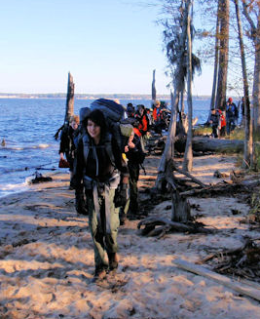
Troop 214 Parent News | November 2011
http://www.bsatroop214.us | Harold Hodnett Scoutmaster

Key Events This Month | Key Events Next Month
Nov. 12 - Popcorn Distribution | Dec. 9-11 - Scout Skills Campout
Nov. 11-13 - Backpacking Campout | Dec. 19 - Court of Honor

Dates to Remember
November 3 - Roundtable
November 5 - University of Scouting; Strickland Park volunteer day 8:30 am
November 6 - Adult Leader "ASM" Meeting
November 7 - PLC 6:30 pm; Troop Mtg 7 pm; Troop Committee; sign-up deadline for Backpacking Campout
November 10 - OA Meeting
November 11 - Veterans' Day
November 11-13 - Backpacking Campout
November 12 - Popcorn distribution
November 14 - Troop Mtg 7 pm
November 21 - Troop Mtg 7 pm
November 24 - Thanksgiving
November 28 - Troop Mtg 7 pm; all popcorn money due

News and Details About Upcoming Events
University of Scouting – University of Scouting will take place on November 5th This all day training “college” will be held at Wake Technical College. For details on classes offered, please see the Council website.
Volunteer Day – The City of Raleigh is organizing a volunteer day for the new Strickland Road Neighborhood Park on November 5th. Trails need to be mulched, and a Girl Scout Troop is coordinating the planting of 170 bushes. Mr. William Hollerung is organizing a group of Troop 214 Scouts to help with this effort. This is a good service opportunity for any Scouts in our Troop that are interested in getting service hours, especially those who missed Stream Clean Up. It will count as community service for rank advancement.
Work will begin at 8:30 am in order to be completed by noon when the park will be dedicated and officially open. Mayor Meeker will speak at the dedication.
Any Troop 214 boys interested in participating should RSVP to Mr. Hollerung at Holler3x@earthlink.net or 787-8686. The Hollerungs would also like to offer any boy that volunteers that day a hot dog lunch at their house; your Scout should let Mr. Hollerung know if he plans to attend the lunch.
Scouts participating should keep track of their service hours and report them to Mr. Hollerung or their Patrol Guide or Adult Patrol Advisor at the earliest opportunity.
Adult Leader "ASM" Meeting – The monthly ASM / adult leader meeting will be held on Sunday, November 6th in the Scout Hut from 7 pm to 8 pm. All current adult volunteers, as well as other interested adults, are welcome to attend. We are always looking for extra help.
The next ASM meeting will be on Sunday, December 4.
Upcoming OA Events – The next Order of the Arrow chapter meeting will be November 10th in the Youth Center at Benson Memorial. We will have dinner at 6:30 pm with the meeting beginning at 7 pm.
If your Scout has questions about OA activities, he should contact Troop 214 OA representative Matthew Kuwalik at jlmkuw@bellsouth.net.
Backpacking Campout – What's better than a long walk in the woods? A long walk in the woods beside nice, natural waters!
Troop 214 will be backpacking on November 11-13 along the Mountains-to-Sea Trail (MST) between Rolling View Recreation Area and Falls Lake Dam. This trail offers some of the most attractive waterfront hiking found anywhere along the MST, which stretches 1000 miles from Clingman's Dome in the Great Smoky Mountains to Jockey's Ridge on the Outer Banks. The 37-mile section along Falls Lake loosely traces the crooked fingers and coves on the south side of the reservoir. At times the well-marked footpath hugs the shoreline, and at others it's tucked back in the woods, passing through wildlife clearings, park lands, and hardwood forests. There are gentle ascents and descents, but not too much climbing. White blazes mark the trail, although it's hard to get lost when all you have to do is hike north towards the lake to re-locate the trail. Falls Lake is narrow just above the dam so the trail has numerous water crossings. But the crossings are on small foot bridges so we won't even get our feet wet (unless we want to). This is a popular section of trail that draws many regular day-hikers, because of the plentiful views of the lake along a number of miles of the trail.
The plan is to camp overnight on Friday November 11th at either Rolling View or Shinleaf. The long trek crew of older Scouts will tackle the 22-mile stretch between Falls Dam and Shinleaf Recreation Area, hiking all day Saturday, camping overnight along the trail, and then hiking most of the day on Sunday. The current short trek crew plan is to tackle 11 miles between Blue Jay Point and Shinleaf, hiking about 7 miles on Saturday, camping overnight along the trail, and then hiking 4 miles on Sunday. We may change up that trek plan to tackle a 13-mile stretch between Rolling View and Shinleaf, depending on the physical ability and confidence level of the Scouts and adults on the short trek crew and vehicle logistics.
The cost of the campout is $8 per person to cover camping fees and transportation, plus food costs which vary by patrol based on menus planned. We can safely estimate grub fees of no more than $12 per person, rounding out the total campout cost to $20. Attendance signup must occur at the November 7th troop meeting and informational fliers will be distributed then. For additional questions about the campout please contact trip committee members Joshua Thomas, Sean Colby, Andy Jones, or Mr. Stuart Thomas.
Popcorn Sales – All popcorn order forms should have been turned in to Ms. Shirley Olsen by October 30. A Scout is Courteous; if your Scout did not sell popcorn, please make sure she knows so she will not be looking for an order form from him. Popcorn will be available for delivery to your customers on the weekend of November 12-13. Please contact Ms. Olsen at sjolsen@bellsouth.net with any questions.
Finally, all popcorn money is due to Ms. Olson no later than November 28. Please ensure your Scout turns in his money on time so that Ms. Olson can wrap up the sale in a timely manner.
Merit Badge University – Merit Badge University is an event open to all area Scouts that provides an opportunity for them to work toward completing one or two merit badges with a focused effort and a firm completion date. Twelve Troop 214 Scouts have signed up for MBU, which will take place at Highlands United Methodist Church on Feb. 25, 2012. Confirmation of registration should come in December. We hope to revive our own Troop 214 Merit Badge Institute next spring.

Recent Highlights
Sailing Campout – Troop 214 headed to the coast the weekend of October 7-9 for a sailing campout. Fair weather and a steady breeze made for great camping and sailing trip. The Troop maintained a steady helm for Beaufort at the Maritime Museum's property on Gallants Channel. The boys were up early Saturday and were excited to explore sailing with the Sea Scouts of Ship 98. After instruction the boys broke up into small groups and took turns at the tiller in what turned out to be a fast day on the water with 15-20 knot winds. A number of groups enjoyed sailing on traditional water craft used as the primary mode of transportation back to the 1600's. After a hearty fish fry dinner the boys settled in for a presentation from a volunteer from the museum displaying hand-carved wooden work boats that represented today's local "dead rise" boats seen on many yachts and work boats in Carteret County. After breaking camp on Sunday, the Troop took down the buffet at the waterfront and shoved off on the 45 ft. catamaran "Lookout". The sails were full and we made great time pulling up to the "hook" of Core Banks National Seashore where the boys explored the beach in search of shells and items of fancy. Then it was off to tie up at Cape Lookout lighthouse and view the history of the 158' diamond marked sentinel that is still active and warning mariners of the dangerous and infamous Lookout Shoals. We had a great Sunday service, passed out shirts made for the occasion, and steered our course back to Raleigh. It would be fair to say "A good time was had by all". Thanks to Mr. Mike Fair and Mr. John Willis for serving as adult advisors for this fun event.
Troop Elections – Troop Elections were held at the October 17 meeting. Congratulations to all of the Patrol Leaders elected, as well as the appointed Assistant Patrol Leaders and other Leadership positions granted. Remember, to actually get credit for Leadership, the Scout holding that job must perform the Leadership duties listed in the Job Description. (Consult the Troop website for the Youth Leadership Position Resources Guide). Scouts should contact their Adult Advisor or Mr. Hodnett if they have any questions about what the job expectations are.
Troop Leadership Training Weekend – Troop Leadership Training was held October 21-23 at Emerald Isle, NC. (Thanks to the generosity of former Scoutmaster Dr. Roberts for allowing us to use his beach house). Eight Scouts and four Old Goats made the trip and had a weekend filled with learning, interactive games, and a whole lot of fun. The main presenters were Mr. Hodnett, Mr. Proffitt, and Troop Instructor Stephen Frein. Also supporting the weekend’s activities were Mr. Setzer and Mr. Holmes. The Old Goat patrol even took care of all meals for the weekend! If you have never been to TLT, you have missed out on some important lessons that will serve you throughout your adult life, as well as missing out on a good time!

Quote of the Month
" We can always find something to be thankful for, and there may be reasons why we ought to be thankful for even those dispensations which appear dark and frowning." ~Albert Barnes

Joke of the Month
The pro football team had just finished their daily practice session when a large turkey came strutting onto the field. While the players gazed in amazement, the turkey walked up to the head coach and demanded a tryout.
Everyone stared in silence as the turkey caught pass after pass and ran right through the defensive line. When the turkey returned to the sidelines, the coach shouted, "You're terrific!!! Sign up for the season, and I'll see to it that you get a huge bonus."
"Forget the bonus," the turkey said, "All I want to know is, does the season go past Thanksgiving Day?" (Source: http://www.ahajokes.com)
Thanks to Scoutmaster Mr. Harold Hodnett and adult leaders Mr. Stuart Thomas, Mr. Jay Sprankle, Mr. Craig Setzer, Mr. Mike Fair, and Ms. Shirley Olsen for contributing to this month’s newsletter.

Pictures from Troop Leadership Training Weekend

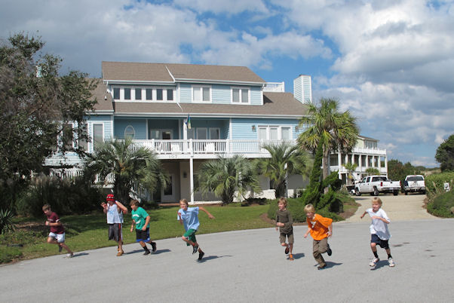
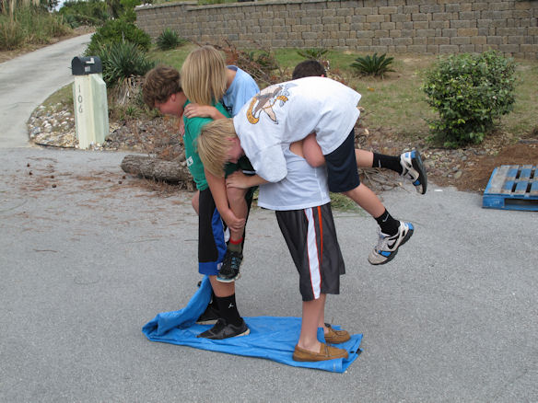
Thanks to Mr. Setzer for sharing!
