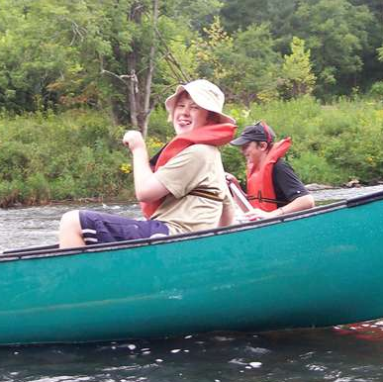
Troop 214 Parent News | July, 2012
http://www.bsatroop214.us | Harold Hodnett Scoutmaster
Key Events This Month | Key Events Next Month
July 8th ASM/Adult Leader Meeting | August 5th AMS/Adult Leader Meeting
July 13-15th Tubing/Canoeing | August 10-13th Skiing/Skiing Campout

Dates to Remember

July 2nd: Troop Meeting 7 PM
July 8th ASM/Adult Leader Meeting 7PM
July 9th Troop Meeting 7 PM
July 13-15th: Tubing/Canoeing Campout
July 16th Troop Meeting 7 PM
July 23rd Troop Meeting 7 PM
July 30th Troop Meeting 7 PM

ASM / Adult Leader Meeting: The next Assistant Soutmaster, Adult Leader meeting will be Sunday, August 5th at 7pm in the Scout Hut. All current leaders and prospective leaders are invited to attend. We strive to hold the meeting to about one hour.

News and Details About Upcoming Events

Order of the Arrow:

Mr. Thomas reports that our OA chapter had its new member cookout on June 14th in place of its regular meeting.
Additionally, he reports that there will be No Chapter meeting in July as is tradition with due to the Scouts busy summer schedule.

Tubing/Canoeing Campout:

According to ASM, Mr. Sam Fouse, we have room for and have reserved seats for 35 participants, adult and youth. I must contact the outfitter with a final count on Tuesday, July 10 or we will have to pay for empty boats. We don't want to do that, so I need a head count as soon as possible. You may do so by e-mailing me at sfouse05@gmail.com and/or signing up on the signup sheets in the patrol rooms at the Scout Hut no later than Monday, July 9th. After that it will be too late.
Please note to all registered adults. If you have been wanting to go on a troop outing, this would be a good one."

Motor boating/Water Skiing Campout

Mr. Hornet notes that Troop 214 is pleased and grateful to be able to offer a Motorboating and Water Skiing campout again this year slated for August 10-13th. Stay tuned for more details and get psyched to have some fun and learn about motorboating safety along with the opportunity to earn the motorboating Merit Badge!

Recent Meetings and Updates:

April District Camporee Pictures Now Online:

Mr. Thomas updates that pictures are online and viewable at:
http://www.bsatroop214.us/images/galleries/Camporee_Apr2012/index.htm
Video Game Lock In update

June 8-9 resulted in another successful video lock-in for the scouts of Troop 214. This event was attended by 21 scouts & 2 scouters. TVs, game consoles, games & controllers were all brought in and set up at multiple stations so the scouts could enjoy all platforms; Xbox 360, Wii, PlayStation & Mr. Thomas even brought in a vintage GameCube for all to enjoy. The gaming began at 6:30 PM & continued into the wee hours of the morning. All scouts & scouters had “game on”! Thanks to Mr. Friedlein for setting up the Wi-Fi & being our “snack runner”. Thanks to Benson UMC for allowing the troop to use their spacious Youth Center as our base of operations. Also, thanks to our adult volunteers Conita Benson & Craig Setzer

Summer Camp 2012
ASM Log from Mr. David Burdett

June 17-23, 2012
Camp Raven Knob
Low Gap, NC

Monday June 18th Report:

Our week is off to a rockin' good start. We all arrived in good order to Camp, and it's a beautiful location. We all made it through in-processing, including the new and exhaustingly slow medical interrogation. (One person just reads the forms, one at a time!). Thanks again to Joe Fiely for excellent preparations!
A small precipitation event shortened Campfire last night, but we all slept well, and our campsite is well established. We have the longest walk to the dining facility, but it's downhill all the way. Good news for those "gravitationaly challenged" who ate too much at breakfast: campsite is uphill all the way from the dining facility!

It's a bit warm today, but everyone has a shady area for classes, and plenty of water to drink. No personnel issues to speak of, though we have identified two lads for the Rusty Broken Knob Award (the opposite of the Camper of the Day Award). I found an old door knob lying on the ground of our campsite (go figure), and will be giving it to the lad(s) who acted like the biggest knob that day. We do have a camper of the day in mind, too, but alas, the day is young!

I'd like to know who is planning on visiting this Wednesday. A headcount will help us with dinner, which is being prepared in campsites. Please respond to this email, burdettandassociates.com, if you are visiting. I'll also have the boys send you an email. Jay/Joe, please collect emails addresses of the boys, especially the 1st and 2nd year scouts.

I'm off for now. Going to check venues, and find the Cripple Creek pioneers. Pictures tomorrow

Friday June 22nd Report:

Another beautiful day at Camp Raven Knob. Sorry for the delay in this report, as we've been very busy last couple of days.
We just got a nice bit of rain, and the temperature finally dropped to the mid 70's, which is normal for this time of year. We've been in the mid 90's last two days. Rain, though, may have inflicted a terminal case of incomplete merit badge-itis on those taking their last requirements in aquatics and shooting badges. No can play when lightning is spotted. Boys are having fun with it, though. They all walked around without their rain jackets, enjoying the cool rain. I imagine for some, it's the first bath they have had all week. Don't worry, moms, our boys take regular showers.

Most everyone else has completed their requirements for their merit badges. Justin and Dylan returned from Cripple Creek pioneer village with pockets full of handicrafts, some unique merit badges, and lots of good stories. They both earned Cooking Merit Badge (using an old time hearth and hand forged utensils) and Rifle Shooting...with a black powder rifle. That is a very tough version of the rifle badge, because they have to learn how to load, fire with accuracy, and reload an old muzzle loader. They also ate much better than we did.

A large contingent of our boys went on their own up to Raven's Knob, a 600 foot climb. Great view from there! Matthew Fiely, fully recovered from a minor illness, led the group of boys. The group included Jeffrey Whittington, a first year camper, who was making his second climb of that hill in the same day. Way to Go, Jeff!

We had open craft night last night. Lots of "interesting" metal, leather, wood, and string projects coming your way. A small cottage industry has arisen in the survival wrist band business, it seems. You may also find that your boy has become a bit of a card shark, as often happens on these trips. Watch out the next time you play poker with him!

We have final campfire tonight, and cleanup in the morning. The rain should clear out for that. Awards go out tonight, too. We've earned Honor Troop (again). One of our boys earned Honor Camper, and 2-3 others have earned Merit Camper. Mr. Setzer, Mrs. Benson, and myself have earned recognition for assisting as counselors in different programs this week.

We should be back at Benson UMC by noon. We will call Joe Fiely when we depart to confirm time. (Troop Committee note: I will not be available to forward e-mail updates on Saturday morning.) Please remember that the boys are NOT released until all of the common gear is cleaned and returned, and the vehicles and trailer are cleaned. We picked a lot of dust up this week, and expect a lot of dirty clothes.

Big thanks also to the other parents who came along. We got a lot done due to the cooperation and support we provided to each other.

Lastly, Matthew Fiely and Andy Jones, along with several other senior scouts, helped make this a successful camping experience for all.

David Burdett

2012-2013 Troop Calendar:
Mr. Thomas reports that the troop's scouts held the annual planning meeting this past month. Campout ideas were nominated and selected for the Sep 2012 through Aug 2013 scout year. Website calendars will be created and published soon. In the interim here is the list of trips and their assigned months. The assigned months are subject to change, but this draft list should be considered pretty close to the final product.
Sep 2012: Seabase / Sailing
Oct 2012: Council Camporee
Nov 2012: USS NC Battleship / Fort Fisher
Dec 2012: Scout Skills
Jan 2013: Aviation / Cherry Point
Feb 2013: Washington DC
Mar 2013: Backpacking
Apr 2013: Whitewater Center
May 2013: Busch Gardens / Jamestown
Jun 2013: Appomattox / Civil War
Jul 2013: Summer Camp
Aug 2013: Motor boating or Mountain Biking (TBD)
Adults who would like to volunteer for the Trip Advisor role and/or scouts who would like to volunteer to be on the trip committee for any campout(s) should notify Mr. Hornet.

Quote of the Month

"Be sure your wisest words are those you do not say."
Robert W. Service

Joke of the Month:

Q. What is the loudest state?

A. ILLI-NOISE

Bada Boom!

Thanks to ASM’s and Adult Leaders Mr. David Burdett, Mr. Stuart Thomas, Mr. Conita Benson, Mr. Craig Setzer and Mr. Sam Fouse for contributing to this month’s newsletter.

Please see next page for exciting photos of a fun-filled and productive week by your Scouts at Camp Raven Knob.

2012 Camp Raven Knob Summer Photos!!!!
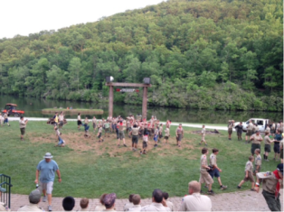 | 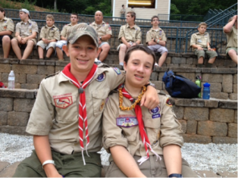
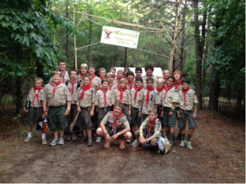 | 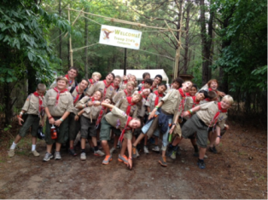
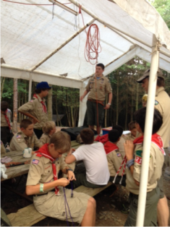 | 