Troop 214 2012 Summer Camp Newsletter

With just 15 short weeks remaining, it is time to start planning for Troop 214’s trip to Raven Knob Scout Reservation (RKSR) for 2012 Summer Camp. Important deadlines are quickly approaching so it is very important that Scouts and parents of Scouts wishing to attend camp stay informed.

Summer Camp Dates to Remember

March 26 - $100 Summer Camp Deposit Due for each Scout attending Camp.
March 26 – Merit Badge\High Adventure program selections can be turned in.
May 28 – Completed BSA Medical Forms Due to Troop Medical Officer for all camp attendees. (Adult and Youth)
May 28 – Remaining balance for Summer Camp Due for Scouts. Payment Due for adults
June 1 - Cancellation deadline for full refund.
June 17 – Depart for Camp. Time: TBD
June 23 – Return from Camp

Summer Camp Contact – I will try to provide all necessary information in this, and future, installments of this newsletter, however, if at any time there are questions regarding Summer Camp, don’t hesitate to ask. I can be reached anytime at fiely@bellsouth.net or at 919-790-1637 most evenings.
YiS,
Joe Fiely
Summer Camp Registrar

Now Taking Reservations – Registration forms have been passed out to troop. The same form can be found in this publication if it got lost or somehow mysteriously vanished.
What do I register for? – Registration generally falls into 3 categories: First Year, Merit Badge Base camp and High Adventure program.
First Year Program - All Scouts who have joined the troop since 1/1/2012, should plan on registering for the Raven Scouts program. This is a half day every day program that will work on fulfilling requirements towards Tenderfoot and 2nd class. Raven Scout program meets in the mornings allowing these Scouts to participate in the merit badge program in the afternoon.
Merit Badge Program – RSKR offers an extensive merit badge offering across 6 periods throughout the day. It is suggested that Scouts attending their 2nd and 3rd years of camp participate in the Merit Badge program. More information can be found in the Summer Camp Leaders Guide found on the Raven Knob web site.
High Adventure Programs - RSKR offers several different program options for older Scouts who are looking for a little more from their summer camp experience:
- Cripple Creek Mountain Man program allows Scouts to spend a week living in the 1800’s. Scouts must be 13 years old and have Scoutmaster approval to participate in Cripple Creek.
- Rampage! offers a buffet of High Adventure activities which includes among others, River Boarding, Caving and Backpacking. Scouts must be 14 years old and be in good physical condition to participate in Rampage!
- Mountain Biking is a half day program that offers a week of trail riding in and around the many trails and logging road of RKSR. Scouts must bring their own Mountain Bike, Helmet and extra tube and be 14 years old to participate in Mountain Biking.
- Climbing Merit badge is a half day program that will teach Scouts the basics of climbing and rappelling first on the tower and then on open rock. Scouts should posses adequate upper body strength and be at least 14 years old to participate in Climbing Merit Badge.
For additional information on all of these High Adventure programs please refer to the Summer Camp Leaders Guide found on the Raven Knob web site.
Camp Fees – The base camp fee for all Scouts is $275. Additional program fees may apply based on merit badge or high adventure programs selected. Lastly, there will be a transportation cost of $20. The first payment for Scouts in the amount of $100 will be due March 26th. Please notify Mr. Fiely if you plan to pay for camp (in full or partially) with Scout Account money.
Medical Forms – Everyone (youth or adult) attending camp must have a completed BSA Medical Form # 34605 signed by a physician within the past 12 months, regardless of program they will be participating in. No other medical forms are accepted. Here is the link to the current medical form (http://www.scouting.org/filestore/pdf/34605_Letter.pdf).

Adult Contingent – Summer Camp cannot be successful without a devoted group of adults accompanying the group. There have already been a number of adults that have done everything from expressing a slight interest to making a firm commitment. In the coming weeks we will be firming up the adult portion of the contingent. So, if you haven’t already, please let the Summer Camp Registrar know if you are interested. In the mean time, here a couple of things to consider if you are thinking about coming along.
- Membership and Training – All adults attending must be registered adults with BSA and at a minimum be Youth Protection trained. Safe Swim Defense, Safety Afloat, Climb on Safely, and Trek Safely are also good to have.
- Med Forms and Physicals – Same policy that applies for youth applies for adults.
- Costs – Adults should expect to pay camp fees. The final cost should be something in the neighborhood of $100. The final cost will be determined when the final count is known.
- Scout Spirit – Regardless of your role with the Troop back home, all adults that attend Summer Camp will be expected to assist in delivering the Scouting program to the entire youth contingent with the advice and direction of the designated Scoutmaster.

Gear Corner – One essential piece of gear that can be pursued now is a foot locker. Foot lockers are easy enough to find at any area Wal-Mart or Kmart 40 weeks out of the year. However, when thousands of area youth begin to make preparations for summer camp, they can become scarce. With that in mind, it’s not a bad idea to secure one now. Below is a picture of one that is available at Wal-Mart. A foot locker should cost around $20 - $30; no more. The most important feature is having the ability to lock with a pad or key lock. Wheels are nice but are not important, since the terrain in nearly every scout camp is dirt or gravel paths. If you have any questions about foot locker or any other gear, feel free to ask any adult leader.
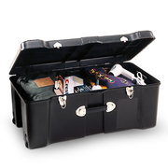

Additional Information regarding Merit Badge descriptions and High Adventure program offerings can be found in the RKSR Summer Camp Leaders guide located on internet at this link: http://www.ravenknob.com/pdf/2012-Guide.pdf

Troop 214 Summer Camp Registration
June 17, 2012 – June 23, 2012
Raven Knob Scout Reservation-Mt Airy, NC

Name: ________________________________
Rank: _________________________________
DOB: _________________________________
Phone Number: _______________________
T-Shirt Size: _______________________

Summer Camp Cost
Base Camp Cost | $275.00
Travel Cost (Approx) | $20.00
Total* | $295.00
*Additional program fees may apply based on Scout Selections as shown on the attached program schedule

$100.00 Deposit Due March 26, 2012
Final payment due May 14, 2012

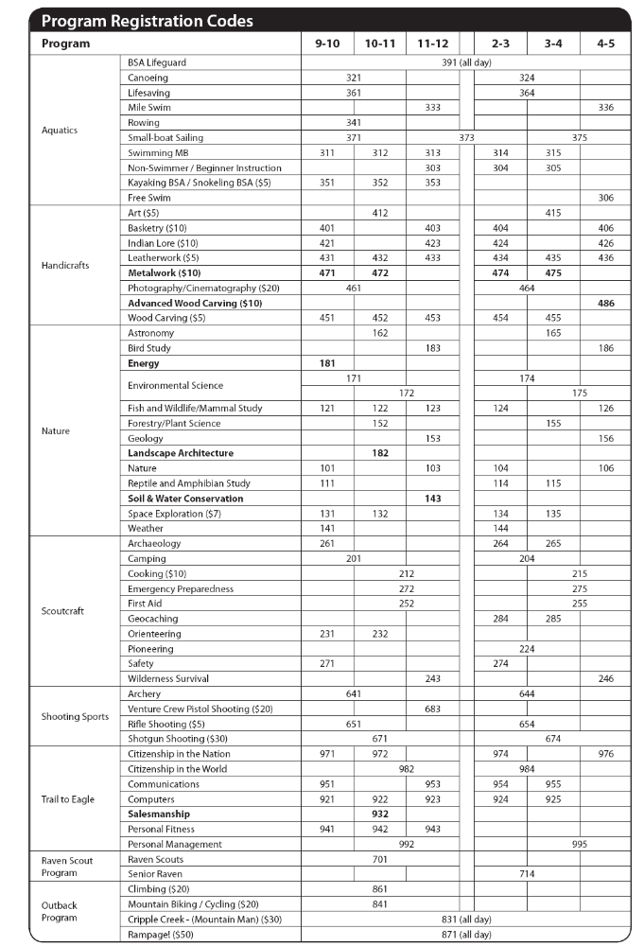
Instructions for selecting Summer Camp Programs
- On the program sheet, circle the program code of the merit badge or other program, you wish to take at summer camp. Circle one selection for each period. Example:
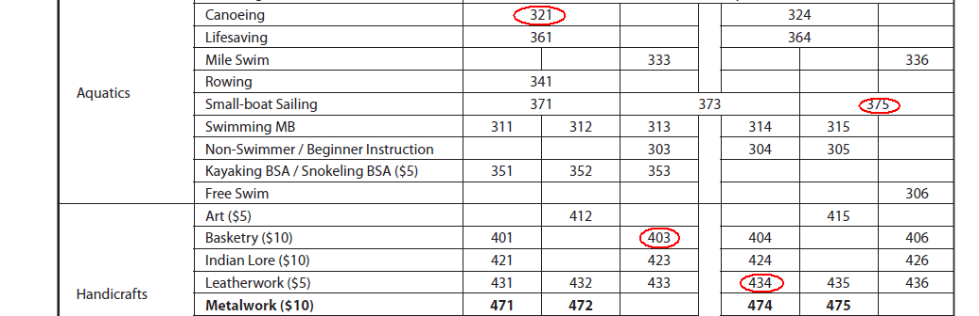
- Scouts should strive for a balanced schedule with a sampling of outdoor and classroom type Merit Badge’s
- A free period(s) are allowed and encouraged in order to have some down time during a busy week.
- ALL FIRST YEAR scouts need to sign up for Raven Scouts Program and may select up to three additional Merit Badges. However, first year scouts cannot take a shooting sport merit badge or a Trail To Eagle. Below are the Merit Badges that Troop 214 recommends for First Year Scouts.
Merit Badges for Raven Scout Program Scouts
Swimming | Bird Study | Fish and Wildlife Management and Mammal Studies (2 Badges)
Geology | Nature | Reptile and Amphibian Studies
Soil and Water Conservation | Space Exploration | Weather
Archeology | Camping | Cooking
Orienteering | Art | Basketry
Indian Lore | Leatherwork

- The following are age restrictions that will be enforced. Please DO NOT sign-up for programs which you don’t meet the age requirements:
  - Climbing: You must be 13 years old on the first day of camp to participate.
  - Mountain Biking: You must be 14 years old on the first day of camp to participate.
  - Cripple Creek (Mountain Man): You must be 13 years old (with Scoutmaster Approval) on the first day of camp to participate.
  - Pistol Shooting: Only for Venture Crew.
  - Rampage!: You must be 14 years old on the first day of camp to participate.
  - Rifle: You must be 13 years old on the first day of camp to participate.
  - Shotgun Shooting: You must be 13 years old on the first day of camp to participate.
  - Snorkeling BSA: You must be 13 years old on the first day of camp to participate.
  - Trail To Eagle: You must be 13 years old on the first day of camp to participate.

- Scouts who have already earned a Shooting Sports Merit Badge are not allowed to sign up for that Shooting Sport MB again.
- All Merit Badge selections are subject to Scout Master approval

