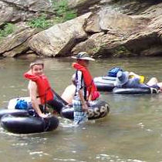
Troop 214 Parent News | Opening: Goats
August 2011 | Game: Eagles
http://www.bsatroop214.us | Service: Raiders
Harold Hodnett Scoutmaster

Key Events This Month | Key Events Next Month
August 12-14 - Canoeing/Tubing Campout | Sept. 9-11 - Offshore Fishing Campout

August 21 - Court of Honor

Dates to Remember
August 1 - Troop Mtg 7 pm
August 4 - Roundtable
August 8 - PLC 6:30 pm; Troop Mtg 7 pm; Troop Committee
August 11 - OA Meeting
August 12-14 - Canoeing/Tubing campout
August 15 - Troop Mtg 7 pm; Boards of Review
August 22 - Troop Mtg 7 pm; Court of Honor
August 25 - School begins for WCPSS traditional calendar students
August 29 - Troop Mtg 7 pm

News and Details About Upcoming Events
Canoeing/Tubing Campout – The Troop is planning a canoeing/tubing campout for the weekend of August 12-14. The Troop has secured a hike-in group campsite, and the committee is now considering several outfitters and float plans that will take us along the south fork of the scenic New River between Jefferson and the Virginia border. It looks like we will be navigating 10-13 miles of the river, which is shallow flatwater through that part of North Carolina. We will also be offering instruction leading to the canoeing merit badge for those interested. The cost should be $50 or less. Those with a fishing license can also bring along their rod and reel and maybe get in a little fishing Saturday evening and/or Sunday morning. A relatively inexpensive fun weekend is anticipated for all.
Sign-up sheets are now posted in the Scout hut for this event. If you would like more information about this campout, or would like to help plan or chaperone, please contact Troy Sturdivant on the planning committee, or adult advisor Mr. Sam Fouse at sfouse@nc.rr.com.
Court of Honor – A Court of Honor will be held on Monday, August 22, in the Benson Memorial UMC sanctuary. This will be in lieu of the regular Monday night troop meeting on this date. Advancement awards and merit badges earned at summer camp will be presented, so Scouts and families should plan to attend!
Popcorn Sales – Troop 214's only annual fundraising activity is our participation in the council popcorn sale. Selling these quality popcorn products puts money in your Scout's account that can be used to pay for campouts, Summer Camp, and other Troop activities. Ms. Shirley Olson, Troop 214 Popcorn Kernel, will be providing information about the sale at the August 22 Court of Honor,
Upcoming OA Events – The next Order of the Arrow chapter meeting will be August 11th in the Youth Center at Benson Memorial. We will have pizza at 6:30 pm with the meeting to begin at 7. It is very important for all active OA members to attend this meeting as there will be a lot for us to discuss. The main focus of the meeting will be Fall Fellowship in September, along with pending chapter and lodge elections. We will also begin planning for the Winter Banquet. If your Scout has questions about OA activities, he should contact Troop 214 OA representative Matthew Fiely at matthewfiely@gmail.com. Scouts who are interested in applying for awards to be given at Winter Banquet should also see Matthew.
Upcoming Campouts – An offshore fishing campout is scheduled for the weekend of September 9-11. Details on this trip will be forthcoming at upcoming meetings. A sailing campout is also tentatively planned for the weekend of October 7-9; confirmation and specific plans for that event will be announced soon.
Website Updates – Announcement from the "Better Late Than Never" department: pictures from the February USS Yorktown campout can now be viewed on the Troop 214 website at http://www.bsatroop214.us/images/galleries/Yorktown_Feb2011/index.htm
Thanks to Mr. Mike Jones for providing the pictures, and to Mr. Stuart Thomas for overseeing maintenance of the Troop web site.

Recent Highlights
Troop 214 @ Camp Daniel Boone – Troop 214 Scouts and adult leaders had a great time during their week at Camp Daniel Boone near Canton NC on July 10-16. The facilities were good. The food wasn't bad. The scenery was great. The staff were attentive and patient. The high adventure programs were a blend of challenge and fun. The weather was nearly perfect, and it was a welcome respite to have cool nights for comfortable sleep in tents. But maybe the best thing about summer camp was the overall experience of Boy Scouts doing productive and educational outdoor activities, and creating positive memories that will last each of them a lifetime.
The planned programs kept everyone pretty busy, but there was also ample downtime for Scouts to laugh and tell stories around the campfire, play cards and other games in the campsite, cool their feet in cold stream waters, and of course hang out at the snack bar and trading post a lot.
This year the Troop 214 scouts showed a lot of maturity, discipline, and Scout spirit. The first-year Scouts all did well on their first long-term camping experience. The slightly older Scouts all did a great job sticking to their individual activity schedules and earning their merit badges. The oldest Scouts demonstrated their manliness by not only participating in high adventure programs, but also (for several of them) feeling oddly obligated to sustain a number of minor injuries along the way (heh).
A Scout is Helpful, and the Troop demonstrated this by performing a volunteer service project for the camp, digging out large rocks and mud along a berm next to a camp building. A Scout is Kind: we bought about 70 ice cream sandwiches and brought them on ice to share with a troop from Texas in their campsite.
A Scout is Brave...and Physically Strong: we fielded the smallest (in physical stature) Tug-of-War team ever for a mid-week competition, and those guys put their heart and soul into it against much bigger opponents.
And a T-214 team competed in and won the Haggis Toss (it wasn't real Haggis pudding).
Josh Jones did an excellent job filling in as Troop SPL for the week. His leadership along with a combined troop effort earned Troop 214 the Daniel Boone Long Rifle award, which is that camp's version of Honor Troop. Many thanks to Mr. David Burdett who served as Scoutmaster for the week, to Mr. Joe Fiely, who did all the heavy lifting in organizing the troop's summer camp trip, and especially to all the adults who gave up their vacation time to attend camp with the Scouts and ensure a successful week.

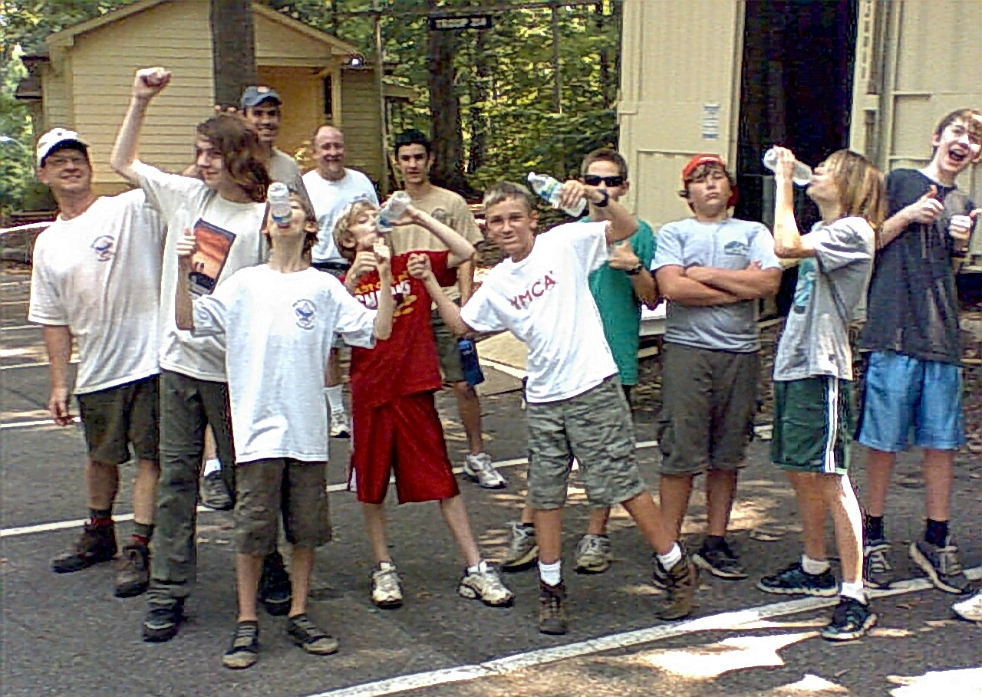
Troop Service Project – On Saturday July 30 several Troop 214 Scouts and leaders answered the call from our charter organization since 1966, Benson Memorial UMC. The church has plans to soon begin an expansion of the Fellowship Hall space and facilities. A larger industrial sized kitchen, showers, and new restrooms and classrooms will be added. Before construction can begin however, most of the furnishings had to be either placed in a temporary storage container, or moved elsewhere on campus. Fifteen scouts and four adult leaders braved the heat and humidity and help move furniture and boxed items into storage. The picture above shows the Scouts and adults celebrating the successful completion of the project.
Several supervising members of the congregation commented on how helpful the Scouts were. In fact, because we had so many volunteers, the work day concluded a bit earlier than planned. Thank you to all the participating scouts and leaders Mr. Harold Hodnett, Mr. Alan Proffitt, Mr. David Burdett, and Mr. Mike Jones from the staff and congregation of BMUMC!
Quote of the Month
" Heat, ma'am! it was so dreadful here, that I found there was nothing left for it but to take off my flesh and sit in my bones." -- Sydney Smith
Joke of the Month
Summer vacation was over and Johnny returned back to school. Only two days later his teacher phoned his mother to tell her that he was misbehaving.
"Wait a minute," she said. "I had Johnny with me for three months and I never called you once when he misbehaved!" (Source: www.broadcaster.org.uk)
Thanks to Scoutmaster Mr. Harold Hodnett, adult leaders Mr. Mike Jones, Mr. David Burdett, Mr. Stuart Thomas, Ms. Shirley Olsen, Mr. Sam Fouse, Mr. John Willis, and Troop 214 OA Representative Matthew Fiely for contributing to this month’s newsletter,

