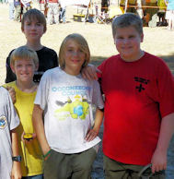
Troop 214 Parent News | April 2012
http://www.bsatroop214.us | Harold Hodnett Scoutmaster
Key Events This Month | Key Events NEXT Month
April 13-15 District Camporee | May 11-14^{3h} Virginia Creeper Campout
April 28th Stream Cleanup | May 18-19th Spring OA Inductions

Dates to Remember

April 2-5th -WCPS Spring Break
April 5th- Roundtable 7 PM
April 9th- Troop Committee, Troop Meeting
AND Troop Elections 7 PM
April 12th OA Meeting
April 13-15th District Camporee
April 16th- Troop Meeting, Troop Elections
7 PM
April 20-21st OA Conclave
April 23rd Troop Meeting 7 pm
April 29th Court of Honor ???
April 30th Troop Meeting 7 PM

A Message from Scoutmaster Harold Hodnett
Welcome! We have many new Scouts and families to welcome into Troop 214. I am honored that you and your young men have been entrusted with us. We will do our best to help them develop and learn their Scouting skills that will benefit them for a lifetime (many of your sons will hopefully attain the rank of Eagle Scout). However, we do need a little help from you, as well. We realize that not everyone is cut out to camp and teach camping skills, but many of you possess skills that are extremely useful. That is the reason that we ask parents to register with BSA so they can not only camp and share in the fun, but so they are authorized to share their knowledge. Contact me to see how you can get involved!
District Camporee: Troop 214 will be participating in the District Camporee on April 13-15th at Falls Lake. This will be a fun event with a lot of different activities happening on Saturday (Troop 214 will be hosting an Orienteering competition). One of the highlights of the event will be the Order of the Arrow (OA) tap out ceremony for recently selected OA members at the evening campfire ceremony. It will be a “low dough” yet very fun campout. We will leave after dinner on Friday and return before lunch on Sunday.
Those of you who have signed up are registered to go. Anyone who didn’t sign up (or is unsure if they are signed up) should contact Mr. Hodnett either in person or via e-mail at: hhodnett@hotmail.com
ASM / Adult Leader Meeting: Due to the WCPSS Spring Break and the Easter holiday, the Adult Leader meeting normally held on the first Sunday of the month will be held on Sunday, April 15th at 7pm in the Scout Hut. All current leaders and prospective leaders are invited to attend. We strive to hold the meeting to about one hour.

News and Details About Upcoming Events

Order of the Arrow

OA representative Matthew Kuwalik reminds us that Neuse River cleanup is slated for this coming Saturday, April 7th and be sure to attend and help out.

Additionally, the next Order of the Arrow meeting will be April 12th at its regularly scheduled time.

Last and certainly not least, for those Scouts who were on the OA ballot, it is very important to them plan to attend the District Camporee April 13-15th for Tap Out!

April District Camporee
Troop 214 will be participating in the District Camporee April 13-15th. This event will be held at B.W. Wells (Falls Lake). Think of it as a mini, mini Jamboree! There will be a lot of activities to participate in. It will be a low effort, inexpensive weekend ($12 event fee, includes a Patch + grub, and a few bucks for gas). This will be an excellent first campout for all new Scouts, as well as fun for experienced Scouts. T-shirts will be available for pre-order as well. More details to come.

Cycling Merit Badge – Spring (and its pollen) have sprung and the Cycling merit badge activities are upon us, according to MB counselor David Burdett.

This year, we are making our 50-mile ride as part of the Virginia Creeper Trail Cycling Campout, May 11-13, 2012. This is about a month earlier than last year’s 50, so note the earlier ride schedule below. I look forward to advising the effort again, and hope other adults and scouts are willing to assist.
For those who remember the last trip to the Creeper, the ride is magnificent, if a bit technical, and demanding! The trail is open, in spite of the loss of a 600-foot trestle due to a tornado last year. The local municipalities razed the remaining structure, and merely paved a connection in the footings of the trestle. Expect a nice climb at each end!
Scouts interested in earning the coveted and Eagle-required Cycling badge will be required, as always, to participate in the training rides leading up to the 50-miler. I will need a blue card, signed by the SM, prior to the first ride. Scouts earning the badge will also assist in trip planning and provide classes during the meeting prior to the trip. To improve flexibility and ease of participation, the City of Raleigh has kindly finished the connector trail from Crabtree Valley Mall to the I-440 trail overpass. We now can travel the greenbelt from Raleigh road all the way to Cary. We will also visit our favorite, the Tobacco Trail, for a ride. We are certainly blessed to have so many safe trail assets at our disposal.
Please note the Training ride schedule. Unless noted, all rides are on Sunday afternoon:

Apr 1 1 PM TBD by Scouts - 15 miles
Apr 15 2 PM Crabtree Valley Trail to Raleigh Road - 15 miles
Apr 22 1 PM Make-up on Crabtree Valley Trail (as needed)
Apr 29 1 PM American Tobacco Trail (Apex) - 25 miles (required)
May 5 1 PM Pullen Park-Cary-Pullen Park - 30 miles (required)
May 12 9 AM White Top-Abingdon-Damascus - 50 miles
Mr. Burdett will remind everyone again next month of the schedule.

Scout Sunday for Troop 214, Pack 214 and the Girl Scouts at Benson Memorial will be Sunday, May 6th. Stay tuned for more exciting news.

Merit Badge Institute:

Troop 214's own Merit Badge Institute is up and running!

Twenty-three scouts have signed up for 9 merit badges including 4 Eagle Required badges! Scouts have been given their prerequisites and are busily working on them in preparation. There still room for a few more scouts. Contact Jay Sprankle, jay_sprankle@yahoo.com.

T-214 Scouts in the Community/News:
Scout Duncan M. had his best Scout Spirit on display this past Sunday (and for a while to come) where he raised close to $700 for cancer research through the St. Baldrick’s Foundation
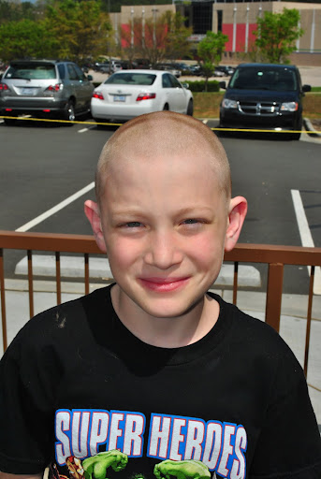
In addition to his fundraising, Duncan also donated his golden locks to help those less fortunate battling the effects of cancer.

Way to go, Duncan!

Recent Meetings and Updates:

Caving!!!,
Twenty-one T214 members (16 scouts + 5 adults) traveled to Grandfather Campground in Boone on Fri Mar 9, under clear and starry, but cold and windy skies! Several of our newest scouts in the Fire Griffins patrol joined us. We quickly established a base camp across three tent sites close to the comfort station, and settled in under a nearly full moon. After an early rise, breakfast, and clean-up, we drove from Boone to Elizabethton, TN to meet up with our guides, Lucas and Seth, from our caving outfitter, REA. After donning our helmets and gloves, we entered Worley's for our safety lecture and instructions. Our path through the cave was a "Figure 9," and we spelunked for 2.5 hours. Scouts and leaders employed individual efforts and teamwork in bouldering, scrambling up steep inclines, and negotiating tight squeezes. Our guides allowed time for some Geology Merit Badge instruction on cave formations and cave flora and fauna, as well as some "playtime" on the sliding slopes. There were several other groups also exploring Worley's Cave that day, and on our way out we crossed paths with T325 from Hayes Barton Baptist in Raleigh. After wading an ankle to knee-deep stream for about 300 yards, we eventually emerged from the cave muddy, wet, and squinty-eyed, but satisfied with our successful expedition!
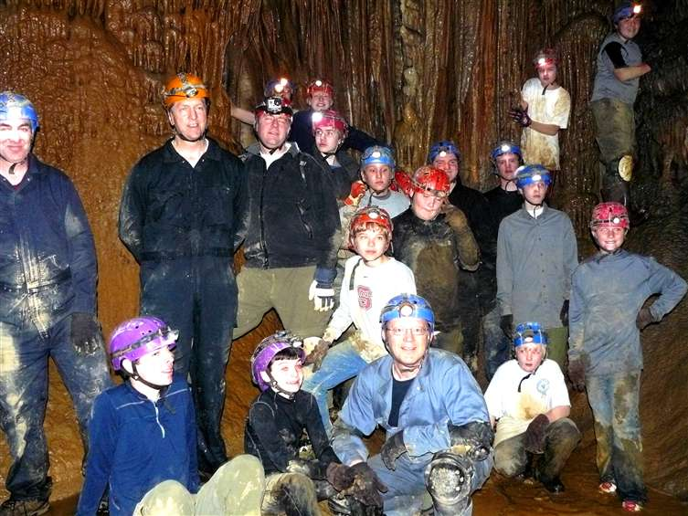The Fairy Ballroom, Hobbit's Hallway, Giant's Causeway, and Thin Floor room were particularly impressive (photos coming soon to the T214 website). Following a change of clothes, REA hosted us for a quick picnic lunch, and then we drove back to Boone. After a hearty campsite dinner, we gathered around a campfire to tell ghost stories and tall tales. Sunday morning after breakfast, we broke camp, held a clean-sweep, conducted our Scout's Own Service c/o of Alex Casey our Chaplain's Aide, and drove to REA headquarters. There, we split into two groups. Younger scouts working on the Geo MB received a rock and mineral lesson and a bag of gemstones (temperatures were too cold for gem mining via the water troughs). Older scouts, who had gem mined previously, went to a nearby restaurant for a hearty hot breakfast. Everyone had an opportunity to gift shop at REA before we left. On our drive home, we stopped for the buffet at Golden Corral. Ten scouts are currently finishing up the Geo MB. "Thank you" to our SPL Sean Colby, our ASPL Andy Jones, our adult leaders, and to all those scouts who helped clean the vehicles and put away the troop gear. Caving 2014 anyone?!

Recent Outings Photos updated on Troop website:
The Washington DC, Aviation, and Caving campout photo galleries have been added to the troop website (http://www.bsatroop214.us/pictures.htm)

Thanks to Mr. (Mike) Jones, Mr. Burdett, and Mr. Setzer (and myself) for providing those many great pics. Please include a note about those in the next newsletter.

Quote of the Month
Conscience is what makes a boy tell his mother before his sister does.

Evan Esar (1899 - 1995)

Joke of the Month
Confucius say:
Man with one watch always know what time it is - Man with two watches never sure.'
Thanks to Scoutmaster Mr. Harold Hodnett, adult leaders Mr. David Burdett, Mr. Mike Jones and Mr. Stuart Thomas, OA Troop 214 Rep Matthew Kuwalik for contributing to this month’s newsletter.

