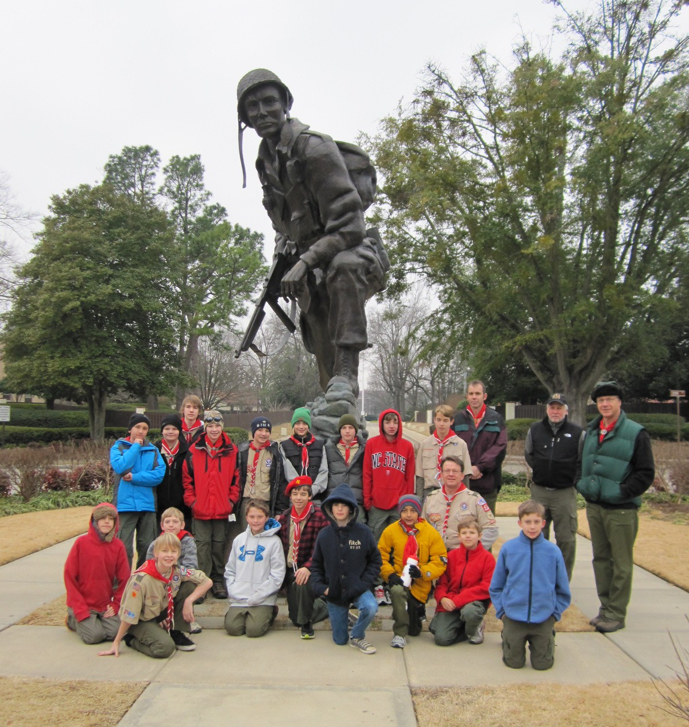
Troop 214 Parent News | March 2012
http://www.bsatroop214.us | Harold Hodnett Scoutmaster
Key Events This Month | Key Events Next Month
March 9-11 Caving Campout | April 13-15 District Camporee
March 16-18 - OA Pow-wow | April OA Conclave, Troop Leader Training

Dates to Remember

8March 1st- Roundtable 7 PM
March 3rd –Council Banquet
March 4th- ASM Meeting
March 5th. PLC 6:30 pm; Troop Mtg 7 pm; Troop Committee
March 8th OA Meeting
March 9-11 Caving Campout
March 12th- Troop Meeting 7 PM
March 16-18th OA Pow Wow
March 17th Merit Badge College
March 19th Troop Meeting
March 26th Troop Meeting

Special Message from Scoutmaster Harold Hodnett

Welcome new Scouts and Parents! I’d like
take this opportunity to welcome all Scouts and Parents to Troop 214!

As of the end of February, we have had Scouts join from 3 different Packs as well as several youth new to Scouting. I’d like to thank all of our existing parent volunteers who help us to deliver one of the best Scouting programs in the area. Without your help in support, it could not be done.

News and Details About Upcoming Events

Calendar Notes – The next Adult Leaders meeting will be Sunday, March 4th at 7 PM at the Scout Hut. This meeting is open to all existing leaders, as well as all new parents who are interested in getting involved with the Troop. Scoutmaster Hodnett will aim to keep the meeting to 1 hour.

Scout Sunday for Troop 214, Pack 214 and the Girl Scouts at Benson Memorial will be Sunday, May 6th.. Stay tuned for more exciting news.
Caving Camp Out and Geology Merit Badge
- Geology Merit Badge sessions: Feb 13, Feb 27, & Mar 5, during troop program (8-8:20pm)
- Caving & Gem Mining Camp Out sign-up deadline Mar 5, (8:30pm)
- Caving & Gem Mining Camp Out Mar 9-11
- Caving & Gem Mining trip committee Contact is ASM Mike Jones (houseofjones@earthlink.net)
and Scout Jonathan Weaver.

Recent and Upcoming OA Events –
The next OA meeting will be March 8th. With the theme for Pow-wow being Lumberjack, pancakes will be served at 6:30 with the meeting starting at 7:00.

Order of the Arrow Pow-Wow:
OA Spring Pow-wow is March 16-18 at Camp Durant. Pow-wow is a fun, competition-filled weekend for all the chapters in Lodge 104. The cost is $20 for the weekend. Only existing OA members are eligible to attend this campout/event.
OA members who went through their Induction in Spring 2011 or earlier are eligible to go on the Brotherhood Trail. There is no extra fee for this activity, but you must inform the registrar at check-in that you want to do the Brotherhood Trail.
If you have questions about Pow-wow please see T-214 OA Rep Matthew Kuwalik or any other T-214 OA member.
NOTE: Pow-wow is also the final weekend to register for the OA Conclave coming in April.

Cycling Merit Badge – Winter-schminter…
Cycling MB Coming up, sooner than you think!

This year, we are making our 50-mile ride as part of the Virginia Creeper Trail Cycling Campout, May 11-13, 2012. This is about a month earlier than last year’s 50, so not the earlier ride schedule below. I look forward to advising the effort again, and hope other adults and scouts are willing to assist.
For those who remember the last trip to the Creeper, the ride is magnificent, if a bit technical, and demanding! The trail is open, in spite of the loss of a 600-foot trestle due to a tornado last year. The local municipalities razed the remaining structure, and merely paved a connection in the footings of the trestle. Expect a nice climb at each end!
Scouts interested in earning the coveted and Eagle-required Cycling badge will be required, as always, to participate in the training rides leading up to the 50-miler. I will need a signed blue card prior to the first ride. Scouts earning the badge will also assist in trip planning and provide classes during the meeting prior to the trip. To improve flexibility and ease of participation, the City of Raleigh has kindly finished the connector trail from Crabtree Valley Mall to the I-440 trail overpass. We now can travel the greenbelt from Raleigh road all the way to Cary. We will also visit our favorite, the Tobacco Trail, for a ride. We are certainly blessed to have so many safe trail assets at our disposal.
Please note the Training ride schedule. Unless noted, all rides are on Sunday afternoon:
Mar 3 (Sat) 1 PM Safety and Maintenance Class
Mar 18 1 PM Crabtree Valley Trail - 10 miles
Mar 25 1 PM Umstead (Heartbreak Hill) - 10 miles
Apr 1 1 PM TBD by Scouts - 15 miles
Apr 15 2 PM Crabtree Valley Trail to Raleigh Road - 15 miles
Apr 22 1 PM Make-up on Crabtree Valley Trail (as needed)
Apr 29 1 PM American Tobacco Trail (Apex) - 25 miles (required)
May 5 1 PM Pullen Park-Cary-Pullen Park - 30 miles (required)
May 12 9 AM White Top-Abingdon-Damascus - 50 miles
Mr. Burdett will remind everyone again next month of the schedule.

Caving Trip - Troop 214 will take what has become its biannual Caving Campout on March 9-11. We will meet at the Scout Hut on Fri Mar 9, at 5 pm, and depart no later than 6 pm, to arrive at Grandfather Campground in Boone by 10 pm (www.grandfatherrv.com). Attendees should eat dinner before leaving or bring a bagged dinner, as the only stops will be short rest stops. The Troop will be tent camping in a group site, which historically has been a windy, north-facing, treeless slope. Small, ground-hugging tents and winter sleeping bags are encouraged, while oversized tents and hammocks are discouraged, due to occasional high winds and unpredictable precipitation including snow and icing.
Participants should wear warm winter clothing for camping including long pants, coats, hats, gloves, footwear, and rain gear are required, as hypothermia is a real risk in the mountains in winter. Old clothing for caving that can get very wet and muddy is also required, including long pants, long sleeves, old hiking or rubber boots, or old athletic shoes, old work gloves, and elbow/knee pads if available. A one-piece, zippered, non-disposable handyman work suit as used for “dirty jobs” is also ideal for caving. A small day-pack is recommended for carrying a water bottle, camera, extra flashlight, batteries, etc... A large garbage bag for bundling muddy apparel afterwards is also recommended. Helmets, headlamps, and a safety lecture will be provided on-site by our caving outfitter, River & Earth Adventures (www.raftcavehike.com ).
On Saturday we will revisit the 550 million year old limestone Worley’s Cave (aka Morril’s Cave) on private land in Elizabethton, TN (http://www.tn.gov/environment/na/natareas/morril/ ) Our trek will take us ~3 miles underground (1.5 miles each way) to visit such geologic features such as the Hobbit's Hallway, the Fairy's Ballroom, Tombstone, Giant's Causeway, Thin Floor Room, the Hall of Masks, Base Camp, and the Bermuda Triangle. Much of the tour will be walking upright, but occasionally crawling and bouldering are required, with optional “tight squeezes” for those interested in a challenge. Saturday night we may have a campfire program opportunity, for those in need of MC or Flag Retirement Ceremony requirements.
On Sunday morning we will revisit the REA gem mining facility in Boone to pan for semiprecious gemstones and minerals. Interested scouts will be able to complete most of the Geology Merit Badge requirements during the Feb 13, Feb 27, and Mar 5, Troop Meeting “Program” segments, as well as during the camp out gem mining activity. One of the final requirements, assembling a gem/mineral collection, will need to be completed after the campout.

April District Camporee
Troop 214 will be participating in the District Camporee April 13-15th. This event will be held at B.W. Wells (Falls Lake). Think of it as a mini, mini Jamboree! There will be a lot of activities to participate in. It will be a low effort, inexpensive weekend ($12 event fee, includes a Patch + grub, and a few bucks for gas). This will be an excellent first campout for all new Scouts, as well as fun for experienced Scouts. T-shirts will be available for pre-order as well. More details to come.

Recent Meetings and Updates:

Merit Badge University reports solid success for Troop 214 Scouts
Merit Badge University, on Feb 25, was a huge success for Troop 214. Eleven scouts attended, earning thirteen merit badges, four of which were Eagle Required. Many thanks to Craig Setzer for checking in and monitoring our scouts, and for collecting the blue cards. Scouts will receive their merit badge at an upcoming troop meeting or Court of Honor.

February Fort Bragg Recap Aviation Campout from ASM David Burdett
Our February Trip was to FT Bragg to see how aviation is used in the military. 26 members of the troop visited the base from 10-12 February. While there we Visited several memorials, including the Army version of Iron Mike, and a memorial to fallen soldiers of the 3rd Special Forces Group, which was built as an Eagle Project. We also visited the 82nd Airborne Museum, and the Airborne and Special Operations Museums, which have excellent galleries and static aircraft displays. Scouts got to meet soldiers on base, and also visit areas where they work, including the 82nd Airborne Division area, and Green Ramp, where paratrooper depart on missions. Many of the soldiers were on their way overseas, or just returning. Facilities were excellent, including the dining facility at Pope Army Airfield. Souvenirs were provided by Old Sarge’s Surplus Store, as a few of the parents discovered. A lot of the boys brought home a variety authentic military apparel for their own use. Our Thanks to SGM (Ret.) William Briggs, who is a Scouter, who was our guide for the weekend.

Quote of the Month

Conscience is what makes a boy tell his mother before his sister does.

Evan Esar (1899 - 1995)

Joke of the Month

Confucius Say:

Confucius he say: Man with one watch always know what time it is - Man with two watches never sure.'

Thanks to Scoutmaster Mr. Harold Hodnett, adult leaders Mr. David Burdett, Mr. Mike Jones and Mr. Stuart Thomas, OA Troop 214 Rep Matthew Kuwalik and last but certainly not least, Cathy Sprankle for contributing to this month’s newsletter.

