Parent News  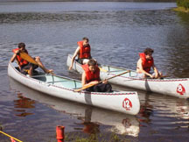 | Openings: New Patrol
Newsletter for the parents of Troop 214 | Games: Cobras
August 2007 | Service: Pack-Men  Theme: Canoeing & Kayaking
http://www.bsatroop214.us | Harold Hodnett Scoutmaster

Key Events This Month | Key Events Next Month
August 10-12 Canoe Kayak Trip | September 14-16 OA Fall Fellowship
August 19 Court of Honor | September 21-23 Deep Sea Fishing
 | September 29 Popcorn Sales Begin!

Dates to Remember
August 5 – ASM Mtg at Scout Hut 7pm
August 6 - PLC meeting 6pm
August 6 - Troop & Committee Mtg 7pm
August 11-12 – Canoe/Kayak trip
August 13 - Troop Mtg 7pm
August 19 – Court of Honor
August 20 – Troop Mtg 7pm

Summer Camp – Once again your Troop sent a large contingent to Summer Camp (38 Scouts and 8 adults). This year’s destination: Camp Raven Knob, outside of Mount Airy. Thanks to Mr. Dvorak’s hard work, our Sunday check in was a breeze and we sailed though the process, including medical checks and swim tests. We had two campsites, almost a mile from the dining hall, so we worked hard for every meal! Monday started off with a “bang” in the form of a lightning strike at camp and one of our own Scouts took a jolt from a discharge across camp as well. (Who could imagine summer camp without at least one trip to the hospital?). Fortunately, our Scout was not seriously injured and returned to camp to continue his advancement. Advancement was achieved in a big way, with several boys completing their Scoutmaster conferences and Boards of Review for rank, not to mention the hoards of Merit Badges earned. One of the highlights of the week was the Wednesday night Order of the Arrow Tap Out ceremony. Two of our own were tapped out at this extremely impressive event! Saturday came quickly and we were back in Raleigh after lunchtime, to end a busy week. Thanks to all of the adults for their help and support on the trip!
Thanks to everyone who made summer camp possible this year. When you see Mr. Hodnett, Mr. Liberty, Mr. Thomas, Mr. Grace, Mr. Wever, Mr. McInnes, Mr. Frein, and Mr. Gale take a moment to thank them for taking a week of their vacation to spend at camp with our scouts. Also, thanks go to all the parents who drove to or from camp, and of course, Mr. Dvorak who handled all the paperwork, medical forms, fee collection, and all other details that have to be taken care of before we can go to camp!
Canoe/Kayak Trip – This trip should be a fun one.

Court of Honor - It’s almost that time again. With summer camp just over, there are sure to be lots of awards, so be sure and put this on your calendar.
Quote of the Month - "You can't fix every problem, but what you can fix, you must." - Bono

Joke of the Month - One Upmanship

A guy driving a Yugo pulled up to a stoplight next to a Rolls-Royce. He rolled down his window and shouted to the driver of the Rolls.

"Hey, buddy, that's a nice car. You got a phone in your Rolls? I've got a phone in my Yugo!"

The driver of the Rolls looked over and said snobbishly, "Yes, I have a phone."

The driver of the Yugo said, "Cool! Hey, you also got a fridge in there, too? I've got one in the back seat of my Yugo!"

The driver of the Rolls, much annoyed, says, "Yes, I have a refrigerator."

The driver of the Yugo said, "That's great, man! Hey, you got a TV in there? You know, I got a TV in the back seat of my Yugo!"

The driver of the Rolls, quite irritated by now, replied, "Of course, I have a television. A Rolls-Royce is the finest luxury car in the world!"

The driver of the Yugo said, "Yes, a very cool car! Hey, you got a bed in there? I got a bed in the back of my Yugo!"

The driver of the Rolls, upset that he did not have a bed, sped away and went straight to the dealer, where he promptly ordered a bed to be installed in the back of his Rolls-Royce.

The next morning, he returned to pick up his car, and the bed looked superb It came complete with silk sheets and a brass-trimmed headboard. It was clearly a bed fit for a Rolls-Royce. So the driver of the Rolls began searching for the Yugo. He drove around all day and finally found the Yugo late that night. It was parked, with all the windows fogged up from the inside.

He got out and knocked on the window of the Yugo. When there wasn't any answer, he continued knocking and knocking until finally, the owner of the Yugo lowered the window, and stuck his soaking wet head out.
"I now have a bed in the back of my Rolls-Royce," the driver of the Rolls stated arrogantly.
The driver of the Yugo looked at him narrowly and said, "You got me out of the shower to tell me THIS ?!?!"

'

Pictures from the the Rocketry Trip & Summer Camp

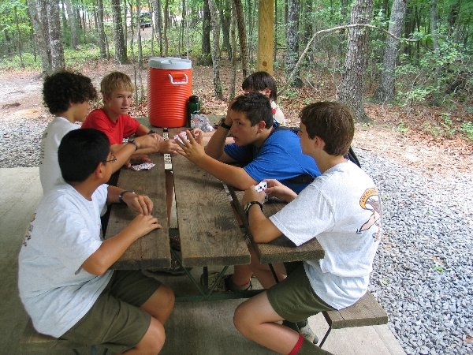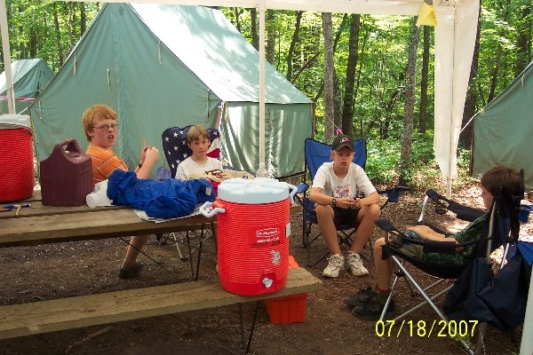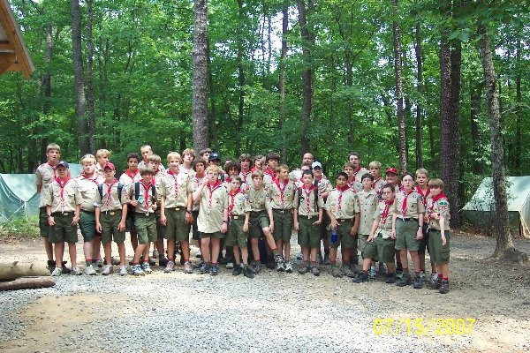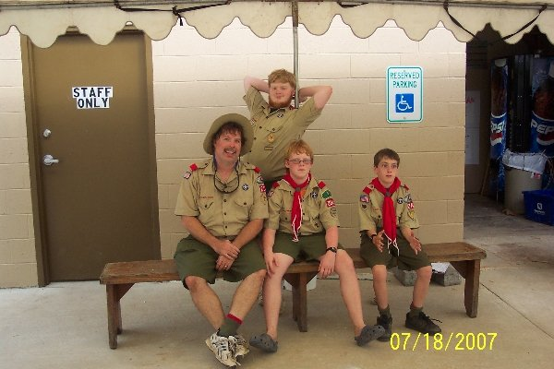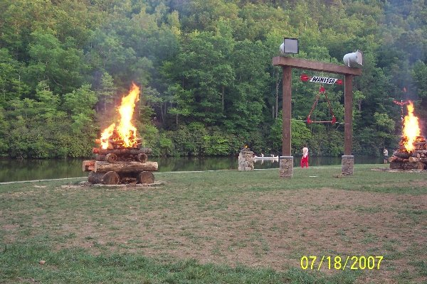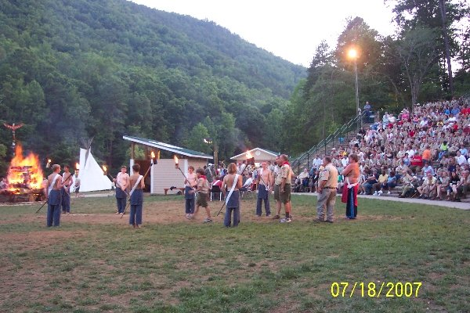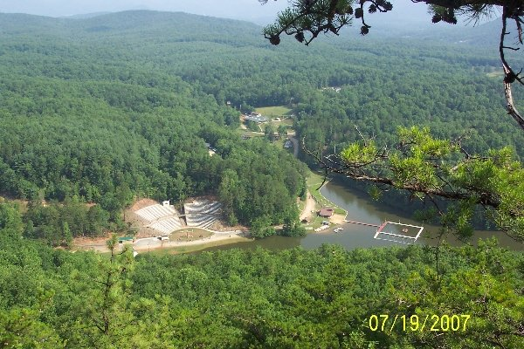

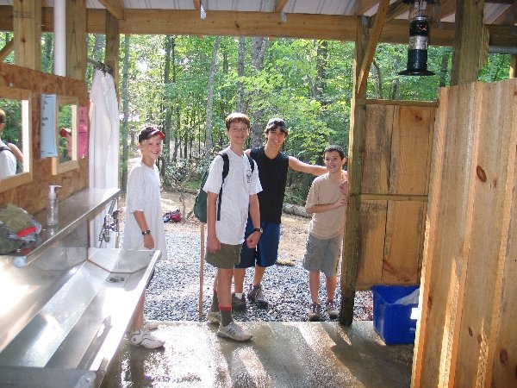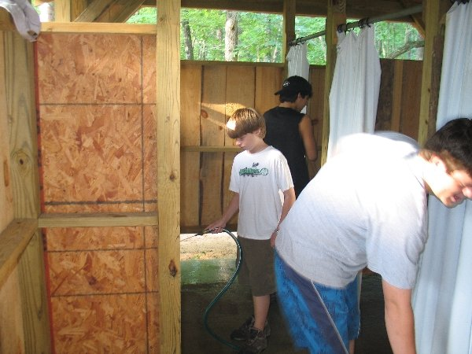

The Lightning Strike!
