Parent News  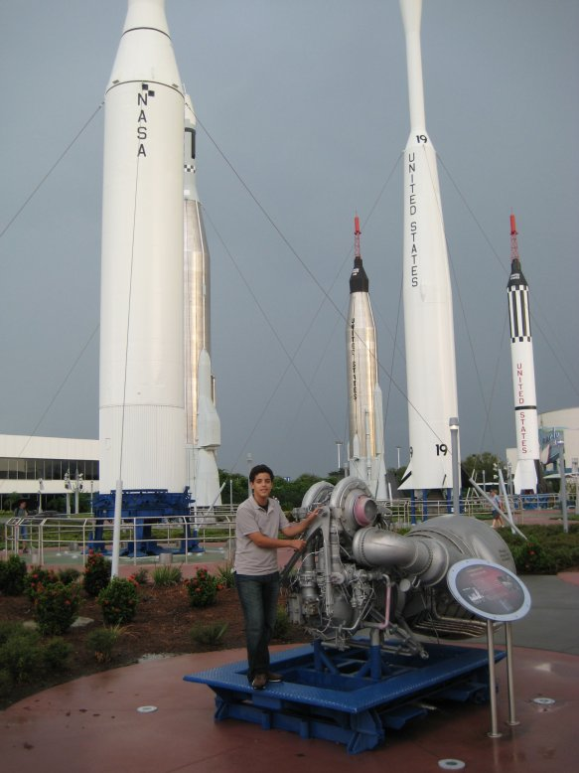 | Openings: Moose
Newsletter for the parents of Troop 214 | Games: Piranhas
November 2007 | Service: Old Goats  Theme:Rocketry and Scout Skills
http://www.bsatroop214.us | Harold Hodnett Scoutmaster

Key Events This Month | Key Events Next Month
November 3 Popcorn Sales End | December 7-9 – Backpacking in Smoky Mts
November 9-11 Rocketry and Scout Skills Campout | December 14 – Popcorn money due
 | December 16 – Court of Honor

Dates to Remember
November 1 - Roundtable
November 3 - Popcorn Sales End
November 4 – ASM Mtg at Scout Hut 7pm
November 5 - PLC meeting 6pm
November 5- Trp & Committee Mtg 7pm
November 6 – Popcorn orders due
November 9-11 – Rocketry and Scout Skills Campout
November 12 – WCPSS off, No Mtg
November 15 – OA Mtg
November 17 – Merit Badge University
November 19 & 26 – Troop Mtg. 7pm

Council Camporee – The Council Camporee was held at Camp Reeves October 26-28. (The last time it was held there was 10 years ago!). This was an extraordinary event! In typical Troop 214 fashion, it rained on us when we drove in and set up camp. However, that didn’t dampen our spirits (except maybe Joseph Heil’s, since he nearly drowned getting across the hidden moat guarding our campsite). The rain on Friday night ushered in wonderful weather for the remainder of the weekend. Your Troop was extremely visible, as we did all of the flag ceremonies on Saturday and Sunday (in front of 1400+ people). Your Troop was also recognized during the awards ceremony for being one of 12 Troops (out of 88) participating in the orienteering course that actually completed it correctly. The Scouts participated in many activities including wilderness survival shelter building, axe throwing, using telescopes, knot tying, cooking demonstrations, and much more. It was a fun filled weekend and the Old Goats did all of the cooking! Thanks to Mr. Thomas for being our Grubmaster. Thanks also to the appointed trip SPL, Brandon Hodnett, who stepped up to the plate for the group.

Court of Honor – Our next Court of Honor is just around the corner in December. Encourage your scout to finish up that merit badge or rank so that he will be ready to receive the award at the December Court of Honor!

Qtrmaster Bldg Workday – We hope to have another workday planned very soon! Bring your gloves, hammers, saw, measuring tape, and any other tool that we might use to put the roof on the building!!

Rocketry and Scout Skills Trip - Who doesn’t like to shoot off rockets? This will be a fun campout with a lot of activities to participate in, highlighted by a cooking competition. (Yes, we will be bringing the Chuck Boxes for this event!). We will be at Camp Reeves and there will be advancement opportunities available besides cooking. We have invited the Webelos from Pack 214 to join us on this trip, so we need to make sure they have a good time so they’ll want to join the Troop!

Popcorn Sales – A big salute to Colonel Olsen for heading up the popcorn drive again this year. All orders and prize choices are due by Sunday, November 3rd! So, if you haven’t acted, do so, post haste!!
Yorktown Trip – The Yorktown trip planned for January has been moved to January 25th. Please note this on your calendars!
Quote of the Month - Be the change in the world you want to see – Ghandi

Joke of the Month - Timmy goes to see his teacher. Ms Smith and says, "We're moving to a new house tomorrow, and my mom needs me to take a day off of school to help her move some boxes and other heavy items.”
"We'll be having a big test tomorrow Timmy," the teacher says. "You can't take the day off."
"Thanks, Ms. Smith," says Timmy. "I knew I could count on you!"

Pictures from the Council Camporee below…

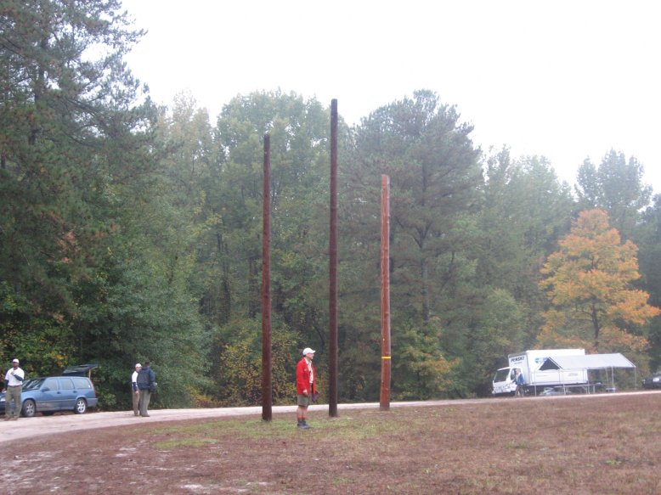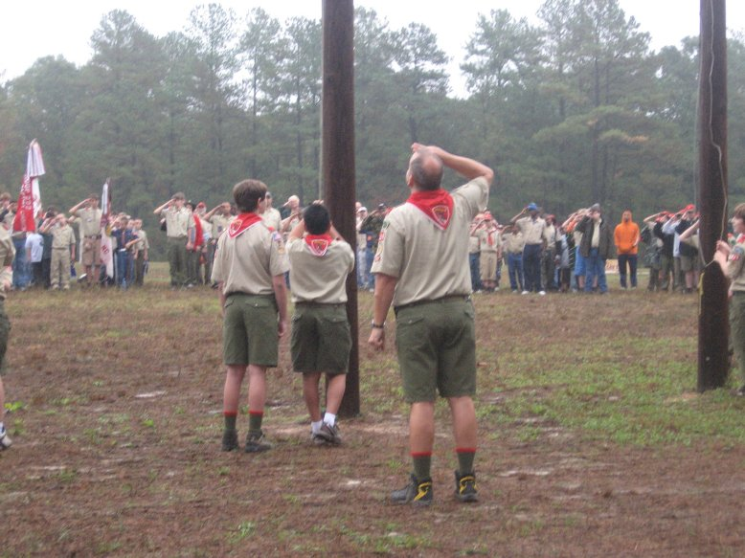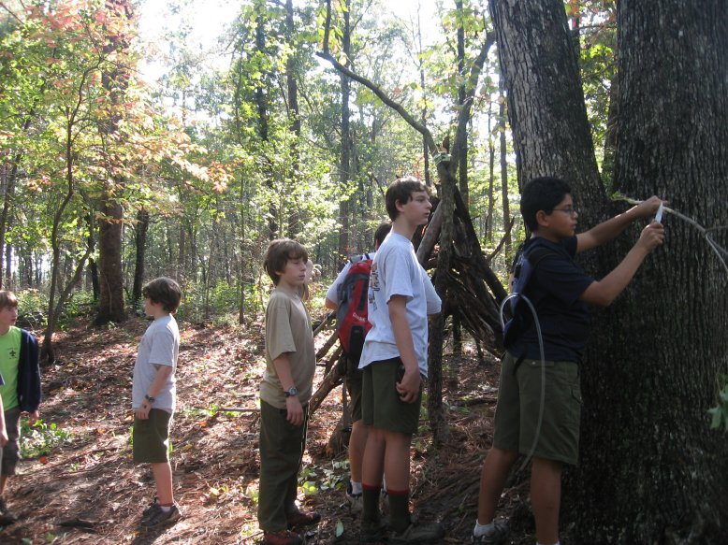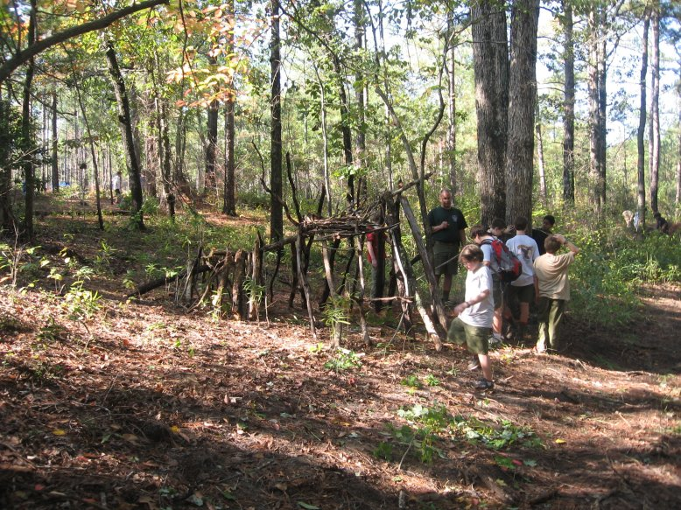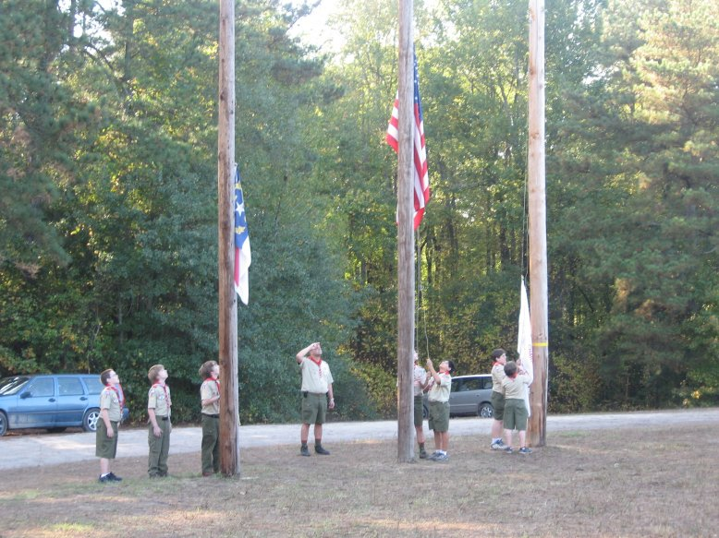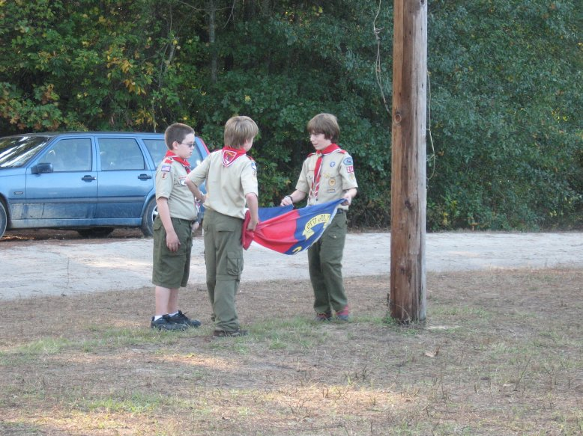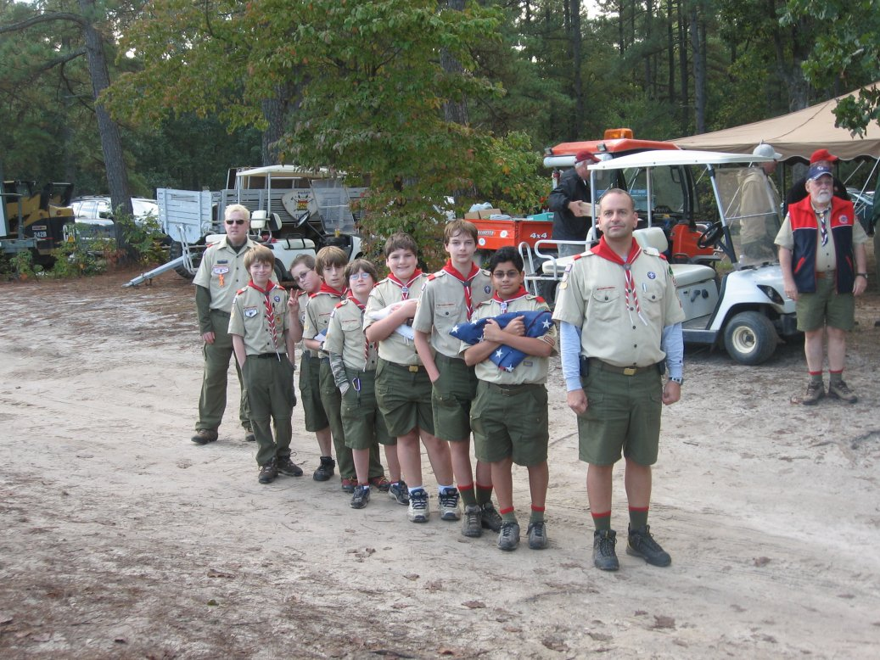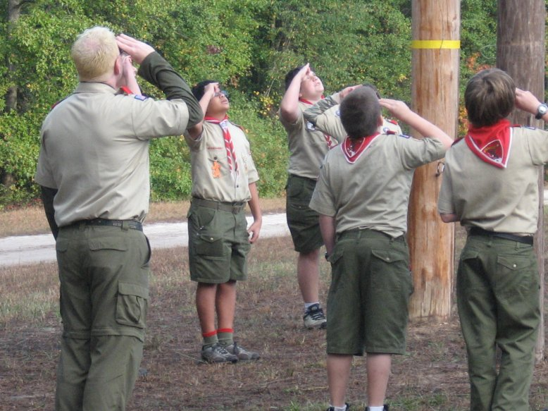
Our former scoutmaster, Mr. Roberts!

