Parent News  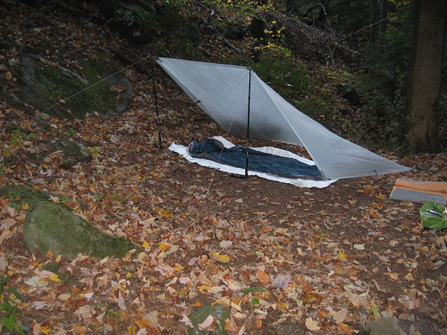 | Openings: Flaming Arrows
Newsletter for the parents of Troop 214 | Games: Old Goats
April 2008 | Service: Pacmen  Theme: Wilderness Survival
http://www.bsatroop214.us | Harold Hodnett Scoutmaster

Key Events This Month | Key Events Next Month
April 12 – Stream Cleanup | May 2-4 – Caving Trip
April 18-20 – Wilderness Survival | May 16-18 – OA Inductions

April 25-27 - TLT

April 28 – Court of Honor

Dates to Remember

April 3– Roundtable
April 10 – OA Mtg
April 12 – Stream Cleanup
April 14 – PLC 6 pm, Troop Mtg 7 pm,
April 14 – Com. Mtg, and Troop Elections
April 18-20 – Wilderness Survival, OA Conclave
April 21 – Troop Mtg 7 pm
April 25-27 – Eagle Summit, TLT
April 28 – Troop Mtg, Court of Honor 7pm

Stream Cleanup – There will be a stream cleanup this weekend running from 9am-11am at the culvert on Forum Drive just behind the theater. There might actually be some water in the stream this weekend!!

Wilderness Survival Campout – This trip got rained out last month, so it will be given another chance this month. The following description is a repeat of what we had here for this activity last month.
The Wilderness Survival training campout is basically a masters course is outdoor skills and being prepared. The Scouts will be learning basic survival skills (building shelters, making fire using various methods, purifying water using various methods, rescue signaling, wilderness navigation by day and night without a compass, first aid, etc.) in a controlled, safe setting. This training and skills practice reduces fear of the unknown, and gives the Scouts self-confidence to deal with survival situations in real life. They will learn by doing, with the bonus of earning the Wilderness Survival merit badge over the weekend. It will be a fun, memorable, and educational experience for Scouts and the attending adults alike!

Troop Leader Training – Once again, former scoutmaster John Roberts has made his beach house available to the troop for this most valuable training. This is a popular trip for obvious reasons. A limited number of scouts will be able to attend, so preference will go to those who are newly elected and need the training. If there is room for more scouts to go (because of room at the house and adult leadership) more will be allowed to participate.

OA Conclave – Conclave is a gathering of the 6 lodges in our section and is action packed and will also have some training opportunities. So its kind of like a Camporee but much bigger. Conclave will be April 18-20th at Camp Bowers, Cape Fear Scout reservation. The cost of Conclave is $27 which covers food, a goodie bag, and special Occoneechee Lodge Items. Our Lodge's theme is: "The 300".
Checks should be made payable to Occoneechee Lodge 104. To be a member of the Lodge's contingent you need to fill out the followign form :
http://www.lodge104.com/downloads/docs/Conclave_Files/2008_Conclave_Delegate_Registration.pdf
and return it to:
Keith Beigert.
Lodge 104 finance Adviser
Keith Biegert
102 Bristol Hill Ct.
Cary, NC 27513
Troop Elections – Troop elections are coming up this month. Boy Scouting is all about leadership, so talk to your scout about taking on a leadership role in the troop!

Busch Gardens Trip – I am so late with this newsletter that the first activity of the month has already taken place. Thanks a million to Mr. Thomas who headed up the trip, and even though he had as much fun as any kid there, sacrificed his weekend (and a significant chunk of change!) to spend with the troop. If your scout went on this trip, a hearty thank you to Mr. Thomas would be in order! He’s even already posted pictures out on the troop website at www.bsatroop214.us
Check’em out!

Court of Honor – The Court of Honor will be held on Monday night April 28th. The PLC will meet and decide on a theme next week, and more details will be forthcoming!

Quote of the Month - “People will accept your ideas much more readily if you tell them Benjamin Franklin said it first.” -- David H. Comins

Joke of the Month – The Lonely Frog - A lonely frog, desperate for any form of company telephoned the Psychic Hotline to find out what his future has in store.
His Personal Psychic Advisor advises him, "You are going to meet a beautiful young girl who will want to know everything about you."
The frog is thrilled and says, "This is great! Where will I meet her, at work, at a party?"
"No" says the psychic, "in a Biology class."

