Parent News  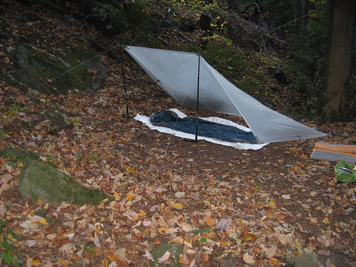 | Openings: Generic
Newsletter for the parents of Troop 214 | Games: Moose
March 2008 | Service: New Patrol  Theme: Wilderness Survival
http://www.bsatroop214.us | Harold Hodnett Scoutmaster

Key Events This Month | Key Events Next Month
March 7-9 – Wilderness Survival | April 3-7 Universal Trip
March 15 – Reptile Amphibian Day | April 25-27 – TLT
March 14-16 – OA Spring Pow Wow | April 27 – Court of Honor

Dates to Remember

March 1 – Trainer Dev. Course
March 3 – PLC 6 pm Troop Mtg 7 pm
March 6 – Roundtable
March 7-9 – Wilderness Survival
March 10 – Committee and Troop Mtg
March 13 – OA Mtg
March 14-16 – OA Spring Pow Wow
March 15 – Reptile/Amphibian Day @ Museum
March 17 – Troop Mtg
March 22 – Skeet Shooting Day Trip
March 24 – Troop Mtg

Wilderness Survival Campout – The Wilderness Survival training campout is basically a masters course is outdoor skills and being prepared. The Scouts will be learning basic survival skills (building shelters, making fire using various methods, purifying water using various methods, rescue signaling, wilderness navigation by day and night without a compass, first aid, etc.) in a controlled, safe setting. This training and skills practice reduces fear of the unknown, and gives the Scouts self-confidence to deal with survival situations in real life. They will learn by doing, with the bonus of earning the Wilderness Survival merit badge over the weekend. It will be a fun, memorable, and educational experience for Scouts and the attending adults alike!

Reptile Amphibian Day – This is a day made for young boys! Frogs and snakes and all kinds of other creepy crawly things at the Museum of Natural Science. Last year, they had a 16 foot Boa Constrictor stretched out on a table… correction, it was stretched out on two tables! There will be an opportunity to earn at least a partial merit badge as well. So, bring your scout out for a really fun day at the museum!

OA Spring Pow Wow – Pow Wow will be March 14-16 at Camp Durant and the cost will be $20. Our chapter's theme for the weekend is superheros so dress up or bring some super hero accessories. During PowWow you can also "get" your brotherhood. This costs an additional $15. Pow Wow is lots of fun so you are encouraged to come out!

Skeet Shooting Day Trip – More info on this at the next scout meeting

Universal Trip – This trip is just around the corner, and to date, we have only one brave soul who has volunteered to be the adult on the trip. We’ll need one more to make the trip happen. I went on the Disney trip two years ago, and had a blast, and it is really a good way to get to know some of the boys in the troop better, and you won’t have to sleep on the ground to do it!! There are a lot of fun rides at Universal. I hope that someone out there will volunteer to be the second adult on the trip. Actually, we need someone to be the first adult, because Mr. Thomas is pretty much just a big kid himself! The schedule will be the following: Leave on the night of April 3rd (Thurs) around 9:30pm, arrive on the 4th around 10:30am, spend Friday and Saturday night in a local hotel, depart Sunday evening (5pm), and return April 7th (Mon) around 9am - if the train is on schedule.

Troop Elections – Troop elections will be held next month. For those parents with scouts who have had no leadership experience, talk to your scout about considering a run for a position. The Scouting program is all about developing leadership skills, and in fact, is a requirement for advancement! Being a patrol leader (or any type of troop position) will certainly sharpen those skills! There are leadership positions other than just patrol leader, so have your scout to explore these possibilities.

Troop Leader Training – Following the troop elections, we’ll have Troop Leader training. This is an excellent workshop that will help give your scout the skills he needs to lead other scouts whether in a patrol, on a campout, or as a troop guide. This is a fun weekend that newly elected leaders are encouraged to attend to help them do the best job that they can in their new position.

Quote of the Month - “Rain and sun are to the flower as praise and encouragement are to the human spirit.”

Joke of the Month –

Jake: Why did the Boy Scout get so dizzy?
Blake: Why?
Jake: Too many Good Turns.

Pictures from the Ski Trip

