  Parent News | Openings: New Patrol
Newsletter for the parents of Troop 214 | Games: Generic
May 2008 | Service: Piranhas  Theme: Caving
http://www.bsatroop214.us | Harold Hodnett  Scoutmaster

Key Events This Month | Key Events Next Month
May 2-4 – Caving Trip | June 20-22 Whitewater Rafting

May 16-18 – OA Inductions

May 26 – Memorial Day/WCPSS Holiday – No meeting

Annual Planning Meeting – Date and time TBA

Dates to Remember

May 1 – Roundtable
May 2-4 – Caving Trip
May 5 – PLC 6 pm, Troop Mtg 7 pm, Committee Meeting 7 pm
May 7 – OA Tap Out 7:30pm
May 8 – OA Meeting
May 11 – Mother’s Day
May 12 – Troop Mtg 7 pm
May 16-18 – OA Inductions
May 19 – Troop Mtg 7 pm
May 26 – Memorial Day, WCPSS Holiday – No Troop Meeting

Details About Upcoming Events
Annual Planning Meeting – The exact date and time will be determined by the PLC at the May 5th meeting and will be communicated as soon as it is finalized. All Scouts should plan to attend and have their say in planning the outings for the next 12 months. In the event that you cannot attend, you should send your ideas in via others. Remember, don’t complain about the activities on the calendar if you didn’t bother to offer any suggestions at the planning meeting!

Caving Trip – Signup for this trip has closed--this promises to be a very exciting event for all who are going.
The group will be departing from Benson at 5 PM Friday May 2 and driving to Grandfather Mountain campground. Saturday they will travel to Worley’s Cave in TN for a 4 ½-5 hour underground hike and spelunking experience. There will be an optional climbing excursion on Sunday morning with a hike or base camp alternative. The group will return to the Scout Hut about 5 PM on Sunday May 4.

OA Tap Out – The Order of the Arrow Tap Out (call out) ceremony will be held on Wednesday May 7 from 7:30pm-8:30pm at the New Life Camp. All Scouts who may be eligible for the OA are
urged to attend, as well as all OA members and anyone else who can support the candidates. The exact time will be announced.

Scout Shop Special – If those uniform pants are starting to get a little snug, the Scout Shop on Atlantic Avenue is offering a buy one, get one free sale on Switchbacks through May 15. Great deal on great pants!

Mike Wooten’s Eagle Court of Honor – Congratulations to Mike Wooten, whose Eagle Court of Honor will be taking place at Benson UMC on Saturday, June 1 at 5 PM. All Scouts and their families are welcome to attend.

April Highlights
Busch Gardens Trip – A small group of Scouts traveled with Mr. Thomas to Williamsburg VA the first weekend in April. The trip included tent camping, and also included some history lessons in historic Jamestown along with a ton of fun at Busch Gardens.
It literally rained 40 of the trip's 48 hours. Friday night it poured for an hour or so--Saturday night it poured the entire night. The heavy rain, runoff water, and some tent setup issues made for some challenges, but everyone worked through it. The light but constant rain was actually a blessing at Busch Gardens, keeping the crowds down so there were little-to-no lines for the rides all day and night. Sunday it was more rain, light but constant. The Scouts toured Jamestown, learned some history, and had fun doing it. Special thanks to the Scouts who planned the Williamsburg trip when the Florida trip fell through, and to their adult advisor. The Troop contingent that was able to attend was small, but that group had enough fun for the entire Troop. Check out the trip photos on the Troop website!

Wilderness Survival Campout – Also in April was the daunting Wilderness Survival campout, which had been postponed from March due to a potentially dangerous weather forecast. Sixteen of our Scouts attended - 3 who had earned the Wilderness Survival merit badge previously and 13 who earned it on the campout. The only gear items allowed were 1-gallon ziplock bags of survival items, a flashlight for comfort and safety, and the clothes on everyone's backs. No tents, no sleeping bags, no backpacks, no totes. Perfect!
The Scouts made shelters from garbage bags, string, and a little duct tape, as well as a large natural shelter. And almost all the shelters kept everyone completely dry through the heavy rain Saturday night, so kudos to the Scouts on that.
The merit badge required everyone to start a fire three different ways and obtain purified water three different ways. Options for starting fires were: flint and steel, magnifying glass, battery and wire, wood and shoelace (bow and drill), rock and blade, and polished coke can bottom with the Sun. Options for purifying water were: boiling, filtering with man-made and natural materials, iodine tablet treatments, UV light exposure, distillation, dew collection, and/or collecting water evaporation from plant matter. The Scouts also learned to navigate by night and by day; various types of rescue signals; wilderness First Aid; protecting themselves from insects, reptiles, and bears; how to identify edible plants; and how to assess and deal with survival priorities. Finally they learned to eat worms and crickets, which was more an exercise in overcoming mental aversions in survival situations than necessary sustenance. The main theme of the campout was improvisation and mental preparation, and the Scouts really embraced those concepts over the weekend. As challenging and uncomfortable as it all may sound, every Scout said they had fun and learned some really useful skills...even the ones who had done a survival campout and earned the merit badge before. The bonus was a renewed appreciation of the comforts of home that we all take for granted. Congrats to all the Scouts who earned the badge, and thanks to the other Scouts who attended to help others and to practice their outdoor skills. Photos of the campout are on the Troop website. Check them out to see what real men look like! (heh)

Troop Leadership Training – The Troop 214 Troop Leadership Training (TLT) weekend course was held April 25-27 at Mr. Roberts’ beach house on Emerald Isle. A total of 12 Scouts attended the event and learned about various aspects of leadership, teambuilding, and other important activities. The course was taught by Mr. Hodnett and Mr. Thomas with additional support by Mr. Greg Jones. There was even “free time” on the beach for a couple of hours Saturday afternoon! The “Old Goats” cooked for the Scouts and took them out to dinner on Saturday night, as a reward for signing up not just for Training, but for being a leader. Congratulations to the following Scouts who completed the training and received their “Trained” strips: Jake Joyner, Graham Dean, Kyle Falkenbach, Josh Curtis, Peter Michaud, Brandon Hodnett, Joshua Thomas, Rob Sprankle, Seth Colby, Kenny Jones, Noah Luxford, and Andy Jones.
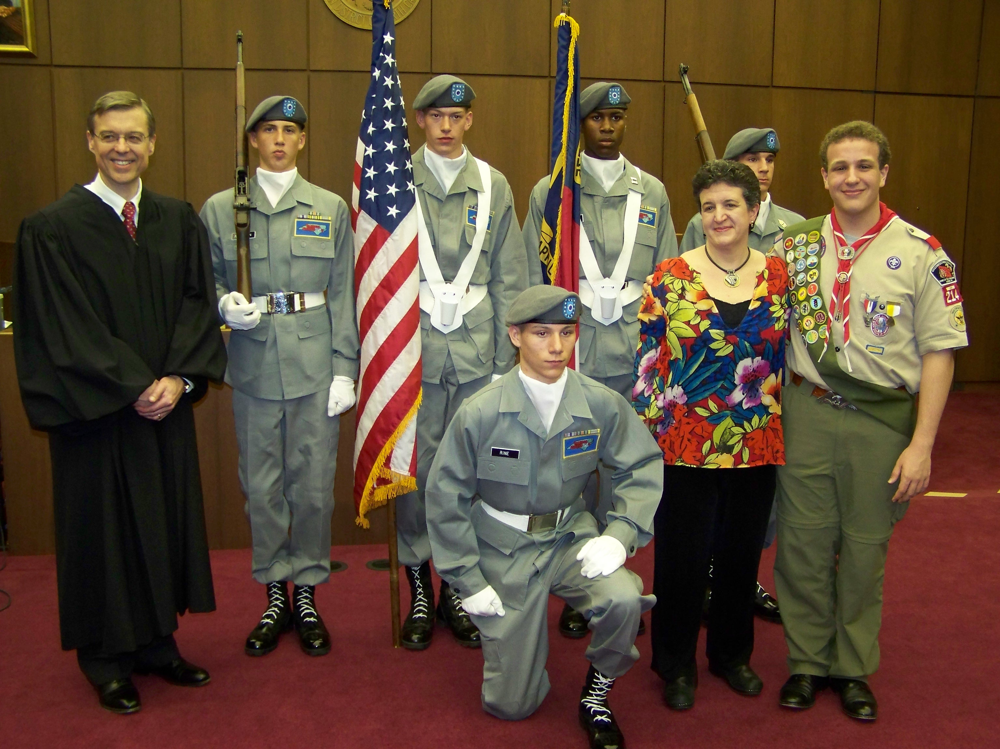

Troop 214 in our Community
You’ll recognize in the picture above our own Andrew Heil, who was asked to recite the pledge of allegiance at a Naturalization Ceremony on March 21 (because of his Eagle Scout Rank and recent God/Country award). In the process of getting prepared for that event, the organizers found out that his mom Margaret is a singer, so she ended up singing the National Anthem and God Bless America! Andrew and his mom had fun fulfilling their civic duty together in this way!!!

Quotes of the Month
For Mother’s Day: “A mother is the truest friend we have, when trials, heavy and sudden, fall upon us; when adversity takes the place of prosperity; when friends who rejoice with us in our sunshine, desert us when troubles thicken around us, still will she cling to us, and endeavour by her kind precepts and counsels to dissipate the clouds of darkness, and cause peace to return to our hearts.” – Washington Irving
For Memorial Day: “A hero is someone who has given his or her life to something bigger than oneself.” -- Joseph Campbell

Joke of the Month – Scoutmaster to scout who doesn’t attend meetings as often as he should: “Say, didn’t you miss the last meeting?” Scout’s reply, “No sir, I didn’t miss it a bit.”

Photos from Troop Leadership Training

