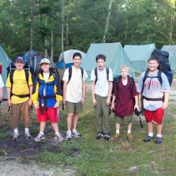
Troop 214 Parent News | Opening: Pack-Rangers
July 2009 | Game: New Patrol
http://www.bsatroop214.us | Service: Raiders
Harold Hodnett Scoutmaster | Program: Goats

Key Event This Month | Key Events Next Month
July 5-11 – Summer Camp | Aug. 16 – Court of Honor
 | Aug. 21-23 – Sea Kayaking Campout

Dates to Remember
July 4 – Independence Day
July 5 – Depart for Summer Camp
July 6 – No Troop Mtg (Summer Camp)
July 9 - OA Meeting
July 11 – Return from Summer Camp
July 12 – ASM Meeting
July 13 – PLC 6:30 pm; Troop Mtg 7 pm; Troop Committee 7 pm
July 18 – Adam Gold Eagle Project 9am
July 20 - Troop Mtg 7 pm
July 26 – Eagle Court of Honor: Graham Dean
July 27 – Troop Mtg 7 pm

Latest News and Details About Upcoming Events
Summer Camp – We are counting down the final days to our departure for Camp Durant. Please have your Scout attending camp at the Crabtree Mall parking lot near Sears at 12 noon on July 5; we depart for camp at 12:30 pm. We have 26 Scouts from Troop 214 attending summer camp this year, including five first-year Scouts. We were very pleased to find out that all of our Scouts got their first choices for merit badge programs. All necessary forms and payment should have been turned in to Mr. Dvorak by now; if you have any last-minute questions, please contact him at bdvorak@tycoelectronics.com. You may also find answers to questions you may have about summer camp in the Camp Durant Leaders’ Guide on the Camp Durant website (http://www.campdurant.com/Summer_Camp_Info.html, scroll to the bottom of the page for link). If you would like to send an email to your Scout while he is at camp (text only please), instructions can be found at http://www.campdurant.com/Email_Your_Scout.html.
Eagle Court of Honor – Graham Dean’s Eagle Court of Honor will be held Sunday, July 26, at 2:00 pm at Benson Memorial. Scouts and families are invited to come help Graham celebrate this important milestone!
Sea Kayaking Campout – Ahoy!! On the weekend of August 21st Troop 214 will have the very special opportunity to spend the weekend at the BSA High Adventure camp, Pamlico Sea Base (website: http://www.pamlicoseabase.org/) located on North Carolina’s Pamlico Sound, adjacent to Camp Bonner. The planning committee is still finalizing plans, but we hope to give participating Scouts the opportunity to earn either the Small Boat Sailing Merit badge or the BSA Kayaking award. The approximate cost of the trip will be $50 plus gas. So brush up on your bowlines or your power strokes and come with us to the beach! Stay tuned to future meetings for additional details.
Call for Adult Volunteers – We need volunteers to be adult advisors for the planned 2009-2010 campouts. Please take a look at the calendar on the Troop 214 website (select the “Calendar” link on the far right side of the main menu) and consider being an adult advisor for one of these exciting trips. It’s a fun way to get more involved with the troop! Please contact Mr. Hodnett at hhodnett@nc.rr.com if you think you might be interested.

Recent Highlights
June Blood Drive – Troop 214 Scouts and adults participated in a blood drive held at Benson Memorial on June 13. Thanks to those volunteers who helped with the blood drive including Ross Gattis, Rob Sprankle, Mr. Frank Castillo, and Mr. Monty Livingston, as well as those who came out to donate. We collected 12 pints, which was disappointing considering we had a goal of 30. Due to the low turnout, we shut down early, and we apologize to anyone who may have come by to donate after that. We will handle such a contingency differently for the next drive--but we hope that at the next drive, many more sign up to donate! Or if you cannot donate yourself, spread the word, and get someone else to sign up! Blood seems to always be in short supply, and is a truly lifesaving gift that you can give. So please consider turning out for the next Benson blood drive, which will probably be sometime in the fall.
Troop 214 in the Community – The Special Olympics of NC held their annual summer games on the weekend of June 5th-7th. Troop 214 had Scouts volunteering at the event and competing as well. Alex Dilalla, David Dvorak, Peter Michaud, and Joshua
Thomas all worked as Competition Assistants performing various tasks where needed. And our own Danny Wever competed in the Team Softball games. Working for and with the Special Olympics athletes and staff was a great experience for the Scouts, and they shall certainly remember it fondly. They lived up to the Scout ideals of; Do a Good Turn Daily, A Scout is Helpful and Friendly and Kind, and to Help Other People at All Times. Troop 214 hopes to make its budding partnership with the Special Olympics of NC a lasting one, with many great years and experiences to come.

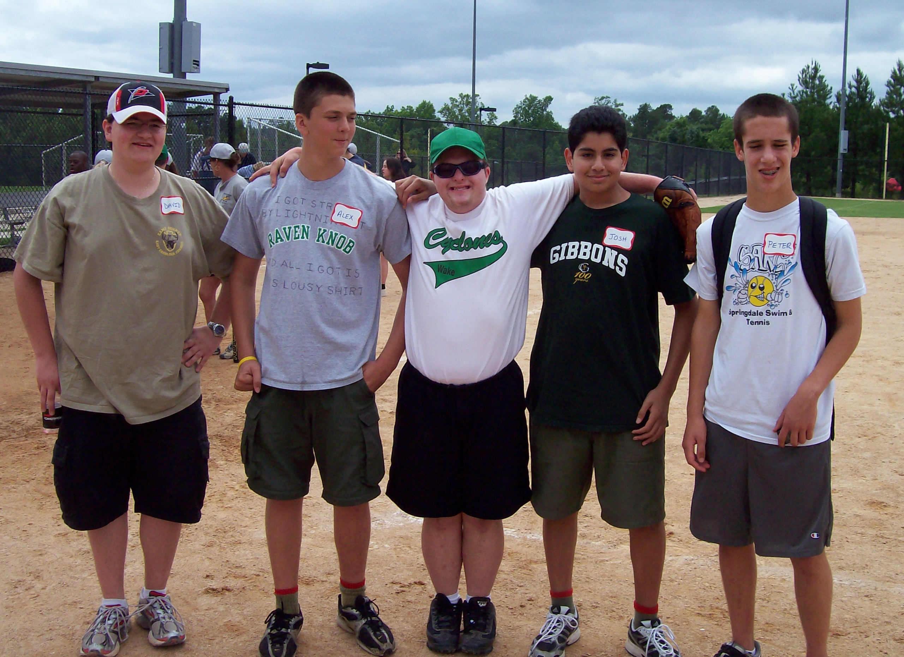

Quote of the Month
Independence Day: “You have to love a nation that celebrates its independence every July 4, not with a parade of guns, tanks, and soldiers who file by the White House in a show of strength and muscle, but with family picnics where kids throw Frisbees, the potato salad gets iffy, and the flies die from happiness. You may think you have overeaten, but it is patriotism.” – Erma Bombeck
Joke of the Month:
Q: What’s the difference between bird flu and swine flu?
A: For bird flu you get “tweetment”, and for swine flu you get “oinkment”!

