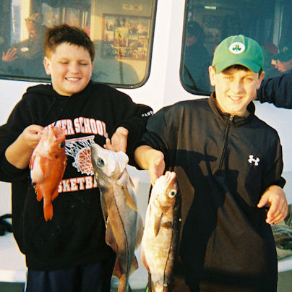

Troop 214 Parent News
September 2011
http://www.bsatroop214.us
Harold Hodnett Scoutmaster

Key Events This Month | Key Events Next Month
Sept. 9-11 - Offshore Fishing Campout | Oct. 3 - Troop Elections (tentative)
 | Oct. 7-9 - Sailing Campout

Dates to Remember
September 1 - Roundtable
September 5 - Labor Day; Troop Mtg 7 pm (for participants of the offshore fishing campout)
September 8 - OA Meeting
September 9-11 - Offshore fishing campout
September 12 - PLC 6:30 pm; Troop Mtg 7 pm; Troop Committee
September 16-18 - OA Fall Fellowship
September 19 - Troop Mtg 7 pm; Boards of Review
September 24 - Popcorn sales begin
September 26 - Troop Mtg 7 pm

News and Details About Upcoming Events
Offshore Fishing Campout – Troop 214 is going deep sea fishing on Morehead City's largest offshore boat, the Continental Shelf! We will be departing from the Scout Hut Friday Sept. 9 at 5 pm sharp for the three-hour drive to the coast. We will camp "seaside" on Gallants Channel in Beaufort, and rise early the next day for a full day of activities. During our four-hour fishing trip on the Continental Shelf, fishing gear, bait and a crew to assist all anglers will be provided. The boat also features plenty of inside accommodations should there be any foul weather. Refreshments will also be available for purchase during the trip.
After returning from our fishing trip, we'll clean our catch, have lunch, do a beach sweep, and then head off to Beaufort to visit the new Blackbeard exhibit at the NC Maritime Museum. After a full day on the water everyone will be ready to get back to camp and prepare our "fresh catch of the day." Thomas Fair will lead the troop with a campfire program after dinner and encourages all members of the troop (Scouts and adults alike) to "be prepared" with skits, jokes, fish tales and your best ghost stories!
Sunday morning those who are not yet "fished out" can add to their haul at the Oceanna Pier in Atlantic Beach.
We will hit the road after lunch and arrive back at the Scout Hut between 4-5 pm on Sunday.
In addition to the cost of the trip ($35 Scouts/$45 adults) participants should plan on $10 for lunch at Golden Corral prior to leaving Beaufort on Sunday, plus money for gas, grub, and bait. If you have questions about the trip, please contact adult advisors Mr. John Willis at jwillis89@nc.rr.com or Mr. Mike Fair at mikefair1@nc.rr.com.
Please note: There will be a short Troop meeting on Labor Day, Sept. 5. This is specifically to plan for the offshore fishing campout, and all Scouts participating in that campout must attend. Scouts not planning to go on the campout do not need to attend the meeting.
Upcoming OA Events – The next Order of the Arrow chapter meeting will be Sept. 8th in the Youth Center at Benson Memorial. We will have dinner at 6:30 pm with the meeting to begin at 7 pm. If your Scout has questions about OA activities, he should contact Troop 214 OA representative Matthew Fiely at matthewfiely@gmail.com.
Popcorn Sales – Troop 214's only annual fundraising activity is our participation in the council popcorn sale. Selling these quality popcorn products puts money in your Scout's account that can be used to pay for campouts, Summer Camp, and other Troop activities. Popcorn sales this year begin on Sept. 24. Ms. Shirley Olson, Troop 214 Popcorn Kernel, will be providing information about the sale at upcoming Troop meetings. If you have questions about the sale, you can reach Ms. Olson by email at sjolsen@bellsouth.net.
Calendar Notes – Please note that there will be no adult leader/ASM meeting in September. As always, if you have any issues that need to be addressed, please email Mr. Hodnett directly at hhodnett@hotmail.com.
New Calendar Available – A 2011-2012 calendar is now available on the Documents page of the Troop 214 web site, or you may access it directly at http://www.bsatroop214.us/documents/Troop214_Documents_and_Forms/T-214_Calendar_2011-2012.pdf. Thanks to Webmaster Kenny Jones and to Mr. Stuart Thomas for overseeing maintenance of the Troop web site.
Please take a few moments to look at the new calendar to see all the exciting events Troop 214 has planned for the coming year. We are still in need of adult advisors for a few campouts: Aviation (February), Wilderness Survival (April) , and Motorboating (Summer 2012). If you are interested in serving as adult advisor for one of these campouts, please contact Mr. Hodnett at hhodnett@hotmail.com

Recent Highlights
Canoeing/Tubing Campout – The Troop went on a flatwater canoe/kayak trip Aug. 12-14th along the south fork of the New River just north of Jefferson, NC. We had 19 youth and 7 adults for a very successful turnout for this outing. For many it was their first canoe experience, so we conducted instructional sessions for three consecutive troop meetings prior to the event.
Our trip started eventfully; we left the Scout Hut Friday evening at 5 pm, and our ETA should have been about 8:20 pm with the gate to the park closing at 9:00. All was fine until we hit a succession of traffic jams on I-40 caused by 13 separate crashes. We didn't arrive at the park until 9:10 pm, and sure enough, the ranger was right on time and had locked the gate at 9:00. However, we were "prepared": all participants had been advised to pack for a backpacking trip because a short hike-in would be needed as the parking lot is about 300 yards from the group campsite. With the gate now locked, 300 yards became over a quarter of a mile. Not to worry, the 214 youth and adults were prepared for a hike and we hiked in from the gate under a glorious full moon. It was actually quite a nice walk.
Saturday morning after a quick breakfast we drove over to Riverside Canoe for our shuttle back to the put-in which was ironically very near our campsite. We then paddled our way down this designated scenic wild river back to the outfitter's campus with a lunch and more than one swim stop along the way. Due to a lack of rain, the river was low and slow and we dragged bottom in many places, but the remedy was simply to stand up, drag the canoe a few feet and get back in. Because the river was slow, our 4-hour trip ended up being closer to 6-hour, but the verdict was unanimous that all had fun and are ready to do it again.
We did receive some serious rain during the night Saturday night into Sunday morning. Despite lots of wet gear, spirits were high on the trip back where we enjoyed a spectacular long distance view of Pilot Mountain descending the mountain out of Sparta, NC, and a lunch stop in Greensboro before arriving back at Benson around 2 pm.
Thanks to Mr. Sam Fouse for serving as adult advisor for the trip, and for Mr. David Burdett for his assisting on this trek and for driving the Benson van. Thanks also go out for the help rendered by the other adults attending: Mr. Thomas, Mr. Mike Jones, Mr. John Norwood, Mr. Joseph Heil, and Mr. Tim Stammers, and to our youth committee chair for this event, Troy Sturdivant.
Summer Court of Honor – The Summer Court of Honor was held Aug. 23; thanks to all who made this gathering a great success! All patrols made efforts to entertain attendees with skits, and some were very good. A very special thanks goes out to Ms. Katrina James for making sure that everyone got their awards. Ms. James puts in a lot of "behind the scenes" work to make sure our Scouts get recognized for their achievements, so if you have an opportunity to do so, take a moment to thank her for her service to our Troop.
CPR/First Aid Training – A group of eight Scouts and six adults took advantage of an opportunity offered Aug. 30 to get training in cardiopulmonary resuscitation (CPR) and first aid. The class, taught by adult leader Mr. Frank Castillo, covered how to recognize heart attacks, strokes, choking, and other breathing emergencies, and provide assistance so people experiencing these conditions have a better chance to survive. Participants also learned how to help people with a variety of injuries such as cuts, sprains, and broken bones, and how to prevent and treat illnesses caused by heat and cold exposure.

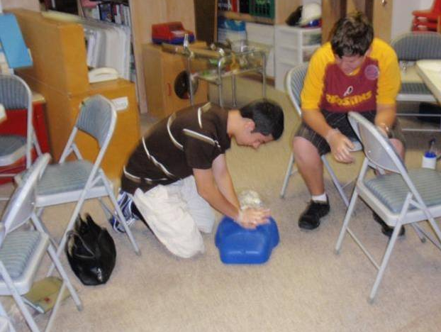
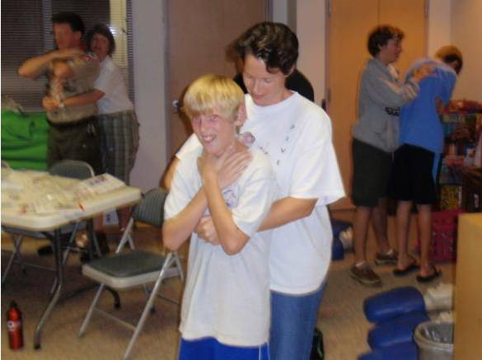
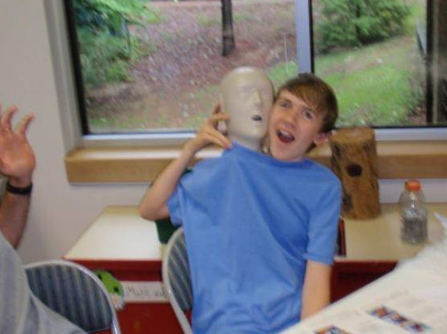
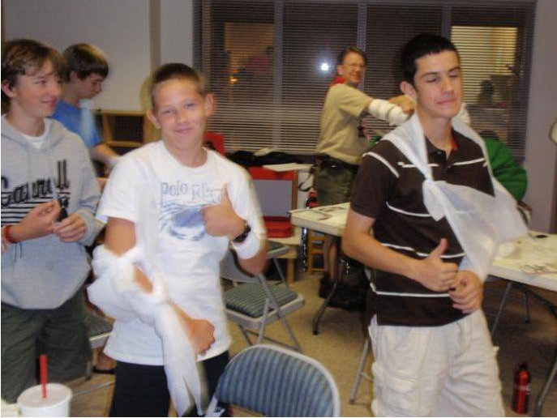

As you can see by the pictures, participants had fun while learning some valuable skills. There is no better way to "Be Prepared" than to take the time to learn what to do in an emergency. Thanks to Mr. Castillo to help some of us be better prepared to help our Troop members, friends, and families in case of emergency.
Quote of the Month
"I can think of no more stirring symbol of man's humanity to man than a fire engine." ~Kurt Vonnegut

Joke of the Month
Our team has some problems:
- The only way we can gain yardage is to run our game films backward.
- We have so many players on the disabled list that the team's bus can use handicapped parking.
- The place kicker attempted a field goal, but missed. He was so mad that he tried to kick himself but missed again.
- The coach laments that that the two toughest problems he faces are defensive linemen and offensive alumni.
- But this year I can assure you that our team is going to move the ball. I just hope that it goes forward.
Have a great football season! (Source: http://www.superbowl-commercials.com)
Thanks to Scoutmaster Mr. Harold Hodnett, and adult leaders Mr. Stuart Thomas, Mr. Sam Fouse, Mr. John Willis, and Mr. Frank Castillo for contributing to this month’s newsletter.

